Required Components

* GMS Core
* MODFLOW Interface

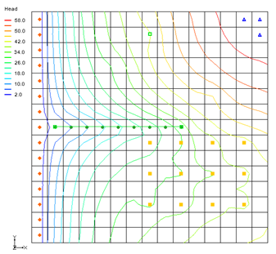

GMS 10.9

GMS 10.9 Tutorial

***MODFLOW – DRT Package***

The MODFLOW drain return package

Objectives

Learn about the MODFLOW drain return package (DRT) interface in GMS and compare the package to the regular MODFLOW drain (DRN) package.

Time

* 25–40 minutes

Prerequisite Tutorials

* MODFLOW – Conceptual Model Approach I

|  |
| --- |
| [1 Introduction 2](#_Toc110411259)  [2 Getting Started 4](#_Toc110411260)  [2.1 Opening the Existing Model 4](#_Toc110411261)  [2.2 Saving the Model with a New Name 4](#_Toc110411262)  [3 Changing from DRN to DRT Boundary Conditions 5](#_Toc110411263)  [3.1 Selecting the Drain Cells 5](#_Toc110411264)  [3.2 Creating DRT Boundary Conditions 5](#_Toc110411265)  [3.3 Deleting DRN Boundary Conditions 6](#_Toc110411266)  [3.4 Saving and Running MODFLOW 6](#_Toc110411267)  [3.5 Examining the Flow Budget 6](#_Toc110411268)  [4 Changing the Return-Flow Cell for the DRT Boundary Conditions 7](#_Toc110411269)  [4.1 Saving and Running MODFLOW 7](#_Toc110411270)  [4.2 Examining the Flow Budget 8](#_Toc110411271)  [5 Creating a Conceptual Model 8](#_Toc110411272)  [5.1 Creating a Coverage 9](#_Toc110411273)  [5.2 Creating the DRT Arc 9](#_Toc110411274)  [5.3 Creating the DRT Point 10](#_Toc110411275)  [5.4 Mapping the Conceptual Model to MODFLOW 11](#_Toc110411276)  [5.5 Examining the DRT Package 11](#_Toc110411277)  [5.6 Saving and Running MODFLOW 12](#_Toc110411278)  [5.7 Viewing the Computed Flows for the Feature Objects 13](#_Toc110411279)  [6 Creating a DRT Parameter 13](#_Toc110411280)  [6.1 Saving and Running MODFLOW 14](#_Toc110411281)  [7 Conclusion 15](#_Toc110411282) |

# Introduction

In MODFLOW, drain boundary conditions are used to simulate water leaving the groundwater system. MODFLOW has two standard packages that are used to model drains: the DRN (Drain) package and the DRT (Drain Return) package. The DRT package can be used to simulate the return flow of water discharged from a drain boundary condition to the groundwater system.

Each drain boundary condition requires specifying a drain elevation and a drain conductance. When the simulated head in a cell is above the drain elevation, water will leave the groundwater system proportional to the drain conductance. When the simulated head in a cell is below the drain elevation, no water leaves the system through the drain boundary condition.

In addition to specifying a drain elevation and conductance, specify a return-flow cell and a return-flow factor (0.0–1.0). A portion of the water that would normally leave the groundwater system through the drain is returned to the model at the return-flow cell. Figure 1 illustrates an example of where a DRT boundary condition may be used.

The DRN package has existed since the first MODFLOW release. The DRT package was introduced with MODFLOW 2000. This tutorial explains how to use the DRT package and compares it to the DRN package. Both packages can be used at the same time if desired.



Figure DRT model, from Banta (2000)[[1]](#footnote-1)

The problem explored in this tutorial is the same one used in the “MODFLOW – Grid Approach” tutorial, and is shown in Figure 2. This problem is a modified version of the sample problem described near the end of the *MODFLOW 88 Reference Manual*. Refer to the “MODFLOW – Grid Approach” tutorial for a complete description of the problem. In brief, it is a grid-based model (no conceptual model) that has three layers, some wells, some drains, recharge, and constant head cells.



Figure Sample problem to be solved

This tutorial will discuss and demonstrate importing an existing MODFLOW simulation, changing DRN boundary conditions to DRT boundary conditions, and changing DRT boundary conditions to return flow to the model. A simple conceptual model will be created to illustrate how DRT can be modeled conceptually and mapped to MODFLOW.

# Getting Started

Do the following to get started:

1. If necessary, launch GMS.

If GMS is already running, select *File |* **New** to ensure that the program settings are restored to their default state. Click **Don’t Save** if asked to save changes.

## Opening the Existing Model

Start with a previously-created MODFLOW model.

1. Click **Open** File:Open Macro.svg to bring up the *Open* dialog.
2. Select “Project Files (\*.gpr)” from the *Files of type* drop-down.

Browse to the *drt* folder and select “modfgrid.gpr”.

Click **Open** to import the project and exit the *Open* dialog.

A grid with head contours and symbols representing wells, drains and other boundary conditions should be visible (Figure 3).

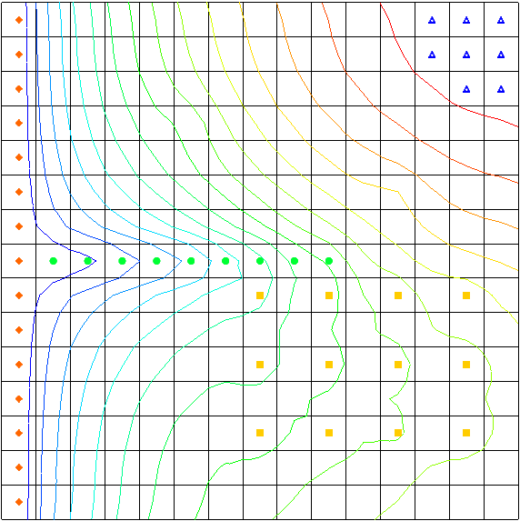

Figure The MODFLOW model

## Saving the Model with a New Name

Now it is possible to start making changes. First, save the model with a new name.

1. Select *File |* **Save As…** to bring up the *Save As* dialog.
2. Select “Project Files (\*.gpr)” from the *Save as type* drop-down.

Enter “drt.gpr” as the *File name*.

Click **Save** to save the project under the new name and close the *Save As* dialog.

# Changing from DRN to DRT Boundary Conditions

Next, delete the DRN boundary conditions and create identical DRT boundary conditions.

## Selecting the Drain Cells

It is necessary to select the cells with the drain boundary condition:

1. Using the **Select Cells** File:Select 3D Cell Tool.svg tool while holding down the *Shift* key, select the cells in columns 2–10 of row 8 (highlighted in Figure 4).

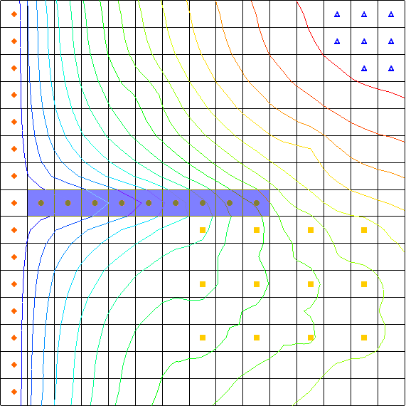

Figure Location of the drain boundary conditions

Select *MODFLOW | Advanced |* **Sources/Sinks…** to bring up the *MODFLOW Sources/Sinks* dialog.

## Creating DRT Boundary Conditions

Next to create new DRT boundary conditions and copy the properties of the existing drain (DRN) boundary conditions.

1. From the list on the left, select “Drain (DRN)”. This spreadsheet shows the DRN boundary conditions.
2. In the *Elevation (m)* column, select the top cell (below the *All* row). While holding down *Shift*, select the bottom cell in the *Conductance (m^2/d)* column.

This should highlight all of the cells in the spreadsheet except for those in the *All* row.

1. Right-click on the one of the selected columns and select **Copy**.
2. Select “Drain (DRT)” from the list on the left.

Click **Add BC** to create new DRT boundary conditions in each of the selected cells.

In the *Elevation (m)* column, select the top cell (below the *All* row), then right-click on the cell and select **Paste**.

The contents from the “Drain (DRN)” cells should be copied to the “Drain (DRT)” cells.

## Deleting DRN Boundary Conditions

Now it is necessary to delete the drain boundary conditions.

1. From the list on the left, select “Drain (DRN)”.

Click **Delete All BCs**.

Click **OK** to exit the *MODFLOW Sources/Sinks* dialog.

Click anywhere outside the grid to unselect the cells.

Notice the color of the boundary conditions has changed slightly to be a darker green (Figure 5).

GMS 10_1 - MODFLOW-DRTPackage - DRN boundary conditions converted to DRT

Figure DRN boundary conditions converted to DRT

## Saving and Running MODFLOW

The next step is to save these changes and run MODFLOW.

1. **Save** File:Save Macro.svg the project.

Select *MODFLOW |* **Run MODFLOW** to bring up the *MODFLOW* model wrapper dialog.

When MODFLOW finishes, turn on *Read solution on exit* and *Turn on contours (if not on already)*.

Click **Close** to import the solution and exit the *MODFLOW* model wrapper dialog.

Fully expand the “File:3D Grid Folder.svg 3D Grid Data” folder in the Project Explorer.

Compare the new and old solutions by alternating between the “File:Generic Folder Locked.svg modfgrid (MODFLOW)” and the “File:Generic Folder Locked.svg drt (MODFLOW)”folders.

Notice the heads are identical in the new “File:Generic Folder Locked.svg drt (MODFLOW)” and the “File:Generic Folder Locked.svg modfgrid (MODFLOW)” solutions.

**Save** File:Save Macro.svg the project with the new solution.

## Examining the Flow Budget

Now to compare the flow budget information from the two models:

1. Select “File:Generic Folder Locked.svg modfgrid (MODFLOW)” in the Project Explorer to make it active.

Select *MODFLOW |* **Flow Budget…** to bring up the *Flow Budget* dialog.

In the *Sources/Sinks* section, on the *DRAINS* row, notice that the value in the *Flow Out* column is “-136,771.6992188” and the value in the *Flow In* column is “0.0”.

Click **OK** to exit the *Flow Budget* dialog.

Select “File:Generic Folder Locked.svg drt (MODFLOW)” to make it active.

Select *MODFLOW |* **Flow Budget…** to bring up the *Flow Budget* dialog.

In the *Sources/Sinks* section, on the *DRAINS (DRT)* row, notice that the value in the *Flow Out* column is also “-136,771.6992188” and the value in the *Flow In* column is also “0.0”.

Click **OK** to exit the *Flow Budget* dialog.

# Changing the Return-Flow Cell for the DRT Boundary Conditions

This tutorial demonstrated that the DRT package can be used exactly as the DRN package. Now, to modify the DRT inputs to simulate the return flow from the drains to the groundwater system. First, save the project with a new name.

1. Select *File |* **Save As…** to bring up the *Save As* dialog.
2. Select “Project Files (\*.gpr)” from the *Save as type* drop-down.

Enter “drt1.gpr” as the *File name*.

Click **Save** to save the project under the new name and exit the *Save As* dialog.

Select *MODFLOW | Optional Packages |* **DRT – Drain Return…**to bring up the *MODFLOW Drain Return Package* dialog.

In the spreadsheet, in the *Return I* and *Return J* columns, enter “15” for each of the DRT boundary condition rows.

In the *Rfprop* column, enter “0.5” for each of the DRT boundary condition rows. This is the return-flow proportion.

Click **OK** to exit the *MODFLOW Drain Return Package* dialog.

## Saving and Running MODFLOW

Now, to save these changes and run MODFLOW:

1. **Save** File:Save Macro.svg the project.

Select *MODFLOW |* **Run MODFLOW**to bring up the *MODFLOW* model wrapper dialog.

When MODFLOW finishes, turn on *Read solution on exit* and *Turn on contours (if not on already)*.

Click **Close** to import the solution and exit the *MODFLOW* model wrapper dialog.

Notice the changes in the new solution (Figure 6).

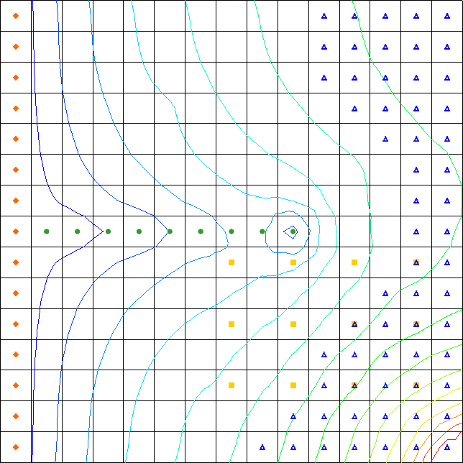

Figure There are visible changes in the contours

1. Compare the new and old solutions by alternately selecting the “File:Generic Folder Locked.svg drt (MODFLOW)” folder and the “File:Generic Folder Locked.svg drt1 (MODFLOW)”folder in the Project Explorer.

Notice the head is different in the new “File:Generic Folder Locked.svg drt1 (MODFLOW)” solution.

**Save** File:Save Macro.svg the project with the new solution.

## Examining the Flow Budget

The next step is to view the flow budget information from the “drt1” model

1. Select the “File:Generic Folder Locked.svg drt1 (MODFLOW)” solution in the Project Explorer to make it active.

Select *MODFLOW |* **Flow Budget…** to bring up the *Flow Budget* dialog.

On the *Cells* tab, in the *Sources/Sinks* section, on the *DRAINS (DRT)* row, there are now values in both the *Flow In* and *Flow Out* columns*.*

Click **OK** to exit the *Flow Budget* dialog.

# Creating a Conceptual Model

The next step is to examine how to use a conceptual model with DRT data. Save the model with a new name before changing to a conceptual model.

1. Select *File |* **Save As…** to bring up the *Save As* dialog.
2. Select “Project Files (\*.gpr)” from the *Save as type* drop-down.

Enter “drt2.gpr” as the *File name* and click **Save** to close the *Save As* dialog.

Right-click in empty space in the Project Explorer and select *New |* **Conceptual Model…** to bring up the *Conceptual Model Properties* dialog.

Enter “modfgrid” as the *Name*.

Click **OK** to close the *Conceptual Model Properties* dialog.

## Creating a Coverage

1. Right-click on the “File:Conceptual Model Icon.svg modfgrid” conceptual model and select **New Coverage…** to bring up the *Coverage Setup* dialog.

Enter “drt” as the *Coverage name*.

In the *Sources/Sinks/BCs* column, turn on *Layer range* and *Drain (DRT)*.

Click **OK** to exit the *Coverage Setup* dialog.

## Creating the DRT Arc

1. Select the “File:Coverage Active Icon.svg drt” coverage to make it active.
2. Using the **Create Arc** File:GMS Create Arc Tool.svg tool, create an arc for the drains as shown in Figure 7. Make sure the left end of the arc does not enter the specified head cell on the left side of the model.

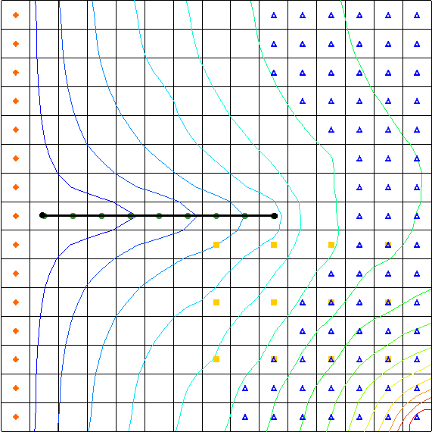

Figure Creating an arc for the drains

Using the **Select Arcs** File:GMS Select Arc Tool.svgtool, double-click on the newly created arc to bring up the *Attribute Table* dialog.

In the spreadsheet, in the *Type* column, select “drain (DRT)” from the drop-down.

In the *Cond. (m^2/d)/(m)* column, enter “4.8”. Leave the other attributes at the default settings.

Click **OK** to exit the *Attribute Table* dialog.

Click anywhere outside the arc to unselect it.

Note that the arc changed color and the nodes changed to squares (Figure 8).

GMS 10_1 - MODFLOW-DRTPackage - DRT Arc after changing attributes

Figure The arc is now green with green squares as the nodes

Using the **Select Objects** File:Select Object Tool.svg tool, select the right arc node.

Click **Properties** File:GMS Properties Macro.svg to bring up the *Attribute Table* dialog.

In the spreadsheet, in the *Bot. elev. (m)* column, enter “30.0”.

Click **OK** to exit the *Attributes Table* dialog.

The left arc node bottom elevation is defaulted to “0.0”, so it is not necessary to edit its value.

## Creating the DRT Point

Now to create a DRT point in the coverage:

1. Using the **Create Point** File:Create Points Tool.svg tool, create a point in the cell at row 2 column 8 (the cell is highlighted in purple in Figure 9).

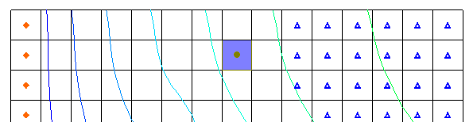

Figure New DRT point

Using the **Select Objects** File:Select Object Tool.svg tool, double-click on the new point to bring up the *Attribute Table* dialog.

In the spreadsheet, in the *Name* column, enter “point\_4”.

In the *Type* column, select “drain (DRT)” from the drop-down.

In the *Cond. (m^2/d)* column, enter “1000.0”.

In the *Bot. elev. (m)* column, enter “10.0”.

In the *Rfprop* column, enter “0.5”.

In the *Auto assign layer* column, select “Use layer range” from the drop-down.

In both the *From layer* and the *To layer* columns, enter “2”.

When completed, the dialog should appear as in Figure 10.

Click **OK** to exit the *Attribute Table* dialog.

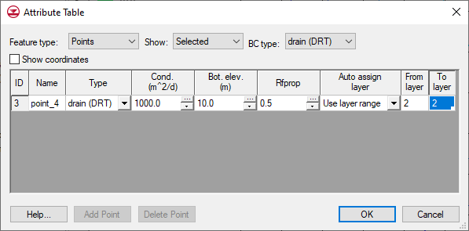

Figure Attribute Table dialog for the DRT point

## Mapping the Conceptual Model to MODFLOW

Now that the conceptual model is set up, it is possible to map it to the MODFLOW grid.

1. Select *Feature Objects |* **Map → MODFLOW** to bring up the *Map → Model* dialog.

Click **OK** to accept the defaults and close the *Map → Model* dialog.

## Examining the DRT Package

Now, to look at the data in MODFLOW that was mapped from the conceptual model.

1. Select *MODFLOW | Optional Packages |* **DRT – Drain Return…**to bring up the *MODFLOW Drain Return Package* dialog.
2. Review the various DRT boundary conditions that were created.

Notice that the boundary conditions created from the arc have a return-flow proportion (Rfprop) of “0.0”, while the boundary condition created from the point has the return-flow proportionof “0.5”.

Notice that the return cell location is defaulted to the same *I, J* location as the boundary condition except that *K* is set to “1”.

At the bottom of the dialog, turn on **IJK** from the *Display cell* options. Notice that the last DRT boundary condition is located at *IJK* “2,8,2” (Figure 11, highlighted at bottom left) and the return *KIJ* is 1,2,8 (Figure 11, highlighted at bottom right).

Click **OK** to exit the *MODFLOW Drain Return Package* dialog.

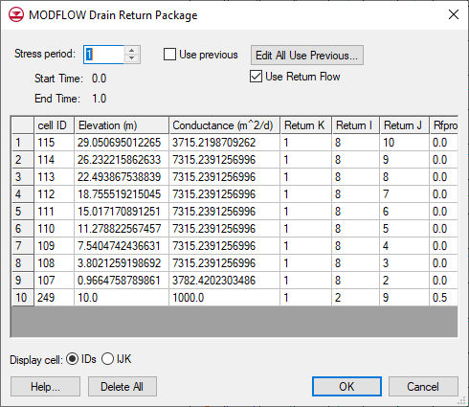

Figure DRT boundary condition and return coordinates

## Saving and Running MODFLOW

Now to save these changes and run MODFLOW:

1. **Save** File:Save Macro.svg the project.

Select *MODFLOW |* **Run MODFLOW**to bring up the *MODFLOW* model wrapper dialog.

When MODFLOW finishes, turn on *Read solution on exit* and *Turn on contours (if not on already)*.

Click **Close** to import the solution and close the *MODFLOW* model wrapper dialog.

Notice some changes in the new solution (Figure 12).

**Save** File:Save Macro.svg the project with the new solution.

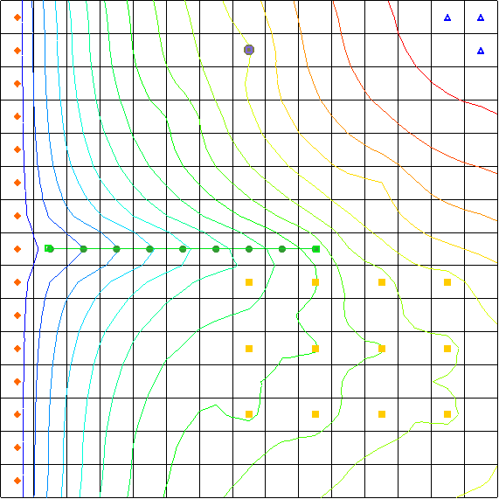

Figure The new solution with contours

## Viewing the Computed Flows for the Feature Objects

Since the DRT boundary conditions were created from feature objects in the map module, it is possible to select the points or arcs that were used to create the boundary conditions and view the computed flow out of the model from those boundary conditions.

1. In the Project Explorer, select the “File:Conceptual Model Icon.svg modfgrid” conceptual model to make it active.

Using the **Select Objects** File:Select Object Tool.svg tool, select the DRT arc in the coverage.

Notice the information strip at the bottom of the GMS window (Figure 13). The computed flow out of the model from the DRT arc is shown there. The DRT point can also be selected to see similar information.



Figure Computed flow from the DRT arc

# Creating a DRT Parameter

Now, to create a DRT parameter by changing the conductance on the DRT arc to use a parameter instead of specifying the conductance value:

1. Using the **Select Objects** File:Select Object Tool.svg tool, double-click on the DRT arc in the coverage to bring up the *Attribute Table* dialog.

In the *Cond. (m^2/d)/(m)* column, in the spreadsheet, enter “-10.0”.

Click **OK** to exit the *Attribute Table* dialog.

Select *Feature Objects |* **Map → MODFLOW** to bring up the *Map → Model* dialog.

Click **OK** to accept the defaults and close the *Map → Model* dialog.

Select *MODFLOW |* **Parameters…** to bring up the *Parameters* dialog.

Click **Initialize From Model**.

Notice that a new parameter has been created.

In the spreadsheet, in the *Value* column, enter “4.8”.

Click **OK** to exit the *Parameters* dialog.

Select *MODFLOW | Optional Packages |* **DRT – Drain Return…**to bring up the *MODFLOW Drain Return Package* dialog.

Notice that the conductance is set to “-10.0” for the boundary conditions that were created by the arc. Also notice that the spreadsheet now has a *Cond. factor* column. The values listed in the *Cond. factor* column are multiplied by the parameter value to give the final conductance value for the DRT boundary condition.

Click **OK** to exit the *MODFLOW Drain Return Package* dialog.

## Saving and Running MODFLOW

Now to save the changes and run MODFLOW:

1. Select *File |* **Save As…** to bring up the *Save As* dialog.
2. Select “Project Files (\*.gpr)” from the *Save as type* drop-down.

Enter “drt3.gpr” as the *File name*.

Click **Save** to save the project under the new name and close the *Save As* dialog.

Select *MODFLOW |* **Run MODFLOW**to bring up the *MODFLOW* model wrapper dialog.

When MODFLOW finishes, turn on *Read solution on exit* and *Turn on contours (if not on already)*.

Click **Close** to exit the *MODFLOW* model wrapper dialog.

Notice that the new solution is the same as the previous run.

# Conclusion

This concludes the “MODFLOW – DRT Package” tutorial. The following key concepts were discussed and demonstrated:

* GMS supports both the DRN and DRT packages. Both packages can be used at the same time if desired.
* The DRT package produces the same results as the DRN package if the return-flow factor is specified as zero.
* DRT data can be viewed and edited in the *DRT Package* dialog.
* DRT data can be defined on points, arcs, and polygons in a conceptual model.

GMS supports DRT parameters.

1. Banta, Edward R. (2000), *MODFLOW-2000, The U.S. Geological Survey Modular Ground-Water Model—Documentation of Packages for Simulating Evapotranspiration with a Segmented Function (ETS1) and Drains with Return Flow (DRT1)*. Open-File Report 00-466, Denver, Colorado, p.32. <http://pubs.usgs.gov/of/2000/0466/report.pdf> . [↑](#footnote-ref-1)