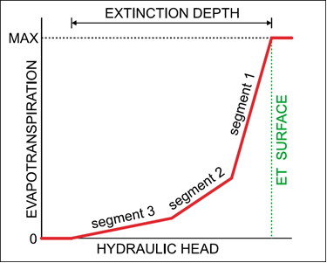

GMS 10.9 Tutorial

***MODFLOW – ETS Package***

The MODFLOW Evapotranspiration Segments (ETS) package interface in GMS

GMS 10.9

Objectives

Learn how to use the MODFLOW Evapotranspiration Segments (ETS) package interface in GMS and compare it to the regular MODFLOW Evapotranspiration (EVT) package.

Time

* 40–60 minutes

Required Components

* GMS Core
* MODFLOW Interface

Prerequisite Tutorials

* MODFLOW – Conceptual Model Approach I

|  |
| --- |
| [1 Introduction 2](#_Toc110411500)  [2 Getting Started 3](#_Toc110411501)  [2.1 Opening the Existing Model 4](#_Toc110411502)  [2.2 Saving the Model with a New Name 4](#_Toc110411503)  [3 Adding ET via the EVT Package 4](#_Toc110411504)  [3.1 Turning on the EVT Package 5](#_Toc110411505)  [3.2 Specifying ET 5](#_Toc110411506)  [3.3 Saving and Running MODFLOW 5](#_Toc110411507)  [3.4 Examining the Flow Budget 6](#_Toc110411508)  [4 Adding ET via the ETS Package 7](#_Toc110411509)  [4.1 Saving the Model with a New Name 7](#_Toc110411510)  [4.2 Switching from the EVT Package to the ETS Package 7](#_Toc110411511)  [4.3 Specifying ET 7](#_Toc110411512)  [4.4 Switching LMT package to Extended Header 8](#_Toc110411513)  [4.5 Saving and Running MODFLOW 8](#_Toc110411514)  [4.6 Examining the Flow Budget 9](#_Toc110411515)  [5 Adding ETS Curve Segments 9](#_Toc110411516)  [5.1 Saving the Model with a New Name 10](#_Toc110411517)  [5.2 Changing NETSEG 10](#_Toc110411518)  [5.3 Defining the PXDP Data 10](#_Toc110411519)  [5.4 Defining the PETM Data 11](#_Toc110411520)  [5.5 Saving and Running MODFLOW 11](#_Toc110411521)  [6 Building a Conceptual Model 12](#_Toc110411522)  [6.1 Saving the Model with a New Name 12](#_Toc110411523)  [6.2 Creating the Conceptual Model 13](#_Toc110411524)  [6.3 Creating a Coverage 13](#_Toc110411525)  [6.4 Creating the Polygon 13](#_Toc110411526)  [6.5 Setting the Polygon Properties 14](#_Toc110411527)  [6.6 Mapping to MODFLOW 14](#_Toc110411528)  [6.7 Examining the ETS Package 14](#_Toc110411529)  [6.8 Saving and Running MODFLOW 15](#_Toc110411530)  [7 Parameters 16](#_Toc110411531)  [7.1 Saving the Model with a New Name 16](#_Toc110411532)  [7.2 Parameterizing the Model 16](#_Toc110411533)  [7.3 Saving and Running MODFLOW 17](#_Toc110411534)  [8 Conclusion 18](#_Toc110411535) |

# Introduction

Evapotranspiration is the moving of water from the ground surface to the atmosphere through evaporation and transpiration. MODFLOW has two standard packages—EVT and ETS—used to model evapotranspiration.

The EVT package—which has existed since at least MODFLOW 88—requires three parameters to determine evapotranspiration: the evapotranspiration (ET) surface elevation, the maximum ET rate, and the extinction depth. When the head in a cell is at or above the ET surface, ET occurs at the maximum ET rate. When the head is below the extinction depth, ET is zero. In between these two points, the ET varies linearly (Figure 1).

The Evapotranspiration Segments Package (ETS)—introduced with MODFLOW 2000—is very similar to the EVT package, but adds the ability to vary the ET nonlinearly between the ET surface and the extinction depth. These packages can be used simultaneously.

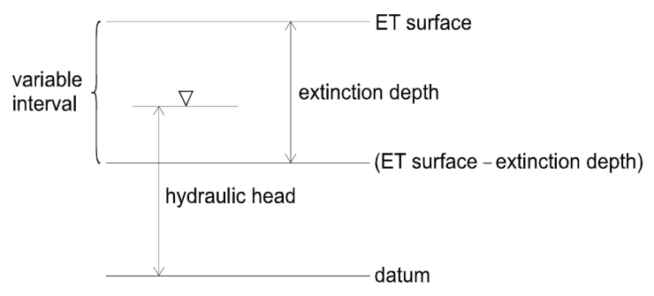

Figure 1 ET model, from Banta (2000)[[1]](#footnote-1)

This tutorial explains how to use the ETS package and compares it to the EVT package. It uses the problem (Figure 2) found in the “MODFLOW – Grid Approach” tutorial, a modified version of the sample problem described near the end of the *MODFLOW 88 Reference Manual*. It is a grid-based model (no conceptual model) with three layers, some wells and drains, recharge, and constant head cells.



Figure 2 Sample problem to be solved

This tutorial discusses and demonstrates:

* Adding ET to the model using the EVT package.
* Adding ET to the model using the ETS package.
* Mimicking the EVT package.
* Defining a nonlinear curve for the ETS package.
* Creating a simple conceptual model illustrating how ETS can be modeled conceptually and mapped to MODFLOW.

# Getting Started

Do the following to get started:

1. If necessary, launch GMS.
2. If GMS is already running, select *File |* **New** to ensure that the program settings are restored to their default state. Click **Don’t Save** if asked to save changes.

## Opening the Existing Model

The first step is to start with a MODFLOW model that has already been created.

1. Click **Open** File:Open Macro.svg to bring up the *Open* dialog.
2. Select “Project Files (\*.gpr)” from the *Files of type* drop-down.
3. Browse to the *et* directory and select “modfgrid.gpr”.
4. Click **Open** to import the project and exit the *Open* dialog.

This opens the model showing a grid with color filled contours and symbols representing wells, drains, and other boundary conditions (Figure 3).

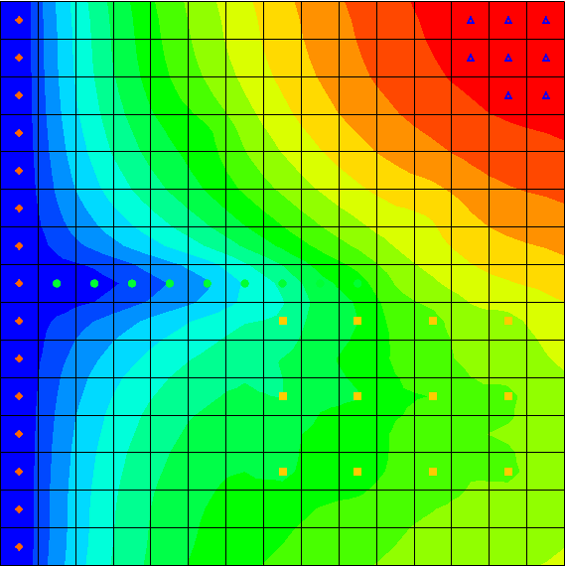

Figure 3 The initial model

## Saving the Model with a New Name

Before making changes, save the model with a new name.

1. Select *File |* **Save As…** to bring up the *Save As* dialog.
2. Select “Project Files (\*.gpr)” from the *Save as type* drop-down.
3. Enter “evt.gpr” as the *File name*.
4. Click **Save** to save the project under the new name and close the *Save As* dialog.

# Adding ET via the EVT Package

The first change is to add ET to the model via the EVT package.

## Turning on the EVT Package

It is necessary to turn on the EVT package.

1. Select *MODFLOW |* **Global Options…** to bring up the *MODFLOW Global/Basic Package* dialog.
2. Click **Packages…** to bring up the *MODFLOW Packages / Processes* dialog.
3. In the *Optional packages / processes* section, turn on *EVT1 – Evapotranspiration*.
4. Click **OK** to exit the *MODFLOW Packages / Processes* dialog.
5. Click **OK** to exit the *MODFLOW Global/Basic Package* dialog.

## Specifying ET

Now it is necessary to specify the ET parameters.

1. Select *MODFLOW | Optional Packages |* **EVT – Evapotranspiration…**to bring up the *MODFLOW EVT Package* dialog.

### Max ET Rate

1. Above the array, in the *View/Edit* drop-down, select “EVTR. Max ET rate”.
2. Click **Constant → Array** to bring up the *Grid Value* dialog.
3. Enter “0.01” as the *Constant value for grid*.
4. Click **OK** to close the *Grid Value* dialog.

### ET Surface

1. Select “SURF. Elevation of ET surface” from the *View/Edit* drop-down.
2. Click **Constant → Array** to bring up the *Grid Value* dialog.
3. Enter “59.0” as the *Constant value for grid*.
4. Click **OK** to close the *Grid Value* dialog.

### Extinction Depth

1. Select “EXDP. ET extinction depth” from the *View/Edit* drop-down.
2. Click **Constant → Array** to bring up the *Grid Value* dialog.
3. Enter “6.0” as the *Constant value for grid*.
4. Click **OK** to close the *Grid Value* dialog.

No more changes will be made for this tutorial example. In the *ET option (NEVTOP)* section, notice that the default selection for the drop-down is “(1) ET only at top layer”.

1. Click **OK** to exit the *MODFLOW EVT Package* dialog.

## Saving and Running MODFLOW

The next steps are to save the changes and run MODFLOW.

1. **Save** File:Save Macro.svg the project.
2. Select *MODFLOW |* **Run MODFLOW** to bring up the *MODFLOW* model wrapper dialog.
3. When MODFLOW finishes, turn on *Read solution on exit* and *Turn on contours (if not on already)*.
4. Click **Close** to import the solution and close the *MODFLOW* model wrapper dialog.

Notice the contours have changed (Figure 4) because the head is lower in the new “evt” solution. The addition of evapotranspiration has caused more water to leave the model, thus lowering the head.

1. Expand the “File:3D Grid Folder.svg 3D Grid Data” folder.
2. Compare the new and old solutions by alternately selecting “File:Generic Folder Locked.svg modfgrid (MODFLOW)” and “File:Generic Folder Locked.svg evt (MODFLOW)” in the Project Explorer.
3. **Save** File:Save Macro.svg the project with the new solution.

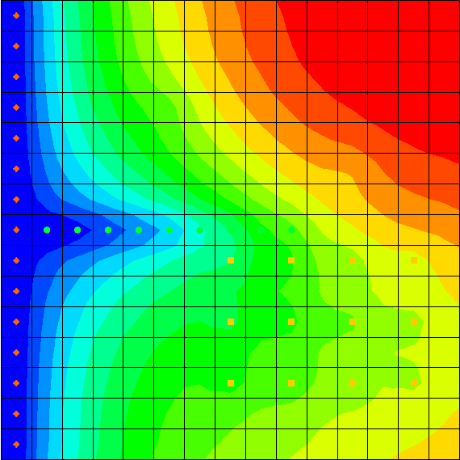

Figure 4 The contours have changed

## Examining the Flow Budget

This tutorial will now take a look at how much water is leaving the system due to evapotranspiration.

1. Select the “File:Generic Folder Locked.svg evt (MODFLOW)” solution in the Project Explorer to make it active.
2. Select *MODFLOW |* **Flow Budget…** to bring up the *Flow Budget* dialog.
3. On the *Cells* tab, notice that in the *Sources/Sinks* section, on the *ET* row*,* there is zero flow in but some flow out.
4. Click **OK** to exit the *Flow Budget* dialog.

# Adding ET via the ETS Package

The next step is to switch to the ETS package to model evapotranspiration. No curve segments will be defined at first so that the ETS package will work just like the EVT package. Segments will be added later.

## Saving the Model with a New Name

Before changing the model to use the ETS package, save the model with a new name.

1. Select *File |* **Save As…** to bring up the *Save As* dialog.
2. Select “Project Files (\*.gpr)” from the *Save as type* drop-down.

Enter “ets1.gpr” as the *File name*.

Click **Save** to save the project under the new name and close the *Save As* dialog.

## Switching from the EVT Package to the ETS Package

First, turn on the ETS package.

1. Select *MODFLOW |* **Global Options…** to bring up the *MODFLOW Global/Basic Package* dialog.
2. Click **Packages…** to bring up the *MODFLOW Packages / Processes* dialog.
3. In the *Optional packages / processes* section, turn off *EVT1 –* *Evapotranspiration* and turn on *ETS1 – Evapotranspiration Segments*.
4. Click **OK** to exit the *MODFLOW Packages / Processes* dialog.
5. Click **OK** to exit the *MODFLOW Global/Basic Package* dialog.

## Specifying ET

Next, specify the ET parameters.

1. Select *MODFLOW | Optional Packages |* **ETS – Evapotranspiration Segments…**to bring up the *MODFLOW ETS Package* dialog.

This dialog is very similar to the *MODFLOW EVT Package* dialog. The ET parameters will be set to the same values that were used for the EVT package.

### Max ET Rate

1. Above the array, in the *View/Edit* drop-down, select “ETSR. Max ET rate”.
2. Click **Constant → Array** to bring up the *Grid Value* dialog.
3. Enter “0.01” as the *Constant value for grid*.
4. Click **OK** to close the *Grid Value* dialog.

### ET Surface

1. Select “ETSS. Elevation” from the *View/Edit* drop-down.
2. Click **Constant → Array** to bring up the *Grid Value* dialog.
3. Enter “59.0” as the *Constant value for grid*.
4. Click **OK** to close the *Grid Value* dialog.

### Extinction Depth

1. Select “ETSX. ET extinction depth” from the *View/Edit* drop-down.
2. Click **Constant → Array** to bring up the *Grid Value* dialog.
3. Enter “6.0” as the *Constant value for grid*.
4. Click **OK** to close the *Grid Value* dialog.

Notice that *NETSEG* was left at “1”. This means there is one curve segment, meaning the curve is linear. Therefore, the ETS package will behave just like the EVT package.

1. Click **OK** when finished to exit the *MODFLOW ETS Package* dialog.

## Switching LMT package to Extended Header

When GMS saves a MODFLOW simulation, by default, it includes the linkage files needed by MT3DMS to run a transport simulation, even if no MT3DMS model is currently defined. If the ETS package is in use, a setting for the MT3DMS linkage files must be changed.

1. Select *MODFLOW |* **OC – Output Control…** to bring up the *MODFLOW Output Control* dialog.
2. In the *Other output* section, select *Extended header format* under the *\*.hff file for transport* option.
3. Click **OK** to close the *MODFLOW Output Control* dialog.

Alternatively, simply turn off *\*.hff file for transport* since MT3DMS will not be used with this model.

## Saving and Running MODFLOW

Now it is possible to save the changes and run MODFLOW.

1. **Save** File:Save Macro.svg the project.
2. Select *MODFLOW |* **Run MODFLOW**to bring up the *MODFLOW* model wrapper dialog.
3. When MODFLOW finishes, turn on *Read solution on exit* and *Turn on contours (if not on already)*.
4. Click **Close** to import the solution and close the *MODFLOW* model wrapper dialog.

The new “File:Generic Folder Locked.svg ets1 (MODFLOW)” solution is identical to the “File:Generic Folder Locked.svg evt (MODFLOW)” solution.

1. Compare solutions by alternately selecting “File:Generic Folder Locked.svg modfgrid (MODFLOW)”, “File:Generic Folder Locked.svg evt (MODFLOW)”,and “File:Generic Folder Locked.svg ets1 (MODFLOW)” in the Project Explorer.
2. **Save** File:Save Macro.svg the project with the new solution.

## Examining the Flow Budget

Now review how much water is leaving the system due to evapotranspiration.

1. Select “File:Generic Folder Locked.svg ets1 (MODFLOW)” to make it active.
2. Select *MODFLOW |* **Flow Budget…** to bring up the *Flow Budget* dialog.
3. On the *Cells* tab, notice the *ET SEGMENTS* row in the *Sources/Sinks* section. There is zero flow in but some flow out. The flow out is the same amount that was previously reported for the EVT package.
4. Click **OK** to exit the *Flow Budget* dialog.

# Adding ETS Curve Segments

The next step will take advantage of the extra functionality in the ETS package by specifying a nonlinear curve, such as the one in Figure 5.



Figure 5 Nonlinear ET curve with three segments

This curve requires some explanation. PXDP and PETM are MODFLOW variables. The ETS1 package documentation describes them as follows:

In the ETS1 Package, the functional relation of evapotranspiration rate to head is conceptualized as a segmented line in the variable interval. The segments that determine the shape of the function in the variable interval are defined by intermediate points where adjacent segments join. The ends of the segments at the top and bottom of the variable interval are defined by the ET surface, the maximum evapotranspiration rate, and the extinction depth. The number of intermediate points that must be deﬁned is one less than the number of segments in the variable interval. For each intermediate point, two values, PXDP and PETM, are entered to define the point. PXDP is a proportion (between zero and one) of the extinction depth, and PETM is a proportion of the maximum evapotranspiration rate. PXDP is 0.0 at the ET surface and is 1.0 at the bottom of the variable interval. PETM is 1.0 at the ET surface and is 0.0 at the bottom of the variable interval.[[2]](#footnote-2)

The curve in Figure 5 is nonlinear. It is defined so that the ET rate drops gradually as the head drops below the ET surface, but then drops more rapidly as the head approaches the extinction depth. The values for PXDP and PETM in this case are as follows:

|  |  |  |
| --- | --- | --- |
| Row | PXDP | PETM |
| 1 | 0.0 | 1.0 |
| 2 | 0.5 | 0.8 |
| 3 | 0.75 | 0.5 |
| 4 | 1.0 | 0.0 |

To use the curve in Figure 5 for the ETS package, change the number of segments (NETSEG) to 3 and define the points where the segments meet. Since there are three segments, two points of intersection need to be defined. It is not necessary to define the first and last points on the curve since they are always at “1.0” and “0.0”. It is only necessary to define the two interior points on the curve.

## Saving the Model with a New Name

Before changing the model to use a nonlinear curve for ETS, save the model with a new name.

1. Select *File |* **Save As…** to bring up the *Save As* dialog.
2. Select “Project Files (\*.gpr) from the *Save as type* drop-down.
3. Enter “ets2.gpr” as the *File name*.
4. Click **Save** to save the project under the new name and close the *Save As* dialog.

## Changing NETSEG

To change the number of segments:

1. Select *MODFLOW | Optional Packages |* **ETS – Evapotranspiration Segments…** to bring up the *MODFLOW ETS Package* dialog.
2. Enter “3” in the *NETSEG* field at the middle-right of the dialog.

## Defining the PXDP Data

The order of entering the values for PXDP and PETM is important, as explained in the package documentation:

PXDP is a proportion of the extinction depth (dimensionless), measured downward from the ET surface, which, with PETM, defines the shape of the relation between the evapotranspiration rate and head. The value of PXDP must be between 0.0 and 1.0, inclusive. Repetitions of PXDP and PETM are read in sequence such that the first occurrence represents the bottom of the first segment, and subsequent repetitions represent the bottom of successively lower segments. *Accordingly, PXDP values for later repetitions (representing lower segments) should be greater than PXDP values for earlier repetitions.*

PETM is a proportion of the maximum evapotranspiration rate (dimensionless) which, with PXDP, defines the shape of the relation between the evapotranspiration rate and head. The value of PETM should be between 0.0 and 1.0, inclusive. Repetitions of PXDP and PETM are read in sequence such that the first occurrence represents the bottom of the first segment, and subsequent repetitions represent the bottoms of successively lower segments. *Accordingly, PETM values for later repetitions (representing lower segments) generally would be less than PETM values for earlier repetitions.[[3]](#footnote-3)*

Define the PXDP values for both points, and apply the same curve to all the cells in the grid. Note that it is possible to have different curves for each cell.

1. Select “PXDP. Curve segments” from the *View/Edit* drop-down.
2. Enter “1” in the *Segment array* field.

This means data for the first point is being viewed and edited.

1. Click **Constant → Array** to bring up the *Grid Value* dialog.
2. Enter “0.5” as the *Constant value for grid* and click **OK** to close the *Grid Value* dialog.
3. Enter “2” in the *Segment array* field in order to view the second segment.
4. Click **Constant → Array** to bring up the *Grid Value* dialog.
5. Enter “0.75” as the *Constant value for grid* and click **OK** to close the *Grid Value* dialog.

## Defining the PETM Data

Next, define the PETM data for both points. Make the same curve apply to all the cells in the grid.

1. Select “PETM. Curve segments” from the *View/Edit* drop-down.
2. Set the *Segment array* to “1”.
3. Click **Constant → Array** to bring up the *Grid Value* dialog.
4. Enter “0.8” as the *Constant value for grid* and click **OK** to close the *Grid Value* dialog.
5. Set the *Segment array* to “2”.
6. Click **Constant → Array** to bring up the *Grid Value* dialog.
7. Enter “0.5” as the *Constant value for grid* and click **OK** to close the *Grid Value* dialog.
8. Click **OK** to exit the *MODFLOW ETS Package* dialog.

## Saving and Running MODFLOW

The next steps are to save these changes and run MODFLOW.

1. **Save** File:Save Macro.svg the project.
2. Select *MODFLOW |* **Run MODFLOW**to bring up the *MODFLOW* model wrapper dialog.
3. When MODFLOW finishes, turn on *Read solution on exit* and *Turn on contours (if not on already)*.
4. Click **Close** to import the solution and close the *MODFLOW* model wrapper dialog.

Notice the very slight changes in the new solution (Figure 6).

1. Compare solutions by alternately selecting “File:Generic Folder Locked.svg modfgrid (MODFLOW)”, “File:Generic Folder Locked.svg evt (MODFLOW)”,“File:Generic Folder Locked.svg ets1 (MODFLOW)”,and “File:Generic Folder Locked.svg ets2 (MODFLOW)”in the Project Explorer.
2. **Save** File:Save Macro.svg the project with the new solution.

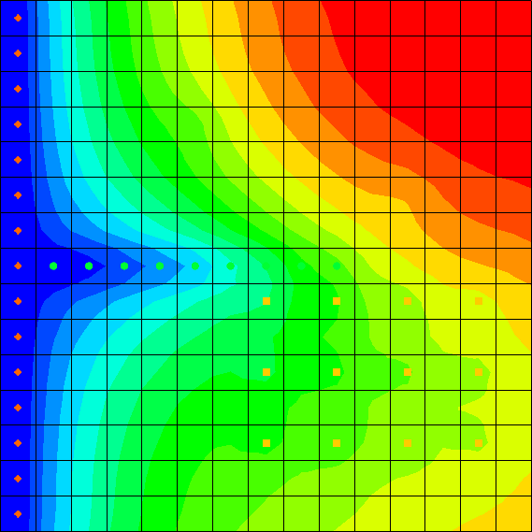

Figure 6 Very slight changes in the contours are noticeable

# Building a Conceptual Model

The next step is to examine how to use a conceptual model with ETS data.

## Saving the Model with a New Name

Before changing the model to use a conceptual model, save the model with a new name.

1. Select *File |* **Save As…** to bring up the *Save As* dialog.
2. Select “Project Files (\*.gpr)” from the *Save as type* drop-down.
3. Enter “ets3.gpr” as the *File name*.
4. Click **Save** to save the project under the new name and close the *Save As* dialog.

## Creating the Conceptual Model

1. Right-click in the Project Explorer and select *New |* **Conceptual Model…** to bring up the *Conceptual Model Properties* dialog.
2. Enter “modfgrid” as the *Name*.
3. Under *Advanced package options to include*, turn on *ETS1 – Evapotranspiration Segments*.
4. Click **OK** to close the *Conceptual Model Properties* dialog.

## Creating a Coverage

1. Right-click on the new “File:Conceptual Model Icon.svg modfgrid” conceptual model and select **New Coverage…** to bring up the *Coverage Setup* dialog.
2. Enter “ets” as the *Coverage name*.
3. In the *Areal Properties* column, turn on *Max ETS rate*, *ETS elev.*, *ETS Extinction depth*, and *ETS Segmented curve*.
4. Click **OK** to exit the *Coverage Setup* dialog.

## Creating the Polygon

1. Select the “File:Coverage Active Icon.svg ets” coverage to make it active.
2. Using the **Create Arc** File:GMS Create Arc Tool.svg tool, create an arc that surrounds the grid. End the arc by clicking on the starting node in order to form a closed polygon (Figure 7).
3. Select *Feature Objects |* **Build Polygons** to create the polygon.

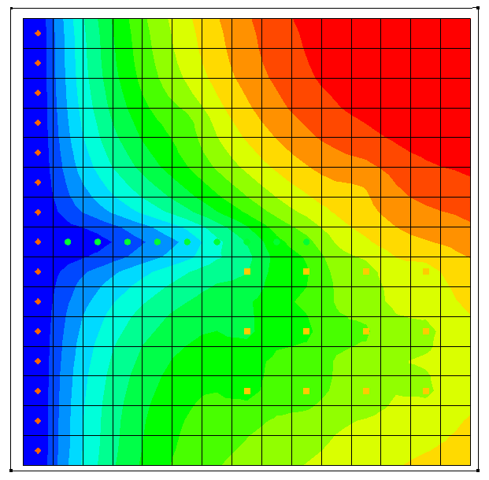

Figure 7 Creating a polygon that encompasses the model grid

## Setting the Polygon Properties

1. Using the **Select Objects** File:Select Object Tool.svg tool, double-click anywhere inside the new polygon to bring up the *Attribute Table* dialog.
2. Enter “0.01” in the *Max ETS rate (m/d)* column.
3. Enter “59.0” in the *ETS elev. (m)* column.
4. Enter “6.0” in the *ETS ext. depth (m)* column.
5. Enter “-1” in the *ETS segmented curve* column.

The value in the *ETS segmented curve* column is the number of an *XY* series. The curves are defined using the *XY Series Editor*, and each *XY* series has a unique number. A value of “-1” indicates that no *XY* series has been specified yet.

1. Click the dotdotdot button in the *ETS segmented curve* column to bring up the *XY Series Editor* dialog.

Enter the values from the following chart into the spreadsheet on the left side of the dialog. These are different values than were used previously. In this case, the first and last values on the curve will be included:

|  |  |  |
| --- | --- | --- |
| Row | PXDP | PETM |
| 1 | 0.0 | 1.0 |
| 2 | 0.4 | 0.9 |
| 3 | 0.8 | 0.6 |
| 4 | 1.0 | 0.0 |

1. Click **OK**to exit the *XY Series Editor* dialog.

Notice the value in the *ETS segmented curve* column has changed.

1. Click **OK**to exit the *Attribute Table* dialog.

## Mapping to MODFLOW

The conceptual model is now set up, so it is possible to map it to the MODFLOW grid.

1. Select *Feature Objects |* **Map → MODFLOW** to bring up the *Map → Model* dialog.
2. Click **OK** to accept the defaults and close the *Map → Model* dialog.

## Examining the ETS Package

The next step is to take a look at the data in MODFLOW that was mapped from the conceptual model.

1. Select *MODFLOW | Optional Packages |* **ETS – Evapotranspiration Segments…** to bring up the *MODFLOW ETS Package* dialog.
2. Select “ETSS. Elevation” from the *View/Edit* drop-down. The cells in the spreadsheet below should all show “59.0”.
3. Select “ETSR. Max ET rate” from the *View/Edit* drop-down. The cells in the spreadsheet below should all show “0.01”.
4. Select “ETSX. ET extinction depth” from the *View/Edit* drop-down. The cells in the spreadsheet below should all show “6.0”.
5. Select “PXDP. Curve segments” from the *View/Edit* drop-down and enter “1” as the *Segment array*. Notice that the cells in the spreadsheet below all show “0.4”.
6. Enter “2” as the *Segment array*. Notice that the cells in the spreadsheet below all show “0.8”.
7. Select “PETM. Curve segments” from the *View/Edit* drop-down and enter “1” as the Segment array. Notice that the cells in the spreadsheet below all show “0.9”.
8. Enter “2” as the Segment array. Notice that the cells in the spreadsheet below all show “0.6”.
9. Click **OK** to close the *MODFLOW ETS Package* dialog.

## Saving and Running MODFLOW

The next steps are to save the changes and run MODFLOW.

1. **Save** File:Save Macro.svg the project.
2. Select *MODFLOW |* **Run MODFLOW**to bring up the *MODFLOW* model wrapper dialog.
3. When MODFLOW finishes, turn on *Read solution on exit* and *Turn on contours (if not on already)*.
4. Click **Close** to import the solution and close the *MODFLOW* model wrapper dialog.

Notice some very slight changes in the new solution (Figure 8).

1. Compare solutions by alternately selecting “File:Generic Folder Locked.svg modfgrid (MODFLOW)”, “File:Generic Folder Locked.svg evt (MODFLOW)”, “File:Generic Folder Locked.svg ets1 (MODFLOW)”, “File:Generic Folder Locked.svg ets2 (MODFLOW)”, and “File:Generic Folder Locked.svg ets3 (MODFLOW)” in the Project Explorer.
2. **Save** File:Save Macro.svg the project with the new solution.

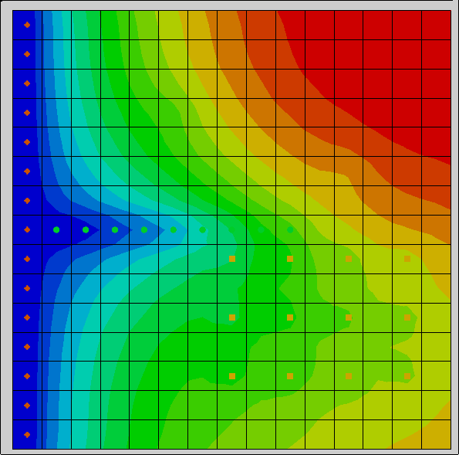

Figure 8 Very slight changes visible in the contours

# Parameters

It is possible to set parameters with the EVT and ETS packages. Use parameters to assign one ET rate to the left side of the model and a different rate to the right side.

## Saving the Model with a New Name

The model should first be saved with a new name.

1. Select *File |* **Save As…** to bring up the *Save As* dialog.
2. Select “Project Files (\*.gpr)” from the *Save as type* drop-down.
3. Enter “ets4.gpr” as the *File name*.
4. Click **Save** to save the project under the new name and close the *Save As* dialog.

## Parameterizing the Model

1. Turn off “File:Map Folder.svg Map Data” in the Project Explorer.
2. Select “File:3D Grid Folder.svg 3D Grid Data” to switch to the **3D Grid** 120px-3D_Grid_Icon module.
3. Using the **Select Cells**File:Select 3D Cell Tool.svg tool, select the rightmost eight columns (see Figure 9).
4. Right-click in the selected area and select **Sources/Sinks…** to bring up the *MODFLOW Sources/Sinks* dialog.
5. Select *Evapotranspiration (ETS)* from the list on the left.
6. In the *All* row, enter “-10.0” in the *ETS Max. et. (m/d)* column.

Note that “-10.0” is not a valid ET rate. It is a key value that indicates these cells will be associated with a parameter. This key value can be any negative number.

1. Click **OK** to exit the *MODFLOW Source/Sinks* dialog.
2. Select *MODFLOW |* **Parameters…** to bring up the *Parameters* dialog.
3. Click **Initialize From Model**to create a new parameter.

This results in GMS looking through the model inputs for negative numbers and creating a parameter whenever one is found. In this case, GMS creates one parameter for the -10 values it encountered in the ETS package.

1. Enter “0.1” in the *Value* column (it may already be set to that value).
2. Click **OK** to exit the *Parameters* dialog.

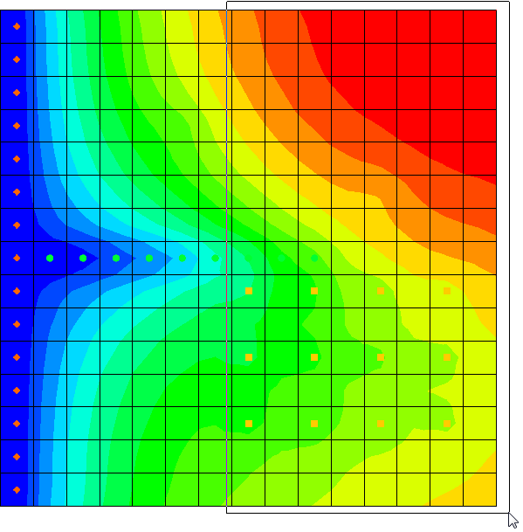

Figure 9 Dragging a box around the rightmost eight columns

## Saving and Running MODFLOW

The next steps are to save the changes and run MODFLOW.

1. **Save** File:Save Macro.svg the project.
2. Select *MODFLOW |* **Run MODFLOW**to bring up the *MODFLOW* model wrapper dialog.
3. When MODFLOW finishes, turn on *Read solution on exit* and *Turn on contours (if not on already)*.
4. Click **Close** to import the solution and close the *MODFLOW* model wrapper dialog.

Notice some very slight changes in the new solution (Figure 10).

1. Compare solutions by alternately selecting “File:Generic Folder Locked.svg modfgrid (MODFLOW)”, “File:Generic Folder Locked.svg evt (MODFLOW)”, “File:Generic Folder Locked.svg ets1 (MODFLOW)”, “File:Generic Folder Locked.svg ets2 (MODFLOW)”, “File:Generic Folder Locked.svg ets3 (MODFLOW)”, and “File:Generic Folder Locked.svg ets4 (MODFLOW)” in the Project Explorer.
2. **Save** File:Save Macro.svg the project with the new solution.

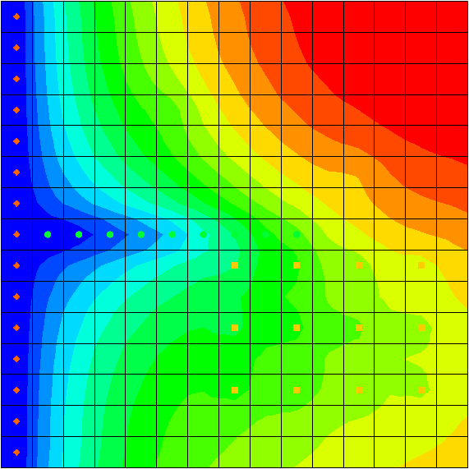

Figure 10 The final solution, showing very slight contour changes

# Conclusion

This concludes the “MODFLOW – ETS Package” tutorial. The following key concepts were demonstrated and discussed:

* GMS supports both the EVT and ETS packages. Both packages can be used at the same time if desired.
* The ETS package produces the same results as the EVT package if only one curve segment is defined.
* ETS data can be viewed and edited in the *MODFLOW ETS Package* dialog.
* The order in which the PXDP and PETM data is entered is important. PXDP values should be in increasing order and PETM values should be in decreasing order.
* ETS data can be defined on polygons in a conceptual model.

1. Banta, Edward R. (2000), *MODFLOW-2000, The U.S. Geological Survey Modular Ground-Water Model—Documentation of Packages for Simulating Evapotranspiration with a Segmented Function (ETS1) and Drains with Return Flow (DRT1)*. Open-File Report 00-466, Denver, Colorado, p.3. <http://pubs.usgs.gov/of/2000/0466/report.pdf> . [↑](#footnote-ref-1)
2. Banta (2000), p.3. [↑](#footnote-ref-2)
3. Banta (2000), p.8. Emphasis added. [↑](#footnote-ref-3)