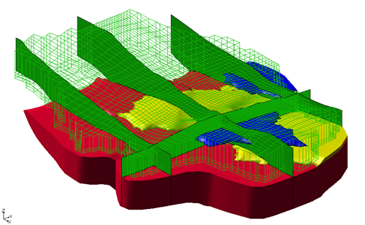

GMS 10.9

GMS 10.9 Tutorial

***MODFLOW – Generating Data from Solids***

Using solid models to represent complex stratigraphy with MODFLOW

Objectives

Learn the steps necessary to convert solid models to MODFLOW data on a 3D grid, and adjust elevations associated with the grid to match the elevations defined by the solid models.

Time

* 40–60 minutes

Required Components

* GMS Core
* Subsurface

Prerequisite Tutorials

* MODFLOW – Conceptual Model Approach I

|  |
| --- |
| [1 Introduction 2](#_Toc203724058)  [1.1 Getting Started 3](#_Toc203724059)  [2 Importing the Solids 4](#_Toc203724060)  [3 Boundary Matching Versus Grid Overlay 4](#_Toc203724061)  [3.1 Boundary Matching 5](#_Toc203724062)  [3.2 Grid Overlay 6](#_Toc203724063)  [3.3 Grid Overlay with K Equivalent 6](#_Toc203724064)  [4 Solids → MODFLOW Using Grid Overlay 6](#_Toc203724065)  [4.1 Displaying the 3D Grid 6](#_Toc203724066)  [4.2 Initializing MODFLOW 7](#_Toc203724067)  [4.3 Activating Cells 7](#_Toc203724068)  [4.4 Solids **→** MODFLOW 8](#_Toc203724069)  [4.5 Viewing the Grid 8](#_Toc203724070)  [5 Solids → MODFLOW Using Boundary Matching 10](#_Toc203724071)  [5.1 Layer Ranges 10](#_Toc203724072)  [5.2 Assigning Layers to Solids 11](#_Toc203724073)  [5.3 Solids **→** MODFLOW 12](#_Toc203724074)  [6 Viewing the Grid 12](#_Toc203724075)  [7 Thin Cells 13](#_Toc203724076)  [7.1 Assigning Minimum Thickness 13](#_Toc203724077)  [7.2 Top Cell Bias 13](#_Toc203724078)  [8 Converting the Conceptual Model 14](#_Toc203724079)  [8.1 Using Materials to Define Hydraulic Conductivity 15](#_Toc203724080)  [9 Running MODFLOW and Viewing the Solution 15](#_Toc203724081)  [10 Solids → HUF 16](#_Toc203724082)  [10.1 Selecting the HUF Package 17](#_Toc203724083)  [10.2 Converting the Solids to HUF Data 17](#_Toc203724084)  [10.3 Viewing the HUF Data 18](#_Toc203724085)  [10.4 Converting the Conceptual Model 19](#_Toc203724086)  [10.5 Running MODFLOW 19](#_Toc203724087)  [11 Conclusion 20](#_Toc203724088) |

# Introduction

Complex stratigraphy can be difficult to simulate in MODFLOW models. MODFLOW uses a structured grid that requires each grid layer to be continuous throughout the model domain. This makes it difficult to explicitly represent common features such as pinchouts and embedded seams in a MODFLOW model.

Solid models can be used to represent arbitrarily complex stratigraphy. Figure 1 shows a cross section through a solid model where different stratigraphic units pinch out. Designing a MODFLOW compatible grid for this type of stratigraphy is difficult.

This tutorial covers the steps necessary to convert solid models (Figure 1) to MODFLOW data. The elevations associated with the finite-difference grid will be adjusted to match the elevations defined by the solid models. The material assigned to each grid cell will be inherited from the solid encompassing the cell. Figure 2 shows a MODFLOW compatible grid of the cross section shown in Figure 1.

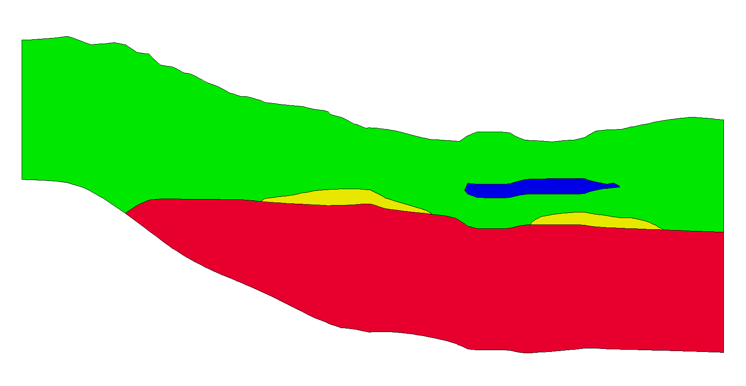

Figure 1: Cross section through a solid model

One of the main benefits of using solid models to define stratigraphy for MODFLOW models is that it provides a grid-independent definition of the layer elevations that can be used to immediately re-create the MODFLOW grid geometry after any change to the grid resolution. Solid models of stratigraphy can be easily created in GMS using the “horizons approach”. The tutorial entitled “Stratigraphy Modeling – Horizons and Solids” explains how to create solid models using GMS.

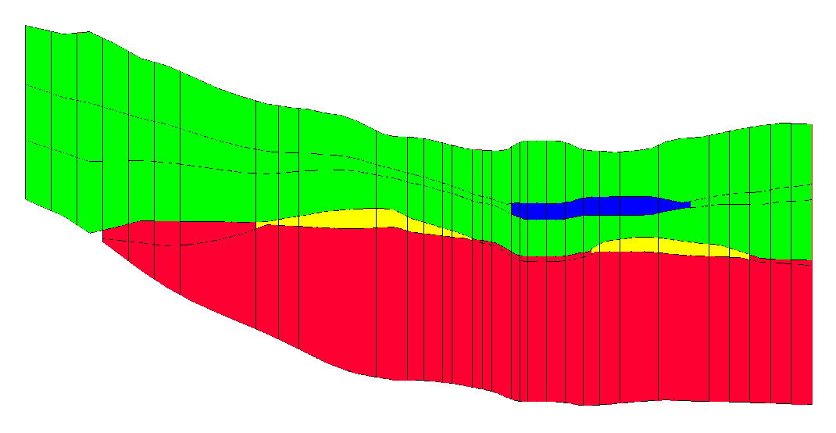

Figure 2: Finite difference grid with elevations and materials inherited from the solid model

This tutorial discusses and demonstrates opening a file containing solids data, using the **Solids → MODFLOW** command. Using the *Grid Overlay* and *Boundary Matching* options, assigning grid layers to the solids, fixing problems associated with thin cells, converting the conceptual model to MODFLOW and running MODFLOW. Finally, converting the solids to HUF data, and converting the conceptual model again and running MODFLOW.

## Getting Started

Do the following to get started:

1. If necessary, launch GMS.
2. If GMS is already running, from the Menu Bar, select the *File |* **New** menu item to ensure that the program settings are restored to their default state. If asked to save changes, click the **Don’t Save** button.

# Importing the Solids

First, import a file containing a set of solids for the site being modeled:

1. From the Macro Bar, click **Open** File:Open Macro.svg to bring up the *Open* dialog.
2. From the *Files of type* drop-down, select “Project Files (\*.gpr)”.
3. Browse to the *sol2mf\sol2mf* directory and select “start.gpr”.
4. Click the **Open** buttonto import the file and close the *Open* dialog.

The imported cross sections show the stratigraphy for the example site (Figure 3).

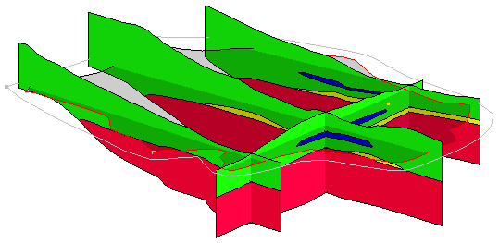

Figure 3: Initial view after opening the project

There are five different solids in this project file. There are two main units labeled upper\_aquifer (green) and lower\_aquifer (red). There are two silty-clay (blue) units inside of the upper\_aquifer, and there is a clay (yellow) unit between the upper\_aquifer and lower\_aquifer.

# Boundary Matching Versus Grid Overlay

There are three options when using the **Solids → MODFLOW** command: the *Boundary Matching* option, the *Grid Overlay* option, and the *Grid Overlay with K Equivalent* option (Figure 4).

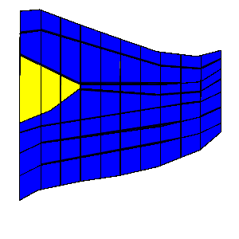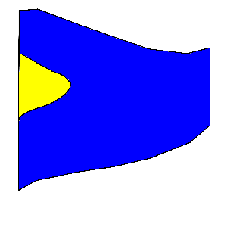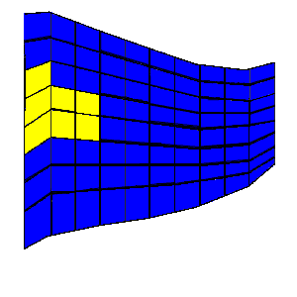

Boundary Matching

Grid Overlay

Solids

Grid

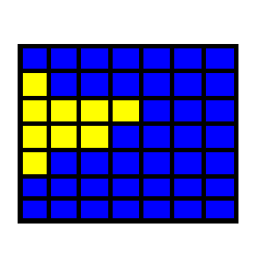

Grid Overlay with

K Equivalent

Figure 4: Solids → MODFLOW options illustrated (side view)

## Boundary Matching

With the *Boundary Matching* option, the top and bottom of the grid are deformed to match the tops and bottoms of the solids. The interior grid layers are also deformed to match the boundaries of the solids. The grid cell materials are set to match the material of the solid of the grid cell center.

This option results in a close fit between the grid and the solids, but it may produce thin cells which can cause stability problems or dry cell issues when running MODFLOW. This option requires determining which grid layers should be associated with certain solids.

## Grid Overlay

The *Grid Overlay* option deforms the top and bottom of the grid to match the tops and bottoms of the solids. The interior grid layer boundaries are deformed to be evenly spaced between the top and bottom of the grid using a simple linear interpolation. The interior grid layers are not changed to match the solid boundaries. As with the *Boundary Matching* option, the grid cell materials are set to match the material of the solid of the grid cell center.

This option does not result in as close a fit between the grid and the solids as the boundary matching option, but it may avoid the thin cell problems associated with the *Boundary Matching* option. The *Grid Overlay* option does not require assigning grid layer ranges to each solid.

## Grid Overlay with K Equivalent

This option is similar to the *Grid Overlay* option. One of the problems with the *Grid Overlay* option is that if there is a relatively thin layer in the solids and the layer does not encompass any cell centers or it encompasses few cell centers, the layer will be under-represented in the MODFLOW grid. This becomes important if the layer is meant to represent a low permeability layer. For such cases, the *Grid Overlay with K Equivalent* (or *Grid Overlay with Keq*) option may give superior results.

The *Grid Overlay with Keq* method is identical to the *Grid Overlay* method in how the elevations of the grid cells are defined. The two methods differ in how the material properties are assigned. Rather than simply assigning materials based on which solid encompasses the cell centers, the Keq method attempts to compute a custom *Kh* and *Kv* value for each cell.

When assigning the material properties to a cell, GMS computes the length of each solid in the cell (from a vertical line at the cell center that intersects the solids) and computes an equivalent *Kh*, *Kv*, and storage coefficient for the cell that takes into account each of the solids in the cell. Thus, the effect of a thin seam in a cell would be included in the *Kh* and *Kv* values for the cell.

# Solids → MODFLOW Using Grid Overlay

This tutorial will first examine the *Grid Overlay* option. With this option, requirements include a set of solids and a grid in the same location.

## Displaying the 3D Grid

The grid was imported as part of the project, but the display of the grid cells was turned off. To turn it back on, do the following:

1. In the Project Explorer, turn on the “File:3D Grid Folder.svg 3D Grid Data” folder checkbox.
2. Expand the “File:3D Grid Folder.svg 3D Grid Data” folder by clicking on the + (plus symbol) next to it.
3. Turn on the “File:3D Grid Icon.svg grid” item checkbox within that folder.

The 3D grid should now be visible (Figure 5).

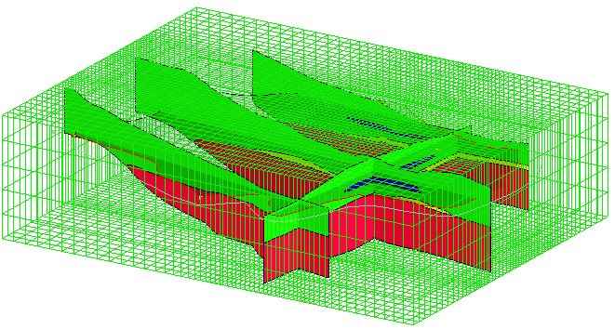

Figure 5: Initial view with 3D grid visible

## Initializing MODFLOW

It is necessary to initialize MODFLOW before executing the **Solids → MODFLOW** menu command.

1. Right-click on “File:3D Grid Icon.svg grid” and select the **New MODFLOW…** context menu item to bring up the *MODFLOW Global/Basic Package* dialog.
2. Click the **OK** button to accept the defaults and close the *MODFLOW Global/Basic Package* dialog. The simulation will appear in the “File:3D Grid Icon.svg grid” folder.

Normally, the starting heads would be set in the *MODFLOW Global/Basic Package* dialog. But since they are set to be equal to the grid top elevation (300) by default, there is no need to do so in this case.

## Activating Cells

It is necessary to inactivate the cells outside the model domain.

1. In the Project Explorer, select the “File:Map Folder.svg Map Data” folder to make it active.
2. From the Menu Bar, select the *Feature Objects |* **Activate Cells in Coverage(s)** menu item.

The cells outside the model domain will disappear (Figure 6).

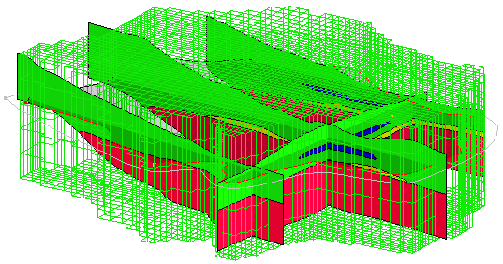

Figure 6: 3D grid showing only active cells

## Solids **→** MODFLOW

1. In the Project Explorer, select the “File:Solids Folder.svg Solid Data” folder to make it active.
2. From the Dynamic Toolbar, select the **Select Solids** 120px-Select_Solids_Tool tool.

Notice that labels for each solid appear (Figure 7).

1. From the Menu Bar, select the *Solids* | **Solids → MODFLOW…** menu item to bring up the *Solids →MODFLOW* dialog.
2. Beneath *Solids →MODFLOW Mode,* select the *Grid Overlay* radio button.
3. Click the **OK** button to close the *Solids →MODFLOW* dialog and execute the deformation.

The deformation may take a few moments to complete. The 3D grid should appear deformed to match the top and bottom of the solids (Figure 7). In the 3D Grid Data folder, the Material Sets data will appear.

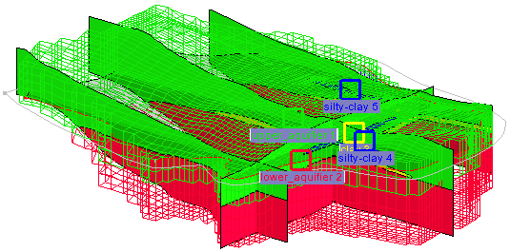

Figure 7: The 3D grid has been deformed

## Viewing the Grid

To examine the grid:

1. From the Macro Bar, click **Display Options** File:Display Options Macro.svg to bring up the *Display Options* dialog.
2. From the list on the left, select “File:3D Grid Icon.svg 3D Grid Data”.
3. On the *3D Grid* tab, turn on *Cell faces*.
4. Click the **OK** button to close the *Display Options* dialog.
5. Select the “File:3D Grid Folder.svg 3D Grid Data” folder to make it active.

Notice that the solid cross sections are now mostly obscured from view by the grid but are still poking out in places. Looking closely, notice that the top of the grid matches the top of the solid cross sections quite well. The grid and cross sections should appear as shown in Figure 8.

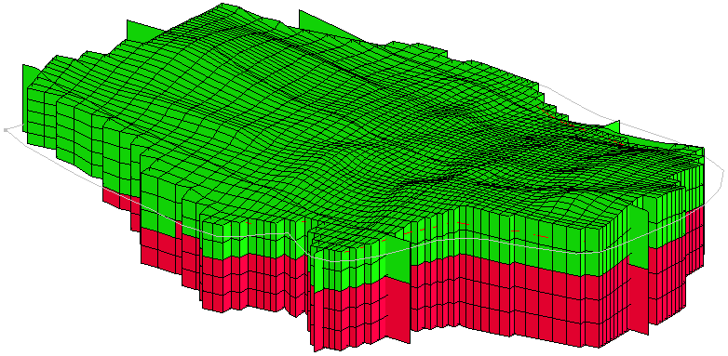

Figure 8: After executing Solids → MODFLOW using grid overlay

Do the following to look at the grid from the side:

1. From the Macro Bar, switch on **Ortho Mode** File:Ortho View Macro.svg. The Graphic Window will switch to Plan View.
2. From the Dynamic Toolbar, use the **Select Cells** File:Select 3D Cell Tool.svg tool, select a cell somewhere near the middle of the grid.
3. From the Macro Bar, switch to **Front View**File:Front View Macro.svg.

The solid cross sections are in front of the grid row.

1. In the Project Explorer, turn off the “File:Solids Folder.svg Solid Data” folder checkbox.
2. In the Mini Grid Toolbar, use the arrow buttons  to view the grid along different rows.

The grid at row 14 should appear similar to Figure 9.

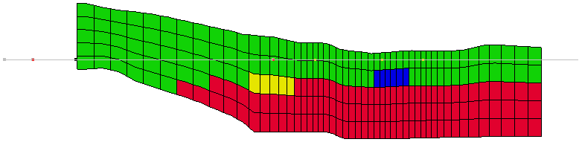

Figure 9: Grid row 14 after Solids → MODFLOW using grid overlay

Feel free to continue reviewing the MODFLOW model at this point before moving on.

# Solids → MODFLOW Using Boundary Matching

The *Boundary Matching* option results in a close fit between the solid boundaries and the grid layer, but it requires more work.

## Layer Ranges

It is necessary to assign a layer range to each of the solids before converting the solids to MODFLOW data using the *Boundary Matching* option. The layer range represents the consecutive sequence of layer numbers in the MODFLOW grid that should coincide with the solid model.

A sample set of layer range assignments is shown in Figure 10. The first example, (a), is a case where each solid is continuous through the model domain with no pinchouts. Each of the solids is given a layer range defined by a beginning and ending grid layer number. The resulting MODFLOW grid is shown in Figure 10(b).



Figure 10: (a) A set of simple solids with grid layer assignments  
 (b) The MODFLOW grid resulting from the layer assignments

A more complex case with pinchouts is illustrated in Figure 11(a). Solid A is given the layer range 1–4, and the enclosed pinchout (solid B) is given the layer range 2–2. The set of grid layers within the defined range that are overlapped by the solid may change from location to location. The layer range represents the set of grid layers potentially overlapped by the solid anywhere in the model domain.

For example, on the left side of the problem shown in Figure 11(a), solid A covers grid layers 1, 2, 3 and 4. On the right side of the model, solid A is associated with grid layers 1, 3 and 4 since the enclosed solid (solid B) is associated with layer 2. Likewise, Solid C is associated with grid layers 5 and 6 on the left side of the model but only with layer 6 on the right side of the model where solid D is associated with layer 5. The resulting MODFLOW grid is shown in (b).



Figure 11: (a) Grid layer assignments for a set of solids with pinchouts  
 (b) The MODFLOW grid resulting from the layer assignments

When assigning layer ranges to solids, care must be taken to define associations that are topologically sound. For example, since solid B in Figure 11(a) is enclosed by solid A, solid B could not be assigned a layer range that is outside the layer range of solid A.

## Assigning Layers to Solids

Now it is possible to assign the grid layers to the solids. Figure 12 is a cross section through the site. Notice that the project must have a minimum of five grid layers in order to represent all of the layers present in this cross section. In this case, the upper\_aquifer (green) will be assigned to layers 1–3. The silty-clay (blue) will be assigned to layer 2. The clay (yellow) will be assigned to layer 4, and the lower\_aquifer (red) will be assigned layers 4–5.

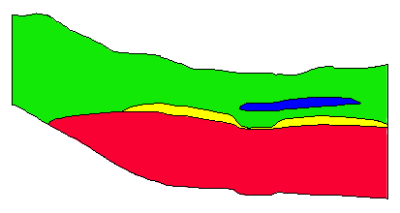

Figure 12: Cross section through the model domain

1. In the Project Explorer, expand the “File:Solids Folder.svg Solid Data” folder, if necessary.
2. Double-click on “File:Solid Module Icon.svg upper\_aquifer 1” in the Project Explorer to bring up the *Properties* dialog.
3. For *Begin Layer,* enter “1”.
4. For *End Layer,* enter “3”.
5. Click the **OK** button to close the *Properties* dialog.
6. Repeat steps 2–5 for the remaining solids, using the values shown in the following table.

|  |  |  |  |  |  |
| --- | --- | --- | --- | --- | --- |
|  | upper\_aquifer 1 | lower\_aquifer 2 | clay 3 | silty-clay 4 | silty-clay 5 |
| *Begin layer* | 1 | 4 | 4 | 2 | 2 |
| *End layer* | 3 | 5 | 4 | 2 | 2 |

## Solids **→** MODFLOW

1. From the Menu Bar, select the *Solids* | **Solids → MODFLOW…** menu item to bring up the *Solids → MODFLOW* dialog.
2. Beneath *Solids → MODFLOW Mode*, select *Boundary Matching*.
3. Click the **OK** button to close the *Solids → MODFLOW* dialog and initiate the conversion.

This command may take a few moments to complete.

# Viewing the Grid

See how the grid has changed by doing the following:

1. In the Project Explorer, select the “File:3D Grid Folder.svg 3D Grid Data” folder to make it active.
2. From the Macro Bar, switch to **Plan View** File:Plan View Macro.svg.
3. Turn on **Ortho Mode** File:Ortho View Macro.svg, so it is highlighted.
4. From the Dynamic Toolbar, using the **Select Cells** File:Select 3D Cell Tool.svg tool, select a cell somewhere near the middle of the grid.
5. From the Macro Bar, switch to **Front View**File:Front View Macro.svg.
6. In the Mini Grid Toolbar, use the arrow buttons , to view row 30 (Figure 13).

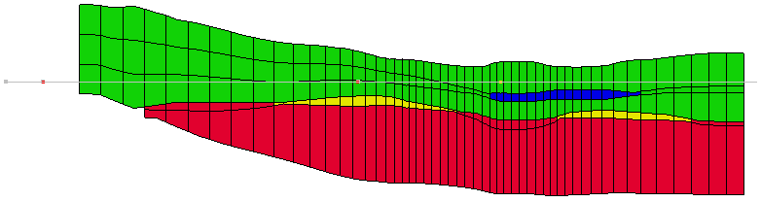

Figure 13: Row 30 of grid after Solids → MODFLOW using boundary matching

Notice that the second layer has both silty-clay (blue) and upper\_aquifer (green) materials assigned to it.

1. Use the Mini Grid arrow buttons  to view the grid along different rows.
2. From the Macro bar, switch to **Side View** File:Side View Macro.svg.
3. In the Mini-Grid Toolbar, use the arrow buttons  to view the grid along different columns.
4. From the Macro bar, switch back to **Front View**File:Front View Macro.svg.

# Thin Cells

The purpose of boundary matching is to ensure that each upper and lower boundary, defined by the solid model, is precisely matched by a layer boundary in the MODFLOW grid. As a result of this approach, thin cells often occur where solids pinchout. Notice the thin cells on the edges of the clay (yellow) and silty-clay (blue) solids in Figure 13. If wanting to limit the effect of the thin cells in the model grid, set a minimum target thickness for each of the solids.

## Assigning Minimum Thickness

To limit the thin cells in the model, do the following:

1. In the Project Explorer, in the “File:Solids Folder.svg Solid Data” folder, double-click on the “File:Solid Module Icon.svg upper\_aquifer 1” solid to bring up the *Properties* dialog.
2. For *Target min. cell thickness,* enter “20.0” (ft).
3. Click the **OK** button to exit the *Properties* dialog.
4. Repeat steps 1–3 for each of the remaining solids.

## Top Cell Bias

Another problem that may occur with boundary matching is the cells in the top layer of the grid may be too thin and subject to wetting and drying. To ensure that the top layer of the grid is sufficiently thick, do the following:

1. In the Project Explorer, in the “File:Solids Folder.svg Solid Data” folder, double-click on the “File:Solid Module Icon.svg upper\_aquifer 1” solid to bring up the *Properties* dialog.
2. From the *Use top cell bias* drop-down, select “Yes”.
3. Click the **OK** button to exit the *Properties* dialog.
4. From the Menu Bar, select the *Solids* | **Solids → MODFLOW…**menu itemto bring up the *Solids → MODFLOW* dialog.
5. Select the **OK** button to close the *Solids → MODFLOW* dialog and execute the **Solids → MODFLOW** menu command.

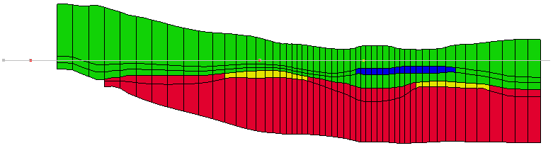

Figure 14: Row 30 of the model grid using target minimum thickness and top cell bias

The grid should now look similar to Figure 14. Notice how the top row and the thin cells in the yellow and blue areas are now thicker compared to Figure 13.

# Converting the Conceptual Model

It is now possible to finish developing the MODFLOW model. In the interest of time, the conceptual model has already been built. It was imported with the project file. For more information on conceptual models, refer to the “MODFLOW – Conceptual Model Approach” tutorial.

1. In the Project Explorer, select the “File:Map Folder.svg Map Data” folder to make it active.
2. From the Macro Bar, switch to **Plan View** File:Plan View Macro.svg.
3. From the Menu Bar, select the *Feature Objects |* **Map → MODFLOW** menu item to bring up the *Map → Model* dialog.
4. Select the *All applicable coverages* radio button.
5. Click the **OK** button to close the *Map → Model* dialog.

The grid should appear similar to Figure 15.

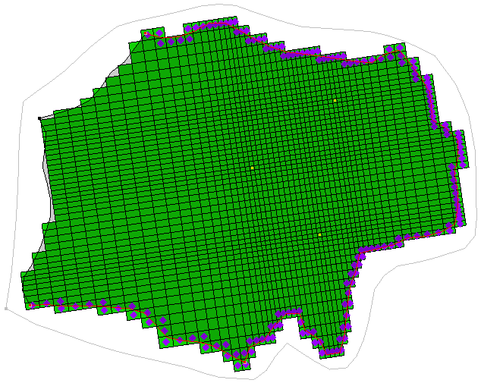

Figure 15: Plan view after map converted to MODFLOW

## Using Materials to Define Hydraulic Conductivity

Next, set the option for MODFLOW to use the material assigned to the grid cell to define the hydraulic conductivity for the cell.

1. From the Menu Bar, select the *MODFLOW* | **LPF – Layer Property Flow…**menu itemto bring up the *LPF Package* dialog.
2. In the *Layer property entry method* section, select the *Use material IDs* radio button.
3. In the *Layer data* section, click the **Material Properties…**button to bring up the *Materials* dialog.
4. On the *MODFLOW* tab, for each material, enter the values for the properties shown in the table below:

|  |  |  |
| --- | --- | --- |
| **Material Name** | *Horizontal k (ft/d)* | *Vert. anisotropy (Kh/Kv)* |
| upper\_aqufier | 15.0 | 3.0 |
| lower\_aquifer | 30.0 | 3.0 |
| clay | 0.5 | 3.0 |
| silty-clay | 1.0 | 3.0 |

1. Click the **OK** button to exit the *Materials* dialog.
2. Click the **OK** button to exit the *LPF Package* dialog.

# Running MODFLOW and Viewing the Solution

It is now possible to run MODFLOW. Before doing so, save the MODFLOW simulation.

1. From the Menu Bar, select the *File* | **Save As…** menu item to bring up the *Save As* dialog.
2. From the *Save as type* drop-down, select “Project Files (\*.gpr)”.
3. As the *File name,* enter “run1\_lpf.gpr”.
4. Click the **Save** button to save the file and close the *Save As* dialog**.**
5. From the Menu Bar, select the *MODFLOW* | **Run MODFLOW** menu item to bring up the *MODFLOW* model wrapper dialog.
6. When MODFLOW has finished running, turn on the *Read solution on exit* and *Turn on contours (if not on already)* checkboxes.
7. Click the **Close** button to close the *MODFLOW* model wrapper dialog and import the MODFLOW solution.
8. From the Macro Bar, click **Display Options** File:Display Options Macro.svg to bring up the *Display Options* dialog.
9. Select “File:3D Grid Icon.svg 3D Grid Data” from the list on the left.
10. On the *3D Grid* tab, turn off *Cell faces* check box.
11. Click the **OK** button to exit the *Display Options* dialog.

The head contours are visible on the grid (Figure 16). If desired, cycle through the layers to see how the head contours change within the different layers. Switch to **Side View** File:Side View Macro.svg to see the contours on the rows or columns.

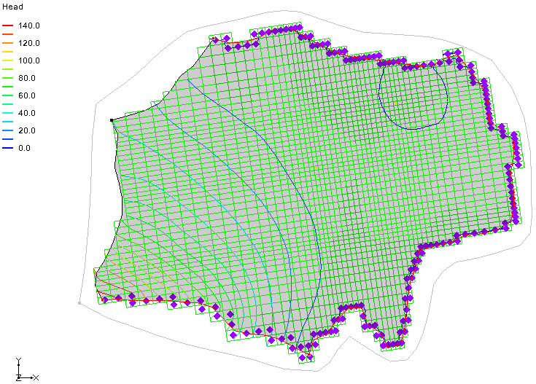

Figure 16: MODFLOW solution with contours visible

# Solids **→** HUF

Now use the HUF (Hydrogeologic-Unit Flow) package in MODFLOW to define the hydraulic properties of the grid cells instead of the LPF package. This package is designed to represent complex stratigraphic relationships in a grid independent fashion.

The hydrostratigraphy is represented using a set of hydrogeologic units. Each unit is defined by two arrays: one for the top elevation and one for the thickness. The thickness values can be set to zero in regions of the model where the unit is not present. When MODFLOW is executed, each cell is compared to the corresponding unit elevation arrays and equivalent hydraulic properties are assigned to the cell. Figure 17 shows an example of HUF units on a MODFLOW grid.

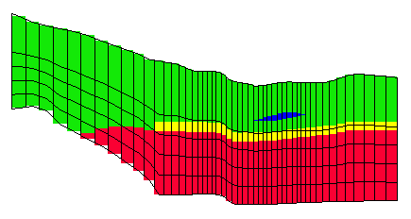

Figure 17: HUF data

## Selecting the HUF Package

First, select the HUF package as the flow package.

1. From the Menu Bar, select the *MODFLOW* | **Global Options…** menu item to bring up the *MODFLOW Global/Basic Package* dialog.
2. Click the **Packages…** button to bring up the *MODFLOW Packages / Processes* dialog.
3. In the *Flow package* section select the *HUF – Hydrogeologic Unit Flow* radio button.
4. Click the **OK** button to exit the *MODFLOW Packages / Processes* dialog.
5. Click the **OK** button to exit the MODFLOW Global/Basic Package dialog.

## Converting the Solids to HUF Data

It is now possible to convert the solids to HUF data. However, when the **Solids → MODFLOW** command ran, some of the cells were inactivated in layers 4 and 5. It is necessary for those cells to be active for this new model.

1. In the Project Explorer, select the “File:Map Folder.svg Map Data” folder to make it active.
2. From the Menu Bar, select the *Feature Objects |* **Activate Cells in Coverage(s)** menu item.
3. In the Project Explorer, select the“File:Solids Folder.svg Solid Data” folder to make it active.
4. From the Menu Bar, select the *Solids* | **Solids → HUF…** menu item to bring up the *Solids → HUF* dialog.
5. Turn on the *Adjust grid cell elevations* check box.

The MODFLOW top elevation array of the top layer and the bottom elevation array of the bottom layer are adjusted to match the tops and bottoms of all the solids. The interior top and bottom elevation arrays are assigned based on the proportions entered in the *Elevation bias* spreadsheet. The entire grid depth for each grid column is distributed according to the entries in the spreadsheet for each layer.

1. In the *Elevation bias* spreadsheet, in the *Fraction* column of row *1,* enter “0.4”.
2. Click the **OK** button to execute the **Solids → HUF** command and close the *Solids → HUF* dialog.

## Viewing the HUF Data

To view the HUF data, do the following:

1. In the Project Explorer, select the “File:3D Grid Folder.svg 3D Grid Data” folder to make it active.
2. From the Macro Bar, click **Display Options** File:Display Options Macro.svg to bring up the *Display Options* dialog.
3. From the list on the left, select “3D Grid Data”.
4. On the *3D Grid* tab, under *Cell edges,* from the *Color* drop-down*,* select the “Specified” menu item.
5. On the *MODFLOW* tab, turn on the *Hydrogeologic units* check box.
6. Click the **OK** button to exit the *Display Options* dialog.
7. From the Macro Bar, switch to **Plan View** File:Plan View Macro.svg.

The display should appear similar to Figure 18.

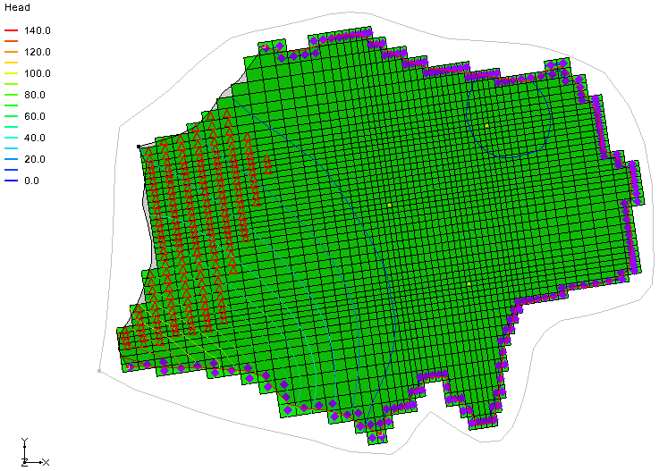

Figure 18: The HUF data is now visible

1. From the Dynamic Toolbar, using the **Select Cells** File:Select 3D Cell Tool.svg tool, select a cell somewhere in the middle of the grid.
2. From the Macro Bar, switch to **Front View** File:Front View Macro.svg.
3. In the Mini-Grid Toolbar, use the arrow buttons  to view the grid along different columns (Figure 19).

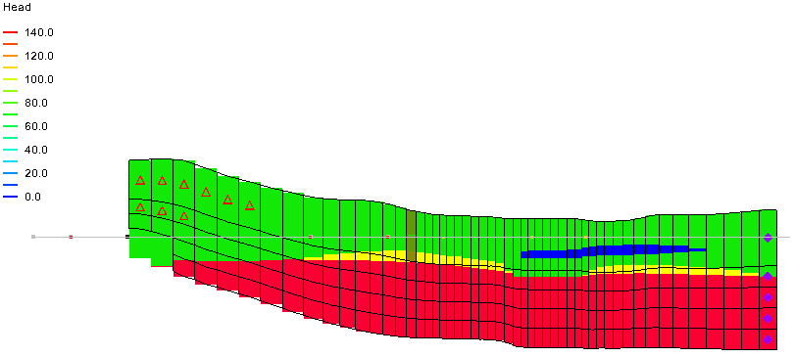

Figure 19: HUF data visible in front view

## Converting the Conceptual Model

It is necessary to convert the conceptual model again to ensure that any cells that were inactive will have the correct boundary conditions.

1. From the Macro Bar, switch to **Plan View** File:Plan View Macro.svg.
2. In the Project Explorer, select the “File:Map Folder.svg Map Data” folder to make it active.
3. Expand the “File:Map Folder.svg Map Data” folder by clicking on the + (plus) symbol next to it.
4. Right-click on the “File:Conceptual Model Icon.svg MODFLOW” conceptual model and select the **Properties…** context menu item to bring up the *Conceptual Model Properties* dialog.
5. From the *Flow package* drop-down, select the “HUF” menu item.
6. Click the **OK** button to exit the *Conceptual Model Properties* dialog.
7. From the Menu Bar, select the *Feature Objects |* **Map → MODFLOW** menu item to bring up the *Map → Model* dialog.
8. Select the *All applicable coverages* radio button.
9. Click the **OK** button to execute the Map → MODFLOW command and close the *Map → Model* dialog.

## Running MODFLOW

It is now possible to save the project and run MODFLOW.

1. From the Menu Bar, select the *File* | **Save As…** menu item to bring up the *Save As* dialog.
2. From the *Save as type* drop-down, select “Project Files (\*.gpr)”.
3. As the *File name*, enter “run1\_huf.gpr”.
4. Click the **Save** button to save the project and close the *Save As* dialog.
5. From the Menu Bar, select the *MODFLOW* | **Run MODFLOW** menu item to bring up the *MODFLOW* model wrapper dialog.
6. When MODFLOW has finished running, turn on *Read solution on exit* and *Turn on contours (if not on already)* checkboxes*.*
7. Click the **Close** button to close the *MODFLOW* model wrapper dialog and import the MODFLOW solution.

The head contours are visible on the grid (Figure 20). Some red triangles may appear on certain grid cells. These cells have gone dry (the water table is below the bottom of the cell) in this simulation. Cycle through the layers to see how the head contours change within the different layers. It is also possible to switch into side view to see the contours on the rows or columns.

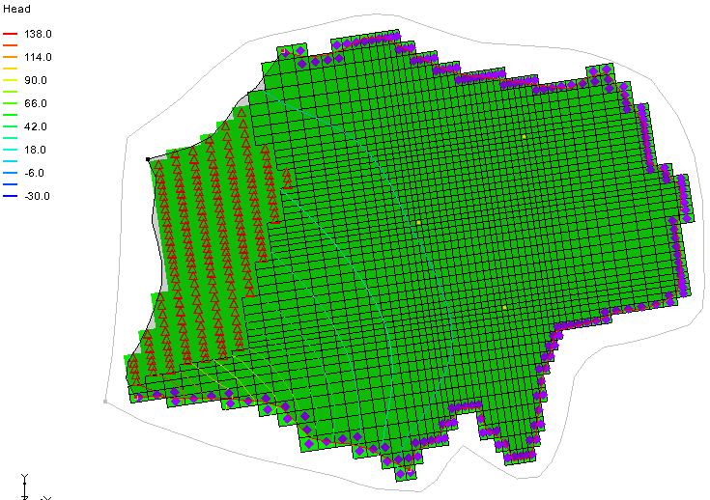

Figure 20: Head contours of the HUF data after MODFLOW run

# Conclusion

This concludes the “MODFLOW – Generating Data from Solids” tutorial. The following concepts were discussed and demonstrated:

* Solids can be used to define the MODFLOW layer elevations. They can also be used to create MODFLOW HUF data.
* It is necessary to assign layer ranges to the solids before using them to create a layered grid if using the **Solids →MODFLOW** *Boundary Matching* option.
* It is possible to use a minimum thickness to avoid thin cells. It is also possible to specify a top cell bias to make the top grid layer thicker.
* If using solids to define the MODFLOW layer data, it is probably best to use the Material IDs approach to define the hydraulic properties of grid cells based on their material.