Required Components

* GMS Core
* MODFLOW Interface
* Geostatistics
* Subsurface

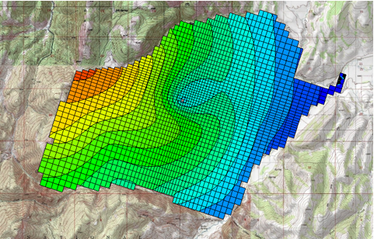

GMS 10.9

GMS 10.9 Tutorial

***MODFLOW – LAK Package***

Use the MODFLOW Lake (LAK3) package to simulate mine dewatering

Objectives

Learn the steps involved in using the MODFLOW Lake (LAK3) package interface in GMS. This tutorial will demonstrate using the LAK3 package to simulate the dewatering of a deep excavation associated with a mining operation.

Time

* 30–45 minutes

Prerequisite Tutorials

* MODFLOW – Conceptual Model Approach II

|  |
| --- |
| [1 Introduction 2](#_Toc110522056)  [1.1 Problem Description 3](#_Toc110522057)  [1.2 Outline 4](#_Toc110522058)  [2 Getting Started 5](#_Toc110522059)  [2.1 Importing the MODFLOW Model 5](#_Toc110522060)  [2.2 Saving a Copy of the Project 5](#_Toc110522061)  [2.3 Turning on the Lake Package 6](#_Toc110522062)  [3 The Lake Model 6](#_Toc110522063)  [3.1 Creating the Lake Coverage 6](#_Toc110522064)  [3.2 Importing the Lake Polygon 6](#_Toc110522065)  [3.3 Setting up the Lake TIN 8](#_Toc110522066)  [3.4 Assigning the Polygon Properties 9](#_Toc110522067)  [3.5 Mapping to MODFLOW 10](#_Toc110522068)  [3.6 The Lake Package Dialog 11](#_Toc110522069)  [3.7 Turning on the GAGE Package 12](#_Toc110522070)  [3.8 Changing the Solver 12](#_Toc110522071)  [3.9 Running the MODFLOW Simulation 13](#_Toc110522072)  [3.10 Viewing the Results 13](#_Toc110522073)  [3.11 Modifying the Model 13](#_Toc110522074)  [3.12 Running the MODFLOW Simulation 14](#_Toc110522075)  [3.13 Viewing the Results 14](#_Toc110522076)  [4 Iterating the Solution Process 15](#_Toc110522077)  [5 Conclusion 16](#_Toc110522078) |

# Introduction

This tutorial illustrates the steps involved in using the Lake (LAK3) package as part of a MODFLOW simulation. The situation discussed is hypothetical, and does not represent an actual real-world situation or operation.

The Lake package is a more sophisticated alternative to the typical approach of using the General Head Boundary (GHB) package to simulate the lake-aquifer interactions. The GHB package is used to define the stage in the lake.

MODFLOW computes the flow required to maintain that stage, given the head losses that occur as the water flows through the lake bottom sediments. With the Lake package, the stage in the lake is computed by MODFLOW based on the water budget.

The water budget is a function of inflow/outflow resulting from head differences between the aquifer and the lake. The flow budget also includes the effect recharge, evaporation, and anthropogenic inflow and discharge. The storage capacity of the lake is determined automatically based on the lake geometry. The Lake package can be used for either steady-state or transient simulations.

The Lake package represents a lake using a set of inactive cells as shown in Figure 1. The blue cells correspond to the lake and have an IBOUND value of zero (the cells are “inactive”). Defining the lake in this fashion allows the lake to interact with lower layers and it allows lateral inflow to the lake.

The lake is also assumed to have lakebed sediments which affect the flow between the aquifer and the lake. The effect of the lakebed sediments is represented with a lakebed leakance term that includes the thickness and the hydraulic conductivity. The flow from the aquifer into the lake is a function of both the lakebed leakance and the conductance of aquifer cells adjacent to the lake.

The Lake package includes an option for simulating “sublakes.” This option makes it possible for the lake to partition into smaller, separated lakes as the lake stage drops.

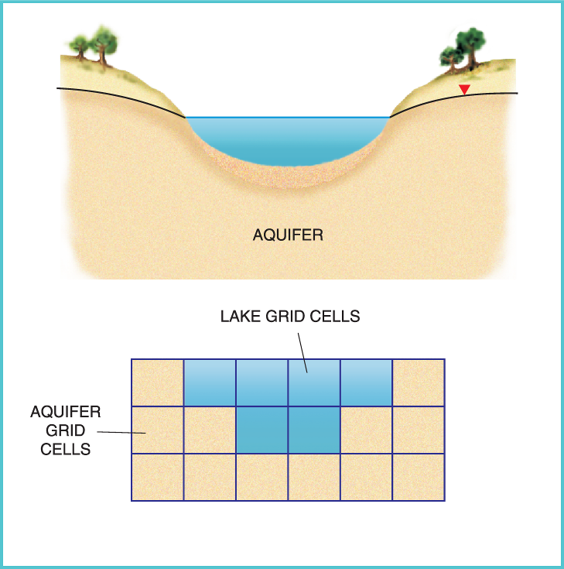

Figure 1 Cell discretization used by the Lake package[[1]](#footnote-1)

## Problem Description

In this tutorial exercise, the Lake package is used to simulate the dewatering of a hypothetical deep excavation associated with a hypothetical mining operation. The model domain is shown in Figure 2. The contours in the map represent ground surface elevation. The aquifer consists primarily of fractured limestone.

The excavation for this mining operation has been proposed in the region indicated in Figure 2. When fully excavated, the mine will be approximately 700 meters wide, 1200 meters long, and about 600 meters deep at the deepest point.

The objective of this exercise is to estimate the amount of water that will need to be pumped out of the bottom of the excavation in order to dewater the site.

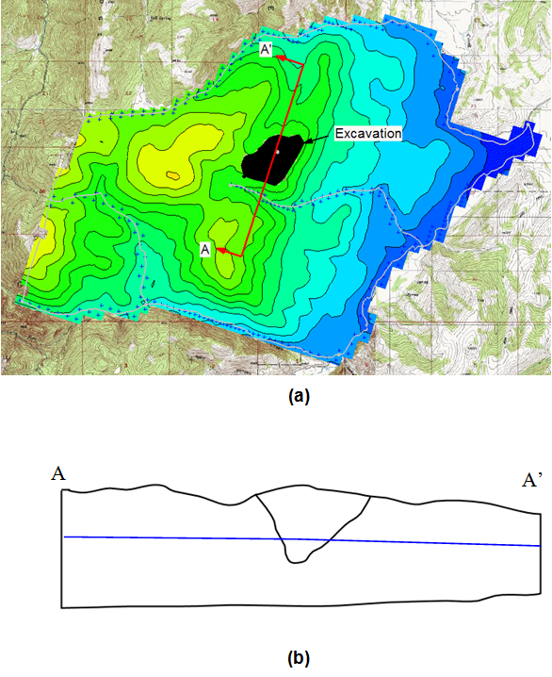

Figure 2 Map of region containing the proposed mine (a) Plan view (b) Cross-section corresponding to A-A’ with water table shown

Although not required, it may be useful to complete the “MODFLOW – Conceptual Model Approach I” tutorial before proceeding.

## Outline

This tutorial will demonstrate and discuss the following key concepts:

1. Opening a file containing a calibrated MODFLOW simulation of the groundwater flow in the region surrounding the proposed excavation site.
2. Turning on the Lake package option.
3. Defining the elevations of the bottom of the lake (excavation) using a TIN.
4. Defining the location of the lake using a polygon in the **Map 52px-Map_Module_Icon** module.
5. Assigning a set of lake properties to the lake polygon in the **Map 52px-Map_Module_Icon** module, including a “withdrawal rate” representing the pumping rate used by the dewatering wells.
6. Using the **Map → MODFLOW** command to discretize the lake data from the polygon to the grid cells.
7. Running the MODFLOW simulation.
8. Importing the solution and examine the resulting lake stage.
9. Repeating steps 5–8 until the resulting stage is within ten meters of the bottom of the lake (excavation).

# Getting Started

Do the following to get started:

1. If necessary, launch GMS.
2. If GMS is already running, from the menu bar, select *File |* **New** to ensure that the program settings are restored to their default state. Click the **Don’t Save** button, if asked to save changes.

## Importing the MODFLOW Model

The first step is to import a file containing a previously-completed MODFLOW model of the site.

1. Click the **Open** File:Open Macro.svg macro to bring up the *Open* dialog.
2. From the *Files of type* drop-down, select “Project Files (\*.gpr)”.
3. Browse to the *modflake\modflake* directory and select “start.gpr”.
4. Click the **Open** button to import the project and exit the *Open* dialog**.**

Notice a set of contours on the grid (Figure 3). These contours represent the computed head from the MODFLOW simulation. This model has been calibrated to pre-excavation conditions. Next steps are to modify the model and simulate the effect of the mine.

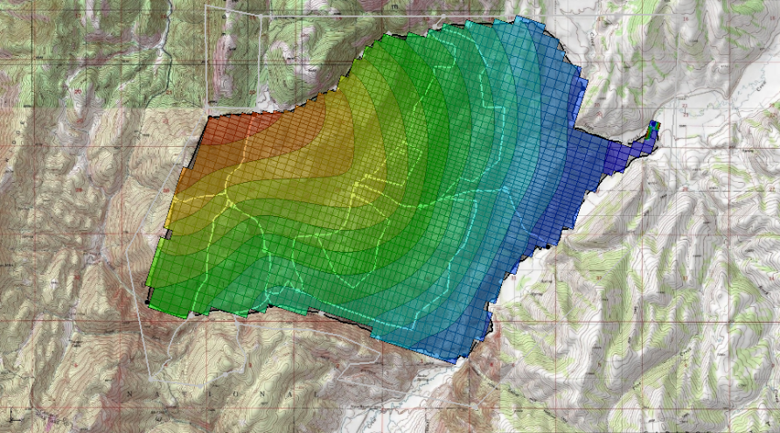

Figure 3 Contoured map of the excavation site

## Saving a Copy of the Project

Before continuing, save a copy of the project under a different name.

1. From the menu bar, select *File* | **Save As…** to bring up the *Save As* dialog.
2. From the *Save as type* drop-down, select “Project Files (\*.gpr)”.
3. For the *File name,* enter “mine01.gpr”.
4. Click the **Save** button to save the project under the new name and close the *Save As* dialog.

While going through the tutorial, periodically click the **Save** File:Save Macro.svg macro to save any changes.

## Turning on the Lake Package

To turn on the Lake package option in the MODFLOW interface:

1. From the menu bar, select *MODFLOW* | **Global Options…** to bring up the *MODFLOW Global/Basic Package* dialog.
2. On the right side, click the **Packages…** button to bring up the *MODFLOW Packages / Processes* dialog.
3. In the *Optional packages / processes* section, turn on *LAK3 – Lake*.
4. Click the **OK** button to exit the *MODFLOW Packages / Processes* dialog.
5. Click the **OK** button to exit the *MODFLOW Global/Basic Package* dialog.

# The Lake Model

## Creating the Lake Coverage

The easiest way to build Lake package data in GMS is to use conceptual modeling tools in the **Map 52px-Map_Module_Icon** module. This allows users to define the boundary of the mine using a polygon and to define the geometry of the mine (the elevations) using a TIN.

First, create a coverage for the lake polygon:

1. In the *Project Explorer*, fully expand the “File:Map Folder.svg Map Data” folder.
2. Right-click on the “File:Conceptual Model Icon.svg Conc. Mod” conceptual model and select **New Coverage…** context menu item to bring up the *Coverage Setup* dialog.
3. For the *Coverage name,* enter “lake”.
4. In the *Sources/Sinks/BCs* column, scroll down and turn on the *Lake* checkbox.
5. At the bottom of the dialog, turn off the *Use to define model boundary (active area)* checkbox.
6. Click the **OK** button to exit the *Coverage Setup* dialog.

## Importing the Lake Polygon

Next to create a polygon representing the boundary of the mine by importing a shapefile:

1. From the menu bar, select *File |* **Open…** to bring up the *Open* dialog.
2. From the *Files of type* drop-down, select “Shapefiles (\*.shp)”.
3. Select “mine\_bound\_poly.shp” and click the **Open** button to import the shapefile and exit the *Open* dialog. If a *specify the projection* warning appears click the **OK** button to open the *Projection – Project\GIS Layers\mine\_bound\_poly.shp* dialog and click the **OK** button to select the default projection and close the *Projection* dialog.

A new entry, “File:GIS Polygon Data Shapefile.svg mine\_bound\_poly.shp”, will appear under “File:GIS Folder.svg GIS Layers” in the Project Explorer. It is behind the grid and the map coverages, so it is partially obscured.

1. In the *Project Explorer*, turn off “File:3D Grid Folder.svg 3D Grid Data” and “File:Map Folder.svg Map Data” checkboxes.

The polygon should appear as a black polygon on top of the map (detail in Figure 4).

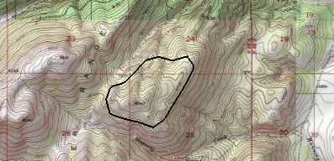

Figure 4 Detail showing the lake polygon

In order to use this polygon in the conceptual model, convert it from a shapefile to a GMS feature object in the “File:Coverage Active Icon.svg lake” coverage. Do the following to convert the polygon:

1. In the *Project Explorer*, select “File:GIS Folder.svg GIS Layers”.
2. From the menu bar, select *GIS |* **Shapes → Feature Objects** to bring up the *Step 1 of 3* page of the *GIS to Feature Objects Wizard* dialog.
3. Click the **Next >** button to go to the *Step 2 of 3* page of the *GIS to Feature Objects Wizard* dialog.
4. Click the **Next >** button to go to the *Step 3 of 3 (Finished)* page of the *GIS to Feature Objects Wizard* dialog (there are no attributes with the shapefile).
5. Click the **Finish** button to close the *GIS to Feature Objects Wizard* dialog.

The **Shapes → Feature Objects** command adds the new feature objects to the active coverage. Since the “File:Coverage Active Icon.svg lake” coverage is currently active, the mine boundary polygon should have been added to the “File:Coverage Active Icon.svg lake” coverage. To confirm, do the following:

1. In the *Project Explorer*, turn off the “File:GIS Folder.svg GIS Layers” checkbox.
2. In the *Project Explorer*, turn on the “File:Coverage Active Icon.svg lake” coverage checkbox.

The lake is visible as a polygon in the “File:Coverage Active Icon.svg lake” coverage (Figure 5).

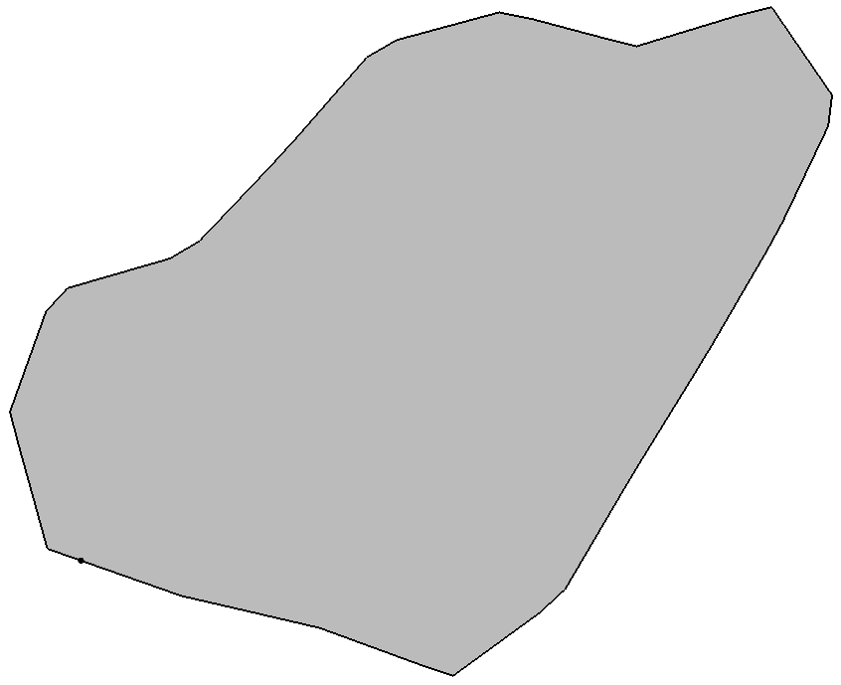

Figure 5 The lake polygon in the lake coverage

## Setting up the Lake TIN

Before entering the lake properties, it is necessary to create a TIN representing the geometry (elevations) of the bottom of the mine. This TIN is used when mapping to MODFLOW to mark the lake cells and assign the proper layer elevations to the cells in the MODFLOW grid in the vicinity of the bottom of the mine. To build the TIN, first create the TIN from the mine boundary polygon, then interpolate the elevations to the TIN from a scatter point set.

1. In the *Project Explorer*, select the “File:Coverage Active Icon.svg lake” coverage to make it active.
2. From the menu bar, select *Feature Objects |* **Map → TIN** to bring up the *Properties* dialog.
3. Enter “mine bottom” as the *TIN name*.
4. Click the **OK** button to close the *Properties* dialog.

A new “File:TIN Module Icon.svg mine bottom” TIN will appear under the “File:TIN Folder.svg TIN Data” folder in the Project Explorer, and the TIN will be visible in the Graphics Window (Figure 6). The density of the triangles in the TIN is a function of the vertex spacing on the arcs defining the polygon boundary. If necessary, the spacing can be adjusted using **Redistribute Vertices**. In this case, the spacing is acceptable and no changes need to be made.

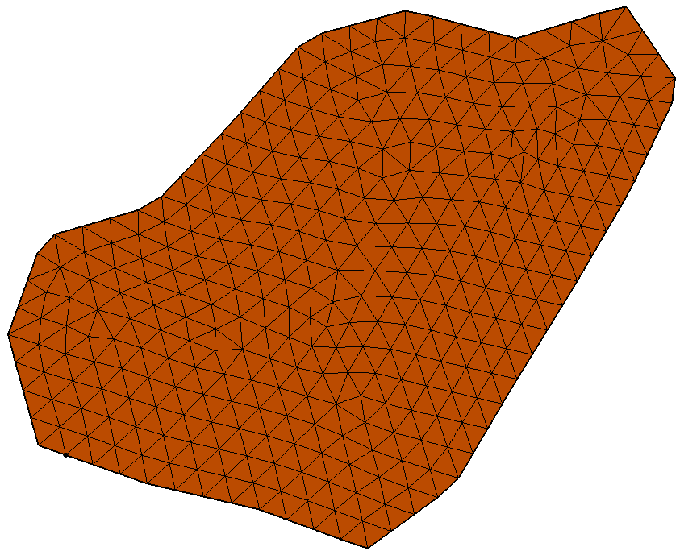

Figure 6 The mine bottom TIN

Do as follows to interpolate the elevations:

1. In the *Project Explorer*, fully expand the “File:2D Scatter Folder.svg 2D Scatter Data” folder.
2. Right-click on the “File:2D Scatter Icon.svg excavation” scatter set, select the *Interpolate To* | **Active TIN** context menu item to bring up the *Interpolate → Object* dialog.
3. For the *Interpolated dataset name,* enter “elevations”.
4. Click the **OK** button to close the *Interpolate → Object* dialog.

Notice some new contours appear on the TIN. Before continuing, view the TIN in oblique view to confirm the interpolation results:

1. Deselect the **Ortho Mode** File:Ortho View Macro.svg macro at the top of the GMS window.
2. Switch to **Oblique View** File:Oblique View Macro.svg.

Use the **Zoom** File:Zoom Tool Icon.svg and **Rotate** File:Rotate Tool.svg tools to view the shape of the mine in 3D (Figure 7). When finished, change the view back to what it was before by doing the following:

1. In the toolbars, switch to **Plan View** File:Plan View Macro.svg.
2. Reselect **Ortho Mode** File:Ortho View Macro.svg.

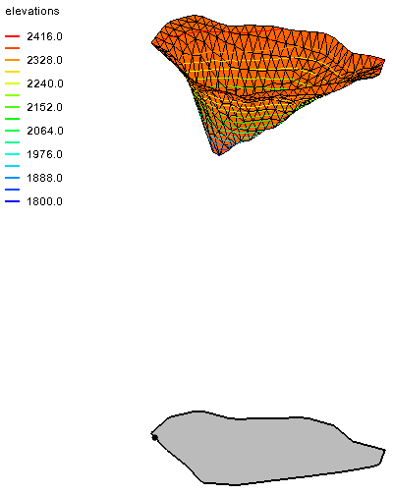

Figure 7 TIN with elevations and the lake polygon

## Assigning the Polygon Properties

It is now possible to assign the lake properties to the mine polygon.

1. In the *Project Explorer*, under “File:Map Folder.svg Map Data” select the “File:Coverage Active Icon.svg lake” coverage to make it active.
2. Using the **Select Objects** File:Select Object Tool.svgtool, double-click on the lake polygon to bring up the *Attribute Table* dialog.
3. In the *Name* column, enter “mine”.
4. In the *Type* column, from the drop-down, select “lake”.
5. In the *Init. Stage (m)* column, enter “2300.0”.
6. In the *Min. Stage (m)* column, enter “1801.0”.
7. In the *Max. Stage (m)* column, enter “2460.0”.
8. In the *Bathymetry* column, click on the **Select TIN** http://www.xmswiki.com/w/images/0/02/Narrow_dot_dot_dot_button.png button to bring up the *Select TIN* dialog.
9. Select “File:TIN Module Icon.svg mine bottom” and click the **OK** button to close the *Select TIN* dialog.

The value in the *Lake Leakance (1/d)* column represents the leakance (K/thickness) of the lake bottom sediments. Since this tutorial is simulating an excavation, there are no lake bottom sediments, so input an arbitrarily large leakance value to simulate minimal resistance to flow.

1. In the *Lake Leakance (1/d)* column, enter “1e6”.

For the precipitation, enter a value in units of *m/d* that corresponds to a rate of just under 0.5 m/yr.

1. In the *Precipitation (m/d)* column, enter “0.0013”.

Since the excavation will be dewatered, it is advisable to be conservative and leave the *Evaporation* at zero.

The *Runoff* represents the volumetric inflow from the adjacent watershed. The basin feeding into the mine has an area of about 3,000,000 m2, so assume that about one-fifth of the precipitation in this area turns into runoff, giving us a volumetric rate of 0.0013/5\*3e6 = 780 m3/d.

1. In the *Runoff (m^3/d)* column, enter “780.0”.

The *Withdrawal* rate represents the volumetric extraction rate due to anthropogenic activities. The tutorial will use this term to represent the pumping rate used to dewater the well. Start with an estimate and then re-run the model until the stage is near the bottom of the mine. Enter the number as a positive value since it is assumed to be extracted by default.

1. In the *Withdrawal (m^3/d)* column, enter “2000.0”.

Finally, there are two columns for the *Parent Lake* and *Sill Elevation (m)*. These properties are used to link multiple lakes together into a system where a large lake can change into multiple smaller lakes as the water level drops. This tutorial will not need to use this feature.

There is also an option called *Adjust Cell Elev*. This option is used to modify the top elevations of the active cells just beneath the lake cells so that the elevations match the lake bathymetry. This option leads to more accurate stage-volume relationships, but it can make the model less robust. Leave the option off for this study.

1. Click the **OK** button to exit the *Attribute Table* dialog.

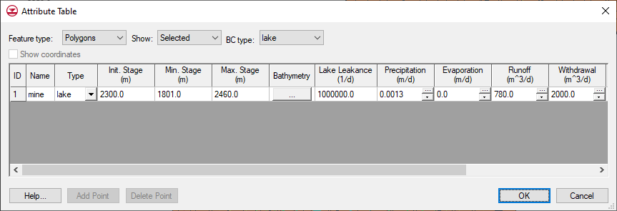

Figure 8 Lake properties in the Attribute Table dialog

## Mapping to MODFLOW

At this point, it is possible to run the **Map → MODFLOW** command to discretize the conceptual model data to the MODFLOW input arrays on the 3D grid. The mine boundary polygon and the mine bottom TIN are used to identify the set of cells that lie inside the body of the mine. These cells are marked as lake cells and are set to be inactive (IBOUND = 0).

The elevations of the cells adjacent to the bottom of the mine are adjusted up or down to match the mine bottom when selecting the *Adjust Cell Elev.* field in the polygon attributes table. A lake object is created in the MODFLOW *Lake Package* dialog and the lake properties entered in the previous section are inherited by this object. The leakance values entered in the previous step are assigned to all grid cells on the perimeter of the lake.

1. In the *Project Explorer*, turn on the “File:3D Grid Folder.svg 3D Grid Data” checkbox and turn off the “File:TIN Module Icon.svg mine bottom” TIN checkbox.
2. From the menu bar, select *Feature Objects |* **Map → MODFLOW** to bring up the *Map → Model* dialog.
3. Click the **OK** button to accept the defaults and close the *Map → Model* dialog.

## The Lake Package Dialog

Now to look at the *MODFLOW Lake Package* dialog to see how the conceptual model was mapped to the grid.

1. From the menu bar, select *MODFLOW | Optional Packages |* **LAK – Lake…**to bring up the *MODFLOW Lake Package* dialog.

The *MODFLOW Lake Package* dialog has some global options at the top and a list of lakes at the bottom. Notice there is one lake listed, and it has the values that were entered into the conceptual model.

Lakes are located in the grid using 2D arrays of lake IDs.

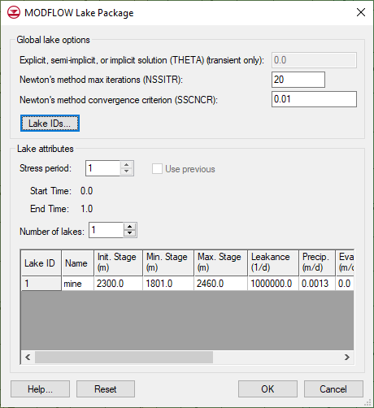

Figure 9 MODFLOW Lake Package dialog

1. Click the **Lake IDs…** button to bring up the *Lake ID* dialog.
2. Use the scroll bars in the 2D array to find the area with 1s (rows 21–32 and columns 23–34).

This is where the lake is in the grid. Each lake has a unique ID number. If there were additional lakes, there would be other areas with different ID numbers (2, 3, and so on).

1. Change the *Layer* field to “2”.

Notice the values are all “0” in this layer, meaning the lake does not extend into the second layer of the model.

1. Click the **OK** button to exit the *Lake ID* dialog.
2. Click the **OK** button to exit the *MODFLOW Lake Package* dialog.

## Turning on the GAGE Package

To determine the stage in the mine resulting from our selected pumping rate, this tutorial will use the GAGE package. Turning on the GAGE package for the lake causes MODFLOW to generate a text file which contains a list of stages versus time steps.

1. From the menu bar, select *MODFLOW |* **Global Options…** to bring up the *MODFLOW Global/Basic Package* dialog.
2. Click the **Packages…** button to bring up the *MODFLOW Packages / Processes* dialog.
3. In the *Optional packages / processes* section, turn on *GAGE – Gage*.
4. Click the **OK** button to exit the *MODFLOW Packages / Processes* dialog.
5. Click the **OK** button to exit the *MODFLOW Global/Basic Package* dialog.

Next, add the lake to the GAGE package:

1. From the menu bar, select *MODFLOW | Optional Packages |* **GAGE – Gage…** to bring up the *Gage Package* dialog.
2. Click the **Add All Lakes** button to add the lake to the *Lake Gages* section.
3. Click the **OK** button to close the *Gage Package* dialog.

## Changing the Solver

Before continuing, it is necessary to change the solver option to use the SIP solver. This solver works better than the other solvers for this particular problem.

1. From the menu bar, select *MODFLOW |* **Global Options…** to bring up the *MODFLOW Global/Basic Package* dialog.
2. Click the **Packages…** button to bring up the *MODFLOW Packages / Processes* dialog.
3. In the *Solver* section, select the *SIP1 – Strongly Impl. Proc*. radio button.
4. Click the **OK** button to exit the *MODFLOW Packages / Processes* dialog.
5. Click the **OK** button to exit the *MODFLOW Global/Basic Package* dialog.

Next, adjust the maximum number of iterations.

1. From the menu bar, select *MODFLOW |* **SIP1 – Strongly Impl. Proc. Solver**… to bring up the *MODFLOW SIP Package* dialog.
2. In the *Maximum iterations per time step (MXITER)* field, enter “1000”.
3. Click the **OK** button to close the *MODFLOW SIP Package* dialog.

## Running the MODFLOW Simulation

Now to save the changes and run MODFLOW:

1. Click the **Save** File:Save Macro.svg macro to save the project.
2. Click the **Run MODFLOW** File:Run MODFLOW Macro.svg macro to bring up the *MODFLOW* model wrapper dialog.
3. When MODFLOW has finished running, turn on *Read solution on exit* and *Turn on contours (if not on already)*.
4. Click the **Close**button to import the solution and close the *MODFLOW* model wrapper dialog.

Notice that the head contours indicate slight drawdown of the water table around the mine.

## Viewing the Results

Next, determine the stage in the mine as a result of the selected pumping rate using the MODFLOW-generated gage file. The gage file can be accessed from the Project Explorer:

1. In the *Project Explorer*, fully expand the “File:3D Grid Folder.svg 3D Grid Data” folder.
2. In the *Project Explorer*, under “File:Generic Folder Locked.svg mine01 (MODFLOW)”, expand “File:Generic Folder.svg Gage Files”, then double-click on “File:External Text File Icon.svg mine01\_mine.gag” to bring up the *View Data File* dialog.

Note that this dialog may not appear if the *Never ask this again* option has been previously checked. If this is the case, skip to step 4 below.

1. Select the desired text editor from the *Open with* drop-down and click the **OK** button to open “mine01\_mine.gag” in that application.
2. Notice that the stage value listed on the last line is approximately 2257 m.

Some drawdown has occurred but still has a long ways to go to dewater the mine.

1. Close the text editor and return to GMS.

## Modifying the Model

Next to increase the pumping rate and run the model again to see the effect on the stage. However, be careful. The LAK3 package is quite sensitive to the initial conditions. For example, if the pumping rate is changed to 10,000 m^3/d, the solution will not converge. Make smaller changes to the pumping rate and also adjust the starting heads and the initial stage to improve convergence.

There are two ways to edit the lake values:

In the first, edit the conceptual model and then map the changes to the grid again. In the second, edit the grid directly by using the *MODFLOW Lake Package* dialog.

The second method does not change the conceptual model, however, so if the conceptual model is remapped to the grid, any changes made directly to the grid will be overwritten.

In this tutorial, the conceptual model method will be used.

Do the following to change the lake properties:

1. In the *Project Explorer*, select the “File:Coverage Active Icon.svg lake” coverage to make it active.
2. Using the **Select Objects** File:Select Object Tool.svg tool, double-click on the lake polygon to bring up the *Attribute Table* dialog.
3. In the *Init. Stage (m)* column, enter “2200.0”.
4. In the *Withdrawal* *(m^3/d)* column, enter “2500.0”.
5. Click the **OK** button to exit the *Attribute Table* dialog.

Now to map these changes from the conceptual model to the grid:

1. Click the **Map → MODFLOW** File:Map to MODFLOW Macro.svg macro to bring up the *Map → Model* dialog.
2. Click the **OK** button to accept the defaults and close the *Map → Model* dialog.

Next, change the starting heads to match the current solution.

1. From the menu bar, select the *MODFLOW |* **Global Options…** to bring up the *MODFLOW Global/Basic Package* dialog.
2. Click the **Starting Heads…** button to bring up the *Starting Heads* dialog.
3. Click the **3D Dataset → Grid…** button to bring up the *Select Dataset* dialog.
4. Since the “Head” dataset is already selected, click the **OK** button to copy the head solution to the starting heads array and close the *Select Dataset* dialog.
5. Click the **OK** button to exit the *Starting Heads* dialog.
6. Click the **OK** button to exit the *MODFLOW Global/Basic Package* dialog.

## Running the MODFLOW Simulation

It is now time to save these changes and run MODFLOW again.

1. Click the **Save** File:Save Macro.svg macro to save the project.
2. From the menu bar, select *MODFLOW* | **Run MODFLOW** to bring up the *MODFLOW* model wrapper dialog.
3. When MODFLOW has finished running, turn on *Read solution on exit* and *Turn on contours (if not on already)*.
4. Click **Close**to import the solution and close the *MODFLOW* model wrapper dialog.

## Viewing the Results

Notice that there is now a little more drawdown around the mine.

1. In the *Project Explorer*, fully expand the “File:3D Grid Folder.svg 3D Grid Data” folder.
2. In the *Project Explorer*, under “File:Generic Folder Locked.svg mine01 (MODFLOW)”, expand “File:Generic Folder.svg Gage Files”,
3. Double-click on “File:External Text File Icon.svg mine01\_mine.gag” to bring up the *View Data File* dialog.

This dialog may not appear if the *Never ask this again* option has been previously checked. If this is the case, skip to step 5 below.

1. Select the desired text editor from the *Open with* drop-down and click the **OK** button to open “mine01\_mine.gag” in that application.
2. Notice that the stage value listed on the last line is approximately 2230 m.

This represents a drop of 27 m from the previous iteration.

1. Close the text editor and return to GMS.

# Iterating the Solution Process

Normally, most real-life projects would require a series of iterations of sections 3.11 to 3.13 in order to find the optimal solution. These iterations involve gradually increasing the pumping rate and updating the initial stage and starting heads array until the desired solution is achieved. If the solution does not converge for a particular iteration, make a smaller change to the withdrawal rate.

Be careful while iterating, as in some cases the model will appear to converge, but the solution will not be valid. If there are any doubts about the solution, open the “model01.out” file in the “mine01 (MODFLOW)” folder in the Project Explorer and look at the lake package iteration output about two-thirds of the way down the file.

As mentioned at the beginning of Section 3.11, it may be easier to edit the lake in the *MODFLOW Lake Package* dialog while iterating instead of editing in the conceptual model. Editing the lake in the dialog allows for skipping the **Map → MODFLOW** step, thereby saving a little time. Just remember that the values in the conceptual model will be out of sync with the values on the grid when using this method.

In this case, follow all the steps in sections 3.11 to 3.12, entering the following to obtain the final solution:

1. In the *Project Explorer*, select the “File:Coverage Active Icon.svg lake” coverage to make it active.
2. Using the **Select Objects** File:Select Object Tool.svg tool, double-click on the lake polygon to bring up the *Attribute Table* dialog.
3. As in section 3.11 step 3, for *Init Stage (m)*, enter “1810.0”.
4. As in section 3.11 step 4, for *Withdrawal (m^3/d),* enter “6340.0”.
5. Click the **OK** button to exit the *Attribute Table* dialog.
6. Click the **Save** File:Save Macro.svg macro to save the project.
7. Click the **Run MODFLOW** File:Run MODFLOW Macro.svg macro to bring up the *MODFLOW* model wrapper dialog.
8. When MODFLOW has finished running, turn on *Read solution on exit* and *Turn on contours (if not on already)*.
9. Click the **Close**button to import the solution and close the *MODFLOW* model wrapper dialog.
10. Click on the **Frame** Frame macro to center the display.

Once done, the model should appear similar to Figure 10.

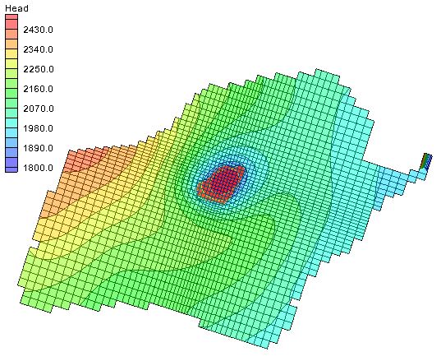

Figure 10 The final contours upon reaching the optimal solution

# Conclusion

This concludes the “MODFLOW – LAK Package” tutorial. The following key concepts were demonstrated and discussed in this tutorial:

* To use the Lake package, both a TIN representing the lake bathymetry and a polygon representing the lake boundary must be created.
* The lake properties are assigned to the lake polygon in the **Map 52px-Map_Module_Icon** module.
* The flow between the aquifer and the lake is a function of both the aquifer conductance and the lakebed leakance.
* The Lake package computes the stage in the lake based on a flow budget for the lake and the lake geometry.
* To determine the amount of pumping required for an excavation, simulate the excavation using the Lake package and adjust the withdrawal rate until the desired stage is found.

1. Merritt, Michael L. and Konikow, Leonard F. (2000). *Documentation of a computer program to simulate lake-aquifer interaction using the MODFLOW ground water flow model and the MOC3D solute-transport model,* U.S. Geological Survey, Water-Resources Investigations Report 00-4167, cover page*.* <http://fl.water.usgs.gov/PDF_files/wri00_4167_merritt.pdf>*.* [↑](#footnote-ref-1)