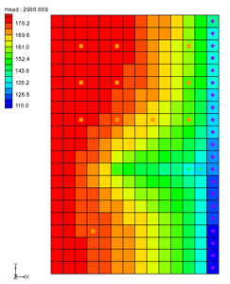

GMS 10.9

GMS 10.9 Tutorial

***MODFLOW – MNW2 Package***

Use the MNW2 package with the sample problem and a conceptual model

Objectives

Learn how to use the MNW2 package in GMS and compare it to the WEL package. Examine the sample MNW2 model that comes with MODFLOW, and then examine a different model that uses the conceptual model approach.

Time

* 35–50 minutes

Required Components

* GMS Core
* MODFLOW Interface

Prerequisite Tutorials

* MODFLOW – Conceptual Model Approach I

|  |
| --- |
| [1 Introduction 2](#_Toc109910270)  [2 Getting Started 4](#_Toc109910271)  [2.1 Importing the Existing Model 5](#_Toc109910272)  [2.2 Saving the Model with a New Name 6](#_Toc109910273)  [3 Viewing the MNW2 Boundary Conditions 6](#_Toc109910274)  [3.1 Opening the MNW2 Package Dialog 6](#_Toc109910275)  [3.2 Stress Period Data 7](#_Toc109910276)  [3.3 Defining the Wells 7](#_Toc109910277)  [3.4 Examining the Well Screen for Well-A 9](#_Toc109910278)  [3.5 Opening the Source/Sinks Dialog 10](#_Toc109910279)  [3.6 Running MODFLOW 11](#_Toc109910280)  [3.7 Examining the Solution 12](#_Toc109910281)  [4 Changing the Active Flag for the Multi-Node Well 13](#_Toc109910282)  [4.1 Running MODFLOW and Viewing the Solution 13](#_Toc109910283)  [5 Drawdown-Limited Wells 13](#_Toc109910284)  [5.1 Running MODFLOW and Viewing the Solution 15](#_Toc109910285)  [6 Creating a Conceptual Model 15](#_Toc109910286)  [6.1 Opening the Existing Conceptual Model 16](#_Toc109910287)  [6.2 Examining the Existing Solution 16](#_Toc109910288)  [6.3 Changing the Model to Use MNW2 16](#_Toc109910289)  [6.4 Changing the Wells to MNW2 17](#_Toc109910290)  [6.5 Examining the MNW2 Package 17](#_Toc109910291)  [6.6 Saving and Running MODFLOW 17](#_Toc109910292)  [6.7 Examining the Solution 18](#_Toc109910293)  [7 Changing to a Multi-Node Well 18](#_Toc109910294)  [7.1 Examining the MNW2 Package 18](#_Toc109910295)  [7.2 Saving and Running MODFLOW 19](#_Toc109910296)  [7.3 Viewing the Flow in the MNW2 Boundary Conditions 19](#_Toc109910297)  [8 Conclusion 20](#_Toc109910298) |

# Introduction

This tutorial is very similar to the “MODFLOW MNW Package” tutorial. The first MNW sample problem was converted to MNW2 using the USGS program “mnw1to2.exe”.

The Multi-Node Well (MNW2) package was created to replace the MNW1 package. Both packages were developed to more accurately model “wells that are completed in multiple aquifers or in a single heterogeneous aquifer, partially penetrating wells, and horizontal wells”. These can be influenced by the effects of dynamic changes in the distribution of pumping or intra-borehole flow that can significantly alter groundwater flow.[[1]](#footnote-1)

The model in this tutorial is the same as the model used in the first MNW package documentation.

The system consists of two aquifers that are separated by a 50-foot-thick confining unit. The upper aquifer is unconfined, has a hydraulic conductivity of 60 ft/d, and has a uniform base of 50 ft above the datum. The lower aquifer is confined and has a transmissivity of 15,000 ft2/d. Storage coefficients of “0.05” and “0.0001” were assigned to layers 1 and 2, respectively. The 66-mi2 area of the test problem was divided into 21 rows of 14 columns. Uniform, square cells that measured 2,500 ft on a side were used throughout the simulated area. Specified heads and drains are assigned in layer 1 and are maintained at the same elevations for all stress periods.

A period of 1,000,970 days was simulated with 5 stress periods. The first two stress periods simulated steady-state conditions, which were achieved by having each stress period be 500,000 days long. Recharge during stress periods 1 and 2 was a uniform 7 inches per year (in./yr). No pumpage was extracted during stress period 1 but multi-node wells were simulated. About 950,000 ft3/d of pumpage was extracted during stress period 2; this is about 35 percent of the total volumetric budget. Transient conditions were simulated during stress periods 3, 4, and 5, which were periods of 60, 180, and 730 days, respectively. Uniform recharge rates of 2, 0, and 12 in./yr, respectively, were applied during stress periods 3, 4, and 5. In addition to the simulation of two multi-node wells (wells A and B), there are 15 other single-node wells that have a combined discharge of 935,350 ft3/d for stress periods 2 through 5.[[2]](#footnote-2)

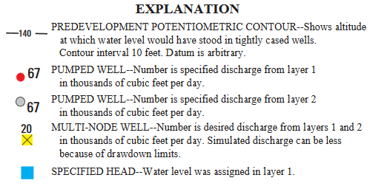

Figure 1 Explanation for Figure 2[[3]](#footnote-3)

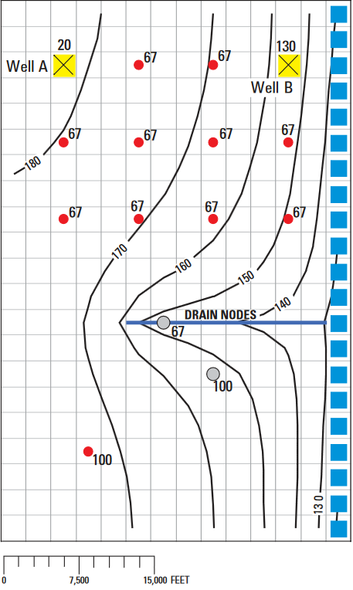

Figure 2 MNW example from the documentation[[4]](#footnote-4)

This tutorial will discuss and demonstrate importing an existing MODFLOW simulation, running the simulation, examining the results to understand the MNW2 package options, and modifying a conceptual model to use MNW2 instead of the WEL package.

# Getting Started

Do the following to get started:

1. If necessary, launch GMS.
2. If GMS is already running, select *File |* **New** to ensure that the program settings are restored to their default state. Click **Don’t Save** if asked to save changes.

## Importing the Existing Model

To start with a MODFLOW model that has already been created:

1. Click **Open** File:Open Macro.svg to bring up the *Open* dialog.
2. Select “MODFLOW Name Files (\*.mfn;\*.nam)” from the *Files of type* drop-down.
3. Browse to the *mnw2\mnw2* folder and select “mnw2.nam”.
4. Click **Open** to exit the *Open* dialog and bring up the *MODFLOW Translator* dialog (Figure 3).

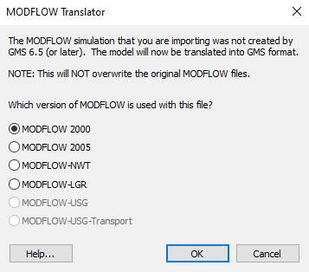

Figure 3 MODFLOW Translator dialog

1. Click **OK** to accept the defaults and start the translation.

The MODFLOW Translator runs and ends with a message saying “MODFLOW 2000 terminated successfully”.

1. Click **Done** to close the *MODFLOW Translator* dialog and import the file.

A grid with symbols representing wells, drains, and specified head boundary conditions will appear (Figure 4).

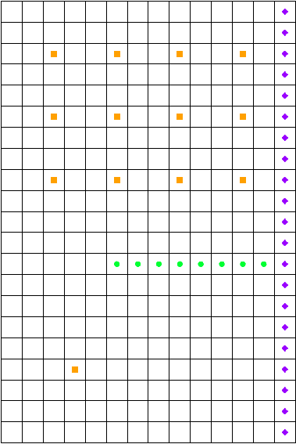

Figure 4 Imported MODFLOW model

## Saving the Model with a New Name

Before making changes, it is a good idea to save the model with a new name.

1. Select *File |* **Save As…** to bring up the *Save As* dialog.
2. Select “Project Files (\*.gpr)” from the *Save as type* drop-down.
3. Enter “mnw2.gpr” as the *File name*.
4. Click **Save** to save the project under the new name and close the *Save As* dialog.

# Viewing the MNW2 Boundary Conditions

Before running the simulation, it is possible to view the MNW2 boundary conditions.

## Opening the MNW2 Package Dialog

1. Select *MODFLOW* | *Optional Packages* | **MNW2 - Multi-Node Well…** to open the *MODFLOW Multi-Node Well (MNW2) Package* dialog (Figure 5).

This dialog is used to add and edit MNW2 wells and to change options associated with the MNW2 package.

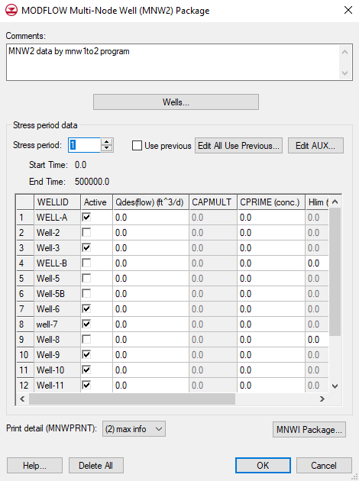

Figure 5 MNW2 Package dialog

The MNW2 documentation contains detailed information on each input option.[[5]](#footnote-5)

## Stress Period Data

The MNW2 package allows certain things to vary per stress period, while other things remain constant for all stress periods. For example, well definitions are constant for all stress periods—that is, wells cannot be defined for some stress periods and not for others, although they can be designated as active or inactive per stress period.

1. Use the increment up arrow Increment up arrow.png to adjust the *Stress period* to “2”.
2. Notice that all of the wells except for “Well-5B” have a specified pumping rate in this stress period.

## Defining the Wells

1. The spreadsheet in the dialog displays data that can vary by stress period, while well additions and deletions are managed through the **Wells…** button.Click **Wells…** to open the *MNW2 Wells* dialog (Figure 6).

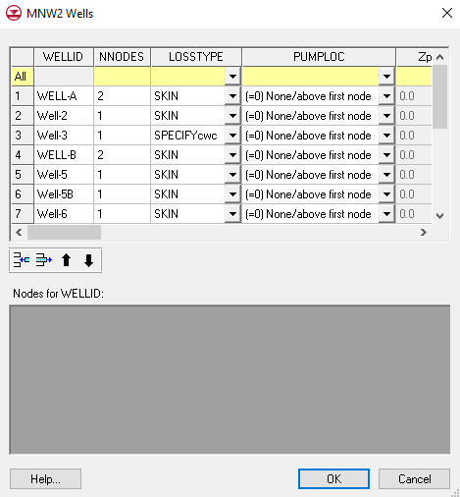

Figure 6 MNW2 Wells dialog

Notice the 16 MNW2 wells listed in the spreadsheet. Most of these are single-node wells. However, the wells named “WELL-A” and “WELL-B” are multi-node wells (they have more than one node).

Wells can be added, deleted, reordered, renamed, and have their options changed in this dialog. The nodes (cells) that are associated with each well are located in the *Nodes for WELLID* section.

1. On the first row in the *WELLID* column, select the “WELL-A” cell.

Notice the nodes for “WELL-A” are listed in the bottom spreadsheet, along with some other variables (*Rw*, *Rskin*, *Kskin*).

1. On the first row in the top spreadsheet (the row for “WELL-A”), enter “-1” in the *NNODES* column.

Notice the change in the *Nodes for WELLID* spreadsheet. Specifying a negative number for NNODES means the well is a vertical well, and instead of specifying the nodes for the well, it is necessary to specify the top and bottom elevations of the well screen. The next step is to change “WELL-A” to use a well screen.

1. In the *Nodes for WELLID* spreadsheet, enter “400.0” in the *Ztop* column.
2. Enter “10.0” in the *Zbotm* column.
3. Click **OK** to exit the *MNW2 Wells* dialog.
4. Click **OK** to exit the *MODFLOW Multi-Node Well (MNW2) Package* dialog.

## Examining the Well Screen for Well-A

To change the display options so the well screen is more noticeable:

1. Select “File:3D Grid Folder.svg 3D Grid Data” in the Project Explorer to switch to the **3D Grid 120px-3D_Grid_Icon** module.
2. Using the **Select Cells** File:Select 3D Cell Tool.svg tool, select the cell in row 3, column 3. This cell contains a well (highlighted in Figure 7).

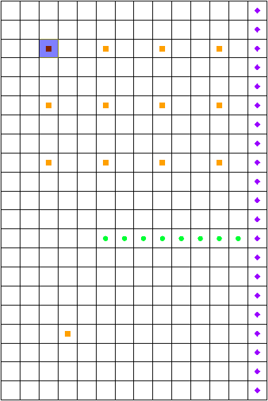

Figure 7 Selected MNW2 well cell

1. Click the **Front View** File:Front View Macro.svg button.

Not much is visible while viewing the grid slice in front view (Figure 8). The *Z* scale can be exaggerated to see things better.

GMS 10_1 - MODFLOW-MNW2Package - front view prior to changing z magnification

Figure 8 The well screen is not easily visible at this scale

1. Click **Display Options** File:Display Options Macro.svg to bring up the *Display Options* dialog.
2. In the section below the list on the left, enter “20.0” for the *Z magnification*.
3. Click **OK** to close the *Display Options* dialog.
4. Click anywhere outside the grid to deselect the cell.

The display should appear similar to Figure 9.

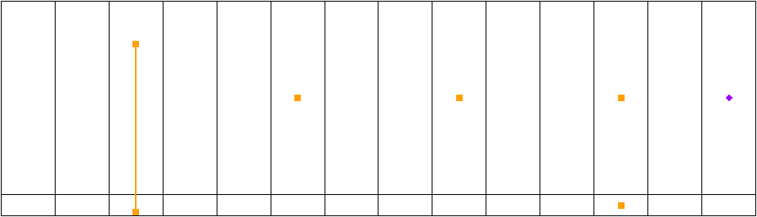

Figure 9 Front view of grid at “WELL-A”

Notice “WELL-A” (the one on the left) is drawn differently than the rest because it is a vertical well and uses a well screen. Square symbols are drawn at the top and bottom of the well screen with a line connecting them. The other wells are drawn with a symbol at the cell center. Notice the well on the right side that has symbols in the top and bottom layer. This is “WELL-B” and it has two nodes—one in each layer.

## Opening the Source/Sinks Dialog

Notice how MNW2 wells are handled by the *Sources/Sinks* dialog.

1. Using the **Select Cells** File:Select 3D Cell Tool.svg tool, select the 3D grid cell with WELL-A in it (highlighted in Figure 10).

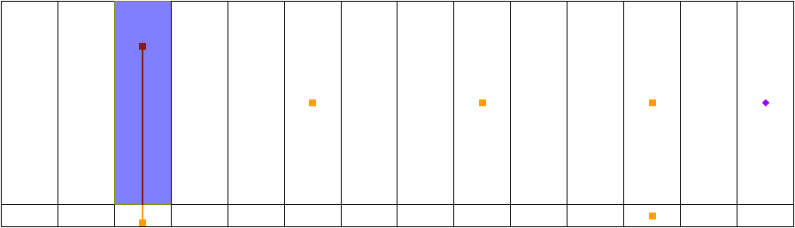

Figure 10 Selected MNW2 well cell

1. Right-click on the selected cell and select **Sources/Sinks…** to bring up the *MODFLOW* *Sources/Sinks* dialog (Figure 11).

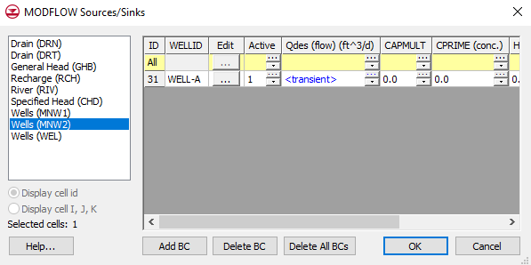

Figure 11 Sources/Sinks dialog

This dialog allows for editing the properties of selected boundary conditions as well as adding additional boundary conditions in the selected cells. With MNW2 wells, some things are defined with the well and remain constant while other things can vary per stress period. Only those things which can vary per stress period are shown in the spreadsheet. Clicking on the button in the *Edit* column brings up the *MNW2 Wells* dialog (discussed earlier), allowing the well definition to be edited.

1. Click **OK** to exit the *MODFLOW Sources/Sinks* dialog.
2. Switch to **Plan View** File:Plan View Macro.svg.

## Running MODFLOW

Before running MODFLOW, it is necessary to change the output options to make it easier to see the results.

1. Select *MODFLOW |* **OC - Output Control…** to bring up the *MODFLOW Output Control* dialog.
2. In the *Output interval* section, select *Output at last time step of each stress period*.
3. Turn on *Save cell by cell flow terms to \*.ccf file*.
4. Click **OK** to exit the *MODFLOW Output Control* dialog.
5. **Save** File:Save Macro.svg the project.
6. Click **Run MODFLOW** File:Run MODFLOW Macro.svg to bring up the *MODFLOW* model wrapper dialog.
7. When MODFLOW finishes, turn on *Read solution on exit* and *Turn on contours (if not on already).*
8. Click **Close** to import the solution and close the *MODFLOW* model wrapper dialog.

Contours should appear on the grid similar to those shown in Figure 12. Notice that “WELL-A” is still selected.

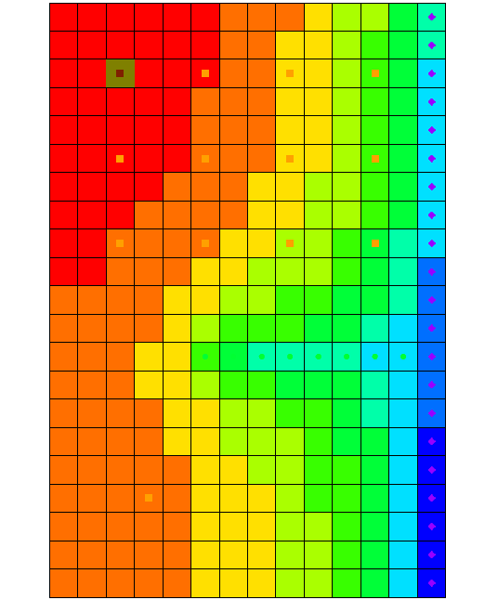

Figure 12 MODFLOW solution

1. **Save** File:Save Macro.svg the project with the new solution.
2. Switch to **Front View** File:Front View Macro.svg.

## Examining the Solution

Look closely at the computed solution. From this view, the water table and the head contours can be seen (Figure 13). Notice that on the left side of the view, the head is greater in the top layer of the model. In contrast, the head on the right side of the view, where the specified head boundary condition is located, is less in layer 1 than in layer 2 of the model. Notice that the head in the selected cell is about “180.0”.

1. Using the **Select Cells** File:Select 3D Cell Tool.svg tool, select the cell in the second layer (Cell ID 325) just below the currently selected cell.

Notice that the head in the cell in the second layer is about “175.7”. This means there is a potential for flow from layer 1 to layer 2 at these particular cells. This shows the effect that the MNW2 multi-node well has on these grid cells.

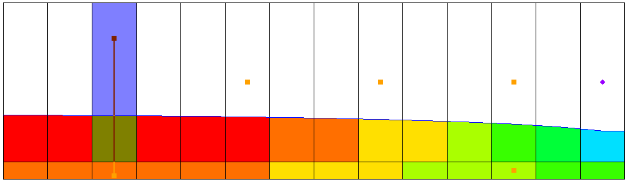

Figure 13 Cell ID 31 selected, showing contours indicating the cell head

1. Select and then right-click on “File:CCF Dataset Active.svg CCF (mnw2.ccf)” in the Project Explorer and select **CCF → Datasets**.

Notice that several additional datasets appear below this one.

1. Select the “File:Dataset Cells Active.svg MNW2” dataset.
2. Click anywhere off the grid to unselect the grid cell.

Notice the head is lower in the top cell because the well screen passing through both layers has allowed the higher head from above to flow into the lower aquifer cells (layer 2). This is an example of intra-borehole flow that can occur when a well is completed in more than one aquifer. The *Flow Budget* dialog shows the effect of the multi-node wells.

1. Using the **Select Cells** File:Select 3D Cell Tool.svg tool while holding down the *Shift* key, select the two well cells on the left of the grid that contain a well screen.
2. Select *MODFLOW |* **Flow Budget…** to bring up the *Flow Budget* dialog.

On the *MNW2* row, notice that the *Flow In* and the *Flow Out* are equal and opposite, just as expected. A flow of about “-11,992.36” leaves the model cell in layer 1 and enters the model cell in layer 2.

1. Click **OK** to exit the *Flow Budget* dialog.

# Changing the Active Flag for the Multi-Node Well

Assume that “WELL-A” was not constructed until after the first stress period in the model. Therefore, the intra-borehole flow and any pumping should not be modeled until after the first stress period. This problem can be avoided by turning off the active flag for the boundary condition.

1. Select *MODFLOW* | *Optional Packages* | **MNW2 - Multi-Node Well…** to open the *MODFLOW Multi-Node Well (MNW2) Package* dialog.
2. In the spreadsheet in the *Stress period data* section, uncheck the box in the *Active* column for the “WELL-A” row.
3. Enter “2” in the *Stress period* field.
4. Notice that “WELL-A” is active in the second stress period.
5. Click **OK** to exit the *MODFLOW Multi-Node Well (MNW2) Package* dialog.

## Running MODFLOW and Viewing the Solution

To run MODFLOW to see how the solution has changed:

1. **Save** File:Save Macro.svg the project.
2. Click **Run MODFLOW** File:Run MODFLOW Macro.svg to bring up the *MODFLOW* model wrapper dialog.
3. When MODFLOW finishes, turn on *Read solution on exit* and *Turn on contours (if not on already)*.
4. Click **Close** to import the solution and close the *MODFLOW* model wrapper dialog.
5. Select and then right-click on “File:CCF Dataset Active.svg CCF (mnw2.ccf)” in the Project Explorer and select **CCF → Datasets**.
6. Select the dataset named “File:Dataset Cells Active.svg MNW2”.

Notice that there is no intra-borehole flow now at “WELL-A” during the first stress period.

# Drawdown-Limited Wells

The MNW2 package also allows wells to be limited by the drawdown in the cell containing the well. This feature allows a well to stop pumping when the head in the cells drops below a specified elevation. Now change the drawdown for one of the wells and see the effect on the solution. Before doing that, though, change the active flag back to its original state for “WELL-A”.

1. Select *MODFLOW* | *Optional Packages* | **MNW2 - Multi-Node Well…** to open the *MODFLOW Multi-Node Well (MNW2) Package* dialog.
2. In the spreadsheet in the *Stress period data* section, check the box in the *Active* column for the “WELL-A” row.
3. Click **OK** to exit the *MODFLOW Multi-Node Well (MNW2) Package* dialog.

To edit one of the MNW2 wells to illustrate the drawdown-limited feature:

1. Switch to **Plan View** File:Plan View Macro.svg.
2. Select the bottom-right well cell (Cell ID 124, highlighted in Figure 14), right-click on it, and select **Sources/Sinks…** to bring up the *MODFLOW Sources/Sinks* dialog.
3. Select “Wells (MNW2)” from the list on the left.

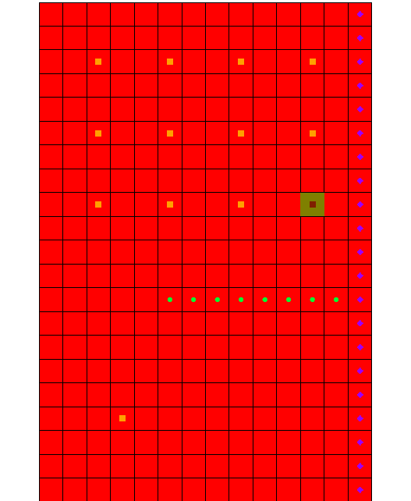

Figure 14 MNW2 boundary condition cell (IJK = 9,12,1, ID = 124)

1. In the spreadsheet on row *124*, scroll to the right to the *Hlim (ft)* column and click the transient_dataset_button button to bring up the *XY Series Editor* dialog.

This allows editing of the value of *Hlim* *(ft)* for the boundary condition. Notice the four rows in the spreadsheet which have a value of “115.0” in the *Hlim (ft)* column.

1. Enter “142.0” in the *Hlim (ft)* column for each of those four rows (replacing the “115.0”).
2. Click **OK** to exit the *XY Series Editor* dialog.
3. Click **OK** to exit the *MODFLOW Sources/Sinks* dialog.

## Running MODFLOW and Viewing the Solution

To run MODFLOW to see how the solution has changed:

1. **Save** File:Save Macro.svg the project.
2. Click **Run MODFLOW** File:Run MODFLOW Macro.svg to bring up the *MODFLOW* model wrapper dialog.
3. When MODFLOW finishes, turn on *Read solution on exit* and *Turn on contours (if not on already)*.
4. Click **Close** to import the solution and close the *MODFLOW* model wrapper dialog.
5. Select and then right-click on “File:CCF Dataset Active.svg CCF (mnw2.ccf)” in the Project Explorer and select **CCF → Datasets**.
6. Select the dataset named “File:Dataset Cells Active.svg MNW2” and change the active time step to the second time step listed in the Time Step window below the Project Explorer. Notice that the flow at the cell that was edited is about “-3127.1” (as seen in the *S* value field above the Graphics Window).
7. Select the “File:Dataset Cells Active.svg Head” dataset. Notice that the head in this cell is about “142.7”.

Remember, the desired flow rate (Qdes) that was specified for the well was “-66850.0”. Nevertheless, the computed flow for this drawdown limited well was only “-3127”. Now it is necessary to look at the head at the next output time.

1. Select the third time step listed in the Time Step window. Notice that the head at the cell is about “141.6”.
2. Change to the “File:Dataset Cells Active.svg MNW2” dataset and notice that the flow in this time step is “0.0”.

Even though the head value is high enough, the well has been deactivated during this stress period. Find out why by examining the well’s settings in the *MNW2 Package* dialog.

1. Select *MODFLOW | Optional Packages |* **MNW2 - Multi-Node Well…**to open the *MODFLOW Multi-Node Well (MNW2) Package* dialog.
2. Change the *Stress period* to “2” and notice the *Hlim (ft)* settings for *Well 12*. The dialog window can be resized in order to see more columns.
3. Change to the third stress period.

Notice that for this stress period, the *QCUT* value has been set to “-1” (making the *Qfrcmn* a percentage value) with a *Qfrcmn* value of “0.45” (45 percent). The *Qfrcmn* value is the minimum pumping rate required for the well to remain active. With a desired flow rate (*Qdes*) of “-66850.0”, it would be necessary to have a flow rate of “-30082.5” for the well to remain active. For the previous stress period, *QCUT* was set to “0” (none), allowing the well to be active.

1. Click **OK** to exit the *MODFLOW Multi-Node Well (MNW2) Package* dialog.

# Creating a Conceptual Model

The next step is to examine how to use a conceptual model with MNW2 data. This will be done by taking the finished model from the “MODFLOW – Conceptual Model Approach 1” tutorial and changing it for use with the MNW2 package.

## Opening the Existing Conceptual Model

1. **Save** File:Save Macro.svg the grid-based MNW2 model before opening the conceptual model.
2. Click **New** File:New Macro.svg to ensure the program settings are restored to their defaults.
3. Click **Open** File:Open Macro.svg to bring up the *Open* dialog.
4. Select “Project Files (\*.gpr)” from the *Files of type* drop-down.
5. Browse to the *mnw2\mnw2\sample* directory and select “modfmap2.gpr”.
6. Click **Open** to import the new project and exit the *Open* dialog.

The Graphics Window should appear similar to Figure 15. Before making any changes, save the project under a new name.

1. Select *File* | **Save As…** to bring up the *Save As* dialog.
2. Select “Project Files (\*.gpr)” from the *Save as type* drop-down.
3. Browse to the *mnw2\mnw2* folder.
4. Enter “MNWmap2.gpr” as the *File name*.
5. Click **Save** to save the project under the new name and close the *Save As* dialog.

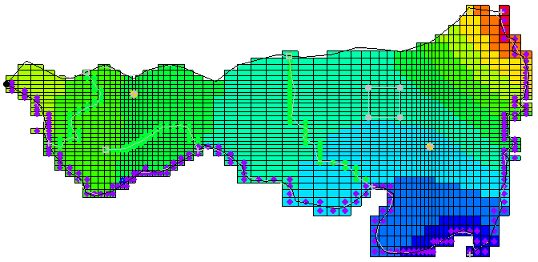

Figure 15 Initial imported model

## Examining the Existing Solution

Before changing to the MNW2 package, look at the flow budget for the existing solution by doing the following:

1. Select *MODFLOW* | **Flow Budget…** to bring up the *Flow Budget* dialog.

Notice the flow budget for the well package has a *Flow Out* rate of about “-2189.2”.

1. Click **OK** to exit the *Flow Budget* dialog.

## Changing the Model to Use MNW2

To change to the MNW2 package, first the WEL package needs to be removed from MODFLOW.

1. Select *MODFLOW |* **Global Options…** to open the *MODFLOW Global/Basic Package* dialog.
2. Click **Packages…** to bring up the *MODFLOW Packages / Processes* dialog.
3. In the *Optional packages / processes* section, make sure the *WEL1 – Well* option is turned off.
4. Click **OK** to exit the *MODFLOW Packages / Processes* dialog.
5. Click **OK** to exit the *MODFLOW Global/Basic Package* dialog.

## Changing the Wells to MNW2

With the WEL packaged turned off, now set the wells to use MNW2.

1. Fully expand the “File:Map Folder.svg Map Data” folder.
2. Select and right-click on the “File:Coverage Active Icon.svg Sources&Sinks” coverage and select **Coverage Setup…** to bring up the *Coverage Setup* dialog.
3. In the *Sources/Sinks/BCs* column, turn on *Wells (MNW2)*.
4. Click **OK** to exit the *Coverage Setup* dialog.
5. Right-click on “File:Coverage Active Icon.svg Sources&Sinks” and select **Attribute Table…** to bring up the *Attribute Table* dialog.
6. In the *All* row of the spreadsheet, select “well (MNW2)” from the drop-down in the *Type* column.
7. On row *16* (“well1”), scroll to the right and enter “-50.0” in the *Qdes (m^3/d)* column.
8. On row *17* (“well2”), enter “-300.0” in the *Qdes (m^3/d)* column.
9. Click **OK** to exit the *Attribute Table* dialog.

With the conceptual model now set up, it is possible to map it to the MODFLOW grid.

1. Click **Map → MODFLOW** Map → MODFLOW to bring up the *Map → Model* dialog.
2. Click **OK** to accept the defaults and close the *Map → Model* dialog.

## Examining the MNW2 Package

To take a look at the data in MODFLOW that was mapped from the conceptual model:

1. Select *MODFLOW* | *Optional Packages* | **MNW2 - Multi-Node Well…** to open the *MODFLOW Multi-Node Well (MNW2) Package* dialog.

Review the two MNW2 wells. These were created by using **Map → MODFLOW** File:Map to MODFLOW Macro.svg.

1. Click **OK** to exit the *MODFLOW Multi-Node Well (MNW2) Package* dialog.

## Saving and Running MODFLOW

Now it is possible to save the changes and run MODFLOW.

1. Select *MODFLOW |* **OC - Output Control…** to bring up the *MODFLOW Output Control* dialog.
2. In the *Other output* section, turn off *\*.hff file for transport*.
3. Click **OK** to exit the *MODFLOW Output Control* dialog.
4. **Save** File:Save Macro.svg the project.
5. Click **Run MODFLOW** File:Run MODFLOW Macro.svg to bring up the *MODFLOW* model wrapper dialog.
6. When MODFLOW finishes, turn on *Read solution on exit* and *Turn on contours (if not on already)*.
7. Click **Close** to import the solution and close the *MODFLOW* dialog.
8. **Save** File:Save Macro.svg the project with the new solution.

## Examining the Solution

Now look at the flow budget for the new solution.

1. Select *MODFLOW* | **Flow Budget…** to bring up the *Flow Budget* dialog.

Notice the flow budget for the MNW2 package has the same *Flow Out* rate of “-2344.6”.

1. Click **OK** to exit the *Flow Budget* dialog.

# Changing to a Multi-Node Well

To create a multi-node well (a well with multiple nodes) from the map data:

1. Right-click on the “File:Coverage Active Icon.svg Sources&Sinks” coverage and select **Attribute Table…** to bring up the *Attribute Table* dialog.
2. Enter “1” in the *From layer* column for “*well2”* (row *17*) in the table.
3. Click **OK** to exit the *Attribute Table* dialog.

The conceptual model is set up so it is possible to map it to the MODFLOW grid.

1. Click **Map → MODFLOW** File:Map to MODFLOW Macro.svg to bring up the *Map → Model* dialog.
2. Click **OK** to accept the defaults and exit the *Map → Model* dialog.

## Examining the MNW2 Package

Next, review the data in MODFLOW that was mapped from the conceptual model.

1. Select *MODFLOW | Optional Packages |* **MNW2 - Multi-Node Well…**to bring up the *MODFLOW Multi-Node Well (MNW2) Package* dialog.
2. Click **Wells…** to bring up the *MNW2 Wells* dialog.
3. In the *WELLID* column on row *2*, select “well2”.
4. In the *NNODES* column, notice that “well2” has 2 nodes.
5. Select “THIEM” from the drop-down in the *LOSSTYPE* column on row *2.*

Wells that have more than one node must specify a LOSSTYPE other than NONE.

1. Click **OK** to exit the *MNW2 Wells* dialog.
2. Click **OK** to exit the *MODFLOW Multi-Node Well (MNW2) Package* dialog.

## Saving and Running MODFLOW

Before saving the changes and running MODFLOW, it is necessary to adjust the parameters associated with the solver.

1. Select *MODFLOW |* **PCG - Pre. Conj.-Gradient Solver…**to bring up the *MODFLOW PCG Package* dialog.
2. Enter “100” as the *Maximum number of outer iterations (MXITER).*
3. Enter “0.5” as the *Relaxation parameter (RELAX).*
4. Click **OK** to exit the *MODFLOW PCG Package* dialog.
5. Select *File |* **Save As…** to bring up the *Save As* dialog.
6. Select “Project Files (\*.gpr)” from the *Save as type* drop-down.
7. Enter “MNWmap3.gpr” as the *File name.*
8. Click **Save** to save the project under the new name and close the *Save As* dialog.
9. Click **Run MODFLOW** File:Run MODFLOW Macro.svg to bring up the *MODFLOW* model wrapper dialog.
10. When MODFLOW finishes, turn on *Read solution on exit* and *Turn on contours (if not on already)*.
11. Click **Close** to import the solution and exit the *MODFLOW* dialog.

## Viewing the Flow in the MNW2 Boundary Conditions

Now view the computed flow out of each of the well2 MNW2 boundary conditions.

1. Select the “File:3D Grid Folder.svg 3D Grid Data” folder to make it active.
2. **Zoom** File:Zoom Tool Icon.svg in on the well on the right side of the model.
3. Using the **Select Cells** File:Select 3D Cell Tool.svg tool, select the cell containing the well (Cell ID 1944).
4. Select *MODFLOW |* **Flow Budget…** to bring up the *Flow Budget* dialog.

Notice that the *Flow Out* of the well in the top layer is about “-169.3”.

1. Click **OK** to exit the *Flow Budget* dialog.
2. Use the up arrow in the Mini Grid Toolbar to switch to *Lay (k)* (layer) “2” of the grid.
3. Using the **Select Cells** File:Select 3D Cell Tool.svg tool, select the cell containing the well (Cell ID 5024).
4. Select *MODFLOW |* **Flow Budget…** to bring up the *Flow Budget* dialog.

Notice that the *Flow Out* rate for this well is about “-130.7”.

1. Click **OK** to exit the *Flow Budget* dialog.

# Conclusion

This concludes the “MODFLOW – MNW2 Package” tutorial. The following key concepts were discussed and demonstrated in this tutorial:

* GMS supports the MNW2 package.
* The MNW2 package produces the same results as the WEL package when there are no multi-node wells.
* MNW2 data can be viewed and edited in the *MODFLOW Multi-Node Well (MNW2) Package* dialog.
* MNW2 wells can be created in the conceptual model and mapped to the grid.

1. Halford, K. J. and Hanson, R. T. (2002). *User Guide for the Drawdown-Limited, Multi-Node Well (MNW) Package for the U.S. Geological Survey’s Modular Three-Dimensional Finite Difference Ground-Water Flow Model, Versions MODFLOW-96 and MODFLOW-2000*. U.S. Geological Survey Open-File Report 02-293, p.2. <https://water.usgs.gov/nrp/gwsoftware/modflow2000/MNW_text.pdf> . [↑](#footnote-ref-1)
2. Halford (2002), pp.15–17. [↑](#footnote-ref-2)
3. Halford (2002), p.16. [↑](#footnote-ref-3)
4. Halford (2002), p.16. [↑](#footnote-ref-4)
5. MNW2 documentation can be found online at <http://pubs.usgs.gov/tm/tm6a30/> [↑](#footnote-ref-5)