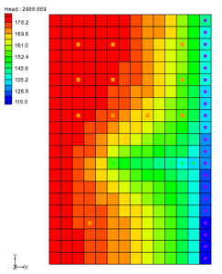

GMS 10.9

GMS 10.9 Tutorial

***MODFLOW – MNW Package***

Use the MNW package with the sample problem and a conceptual model

Objectives

Learn how to use Multi-Node Well (MNW) package in GMS and compare it to the WEL package. Both packages can be used at the same time if desired. Examine the sample MNW model that comes with MODFLOW and then examine a different model that uses the conceptual model approach.

Time

* 30–45 minutes

Required Components

* GMS Core
* MODFLOW Interface

Prerequisite Tutorials

* MODFLOW – Conceptual Model Approach I

|  |
| --- |
| [1 Introduction 2](#_Toc109907716)  [2 Getting Started 4](#_Toc109907717)  [2.1 Importing the Existing Model 4](#_Toc109907718)  [2.2 Saving the Model with a New Name 5](#_Toc109907719)  [2.3 Viewing the MNW Boundary Conditions 6](#_Toc109907720)  [2.4 Reviewing the Source/Sinks Dialog 6](#_Toc109907721)  [2.5 Running MODFLOW 7](#_Toc109907722)  [2.6 Examining the Solution 8](#_Toc109907723)  [3 Changing the Active Flag for the Multi-Node Well 9](#_Toc109907724)  [3.1 Running MODFLOW and Viewing the Solution 10](#_Toc109907725)  [4 Drawdown Limited Wells 10](#_Toc109907726)  [4.1 Running MODFLOW and Viewing the Solution 11](#_Toc109907727)  [4.2 Drawdown Limited Multi-Node Wells 12](#_Toc109907728)  [5 Create a Conceptual Model 14](#_Toc109907729)  [5.1 Open the Existing Conceptual Model 14](#_Toc109907730)  [5.2 Examining the Existing Solution 15](#_Toc109907731)  [5.3 Changing the Model to Use MNW 15](#_Toc109907732)  [5.4 Changing the Wells to MNW 15](#_Toc109907733)  [5.5 Examine the MNW Package 16](#_Toc109907734)  [5.6 Saving and Running MODFLOW 16](#_Toc109907735)  [5.7 Examining the Solution 16](#_Toc109907736)  [6 Changing to a Multi-Node Well 16](#_Toc109907737)  [6.1 Examine the MNW Package 17](#_Toc109907738)  [6.2 Saving and running MODFLOW 17](#_Toc109907739)  [6.3 Viewing the Flow in the MNW Boundary Conditions 17](#_Toc109907740)  [7 Conclusion 18](#_Toc109907741) |

# Introduction

The Multi-Node Well (MNW) package was developed to more accurately model wells that are completed in multiple aquifers or in a single heterogeneous aquifer, partially penetrating wells, and horizontal wells that can be influenced by the effects of dynamic changes in the distribution of pumping or intra-borehole flow that can significantly alter groundwater flow.[[1]](#footnote-1)

The problem in this tutorial (Figure 1 and Figure 2) is the same as the model used in the MNW documentation:

The system consists of two aquifers that are separated by a 50-foot-thick confining unit. The upper aquifer is unconfined, has a hydraulic conductivity of 60 ft/d, and has a uniform base of 50 ft above the datum. The lower aquifer is confined and has a transmissivity of 15,000 ft2/d. Storage coefficients of 0.05 and 0.0001 were assigned to layers 1 and 2, respectively. The 66-mi2 area of the test problem was divided into 21 rows of 14 columns. Uniform, square cells that measured 2,500 ft on a side were used throughout the simulated area. Specified heads and drains are assigned in layer 1 and are maintained at the same elevations for all stress periods.

A period of 1,000,970 days was simulated with 5 stress periods. The first two stress periods simulated steady-state conditions, which were achieved by having each stress period be 500,000 days long. Recharge during stress periods 1 and 2 was a uniform 7 inches per year (in./yr). No pumpage was extracted during stress period 1 but multi-node wells were simulated. About 950,000 ft3/d of pumpage was extracted during stress period 2; this is about 35 percent of the total volumetric budget. Transient conditions were simulated during stress periods 3, 4, and 5, which were periods of 60, 180, and 730 days, respectively. Uniform recharge rates of 2, 0, and 12 in./yr, respectively, were applied during stress periods 3, 4, and 5. In addition to the simulation of two multi-node wells (wells A and B), there are 15 other single-node wells that have a combined discharge of 935,350 ft3/d for stress periods 2 through 5.[[2]](#footnote-2)

This tutorial discusses and demonstrates importing an existing MODFLOW simulation, running the simulation, examining the results to understand the MNW package options, and modifying a conceptual model to use MNW instead of the WEL package.

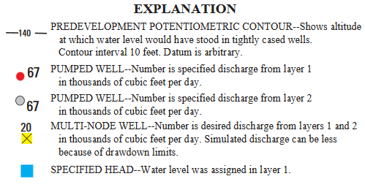

Figure 1 Legend for Figure 2[[3]](#footnote-3)

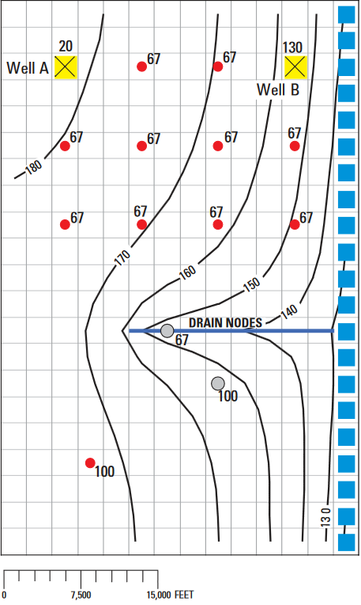

Figure 2 MNW example from the documentation[[4]](#footnote-4)

# Getting Started

Do the following to get started:

1. If necessary, launch GMS.
2. If GMS is already running, select *File |* **New** to ensure that the program settings are restored to their default state. Click **Don’t Save** if asked to save changes.

## Importing the Existing Model

This tutorial will start with a MODFLOW model that has already been created.

1. Click **Open** File:Open Macro.svg to bring up the *Open* dialog.
2. Select “All Files (\*.\*)” from the *Files of type* drop-down.
3. Browse to the *mnw\mnw* folder and select “mnw1.nam”.
4. Click **Open** to exit the *Open* dialog and bring up the *MODFLOW Translator* dialog.
5. Click **OK** to accept the default options and initiate the translation of the file.
6. When MODFLOW 2000 terminates successfully, click **Done** to close the *MODFLOW Translator* dialog and finish importing the file.

A grid with symbols representing wells, drains, and specified head boundary conditions should appear (Figure 3).

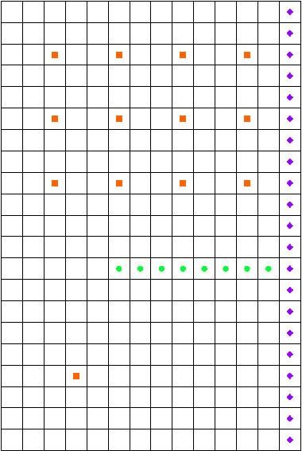

Figure 3 Imported MODFLOW model

## Saving the Model with a New Name

Before making changes, it is best to save the model with a new name.

1. Select *File |* **Save As…** to bring up the *Save As* dialog.
2. Select “Project Files (\*.gpr)” from the *Save as type* drop-down.
3. Enter “MNW.gpr” as the *File name*.
4. Click **Save** to save the project under the new name and close the *Save As* dialog.

## Viewing the MNW Boundary Conditions

Before running the simulation, it is possible to view the MNW boundary conditions.

1. Select *MODFLOW | Optional Packages |* **MNW1 - Multi-Node Well…** to open the *MODFLOW Multi-Node Well Package* dialog.

This dialog is used to edit existing MNW boundary conditions and to change options associated with the MNW package. The options located near the top of the dialog apply to the MNW package, while the spreadsheet near the bottom allows editing of individual MNW boundary conditions. Instead of repeating all of the MNW documentation here, review it on the USGS MODFLOW website as needed for more information on each input option.[[5]](#footnote-5)

Now to examine the MNW boundary conditions:

1. Notice the 17 MNW wells listed in the spreadsheet.

Most of these are single-node wells. However, the wells named “Well-A” and “Well-B” are multi-node wells. Notice that for each of the wells labeled “Well-A”, the *Well ID* is “1”, and for each of the wells labeled “Well-B”, the *Well ID* is “4”.

1. Enter “2” for the *Stress period.*

Notice that nearly all of the wells have a specified pumping rate in this stress period except for “Well-A” and “Well-B”. Only one of the boundary conditions associated with each of the multi-node wells has a desired pumping rate specified. The MNW package will determine how much of the desired flow should come from each of the nodes associated with a multi-node well.

GMS now has the *Name*, *Active*, and *Well ID* fields. *Name* is a label used to identify a boundary condition. *Active* is a flag used to determine if the boundary condition is used during a particular stress period. The *Well ID* field is used to identify multi-node wells. Refer to the MNW documentation[[6]](#footnote-6) for a full explanation of each of the inputs to the MNW boundary conditions.

1. Click **OK** to close the *MODFLOW Multi-Node Well Package* dialog.

## Reviewing the Source/Sinks Dialog

1. Switch to the 3D Grid module by selecting the “File:3D Grid Folder.svg 3D Grid Data” item in the Project Explorer.
2. Using the **Select Cells** File:Select 3D Cell Tool.svg tool, select the 3D grid cell highlighted in Figure 4.

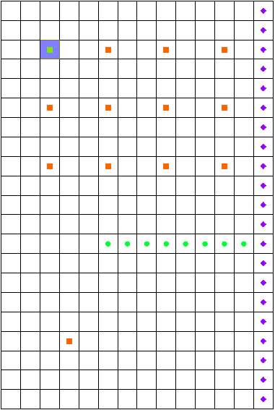

Figure 4 Selected MNW well cell (IJK: 3,3,1)

1. Right-click on the selected cell and select **Sources/Sinks…** to bring up the *MODFLOW* *Sources/Sinks* dialog.

This dialog allows for editing of the properties of a selected boundary condition, as well as the adding of additional boundary conditions in the selected cells. Note that some of the properties available for MNW boundary conditions (such as *Well ID*) do not allow entering a time series. Therefore, the values entered in this dialog for these properties will be assigned to the boundary condition for all stress periods.

1. Select **OK** to exit the *MODFLOW* *Sources/Sinks* dialog.

## Running MODFLOW

Before running MODFLOW, it is necessary to change the output options to make it easier to see the results.

1. Select *MODFLOW |* **OC - Output Control…** to bring up the *MODFLOW Output Control* dialog.
2. In the *Output interval* section, select *Output at last time step of each stress period*.
3. Turn on *Save cell by cell flow terms to \*.ccf file*.
4. Click **OK** to exit the *MODFLOW Output Control* dialog.

Now to save these changes and run MODFLOW:

1. **Save** File:Save Macro.svg the project.
2. Select *MODFLOW* | **Run MODFLOW**to bring up the *MODFLOW* model wrapper dialog.
3. When MODFLOW finishes, turn on *Read solution on exit* and *Turn on contours (if not on already)*.
4. Click **Close** to close the *MODFLOW* model wrapper dialog.

Contours should appear on the grid similar to those shown in Figure 5.

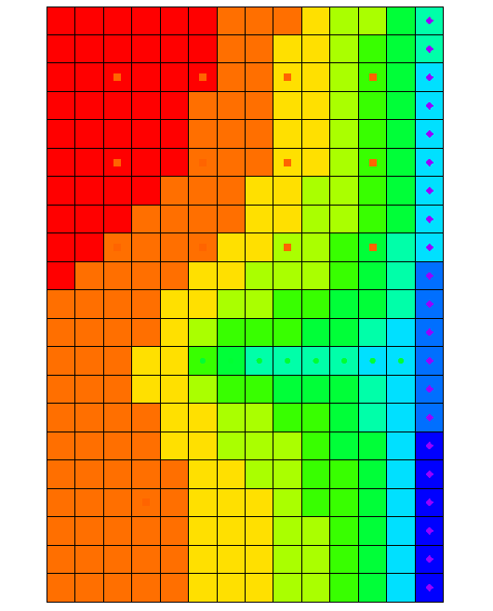

Figure 5 MODFLOW solution

1. **Save** File:Save Macro.svg the project with the new solution.

## Examining the Solution

Now to look closely at the computed solution:

1. If necessary, re-select the grid cell selected in Figure 4 (Cell ID: 31).
2. Switch to **Front View** File:Front View Macro.svg.
3. Click **Display Options** File:Display Options Macro.svg to bring up the *Display Options* dialog.
4. In the section below the list on the left, enter “20.0” for the *Z magnification.*
5. Click **OK** to close the *Display Options* dialog.

From this view, it is possible to see the water table and the head contours (Figure 6). Notice that on the left side of the view, the head is greater in the top layer of the model. In contrast, the head on the right side of the view—where the specified head boundary condition is located—is less in layer 1 than in layer 2 of the model. Notice that the head in the selected cell is about “179.8”.

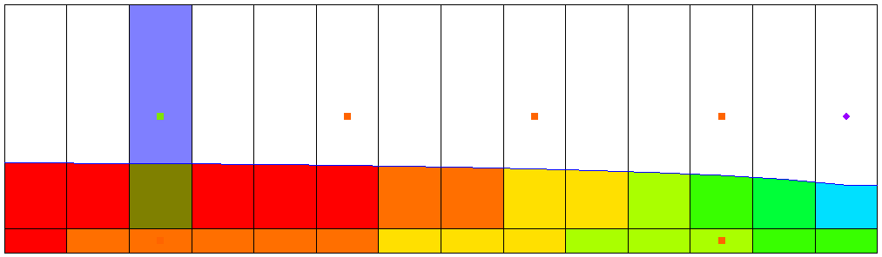

Figure 6 Front view showing water table and head contours

1. Select the cell directly below the one currently selected (Cell ID: 325).

Notice that the head in the cell in the second layer is about “175.8”. This means there is a potential for flow from layer 1 to layer 2 at these particular cells. It is also possible to see what effect the MNW multi-node well has on these grid cells.

1. Select “File:CCF Dataset Active.svg CCF (MNW.ccf)” in the Project Explorer, then right-click on it and select **CCF → Datasets**.
2. Select the new “File:Dataset Cells Active.svg MNW” dataset.
3. Click anywhere off the grid to unselect the grid cell.

Notice that flow is occurring between the multi-node well boundary conditions at these cells. This is an example of intra-borehole flow that can occur when a well is completed in more than one aquifer. The effect of the multi-node wells is visible by looking at the *Flow Budget* dialog.

To select the two wells on the left side of the grid, click the first cell, then hold down the Shift key and click the second cell.(Cell IDs: 325 and 31)

1. Select *MODFLOW |* **Flow Budget…** to bring up the *Flow Budget* dialog.

Notice that values on the *MNW* row in the *Flow In* and the *Flow Out* columns are equal and opposite, just as expected. A flow of about “-16088.6” leaves the model cell in layer one and enters the model cell in layer two.

1. Click **OK** to exit the *Flow Budget* dialog.

# Changing the Active Flag for the Multi-Node Well

Now it is possible to see the effect of turning off the active flag for the multi-node well. Assume that “Well-A” was not constructed until after the first stress period in the model. Therefore, do not model the intra-borehole flow or any pumping until after the first stress period. This can be accomplished by turning off the active flag for the boundary condition.

1. Select *MODFLOW | Optional Packages |* **MNW1 - Multi-Node Well…**to open the *MODFLOW Multi-Node Well Package* dialog.
2. In the spreadsheet at the bottom, uncheck the box in the *Active* column for both “Well-A” boundary conditions.
3. Change the *Stress period* to “2” just above the spreadsheet.

Notice that “Well-A” is active in stress period “2”.

1. Click **OK** to exit the *MODFLOW Multi-Node Well Package* dialog.

## Running MODFLOW and Viewing the Solution

Now it is possible to run MODFLOW to see how the solution has changed.

1. **Save** File:Save Macro.svg the project.
2. Click the **Run MODFLOW** File:Run MODFLOW Macro.svg macro to bring up the *MODFLOW* model wrapper dialog.
3. When MODFLOW finishes, turn on *Read solution on exit* and *Turn on contours (if not on already)*.
4. Click **Close** to exit the *MODFLOW* model wrapper dialog.
5. Select and then right-click on “File:CCF Dataset Active.svg CCF (MNW.ccf)” in the Project Explorer and select **CCF → Datasets**.
6. Select the “File:Dataset Cells Active.svg MNW” dataset.

Notice that there is no intra-borehole flow now at “Well-A” during the first stress period.

# Drawdown Limited Wells

The MNW package also allows for wells to be limited by the drawdown in the cell containing the well. This feature allows a well to stop pumping when the head in the cells drops below a specified elevation. The next step in the tutorial will be to change the drawdown for one of the wells and see the effect on the solution. However, first change the active flag back to its original state for “Well-A”.

1. Select *MODFLOW | Optional Packages |* **MNW1 - Multi-Node Well…**to open the *MODFLOW Multi-Node Well Package* dialog.
2. In the spreadsheet at the bottom, check the box in the *Active* column for both “Well-A” boundary conditions.
3. Click **OK** to exit the *MODFLOW Multi-Node Well Package* dialog.

Now to edit one of the MNW wells to illustrate the drawdown-limited feature:

1. Switch to **Plan View**Plan View.
2. Select the “File:Dataset Cells Active.svg MNW” dataset and change the active time step to the second time step listed in the Time Step Window below the Project Explorer, as shown in Figure 7.

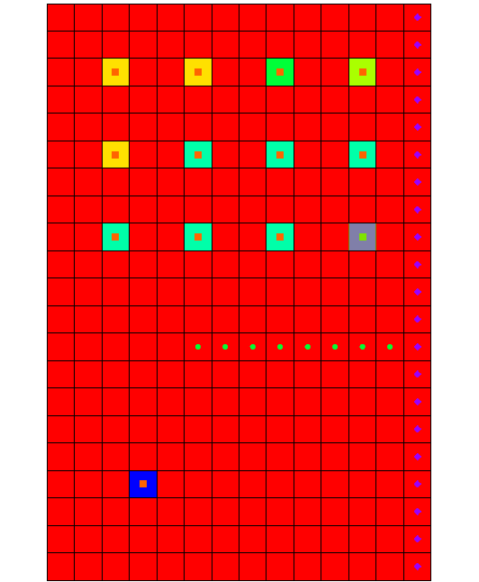

Figure 7 MNW boundary condition cell

1. Select the cell highlighted in dark green as in Figure 7 (bottom right cell of the group of wells, Cell ID: 124), then right-click and select **Sources/Sinks…** to bring up the *MODFLOW Sources/Sinks* dialog.
2. Scroll to the right in the spreadsheet to the *Hlim* column and click the transient_dataset_button button on row *124* to bring up the *XY Series Editor* dialog.
3. In the *Hlim* column, on rows 2–5, enter “142.0”.
4. Click **OK** to exit the *XY Series Editor* dialog.
5. Click **OK** to exit the *MODFLOW Sources/Sinks* dialog.

## Running MODFLOW and Viewing the Solution

Now to run MODFLOW to see how the solution has changed:

1. **Save** File:Save Macro.svg the project.
2. Click the **Run MODFLOW** File:Run MODFLOW Macro.svg macro to bring up the *MODFLOW* model wrapper dialog.
3. When MODFLOW finishes, turn on *Read solution on exit* and *Turn on contours (if not on already)*.
4. Click **Close** to import the solution and close the *MODFLOW* model wrapper dialog.
5. Select “File:CCF Dataset Active.svg CCF (MNW.ccf)” in the Project Explorer, then right-click on it and select **CCF → Datasets**.
6. Select the “File:Dataset Cells Active.svg MNW” dataset and change the active time step to the second time step listed in the Time Step Window below the Project Explorer.

Notice that the flow at the cell that was edited is about “-5754.48”.

1. Select the “File:Dataset Cells Active.svg Head” dataset.

Notice that the head in this cell is about “143.29”. Remember, the desired flow rate (*Qdes*) that was specified for the well was “66850.0”. Nevertheless, the computed flow for this drawdown limited well was only “6130”. Now it is possible to look at the head at the next output time.

1. Select the third time step listed in the Time Step Window. Notice that the head at the cell is about “142.37”.
2. Change to the “File:Dataset Cells Active.svg MNW” dataset and notice that the flow in this time step is “0.0”.

Even though the head value is high enough, the well has been deactivated during this stress period. Find out why by examining the well’s settings.

1. Select *MODFLOW* | *Optional Packages |* **MNW1 - Multi-Node Well…**to open the *MODFLOW Multi-Node Well Package* dialog.
2. Change *Stress period* to “2” and notice the settings for *Cell ID* *124* near the bottom of the spreadsheet.
3. Change *Stress period* to “3”.

Notice that, for this stress period, the *QCUT* value has been set to “Percent (2)” with a *Qfrcmn* value of “45.0” (a percentage). The *Qfrcmn* value is the minimum pumping rate required for the well to remain active. With a desired flow rate (*Qdes*) of “-66850.0”, a flow rate of “-30082.5” is needed for the well to remain active. For the previous stress period, *QCUT* was set to “None (0)”, allowing the well to be active.

1. Click **OK** to exit the *MODFLOW Multi-Node Well Package* dialog.

## Drawdown Limited Multi-Node Wells

For multi-node wells, the limiting water level needs to be specified for the first multi-node cell listed in the MNW package dialog.

1. Select *MODFLOW* | *Optional Packages |* **MNW1 - Multi-Node Well…**to open the *MODFLOW Multi-Node Well Package* dialog.
2. Change *Stress period* to “2”.

Notice that (for this stress period) the first “Well-A” has a flow rate of “-20000”.

1. Scroll to the right in the spreadsheet so the *Hlim* and *DD* columns are visible.

Notice that the *Hlim* value is set to “50.0” and the *DD* is set to “Relative (2)”. When using relative drawdown, the *Hlim* value used by MODFLOW is calculated by either adding or subtracting *Hlim* from *Href*. When the *Qdes* value is greater than zero, *Hlim* is added to *Href*, and when the *Qdes* value is less than zero, *Hlim* is subtracted from *Href*. To demonstrate how the sign of the *Qdes* value can affect the model, adjust the *Qdes* values for “Well-A”:

1. Scroll to the left in the spreadsheet to the *Qdes(flow) (ft^3/d)* column and enter “-1.0” on row *1* (“Well-A”).
2. On row *2*, enter “-19999.0” for *Qdes(flow) (ft^3/d)* (the second “Well-A” cell). The combined value of *Qdes* for “Well-A” remains “-20000”.
3. Click **OK** to exit the *MODFLOW Multi-Node Well Package* dialog.

Before running MODFLOW with these changes, it is necessary to check head and multi-node well values in the first cell to verify that they will remain the same.

1. Using the **Select Cells** File:Select 3D Cell Tool.svg tool, select the top-left well cell (Well-A, Cell ID: 31, see Figure 8).
2. Select the second time step in the Time Step Window. Notice that the flow for the cell is about “-20120.7”.

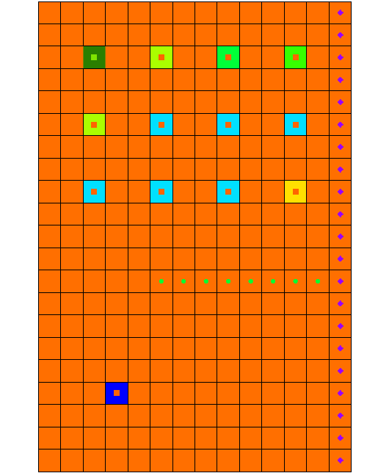

Figure 8 Selected MNW well cell

1. Select the “File:Dataset Cells Active.svg Head” dataset in the Project Explorer. Notice that the head value is about “164.60”.
2. **Save** File:Save Macro.svg the project.
3. Click the **Run MODFLOW** File:Run MODFLOW Macro.svg macro to bring up the *MODFLOW* model wrapper dialog.
4. When MODFLOW finishes, turn on *Read solution on exit* and *Turn on contours (if not on already)*.
5. Click **Close** to import the solution and close the *MODFLOW* model wrapper dialog.
6. Select the “File:Dataset Cells Active.svg Head” dataset and select the second time step in the Time Step Window. Notice that the head in this cell remains at about “164.60”.
7. Select “File:CCF Dataset Active.svg CCF (MNW.ccf)” in the Project Explorer, then right-click on it and select **CCF → Datasets**.
8. Select the “File:Dataset Cells Active.svg MNW” dataset and select the second time step in the Time Step Window. Notice that the flow remains at about “-20120.7”.
9. Now update the *Qdes* values so that their total stays the same, but change the sign of the *Qdes* value for the first cell to positive.Select *MODFLOW | Optional Packages |* **MNW1 - Multi-Node Well…**to open the *MODFLOW Multi-Node Well Package* dialog.
10. Change *Stress period* to “2”.
11. On row *1* (the first “Well-A” cell), enter “1.0” in the *Qdes(flow) (ft^3/d)* column.
12. On row *2* (the second “Well-A” cell), enter “-20001.0” in the *Qdes(flow) (ft^3/d)* column.
13. Click **OK** to exit the *MODFLOW Multi-Node Well Package* dialog.
14. **Save** File:Save Macro.svg the project.
15. Click the **Run MODFLOW** File:Run MODFLOW Macro.svg macro to bring up the *MODFLOW* model wrapper dialog.
16. When MODFLOW finishes, turn on *Read solution on exit* and *Turn on contours (if not on already)*.
17. Click **Close** to import the solution and close the *MODFLOW* model wrapper dialog.
18. Select the “File:Dataset Cells Active.svg Head” dataset and select stress period 2 in the Time Step Window. Notice that the head in this cell has changed to about “165.62”.
19. Select “File:CCF Dataset Active.svg CCF (MNW.ccf)” in the Project Explorer, then right-click on it and select **CCF → Datasets**.
20. Select the “File:Dataset Cells Active.svg MNW” dataset and select the second time step in the Time Step Window.

Notice that the flow has changed to about “-13809.84”. This change has been caused by a higher *Hlim* value, which was in turn brought about by changing the sign of the *Qdes* value in the first “Well-A” cell. Less flow could be taken from the model by the well to maintain a higher head value.

# Create a Conceptual Model

The next step is to examine how to use a conceptual model with MNW data. We’ll do this by taking the finished model for the “MODFLOW – Conceptual Model Approach” tutorial and changing it to use the MNW package.

## Open the Existing Conceptual Model

1. Before opening the conceptual model, **Save** File:Save Macro.svg the grid-based MNW model.
2. Click **New** File:New Macro.svg to reset GMS back to the default settings.
3. Click **Open** File:Open Macro.svg to bring up the *Open* dialog.
4. Select “Project Files (\*.gpr)” from the *Files of type* drop-down.
5. Browse to the *mnw\mnw\sample* directory and select “modfmap2.gpr”.
6. Click **Open** to import the project and exit the *Open* dialog.

Before making any changes, it is good to save the project under a new name.

1. Select *File* | **Save As…** to bring up the *Save As* dialog.
2. Select “Project Files (\*.gpr)” from the *Save as type* drop-down.
3. Browse to the *mnw\mnw* directory.
4. Enter “MNWmap.gpr” as the *File name*.
5. Click **Save** to save the project under the new name and close the *Save As* dialog.

## Examining the Existing Solution

Before changing to the MNW package, look at the flow budget for the existing solution:

1. Select *MODFLOW* | **Flow Budget…** to bring up the *Flow Budget* dialog.

Notice the flow budget for the well package has a flow out rate of about “-2344.60”.

1. Click **OK** to exit the *Flow Budget* dialog.

## Changing the Model to Use MNW

To change to the MNW package, first the WEL package needs to be removed from MODFLOW.

1. Select *MODFLOW |* **Global Options…** to open the *MODFLOW Global/Basic Package* dialog.
2. Click **Packages…** to bring up the *MODFLOW Packages / Processes* dialog.
3. In the *Optional packages / processes* section, turn off *WEL1* - *Well* to disable the WEL package.
4. Click **OK** to exit the *MODFLOW Packages / Processes* dialog.
5. Click **OK** to exit the *MODFLOW Global/Basic Package* dialog.

## Changing the Wells to MNW

1. Fully expand the “File:Map Folder.svg Map Data” folder.
2. Right-click on the “File:Coverage Active Icon.svg Sources&Sinks” coverage under the “File:Conceptual Model Icon.svg East Texas” conceptual model in the Project Explorer and select **Coverage Setup…** to bring up the *Coverage Setup* dialog.
3. In the *Sources/Sinks/BCs* section, turn on *Wells (MNW)*.
4. Click **OK** to exit the *Coverage Setup* dialog.
5. Right-click on “File:Coverage Active Icon.svg Sources&Sinks” and select **Attribute Table…** to bring up the *Attribute Table* dialog.
6. On the *All* row of the spreadsheet, select “well (MNW)” from the *Type* drop-down column.
7. Scroll to the right and enter “-50.0” in the *Qdes (m^3/d)* column on row *16*.
8. Enter “-300.0” in the *Qdes (m^3/d)* column on row *17*.
9. Click **OK** to exit the *Attribute Table* dialog.

The conceptual model is set up so now it can be mapped to the MODFLOW grid.

1. Click the **Map → MODFLOW** File:Map to MODFLOW Macro.svg macro to bring up the *Map → Model* dialog.
2. Click **OK** to accept the defaults and close the *Map → Model* dialog.

## Examine the MNW Package

The next step is to review the data in MODFLOW that was mapped from the conceptual model.

1. Select *MODFLOW | Optional Packages |* **MNW1 - Multi-Node Well…**to bring up the *MODFLOW Multi-Node Well Package* dialog.

Review the two MNW boundary conditions that were created.

1. Click **OK** to exit the *MODFLOW Multi-Node Well Package* dialog.

## Saving and Running MODFLOW

Before saving the changes and running MODFLOW, adjust the output control.

1. Select *MODFLOW |* **OC - Output Control…** to bring up the *MODFLOW Output Control* dialog.
2. In the *Other output* section, turn off *\*.hff file for transport*.
3. Click **OK** to exit the *MODFLOW Output Control* dialog.
4. **Save** File:Save Macro.svg the project.
5. Click the **Run MODFLOW** File:Run MODFLOW Macro.svg macro to bring up the *MODFLOW* model wrapper dialog.
6. When MODFLOW finishes, turn on *Read solution on exit* and *Turn on contours (if not on already)*.
7. Click **Close** to import the solution and close the *MODFLOW* model wrapper dialog.
8. **Save** File:Save Macro.svg the project with the new solution.

## Examining the Solution

Look at the flow budget for the new solution:

1. Select *MODFLOW* | **Flow Budget…** to bring up the *Flow Budget* dialog.

Notice the flow budget for the MNW package has the same approximate *flow out* rate of “-2344.6”.

1. Click **OK** to exit the *Flow Budget* dialog.

# Changing to a Multi-Node Well

Now to create a multi-node well from the map data:

1. Right-click on “File:Coverage Active Icon.svg Sources&Sinks” and select **Attribute Table…** to bring up the *Attribute Table* dialog.
2. In row *17* (“well2”), scroll to the right and enter “1” in the *From layer* column.
3. Click **OK** to exit the *Attribute Table* dialog.

The conceptual model can now be mapped to the MODFLOW grid.

1. Click the **Map → MODFLOW** File:Map to MODFLOW Macro.svg macro to bring up the *Map → Model* dialog.
2. Click **OK** to accept the defaults and close the *Map → Model* dialog.

## Examine the MNW Package

Now to look at the data in MODFLOW that was mapped from the conceptual model.

1. Select *MODFLOW | Optional Packages |* **MNW1 - Multi-Node Well…**to bring up the *MODFLOW Multi-Node Well Package* dialog.

Review the various MNW boundary conditions that were created.

1. Notice that “well2” is associated with two MNW boundary conditions and that the *Well ID* is 1 for each of the boundary conditions.
2. Notice also that the *Qdes* has only been assigned to one of the “well2” boundary conditions.

The MNW package will calculate the amount of flow that each of the wells will take from the aquifer.

1. Click **OK** to exit the *MODFLOW Multi-Node Well Package* dialog.

## Saving and running MODFLOW

Now it is possible to save the changes and run MODFLOW. Before doing so, adjust the parameters associated with the solver.

1. Select *MODFLOW* | **PCG - Pre. Conj.-Gradient Solver…** to bring up the *MODFLOW PCG Package* dialog.
2. Enter “100” as the *Maximum number of outer iterations (MXITER).*
3. Enter “0.5” as the *Relaxation parameter* *(RELAX).*
4. Click **OK** to exit the *MODFLOW PCG Package* dialog.
5. Select *File* | **Save As…** to bring up the *Save As* dialog.
6. Select “Project Files (\*.gpr)” from the *Save as type* drop-down.
7. Enter “MNWmap2.gpr” as the *File name.*
8. Click **Save** to save the project under the new name and close the *Save As* dialog.
9. Click the **Run MODFLOW** File:Run MODFLOW Macro.svg macro to bring up the *MODFLOW* model wrapper dialog.
10. When MODFLOW finishes, turn on *Read solution on exit* and *Turn on contours (if not on already)*.
11. Click **Close** to import the solution and close the *MODFLOW* dialog.

## Viewing the Flow in the MNW Boundary Conditions

View the computed flow out of each of the MNW boundary conditions associated with well2 by doing the following:

1. Select “File:3D Grid Folder.svg 3D Grid Data” to make it active.
2. **Zoom** File:Zoom Tool Icon.svg in around the well on the right side of the model.
3. Using the **Select Cell** File:Select 3D Cell Tool.svg tool, select the cell containing the well (Cell ID: 1944).
4. Select *MODFLOW |* **Flow Budget…** to bring up the *Flow Budget* dialog.

Notice that the flow out of the well in the top layer is about “-170.08”. Now to view the flow out of the well in the second layer:

1. Click **OK** to exit the *Flow Budget* dialog.
2. Using the Mini Grid Toolbar, change the *Lay (k)* to “2”.
3. Select the cell containing the well (Cell ID: 5024) using the **Select Cell** File:Select 3D Cell Tool.svg tool.
4. Select *MODFLOW |* **Flow Budget…** to bring up the *Flow Budget* dialog.

Notice that the flow rate for this well is about “-129.92”.

1. Click **OK** to exit the *Flow Budget* dialog.
2. **Save** File:Save Macro.svg the project.

# Conclusion

This concludes the “MODFLOW – MNW Package” tutorial. The following key concepts were discussed and demonstrated in this tutorial:

* GMS supports both the WEL and MNW packages. Both packages can be used at the same time if desired.
* The MNW package produces the same results as the WEL when there are no multi-node wells.
* MNW data can be viewed and edited in the MNW package dialog.

1. Halford, K. J. and Hanson, R. T. (2002). *User Guide for the Drawdown-Limited, Multi-Node Well (MNW) Package for the U.S. Geological Survey’s Modular Three-Dimensional Finite Difference Ground-Water Flow Model, Versions MODFLOW-96 and MODFLOW-2000*. U.S. Geological Survey Open-File Report 02-293, p.15–17. <https://water.usgs.gov/nrp/gwsoftware/modflow2000/MNW_text.pdf> . [↑](#footnote-ref-1)
2. Halford (2002). [↑](#footnote-ref-2)
3. Ibid. [↑](#footnote-ref-3)
4. Halford (2002). [↑](#footnote-ref-4)
5. “MNW1 – Multi-Node, Drawdown Limited Well Package”, *Online Guide to MODFLOW*. U.S. Geological Survey, 2016. <http://water.usgs.gov/nrp/gwsoftware/modflow2000/MFDOC/index.html?mnw.htm>. [↑](#footnote-ref-5)
6. “MNW1” (2016). [↑](#footnote-ref-6)