Required Components

* GMS Core
* MODFLOW Interface

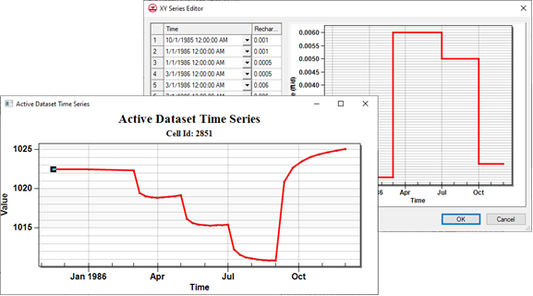

GMS 10.9

GMS 10.9 Tutorial

***MODFLOW – Building a Transient Model***

Creating transient MODFLOW models with time-varying inputs

Objectives

GMS provides a powerful suite of tools for inputting and managing transient data. These tools allow all data to be managed using a date/time format that eliminates much of the extra data processing that is often required with modeling projects. This tutorial illustrates how these tools are used.

Time

* 30–50 minutes

Prerequisite Tutorials

* MODFLOW – Conceptual Model Approach I

|  |
| --- |
| [1 Introduction 2](#_Toc203725450)  [1.1 Getting Started 2](#_Toc203725451)  [2 Importing and saving the Project 2](#_Toc203725452)  [3 Transient Data Strategy 3](#_Toc203725453)  [4 Entering Transient data in the Map Module 4](#_Toc203725454)  [4.1 Assigning the transient Recharge Rate 4](#_Toc203725455)  [4.2 Importing Transient Recharge Data 6](#_Toc203725456)  [4.3 Importing Pumping Well Data 8](#_Toc203725457)  [4.4 Assigning Specific Yield 9](#_Toc203725458)  [5 Initializing MODFLOW Stress Periods 10](#_Toc203725459)  [5.1 Changing the MODFLOW Simulation to Transient 10](#_Toc203725460)  [5.2 Setting up the Stress Periods 11](#_Toc203725461)  [6 Converting the Conceptual Model 11](#_Toc203725462)  [7 Setting Starting Heads 12](#_Toc203725463)  [8 Saving and Running MODFLOW 12](#_Toc203725464)  [9 Setting up an Animation 13](#_Toc203725465)  [10 Conclusion 14](#_Toc203725466) |

# Introduction

Building a transient simulation typically requires the management of large amounts of transient data from a variety of sources, including pumping well data, recharge data, river stages, and water levels in observation wells. Gathering and formatting such data can be tedious. GMS provides tools for importing time series data and converting that data into inputs for MODFLOW models.

The model this tutorial uses is the same model used in the “MODFLOW – Model Calibration” tutorial. This tutorial will use the computed heads from the steady-state calibrated flow model as the starting heads for the transient simulation. Transient recharge and pumping conditions will be modeled. The recharge rates will be manually entered but the pumping rates will be imported from a text file.

This tutorial discusses and demonstrates opening a MODFLOW model and solution, entering transient data, importing a well pump data file, setting up stress periods and defining additional inputs, running MODFLOW, and creating an animation.

## Getting Started

Do the following to get started:

1. If necessary, launch GMS.
2. If GMS is already running, from the Menu Bar, select the *File* | **New** menu item to ensure that the program settings are restored to their default state. Click the **Don’t Save** button if asked to save changes.

# Importing and saving the Project

To import the project:

1. From the Macro Bar, click **Open** File:Open Macro.svg to bring up the *Open* dialog.
2. From the *Files of type* drop-down, select “Project Files (\*.gpr)”.

Browse to the *trans\trans* directory and select “start.gpr”.

Click the **Open** button to import the project and close the *Open* dialog.

A MODFLOW model with a solution and a set of map coverages should be visible (Figure 1). Two of the coverages are the source/sink and hydraulic conductivity coverages used to define the conceptual model. The active coverage is the recharge coverage.

Before continuing, save the project with a new name.

From the Menu Bar, select the *File* | **Save As…** menu item to bring up the *Save As* dialog.

From the *Save as type* drop-down, select “Project Files (\*.gpr)”.

As the *File name,* enter **“**trans1.gpr”.

Click the **Save** button to close the *Save As* dialog.

It is recommended to save the project periodically.

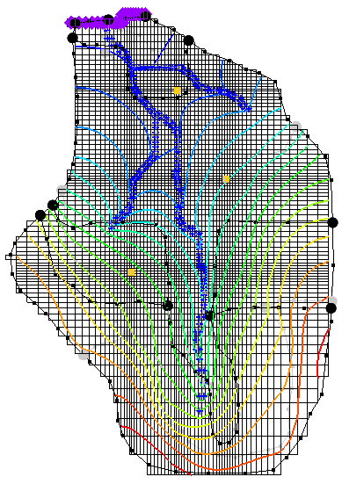

Figure 1: The initial project in the Graphics Window

# Transient Data Strategy

When entering the time values associated with transient data, MODFLOW requires that the time be entered as scalar time values relative to a time value of zero at the beginning of the simulation. Furthermore, the times must be compatible with the time unit selected for the model. This approach can be time consuming since transient data must be converted from a date/time format to a relative time format.

The strategy used in GMS for managing transient data makes it possible to enter all time values using a simple date/time format. Transient data are entered into the conceptual model using date/time values. The time at the beginning of the first MODFLOW stress period is the reference time. This represents the date/time corresponding to “time=0.0” in the simulation.

When the model is converted from the conceptual model to the grid model, the time values in the conceptual model are automatically mapped to the appropriate time values corresponding to the MODFLOW stress periods. When the MODFLOW model is saved to disk, the date/time values are converted to the appropriate relative time values.

In addition to ease of use, another advantage of the transient data strategy used in GMS is that both the spatial and temporal components of the conceptual model are defined independently of the discretization used in both the grid spacing and the stress period size. The stress period spacing can be changed, and the model can be regenerated from the conceptual model in seconds.

# Entering Transient data in the Map Module

The first step in setting up the transient model is to associate the transient data with feature objects in the **Map** 111px-Map_Module_Icon module.

## Assigning the transient Recharge Rate

First, it is necessary to assign the transient recharge rate for the recharge zones. The recharge zones are shown in Figure 2. There are four recharge zones defined by five polygons. Leave the recharge rate for zone 1 at zero and assign a transient recharge rate to the other three zones.

To assign the recharge data:

1. In the Project Explorer, expand the “File:Map Folder.svg Map Data” folder and the “conceptual%20Model BigVal” conceptual model.

Select the “File:Coverage Active Icon.svg Recharge” coverage to make it active.

From the Dynamic Toolbar, using the **Select Polygons**File:GMS Select Polygon Tool.svg tool, select the polygon corresponding to recharge zone 2 in Figure 2.

From the Macro Bar, click **Properties** File:GMS Properties Macro.svg to bring up the *Attribute Table* dialog.



Figure 2: Recharge zones

In the table, in the *Recharge rate (ft/d)* column, click the down arrow transient_dataset_arrow button and select “<transient>” from the drop-down.

Just above the down arrow transient_dataset_arrow button, click the transient_dataset_button button to bring up the *XY Series Editor* dialog.

At the bottom-left of the dialog, turn on the *Use dates/times* checkbox.

Enter the data from the following table into the appropriate columns and rows in the *XY Series Editor* dialog spreadsheet (can be copy and pasted by column). Once done, the dialog should appear as in Figure 3.

|  |  |  |  |  |  |  |  |  |  |  |  |  |  |  |  |  |  |  |  |  |  |  |
| --- | --- | --- | --- | --- | --- | --- | --- | --- | --- | --- | --- | --- | --- | --- | --- | --- | --- | --- | --- | --- | --- | --- |
| |  |  | | --- | --- | | Time | Recharge rate (ft/d) | | Oct 1,1985 12:00:00 AM | 0.001 | | Jan 1, 1986 12:00:00 AM | 0.001 | | Jan 1, 1986 12:00:00 AM | 0.0005 | | Mar 1, 1986 12:00:00 AM | 0.0005 | | Mar 1, 1986 12:00:00 AM | 0.006 | | July 1, 1986 12:00:00 AM | 0.006 | | July 1, 1986 12:00:00 AM | 0.005 | | Oct 1, 1986 12:00:00 AM | 0.005 | | Oct 1, 1986 12:00:00 AM | 0.001 | | Dec 1, 1986 12:00:00 AM | 0.001 | |

Click the **OK** button to exit the *XY Series Editor* dialog.

Click the **OK** button to exit the *Attribute Table* dialog.

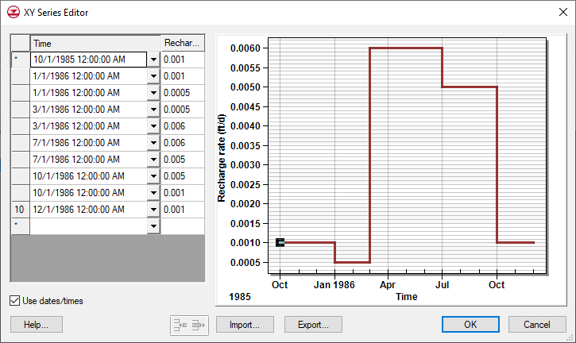

Figure 3: XY Series Editor showing recharge rate

Depending on the computer settings, the dates may be formatted differently than shown in Figure 3. Those shown above are formatted *month/day/year*.

## Importing Transient Recharge Data

Instead of repeating this same procedure for the other recharge zones, the data will be imported from a text file. Transient data can be imported for polygons, arcs, points, or nodes. The format for the text files is shown below.

Name Date Recharge

zone 3 Dec 3, 1999 0.0005

zone 3 Jan 30, 2000 0.001  
zone 4 Mar 27, 2000 0.002  
…

In the case above, there is only a date field; GMS also supports specifying both a date and a time. Later in this tutorial, pumping data that has both a date and a time specified will be imported. The *Name* column is used to match the *Date* data with a particular polygon.

1. From the Macro Bar, click **Open** File:Open Macro.svg to bring up the *Open* dialog.

From the *Files of type* drop-down, select “Text Files (\*.txt;\*.csv)”.

Browse to the *trans\trans* directory and select “trans\_recharge.csv”.

Click the **Open** button to close the *Open* dialog and bring up the *Step 1 of 2* page of the *Text Import Wizard* dialog.

This wizard is used to import text data into a GMS project (Figure 4).

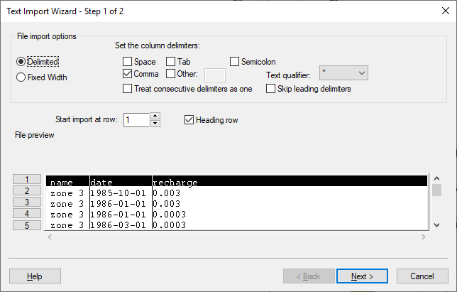

Figure 4: Step 1 of 2 page of the Text Import Wizard dialog

Below the *File import options* section, turn on the *Heading row* checkbox and click the **Next >** button to go to the *Step 2 of 2* page of the *Text Import Wizard* dialog (Figure 5).

From the *GMS data type* drop-down, select the “Transient polygon data” item.

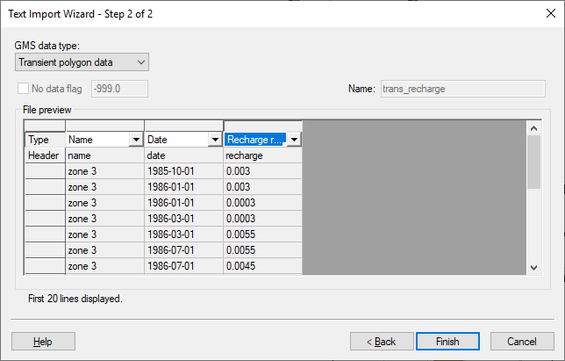

Figure 5: Step 2 of 2 Page of the Text Import Wizard Dialog

Notice that the *Name* and the *Date* columns were automatically recognized by GMS. Now it is necessary to specify the field for the third column of data.

At the top of the third column of the *File preview* spreadsheet, from the *Type* drop-down, select the “Recharge rate TS” item.

Click the **Finish** button to close the *Text Import Wizard* dialog.

At the prompt regarding step function or continuous time series, click the **No** button.

Double-click on any of the polygons in zone 3 or zone 4 (see Figure 2) to open the *Attribute Table* dialog.

In the *Recharge rate (ft/d)* column, click the transient_dataset_button button to open the *XY Series Editor* dialog. A time series curve of the imported data will appear which should match Figure 6.

Click the **OK** button to exit the *XY Series Editor* dialog.

Click the **OK** button to exit the *Attribute Table* dialog.

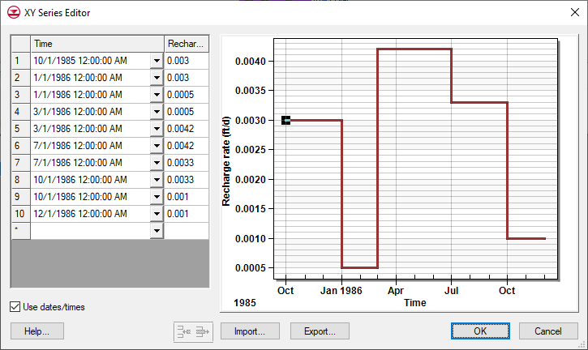

Figure 6: XY Series Editor showing recharge rate for zone 3

## Importing Pumping Well Data

In addition to the transient recharge data, this simulation will also contain a transient pumping schedule for the three wells in the model. Since the model only has three wells, the transient pumping schedules could be entered by hand. To save time, the well data will be imported from a text file. This method is useful for models with many wells or complicated pumping schedules.

Pumping well data is typically imported using two files:   
The first file contains the name, screen geometry, and *xy* coordinates of the wells, known as the Well Information File.   
The second file contains the pumping schedules, known as the Pumping Schedule File. For this tutorial, since the well locations are already defined, only the pumping schedules need to be imported. The format for this file is as follows:

Name date time Q

"well 1" 12/3/1999 18:00:00 625.0

"well 1" 1/30/2000 7:38:25 0.0  
"well 1" 3/27/2000 18:00:00 200.0  
"well 2" 12/3/1999 18:00:00 0.0  
"well 2" 12/5/1999 14:48:32 100.0

…

When importing text data for points, it is necessary to indicate to GMS which point matches with the date/time data. This can be done using a name, an ID, or an *xy* coordinate. In the case above, a name is being used.

The first time an entry is found for a particular well, the well type is changed to transient if the well is steady-state, and a pumping rate time series is created for the well. Each time a subsequent line is imported with the same well name, GMS adds a point to the time series. The dates and times can be in any standard format.

To import the well pumping data file:

1. In the Project Explorer, under the “Map Data” folder, select the “File:Coverage Active Icon.svg Sources & Sinks” coverage to make it active.

From the Macro Bar, click **Open** File:Open Macro.svg to bring up the *Open* dialog.

From the *Files of type* drop-down, select “Text Files (\*.txt;\*.csv)”.

Browse to the *trans\trans* directory and select “pumping.txt”.

Click the **Open** button to close the *Open* dialog and bring up the *Step 1 of 2* page of the *Text Import Wizard* dialog.

Below the *File import options* section, turn on the *Heading row* checkbox and click the **Next >** button to go to the *Step 2 of 2* page of the *Text Import Wizard* dialog.

From the *GMS data type* drop-down, select the “Pumping data” item. Notice that GMS automatically recognized all of the fields in the file.

Click the **Finish** button to close the *Text Import Wizard* dialog.

At the prompt to import the pumping data as a step function, click the **Yes**button.

From the Dynamic Toolbar, using the **Select Points\Nodes** File:GMS Select Node Tool.svg tool, double-click on any of the wells to bring up the *Attribute Table* dialog.   
Notice that the *Flow rate (ft^3/d)* says “**<**transient**>**” for all of them. The transient_dataset_button button can be clicked to see the curve, if desired.

Click the **OK** button to exit the *Attribute Table* dialog.

## Assigning Specific Yield

It is necessary to assign the storage coefficient to the aquifer. Since this is a one-layer unconfined aquifer, the specific yield needs to be assigned.

1. In the Project Explorer, under the “ Map Data” folder, double-click on the   
   “File:Coverage Active Icon.svg Hydraulic Conductivity” coverage to bring up the *Coverage Setup* dialog.

In the *Areal Properties* column, turn on the *Specific yield* checkbox.

Click the **OK** button to exit the *Coverage Setup* dialog.

From the dynamic tool bar, using the **Select Polygons** File:GMS Select Polygon Tool.svg tool and while holding down the *Shift* key, select the polygons labeled 1 and 2 in Figure 7.



Figure 7: Hydraulic conductivity zones

From the Macro Bar, click **Properties** File:GMS Properties Macro.svg to bring up the *Attribute Table* dialog.

In the *All* row of the spreadsheet, in the *Spec. yield* column, enter “0.2”.

Click the **OK** button to exit the *Attribute Table* dialog.

Repeat steps 4–7 for zones 3 and 4, being sure to select both zones labeled “3”. In the *All* row of the spreadsheet, in the *Spec. yield* column, enter “0.15”.

# Initializing MODFLOW Stress Periods

MODFLOW discretizes time using stress periods and time steps. A length of time is associated with each stress period, and boundary conditions (or stresses) can change at the beginning of a stress period. Stress periods are subdivided into time steps. Before converting the conceptual model, it is necessary to set up the stress periods.

## Changing the MODFLOW Simulation to Transient

First, change the current MODFLOW simulation from a steady-state simulation to a transient simulation.

1. In the Project Explorer, expand the “File:3D Grid Folder.svg 3D Grid Data” folder, the “120px-3D_Grid_Icon grid” item, and the “File:MODFLOW Folder.svg MODFLOW” item underneath that, by clicking on the + (plus sign) next to each item.

Right-click on the “File:MODFLOW Package Icon.svg Global” package and select the **Properties…** context menu item to bring up the *MODFLOW Global/Basic Package* dialog.

In the *Model type* section, select the *Transient* radio button.

## Setting up the Stress Periods

Now set up the stress period information for MODFLOW.

1. Click the **Stress Periods…** button to bring up the *Stress Periods* dialog.
2. For the *Number of stress periods,* enter “7”.

The stress periods need to match the times where the input data in the map module changes. For example, the value for recharge changes at three different dates: Jan 1, 1986, Mar 1, 1986, and July 1, 1986. Therefore, it is necessary to make sure that stress periods start at those times and at the times corresponding to changes in the pumping schedules.

Turn on the *Use dates/times* checkbox.

When the *Use dates/times* option is used, all input fields in the MODFLOW interface in the *3D Grid* module expect the date/time format for input. The date/time format is used to display time values such as the time step values when post-processing. If this option is not used, scalar time values (100, 120, etc.) are displayed.

In the spreadsheet, on the first row, uncheck the box in the *Steady state*column.

The *Steady state* check box is on by default so that the transient model starts from a steady-state condition.

The starting heads can be set to the solution from a steady state run or allowed enough time at the beginning of the transient model for the heads to stabilize before applying any changes in stresses. Since a steady-state model and solution already exist, the tutorial will use the solution as the starting heads for the transient model.

From the table below, enter the date time and number of time steps for the stress periods (can be copied and pasted by column). As the dates are entered, the stress period length is automatically calculated.

|  |  |  |
| --- | --- | --- |
| Row | Start | Num Time Steps |
| 1 | Oct 1, 1985 12:00:00 AM | 2 |
| 2 | Jan 1, 1986 12:00:00 AM | 1 |
| 3 | Mar 1, 1986 12:00:00 AM | 8 |
| 4 | May 1, 1986 12:00:00 AM | 4 |
| 5 | June 1, 1986 12:00:00 AM | 4 |
| 6 | July 1, 1986 12:00:00 AM | 8 |
| 7 | Sept 1, 1986 12:00:00 AM | 8 |
| End | Dec 1, 1986 12:00:00 AM |  |

Click the **OK** button to exit the *Stress Periods* dialog.

If a prompt comes up, click the **OK** button.

Click the **OK** button to exit the *MODFLOW Global/Basic Package* dialog.

# Converting the Conceptual Model

Now to convert the conceptual model data to MODFLOW input data:

1. In the Project Explorer, under “ Map Data”, right-click on the “File:Conceptual Model Icon.svg BigVal” conceptual model and select *Map to |* **MODFLOW/MODPATH** context menu item to bring up the *Map →Model* dialog.

Select the *All applicable coverages* radio button.

Click the **OK** button to close the *Map →Model* dialog.

At the prompt to acknowledge that the *xy* series will be extrapolated to the numerical model, click the **OK** button.

# Setting Starting Heads

As mentioned earlier, transient models require starting off with a steady-state stress period, setting the starting heads equal to the solution generated from a steady-state model, or allowing some time in the beginning of the transient model for the heads to stabilize before applying any changes in stresses (pumping rates, recharge rates, etc.). The second approach will be used in this case.

1. In the Project Explorer, in the “ 3D Grid Data” folder, expand the “File:MODFLOW Package Icon.svg Global” package.
2. Double-click on the “File:Dataset Cells Active.svg Starting Heads” dataset to bring up the *Starting Heads* dialog.

Click the **3D Dataset → Grid…** button to bring up the *Select Dataset* dialog.

In the *Solution* section, expand the “120px-3D_Grid_Inactive grid”and “120px-Generic_Folder_Locked start (MODFLOW)” items, then select the “File:Dataset Cells Active.svg Head” dataset.

Click the **OK** button to exit the *Select Dataset* dialog.

Click the **OK** button to exit the *Starting Heads* dialog.

The starting head could also have been set to start with a steady-state stress period by checking the *Steady state* option for the first stress period in the *Stress Period* dialog.

# Saving and Running MODFLOW

It is now possible to save the model and launch MODFLOW.

1. From the Macro Bar, click **Save** *save*.

From the Macro Bar, click **Run MODFLOW** File:Run MODFLOW Macro.svg to bring up the *MODFLOW* model wrapper dialog.

Once MODFLOW has finished running, turn on the *Read solution on exit* and *Turn on contours (if not on already)* checkboxes.

Click the **Close** button to close the *MODFLOW* model wrapper dialog.

The contours should change slightly (Figure 8).

In the Project Explorer, in the “ 3D Grid Data” folder, expand the “File:Generic Folder Locked.svg trans1 (MODFLOW)” item.

Select the “File:Dataset Cells Active.svg Head” dataset.

Use the *Time Steps* window to cycle through the different time steps of the solution to see how the pumping schedules of the wells affect the computed heads.

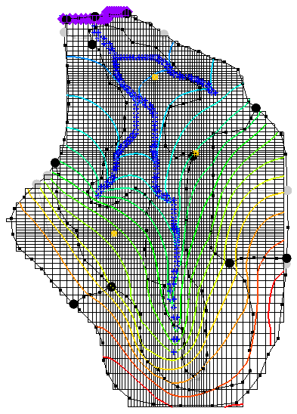

Figure 8: Contours after MODFLOW run

# Setting up an Animation

How the head changes over time can be shown by generating an animation. To set up the animation:

1. From the Menu Bar, select the *Display |* **Animate…** menu item to bring up the *Options* page of the *Animation Wizard* dialog.

In the *File Type* section, turn on the *Animation file* checkbox.

Click the  *Open* button and set the save location and file name for the animation file.

In the *Options* section, turn on the *Dataset* checkbox.

Click the **Next >** button to go to the *Datasets* page of the *Animation Wizard* dialog.

Turn on the Display clock checkbox.

Click the **Finish** button to generate the animation and close the *Animation Wizard* dialog.

The generated animation file can be viewed in a media player application outside of GMS.

# Conclusion

This concludes the “MODFLOW – Managing Transient Data” tutorial. The following topics were discussed and demonstrated:

* When opening the *Properties* dialog for objects in the **Map** File:Map Module Icon.svg module, transient data can be entered by using the transient_dataset_button_and_arrow buttons.
* It is possible to import transient data for points, arcs, polygons, and nodes using the *Text Import Wizard* dialog. The points, arcs, polygons, and nodes must already exist in the active coverage.
* GMS can show dates and times as scalar values (0.0, 2.5, etc.) or in date/time format (12/03/2003).
* The MODFLOW stress periods must be defined before using the *Feature Objects |* **Map → MODFLOW / MODPATH** command with a transient simulation.