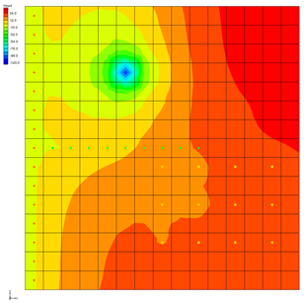

GMS 10.9

GMS 10.9 Tutorial

***MODFLOW – NWT***

Use MODFLOW-NWT with a Simple Model

Objectives

Learn the basics of the MODFLOW–NWT interface in GMS.

Time

* 25–40 minutes

Required Components

* GMS Core
* MODFLOW Interface

Prerequisite Tutorials

* MODFLOW – Grid Approach

|  |
| --- |
| [1 Introduction and Description 2](#_Toc178174411)  [1.1 Getting Started 3](#_Toc178174412)  [2 Import the MODFLOW 2000 Model 3](#_Toc178174413)  [2.1 Switch to MODFLOW-NWT LPF Project 4](#_Toc178174414)  [2.2 Save the MODFLOW–NWT LPF Project 4](#_Toc178174415)  [2.3 Run the Model 5](#_Toc178174416)  [3 Switch to the UPW and NWT Packages 5](#_Toc178174417)  [3.1 Save the MODFLOW-NWT UPW Project 5](#_Toc178174418)  [3.2 Run the Model and Compare Solutions 5](#_Toc178174419)  [4 Switch back to MODFLOW-NWT LPF Model 6](#_Toc178174420)  [4.1 Increase Pumping to Create a Dry Well 7](#_Toc178174421)  [4.2 Run the Model 7](#_Toc178174422)  [4.3 HDRY 8](#_Toc178174423)  [5 Switch back to UPW 9](#_Toc178174424)  [5.1 Specify PHIRAMP 9](#_Toc178174425)  [5.2 Save the MODFLOW-NWT UPW Dry Cell Project 10](#_Toc178174426)  [5.3 Run the Model 10](#_Toc178174427)  [5.4 Examine the Well 11](#_Toc178174428)  [5.5 Save and Run the Model 11](#_Toc178174429)  [5.6 Reduced Pumping Rates 12](#_Toc178174430)  [6 Conclusion 12](#_Toc178174431) |

# Introduction and Description

MODFLOW–NWT uses a Newton method which can handle cell drying and rewetting situations better than previous versions of MODFLOW. For some model scenarios, using MODFLOW–NWT can help to achieve convergence. GMS includes an interface to MODFLOW–NWT and the UPW and NWT packages included with MODFLOW–NWT.

This tutorial builds on the “MODFLOW – Grid Approach” tutorial. The purpose of this tutorial is to simply demonstrate the MODFLOW–NWT interface in GMS rather than to go in-depth on every feature.

The problem to be solved in this tutorial is the same as the one in the “MODFLOW – Grid Approach” tutorial and is shown in Figure 1. This problem is a modified version of the sample problem described near the end of the *MODFLOW Reference Manual*. Three aquifers will be simulated using three layers in the computational grid.

The grid covers a square region measuring 75000 feet by 75000 feet. The grid consists of 15 rows and 15 columns, each cell measuring 5000 feet by 5000 feet in plan view. For simplicity, the elevation of the top and bottom of each layer is flat. The hydraulic conductivity values shown are for the horizontal direction. For the vertical direction, vertical anisotropy (KH/KV) factors of 10, 5, and 5 are used for layers 1, 2, and 3, respectively.

Flow into the system is due to infiltration from precipitation and will be defined as recharge in the input. Flow out of the system is due to buried drain tubes, discharging wells (not shown in Figure 1), and a lake which is represented by a constant head boundary on the left. Starting heads are set equal to zero, and a steady-state solution is computed.



Figure 1 Sample problem to be solved

This tutorial will discuss and demonstrate:

* Importing an existing MODFLOW 2000 model.
* Switching to MODFLOW–NWT while continuing to use the LPF and PCG packages, and comparing the results.
* Switching to the UPW and NWT packages, and comparing the results.
* Switching back to MODFLOW 2000, and increasing the pumping rate, causing a well to go dry.
* Switching back to MODFLOW–NWT, and comparing how it handles dry cells.
* Examining how *IPHDRY* affects the head solution.

## Getting Started

Do the following to get started:

If necessary, launch GMS.

If GMS is already running, select *File |* **New** to ensure that the program settings are restored to their default state. Click **Don’t Save** if asked to save changes.

# Import the MODFLOW 2000 Model

To import an existing model:

1. Click **Open** File:Open Macro.svg to bring up the *Open* dialog.
2. Select “Project Files (\*.gpr)” from the *Files of type* drop-down.

Browse to the *nwt*\ folder and select “modfgrid.gpr”.

Click **Open** to import the file and close the *Open* dialog.

A MODFLOW model with color contours of the head solution will be visible (Figure 2).

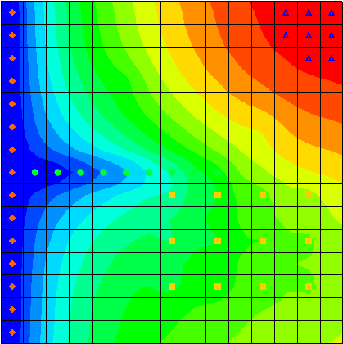

Figure 2 Initial view with contours and head solution visible

## Switch to MODFLOW-NWT LPF Project

The next step is to switch the model to use MODFLOW–NWT.

1. Select *MODFLOW |* **Global Options…** to bring up the *MODFLOW Global/Basic Package* dialog.

In the *MODFLOW version* section, select *NWT*.

Click **Packages…** to bring up the *MODFLOW Packages / Processes* dialog.

Notice that *LPF – Layer Property Flow* is selected in the *Flow package* section and *SIP1 – Strongly Impl. Proc.* is selected in the *Solver* section. These will be left unchanged for now.

Click **OK** to exit the *MODFLOW Packages / Processes* dialog.

Click **OK** to exit the *MODFLOW Global/Basic Package* dialog.

If necessary, click **No**to the pop-up asking to switch to the NWT Solver.

That feature will be explored later.

## Save the MODFLOW–NWT LPF Project

Before continuing, it is important to save the project with a new name.

1. Select *File* | **Save As…** to bring up the *Save As* dialog.
2. Select “Project Files (\*.gpr)” from the *Save as type* drop-down.

Enter“nwt\_lpf.gpr” as the *File name.*

Click **Save** to close the *Save As* dialog.

It is recommended to save the project periodically using **Save** File:Save Macro.svg.

## Run the Model

It is now possible to run the model.

1. Click **Run MODFLOW** File:Run MODFLOW Macro.svg to bring up the *MODFLOW* model wrapper dialog.

Once MODFLOW has finished, turn on *Read solution on exit* and *Turn on contours (if not on already)*.

Click **Close** to import the solution and exit the *MODFLOW* model wrapper dialog.

GMS imports the solution and contours the head dataset. Notice the head contours are exactly the same as they were before. Because this tutorial is still using the LPF and SIP1 packages, switching to MODFLOW–NWT hasn't changed anything.

# Switch to the UPW and NWT Packages

Now to switch to the UPW and NWT packages:

1. Select *MODFLOW |* **Global Options…** to bring up the *MODFLOW Global/Basic Package* dialog.

Click on **Packages…** to bring up the *MODFLOW Packages / Processes* dialog.

In the *Flow package* section, select *UPW – Upstream*.

Notice the *Solver* section automatically switches to *NWT –* *Newton.* These two packages go together and if one is used, the other must be used also.

Click **OK** to exit the *MODFLOW Packages / Processes* dialog.

Click **OK** to exit the *MODFLOW Global/Basic Package* dialog.

## Save the MODFLOW-NWT UPW Project

The next step is to save the project with a new name.

1. Select *File* | **Save As…** to bring up the *Save As* dialog.
2. Select “Project Files (\*.gpr)” from the *Save as type* drop-down.
3. Enter“nwt\_upw.gpr” as the *File name.*
4. Click **Save** to close the *Save As* dialog.

## Run the Model and Compare Solutions

It is now possible to run the model.

1. Click **Run MODFLOW** File:Run MODFLOW Macro.svg to bring up the *MODFLOW* model wrapper dialog.

Once MODFLOW has finished, turn on *Read solution on exit* and *Turn on contours (if not on already)*.

Click **Close** to import the solution and exit the *MODFLOW* model wrapper dialog.

GMS imports the solution and contours the head dataset. Notice the head contours are slightly different. The UPW and NWT packages give almost the same answer as the LPF and SIP1 packages when there are no cell wetting and drying conditions.

In the Project Explorer, click back and forth on the two solutions – “File:Generic Folder Locked.svg nwt\_lpf (MODFLOW)” and “File:Generic Folder Locked.svg nwt\_upw (MODFLOW)” – (red arrows in Figure 3) to compare them.

It may be necessary to expand the “File:3D Grid Folder.svg 3D Grid Data” folder and “File:3D Grid Icon.svg grid” item.

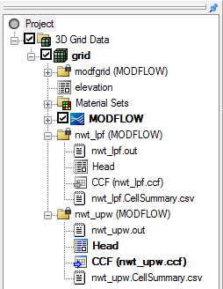

Figure 3 Project Explorer showing both solutions

# Switch back to MODFLOW-NWT LPF Model

The next step is to go back and load the MODFLOW–NWT model that used the LPF package.

1. Click **New** File:New Macro.svg to clear the current project.
2. If prompted to save changes, select **Don’t Save**.
3. Select the directory that ends in “nwt\_lpf.gpr” from the list of recent files at the bottom of the *File* menu.) (Figure 4).

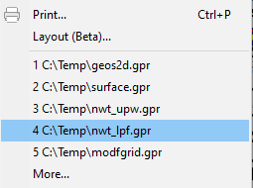

Figure 4 Reopen the nwt\_lpf.gpr model

## Increase Pumping to Create a Dry Well

Now to increase the pumping rate of one of the wells in order to cause the cells to go dry:

1. In the *Mini-Grid Toolbar*, click on the up arrow to change the view to *Lay (k)* (layer) “2” (Figure 5).



Figure 5 Switching to layer 2

Using the **Select Cells** File:Select 3D Cell Tool.svg tool, right-click on the well cell in the upper left (*IJK* :4, 6, 2), and select **Sources/Sinks…** to bring up the *MODFLOW Sources/Sinks* dialog. (Figure 6)

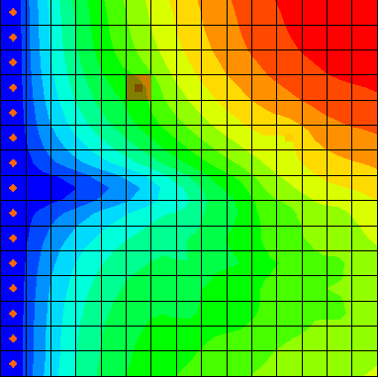

Figure 6 The well cell to select

Select “Wells (WEL)” from the list on the left.

For the *Q (flow) (m^3/d)* column of row 276 on the right, enter “-190000”.

Click **OK** to close the *MODFLOW Sources/Sinks* dialog.

## Run the Model

Now it is time to save these changes and run the model.

1. Click **Run MODFLOW** File:Run MODFLOW Macro.svg to bring up the *MODFLOW* model wrapper dialog.
2. When prompted to save changes, click **Yes**.

Once MODFLOW has finished, turn on *Read solution on exit* and *Turn on contours (if not on already)*.

Click **Close** to import the solution and exit the *MODFLOW* model wrapper dialog.

GMS reads the solution and contours the head dataset. Notice the cell with the well has gone dry. A triangle symbol appears in the cell to indicate the cell is dry (Figure 7).

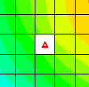

Figure 7 Dry cell symbol indicating the well went dry

## HDRY

The LPF package will assign a key value, the HDRY value, to any cells which go dry. The next step is to look at the HDRY value.

1. Select *MODFLOW |* **LPF – Layer Property Flow…**to bring up the *LPF Package* dialog.

In the upper-right section, click **More LPF Options…** to bring up the *LPF Package Options* dialog.

Notice the value of *Head assigned to dry cells (HDRY)* is “-888.0”.

Click **OK** to exit the *LPF Package Options* dialog.

Click **OK** to exit the *LPF Package* dialog.

The next step is to look at the head solution.

In the Project Explorer, under “File:Generic Folder Locked.svg nwt\_lpf (MODFLOW)”, right-click on “File:Dataset Cells Active.svg Head” and select **View Values…** to bring up the *Edit Dataset Values* dialog.

It may be necessary to expand “File:3D Grid Folder.svg 3D Grid Data”, “File:3D Grid Icon.svg grid”, and “File:Generic Folder Locked.svg nwt\_lpf (MODFLOW)” in order to find the dataset.

Scroll down to row *51* to view values.

Notice the “-888.0” value in the *f* column and the “0” in the *Active* column for that cell (Figure 8).

The “0” in the *Active* column indicates that the cell is inactive. GMS doesn’t display contours for it because there is no data for that cell.

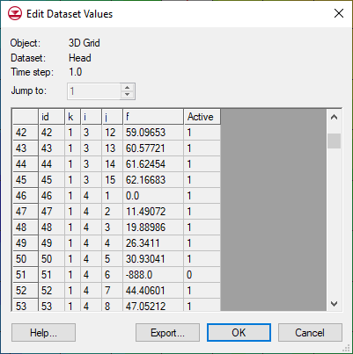

Figure 8 HDRY value in head solution

Click **OK** to exit the *Edit Dataset Values* dialog.

# Switch back to UPW

Now it is possible to see how MODFLOW–NWT and the UPW package handle the dry cell.

1. Select *MODFLOW |* **Global Options…** to bring up the *MODFLOW Global/Basic Package* dialog.

Click **Packages…** to bring up the *MODFLOW Packages / Processes* dialog.

In the *Flow package* section, select *UPW – Upstream Weighting*.

Click **OK** to exit the *MODFLOW Packages / Processes* dialog.

Click **OK** to exit the *MODFLOW Global/Basic Package* dialog.

## Specify PHIRAMP

MODFLOW–NWT has a unique feature that will reduce the pumping rate in cells as the head drops below a user-specified percentage of cell thickness. The MODFLOW–NWT documentation describes this feature as follows:

Negative pumping rates specified in the Well Package are reduced to zero when the groundwater head drops to the cell bottom using a cubic formula and its derivative. This option is only available for unconfined (convertible) layers.[[1]](#footnote-1)

The user-specified percentage of cell thickness is the variable PHIRAMP in the WEL package.

1. Select *MODFLOW* | *Optional Packages* | **WEL – Well…** to bring up the *MODFLOW Well Package* dialog.

At the bottom-right side of the dialog, turn on *Specify PHIRAMP*.

The default value is “0.25”. When the head in the cell drops below 25% of the cell thickness, the pumping rate will be reduced by MODFLOW–NWT.

Select **OK** to accept the default and exit the *MODFLOW Well Package* dialog.

## Save the MODFLOW-NWT UPW Dry Cell Project

The project should now be saved with a new name.

1. Select *File* | **Save As…** to bring up the *Save As* dialog.
2. Select “Project Files (\*.gpr)” from the *Save as type* drop-down.

Enter“nwt\_upw.gpr” as the *File name.*

Click **Save** to close the *Save As* dialog.

Select **Yes** when prompted to replace the existing file.

## Run the Model

Now to run MODFLOW:

1. Click **Run MODFLOW** File:Run MODFLOW Macro.svg to bring up the *MODFLOW* model wrapper dialog.

Once MODFLOW has finished, turn on *Read solution on exit* and *Turn on contours (if not on already)*.

Click **Close** to import the solution and exit the *MODFLOW* model wrapper dialog.

Notice the UPW solution (Figure 9) varies greatly from the one generated using the LPF package. The heads in the UPW solution are much lower because, with the LPF package, as soon as the cell went dry, the pumping stopped. In the UPW package, the pumping continued but at a reduced rate (as the tutorial will show).

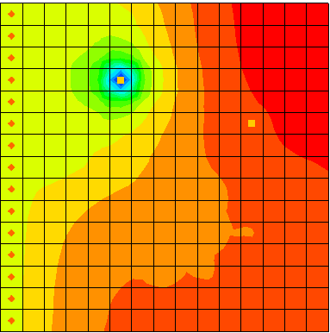

Figure 9 UPW package showing slower pump rate once well was low

## Examine the Well

Notice the cell with the well no longer appears dry, but it is clear that there is considerable drawdown around the well.

1. Using the **Select Cells** File:Select 3D Cell Tool.svg tool, click on the well cell (*IJK* coordinates :4,6,2).

Notice the *S* value in the GMS *XYZF Bar* is about “-104” (Figure 10).



Figure 10 Head in cell (4,6,2)

Right-click on the well cell and select **Properties…** to bring up the *3D Grid Cell Properties* dialog.

Notice the *Top elevation* of this cell is “-45” and the *Bottom elevation* is “-120”, so the head is just above the bottom elevation.

Click **OK** to exit the *3D Grid Cell Properties* dialog.

In the *Mini-Grid Toolbar*, click on the down arrow to change the view to *Lay (k)* (layer) “1”.

Click on the cell in layer 1 that is directly above the well in layer 2 (the cell with *IJK* (4,6,1)).

Notice the head in the cell is about “-94” according to the GMS *XYZF Bar*. Although the head in the cell above the well is below the bottom of the first layer, the cell is still contoured and is showing the dry cell symbol. The following steps show why.

Select *MODFLOW |* **UPW – Upstream Weighting…** to bring up the *UPW Package* dialog.

Click **More UPW Options…** to bring up the *UPW Package Options* dialog.

By default, the UPW package does not assign the *HDRY* value to cells that go dry. The *IPHDRY* variable may be turned on by doing the following:

Turn on *Set head to HDRY (IPHDRY)*.

Click **OK** to exit the *UPW Package Options* dialog.

Click **OK** to exit the *UPW Package* dialog.

## Save and Run the Model

Now to run MODFLOW again:

1. Select *MODFLOW* | **Run MODFLOW** to bring up the *MODFLOW* model wrapper dialog.
2. Click **Yes** if asked to save.
3. Once MODFLOW has finished, turn on *Read solution on exit* and *Turn on contours (if not on already)*.
4. Click **Close** to import the solution and exit the *MODFLOW* model wrapper dialog.

Notice that the dry cell symbol now appears in the cell above the well.

## Reduced Pumping Rates

MODFLOW–NWT reduced the pumping rate of the well as the water table got close to the bottom of the cell.

1. In the Project Explorer, double-click on the “File:External Text File Icon.svg nwt\_upw.out” item.

If prompted to pick the viewer in a *View Data File* dialog, click **OK** to accept the default or pick another one.

In the selected text editor, use *Ctrl-F* to search for the word “reduced” until you locate the lines shown in Figure 11.

GMS 10_1 - MODFLOW-NWT - nwt_upw output example

Figure 11 Reduced pumping rate as shown in the .out file

1. Once done reviewing this data and any other data within the file, close the text editor.

# Conclusion

This concludes the “MODFLOW–NWT” tutorial. The following topics were discussed and demonstrated:

* GMS includes an interface to MODFLOW–NWT and the UPW and NWT packages.
* MODFLOW–NWT can be used with either the LPF or UPW flow packages. The UPW package typically produces very similar results to the LPF package if there is no cell drying or rewetting taking place.
* The UPW package does not assign the *HDRY* value to dry cells unless the *IPHDRY* option is turned on.
* MODFLOW–NWT will reduce the pumping rate in a well as the water table approaches the bottom of the cell.

1. Niswonger, Richard G.; Panday, Sorab; and Ibaraki, Motomu, 2011. “MODFLOW-NWT: A Newton Formulation for MODFLOW-2005” from *U.S. Geological Survey Techniques and Methods 6–A37*, p.14. <http://pubs.usgs.gov/tm/tm6a37/pdf/tm6a37.pdf> . [↑](#footnote-ref-1)