Required Components

* GMS Core
* Geostatistics
* MODFLOW Interface
* PEST

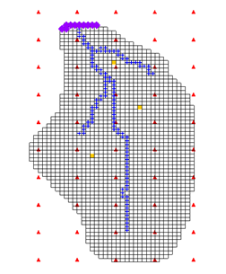

GMS 10.9

GMS 10.9 Tutorial

***MODFLOW – Advance PEST Pilot Points***

Edit regularization options and use more than one set of pilot points to calibrate a MODFLOW model

Objectives

This tutorial demonstrates the features and options related to pilot points when used with PEST. It will review using fixed-value pilot points, regularization, and multiple parameters.

Time

* 20–30 minutes

Prerequisite Tutorials

* MODFLOW – PEST Pilot Points

|  |
| --- |
| [1 Introduction 2](#_Toc203728867)  [1.1 Getting Started 3](#_Toc203728868)  [2 Importing the Project 3](#_Toc203728869)  [3 Changing the Regularization Option 4](#_Toc203728870)  [3.1 Saving the Project 4](#_Toc203728871)  [3.2 Prior Information Equations 5](#_Toc203728872)  [3.3 Running PEST 5](#_Toc203728873)  [4 Multiple Parameters using Pilot Points 6](#_Toc203728874)  [4.1 Creating a Second Set of Pilot Points 6](#_Toc203728875)  [4.2 Creating the New HK Parameter 8](#_Toc203728876)  [4.3 Creating the New HK Parameter 8](#_Toc203728877)  [4.4 Saving the Project and Running PEST 9](#_Toc203728878)  [5 A Note on Highly Parameterized Models 11](#_Toc203728879)  [6 Conclusion 11](#_Toc203728880) |

# Introduction

Pilot points can be thought of as a 2D scatter point set. Instead of creating a zone and having the inverse model estimate one value for the entire zone, the value of the parameter within the zone is interpolated from the pilot points. The inverse model then estimates the values at the pilot points. Using pilot points will vary values from cell to cell. When the inverse model runs, the values at the pilot points are adjusted and re-interpolated to the grid cells until the objective function is minimized.

PEST (Parameter ESTimation) provides an option for the pilot point method called regularization. Regularization imposes an additional measure of constraint to the parameter being interpolated. This constraint is imposed by providing PEST with additional information about the parameter in the form of prior information equations. This constraint makes the inversion process much more stable and makes it possible to violate one of the typical constraints associated with parameter estimation: namely, the requirement that the number of parameters is less than the number of observations.

With regularization, the number of parameters can exceed the number of observations. As a result, complex hydraulic conductivity distributions can be defined, resulting in low residual error. The pilot point method with regularization is a powerful feature of PEST.

There are two methods available in GMS for defining the prior information equations for PEST. The two methods can be used simultaneously but are usually used separately. The first method is *Preferred homogeneous regularization*. When this option is selected, the prior information equations written to the PEST control file relate the pilot points to one another. These equations indicate to PEST that—in the absence of any strong influence from the PEST objective function—pilot points that are near one another should have the same value.

The second method of regularization is *Preferred value regularization*. When this option is selected, previous information equations written to the PEST control file relate the pilot points to their starting value. These equations indicate to PEST that—in the absence of any strong influence from the PEST objective function—the pilot point values should be equal to their starting value. Depending on the particular problem being solved, one method may be preferred over the other.

The model being calibrated in this tutorial is the same model featured in the “MODFLOW – PEST Pilot Points” tutorial. The model includes observed flow data for the stream and observed heads at a set of scattered observation wells. The conceptual model for the site consists of a set of recharge and hydraulic conductivity zones. These zones will be marked as parameters and an inverse model will be used to find a set of recharge and hydraulic conductivity values that minimize the calibration error.

This tutorial will discuss and demonstrate the following:

* Opening a MODFLOW model and solution.
* Changing regularization options and running PEST.
* Using pilot points on different zones and different parameter types.

## Getting Started

Do the following to get started:

1. If necessary, launch GMS.
2. If GMS is already running, from the menu bar, select the *File |* **New** menu item to ensure that the program settings are restored to their default state. If asked to save changes, click the **Don’t Save** button.

# Importing the Project

First, import the modeling project:

1. From the Macro Bar, click **Open** File:Open Macro.svg to bring up the *Open* dialog.
2. From the *Files of type* drop-down, select “Project Files (\*.gpr)”.
3. Browse to the *pilotpointsAdvanced\pilotpointsAdvanced* directory and select “mfpest\_pilot\_fixed.gpr”.
4. Click the **Open** button to import the project and exit the *Open* dialog.

The initial MODFLOW model should appear similar to Figure 1.

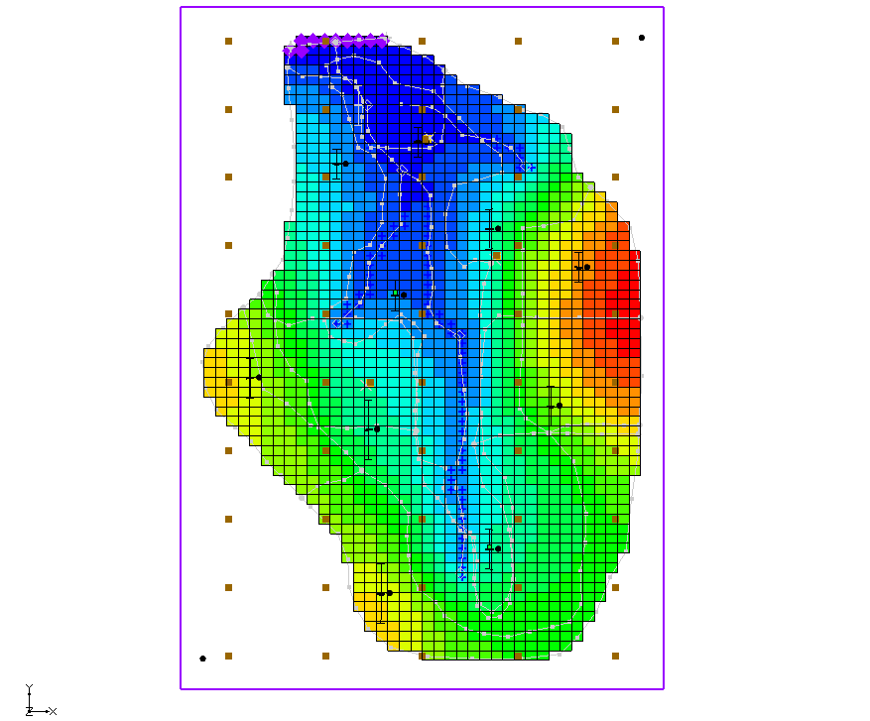

Figure 1: The initial MODFLOW model

# Changing the Regularization Option

First, the regularization option needs to be changed to use the *Preferred value regularization* option.

1. From the Menu Bar, select the *MODFLOW |* **Parameter Estimation…** menu item to open the *PEST* dialog.
2. In the *Tikhonov regularization (only used with pilot points)* section, turn off the *Preferred homogeneous regularization* checkbox.
3. Turn on the *Preferred value regularization* checkbox.
4. Click the **OK** button to close the *PEST* dialog.

## Saving the Project

Before running MODFLOW, the project should be saved.

1. From the Menu Bar, select the *File* | **Save As…** menu item to bring up the *Save As* dialog.
2. From the *Save as type* drop-down, select “Project Files (\*.gpr)”.
3. For the *File name,* enter“mfpest\_pilot\_pref\_val.gpr”.
4. Click the **Save** button to close the *Save As* dialog.

## Prior Information Equations

If desired, compare the different prior information equations written from GMS by looking at the RPF files in the MODFLOW directories using a text editor. The prior information equations for *Preferred homogenous regularization*, found in “mfpest\_pilot\_fixed.rpf”, should look similar to Figure 2.

GMS 10_1 - MODFLOW-AdvancedPest- run_SvdAssist_rpf

Figure 2: Prior information equations from preferred homogenous regularization

Notice that these equations define a relationship between the different pilot points. In addition, the weight applied to these equations changes as shown by the last number written to each line. In contrast, the prior information equations for *Preferred value regularization*, found in “mfpest\_pilot\_pref\_val.rpf” as shown in Figure 3, have the same weight applied and define a preferred value for each point.

GMS 10_1 - MODFLOW-AdvancedPest- mfpest_pilot_pref_val_rpf

*Figure 3: Prior information equations from preferred value regularization*

## Running PEST

With the project saved, the next step is to run PEST.

1. From the Macro Bar, click **Run MODFLOW** File:Run MODFLOW Macro.svg to bring up the *MODFLOW/PEST Parameter Estimation* dialog.

PEST may take several minutes to run, depending on the speed of the computer being used. Once PEST is finished, import the solution.

1. Turn on the *Read solution on exit* and *Turn on contours (if not on already)* checkboxes.
2. Click the **Close**buttonto exit the *MODFLOW/PEST Parameter Estimation* dialog.
3. From the Menu Bar, select the *MODFLOW |* **Parameters…** menu item to open the *Parameters* dialog.
4. At the bottom right, click the **Import Optimal Values** buttonto bring up the *Open* dialog.
5. From the file type drop-down to the right of the *File name* field, select “PAR File (\*.par,\*.bpa)”.
6. Browse to the *pilotpointsAdvanced/pilotpointsAdvanced/mfpest\_pilot\_pref\_val\_MODFLOW* directory and select “mfpest\_pilot\_pref\_val.par”.
7. Click the **Open** button to exit the *Open* dialog.
8. Click the **OK** button to close the *Parameters* dialog.

The project should appear similar to Figure 4.

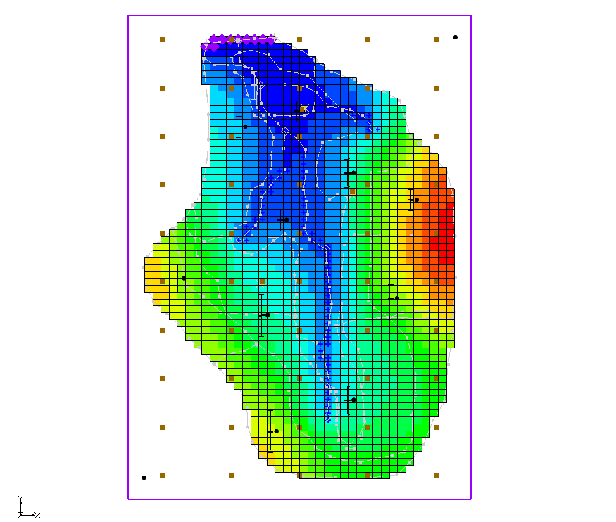

Figure 4: Optimal values

# Multiple Parameters using Pilot Points

In GMS, pilot points can be used with HK and RCH parameters. Multiple HK (or RCH) parameters that use the same or different pilot points can exist. Create a second HK parameter and a new set of pilot points.

1. In the Project Explorer, turn off the “File:3D Grid Folder.svg 3D Grid Data” folder, by clicking on the checkbox.
2. From the “ Map Data” folder, in the “ BigVal” conceptual model, select the   
   “File:Coverage Active Icon.svg Hydraulic Conductivity” coverage to make it active.
3. From the Dynamic Toolbar, using the **Select Polygons** File:GMS Select Polygon Tool.svg tool, double-click the polygon surrounding the river in the middle of the model to bring up the *Attribute Table* dialog.
4. In the *Horizontal K (m/d)* column, enter “-60.0”.
5. Click the **OK** button to close the *Attribute Table* dialog.
6. Right-click on “File:Coverage Active Icon.svg Hydraulic Conductivity” and select the *Map To |* **MODFLOW/MODPATH** context menu item.

## Creating a Second Set of Pilot Points

Now create another scatter point set for the new HK parameter by creating a 2D grid and converting it to a scatter point set.

1. Right-click on an empty space in the Project Explorer and select the *New |* **2D Grid…** context menu item to open the *Create Finite Difference Grid* dialog.
2. In the *X-Dimension* section, for the *Origin* enter “2240.0”,   
    for the *Length* enter “4075.0” (m),   
    and for the *Number cells* enter “3”.
3. In the *Y-Dimension* section, for the *Origin* enter “700.0”,   
    for the *Length* enter “11100.0” (m),   
    and for the *Number cells* enter “5”.
4. In the *Z-Dimension* section, for the *Origin* enter “0.5”. This value will be assigned to the scatter points created from the grid.
5. In the *Orientation / type* section, from the *Type* drop-down, select “Cell centered”.

The dialog should appear similar to Figure 5.

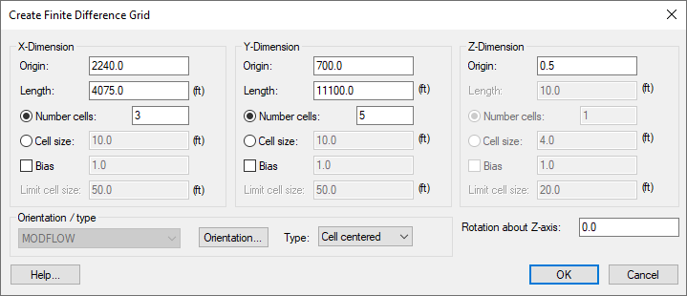

Figure 5: Create Finite Difference Grid dialog

1. Click the **OK** button to close the *Create Finite Difference Grid* dialog.
2. Under the “File:3D Grid Folder.svg 2D Grid Data” folder, right-click on “File:2D Grid Icon.svg grid”.
3. Select the *Convert To |* **2D Scatter Points** context menu item to bring up the *Scatter Point Set Name* dialog.
4. For the *New scatter point set name,* enter “HK\_60”.
5. Click the **OK** button to close the *Scatter Point Set Name* dialog. The new scatter set will appear in the 2D Scatter Data folder.
6. Right-click on the same “File:2D Grid Icon.svg grid” item and select the **Delete** context menu item.

The new scatter points should appear interspersed with the previous scatter points (Figure 6). Feel free to experiment, turn each set of scatter points on and off to more clearly see their locations.

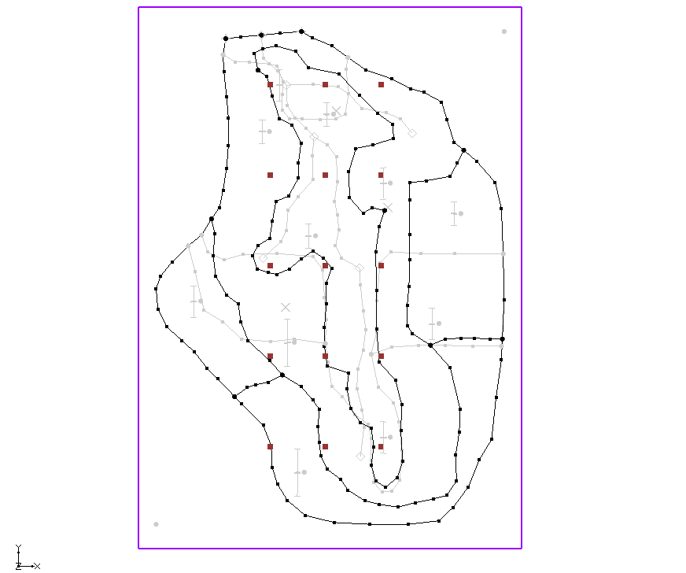

*Figure 6: New scatter points (“HK” scatter set turned off)*

## Creating the New HK Parameter

Now, a new parameter for the newly created pilot points should be created.

1. From the Menu Bar, select the *MODFLOW |* **Parameters…** menu item to open the *Parameters* dialog.
2. Click the **Initialize From Model** button in the bottom right of the dialog.

Notice that a line for “HK\_60” is added to the bottom of the list of parameters.

1. On the “HK\_60” row, enable the checkboxes in the *Param. Est. Solve* and *Log Xform* columns.
2. In the “HK\_60” row, in the *Value* column, click on the drop-down Small drop-down arrow button from Parameters dialog, and select “<Pilot points>”.
3. In the “HK\_60” row, in the *Value* column, above the drop-down Small drop-down arrow button from Parameters dialog, click on the Blank button from Parameters dialog button to open the *2D Interpolation Options* dialog.
4. In the *Interpolating from* section, from the *Object* drop-down, select “HK\_60 (active)”.
5. Click the **OK** button to exit the *2D Interpolation Options* dialog.
6. Click the **OK** button to exit the *Parameters* dialog.

## Creating the New HK Parameter

Use pilot points to estimate recharge with the model. For the RCH parameter, use the same set of pilot points that the “HK\_30” parameter uses, but create a new dataset with starting values for the RCH parameter.

1. In the Project Explorer, in the “ Map Data” folder, right-click the “File:Coverage Active Icon.svg Recharge”coverage and select the **Attribute Table…** context menu item to bring up the *Attribute Table* dialog.
2. From the *Feature type* drop-down, select “Polygons”.
3. In the *All* row and in the *Recharge rate (m/d)* column, enter “-150.0”.
4. Click the **OK** button to close the *Attribute Table* dialog.
5. Right-click on the “File:Coverage Active Icon.svg Recharge”coverage and select the *Map To |* **MODFLOW/MODPATH** context menu item.

### Creating New Starting Values for the RCH Parameter:

Next, create a new dataset on the HK scatter set to provide the starting values for the RCH parameter.

1. In the Project Explorer, under the “ 2D Scatter Data” folder, select the “File:2D Scatter Icon.svg HK” scatter point set to make it active.
2. From the Menu Bar, select *Edit |* **Dataset Calculator…** to bring up the *Data Calculator* dialog.
3. At the bottom left of the dialog, in the *Expression* field, enter “1e-5”.
4. At the bottom left of the dialog, in the *Result* field, enter “RCH”.
5. Click the **Compute** button to create a new dataset with all values equal to “1.0e-5”.
6. Click the **Done** button to exit the *Data Calculator* dialog.

### Editing the RCH Parameters:

The RCH parameters should now be edited to use pilot points.

1. From the Menu Bar, select *MODFLOW |* **Parameters…** menu item to bring up the *Parameters* dialog.
2. In the *Name* column, select “RCH\_180” and click the **Delete** button at the bottom of the dialog.
3. In the *Name* column, select “RCH\_210” and click the **Delete** button at the bottom of the dialog.
4. In the *Value* column for the “RCH\_150” row, click the drop-down Small drop-down arrow button from Parameters dialog and select “<Pilot points>”. This turns on the pilot points option for this parameter.
5. In the *Value* column for parameter “RCH\_150”, above the drop-down Small drop-down arrow button from Parameters dialog, click on the Blank button from Parameters dialog button to bring up the *2D Interpolation Options* dialog.
6. In the *Interpolating from* section, from the *Object* drop-down, select “HK (active)”.
7. In the *Interpolating from* section, from the *Dataset* drop-down, select “RCH”.
8. Click the **OK** button to close the *2D Interpolation Options* dialog.
9. Click the **OK** button to close the *Parameters* dialog.

## Saving the Project and Running PEST

Before running PEST, the project should be saved.

1. From the Menu Bar, select the *File* | **Save As…** menu item to bring up the *Save As* dialog.
2. From the *Save as type* drop-down, select “Project Files (\*.gpr)”.
3. As the *File name,* enter **“**mfpest\_pilot\_2zones.gpr”.
4. Click the **Save** button to close the *Save As* dialog.

When pilot points are assigned to both HK and RCH parameters, the prior information equations for the HK and RCH parameters are assigned to different regularization groups. This helps PEST to differentiate weighting among pertinent prior information equations. In other words, PEST works better with this option.

1. From the Macro Bar, click **Run MODFLOW** File:Run MODFLOW Macro.svg to bring up the *MODFLOW/PEST Parameter Estimation* dialog.

PEST may take several minutes to run, depending on the speed of the computer being used. Once PEST is finished, import the solution.

1. Turn on the *Read solution on exit* and *Turn on contours (if not on already)* checkboxes.
2. Click the **Close**buttonto exit the *MODFLOW/PEST Parameter Estimation* dialog.
3. From the Menu Bar, select the *MODFLOW |* **Parameters…** menu item to open the *Parameters* dialog.
4. Click the **Import Optimal Values** buttonat the bottom right to bring up the *Open* dialog.
5. From the file type drop-down to the right of the *File name* field, select “PAR File (\*.par,\*.bpa)”.
6. Browse to the *pilotpointsAdvanced/pilotpointsAdvanced/mfpest\_pilot\_2zones\_MODFLOW* directory and select “mfpest\_pilot\_2zones.par”.
7. Click the **Open** button to exit the *Open* dialog.
8. Click the **OK** button to close the *Parameters* dialog.
9. In the Project Explorer, turn on the “https://www.xmswiki.com/images/thumb/b/be/3D_Grid_Folder.svg/60px-3D_Grid_Folder.svg.png 3D Grid Data” checkbox.

The solution should appear similar to Figure 7. Feel free to compare the solutions by alternating between them in the Project Explorer.

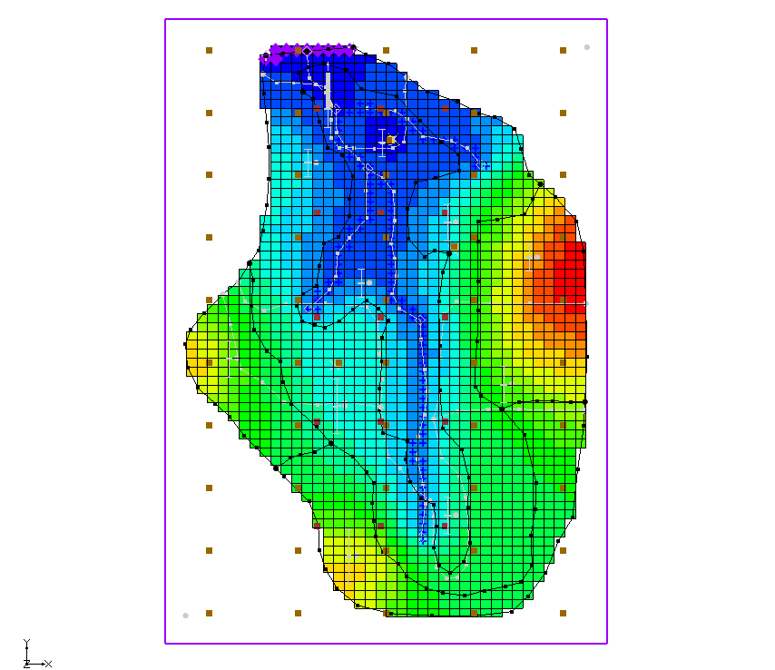

*Figure 7: After the final run*

# A Note on Highly Parameterized Models

The model that was created has over 100 parameters. This is a fairly simple MODFLOW model that converges rather quickly. Most real-world problems take longer to run, so it may not be practical to run MODFLOW over 100 times for each PEST iteration.

However, PEST supports an innovative method known as SVD-Assist (Singular Value Decomposition-Assist) which can dramatically reduce the number of model runs required for each PEST iteration. When combining SVD-Assist with Parallel PEST, it becomes practical to use PEST with models containing hundreds or even thousands of parameters. Learn more about these methods in the “MODFLOW – Advanced PEST” tutorial.

# Conclusion

This concludes the “MODFLOW – Advanced PEST Pilot Points” tutorial. The following key topics were discussed and demonstrated:

* Two different regularization options are available for pilot points: preferred homogeneous and preferred value.
* Multiple sets of pilot points can be used with the same MODFLOW model.