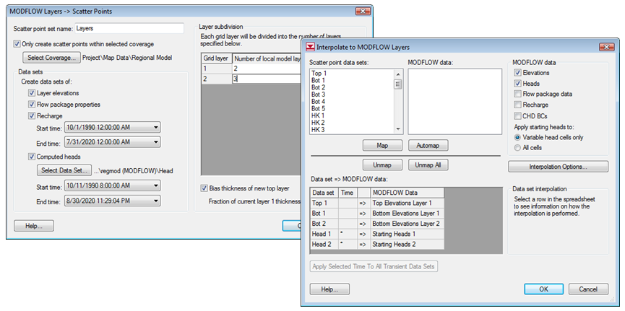

Required Components

* GMS Core
* Geostatistics
* MODFLOW Interface

Time

* 20–35 minutes

GMS 10.9 Tutorial

***MODFLOW – Regional-to-Local Model Conversion, Transient***

Create a local model from a regional model using convenient tools provided in GMS

GMS 10.9

Objectives

This tutorial instructs on how to use the convenient tools provided in GMS to perform the steps involved in a typical regional-to-local model conversion. This tutorial uses a transient model. A steady-state example is provided in the “MODFLOW – Regional-to-Local Model Conversion, Steady-State” tutorial.

Prerequisite Tutorials

* MODFLOW ‒ Regional-to-Local Model Conversion, Steady-State.

|  |
| --- |
| 1 Introduction 2  1.1 Getting Started 2  2 Importing the Regional Model 2  3 Converting the Layer Data to a Scatter Point Set 3  4 Building the Local Conceptual Model 5  4.1 Creating a New Coverage 5  4.2 Creating the Boundary Arcs and Building the Polygon 5  4.3 Marking the Specified Head Arcs 6  5 Creating the Local MODFLOW Model 7  5.1 Creating the Grid 7  5.2 Creating a New MODFLOW Model 7  5.3 Inactivating Cells 8  5.4 Mapping the Properties 9  6 Interpolating the Layer Data 9  7 Saving and Running the Local Model 10  8 Conclusion 11 |

# Introduction

The “MODFLOW – Regional-to-Local Model Conversion, Steady-State” tutorial covers the foundational methods for regional-to-local model conversion and should be completed prior to this tutorial. The same model is used here, with the key difference being that this tutorial focuses on a transient simulation. Background information and model details are omitted here, as they are provided in the steady-state tutorial.

This tutorial demonstrates how to import a regional conceptual model and convert layer data to a scatter point set. A local conceptual model and 3D grid will be created, the conceptual model will be mapped to a MODFLOW simulation, layer data will be interpolated, and the MODFLOW model will be executed.

## Getting Started

Do the following to get started:

1. If necessary, launch GMS.
2. If GMS is already running, select the *File* | **New** command to ensure that the program settings are restored to their default state. Click **Don’t Save** if asked to save changes.

# Importing the Regional Model

The first step in the model conversion process is to build a regional model. Since the focus of this tutorial is primarily on the conversion process, a previously constructed model will be imported.

1. Click **Open** File:Open Macro.svg to bring up the *Open* dialog.
2. Select “Project Files (*.gpr)” from the *Files of type* drop-down.
3. Browse to the *reg2loc\reg2loc* directory and select “regmod.gpr”.
4. Click **Open** to import the project and exit the *Open* dialog.

The bottom layer (layer 2) of the two-layer model is currently displayed (Figure 1). The wells are located in this layer. After viewing the bottom layer, use the arrow buttons in the *Mini-Grid Toolbar*  to go to the top layer (layer 1).

This model was developed using the conceptual model approach. The boundary of the local site is markey by a red rectangle. The imported project includes the solution from the regional model, and the contours of computed head should be visible.

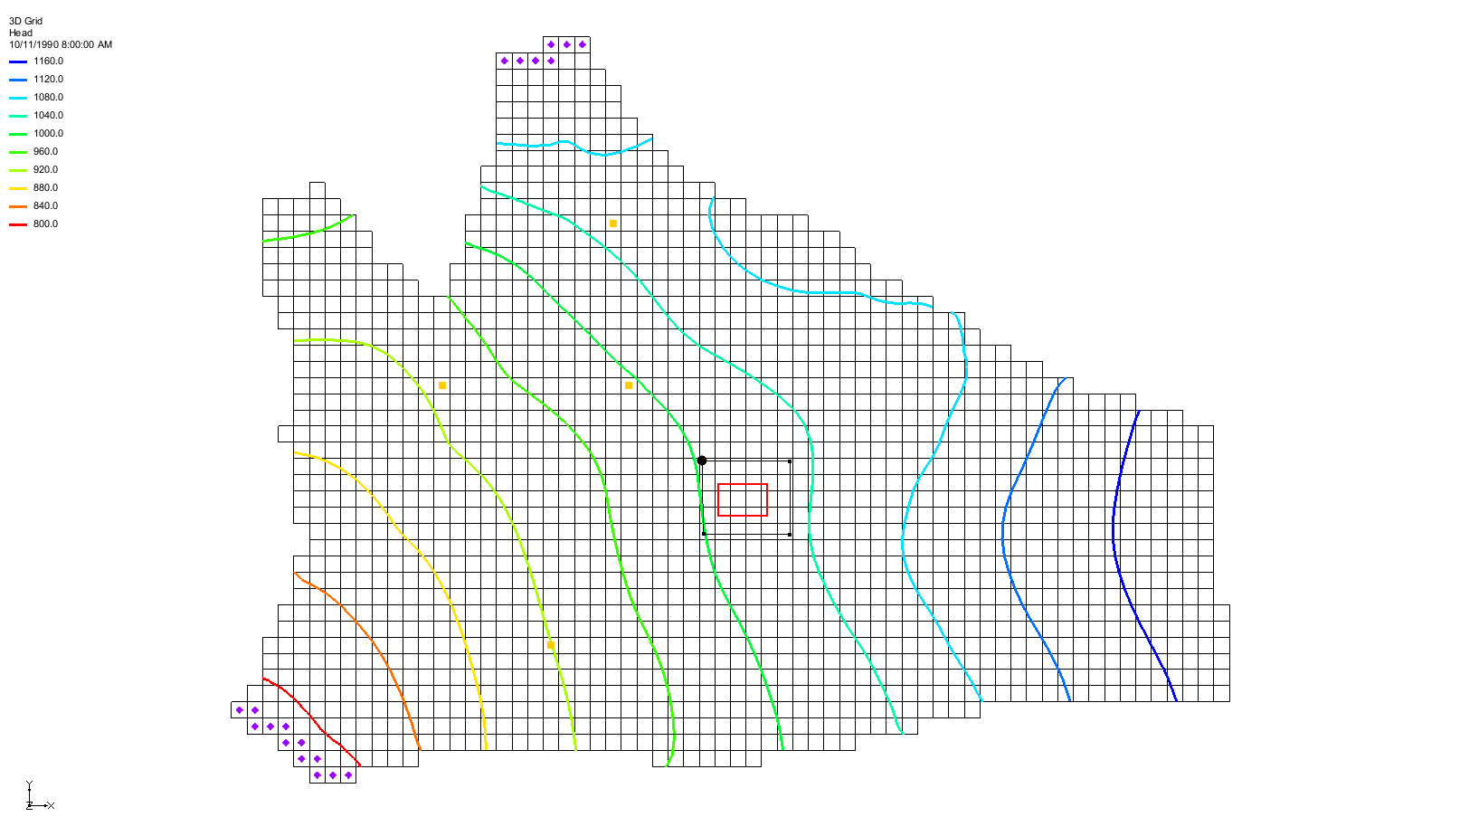

Figure 1 The initial project, showing the wells on layer 2

# Converting the Layer Data to a Scatter Point Set

The first step in converting the regional model to a local model is to convert the MODFLOW layer data to a 2D scatter point set.

1. Select the “File:3D Grid Folder.svg 3D Grid Data” folder in the Project Explorer to make it active.
2. Select *Grid |* **MODFLOW Layers → 2D Scatter Points…** to open the *MODFLOW Layers → Scatter Points* dialog.
3. Enter “Regional Data” as the *Scatter point set name*.
4. Turn on *Only create scatter points within selected coverage*.
5. Click **Select Coverage*…*** to bring up the *Select Coverage* dialog.
6. Expand “File:Conceptual Model Icon.svg Regional Model” and select the “File:Coverage Active Icon.svg Scatter Points” coverage.
7. Click **OK** to close the *Select Coverage* dialog.
8. In the *Datasets* section, turn on *Layer elevations*, *Flow package properties*, *Recharge*, and *Computed heads*.
9. Accept the default date and time stamps for the *Recharge* dataset.
10. Under *Computed heads*, click **Select Dataset …**to bring up the *Select Dataset* dialog.
11. Under “File:Generic Folder Locked.svg regmod (MODFLOW)”, select the “File:Dataset Cells Active.svg Head” dataset.
12. Click **OK** to close the *Select Dataset* dialog.
13. In the spreadsheet in the *Layer subdivision* section, enter “2” and “3” in the *Number of local model layers* column for grid layers *1* and *2*, respectively.
14. At the bottom of the *Layer subdivision* section, turn on *Bias thickness of new top layer*.

The dialog should now look like Figure 2.

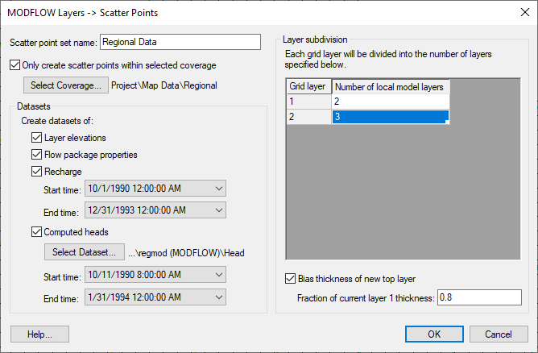

Figure 2 MODFLOW Layers → Scatter Points dialog

1. Click **OK** to exit the *MODFLOW Layers → Scatter Points* dialog.

A set of scatter points should appear at the cell centroids within the local site (Figure 3). This scatter point set includes dataset for computed heads, recharge, hydraulic conductivity, and the top and bottom elevations of the model layers.

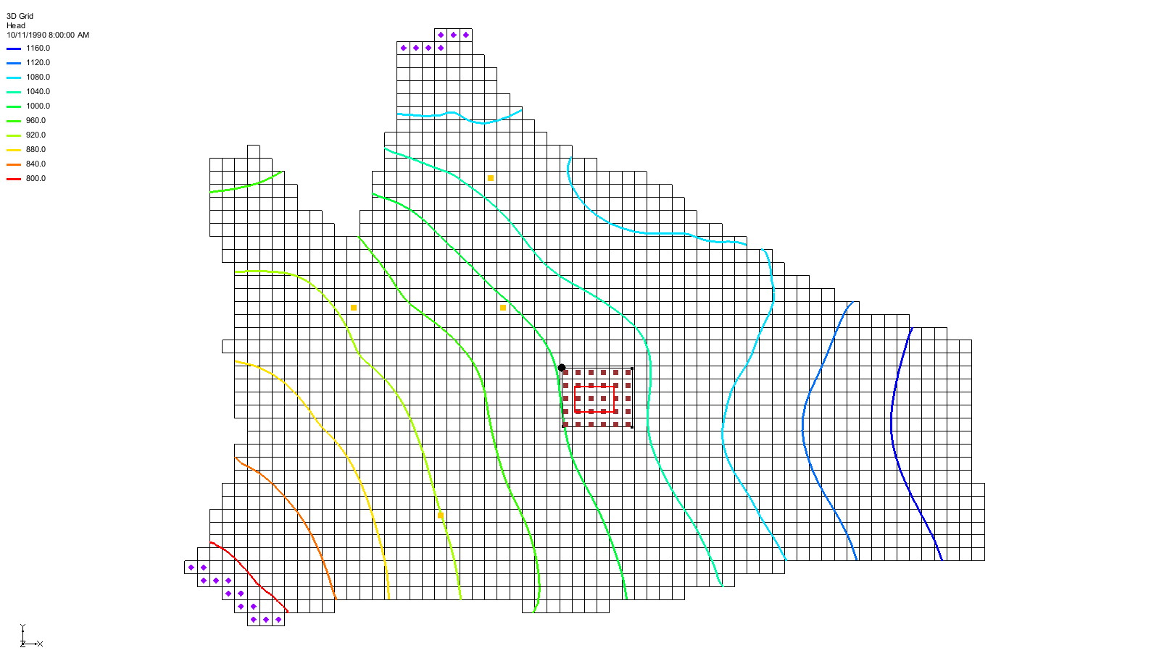

Figure 3 Scatter points in the local site on layer 1

# Building the Local Conceptual Model

The simplest way to build the local model is to create a conceptual model in the *Map* module. To do this:

1. Right-click on “File:Map Folder.svg Map Data” in the Project Explorer and select **New Conceptual Model…** to bring up the *Conceptual Model Properties* dialog.
2. Enter “Local Model” as the *Name*.
3. Click **OK** to close the *Conceptual Model Properties* dialog.

## Creating a New Coverage

To create a new source/sink coverage under the new “Local Model”:

1. Right-click on “File:Conceptual Model Icon.svg Local Model” and select **New Coverage…** to open the *Coverage Setup* dialog.
2. Enter “local ss” as the *Coverage name*.
3. In the *Sources/Sinks/BCs* column, turn on *Layer range* and *Specified Head (CHD).*
4. Change the *Default layer range* to be “1” to “5”.

Click **OK** to close the *Coverage Setup* dialog.

## Creating the Boundary Arcs and Building the Polygon

To create the boundary arcs:

1. Using the **Zoom** File:Zoom Tool Icon.svg tool, drag a box around the local site boundary (the red rectangle).
2. Select “File:Coverage Active Icon.svg local ss” under “File:Conceptual Model Icon.svg Local Model” in the Project Explorer to make it active.
3. Using the **Create Arc** File:GMS Create Arc Tool.svg tool, create a single arc forming a rectangle directly on top of the red rectangle (Figure 4). If the red rectangle isn’t visible, turn on   
   “File:Annotations Folder.svgAnnotation Data” in the Project Explorer.

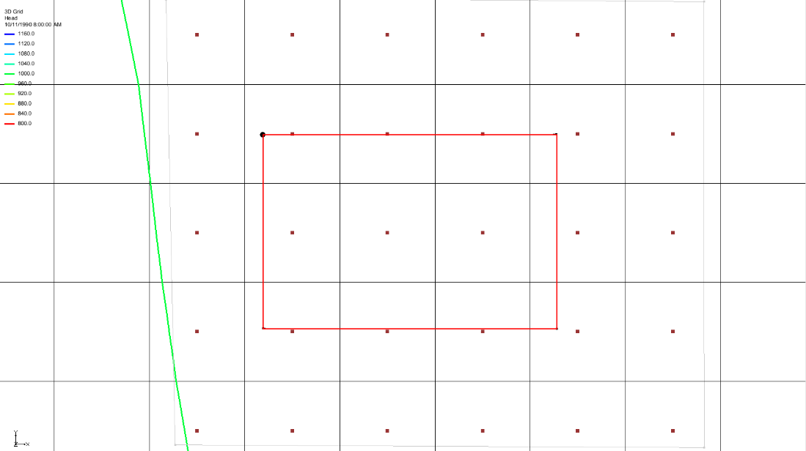

Figure 4 Arc created on boundary of local model, layer 2

To build a polygon defining the model domain:

1. Select *Feature Objects |* **Build Polygons** to create a polygon (Figure 5).

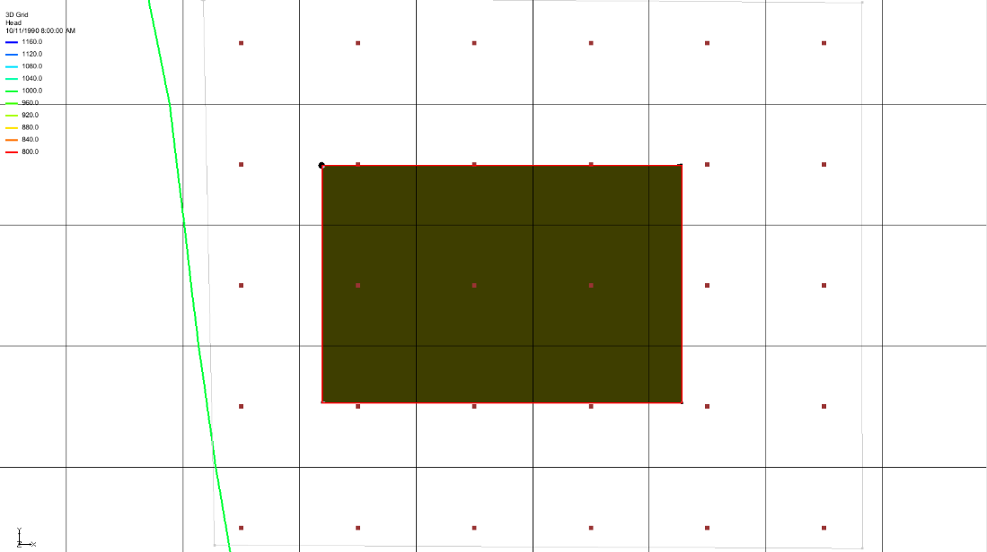

Figure 5 The polygon created from the arc, when selected

## Marking the Specified Head Arcs

The next step is to mark the specified head boundaries.

1. Using the **Select Arcs** File:GMS Select Arc Tool.svg tool, select the boundary arc of the model.
2. Click the **Properties** File:GMS Properties Macro.svg macro to open the *Attribute Table* dialog.
3. In the *Type* column, select “spec. head (CHD)” from the drop-down.
4. Click **OK** to close the *Attribute Table* dialog.

# Creating the Local MODFLOW Model

It is now possible to convert the conceptual model to a grid model. The first step is to create a new grid frame that fits the local model.

1. In the Project Explorer, right-click on the empty space and select *New |* **Grid Frame**.
2. Right-click on the “File:Grid Frame Icon.svg Grid Frame” and select **Fit to Active Coverage**.

The grid frame will resize to fit just outside the red rectangle. If needed, use the **Grid Frame** File:Select Grid Frame Tool.svg tool to reposition the frame for better alignment with the local grid boundary.

## Creating the Grid

Next, to create the grid:

1. Right-click on “File:Grid Frame Icon.svg Grid Frame” in the Project Explorer and select *Map To |* **3D Grid** to bring up the *Create Finite Difference Grid* dialog.
2. Click **OK** at the prompt to delete the existing grid.
3. Click **OK** at the prompt to delete all current MODFLOW and MODPATH data.
4. In the *X-Dimension* section, enter “60” for the *Number cells*.
5. In the *Y-Dimension* section, enter “40” for the *Number cells*.
6. In the *Z-Dimension* section, enter “5” for the *Number cells*.
7. Click **OK** to create the grid and close the *Create Finite Difference Grid* dialog.
8. **Zoom** File:Zoom Tool Icon.svg in on the newly created grid. The view should be similar to the new local grid image.

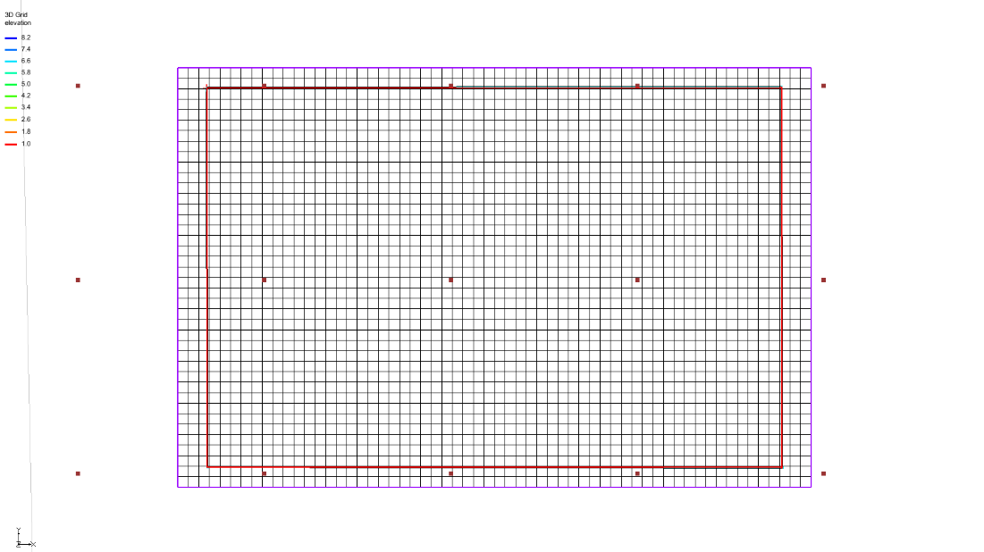

Figure 6 The new local grid

## Creating a New MODFLOW Model

Now create the new MODFLOW simulation by doing the following:

1. Select the “File:3D Grid Folder.svg 3D Grid Data” folder in the Project Explorer to make it active.
2. Select *MODFLOW* | **New Simulation…** to bring up the *MODFLOW Global/Basic Package* dialog.
3. Click **Packages…**to bring up the *MODFLOW Packages / Processes* dialog.
4. In the *Optional packages / processes* section, turn on *CHD1 – Time-Variant Specified-Head* and *RCH1 – Recharge*.
5. Select **OK** to close the *MODFLOW Packages / Processes* dialog and return to the *MODFLOW Global/Basic Package* dialog.
6. In the *Model type* section, select *Transient.*
7. Click **Stress Periods…**to bring up the *Stress Periods* dialog.
8. Enter “7” as the *Number of stress periods*.
9. Turn on *Use dates/times*.
10. From the following table, enter the times and number of time steps for the stress periods:

|  |  |  |  |  |  |  |  |  |  |  |  |  |  |  |  |  |  |  |  |  |  |  |  |  |  |  |  |
| --- | --- | --- | --- | --- | --- | --- | --- | --- | --- | --- | --- | --- | --- | --- | --- | --- | --- | --- | --- | --- | --- | --- | --- | --- | --- | --- | --- |
| |  |  |  | | --- | --- | --- | |  | Start | Num Time Steps | | **1** | 4/15/1991 12:00:00 AM | 3 | | **2** | 4/20/1991 12:00:00 AM | 4 | | **3** | 4/30/1991 12:00:00 AM | 6 | | **4** | 5/20/1991 12:00:00 AM | 10 | | **5** | 7/19/1991 12:00:00 AM | 20 | | **6** | 10/17/1991 12:00:00 AM | 30 | | **7** | 4/15/1992 12:00:00 AM | 40 | | **End** | 12/1/1993 12:00:00 AM |  | |

1. Click **OK** to exit the *Stress Periods* dialog.
2. Click **OK** to exit the *MODFLOW Global/Basic Package* dialog.

## Inactivating Cells

1. Select the “File:Map Folder.svg Map Data” folder in the Project Explorer to make it active*.*
2. Select *Feature Objects* | **Activate Cells in Coverage(s)**.
3. Click **OK** to accept the warning (if applicable).

If the arcs closely match the grid boundary, no cells may be inactivated. However, if the grid (purple) extends significantly beyond the boundary arc (red), some cells located between the grid and the arc will be inactivated (Figure 7).

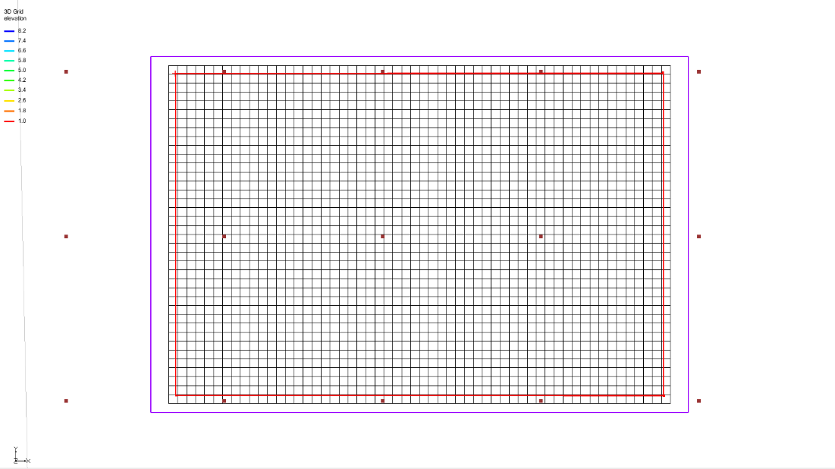

Figure 7 Cells inactivated between the grid frame and coverage boundary arc

## Mapping the Properties

To convert the MODFLOW data to the grid:

1. Right-click on the “File:Conceptual Model Icon.svg Local Model” conceptual model in the Project Explorer and select *Map To |* **MODFLOW/MODPATH** to bring up the *Map → Model* dialog.
2. Select *All applicable coverages* and click **OK** to close the *Map → Model* dialog.

The MODFLOW data will appear around the edges of the grid (Figure 8).

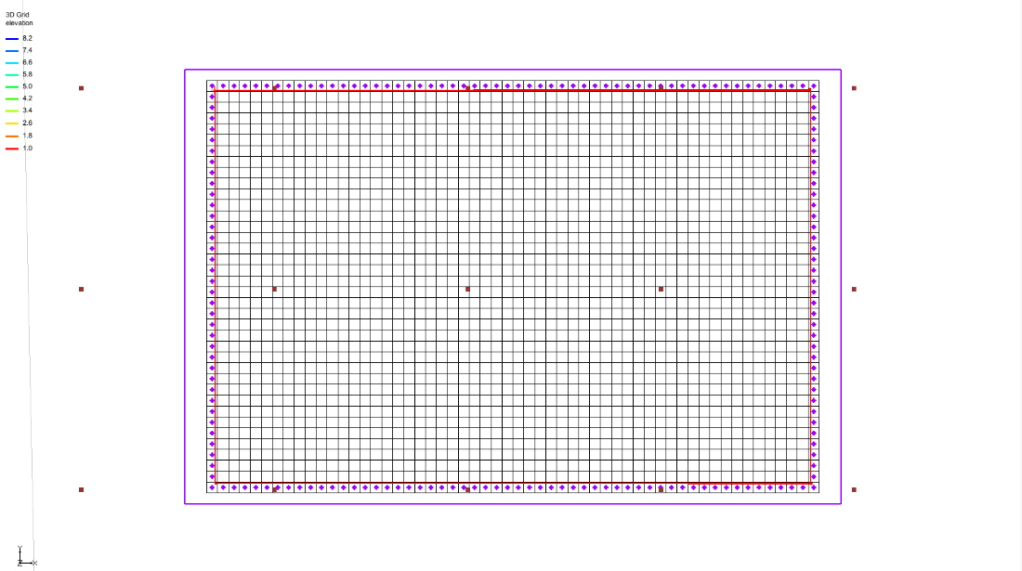

Figure 8 The MODFLOW data mapped to the grid (right next to the red boundary)

# Interpolating the Layer Data

The final step in the conversion process is to interpolate the regional data from the scatter points and to the MODFLOW layer arrays.

1. Right-click on the “File:2D Scatter Icon.svg Regional Data”scatter set in the Project Explorer and select *Interpolate To |* **MODFLOW Layers…** to open the *Interpolate to MODFLOW Layers* dialog.
2. In the *MODFLOW data* section on the right, turn on *Flow package data*, *Recharge*, and *CHD BCs*.
3. Click **Automap**.

GMS will automatically map datasets to MODFLOW layers.

1. Click **OK** to close the *Interpolate to MODFLOW Layers* dialog.

GMS will take a few moments to interpolate the scatter points to the MODFLOW arrays.

1. Once the interpolation completes, turn off “File:2D Scatter Folder.svg 2D Scatter Data” to make it easier to see the grid.

# Saving and Running the Local Model

It is now possible to save the MODFLOW model and run the simulation.

1. Select “File:3D Grid Folder.svg 3D Grid Data” to make it active.
2. Select *File* | **Save As…** to bring up the *Save As* dialog.
3. Select “Project Files (*.gpr)” from the *Save as type* drop-down.
4. Enter “locmod.gpr” for the *File name*.
5. Click **Save** to save the project under the new name and close the *Save As* dialog.
6. Select *MODFLOW* | **Run MODFLOW** to bring up the *MODFLOW* model wrapper dialog.
7. When the simulation finishes, turn on *Read solution on exit* and *Turn on contours (if not on already)*.
8. Click **Close** to exit the *MODFLOW* model wrapper dialog.

A set of head contours, closely resembling those from the regional model, should now be visible (Figure 9). At this stage, the local flow model is complete, and injection and extraction wells can be added for pump-and-treat simulations.

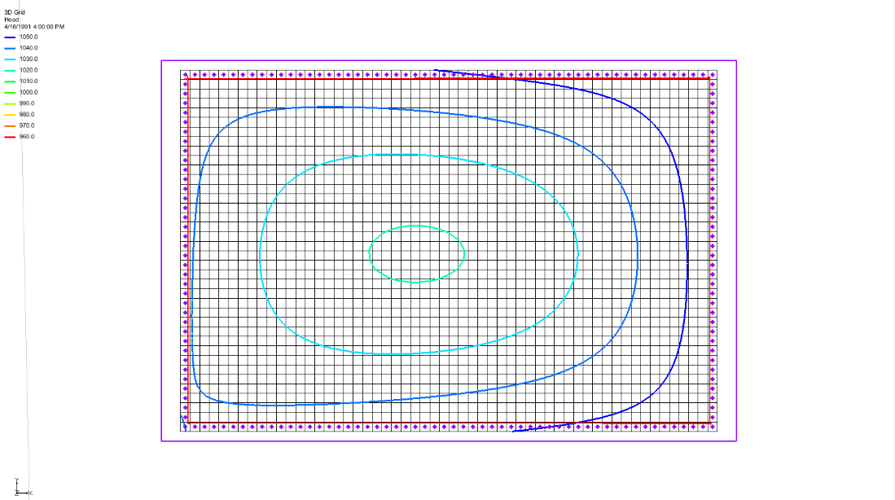

Figure 9 Contours visible after MODFLOW run

# Conclusion

This concludes the “MODFLOW – Regional-to-Local Model Conversion, Transient” tutorial. The following key concepts were discussed and demonstrated:

1. The *Grid* | **MODFLOW Layers → 2D Scatter Points…** command converts MODFLOW elevation data, flow package properties, recharge, and computed heads data into a scatter point dataset.
2. The basic steps for performing a regional-to-local model conversion in GMS are:

* Generate the regional model and compute a solution
* Use the **MODFLOW Layers → 2D Scatter Points…** command to create a scatter point set containing layer and head data from the regional model
* Create the 3D grid for the local-scale model

Interpolate the heads and layer data from the scatter points to the MODFLOW layer arrays for the local-scale model.