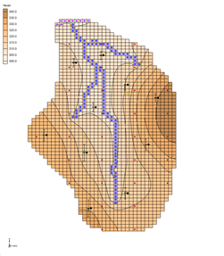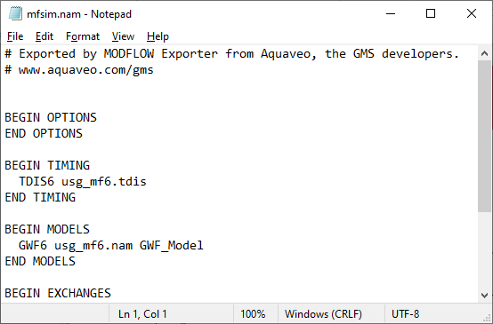

GMS 10.9

GMS 10.9 Tutorial

***MODFLOW – Saving MODFLOW 6***

Save a MODFLOW 6 Simulation in Native Text Format

Objectives

This tutorial explains how to save MODFLOW simulations in MODFLOW 6 native text format.

Time

* 25–40 minutes

Required Components

* GMS Core
* MODFLOW Interface
* Geostatistics
* Text Editor Software

Prerequisite Tutorials

* MODFLOW – Saving Native Text

|  |
| --- |
| 1 Introduction 2  1.1 Getting Started 2  2 Exporting a MODFLOW Simulation 2  2.1 Saving the Project 3  2.2 Exporting MODFLOW 6 from GMS 4  2.3 Viewing the MODFLOW 6 Text Files 4  3 MODFLOW Simulations with Unsupported Features 6  3.1 Saving the Project with MODFLOW 6 6  4 MODFLOW Simulations with Unsupported Parameters 7  4.1 Saving the Project with MODFLOW 6 8  5 Importing a MODFLOW-USG Simulation 9  5.1 Saving the Project with MODFLOW 6 9  6 Conclusion 10 |

# Introduction

MODFLOW 6 requires that older MODFLOW project files be converted into the file format it uses. GMS allows saving MODFLOW project files into the MODFLOW 6 file format. This feature is similar to the process used to save native text files.

Currently, GMS does not convert MODFLOW-LGR files to MODFLOW 6. Also, not all MODFLOW packages are supported in MODFLOW 6.

This tutorial will demonstrate:

* Exporting a MODFLOW 2000 simulation to MODFLOW 6
* Exporting a MODFLOW simulation with unsupported features or parameters to MODFLOW 6
* Exporting a MODFLOW-USG simulation to MODFLOW 6

## Getting Started

Do the following to get started:

If necessary, launch GMS.

If GMS is already running, select *File |* **New** to ensure that the program settings are restored to their default state.

# Exporting a MODFLOW Simulation

Start with importing a MODFLOW simulation. This simulation is one of the example files that ships with the USGS MODFLOW source code.

1. Click **Open** File:Open Macro.svg to bring up the *Open* dialog.
2. Select “MODFLOW Name Files (*.mfn;*.nam)” from the *Files of type* drop-down.

Browse to the *modflow6\modflow6\modfgrid* directory and select “modfgrid.mfn”*.*

Click **Open** to close the *Open* dialog and bring up the *MODFLOW Translator* dialog.

This dialog appears when importing MODFLOW native text files. The MODFLOW translator allows valid MODFLOW simulations to be imported into GMS.

Select *MODFLOW 2000* (the default option).

Click **OK** to initiate the translator.

The *MODFLOW Translator* dialog will disappear briefly then reappear to show the progress of the translation.

MODFLOW will run and export a new set of files, including an HDF5 file. GMS will work with these files, preserving the original native text model files.

When the file conversion is complete, click **Done** to close the *MODFLOW Translator* dialog.

A MODFLOW model similar to Figure 1 should appear.

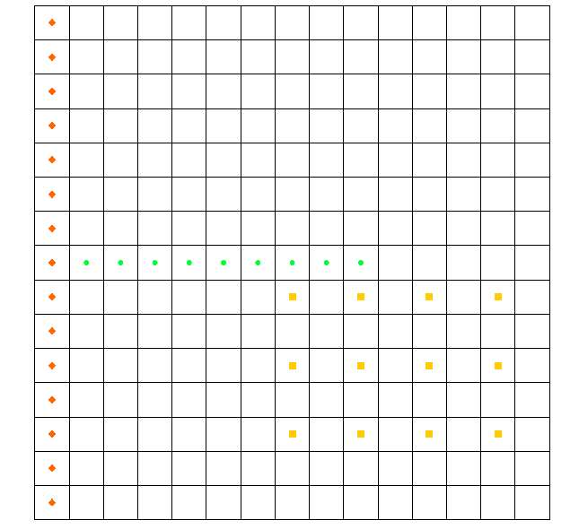

Figure Imported MODFLOW model

## Saving the Project

Now it is possible to save the project as if MODFLOW were going to be run.

1. Select *File |* **Save As…** to bring up the *Save As* dialog.

Browse to the *modflow6\modflow6* directory*.*

Select “Project Files (*.gpr)” from the *Save as type* drop-down.

Enter “modfgrid.gpr” as the *File name*.

Click **Save** to save the project and close the *Save As* dialog.

When a project is saved in GMS, a GPR file is created. The GPR file contains GMS-specific data. If a MODFLOW simulation is in the current project, then a folder is created that contains all of the MODFLOW inputs. The new folder name will use the name of the current project name with “_MODFLOW” added to the end. In this project, a new folder called “modfgrid_MODFLOW” was created.

## Exporting MODFLOW 6 from GMS

Now to export the simulation into the MODFLOW 6 native text format:

1. Select *MODFLOW |* **Global Options…** to bring up the *MODFLOW Global/Basic Package* dialog.

In the *MODFLOW version* section, turn on *Save MODFLOW 6 copy*.

Click **OK** to exit the *MODFLOW Global/Basic Package* dialog.

Select *File |* **Save** to save the project.

By turning on the *Save MODFLOW 6 copy* option, an additional set of MODFLOW input files are saved in the MODFLOW 6 text format.

## Viewing the MODFLOW 6 Text Files

The next step is to go look at the MODFLOW 6 text files that were just saved.

1. In the Project Explorer, Right-click on “File:MODFLOW Folder.svg MODFLOW” and select **Open Containing Folder…** to bring up a new window in Windows Explorer.

Browse to the *modflow6\modflow6\modfgrid_MODFLOW_mf6* directory to bring up the MODFLOW 6 text files (Figure 2).

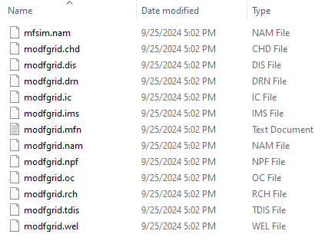

Figure Native text MODFLOW 6 files saved From GMS

Using a text editor, open the “modfgrid.mfn” file.

This file is created as the model is saved in MODFLOW 6 format. Near the bottom of the file you can see that some “NOTES” are printed. The BAS6 and LPF packages are not directly supported in MODFLOW 6. The information in these packages is contained in the IC, DIS, NPF, and STO packages. The SIP solver is also not supported in MODFLOW 6; it is replaced by the IMS package (similar to the SMS solver in MODFLOW-USG). In this case the MODFLOW 6 simulation supports all of the features of the MODFLOW 2000 model but there are other cases where certain features and packages are not supported.

Using a text editor, open the “mfsim.nam” file (Figure 3).

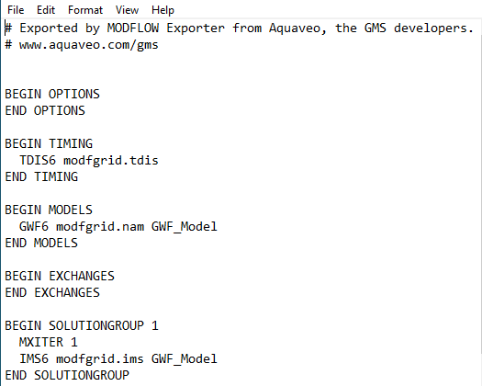

Figure MODFLOW 6 mfsim.nam text file from GMS

This file is required for all MODFLOW 6 simulations. The file must be named “mfsim.nam” and should not be renamed. Notice that the other files have the prefix modfgrid. This file has MODFLOW 6 inputs for time discretization (TDIS), groundwater models (GWF6), and the solver (IMS).

Using a text editor, open the “modfgrid.nam” name file (Figure 4).

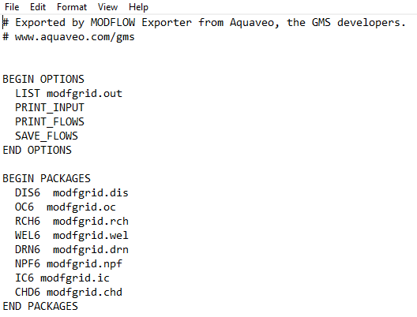

Figure MODFLOW 6 name file

This file is similar to the MODFLOW name file from previous versions. Notice the different packages that are included under the BEGIN PACKAGES section.

# MODFLOW Simulations with Unsupported Features

Now to open a simulation with features which are not supported in MODFLOW 6.

1. Select *File |* **New** to clear the current project and start a new one.
2. Click **Open** File:Open Macro.svg to bring up the *Open* dialog.
3. Select “MODFLOW Name Files (*.mfn;*.nam)” from the *Files of type* drop-down.

Browse to the *modflow6\modflow6\mnw1* directory and select “mnw1.nam”*.*

Click **Open** to close the *Open* dialog and bring up the *MODFLOW Translator* dialog.

Select *MODFLOW 2000*.

Click **OK** to initiate the translator.

The *MODFLOW Translator* dialog will disappear briefly then reappear to show the progress of the translation.

When the file conversion is complete, click **Done** to close the *MODFLOW Translator* dialog.

A MODFLOW model similar to Figure 5 should appear.

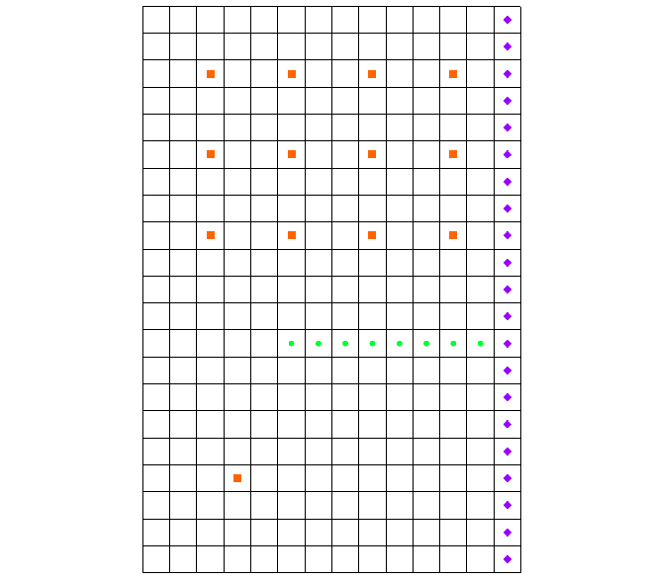

Figure Imported MODFLOW model

## Saving the Project with MODFLOW 6

Now it is possible to save the project as if MODFLOW 6 were going to be run.

1. Select *MODFLOW |* **Global Options…** to bring up the *MODFLOW Global/Basic Package* dialog.

In the *MODFLOW version* section, turn on *Save MODFLOW 6 copy*.

Click **OK** to exit the *MODFLOW Global/Basic Package* dialog.

1. Select *File |* **Save As…** to bring up the *Save As* dialog.

Browse to the *modflow6\modflow6* directory*.*

Select “Project Files (*.gpr)” from the *Save as type* drop-down.

Enter “mnw1.gpr” as the *File name*.

Click **Save** to save the project and close the *Save As* dialog.

When this model is saved in MODFLOW 6 format some errors are reported and the *MODFLOW 6 Export* dialog appears.

Scroll to the bottom of the text window in the *MODFLOW 6 Export* dialog.

Notice that the BCF package is not supported by MODFLOW 6. The BCF package cannot be converted to the NPF and STO packages. Since these packages are required for a MODFLOW 6 model, an error is reported, and the export is aborted.

Click **OK** to close the *MODFLOW 6 Export* dialog.

# MODFLOW Simulations with Unsupported Parameters

Now to open a simulation with parameters not supported by MODFLOW 6:

1. Select *File |* **New** to clear the current project and start a new one.
2. Click **Open** File:Open Macro.svg to bring up the *Open* dialog.
3. Select “MODFLOW Name Files (*.mfn;*.nam)” from the *Files of type* drop-down.

Browse to the *\modflow6\modflow6\etsdrt* directory and select “etsdrt.nam”*.*

Click **Open** to close the *Open* dialog and bring up the *MODFLOW Translator* dialog.

Select *MODFLOW 2005* (the default option).

Click **OK** to initiate the translator.

The *MODFLOW Translator* dialog will disappear briefly, then reappear to show the progress of the translation.

When the file conversion is complete, click **Done** to close the *MODFLOW Translator* dialog.

A MODFLOW model similar to Figure 6 should appear.

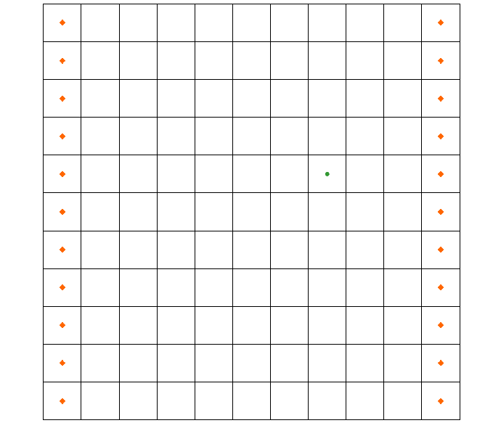

Figure Imported MODFLOW model

## Saving the Project with MODFLOW 6

Now it is possible to save the project as if MODFLOW were going to be run.

1. Select *MODFLOW |* **Global Options…** to bring up the *MODFLOW Global/Basic Package* dialog.

In the *MODFLOW version* section, turn on *Save MODFLOW 6 copy*.

Click **OK** to exit the *MODFLOW Global/Basic Package* dialog.

1. Select *File |* **Save As…** to bring up the *Save As* dialog.

Browse to the *modflow6\modflow6* directory*.*

Select “Project Files (*.gpr)” from the *Save as type* drop-down.

Enter “etsdrt.gpr” as the *File name*.

Click **Save** to save the project and close the *Save As* dialog.

When this model is saved in MODFLOW 6 format some errors are reported and the *MODFLOW 6 Export* dialog is shown.

1. Scroll to the bottom of the text window in the *MODFLOW 6 Export* dialog.

Notice that “parameters” are not supported by MODFLOW 6. Thus, an error is reported and the export is aborted.

Click **OK** to close the *MODFLOW 6 Export* dialog.

# Importing a MODFLOW-USG Simulation

Now to read in a MODFLOW-USG simulation:

1. Select *File |* **New** to clear the current project and start a new one.

Click **Open** File:Open Macro.svg to bring up the *Open* dialog.

Select “Project Files (*.gpr)” from the *Files of type* drop-down.

Browse to the *modflow6\modflow6\usg* directory and select “usg.gpr”.

Click **Open** to import the file and close the *Open* dialog**.**

A model similar to Figure 7 should appear.

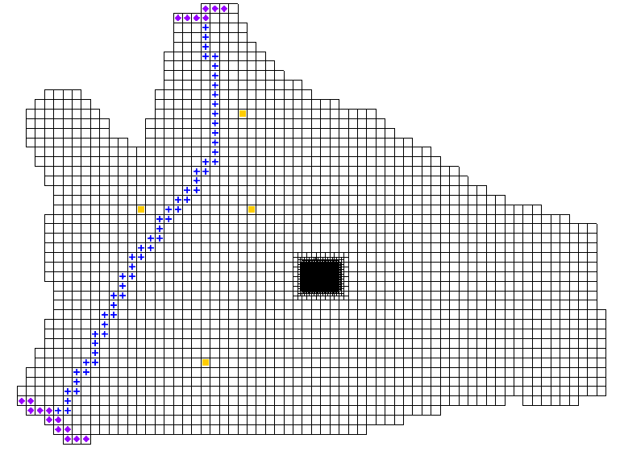

Figure MODFLOW-USG model with pilot points

## Saving the Project with MODFLOW 6

Now it is possible to save the project as if MODFLOW were going to be run.

1. Select *MODFLOW |* **Global Options…** to bring up the *MODFLOW Global/Basic Package* dialog.

In the *MODFLOW version* section, turn on *Save MODFLOW 6 copy*.

Click **OK** to exit the *MODFLOW Global/Basic Package* dialog.

1. Select *File |* **Save As…** to bring up the *Save As* dialog.

Browse to the *modflow6\modflow6* directory*.*

Select “Project Files (*.gpr)” from the *Save as type* drop-down.

Enter “usg_mf6.gpr” as the *File name*.

Click **Save** to save the project and close the *Save As* dialog.

This simulation saves without any errors or warnings because MODFLOW 6 supports all of the packages in this model. Further, this type of grid can be represented by the DISV package in MODFLOW 6.

# Conclusion

This concludes the “MODFLOW – Saving MODFLOW 6” tutorial. The following topics were discussed and demonstrated:

* MODFLOW 2000, 2005, NWT, USG can be saved to MODFLOW 6.
* Not all MODFLOW 2000, 2005, NWT, USG packages are supported by MODFLOW 6.