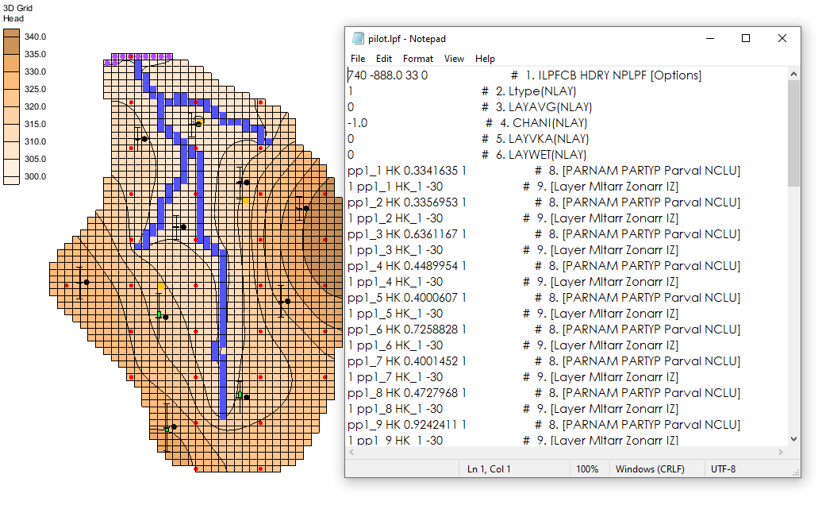

GMS 10.9

GMS 10.9 Tutorial

***MODFLOW –*** ***Saving Native Text***

Save a MODFLOW Simulation in Native Text Format

Objectives

This tutorial explains how to save MODFLOW simulations in MODFLOW's native text format. GMS provides functionality that saves native text files which include MODFLOW documentation. These files are easy to read and clarify the contents of the file.

Time

* 25–40 minutes

Required Components

* GMS Core
* MODFLOW Interface
* Text Editor Software

Prerequisite Tutorials

* MODFLOW ‒ Grid Approach

|  |
| --- |
| 1 Introduction 2  1.1 Getting Started 2  2 Importing the Simulation 2  2.1 Saving the Project 3  2.2 Viewing MODFLOW Files 4  2.3 Exporting Native Text from GMS 6  2.4 Viewing the Native Text Files 7  3 Importing the Simulation with Parameters 8  3.1 Exporting Native Text from GMS 10  3.2 Viewing the Native Text 10  4 Importing the Simulation with Pilot Points 11  4.1 Exporting Native Text from GMS 12  4.2 Viewing the Native Text 13  4.3 Exporting Native Text from GMS with External Arrays 15  5 Conclusion 16 |

# Introduction

GMS uses a modified version of MODFLOW that can read data from HDF5[1] files. Large portions of the MODFLOW inputs are stored in an HDF5 file when creating a MODFLOW model in GMS. Large MODFLOW models are stored more efficiently using HDF5. Compression ratios of 95% are common when compared to text files. The read/write times for HDF5 files are also much faster.

Even though using HDF5 files with MODFLOW is extremely efficient, many users prefer to also save MODFLOW simulations in the native MODFLOW format. This is particularly true when archiving a completed modeling project.

Native MODFLOW text files can be saved from GMS. Since GMS version 10.0, these text files contain documentation comments that more clearly identify the contents of each line in the MODFLOW input file. Parameter definitions are also included in the text files.[2] This tutorial discusses and demonstrates the native text exporting options available in GMS using various MODFLOW simulations (including one with parameters and one with pilot points), as well as changing the array saving options before saving the simulation in native text format.

## Getting Started

Do the following to get started:

If necessary, launch GMS.

If GMS is already running, from the menu bar, select *File |* **New** to ensure that the program settings are restored to their default state.

# Importing the Simulation

Start by importing a MODFLOW simulation. This simulation is one of the example files that ships with the USGS MODFLOW source code.

1. From the Macro Bar, click **Open** File:Open Macro.svg to bring up the *Open* dialog.
2. From the *Files of type* drop-down, select “MODFLOW Name Files (*.mfn;*.nam)”.

Browse to the *text\text\mnw1* directory and select “mnw1.nam”*.*

Click the **Open** button to close the *Open* dialog and bring up the *MODFLOW Translator* dialog.

This dialog appears when importing MODFLOW native text files. When the **OK** button is clicked, MODFLOW will run and export a new set of files, including an HDF5 file. GMS will work with these files, preserving the original native text model files. The MODFLOW translator allows valid MODFLOW simulations to be imported into GMS.

Select the *MODFLOW 2000* (the default option) radio button.

Click the **OK** button to initiate the translator. The *MODFLOW Translator* dialog will disappear briefly, then reappear to show the progress of the translation.

When the file conversion is complete, click the **Done** button to close the *MODFLOW Translator* dialog.

A MODFLOW model similar to Figure 1 should appear.

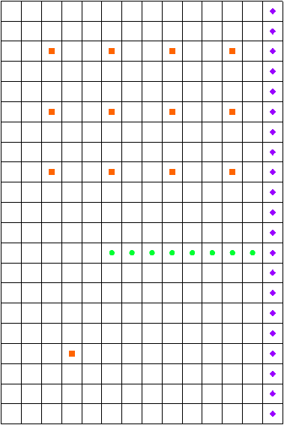

Figure 1: Imported MODFLOW model

## Saving the Project

Now it is possible to save the project as if MODFLOW were going to be run.

1. From the Menu Bar, select *File |* **Save As…** to bring up the *Save As* dialog.

Browse to the *text\text* directory*.*

From the *Save as type* drop-down, select “Project Files (*.gpr)”.

Enter “mnw1.gpr” as the *File name*.

Click the **Save** buttonto save the project and close the *Save As* dialog.

When a project is saved in GMS, a GPR file is created. The GPR file contains GMS-specific data. If a MODFLOW simulation is in the current project, then a folder is created that has all of the MODFLOW inputs. The new folder name will use the name of the current project name with “_MODFLOW” added to the end. In this project, a new folder called “mnw1_MODFLOW” was created.

## Viewing MODFLOW Files

To quickly view the MODFLOW input files, do the following:

1. In the Project Explorer, expand the “File:3D Grid Folder.svg 3D Grid Data” folder and the “File:3D Grid Icon.svg grid” item, by clicking on the plus buttons next to each folder.
2. Right-click on the “File:MODFLOW Folder.svg MODFLOW” item and select the **Open Containing Folder…** context menu item to bring up a new window in Windows Explorer.

A file browser showing the directory where the MODFLOW files are stored will appear. Files similar to those in Figure 2 should be present.

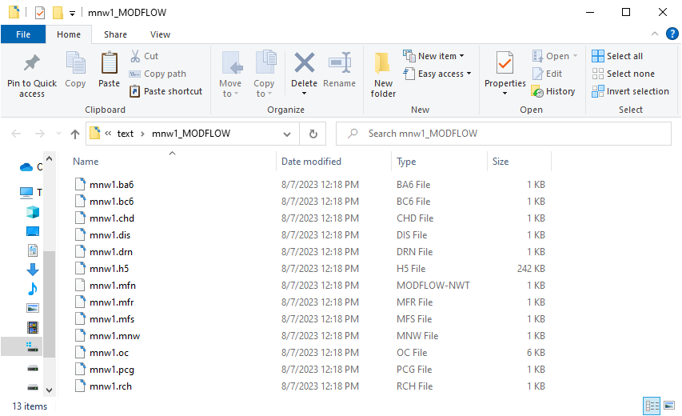

Figure 2: MODFLOW input files saved from GMS

All of the files in this directory are text files except for the “mnw1.h5” file. The next step is to examine the contents of the files.

Using a text editor, open the “mnw1.bc6” file.

This is the BCF package file. This file contains information on the hydraulic properties of the grid cells (Figure 3). Notice the lines that begin with “HDF5”. When MODFLOW reads these lines, it will get data from the “mnw1.h5” file. The lines are arrays that define the aquifer properties (storage, hydraulic conductivity, and transmissivity).

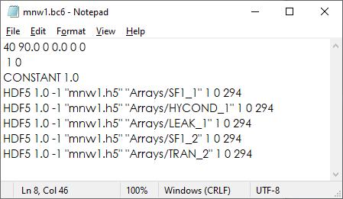

Figure 3: MODFLOW BCF package file saved from GMS

There are many free viewers available to browse the contents of HDF5 files. Figure 4 shows “mnw1.h5” as seen in HDFView[3], an application provided by the developers of HDF5 which allows viewing and editing of HDF5 files.

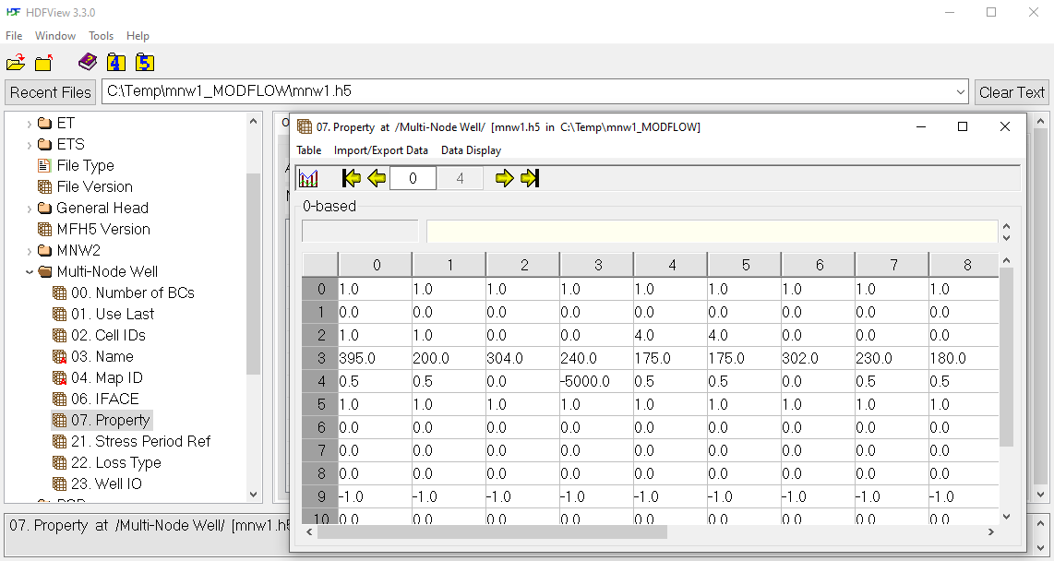

Figure 4: HDFView of “mnw1.h5”

Now to look at the original MODFLOW files. The original BCF file contains similar information as in the BC6 file. However, the information is in a different format.

In the Project Explorer, expand the “File:3D Grid Folder.svg 3D Grid Data” folder and the “File:3D Grid Icon.svg grid” item, by clicking on the plus buttons next to each folder.

Right-click on the “File:MODFLOW Folder.svg MODFLOW” item and select the **Open Containing Folder…** context menu item to bring up a new window in Windows Explorer.

Browse to the *text\text\mnw1* directory.

This is the directory containing the original MODFLOW files. Files similar to those in Figure 5 should be present.

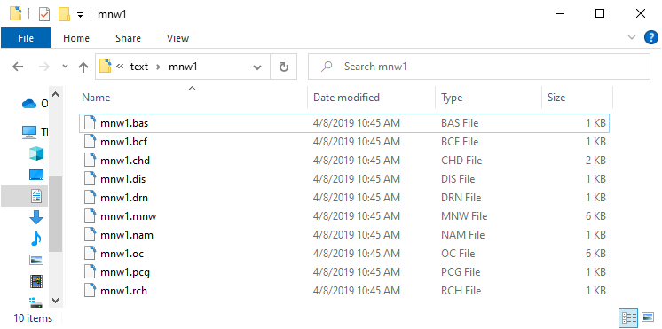

Figure 5: Original MODFLOW input files

Using a text editor, open “mnw1.bcf”(Figure 6).

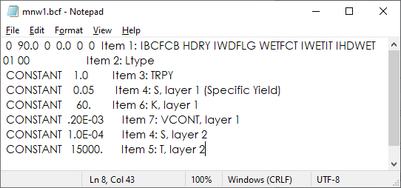

Figure 6: MODFLOW BCF file

When the two files are compared, notice that the numbers on lines 1 and 2 of the file are the same. However, in the original files, some text is on the right side of the file. MODFLOW will ignore this text because it is only expecting to read numbers on those lines. Also notice that instead of referencing an HDF5 file for the aquifer properties, the values for these arrays are listed in this file.

## Exporting Native Text from GMS

Now to export the simulation in MODFLOW native text format:

1. Close the text editor and Windows Explorer windows and return to GMS.

From the Menu Bar, select the *MODFLOW |* **Global Options…** menu item to bring up the *MODFLOW Global/Basic Package* dialog.

In the *MODFLOW version* section, turn on the *Save native text copy* check box.

Click the **OK** button to exit the *MODFLOW Global/Basic Package* dialog.

From the Menu Bar, select *File |* **Save** to save the project.

By turning on the *Save native text copy* option, an additional set of MODFLOW input files are saved in the native text format.

## Viewing the Native Text Files

The next step is to go look at the BCF package file in the native text files that were just saved.

1. In the Project Explorer, expand the “File:3D Grid Folder.svg 3D Grid Data” folder and the “File:3D Grid Icon.svg grid” item, by clicking on the plus buttons next to each folder.
2. Right-click on the “File:MODFLOW Folder.svg MODFLOW” item and select the **Open Containing Folder…** context menu item to bring up a new window in Windows Explorer.

Browse to the *text\text\mnw1_MODFLOW_text* directory to bring up the MODFLOW native text files (Figure 7).

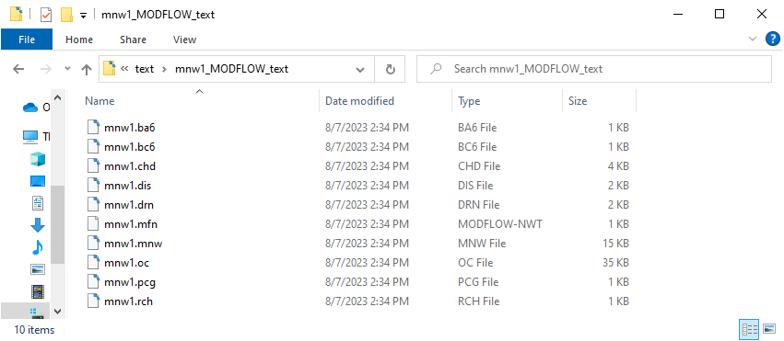

Figure 7: Native text MODFLOW files saved from GMS

Using a text editor, open the “mnw1.bc6” file (Figure 8).

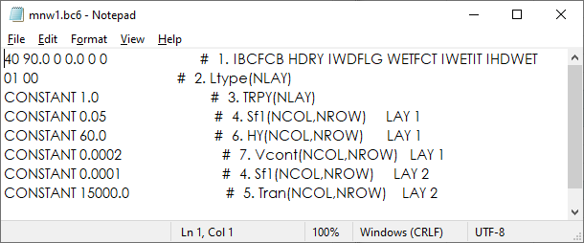

Figure 8: MODFLOW BCF file saved in native text format from GMS

Notice that this file is very similar to the original MODFLOW text file. There are some minor differences such as the format of the numbers. Look at the comments on the right side of the file. These all begin with the “#” symbol. The number on this line indicates the MODFLOW input dataset number for the BCF file.

After the number, notice the documented variable name that is read from this line. These dataset numbers and variable names come straight from the MODFLOW documentation so they will be those mentioned in the Online Guide to MODFLOW BCF documentation (Figure 9).[4] Notice the dataset numbers and the variable names. These are the items written in the comments on the right side of the BCF file shown above.

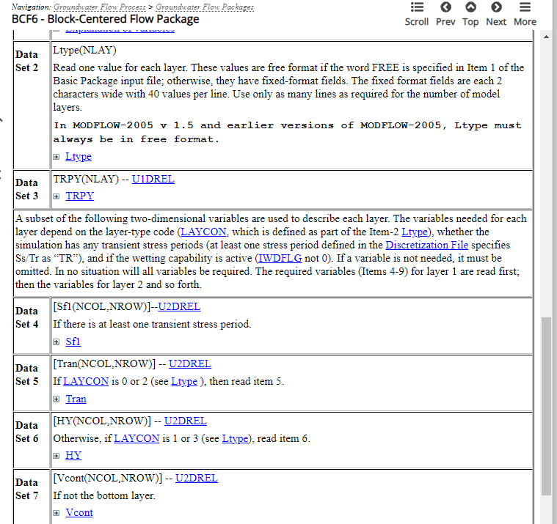

Figure 9: Online Guide to MODFLOW

Feel free to view some of the other MODFLOW input files at this point. When finished, close the text editors and file browser and return to GMS.

# Importing the Simulation with Parameters

Now it is necessary to import another MODFLOW simulation that has parameters.

1. From the Menu Bar, select *File |* **New** to clear the current project and start a new one.

From the Macro Bar, click **Open** File:Open Macro.svg to bring up the *Open* dialog.

From the *Files of type* drop-down, select “MODFLOW Name Files (*.mfn;*.nam)”.

Browse to the *text\text\etsdrt* directory and select “etsdrt.nam”*.*

Click the **Open** button to close the *Open* dialog and bring up the *MODFLOW Translator* dialog.

Select the *MODFLOW 2005* radio button as the version to use and click the **OK** button to initiate the translator.

Once the translator is finished, click the **Done** button to close the *MODFLOW Translator* dialog.

A MODFLOW model similar to Figure 10 should be visible.

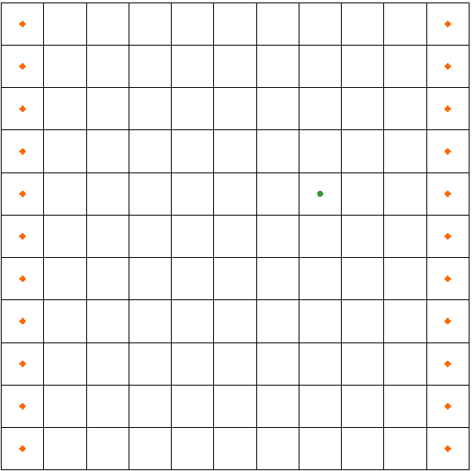

Figure 10: MODFLOW model of the etsdrt simulation

From the Menu Bar, select the *MODFLOW |* **Parameters…** menu item to bring up the *Parameters* dialog.

Four parameters imported as part of the simulation will be visible (Figure 11).

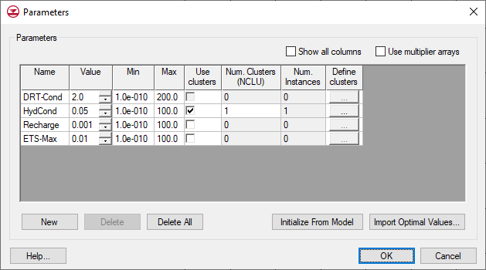

Figure 11: MODFLOW parameters

1. Click the **OK** button to exit the *Parameters* dialog.

When exporting the native text files, the parameters will be included in the text files as well.

## Exporting Native Text from GMS

To save this simulation in native text format, do the following:

1. From the Menu Bar, select the *MODFLOW |* **Global Options…** menu item to bring up the *MODFLOW Global/Basic Package* dialog.

In the *MODFLOW version* section, turn on the *Save native text copy* check box.

Click the **OK** button to exit the *MODFLOW Global/Basic Package* dialog.

From the menu bar, select *File |* **Save As…** to bring up the *Save As* dialog.

From the *Save as type* drop-down, select “Project Files (*.gpr)”.

Browse to the *text\text* directory*.*

Enter “etsdrt.gpr” as the *File name*.

Click the **Save** button to export the files and close the *Save As* dialog.

## Viewing the Native Text

Now to view the text files to see how the parameters were included in the files:

1. In the Project Explorer, expand the “File:3D Grid Folder.svg 3D Grid Data” folder and the “File:3D Grid Icon.svg grid” item, by clicking on the plus buttons next to each folder.
2. Right-click on the “File:MODFLOW Folder.svg MODFLOW” item and select the **Open Containing Folder…** context menu item to bring up a new window in Windows Explorer.

Browse to the *text\text\etsdrt_MODFLOW_text* directory.

The files shown in Figure 12 should be present.

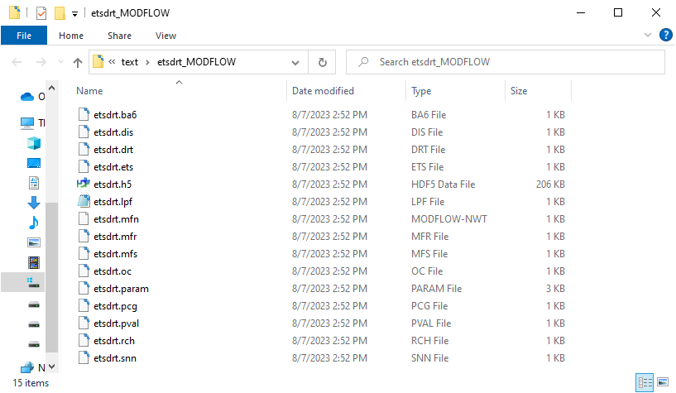

Figure 12: MODFLOW native text files

Now to look at some of the files that have parameters defined. The ETS, DRT, RCH, and LPF packages all have parameters defined. First look at the ETS package.

Using a text editor, open the “etsdrt.ets” file ( Figure 13).

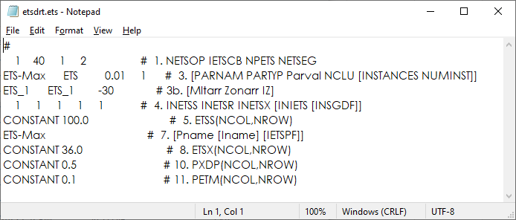

Figure 13: ETS package file

Notice that the parameter “ETS-Max” has been included in the file (see lines 3 and 7). Now to look at the DRT file.

Using a text editor, open the “etsdrt.drt” file.

The file should look like Figure 14.

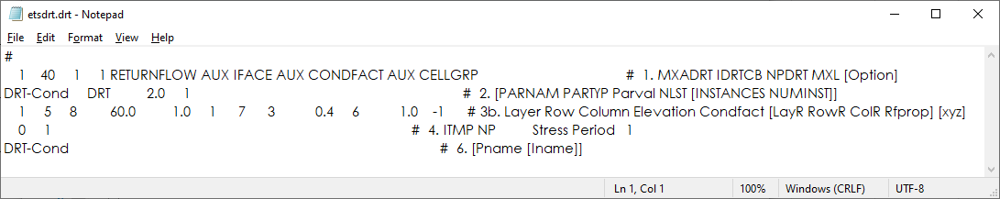

Figure 14: DRT package file

Notice lines 2, 3b, and 6. These lines define the parameter and its usage in the simulation. Also notice that the total width of the text in this file is much greater than the text in other files previously examined. The documentation comments are all aligned on the right side of the file and a small buffer is placed between the comments and the MODFLOW inputs. This makes reading the documentation easier than with non-aligned comments.

# Importing the Simulation with Pilot Points

Now to read in a MODFLOW simulation that uses pilot points[5] with an array parameter:

1. From the Menu Bar, select the *File |* **New** menu item to clear the current project and start a new one.

From the Macro Bar, click **Open** File:Open Macro.svg to bring up the *Open* dialog.

From the *Files of type* drop-down, select “Project Files (*.gpr)”.

Browse to the *text\text\pilot* directory and select “pilot.gpr”.

Click the **Open** button to import the file and close the *Open* dialog**.**

A model similar to Figure 15 should appear.

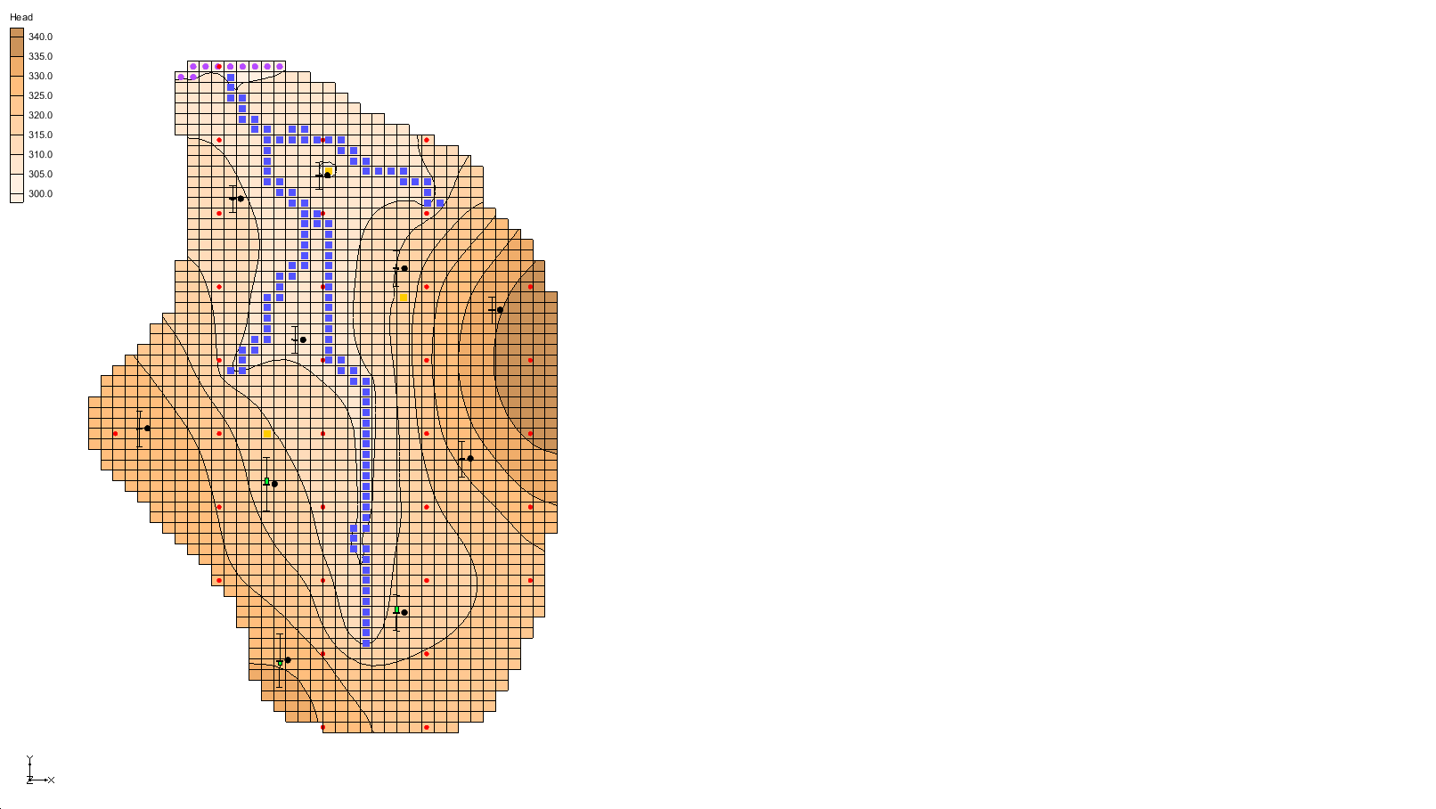

Figure 15: MODFLOW model with pilot points

## Exporting Native Text from GMS

To save this simulation in native text format, do the following:

1. From the Menu Bar, select the *MODFLOW |* **Global Options…** menu item to bring up the *MODFLOW Global/Basic Package* dialog.

Notice that the *Save native text copy* option is not available in the *MODFLOW version* section. This option will only work when *Forward* is selected in the *Run options* section. Typically, a model calibration would be completed, then a final forward run model would be completed with the calibrated parameter values. The native text would then be exported. With the stochastic option, a switch back to a forward run is necessary in order to save the native text.

In the *Run options* section, select the *Forward* radio button.

In the *MODFLOW version* section, turn on the *Save native text copy* check box.

Click the **OK** button to exit the *MODFLOW Global/Basic Package* dialog.

From the Menu Bar, select the *File |* **Save As…** menu item to bring up the *Save As* dialog.

From the *Save as type* drop-down, select “Project Files (*.gpr)”.

Browse to the *text\text* directory*.*

As the *File name,* enter “pilot.gpr”.

Click the **Save** button to export the files and close the *Save As* dialog.

## Viewing the Native Text

Now view the text files and see how the parameters were included in the files.

1. In the Project Explorer, expand the “File:3D Grid Folder.svg 3D Grid Data” folder and the “File:3D Grid Icon.svg grid” item, by clicking on the plus buttons next to each folder.

Right-click on “File:MODFLOW Folder.svg MODFLOW” and select the **Open Containing Folder…** context menu item to bring up a Windows Explorer window.

Browse to the *text/text/pilot_MODFLOW_text* directory.

The files shown in Figure 16 should be present.

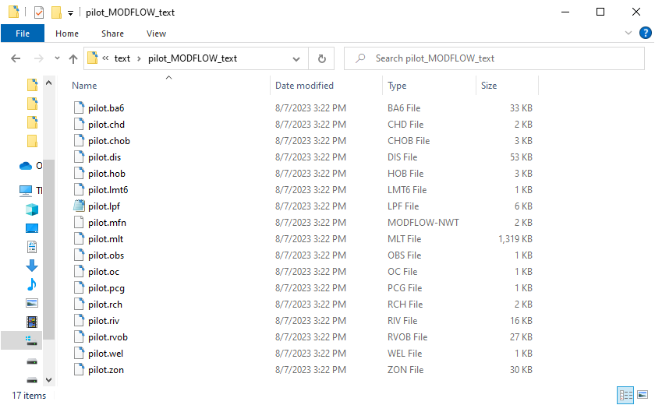

Figure 16: MODFLOW native text files

Now to review some of the files that are related to the pilot points, beginning with the LPF package:

Using a text editor, open the “pilot.lpf” file (Figure 17).

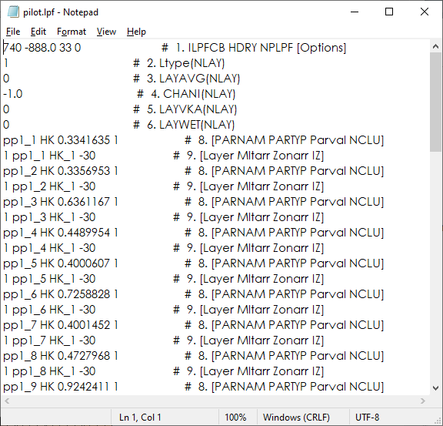

Figure 17: LPF package file

Notice that many of the lines in the file have the 8 and 9 line numbers. These lines define the pilot point parameters. The pilot point parameters are named pp#_#, where the first # is the index of the pilot point set (it is possible to have multiple sets of pilot point parameters) and the second # is an index for the point number.

The next file to review is the multiplier file. This is where the multiplier arrays related to each pilot point are written.

Using a text editor, open the “pilot.mlt” file (Figure 18).

A multiplier array is created for each pilot point. When MODFLOW runs, the value at each point is multiplied by its multiplier array, resulting in one array for each pilot point. All of these arrays are then combined (added together) to create the final value at each cell. Looking at text files with array data can be difficult since the arrays contain such large amounts of data.

GMS has export options to allow arrays to be external from the MODFLOW package files. One of these options is demonstrated here.

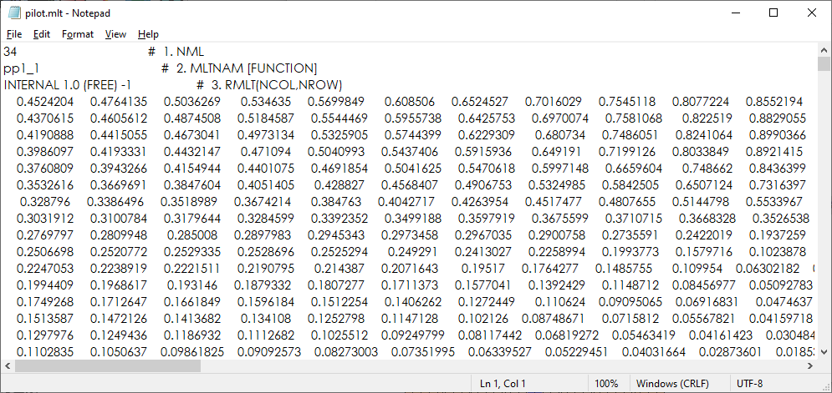

Figure 18: MLT package file

## Exporting Native Text from GMS with External Arrays

The next step is to save this simulation in native text format again with external arrays.

1. In GMS, from the Menu Bar, select the *Edit |* **Preferences…** menu item to bring up the *Preferences* dialog.

Select “MODFLOW” from the list on the left.

Turn on the *Save copy of MODFLOW simulation in native text format* checkbox.

From the drop-down, select “Write external arrays to ‘arrays’ folder”

Click the **OK** button to exit the *Preferences* dialog.

From the Menu Bar, select the *File |* **Save** menu item to export the files.

Return to the Windows Explorer window where the native text files are shown. A new directory called “arrays” should have been created. First, look at the MLT file again and then it will be possible to examine the arrays that were created in the “arrays” folder.

Using a text editor, open the “pilot.mlt” file.

Instead of seeing large amounts of floating-point numbers in this file, there are simply references to external files (Figure 19). This is accomplished through the “OPEN/CLOSE” statement on each row in the file. Notice the format of the names of the array files. External arrays are placed in their own text files and are named using the following pattern: “myProject_array_PACKAGE_VARIABLE_LAYERorSP”.

In this example, the first pilot point multiplier array is named “pilot_array_MLT_pp1_1.txt”. So “pilot” is the project name. “MLT” is the package. And “pp1” is the variable (or parameter). Lastly, “1” refers to the pilot point index. Here are two more examples:

* The ibound array for layer 1 would have the following name: “myProject_array_BAS_IBOUND_1.txt”.
* The recharge array for stress period 3 would have the following name: “myProject_array_RCH_RECH_3.txt”.

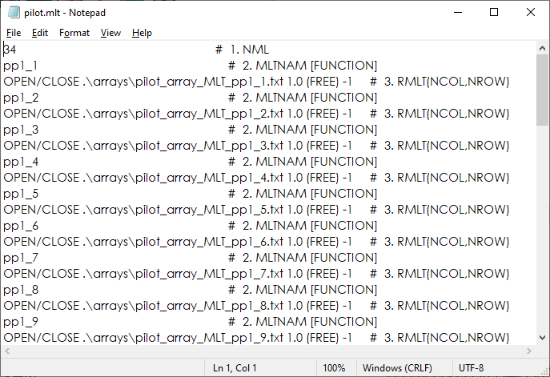

Figure 19: MLT package file with external arrays

Return to Windows Explorer and open the *arrays* directory. Notice the external arrays created when the native text files were saved.

To export the arrays, it was necessary to turn on a preference that will remain turned on in any new GMS project unless it is reset. To reset this preference setting:

1. In GMS, from the Menu Bar, select the *Edit |* **Preferences…** menu item to bring up the *Preference* dialog.

Select “MODFLOW” from the list on the left.

Turn off the *Save copy of MODFLOW simulation in native text format* checkbox.

Click the **OK** button to exit the *Preference* dialog.

# Conclusion

This concludes the “MODFLOW – Saving Native Text” tutorial. The following topics were discussed and demonstrated:

* HDF5 is a binary, cross-platform file format.
* GMS stores most of the MODFLOW data in an HDF5 file.
* GMS can export native text format MODFLOW files.
* Native text format MODFLOW files from GMS also include useful documentation comments.
* It is possible to export native text format MODFLOW files from GMS with external arrays.

1. See <https://www.hdfgroup.org>. HDF5 is a binary, cross-platform file format for storing data.
2. Earlier versions of GMS also exported native text files, but these files only removed references to the HDF5 file. No documenting comments and parameters were written to the text files.
3. See <http://www.hdfgroup.org/products/java/hdf-java-html/hdfview/>
4. See <http://water.usgs.gov/nrp/gwsoftware/modflow2000/MFDOC/index.html?bcf.html>
5. Pilot points are used with PEST as part of automated model calibration. To learn more about pilot points, complete the” MODFLOW – PEST Pilot Points” tutorial.