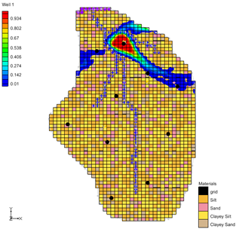

GMS 10.9

GMS 10.9 Tutorial

***MODFLOW – Stochastic Modeling, Inverse***

Use PEST to calibrate multiple MODFLOW simulations using material sets

Objectives

This tutorial will show how to use the stochastic inverse modeling option for MODFLOW and calibrate multiple MODFLOW models with equally probable “realizations” of the aquifer stratigraphy. This approach is demonstrated using the LPF and HUF packages.

Time

* 45–60 minutes

Required Components

* GMS Core
* MODFLOW Interface
* PEST
* Parallel PEST
* Stochastic & T-PROGS

Prerequisite Tutorials

* MODFLOW – Advanced PEST
* MODFLOW – Stochastic Modeling, Indicator Simulations

|  |
| --- |
| 1 Introduction 2  2 Getting Started 3  2.1 Importing the Project 3  2.2 Reviewing the MODFLOW Model Data 4  3 Selecting the Stochastic Option 5  3.1 Saving the Project and Running MODFLOW 5  3.2 Importing and Viewing the MODFLOW Solutions 6  4 Using PEST SVD Assist 7  4.1 Saving the Project and Running MODFLOW 8  4.2 Importing and Viewing the MODFLOW Solutions 8  4.3 Probabilistic Capture Zones 8  5 Stochastic Inverse with HUF 9  5.1 Importing and Viewing the MODFLOW Solutions 10  6 Conclusion 12 |

# Introduction

GMS supports three methods for performing stochastic simulations: parameter randomization, indicator simulations, and PEST Null Space Monte Carlo. This tutorial will use the indicator simulation approach in conjunction with PEST to create multiple calibrated MODFLOW models. The former approach is described in a separate tutorial.

The indicator simulation approach allows for generation of multiple, equally probable realizations of the aquifer stratigraphy. These realizations represent different distributions of material (indicator) zones within the aquifer. A set of aquifer properties is associated with the materials and the model is run once for each of the *N* realizations.

In GMS, the multiple realizations of the aquifer heterogeneity are typically generated using the T-PROGS software. T-PROGS can be used to generate two types of output: multiple material sets (arrays of material IDs), or multiple MODFLOW HUF input sets. For this tutorial, a pre-defined set of material sets generated by T-PROGS will be used. The steps involved in running a T-PROGS simulation are described in the “T-PROGS” tutorial.

A groundwater model for a medium-sized basin is shown in Figure 1. The basin encompasses 72.5 square kilometers. It is in a semi-arid climate, with average annual precipitation of 0.381 m/yr. Most of this precipitation is lost through evapotranspiration. The recharge that reaches the aquifer eventually drains into a small stream at the center of the basin.

This stream drains to the north and eventually empties into a lake with an elevation of 304.8 m. Three wells in the basin extract water from the aquifer. The perimeter of the basin is bounded by low permeability crystalline rock. There are ten observation wells in the basin and a stream flow gauge at the bottom end of the stream.

This tutorial will discuss and demonstrate opening a MODFLOW model using the LPF package, running PEST in stochastic inverse mode, and running Parallel PEST with SVD Assist in stochastic inverse mode. It will then show how to view probabilistic capture zones, open a MODFLOW model using the HUF package, and running PEST in stochastic inverse mode.

Multiple realizations of the aquifer properties have been generated.

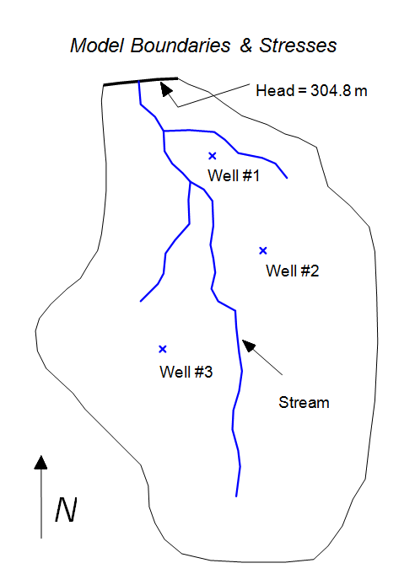

Figure 1 Sample model used in calibration exercise

# Getting Started

Do the following to get started:

1. If necessary, launch GMS.

If GMS is already running, select *File |* **New** to ensure that the program settings are restored to their default state.

## Importing the Project

First, import a project containing the MODFLOW model and the material sets generated by T-PROGS:

1. Click **Open** File:Open Macro.svg to bring up the *Open* dialog.
2. Select “Project Files (*.gpr)” from the *Files of type* drop-down.

Browse to the *sto_inv_matset\sto_inv_matset* directory and select “lpf.gpr”.

Click **Open** to import the project and exit the *Open* dialog.

A one layer MODFLOW model showing a four-material distribution should be visible (Figure 2).

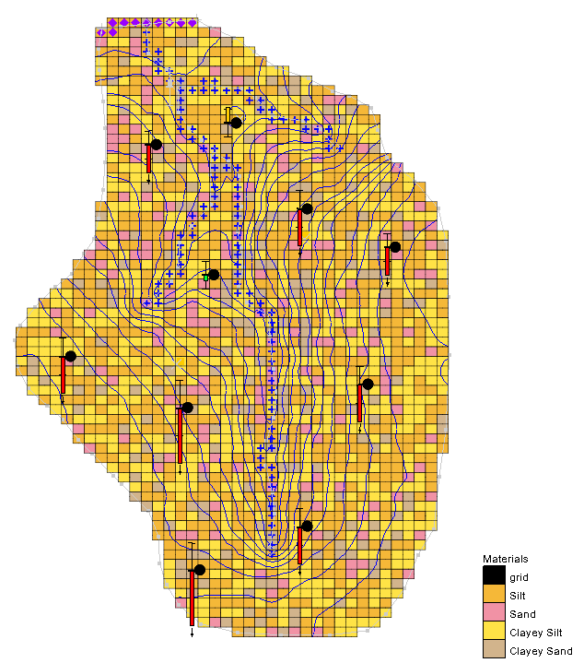

Figure 2 The initial one layer MODFLOW model

Now view the different material sets generated by T-PROGS:

Fully expand the “File:3D Grid Folder.svg 3D Grid Data” folder in the Project Explorer:

Select the “File:Materials Display Options.svg TPROGS 1” material set, then use the up and down arrow keys on the keyboard to cycle through the material sets.

## Reviewing the MODFLOW Model Data

Most of the MODFLOW data for the model (boundary conditions, well pumping rate, top and bottom elevations, etc.) has already been entered. Before continuing, review the MODFLOW data that are somewhat more unique to this type of simulation.

1. Select *MODFLOW* | **LPF – Layer Property Flow…**to open the *LPF Package* dialog.

At the top of the dialog, notice that the *Use material IDs* option is selected for the *Layer property entry method*. This means that an array of *K* (hydraulic conductivity) values will not be entered, as is normally the case with MODFLOW. Instead, material IDs will be used to define the *K* values.

Click **Material IDs…** to open the *Materials* dialog.

This dialog illustrates the material IDs assigned to cells. These material IDs are inherited from the active material set generated by T-PROGS.

Click **OK** to exit the *Materials* dialog.

Click **Material Properties…** to open the *Materials* dialog.

This dialog is used to assign aquifer properties, including hydraulic conductivity, to each of the materials used by the model. Notice that a key value has been assigned in the *Horizontal k (m/d)* column for each material. Defined parameters are also being used with the materials. When the MODFLOW model is saved, GMS uses the array of material IDs, the list of material properties, and the parameters to automatically generate the array of *K* values required by MODFLOW.

Click **OK** to exit the *Materials* dialog.

Click **OK** to exit the *LPF Package* dialog.

Select *MODFLOW |* **Parameters…** to open the *Parameters* dialog.

Notice that the dialog lists four parameters that correspond to the four materials that are assigned to the model grid.

Click **OK** to exit the *Parameters* dialog.

# Selecting the Stochastic Option

Before running MODFLOW, turn on the appropriate stochastic simulation options. First, select the stochastic inverse run option:

1. Select *MODFLOW* | **Global Options…** to open the *MODFLOW Global/Basic Package* dialog.

In the *Run options* section, select the *Stochastic Inverse*.

Click **OK** to exit the *MODFLOW Global/Basic Package* dialog.

Next, specify the use of the material set method (as opposed to HUF set) in the stochastic simulation. When choosing the material set option, specify the desired group (folder) of material sets to use. In this case, use the “TPROGS” folder that has only two simulations.

Select *MODFLOW* | **Stochastic…** to bring up the *Stochastic Options* dialog.

In the *Simulation Method* section, select *Material sets*.

Select “TPROGS” from the *Material sets* drop-down.

Click **OK** to exit the *Stochastic Options* dialog.

## Saving the Project and Running MODFLOW

Now save the project and run MODFLOW in stochastic mode.

1. Select *File* | **Save As…** to bring up the *Save As* dialog.
2. Select “Project Files (*.gpr)” from the *Save as type* drop-down.

Enter“lpf_sto.gpr” as the *File name*.

Click **Save** to save the project under the new name and close the *Save As* dialog.

Select *MODFLOW* | **Run MODFLOW** to bring up the *MODFLOW/PEST Parameter Estimation* dialog.

PEST and MODFLOW are now running in stochastic inverse mode. As each model run finishes, the spreadsheet on the lower right will indicate the number of PEST iterations, the model error, and the parameter values. Depending on the speed of the computer, the simulation may take several minutes to complete.

## Importing and Viewing the MODFLOW Solutions

Once all the MODFLOW runs are completed, import the solutions.

1. Turn on *Read solution on exit* and *Turn on contours (if not on already)*.

Click **Close** to close the *MODFLOW/PEST Parameter Estimation* dialog and bring up the *Reading Stochastic Solutions* dialog.

Click **OK** to close the *Reading Stochastic Solutions* dialog and import the solutions.

Fully expand the new “File:Generic Folder.svg lpf_sto (MODFLOW)(STO)” folder in the Project Explorer.

Select the “File:Generic Folder Locked.svg lpf_sto001 (MODFLOW)” solution in the Project Explorer.

The model should appear similar to Figure 3.

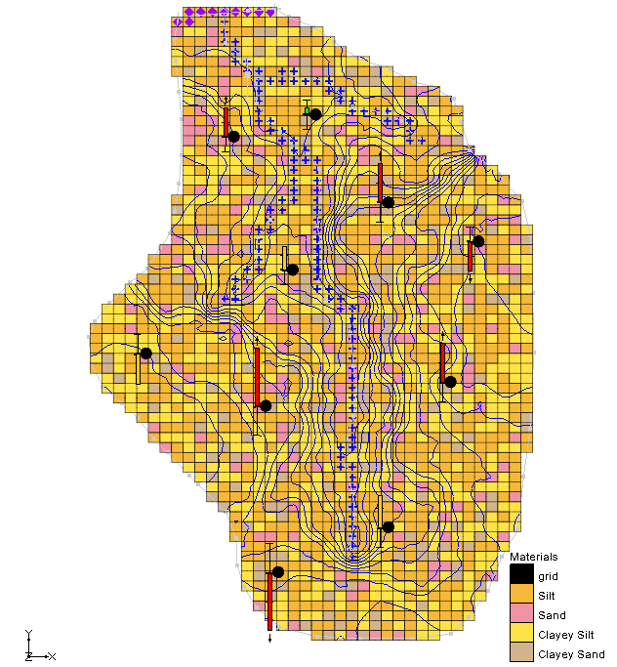

Figure 3 Contours for the lpf_sto001 solution

Select the “File:Generic Folder Locked.svg lpf_sto002 (MODFLOW)” solution in the Project Explorer.

Notice that the contours for each solution vary greatly according to the distribution of materials (compare Figure 3 and Figure 4). Notice also that the material set is updated to correspond to the material set used to generate each particular solution.

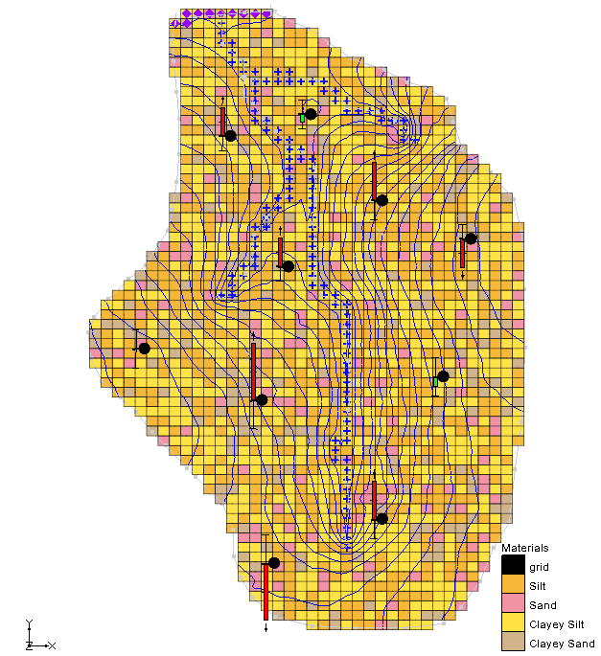

Figure 4 Contours for the lpf_sto002 solution

# Using PEST SVD Assist

Instead of specifying a single value for each material, it is possible to use pilot points to estimate the HK of each material. Specifying pilot points and undertaking a stochastic inverse model with early versions of PEST would take too much time due to the number of model runs required. However, SVD-Assist greatly reduces the number of required runs, and the process can be sped up further by using Parallel PEST.

First, assign pilot points to the parameters then turn on Parallel PEST and SVD Assist:

1. Select *MODFLOW |* **Parameters…** to open the *Parameters* dialog.

From the “HK_Sand” parameter row, use the http://www.xmswiki.com/images/e/e4/Small_drop-down_arrow_button_from_Parameters_dialog.png drop-down in the *Value* column to select “<Pilot points>”.

Click the http://www.xmswiki.com/images/5/54/Blank_button_from_Parameters_dialog.png button above the http://www.xmswiki.com/images/e/e4/Small_drop-down_arrow_button_from_Parameters_dialog.png drop-down on the “HK_Sand” parameter row to bring up the *2D Interpolation Options* dialog.

Use the *Interpolating from* section in the *Dataset* drop-down to select “sand”.

Click **OK** to exit the *2D Interpolation Options* dialog.

Repeat steps 2–5 for the other three parameters (“HK_Silt”, “HK_ClSilt”, and “HK_ClSand”), selecting the respective dataset material for step 4 (e.g. “sand” for HK_Sand).

Click **OK** to exit the *Parameters* dialog.

Select *MODFLOW |* **Parameter Estimation…** to open the *PEST* dialog.

In the *Parallel PEST* section, turn on *Use Parallel PEST*.

In the *SVD options* section, turn on *Use SVD* and *Use SVD-Assist*.

Select **OK** to exit the *PEST* dialog.

## Saving the Project and Running MODFLOW

Before running MODFLOW in stochastic mode, save the project:

1. Select *File* | **Save As…** to bring up the *Save As* dialog.
2. Select “Project Files (*.gpr)” from the *Save as type* drop-down.

Enter“lpf_sto1.gpr” as the *File name*.

Click **Save** to save the project under the new name and close the *Save As* dialog.

Click **Run MODFLOW** File:Run MODFLOW Macro.svg to bring up the *MODFLOW/PEST Parameter Estimation* dialog.

Parallel PEST and MODFLOW now run in stochastic inverse mode. The time needed to finish this run will vary depending on the speed of the computer running it.

## Importing and Viewing the MODFLOW Solutions

Once all the MODFLOW runs are completed, import the solutions:

1. Turn on *Read solution on exit* and *Turn on Contours (if not on already)*.

Click **Close** to exit the *MODFLOW/PEST Parameter Estimation* dialog and bring up the *Reading Stochastic Solutions* dialog.

Click **OK** to import the solutions and close the *Reading Stochastic Solutions* dialog.

Fully expand the new “File:Generic Folder.svg lpf_sto1 (MODFLOW)(STO)” folder in the Project Explorer.

Notice that the observation targets for these new results are more similar than those in the previous stochastic inverse run.

## Probabilistic Capture Zones

Now import the results from a stochastic inverse run using the “TPROGS_A” material sets:

1. Select *MODFLOW |* **Read Solution…** to bring up the *Open* dialog.
2. From the drop-down box to the right of the *File name* field, select “MODFLOW Name File (*.mfn)”.

Browse to the *sto_inv_matset\sto_inv_matset\run1_MODFLOW* directory and select “run1.mfn”.

Click **Open** to exit the *Open* dialog and bring up the *Reading Stochastic Solutions* dialog.

Click **OK** to import all of the solutions and close the *Reading Stochastic Solutions* dialog.

Right-click on the new “File:Generic Folder.svg run1 (MODFLOW)(STO)” folderin the Project Explorer and select **Risk Analysis…** to bring up the *Risk Analysis Wizard* dialog.

Below the list field, select *Probablistic capture zone analysis*.

Click **Next** to go to the *Capture Zone Analysis* dialog.

Click **Finish** to run the analysis and close the *Capture Zone Analysis* dialog.

MODPATH is now running in the background. A progress bar should update as MODPATH is run for each of the simulations in the stochastic solution. When MODPATH is finished running, GMS will create a new dataset for each well in the model. The probability of capture from each cell to each well in the model can be viewed.

Expand “http://www.xmswiki.com/images/1/1a/GMS_Display_Themes_icon.png Display Themes” in the Project Explorer and select “color fill contours”.

Contours similar to Figure 5 will now be visible showing the probabilistic capture zone for the well near the top of the model.

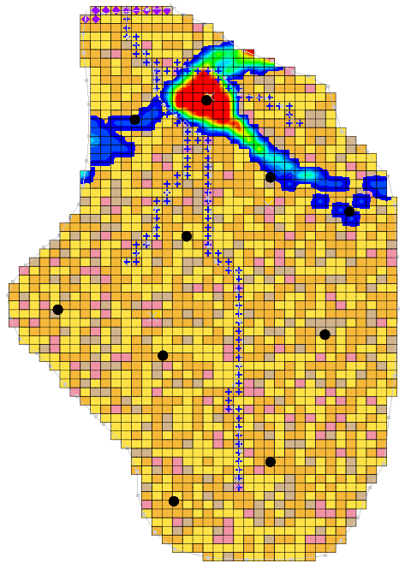

Figure 5 Probabilistic capture zone for a well

# Stochastic Inverse with HUF

The stochastic inverse approach can also be used with multiple HUF data sets. Now import a project with multiple HUF datasets and run a stochastic inverse model.

1. **Save** File:Save Macro.svg the current project.

Click**New** File:New Macro.svg to start a new project and reset to GMS defaults.

Click**Open** File:Open Macro.svg to bring up the *Open* dialog.

Select “Project Files (*.gpr)” from the *Files of type* drop-down.

Browse to the *sto_inv_matset\sto_inv_matset* directory and select “huf.gpr”.

Click **Open** to open the project and exit the *Open* dialog.

Select “File:3D Grid Folder.svg 3D Grid Data” to make it active.

Select *Edit* | **Select by ID…** to bring up the *Find Grid Cell* dialog.

In the *Cell ID* field, enter “1452”.

Click **OK** to close the *Find Grid Cell* dialog.

Switch to **Side View** File:Side View Macro.svg.

The model should appear similar to Figure 6. This model is the same as the one previously used. However, this model uses the HUF package instead of the LPF package. Notice the different hydrogeologic units defined in the HUF package now visible.

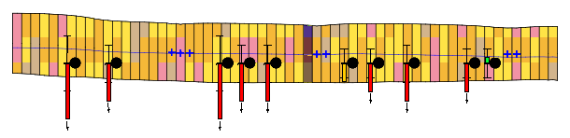

Figure 6 Hydrogeologic units from the HUF package

Select *MODFLOW |* **Global Options…** to open the *MODFLOW Global/Basic Package* dialog.

In the *Run Options* section, select the *Stochastic Inverse* option.

Click **OK** to exit the *MODFLOW Global/Basic Package* dialog.

Select *MODFLOW |* **Stochastic…** to bring up the *Stochastic Options* dialog.

In the *Simulation Method* section, select *HUF sets* and select “TPROGS” from the drop-down to the right.

Click **OK** to exit the *Stochastic Options* dialog.

Select *File |* **Save As…** to bring up the *Save As* dialog.

Select “Project Files (*.gpr)” from the *Save as type* drop-down.

Enter“huf_sto.gpr” as the *File name*.

Click **Save** to save the project under the new name and close the *Save As* dialog.

Select *MODFLOW |* **Run MODFLOW** to bring up the *MODFLOW/PEST Parameter Estimation* dialog.

Parallel PEST and MODFLOW are now running in stochastic inverse mode. The model run may take several minutes, depending on the speed of the computer being used.

## Importing and Viewing the MODFLOW Solutions

Once all the MODFLOW runs are completed, import the solutions.

1. Turn on *Read solution on exit* and *Turn on contours (if not on already)*.

Click **Close** to close the *MODFLOW/PEST Parameter Estimation* dialog and bring up the *Reading Stochastic Solu*tions dialog.

Click **OK** to import all converged solutions and close the *Reading Stochastic Solutions* dialog.

Switch to **Plan View** File:Plan View Macro.svg.

Fully expand the “File:3D Grid Folder.svg 3D Grid Data” folder.

In the “File:Generic Folder.svg huf_sto (MODFLOW)(STO)” folder, select the “File:Generic Folder Locked.svg huf_sto002 (MODFLOW)” solution.

The model should appear similar to Figure 7. Notice that the HUF data is updated to correspond to the HUF set used to generate that particular solution. Feel free to review the “File:Generic Folder Locked.svg huf_sto001 (MODFLOW)” solution as well.

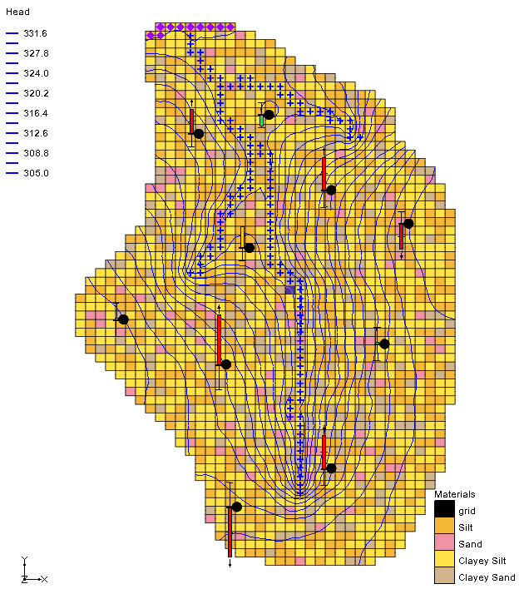

Figure 7 The final view of the model for the huf_sto002 solution

# Conclusion

This concludes the “MODFLOW – Stochastic Modeling, Inverse” tutorial. The following key concepts were discussed and demonstrated in this tutorial:

* Calibrating multiple models using the stochastic inverse modeling option.
* The stochastic inverse modeling approach supports material sets and HUF sets.
* Material sets and HUF sets can be created using TPROGS.
* The *Risk Analysis Wizard* can be used to do a probabilistic capture zone analysis.