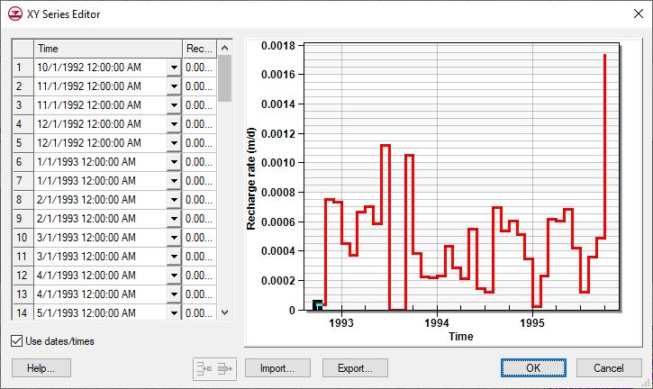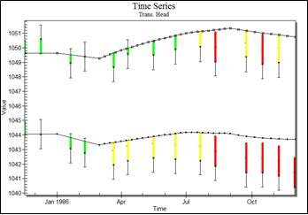

GMS 10.9

GMS 10.9 Tutorial

***MODFLOW – Transient Calibration***

Calibration transient MODFLOW models

Objectives

GMS provides a powerful suite of tools for inputting and managing transient data. These tools allow all data to be managed using a date/time format that eliminates much of the extra data processing that is often required with modeling projects. This tutorial illustrates how these tools are used with transient model calibration.

Time

* 20–35 minutes

Required Components

* GMS Core
* MODFLOW Interface

Prerequisite Tutorials

* MODFLOW – Managing Transient Data
* MODFLOW – Model Calibration

|  |
| --- |
| [1 Introduction 2](#_Toc109737837)  [1.1 Getting Started 2](#_Toc109737838)  [2 Importing the Project 3](#_Toc109737839)  [3 Save the Project with a New Name 3](#_Toc109737840)  [4 Entering Transient Data in the Map Module 3](#_Toc109737841)  [4.1 Importing Transient Recharge Data 4](#_Toc109737842)  [4.2 Importing Pumping Well Data 5](#_Toc109737843)  [4.3 Assigning Storage Parameters 6](#_Toc109737844)  [5 Initializing MODFLOW Stress Periods 7](#_Toc109737845)  [5.1 Changing the MODFLOW Simulation to Transient 7](#_Toc109737846)  [5.2 Setting Up the Stress Periods 7](#_Toc109737847)  [6 Converting the Conceptual Model 8](#_Toc109737848)  [7 Saving and Running MODFLOW 9](#_Toc109737849)  [8 Creating Observation Wells 9](#_Toc109737850)  [9 Importing Transient Head Observations 11](#_Toc109737851)  [10 Saving and Running MODFLOW 11](#_Toc109737852)  [11 Creating a Time Series Plot 12](#_Toc109737853)  [11.1 Creating Transient Observation Plots in Excel 13](#_Toc109737854)  [12 Conclusion 14](#_Toc109737855) |

# Introduction

Building a transient simulation typically requires the management of large amounts of transient data from a variety of sources, including pumping well data, recharge data, river stages, and water levels in observation wells. Gathering and formatting such data can be very tedious. GMS provides tools for importing time series data and converting that data to inputs for MODFLOW models.

The model in this tutorial is the same one used in the “MODFLOW – Conceptual Model” tutorial. It starts with a steady state model then sets up MODFLOW stress periods and imports transient recharge and pumping data. Next, the tutorial will show importing a set of transient-field-observed heads from observation wells and then calibrating the model. Finally, it will demonstrate adjusting the hydraulic conductivity, specific storage, and specific yield values to see how they affect the model.

This tutorial will discuss and demonstrate:

* Opening a MODFLOW model and solution.
* Setting up a transient observation coverage.
* Importing transient head observations.
* Creating plots to visualize error in the model.
* Adjusting model parameters to better match the transient data.

## Getting Started

Do the following to get started:

1. If necessary, launch GMS.
2. If GMS is already running, select *File |* **New** to ensure that the program settings are restored to their default state.
3. If asked to save changes, click **Don’t Save** to close the dialog and restore GMS to a default state.

# Importing the Project

First, import the project:

1. Click **Open** File:Open Macro.svg to bring up the *Open* dialog.
2. Select “Project Files (\*.gpr)” from the *Files of type* drop-down.
3. Browse to the *trans\_calib\trans\_calib* directory and select “start.gpr”.
4. Click **Open** to import the file and exit the *Open* dialog.

A MODFLOW model with a set of head contours should be visible (Figure 1).

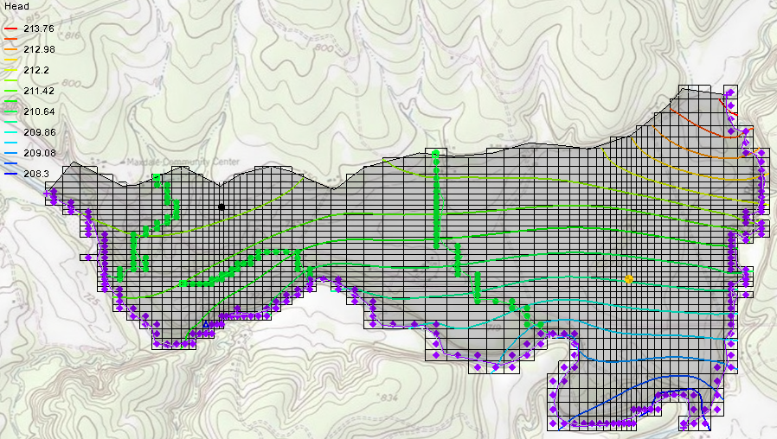

Figure 1 The initial model after importing

# Save the Project with a New Name

Before continuing, save the project with a new name.

1. Select *File* | **Save As…** to bring up the *Save As* dialog.
2. Select “Project Files (\*.gpr)” from the *Save as type* drop-down.
3. Enter “trans1.gpr” as the *File name*.
4. Click **Save** to save the project under the new name and close the *Save As* dialog.

It is strongly recommended to save the project periodically.

# Entering Transient Data in the Map Module

The first step in setting up the transient model is to associate the transient data with the recharge polygon and the pumping well in the Map module.

## Importing Transient Recharge Data

Start with assigning the transient recharge rate for the recharge polygon by importing time series data from a text file. Transient data can be imported for polygons, arcs, points, or nodes. The format for the text files is shown in Figure 2.

GMS 10_1 - MODFLOW-TransientCalibration - example of transient recharge data

Figure 2 Example of transient recharge data in a text file

Only a date field is present in the example above, though GMS supports specifying both a date and a time. The *Id* column matches the *Date* data with a particular polygon.

1. Fully expand the “File:Map Folder.svg Map Data” folder in the Project Explorer.
2. Under the “File:Conceptual Model Icon.svg East Texas” conceptual model, select the “File:Coverage Active Icon.svg Recharge” coverage to make it active.
3. Click **Open** File:Open Macro.svg to bring up the *Open* dialog.
4. Select “Text Files (\*.txt;\*.csv)” from the *Files of type* drop-down.
5. Select “recharge.csv” and click **Open** to exit the *Open* dialog and bring up *Step 1 of 2* of the *Text Import Wizard* dialog (top shown in Figure 3).

This wizard is used to import text data into a GMS project. Note that if the text file being imported has a heading row, the *Heading row* box must be checked for the data to be properly imported (red arrow in Figure 3). In this example, there is not a heading row so the box should not be checked here.

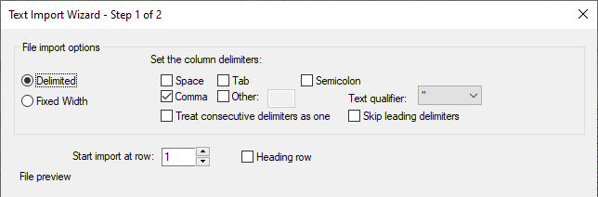

Figure 3 The top of the Text Import Wizard dialog

1. Click **Next >** to go to *Step 2 of 2* of the *Text Import Wizard* dialog.
2. Select “Transient polygon data” from the *GMS data type* drop-down.
3. In the *File preview* section in the *Type* row, select “ID” from the drop-down in the first (left-hand) column.
4. Select “Date” from the drop-down in the second (middle) column.
5. Select “Recharge rate TS” from the drop-down in the third (right-hand) column.

The dialog should appear similar to Figure 4.

1. Click on **Finish** to close the *Text Import Wizard* dialog.
2. When asked to make the time series a step function, click **Yes**.

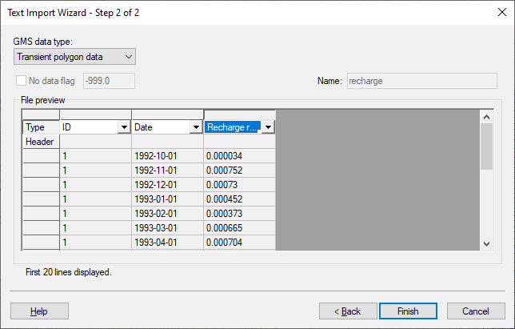

Figure 4 Step 2 of 2 page of the Text Import Wizard dialog

## Importing Pumping Well Data

In addition to the transient recharge data, the simulation will also contain a transient pumping schedule for a well in the model. Pumping well data is typically imported using two files. The first file contains the name, screen geometry, and *xy* coordinates of the wells. The second file contains the pumping schedules. Since the well locations are already defined, only import the pumping schedules. The format for the second file is shown in Figure 5.

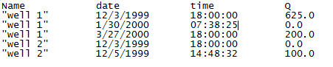

Figure 5 Pumping schedule data file format

When importing text data for points, it is important to indicate to GMS to which point the date and time data belongs. This can be done using a name, an id, or an *xy* coordinate. In the case above, a name is being used. The first time an entry is found for a particular well, if the well is steady state, it is changed to transient, and a pumping rate time series is created for the well. Each time a subsequent line is read with the same well name, GMS adds a point to the time series. The dates and times can be in any standard format.

To import the well pumping data file:

1. Select the “File:Coverage Active Icon.svg Sources&Sinks” coverage to make it active.
2. Click **Open** File:Open Macro.svg to bring up the *Open* dialog.
3. Select “Text Files (\*.txt;\*.csv)” from the *Files of type* drop-down.
4. Select “pumping.csv” and click **Open** to exit the *Open* dialog and bring up *Step 1 of 2* of the *Text Import Wizard* dialog.
5. Since there is not a heading row in this file, click **Next >** to go to *Step 2 of 2* of the *Text Import Wizard* dialog.
6. Select “Pumping data” from the *GMS data type* drop-down.
7. In the *File preview* section on the *Type* row, select “Name” from the drop-down in the first (left-hand) column.
8. Select “Date” from the drop-down in the second (middle) column.
9. Select “Flow rate TS” from the drop-down in the third (right-hand) column.

The dialog should appear similar to Figure 6.

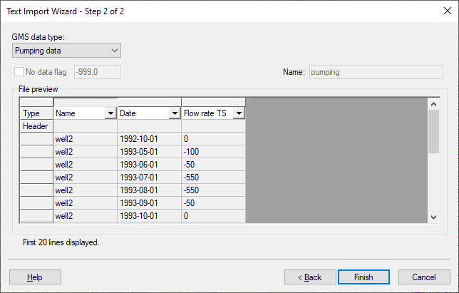

Figure 6 Second step of the Text Import Wizard dialog for the pumping data

1. Click **Finish** to close *Step 2 of 2* of the *Text Import Wizard* dialog.
2. Click **Yes**at the prompt to import the pumping data as a step function.
3. Using the **Select Points\Nodes** File:GMS Select Node Tool.svg tool, double-click on the well on the east (right) side of the model to open the *Attribute Table* dialog.
4. Notice that the *Flow rate* says “<transient>”. To see the curve, click on the http://www.xmswiki.com/w/images/0/0d/Attribute_Table_dialog_dot_dot_dot_ellipses_button.png button to bring up the *XY Series Editor* dialog.
5. Click **Cancel** to close the *XY Series Editor* dialog.
6. Click **Cancel** to exit the *Attribute Table* dialog.

## Assigning Storage Parameters

Next, assign the storage coefficient to the aquifer. Since this is a two-layer model with an upper unconfined aquifer and a lower confined aquifer, specific yield and specific storage must be assigned.

1. Double-click on the “File:Coverage Active Icon.svg Layer 1” coverage in the Project Explorer to bring up the *Coverage Setup* dialog.
2. In the *Areal Properties* column, turn on *Specific yield*.
3. Click **OK** to exit the *Coverage Setup* dialog.
4. Using the **Select Polygons** File:GMS Select Polygon Tool.svg tool, double-click on the polygon to open the *Attribute Table* dialog.
5. Enter “0.01” in the *Spec. yield* column of the spreadsheet.
6. Click **OK** to exit the *Attribute Table* dialog.
7. Double-click on the “File:Coverage Active Icon.svg Layer 2” coverage in the Project Explorer to bring up the *Coverage Setup* dialog.
8. In the *Areal Properties* column, turn on *Specific storage*.
9. Click **OK** to exit the *Coverage Setup* dialog.
10. Using the **Select Polygons** File:GMS Select Polygon Tool.svg tool, double-click on the polygon to open the *Attribute Table* dialog.
11. Enter “0.0001” in the *Spec. storage (1/m)* column of the spreadsheet.
12. Click **OK** to exit the *Attribute Table* dialog.

# Initializing MODFLOW Stress Periods

MODFLOW discretizes time using stress periods and time steps. A length of time is associated with each stress period, and boundary conditions (or stresses) can change at the beginning of a stress period. Stress periods are subdivided into time steps. Before converting the conceptual model, set up the stress periods.

## Changing the MODFLOW Simulation to Transient

Start with changing the current MODFLOW simulation from a steady state simulation to transient.

1. In the Project Explorer, expand “File:3D Grid Folder.svg 3D Grid Data” folder until the contents of the “File:MODFLOW Folder.svg MODFLOW”item are visible.
2. Right-click on the“File:MODFLOW Package Icon.svg Global” package and select **Properties*…*** to open the *MODFLOW Global/Basic Package* dialog.
3. In the *Model type* section, select “Transient”.

## Setting Up the Stress Periods

Now to set up the stress period information for MODFLOW:

1. Click **Stress Periods…** to open the *Stress Periods* dialog.
2. Enter “37” as the *Number of stress periods*.

It is necessary for the stress periods to match the times where the input data in the map module changes. For example, the value for recharge changes monthly. Therefore, make sure that the stress periods start at those times and at the time corresponding to changes in the pumping schedules.

1. Turn on *Use dates/times*.

When the *Use dates/times* option is used, all input fields in the MODFLOW interface in the 3D Grid module expect the date/time format for input. The date/time format is used to display time values such as the time step values when post-processing. If this option is not used, scalar time values (e.g., 100, 120, etc.) are displayed.

1. Using an outside text editor application, open the “stress\_periods.txt” file found in the *Tutorials\MODFLOW\trans\_calib\* directory*.*
2. Press *Ctrl-A* to select all of the text in the file and *Ctrl-C* to copy the text to the clipboard.
3. Return to GMS and click in the *Start* column of row *1* in the *Stress Periods* dialog.
4. Press *Ctrl-V* to paste the dates into the spreadsheet from the clipboard.

This should give monthly stress periods from Oct 1, 1992 through Oct 1, 1995. The dialog should look similar to Figure 7.

1. The first stress period (row *1*) should have a *Length* of “0.0” and the box in the *Steady state* column should be checked (if not, change them).

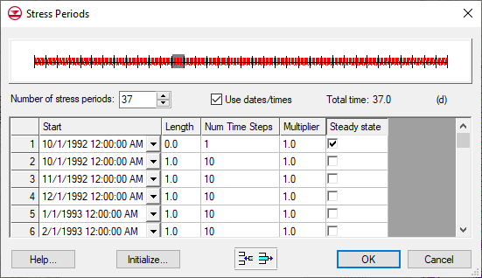

Figure 7 Stress Periods dialog

At this point, the number of time steps and the multiplier for each stress period can be adjusted. For this example, the default values will be used.

1. Click **OK** to exit the *Stress Periods* dialog.
2. If a warning appears indicating the first stress period is zero or negative, click **OK** to continue.
3. Click **OK** to exit the *MODFLOW Global/Basic Package* dialog.

# Converting the Conceptual Model

Now convert the conceptual model data to MODFLOW input data.

1. Right-click on the “File:Conceptual Model Icon.svg East Texas” conceptual model and select *Map to |* **MODFLOW/MODPATH** to bring up the *Map → Model* dialog.
2. Select *All applicable coverages* and click **OK** to close the *Map → Model* dialog.
3. If necessary, select **OK** to acknowledge that the *xy* series will be extrapolated to the numerical model.

# Saving and Running MODFLOW

Now save the model and launch MODFLOW.

1. **Save**File:Save Macro.svgthe project.
2. Click **Run MODFLOW** File:Run MODFLOW Macro.svg to bring up the *MODFLOW* model wrapper dialog.
3. Once MODFLOW has finished, turn on *Read solution on exit* and *Turn on contours (if not on already)*.
4. Click **Close** to close the *MODFLOW* model wrapper dialog and import the new solution.

The contours should change (Figure 8).

1. Expand the “File:Generic Folder Locked.svg trans1 (MODFLOW)” solution in the Project Explorer and select the “File:Dataset Cells Active.svg Head” dataset.
2. Use the *Time Steps* window below the Project Explorer to cycle through a few of the different time steps of the solution to see how the pumping schedules of the wells affect the computed heads.

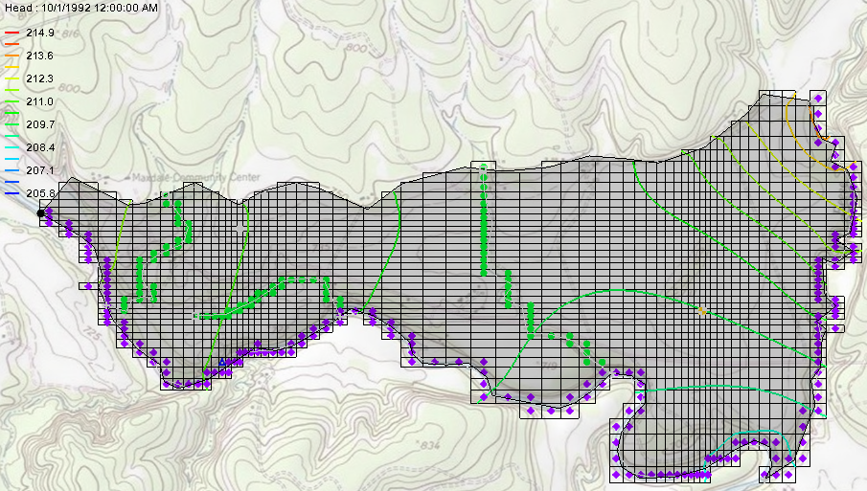

Figure 8 Changed contours after MODFLOW run

# Creating Observation Wells

Now to use a shape file to define the locations of the observation wells, and then import the time series data of the transient observed heads.

1. Right-click on the “File:Conceptual Model Icon.svg East Texas” conceptual model and select **New Coverage…** to open the *Coverage Setup* dialog.
2. Enter “Obs” as the *Coverage name*.
3. In the *Observation Points* column, turn on the *Trans. Head*.
4. From the *3D grid layer option for obs. pts.* drop-down near the bottom of the dialog, select “By layer number”.
5. Click **OK** to exit the *Coverage Setup* dialog.
6. Click **Open** File:Open Macro.svg to bring up the *Open* dialog.
7. Select “Shapefiles (\*.shp)” from the *Files of type* drop-down.
8. Browse to the *trans\_calib\trans\_calib* directory and select “wells\_pts.shp”.
9. Click **Open** to import the shapefile and exit the *Open* dialog.

The shapefile will appear under “GIS Layers” in the Project Explorer.

1. Right-click on “File:GIS Scatter Point Shapefile.svg wells\_pts.shp” and select *Convert to |* **Feature Objects** to bring up the *Step 1 of 3* page of the *GIS to Feature Objects* *Wizard* dialog.
2. From the *Select a coverage for mapping* drop-down menu, select “Obs” and in the *Map Shapefile?* section select “wells\_pts.shp”.
3. Click **Next >** to go to the *Step 2 of 3* page of the *GIS to Feature Objects* *Wizard* dialog.
4. In the *Mapping preview* section on the *Mapping* row, select “Name” from the drop-down in the *NAME* column (Figure 9).

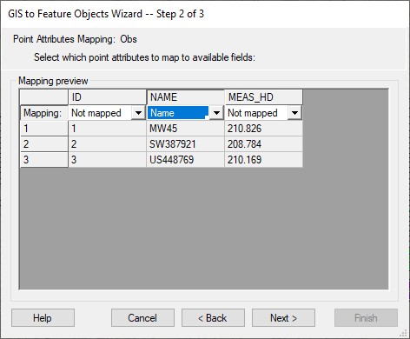

Figure 9 Mapping the Name

1. Click **Next >** to go to the *Step 3 of 3* page of the *GIS to Feature Objects Wizard* dialog.
2. Click **Finish** to close the *GIS to Feature Objects Wizard* dialog.
3. Right-click on the “File:Coverage Active Icon.svg Obs” coverage and select **Attribute Table…** to open the *Attribute Table* dialog.
4. If necessary, change the *Feature type* to “Points”.
5. On the *All* row of the spreadsheet, from the *Type* drop-down select “obs. pt”.
6. Click **OK** to exit the *Attribute Table* dialog.

# Importing Transient Head Observations

Points in the “File:Coverage Active Icon.svg Obs” coverage have now been created from the points in the shape file. Now import the transient head data.

1. Click **Open** File:Open Macro.svg to bring up the *Open* dialog.
2. Select “Text Files (\*.txt;\*.csv)” from the *Files of type* drop-down.
3. Browse to the trans\_calib\*trans\_calib* directory and select “well\_head.txt”.
4. Click **Open** to exit the *Open* dialog and bring up the *Step 1 of 2* page of the *Text Import Wizard* dialog.
5. In the section below the *File import options* section, turn on *Heading row*.
6. Click **Next >** to go to the *Step 2 of 2* page of the *Text Import Wizard* dialog.
7. From the *GMS data type* drop-down select “Transient observation data”.

Notice how GMS has automatically mapped the *Type* row in the *File preview* section based on the names of the columns in the header.

1. Click **Finish** to exit the *Text Import Wizard* dialog.
2. Using the **Select Points\Nodes** File:GMS Select Node Tool.svg tool, double-click on the west (left) observation well to bring up the *Attribute Table* dialog.
3. In the *Obs. Trans. Head* column in the spreadsheet, click on the http://www.xmswiki.com/w/images/f/fc/Dot_dot_dot_button.png button to bring up the *XY Series Editor* dialog.
4. When done reviewing the time series, click on **OK** to close the *XY Series Editor* dialog.
5. Click **OK** to close the *Attribute Table* dialog.
6. Repeat steps 9–12 for each of the other two observation wells, if desired.

# Saving and Running MODFLOW

It is now possible to save the model and launch MODFLOW.

1. **Save**File:Save Macro.svgthe project.
2. Click **Run MODFLOW** File:Run MODFLOW Macro.svg to bring up the *MODFLOW* model wrapper dialog.
3. Once MODFLOW has finished, turn on *Read solution on exit* and *Turn on contours (if not on already)*.
4. Click **Close** to import the solution and close the *MODFLOW* model wrapper dialog.
5. Right-click on the “File:Generic Folder Locked.svg trans1 (MODFLOW)” solution folder and select **Properties…** to bring up the *Properties* dialog.

The *Properties* dialog shows the model error. Notice there is only an error associated with heads. Currently, the model only has head observations and lacks any flow observations.

1. Click **OK** to exit the *Properties* dialog.
2. Expand the “File:Generic Folder Locked.svg trans1 (MODFLOW)” folder in the Project Explorer and select the “File:Dataset Cells Active.svg Head” dataset.
3. Use the *Time Steps* window to cycle through the different time steps of the solution.

Notice that targets on the observations change as the time steps change. If the current time step of the MODFLOW heads is before or after the time series data for a particular well, then the target for that well will appear washed out (or faded) as in Figure 10.

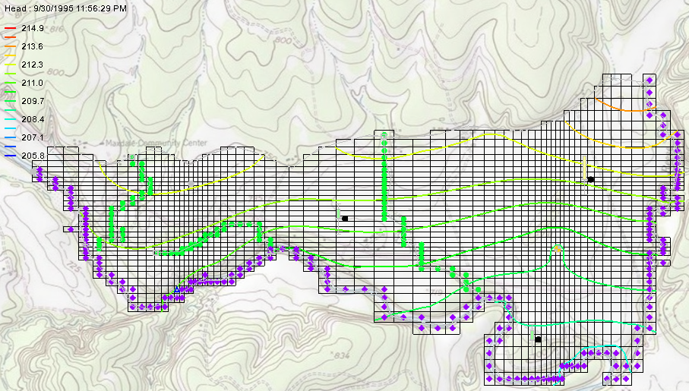

Figure 10 Well targets showing as washed out

# Creating a Time Series Plot

GMS can create a time series plot useful for transient observation data.

1. Click **Plot Wizard** File:Plot Wizard Macro.svg to bring up the *Step 1 of 2* page of the *Plot Wizard* dialog.
2. In the *Plot Type* section, select “Time Series” from the list on the left.
3. Click **Next >** to go to the *Step 2 of 2* page of the *Plot Wizard* dialog.
4. In the lower section, turn on *Calibration Target* and *Observed Values*.
5. In the spreadsheet on row *1* (the row with “MW45” in the *Points* column), check the box in the *Show* column.
6. Click **Finish** to create the plot.

A plot similar to Figure 11 should appear.

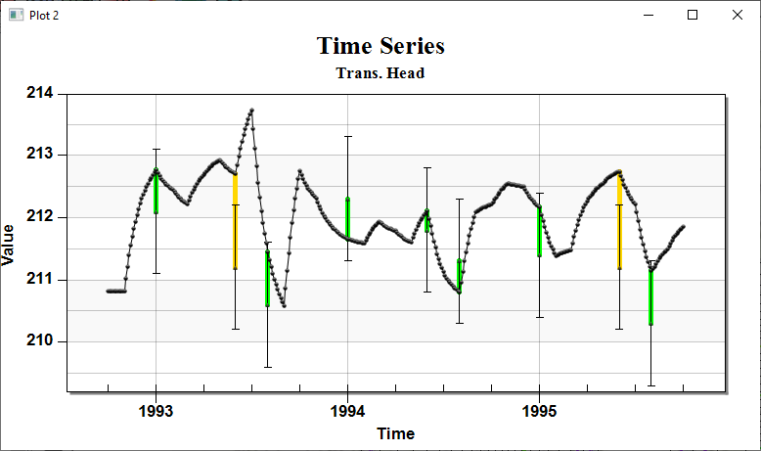

Figure 11 A plot of the time series

Notice that the computed heads are sometimes within the min/max of the calibration target (green targets) and at other times the computed heads are just outside of the calibration target well (yellow targets). Time series plots for the other two wells can also be made at this point, if desired, by repeating steps 1–6 and checking the box next to “US448769” or “SW387921” in step 5 instead the one next to “MW45”.

## Creating Transient Observation Plots in Excel

The transient observation plots in GMS are useful for quickly understanding the relationship between the observed data and the computed values from MODFLOW. However, when preparing reports of modeling projects, it is useful to use a spreadsheet application (such as Microsoft Excel) to create plots. The transient observation data can be exported from GMS to a text file. This text file can then be opened in the spreadsheet application and used to generate plots for a report.

If the spreadsheet application is installed with the ability to run macros, continue with the steps below. Otherwise, skip to the next section.

1. Select MODFLOW | **Observations…** to bring up the *Observations* dialog.
2. Click **Export Trans. Obs...** to bring up the *Transient Observation Filename* dialog.
3. Accept the default *File name* of “TransObservation.csv” and click **Save** to close the *Transient Observation Filename* dialog.
4. Click **OK** to close the *Observations* dialog.
5. In Windows Explorer, browse to the *trans\_calib\trans\_calib* directory and double-click on “modflow trans obs plotter.xls” to open it into the default spreadsheet application.
6. In the spreadsheet application, enter “TransObservation.csv”in the *File name* field and click **Import File**.
7. Click **Yes** at the prompt to delete existing sheets.

A macro should run to create a new sheet for each observation point along with a plot. These sheets are a copy of the “template” base sheet with the data for each observation point added to the sheet. The base sheet can be modified with the desired plotting options, and the macro can be run again to create plots with the desired customizations.

Feel free to try adjusting the hydraulic conductivity and the storage parameters to see if this results in a better fit with the observation data.

# Conclusion

This concludes the “MODFLOW – Transient Calibration” tutorial. The following key concepts were discussed and demonstrated in this tutorial:

* When bringing up the properties dialog for objects in the Map module, it is possible to enter transient data by using the http://www.xmswiki.com/w/images/0/0d/Attribute_Table_dialog_dot_dot_dot_ellipses_button.png and http://www.xmswiki.com/w/images/e/e4/Small_drop-down_arrow_button_from_Parameters_dialog.png buttons.
* It is possible to import transient data for points, arcs, polygons, and nodes using the *Text Import Wizard* dialog. The points, arcs, polygons, and nodes must already exist in the active coverage.
* It is possible to use a shapefile to define the location of observation wells.
* It is possible to import transient head observations.
* It is possible to create time series plots with calibration targets to show how well a model fits the observed data.