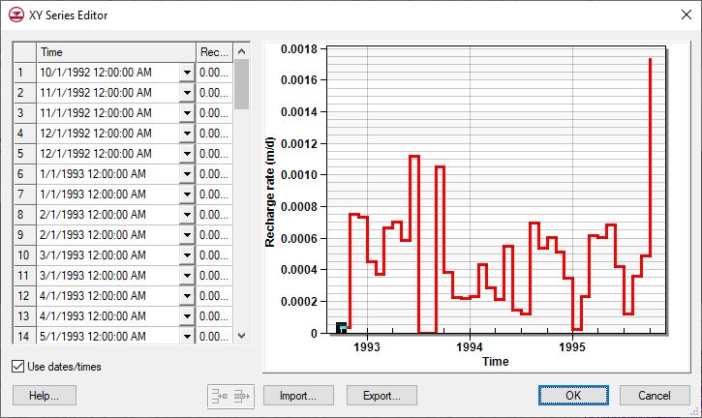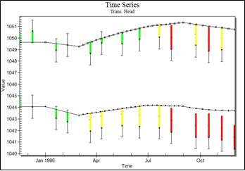

GMS 10.9

GMS 10.9 Tutorial

***MODFLOW – PEST Transient Pump Test Calibration***

Tools for calibrating transient MODFLOW models

Objectives

Learn how to setup a transient simulation, import transient observation data, and use PEST to calibrate the model.

Time

* 30–45 minutes

Required Components

* GMS Core
* MODFLOW Interface

Prerequisite Tutorials

* MODFLOW – PEST Pilot Points

|  |
| --- |
| 1 Introduction 2  1.1 Getting Started 3  2 Importing the Project 3  2.1 Save the Project with a New Name 4  3 Setting up the Transient MODFLOW Model 4  3.1 Entering MODFLOW Stress Period Data 5  3.2 Regarding Initial Conditions 5  4 Entering Pumping Data 6  5 Importing Transient Observation Data 6  5.1 Adjusting the Coverage Set Up 7  5.2 Importing Transient Data Text File 7  6 Saving and Running MODFLOW 9  7 Creating a Time Series Plot 9  8 Running PEST 10  9 Pilot Points 12  9.1 Using Pilot Points with the Parameters 12  10 Running PEST with SVD-Assist 13  11 Conclusion 15 |

# Introduction

Pump test data is a common type of transient data available to groundwater model developers. This tutorial will take an existing steady state MODFLOW model and update the model to simulate a pump test.

The model in this tutorial is the same model used in the “MODFLOW – Generating Data from Solids” tutorial. The study area is shown in Plan ViewFile:Plan View Macro.svg in Figure 1. In the previous tutorial, the production well near the center of the study area was pumping during the pump test. The other two production wells were not pumping during the test. A few head measurements were taken at these wells during the test. One monitoring well was sampled frequently during the pump test. Other monitoring wells underwent less frequent measurements.



Figure 1 Study area for ground water model

There are two main aquifers in the area, as shown in the cross section in Figure 2. The lower-confined aquifer (red) is overlain by an upper unconfined aquifer (green). The lower aquifer is where the pumping well and main observation well are located. In some areas, there is an aquitard (yellow) that overlays portions of the lower aquifer.

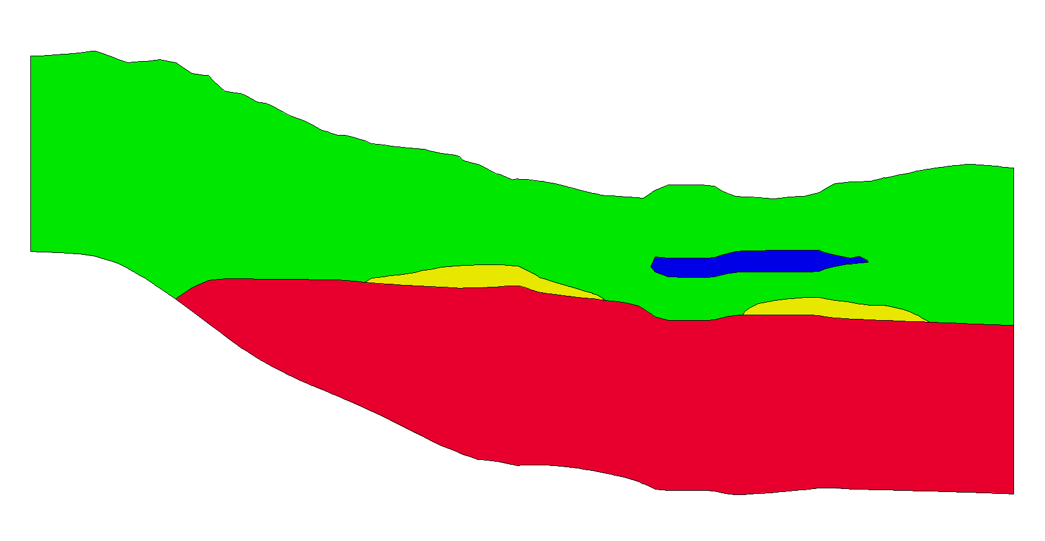

Figure 2 Cross section through the study area

Transient observation data at multiple observation wells will be imported. The model has already been parameterized into different zones of hydraulic conductivity (HK), specific yield (SY), and specific storage (SS) for the upper and lower aquifers; there is also a parameter for estimating recharge. The model will be run with the current parameter values to see how well the model matches the pump test. Then PEST will optimize the parameter values. Finally, pilot points will be plotted with the parameters to see if it is possible to improve the match between the simulated and field-observed values.

This tutorial will demonstrate and discuss:

* Opening a MODFLOW model and solution.
* Setting up MODFLOW stress periods.
* Importing transient observation data and creating plots.
* Running PEST to calibrate the transient model.

## Getting Started

Do the following to get started:

1. If necessary, launch GMS.
2. If GMS is already running, select *File |* **New** to ensure that the program settings are restored to their default state.

# Importing the Project

First, import the project:

1. Click **Open** File:Open Macro.svg to bring up the *Open* dialog.
2. Select “Project Files (*.gpr)” from the *Files of type* drop-down.
3. Browse to the *Tutorials\MODFLOW\trans_pest_pumptest* directory and select “start.gpr”.
4. Click **Open** to import the project and exit the *Open* dialog.

A MODFLOW model with a solution and a set of map coverages will appear (Figure 3).

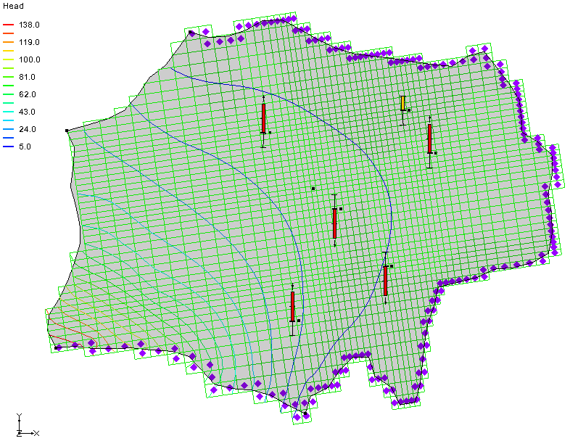

Figure 3 Steady state MODFLOW model

## Save the Project with a New Name

Before continuing, save the project with a new name.

1. Select *File* | **Save As…** to bring up the *Save As* dialog.
2. Select “Project Files (*.gpr)” from the *Save as type* drop-down.
3. Enter “pumptest.gpr” as the *File name*.
4. Click **Save** to save the file under the new name and close the *Save As* dialog.

It is recommended to save the project periodically.

# Setting up the Transient MODFLOW Model

The pump test occurred over a two-week period. Data was collected at the main observation well during the first three days while the well was pumping, and then more sporadically over the next ten days while the well was off. Set up the transient MODFLOW model to have at least two stress periods: one stress period with the well on for 3 days and one stress period with the well off for 10 days.

1. Select *MODFLOW |* **Global Options…** to open the *MODFLOW Global/Basic Package* dialog.
2. In the *Model type* section, select *Transient*.
3. Click on **Stress Periods…** to bring up the *Stress Periods* dialog.

## Entering MODFLOW Stress Period Data

In the *Stress Periods* dialog, it is possible to set the number of stress periods, how long each period will be, and the number of time steps in each period.

1. Increase the *Number of stress periods* to “3”.
2. In the spreadsheet, in the *Start* column on row *2* (this is the second stress period) enter “0.0”. The *Length* of the first stress period will be updated automatically to “0.0”.
3. In the *Start* column of row *3,* enter “3.0”. The *Length* of the second stress period will be updated automatically to “3.0”.
4. In the *Start* column of the *End* row, enter “13.0”. The *Length* of the third stress period will be updated automatically to “10.0”.
5. In the *Num Time Steps* column for rows *2* and *3,* enter “10”*.*
6. In the *Multiplier* column for rows *2* and *3,* enter “1.5”.

This increases the number of time steps at the beginning of the stress period so that the effect of the change in stresses can be seen more accurately. When finished, the dialog should appear similar to Figure 4.

1. Click **OK** to exit the *Stress Periods* dialog.
2. Click **OK** at the prompt. The first stress period has a length of zero because it is a steady state stress period.
3. Click **OK** to exit the *MODFLOW Global/Basic Package* dialog.

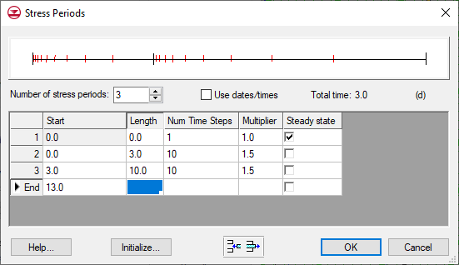

Figure 4 Stress Periods dialog

## Regarding Initial Conditions

With a transient model, it is important to have an initial condition that is consistent with the model inputs. If the initial condition is not consistent with model parameters, then the model response in the early time steps will reflect not only the model stresses but also the adjustment of computed head values to offset the lack of correspondence between the model inputs and the initial head values.[1]

In this case, the first stress period has been set to be steady state. This will prevent any lack of correspondence between model inputs and the initial heads for the transient stress periods. This is important when calibrating a transient model. When allowing a tool like PEST to change the model inputs, it is necessary to make sure that the initial heads correspond to the new inputs that PEST has chosen. The easiest way to do this is to have the first stress period of the model be steady state.

# Entering Pumping Data

It is necessary to update the well data so that the well will have the appropriate pumping rate for the first stress period and 0.0 for the second stress period. Edit the well data in the WEL Package.

1. Select *MODFLOW* | *Optional Packages* | **WEL – Well…** to open the *MODFLOW Well Package* dialog.

This dialog contains a spreadsheet listing all of the pumping wells in the model. Currently, all of the wells have a flow rate of “0.0”.

1. In the *Stress period* field, enter “2”.
2. Uncheck *Use previous* to the right of *Stress period*.
3. For the well named “w-15” (row *2* of the spreadsheet), enter “-130000.0” in the *Q (flow)(ft^3/d)* column.
4. In the *Stress period* field, enter “3”.
5. Uncheck *Use previous*.
6. For the well named “w-15”, enter ”0.0” in the *Q (flow)(ft^3/d)* column.
7. Select **OK** to exit the *MODFLOW Well Package* dialog.

# Importing Transient Observation Data

The transient field-measured head values should now be imported. This type of data can be imported using the *Text Import Wizard* dialog. The *Text Import Wizard* dialog can import transient data in multiple formats, including date/time and relative time. In this example problem, relative time is being used, where the beginning of the simulation is time “0.0” and the units are days. The format for this kind of data is shown in Figure 5.

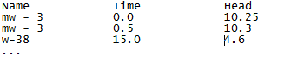

Figure 5 Transient observation data file using relative time

## Adjusting the Coverage Set Up

Before importing the transient observation data, make sure that the coverage with the observation points is set up correctly.

1. Fully expand the “File:Map Folder.svg Map Data” folder in the Project Explorer.
2. Double-click on the “File:Coverage Active Icon.svg Obs” coverage under the “File:Conceptual Model Icon.svg MODFLOW” conceptual model to bring up the *Coverage Setup* dialog.
3. In the *Observation Points* column, turn on *Trans. Head.*
4. Click **OK** to exit the *Coverage Setup* dialog.

## Importing Transient Data Text File

It is now possible to import the transient observation data.

1. Click **Open** File:Open Macro.svg to bring up the *Open* dialog.
2. Select “Text Files (*.txt;*.csv)” from the *Files of type* drop-down.
3. Select “obs_wells_trans.csv” and click **Open** to exit the *Open* dialog and bring up the *Step 1 of 2* page of the *Text Import Wizard* dialog (Figure 6).

This wizard is used to import text data into a GMS project.

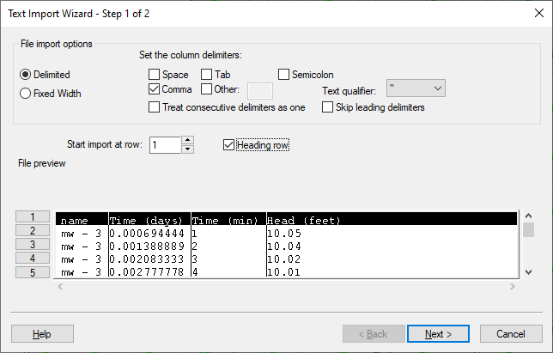

Figure 6 Text Import Wizard with Heading row checked

1. In the section below the *File import options* section, turn on *Heading row*.
2. Click **Next** to go to the *Step 2 of 2* page of the *Text Import Wizard* dialog.
3. Select “Transient observation data” from the *GMS data type* drop-down.

The dialog should appear similar to Figure 7.

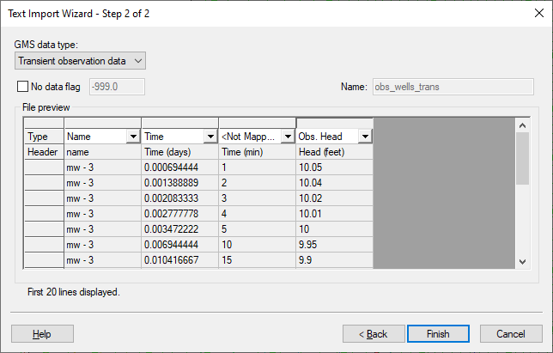

Figure 7 Step 2 of the Text Import Wizard

Notice that the *Name*, *Time*, and *Head* columns were automatically recognized by GMS. There are two time columns, one in units of days and one in units of minutes. This example will only use the data in the *Time (days)* column. The *Time (min)* column will be ignored for this example, and is therefore not mapped in the *Type* row. The dialog is already set up in the desired way.

1. Click **Finish** to close the *Text Import Wizard* dialog.
2. Using the **Select Objects** File:Select Object Tool.svg tool, double-click on the “mw – 3” well near the center of the model to bring up the *Attribute Table* dialog.
3. View the imported time series data clicking the http://www.xmswiki.com/w/images/f/fc/Dot_dot_dot_button.png button in the *Obs. Trans Head* column to bring up the *XY Series Editor* dialog (Figure 8).
4. When done reviewing the data, click **Cancel** to exit the *XY Series Editor* dialog.
5. Click **Cancel** to exit the *Attribute Table* dialog.

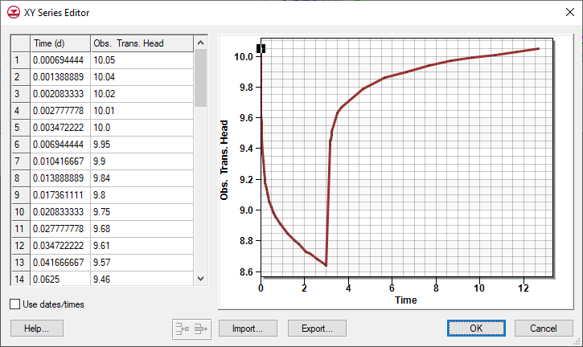

Figure 8 Time series data for well “mw - 3”

# Saving and Running MODFLOW

To save the model and launch MODFLOW:

1. **Save**File:Save Macro.svgthe project.
2. Click **Run MODFLOW** File:Run MODFLOW Macro.svg to bring up the *MODFLOW* model wrapper dialog.
3. Once MODFLOW has finished, turn on *Read solution on exit* and *Turn on contours (if not on already).*
4. Click **Close** to close the *MODFLOW* model wrapper dialog.

The contours should change (Figure 9). The current view shows the top layer of the grid. The pumping well and some of the observation wells are in layer 5.

1. Use the Mini Grid Toolbar  to change to layer “5”.
2. Expand the “File:3D Grid Folder.svg3D Grid Data” folder in the Project Explorer so the “File:Generic Folder Locked.svg pumptest (MODFLOW)” solution is visible and expanded.
3. Select the “File:Dataset Cells Active.svg Head” dataset to make it active.
4. Use the Time Step window below the Project Explorer to cycle through the different time steps of the solution to see the effect of the pump test.

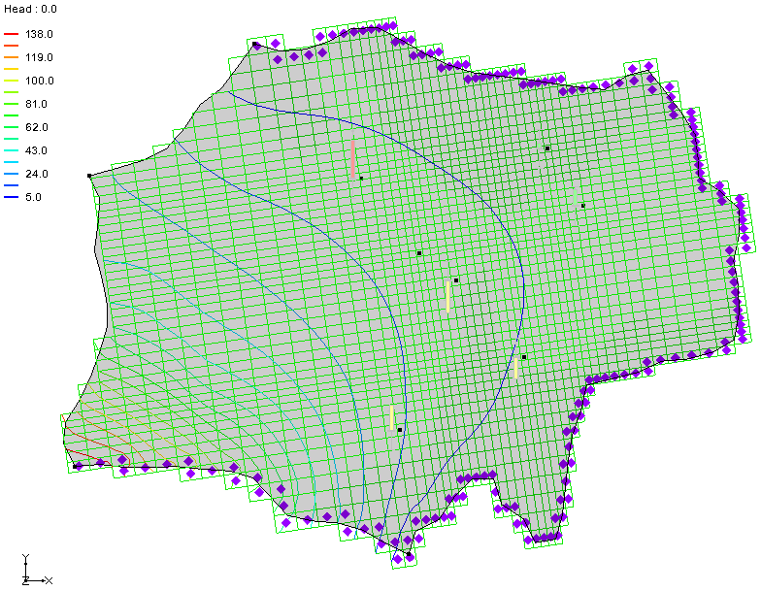

Figure 9 The contours changed slightly after running MODFLOW

# Creating a Time Series Plot

One of the useful tools for working with transient calibration data is the time series plot. This plot allows seeing how well the simulated heads match the field measurements.

1. Click **Plot Wizard** File:Plot Wizard Macro.svg to bring up the *Step 1 of 2* page of the *Plot Wizard* dialog.
2. In the *Plot Type* section, select “Time Series” from the list on the left.
3. Click **Next** to go to the *Step 2 of 2* page of the *Plot Wizard* dialog.
4. In the bottom section, turn on *Calibration Target* and *Observed Values*.
5. Below those options, check the box in the *Show* column on the “mw - 3” row.
6. Click **Finish** to close the *Plot Wizard* dialog and generate the plot.

A plot similar to Figure 10 will appear. The model simulated heads are currently a little low at this particular well. Use PEST to help calibrate the transient model.

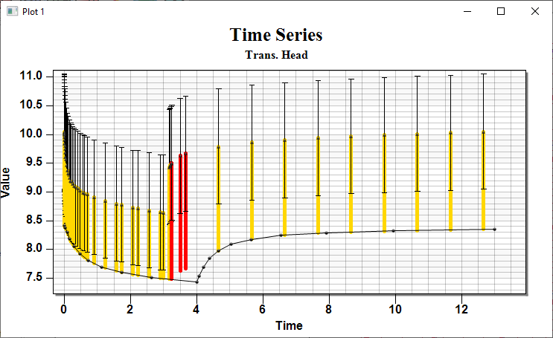

Figure 10 Time series plot

To view other observation wells in the model, do the following:

1. Right-click on the plot and select **Plot Data…** to bring up the *Data Options* dialog.
2. In the bottom section on the *Plot Wizard - Step 2 of 2* tab, uncheck the *Show* box next to “mw - 3” and check the *Show* box next to the desired point (well).
3. Click **OK** to close the *Data Options* dialog.
4. Repeat steps 7–9 to view a plot for any of the other wells.
5. When done reviewing the other wells, change the plot back to displaying the data for the “mw - 3" well.

The plot will change according to which point is selected in the *Data Options* dialog.

# Running PEST

Change the MODFLOW simulation so that PEST is used to estimate the values of HK (hydraulic conductivity), SY (specific yield), and SS (specific storage) of the upper and lower aquifer. Allow PEST to estimate the value of recharge (RCH).

1. Select *MODFLOW |* **Global Options…** to open the *MODFLOW Global/Basic Package* dialog.
2. In the *Run options* section, select *Parameter Estimation*.
3. Click **OK** to exit the *MODFLOW Global/Basic Package* dialog.

At this point, the model would normally be parameterized. Model parameterization is explained in the “MODFLOW – Automated Parameter Estimation” tutorial. This model has already been parameterized, so it is now possible to run PEST. This model uses material zones to assign properties to the aquifers. The HK, SY, and SS parameter key values have been entered in the *Materials* dialog.

1. If desired, view the material properties by selecting *Edit |* **Materials…** to bring up the Materials dialog.
2. Click **Cancel** when done to close the dialog.

While this next step can be completed without Parallel PEST, it will take significantly longer to complete.

1. Select *MODFLOW |* **Parameter Estimation…** to open the *PEST* dialog.
2. In the *Parellel PEST* section, turn on *Use Parallel PEST*.
3. In the *SVD options* section, turn on the *Use SVD* option.
4. Click **OK** to exit the *PEST* dialog.

It is now possible to run Parallel PEST.

1. Select *File* | **Save As…** to bring up the *Save As* dialog.
2. Select “Project Files (*.gpr)” from the *Save as type* drop-down.
3. Enter “pumptest_pest.gpr” as the *File name*.
4. Click **Save** to save the project under the new name and close the *Save As* dialog.
5. Click **Run MODFLOW** File:Run MODFLOW Macro.svg to bring up the *MODFLOW* model wrapper dialog.

Depending on the speed of the computer being used, Parallel PEST will take several minutes to run this problem. When the run finishes, notice that PEST completed 2 iterations and had a final model error of about 697.

1. When MODFLOW is finished, turn on *Read solution on exit* and *Turn on contours (if not on already)*.
2. Click **Close** to exit the *MODFLOW* model wrapper dialog.

The contours and time series plot should update (Figure 11). Notice the minor improvement in the match by using the field-observed values.

It is desirable to improve the fit between the simulated and the observed heads. This can be done by adjusting some of the PEST input parameters to allow PEST to run more with this model, or by using pilot points with the parameters. In this tutorial, pilot points will be used to try to get a better fit at all of the wells.

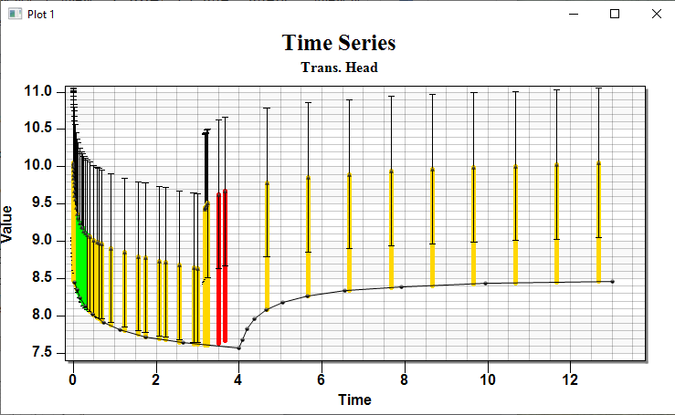

Figure 11 Time series plot after PEST run

# Pilot Points

Now import pilot point data. For more information on pilot points, refer to the “MODFLOW – Pest Pilot Points” tutorial.

1. Click **Open** File:Open Macro.svg to bring up the *Open* dialog.
2. Select “Text Files (*.txt;*.csv)” from the *Files of type* drop-down.
3. Select “pp.txt” and click **Open** to exit the *Open* dialog and bring up the *Step 1 of 2* page of the *Text Import Wizard* dialog.
4. In the section below the *File import options* section, turn on *Heading row*.
5. Click **Next** to go to the *Step 2 of 2* page of the *Text Import Wizard* dialog.
6. Change the *GMS data type* drop-down menu to be “2D scatter points”.
7. Click **Finish** to import the pilot point data and close the *Text Import Wizard* dialog.

## Using Pilot Points with the Parameters

It is necessary to change the MODFLOW parameters to use the imported pilot points.

1. Select *MODFLOW |* **Parameters…** to bring up the *Parameters* dialog.
2. In the spreadsheet in the *Parameters* section, click on the drop-down http://www.xmswiki.com/w/images/e/e4/Small_drop-down_arrow_button_from_Parameters_dialog.png button in the *Value* column on the “HK_15” row and select “<Pilot points>”.

The interpolation options associated with the pilot points can be changed by clicking on the http://www.xmswiki.com/w/images/0/0d/Attribute_Table_dialog_dot_dot_dot_ellipses_button.png button above the drop-down http://www.xmswiki.com/w/images/e/e4/Small_drop-down_arrow_button_from_Parameters_dialog.png button in the *Value* column.

1. Click on the http://www.xmswiki.com/w/images/0/0d/Attribute_Table_dialog_dot_dot_dot_ellipses_button.png button in the *Value* column on the “HK_15” row to bring up the *2D Interpolation Options* dialog.

In this dialog, select the scatter point set and dataset used with the parameter as well as the interpolation scheme.

1. In the *Interpolating from* section, select “HK_15” from the *Dataset* drop-down.
2. Click **OK** to exit the *2D Interpolation Options* dialog.
3. Repeat steps 2–5 for the “HK_30” and “RCH_300” rows, selecting “HK_30”and **“**RCH_300” (respectively) in step 4.
4. When finished, select **OK** to exit the *Parameters* dialog.

# Running PEST with SVD-Assist

Now run Parallel PEST again. However, this time use the SVD-Assist option. Currently, there are 24 pilot points for each parameter. This means that for each PEST iteration, PEST will run MODFLOW once for each existing pilot point. For this model, that would be a total of 72 MODFLOW runs in addition to runs for the other 3 parameters. Using SVD-Assist, PEST can decrease the number of necessary MODFLOW runs for each PEST iteration.

1. Select *MODFLOW |* **Parameter Estimation…** to open the *PEST* dialog.
2. In the *SVD options* section, turn on *Use SVD-Assist*.
3. Click **OK** to exit the *PEST* dialog.
4. Select *File* | **Save As…** to bring up the *Save As* dialog.
5. Select “Project Files (*.gpr)” from the *Save as type* drop-down.
6. Enter “pumptest_pest_pp.gpr” as the *File name*.
7. Click **Save** to save the project under the new name and close the *Save As* dialog.
8. Click **Run MODFLOW** File:Run MODFLOW Macro.svg to bring up the *MODFLOW* model wrapper dialog.

Depending on the speed of the computer being used, Parallel PEST may take several minutes to run this problem. When finished, PEST will have completed five iterations and will have a final model error of about 19.6.

1. When PEST finishes, turn on *Read solution on exit* and *Turn on contours (if not on already)*.
2. Click **Close** to import the solution and close the *MODFLOW* model wrapper dialog.

The contours and time series plot should update, and the time series curve for the observation well should appear similar to Figure 12. The match between the field values and the model simulated values have significantly improved.

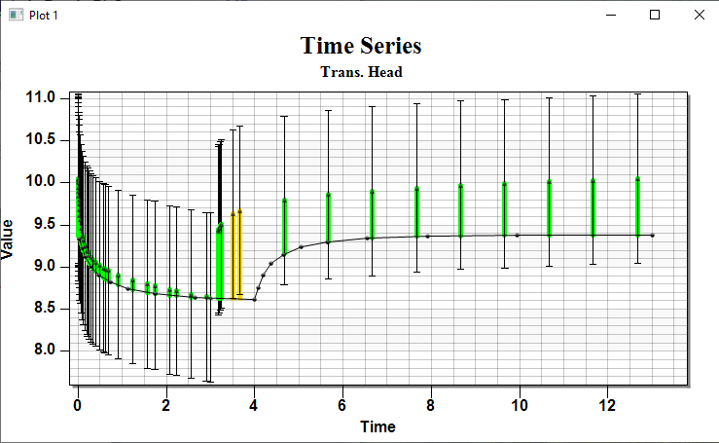

Figure 12 Time series Plot after PEST Calibration

To see the final hydraulic conductivity and recharge arrays:

1. Fully expand the “File:Generic Folder Locked.svg pumptest_pest_pp (MODFLOW)” solution in the Project Explorer.
2. Select “File:Dataset Cells Active.svg HK Parameter -30, -15”.

This dataset displays the final hydraulic conductivity array computed from the pilot points. The recharge is also available. The model should appear similar to Figure 13.

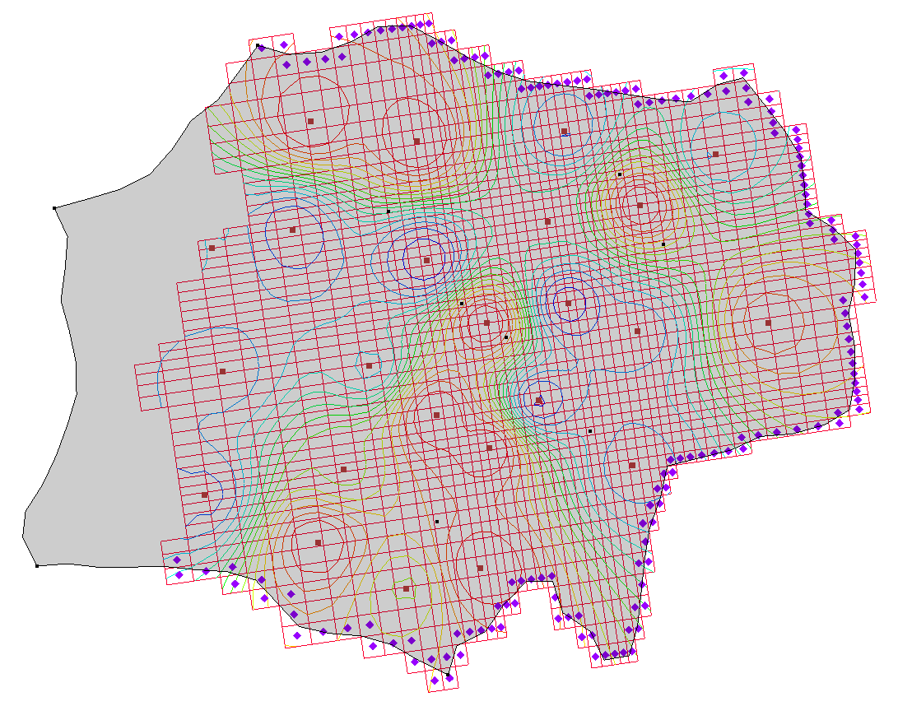

Figure 13 Final appearance of the model

# Conclusion

This concludes the “MODFLOW – PEST Transient Pump Test Calibration” tutorial. The following key concepts were discussed and demonstrated:

* Importing transient observation data with the *Text Import Wizard*.
* Using PEST to calibrate transient MODFLOW models.
* It is important to have the first stress period as steady state when calibrating a transient model so that the computed heads for the first transient stress period are consistent with the model input parameters.
* Viewing the final array values from parameters that use pilot points by selecting the dataset under the MODFLOW solution.

1. Anderson, Mary P. and Woessner, William W. (1991). *Applied Ground Water Modeling.* Academic Press, Waltham, Massachusetts, p.199.