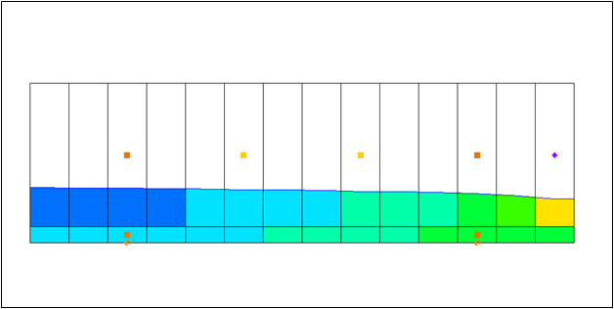

GMS 10.9

GMS 10.9 Tutorial

***MODFLOW-USG – CLN Observation Wells***

Create CLN well observations in GMS

Objectives

Learn how to create CLN well observations using MODFLOW-USG and GMS.

Time

* 20–30 minutes

Required Components

* GMS Core
* MODFLOW-USG Model & Interface

Prerequisite Tutorials

* MODFLOW-USG CLN Process

|  |
| --- |
| 1 Introduction 2  1.1 Description of Problem 2  1.2 Outline 3  2 Getting Started 3  3 Creating the CLN Well 4  4 Creating the Observation Point 6  5 Map to MODFLOW 7  6 Review Model Inputs 7  6.1 CLN WEL package 7  6.2 CLN – Connected Linear Network 8  6.3 Observations 9  7 Saving and Running MODFLOW 9  8 Examining the Results 10  9 Changing the Observation or Well Name 10  10 Conclusion 11 |

# Introduction

Head observations for CLN (Connected Linear Network) wells can be created to measure the computed head in a CLN node (cell). The process is similar to creating head observations in the groundwater domain, but with some key differences.

Creating a CLN observation well requires two steps:

1. Create a CLN well that is non-pumping.
2. Create an observation point that is linked to the CLN well and will be used by PEST to determine the head at the point.

An observation can be associated with a CLN well that is pumping (if you wanted to know the draw down at that well), but in general observation wells are not pumped.

## Description of Problem

The problem in this tutorial is the same simulation (Figure 1) described in the *MODFLOW-USG CLN Process* tutorial, but with simplified stress periods.

The system consists of two aquifers that are separated by a 50-foot-thick confining unit. In addition to the simulation of two multi-node wells (wells A and B) modeled using the CLN process, there are 15 other single-node wells modeled using the WEL package.[1]

|  |  |
| --- | --- |
|  |  |

Figure 1 Flow model from MNW1 documentation[2]

## Outline

This tutorial will demonstrate the following topics:

1. Opening an existing simulation that uses the CLN package.
2. Adding a CLN well and an observation point to the simulation using a conceptual model.
3. Running the simulation and examining the results.

# Getting Started

Do the following to get started:

1. If necessary, launch GMS.
2. If GMS is already running, select *File |* **New** to ensure that the program settings are restored to their default state.
3. Click **Open** File:Open Macro.svg (or *File |* **Open…**) to bring up the *Open* dialog.
4. Browse to the *ClnObservation* directory and select “start.gpr”.
5. Click **Open** to import the file and close the *Open* dialog.

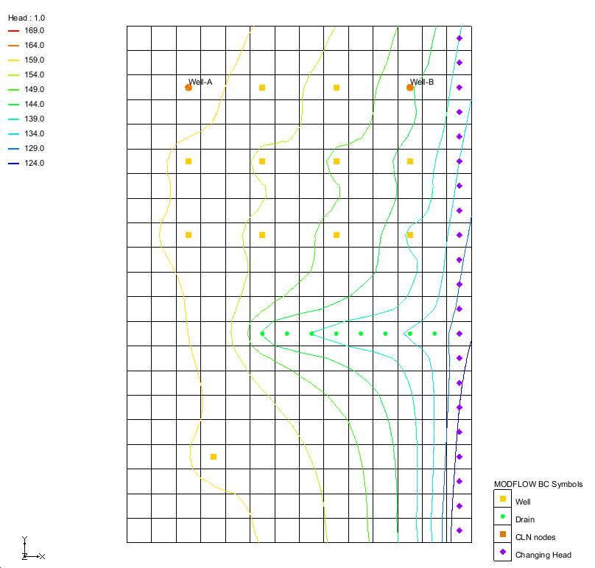

Figure 2 Imported CLN process example

The Graphics Window should appear as in Figure 2. This model has well, drain, and changing head (CHD) sources/sinks. In addition, the orange symbols in the upper left and right are the CLN nodes represented by Well-A and Well-B.

Before continuing, save the project with a new name.

1. Select *File* | **Save As…** to bring up the *Save As* dialog.
2. Browse to the *ClnObservations* directory.
3. For the *File name,* enter “ClnObservations.gpr”.
4. From the *Save as type* drop-down, select “Project Files (*.gpr)”.
5. Click **Save** to save the project file and close the *Save As* dialog.

# Creating the CLN Well

The first step is to create a non-pumping CLN well. The well will be created in the middle of the model (approximately).

1. In the Project Explorer, right-click on “File:Coverage Active Icon.svg CLN wells” and select **Attribute Table…** to open the *Attribute Table* dialog for this coverage.
2. Underneath the *Feature type:* drop-down, turn on *Show coordinates*.
3. Change the *BC type* to “ANY/NONE”.
4. The last row is blank. In the last row, enter the values on Table 1 below to create the observation well (Figure 3):

|  |  |
| --- | --- |
| Name | Obs1 |
| X | 16700 |
| Y | 26300 |
| Z | 0 |
| Type | well (CLN) |
| Flow rate | 0 |
| Use screen | 🗹 (on) |
| Top scr. | 500 |
| Bot scr. | 0 |
| IFLIN | 🞎 (off) |
| IFCON | Thiem with skin (1) |
| FSKIN | 1 |
| FANISO | 1 |
| FRAD | 0.5 |
| CONDUITK | 43100000 |

Table 1 Observation well

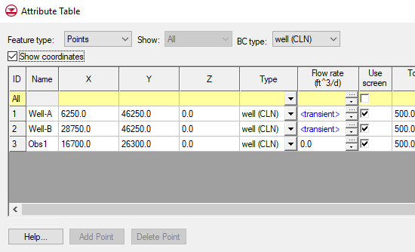

Figure 3 Observation well created using the Attribute Table dialog

1. Click **OK** to close the *Attribute Table* dialog.

A new well should appear in approximately the middle of the model. When a CLN well is created in the MODFLOW model, after mapping the coverage to MODFLOW, two things occur:

* CLN cells are created that are connected to the 3D groundwater cells
* A well is created in the lowest CLN cell

In this case a well screen from 500.0 to 0.0 will result in 2 CLN cells, one CLN cell for each layer in the grid and the CLN well will be placed in the CLN cell associated with layer 2.

# Creating the Observation Point

The second step is to create the observation point that will be associated with the CLN cell where the CLN well “Obs1” is located. The observation point will be “linked” to the CLN cell by being in the same groundwater cell and by having the same name as the CLN well (in this case “Obs1”). The observation point does not need to be in the exact same location as the CLN well, but it can be. The computed head for this observation point will be the head in the CLN cell, not the groundwater cell nor the location of the observation point.

1. Right-click on “File:Conceptual Model Icon.svg CLN*”* in the Project Explorer and select **New Coverage…** to bring up the *Coverage Setup* dialog.
2. For the *Coverage name,* enter “Observations”.
3. In the *Observation Points* section, turn on “Trans. Head”.
4. Click **OK** to close the *Coverage Setup* dialog.

A new “File:Coverage Active Icon.svg Observations” coverage will appear in the Project Explorer.

1. In the Project Explorer, right-click on “File:Coverage Active Icon.svg Observations” and select **Attribute Table** to open the *Attributes Table* dialog for the coverage.
2. Underneath the *Feature type:* drop-down, turn on *Show coordinates*.
3. In the blank row, enter the values found in Table 2 below:

|  |  |
| --- | --- |
| Name | Obs1 |
| X | 15800 |
| Y | 25800 |
| Z | 0 |
| Type | obs.pt |

Table 2 Observation point

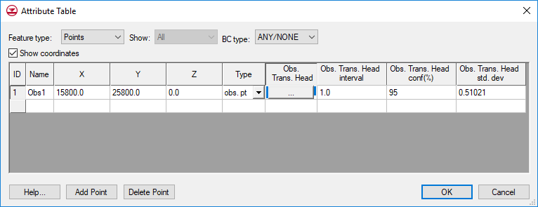

Figure 4 Observation well created using the Attribute Table dialog

1. Click the File:Dot dot dot button.png button in the *Obs. Trans. Head* column to open the *XY Series Editor*.
2. Enter the values in Table 3 below:

|  |  |
| --- | --- |
| Time (d) | Obs. Trans. Head |
| 10 | 152 |
| 500 | 148 |
| 900 | 159 |

Table 3 XY series values

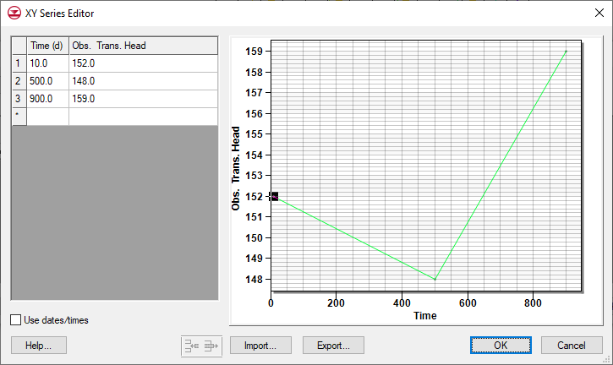

Figure 5 XY Series of the observed head values over time

1. Click **OK** to exit the *XY Series Editor* dialog.
2. Change the *Obs. Trans. Head interval* to “2.0”.
3. Leave the remaining fields at the default values and click **OK** to exit the *Attribute Table* dialog.

# Map to MODFLOW

The data added in the conceptual model needs to be mapped to the grid model.

1. Right-click on the “File:Conceptual Model Icon.svg CLN” conceptual model and select *Map To* | **MODFLOW/MODPATH** to open the *Map → Model* dialog.
2. Check *All applicable coverages* and click **OK** to close the *Map → Model* dialog.

# Review Model Inputs

The values mapped to the MODFLOW-USG simulation can now be viewed.

## CLN WEL package

1. Select *MODFLOW | Optional Packages* | **CLN WEL – CLN Well…** to bring up the *MODFLOW CLN Wells Package* dialog.

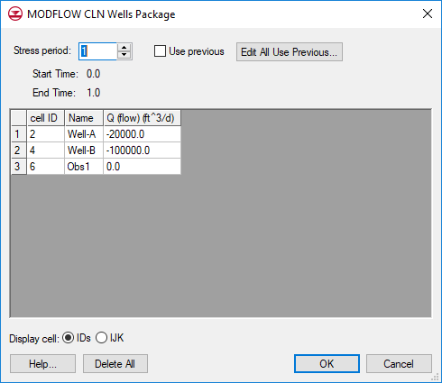

Figure 6 CLN Wells Package dialog

Notice the new Obs1 well appears and has a pumping rate of zero.

1. Click **OK** to close *MODFLOW CLN Wells Package* dialog.

## CLN – Connected Linear Network

1. Select *MODFLOW | Optional Packages* | **CLN – Connected Linear Network…** to bring up the *CLN Process* dialog.
2. From the list on the left, select “SegmentNodes”. A table will appear to the right of the list.

The CLN process contains nodes that can be connected together. For this simulation there are three CLN wells, and each well consists of two nodes. Each well has a unique *ClnSegmentId*, and each node has a unique *IFNO* value. Well-A is made up of the two nodes with a *ClnSegmentId* of “1”, and Well-B is made up of the two nodes with a *ClnSegmentId* of “2”. The new well, Obs1, is made up of the two nodes with a *ClnSegmentId* of “3”.

1. From the list on the left, select “Nodes”. The table on the right will change to show node information.

This table shows the values for each CLN node.

1. Click **OK** to close the *CLN Process* dialog.

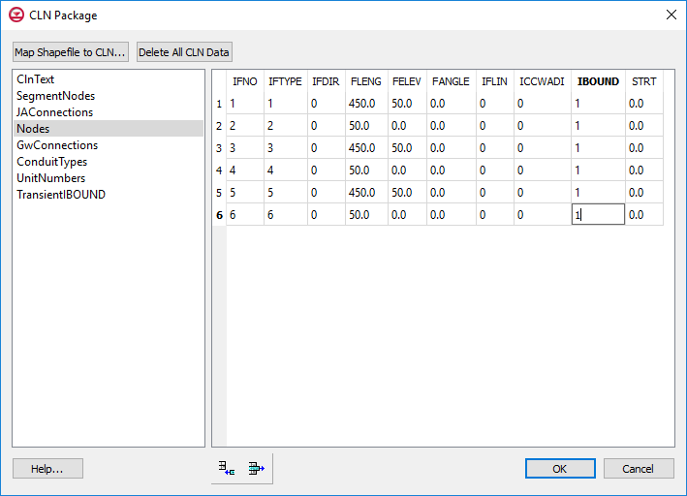

Figure 7 CLN Process dialog

## Observations

1. Select *MODFLOW |* **Observations…** to bring up the *MODFLOW-USG* *Observations* dialog.

The *Observations* dialog shows the observation data that will be used with PEST utilities. Notice with “Wells” selected on the left, there is one well listed, the Obs1 well.

1. From the list on the left, select “Cln Well To Node”.

Notice there is one well listed, the Obs1 well, and the *Node ID* is the CLN node ID (6).

1. From the list on the left, select “Cln Well Sample”.

Notice the times and head observations are listed in the table.

1. Click **OK** to close the *MODFLOW-USG Observations* dialog.

# Saving and Running MODFLOW

The changes should now be saved before running MODFLOW.

1. Click **Save** File:Save Macro.svg to save the project.
2. Click the **Run MODFLOW** File:Run MODFLOW Macro.svg macro in the toolbar to bring up the *MODFLOW* model wrapper dialog.
3. When MODFLOW finishes, check the *Read solution on exit* and *Turn on contours (if not on already)* boxes.
4. Click **Close** to close the *MODFLOW* model wrapper dialog.
5. Click **Save** File:Save Macro.svg to save the project with the new solution.

The simulation should now appear as shown in Figure 8.

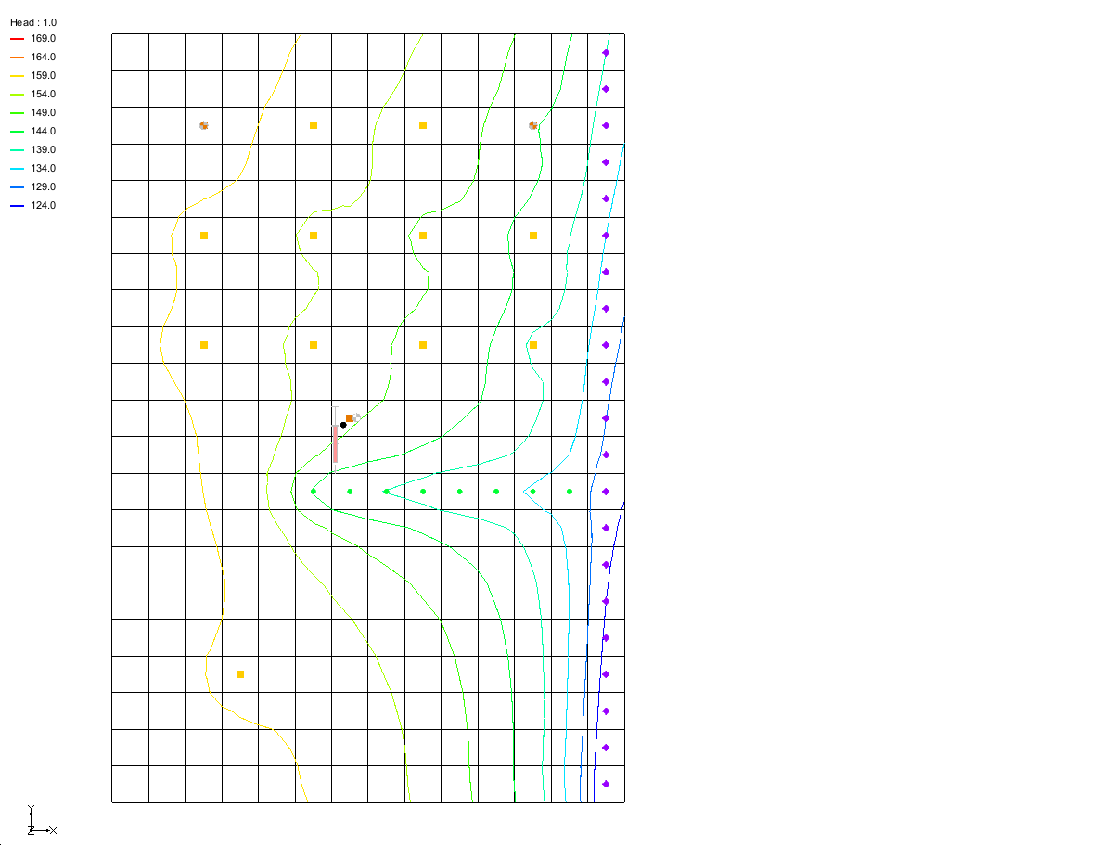

Figure 8 Solution with CLN observation well

# Examining the Results

Examine the solution and compare it to the solution using the MNW2 package.

1. If necessary, expand the “File:Generic Folder Locked.svg ClnObservations (MODFLOW)” item in the Project Explorer.
2. In the “File:Generic Folder Locked.svg ClnObservations (MODFLOW)” folder select the “File:Dataset Cells Active.svg Head” dataset.
3. In the *Time Steps* window, use the down arrow key to step through the time steps and watch how the contours and the calibration target changes.

# Changing the Observation or Well Name

To illustrate that the observation point name and the CLN well name must match for the observation to be linked to the CLN well:

1. In the Project Explorer, right-click on “File:Coverage Active Icon.svg Observations” and select **Attribute Table** to open the *Attribute Table* dialog for the coverage.
2. Change the *Name* to “Obs2”.
3. Click **OK** to close the *Attribute Table* dialog.

Notice that GMS provides a warning that the link between the observation point and the CLN well will be broken.

1. Click **Accept Changes** to close the warning dialog.

# Conclusion

This concludes the tutorial. Here are the key concepts from this tutorial:

Head observations can be associated with CLN Wells.

An observation point is “linked” to a CLN Well by being in the same 3D grid cell as the CLN Well and by having the same name.

1. K.J. Halford and R.T. Hanson. (2002). User Guide for the Drawdown-Limited, Multi-Node Well (MNW) Package for the U.S. Geological Survey’s Modular Three-Dimensional Finite Difference Ground-Water Flow Model, Versions MODFLOW-96 and MODFLOW-2000. Open-File Report 02-293, pp15–17. https://water.usgs.gov/nrp/gwsoftware/modflow2000/MNW_text.pdf.
2. Ibid, p.16.