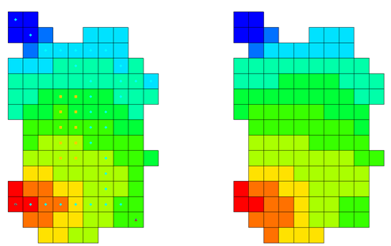

GMS 10.9

GMS 10.9 Tutorial

***MODFLOW-USG – Converting from MODFLOW-2005***

How to convert a non-MODFLOW-USG model into a MODFLOW-USG model

Objectives

Learn how to create a MODFLOW-USG model from an existing, non-MODFLOW-USG model in GMS.

Time

* 15–30 minutes

Required Components

* GMS Core
* MODFLOW Interface

Prerequisite Tutorials

* MODFLOW – Grid Approach

|  |
| --- |
| 1 Introduction 2  1.1 Getting Started 2  2 Importing a MODFLOW-2005 Model 2  2.1 Saving and Running MODFLOW-2005 3  3 Changing to MODFLOW-USG 4  3.1 Saving and Running MODFLOW-USG 5  3.2 Comparing Results 5  4 Importing a MODFLOW-2005 Model and Converting to a UGrid 6  4.1 Saving and Running MODFLOW-2005 7  5 Converting from a 3D Grid to a UGrid 7  5.1 Comparing Grids 8  5.2 Saving and Running MODFLOW-USG 8  5.3 Comparing Results 9  6 Conclusion 10 |

# Introduction

MODFLOW-USG supports most of the packages from MODFLOW-2005. It can import and use structured grid model files from MODFLOW-2000 and MODFLOW-2005. For simple models, it is easy to convert them for use in MODFLOW-USG. The GMS interface makes this process simple.

Converting the model from using a structured grid to an unstructured grid requires a bit more work, including the creation of a DISU file. In GMS, the model must first be converted to a new type of unstructured grid object (i.e., a UGrid). This conversion is handled automatically by GMS, which creates the DISU file automatically so no manual file editing is needed.

This tutorial discusses and demonstrates importing a model built for MODFLOW-2005, saving it, running it, and reviewing the results. The model is then switched to use MODFLOW-USG using a structured grid, the model is saved, MODFLOW is run, and the results are reviewed. The tutorial then compares the MODFLOW-2005 and MODFLOW-USG results.

In the later part of the tutorial, a more complex MODFLOW-2005 model is imported, saved, executed, and analyzed. The model is then converted to MODFLOW-USG with an unstructured grid, saved, run, and its results reviewed. Finally, the results from MODFLOW-2005 and MODFLOW-USG are compared.

## Getting Started

Do the following to get started:

1. If necessary, launch GMS.
2. If GMS is already running, select *File |* **New** to ensure that the program settings are restored to their default state.

# Importing a MODFLOW-2005 Model

Start by opening a MODFLOW-2005 model. This model is one of the USGS sample models shipped with MODFLOW-2005.

1. Click **Open** File:Open Macro.svg to bring up the *Open* dialog.
2. Select “MODFLOW Name Files (*.mfn;*.nam)” from the *Files of type* drop-down.
3. Browse to the *usg-from-mf2005\usg-from-mf2005\test1ss* directory and select “test1ss.nam”.
4. Click **Open** to exit the *Open* dialog and bring up the *MODFLOW Translator* dialog.
5. Select *MODFLOW 2005* and click **OK** to begin the translation process.
6. When it finishes translating the file into a standard GMS format, click **Done** to close the *MODFLOW Translator* dialog.

A simple, steady-state model should appear (Figure 1). It uses the Streamflow Routing, General-Head Boundary, Recharge, and Evapotranspiration packages.

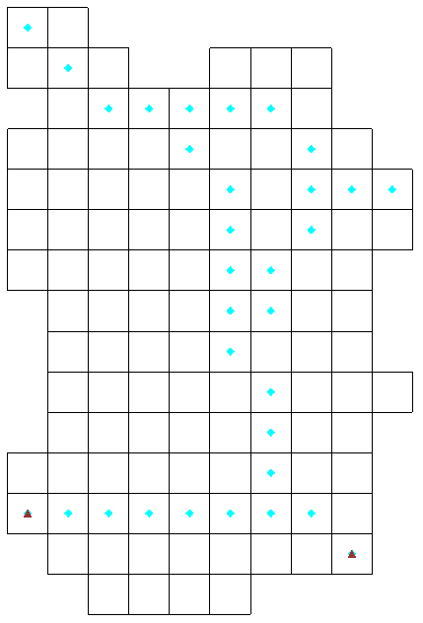

Figure 1 The imported model

## Saving and Running MODFLOW-2005

To save the project and run MODFLOW 2005:

1. Click **Save** File:Save Macro.svg to open the *Save As* dialog.
2. Select “Project Files (*.gpr)” from the *Save as type* drop-down.
3. Click **Up One Level** Up One Level icon to go to the *usg-from-mf2005\usg-from-mf2005*folder.
4. Enter “test1ss.gpr” as the *File name*.
5. Click **Save** to save the project under the new name and close the *Save As* dialog.
6. Click the **Run MODFLOW** File:Run MODFLOW Macro.svg macro to bring up the *MODFLOW* model wrapper dialog.
7. When it finishes, turn on *Read solution on exit* and *Turn on contours (if not on already)*.
8. Click **Close** to import the solution and close the *MODFLOW* model wrapper dialog.

Block fill contours should be visible on the model, similar to Figure 2.

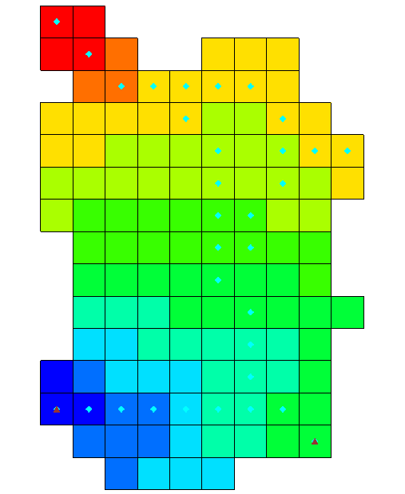

Figure 2 Block fill contours after obtaining a solution

# Changing to MODFLOW-USG

Now, change the model to use MODFLOW-USG. Other than changing the solver, no other changes should be made to the model. The model will still use the same structured grid.

1. Select *MODFLOW |* **Global Options…** to open the *MODFLOW Global/Basic Package* dialog.
2. In the *MODFLOW version* section, select *USG*.
3. Click **OK** to close the *MODFLOW Global/Basic Package* dialog.

A warning will appear stating that MODFLOW-USG only supports the SMS solver. This is because MODFLOW-USG uses the SMS Sparse Matrix solver developed by the USGS.[1]

1. Click **OK** to close the warning dialog.

## Saving and Running MODFLOW-USG

To run MODFLOW again and compare the results:

1. Select *File |* **Save As…** to bring up the *Save As* dialog.
2. Select “Project Files (*.gpr)” from the *Files of type* drop-down.
3. Enter “test1ss-usg.gpr” as the *File name*.
4. Click **Save** to save the file under the new name and close the *Save As* dialog.
5. Click the **Run MODFLOW** File:Run MODFLOW Macro.svg macro to bring up the *MODFLOW* model wrapper dialog.
6. When it finishes, turn on *Read solution on exit* and *Turn on contours (if not on already)*.
7. Click **Close** to import the solution and close the *MODFLOW* model wrapper dialog.

Notice that the block-fill contours are still visible.

1. **Save** File:Save Macro.svg the project with the new solution.

## Comparing Results

To compare the results:

1. In the Project Explorer, alternately click on the “File:Generic Folder Locked.svg test1ss (MODFLOW)” solution and the “File:Generic Folder Locked.svg test1ss-usg (MODFLOW)” solution.

Notice that the solutions appear to be identical.

1. Double-click the “File:External Text File Icon.svg test1ss.out” file in the Project Explorer to bring up the *View Data File* dialog. Note that if the *Never ask this again* option was previously checked in this dialog, this dialog will not appear. In this case, skip to step 6.
2. Select the desired text editor from the *Open with* drop-down and click **OK** to open the file in that text editor.
3. Repeat steps 2–3 with the “File:External Text File Icon.svg test1ss-usg.out” file in the Project Explorer.
4. In the external text editor, scroll to the bottom of each file and compare the volumetric budget results (Figure 3).

Notice that the results are very similar, though not exactly the same. This demonstrates that a MODFLOW-2005 model using a structured grid can be converted to MODFLOW-USG and produce very similar results with very little effort, so long as the original model does not use any packages that are not supported by MODFLOW-USG.

1. When finished examining the files, close both and return to GMS.

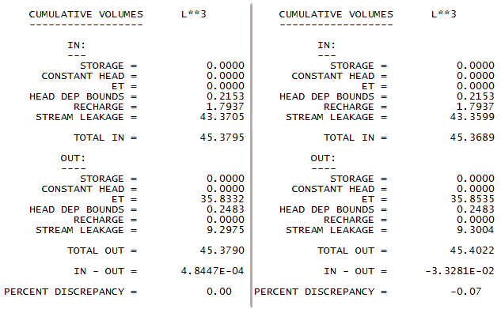

Figure 3 Comparing the volumetric budget results

# Importing a MODFLOW-2005 Model and Converting to a UGrid

Next, open another MODFLOW-2005 model that uses the UZF package. This package is not supported by MODFLOW-USG. In this case, the structured grid will be converted into an unstructured grid.

1. Click **New** File:New Macro.svg to start a new project and reset back to default settings. If asked to save, click **Don’t Save**.
2. Click **Open** File:Open Macro.svg to bring up the *Open* dialog.
3. Select “MODFLOW Name Files (*.mfn;*.nam)” from the *Files of type* drop-down.
4. Browse to the *usg-from-mf2005\usg-from-mf2005\UZFtest2* directory and select “UZFtest2.nam”.
5. Click **Open** to close the *Open* dialog and bring up the *MODFLOW Translator* dialog.
6. Select *MODFLOW 2005* and click **OK** to begin the translation into the standard GMS format.
7. When it finishes, click **Done** to close the *MODFLOW Translator* dialog.

A model similar to the one shown in Figure 1 should now be visible but with some additional symbols (Figure 4). This model uses the same grid layout as before. However, this model is transient and uses the UZF and Well packages instead of the Recharge and Evapotranspiration packages.

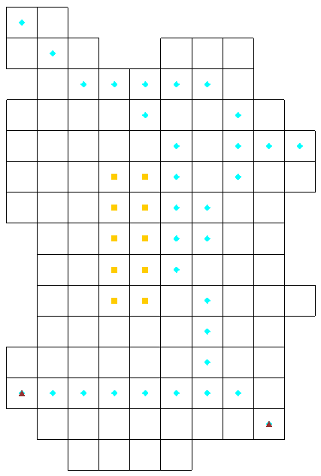

Figure 4 Model is slightly different than in Figure 1

## Saving and Running MODFLOW-2005

Next, to save the project and run MODFLOW-2005:

1. Click **Save** File:Save Macro.svg to open the *Save As* dialog.
2. Select “Project Files (*.gpr)” from the *Save as type* drop-down.
3. Click **Up One Level** Up One Level icon to go to the *usg-from-mf2005\usg-from-mf2005*folder.
4. Enter “UZFtest2.gpr” as the *File name*.
5. Click **Save** to save the project under the new name and close the *Save As* dialog.
6. Click the **Run MODFLOW** File:Run MODFLOW Macro.svg macro to bring up the *MODFLOW* model wrapper dialog.
7. When it finishes, turn on *Read solution on exit* and *Turn on contours (if not on already)*.
8. Click **Close** to import the solution and close the *MODFLOW* model wrapper dialog.

The model should have block-fill contours similar to those shown in Figure 2 will be visible on the model.

1. **Save** File:Save Macro.svg the project with the solution.

# Converting from a 3D Grid to a UGrid

MODFLOW-USG supports unstructured grids, or grids with all different kinds of cells and discontinuous layers. GMS provides support for these types of grids using an unstructured grid—or UGrid—object. This tutorial will now demonstrate converting the model from using a structured grid to an unstructured grid. No new cell types will be introduced into the model, and no discontinuous layers will be created, but the model will use a grid that supports this.

1. Right-click on “File:MODFLOW Folder.svg MODFLOW” in the Project Explorer and select **Convert to MODFLOW-USG Simulation**.
2. Click **No** when asked to include inactive cells in the new UGrid.
3. Click **OK** when advised that the SIP and UZF packages are not supported by MODFLOW-USG.

Notice that GMS created a new Project Explorer folder called “UGrid Data”. This folder contains one “Ugridlocksingle ugrid” containing (among other things) a new “File:MODFLOW Folder.svg MODFLOW” simulation.

## Comparing Grids

GMS created the UGrid from only the active cells of the structured, 3D grid. Therefore, the grids have a different number of cells.

1. Right-click on the structured “File:3D Grid Icon.svg grid” in the Project Explorer and select **Properties…** to open the *Properties* dialog.

Notice the *Number of cells* is “150” (scroll down the list if needed).

1. Click **OK** to exit the *Properties* dialog.
2. Right-click on the “Ugridlocksingle ugrid” and select **Properties…** to open the *UGrid* *Properties* dialog.

Notice the *Number of cells* is “116”. The number is lower because the inactive cells in the structured grid were not preserved in the UGrid.

1. Click **OK** to exit the *UGrid* *Properties* dialog.

Now hide the old model while working with the new model.

1. Turn off “File:3D Grid Folder.svg 3D Grid Data” in the Project Explorer to hide the old model.

## Saving and Running MODFLOW-USG

To save the project and run MODFLOW-USG:

1. **Save** File:Save Macro.svg the project.
2. Select the “File:MODFLOW Folder.svg MODFLOW” simulation under “Ugridlocksingle ugrid” in the Project Explorer to make it active.
3. Click the **Run MODFLOW** File:Run MODFLOW Macro.svg macro to bring up the *MODFLOW* model wrapper dialog.
4. When MODFLOW-USG finishes, turn on *Read solution on exit* and *Turn on contours (if not on already)*.
5. Click **Close** to import the solution and exit the *MODFLOW* model wrapper dialog.

Block-fill contours similar to those shown in Figure 2 should now be visible (Figure 5).

1. If needed, click **Contours**  to open the *Dataset Contour Options - UGrid - Head* dialog.
2. Select “Block Fill” from the *Contour method* drop-down.
3. Click **OK** to close the *Dataset Contour Options - UGrid - Head* dialog.

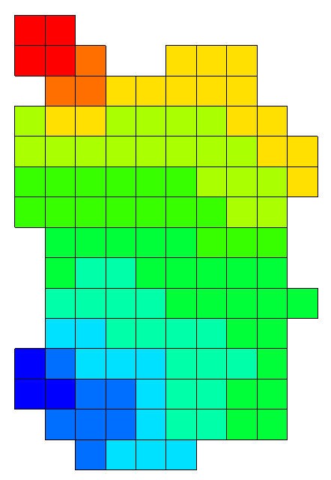

Figure 5 Block fill similar to Figure 2

## Comparing Results

To compare the results of the two models:

1. Double-click “File:External Text File Icon.svg UZFtest2.out” under the 3D grid MODFLOW solution to bring up the *View Data File* dialog. If the *Never ask this again* option was previously turned on, this dialog will not appear. In this case, skip to step 3.
2. Select the desired text editor from the *Open with* drop-down and click **OK** to close the *View Data File* dialog and open the file in the selected external text editor.
3. Follow steps 1–2 for the “File:External Text File Icon.svg UZFtest2.out” file under the UGrid MODFLOW solution.
4. Scroll to the bottom of each file and compare the volumetric budget results.

Notice that the results are quite different. The new USG model doesn’t include the UZF package, so there is no Recharge or ET. The Recharge and EVT packages in the new model could be used to mimic what the UZF package is doing in the old model. However, that goes beyond the scope of this tutorial.

Version 1.3 (released December 2015) of MODFLOW-USG does not support the HUF, MNW1, MNW2, and UZF MODFLOW-2005 packages.

# Conclusion

This concludes the “MODFLOW-USG: Converting from MODFLOW-2005” tutorial. The following key concepts were discussed and demonstrated in this tutorial:

* A model can be converted to MODFLOW-USG and run with a structured grid by simply changing an option in the *MODFLOW Global/Basic Package* dialog.
* To convert a model to an unstructured grid, right-click on the model and select the **Convert to MODFLOW-USG Simulation** command. This creates a new UGrid and MODFLOW simulation.
* Some MODFLOW-2005 packages, such as UZF, are not supported in MODFLOW-USG.

1. The LMG (or SAMG) solver developed by Fraunhofer SCAI also works with MODFLOW-USG and may also be available in the GMS license. Contact Aquaveo at <http://www.aquaveo.com/> for licensing information.