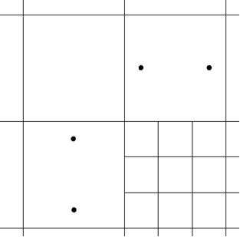

GMS 10.9

GMS 10.9 Tutorial

***MODFLOW-USG – GNC Package***

The GNC (Ghost Node Correction) package interface in GMS

Objectives

Learn how GMS supports the GNC (Ghost Node Correction) package for MODFLOW-USG.

Time

* 15–30 minutes

Required Components

* GMS Core
* MODFLOW Interface

Prerequisite Tutorials

* MODFLOW – Grid Approach

|  |
| --- |
| [1 Introduction 2](#_Toc110249064)  [2 Getting Started 3](#_Toc110249065)  [2.1 Opening an Existing Model 3](#_Toc110249066)  [2.2 Examining the Solution 4](#_Toc110249067)  [3 Using the GNC Package 5](#_Toc110249068)  [3.1 Adding GNC Data 5](#_Toc110249069)  [3.2 Saving and Running MODFLOW 7](#_Toc110249070)  [4 Comparing Solutions 7](#_Toc110249071)  [4.1 Comparing Heads 7](#_Toc110249072)  [4.2 Comparing Velocity Vectors 9](#_Toc110249073)  [5 Conclusion 10](#_Toc110249074) |

# Introduction

The Ghost Node Correction (GNC) package is an optional package included in MODFLOW-USG. It can be used to correct errors in the model that are created “when a line between two connected nodes does not bisect the shared face at a right angle.”[[1]](#footnote-1) The typical reason these errors would exist is if there is a nested or quadtree grid refinement present in the model grid. This tutorial is based on the first example problem included with the MODFLOW-USG documentation.

This tutorial will discuss and demonstrate:

* Opening a model containing a nested grid.
* Running the model and examining the results.
* Turning on the GNC package.
* Using GMS to compute the GNC package data.
* Saving and running the model.
* Comparing the new results to the old.

Figure 1 shows a conceptualization of ghost nodes.

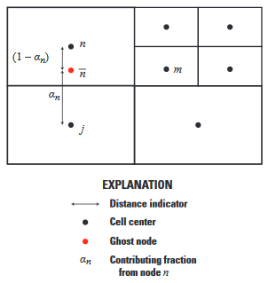

Figure Ghost node conceptualization for nested grids[[2]](#footnote-2)

# Getting Started

To get started, do the following:

1. If necessary, launch GMS.
2. If GMS is already running, select *File |* **New** to ensure that the program settings are restored to their default state.

## Opening an Existing Model

Start by opening a MODFLOW-USG one-layer, confined model based on the nested grid example included with the MODFLOW-USG documentation:

1. Click **Open** File:Open Macro.svg to bring up the *Open* dialog.
2. Select “Project Files (\*.gpr)” from the *Files of type* drop-down.
3. Browse to the *GncPackage\GncPackage\* directory and select “nested.gpr”.
4. Click **Open** to import the project and exit the *Open* dialog.

The project should appear similar to Figure 2. Flow is from left to right with the cells on the left side set as constant head cells with a value of “1.0”. Cells on the right side are set as constant head cells with a value of “0.0”.

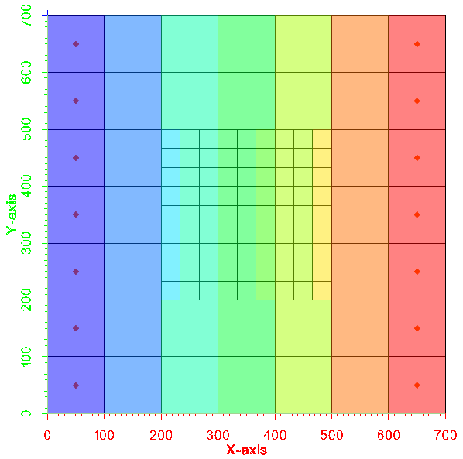

Figure Nested grid example included with MODFLOW-USG

## Examining the Solution

This project file includes a solution. Review the solution by doing the following:

1. Double-click on “File:External Text File Icon.svg nested.out” under the “File:Generic Folder Locked.svg nested (MODFLOW)” solution in the Project Explorer to bring up the *View Data File* dialog. If the *Never ask this again* option was previously turned on, this dialog will not appear. If this is the case, skip to step 3.
2. Select the desired text editor from the *Open with* drop-down and click **OK** to open the desired text editor and close the *View Data File* dialog.
3. In the external text editor, scroll to the bottom of the file to the volumetric budget section (Figure 3).

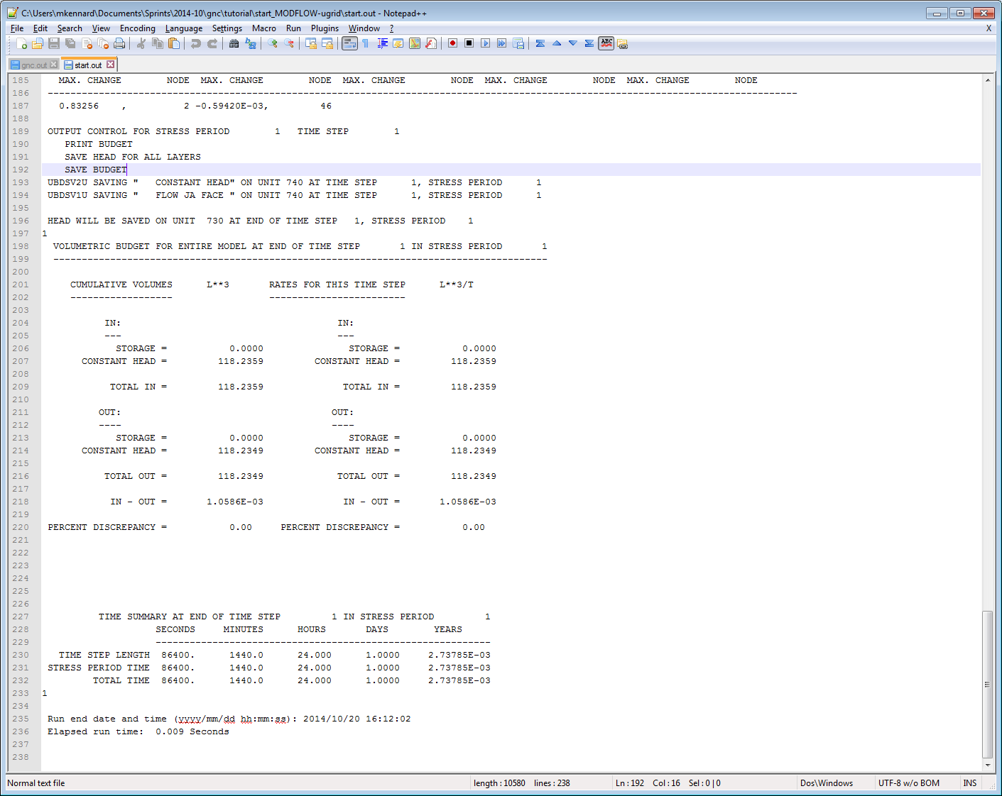

Figure Budget for model without ghost nodes

Notice the total in and total out is “118.2359”. According to the MODFLOW-USG documentation, "Using Darcy’s Law and the input parameters for this problem, the correct groundwater flow rate through the aquifer system is 116.67 m3/d."[[3]](#footnote-3) A MODFLOW 2005 simulation of the same area without the refined grid cells would match this groundwater flow rate.

The error is small—about 1.3 percent. The error is due to the 3-to-1 refinement of the nested grid and the fact that the line connecting the centers of some cells to their adjacent cells does not perpendicularly bisect the faces between the cells.

# Using the GNC Package

In order to reduce the error in the model, this tutorial will demonstrate how to use the GNC package.

1. Close the text editor and return to GMS.
2. Double-click the “File:MODFLOW Package Icon.svg Global” package in the Project Explorer to bring up the *MODFLOW Global/Basic Package* dialog.
3. Click **Packages…** to bring up the *MODFLOW Packages / Processes* dialog.
4. Turn on *GNC – Ghost Node Correction*.
5. Click **OK** to close the *MODFLOW Packages / Processes* dialog.
6. Click **OK** to exit the *MODFLOW Global/Basic Package* dialog.

## Adding GNC Data

With the package enabled, it is now possible to supply the data.

1. Right-click on “File:MODFLOW Folder.svg MODFLOW” and select *Optional Packages* | **GNC –** **Ghost Node Correction**… to bring up the *GNC Package* dialog.

The package consists of three tables, listed in the left column of the dialog. Refer to the MODFLOW-USG documentation for details about each.

* “GncText”: A list of text lines that can appear at the top of GNC package files.
* “GncFlags”: A list of options, or flags, used to control the GNC package.
* “GncNodes”: A list of ghost node data for each ghost node.

1. Select “GncNodes” from the list on the left. Following is a brief explanation[[4]](#footnote-4) for each column:

* *NodeN* is the node number of the cell in which the ghost node is located.
* *NodeM* is the node number of the connecting cell, *m*, to which flow occurs from the ghost node.
* *NodeJ* is the node number of a contributing cell *j*, which contributes to the interpolated head value at the ghost node.
* *AlphaJ* is the contributing factor *αj* of the ghost node.

Ghost node data can be added by hand. In this case, GMS will calculate the data.

1. Turn on *Create points at ghost node locations when generating*.
2. Click **Generate Ghost Node Data**.
3. Click **OK** to exit the *GNC Package* dialog.

The “GncNodes” table is now populated. A new UGrid named “Ugrid_lock_3D Ghost Nodes” has also been created. It has points where GMS calculated that ghost nodes should be located. To see the points, turn on the display of UGrid points.

1. Click **Display Options** File:Display Options Macro.svg to bring up the *Display Options* dialog.
2. Select “Ugrid: Ghost Nodes” from the list on the left.
3. Check on *Define UGrid specific options*.
4. On the *UGrid* tab, turn on *Points* and click **OK** to close the *Display Options* dialog.

The model should appear similar to Figure 4.

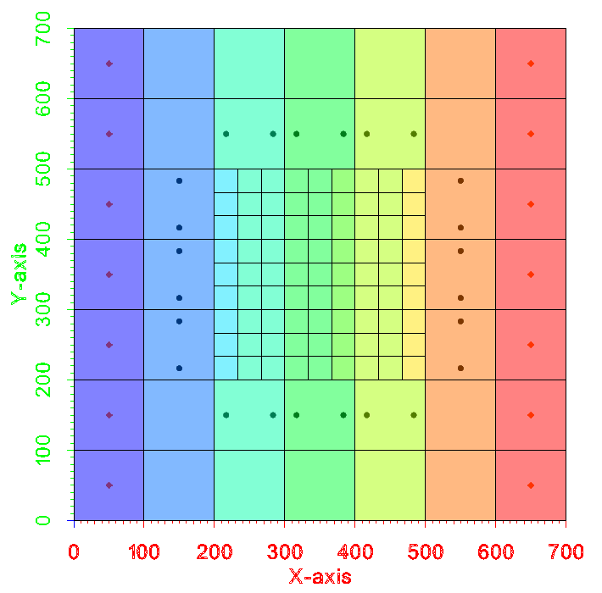

Figure Model after creating ghost nodes

## Saving and Running MODFLOW

Now save the model with a new name. This way, both the old and the new solutions will be available in the project after running MODFLOW.

1. Select *File |* **Save As…** to bring up the *Save As* dialog.
2. Select “Project Files (\*.gpr)” from the *Save as type* drop-down.
3. Enter “nestedGnc.gpr” as the *File name* and click **Save** to save under the new name and exit the *Save As* dialog.
4. Click **Run MODFLOW** File:Run MODFLOW Macro.svg to bring up the *MODFLOW* model wrapper dialog.
5. When the model finishes, turn on *Read solution on exit* and *Turn on contours (if not on already)*.
6. Click **Close** to import the solution and exit the *MODFLOW* model wrapper dialog.

# Comparing Solutions

## Comparing Heads

To review the output to see if the error in the model was reduced:

1. Double-click on “File:External Text File Icon.svg nestedGnc.out” in the Project Explorer to bring up the *View Data File* dialog. If the *Never ask this again* option had previously been turned on, this dialog will not appear. If this is the case, skip to step 3.
2. Select the desired external text editor from the *Open with* drop-down and click **OK** to open the output file in that text editor and close the *View Data File* dialog.
3. In the external text editor, scroll to the volumetric budget section at the bottom of the file.

Notice that the total in and total out is now very close to the ideal of 116.67 m3/d, demonstrating that the GNC package reduced the error in the model. Now to look at the difference in the calculated heads at the cells using the dataset calculator to create a new dataset that is the difference between the two MODFLOW solutions.

1. Select “Ugrid_lock_3D ugrid” in the Project Explorer to make it active.
2. Click **Data Calculator** File:Data Calculator Macro.svg to bring up the *Data Calculator* dialog.
3. In the *Expression* field, enter “abs(d2-d6)”.

This expression will create a dataset generated from the absolute value of the difference between dataset d2 [nested (MODFLOW)/Head] and dataset d6 [nestedGnc (MODFLOW) /Head].

1. In the *Result* field, enter “Head Difference”. This is the name of the new dataset.
2. Click **Compute**.

Notice the new dataset appears in the *Datasets* list.

1. Click **Done** to exit the *Data Calculator* dialog.

The “Head Difference” dataset is now contoured on the UGrid (Figure 5). The maximum difference in the head values is only about “0.014”.

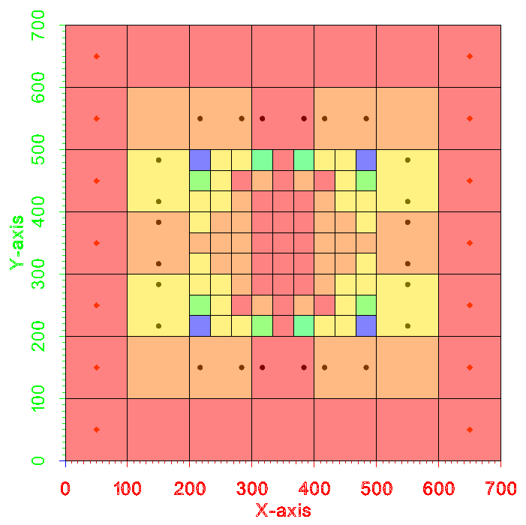

Figure Contours of the difference in calculated head

## Comparing Velocity Vectors

Another way to see the difference in the two solutions is to look at the velocity vectors.

1. Right-click on “File:CCF Dataset Active.svg CCF (nested.ccf)” under “File:Generic Folder Locked.svg nested (MODFLOW)” and select **CCF → Velocity Vectors** to create a new “File:Vector Dataset Inactive.svg Velocity vectors” dataset.
2. Repeat step 1 for the “File:CCF Dataset Active.svg CCF (nestedGnc.ccf)” dataset under the “File:Generic Folder Locked.svg nestedGnc (MODFLOW)” solution.
3. Click **Display Options** File:Display Options Macro.svg to bring up the *Display Options* dialog.
4. Select “Ugrid: ugrid” from the list on the left.
5. Check on *Define UGrid specific options*.
6. On the *UGrid* tab in the bottom section, turn off *Face contours* and turn on *Vectors*.
7. Click **OK** to close the *Display Options* dialog.
8. Click on the “File:Vector Dataset Active.svg Velocity vectors” dataset under the “File:Generic Folder Locked.svg nestedGnc (MODFLOW)” solution.

Notice the vector arrows (Figure 6).

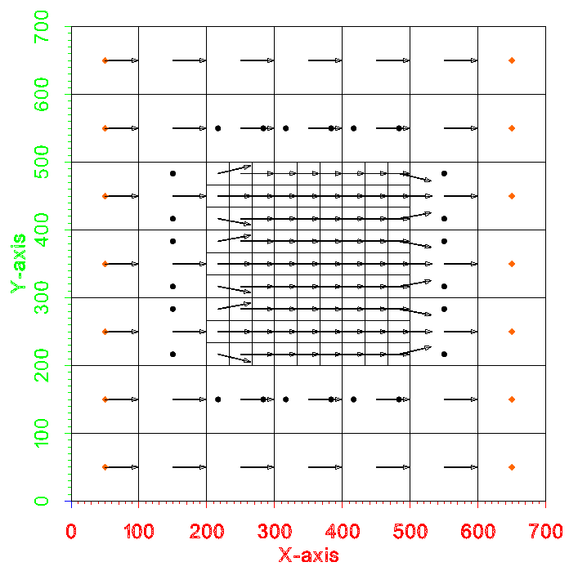

Figure Velocity vectors

1. Alternate between the two “File:Vector Dataset Active.svg Velocity vectors” datasets in the two solutions to compare them.

Notice the velocity vectors in the solution created using ghost nodes are generally straighter (left to right) than the ones created without ghost nodes.

# Conclusion

This concludes the “MODFLOW-USG – GNC Package” tutorial. The following key concepts were discussed and demonstrated in this tutorial:

* GMS includes an interface to the Ghost Node Correction (GNC) package.
* The GNC package is used to correct errors in the model that are created “when a line between two connected nodes does not bisect the shared face at a right angle”.
* Typically, the errors that the GNC Package corrects are small.

1. Panday, Sorab; Langevin, Christian.D.; Niswonger, Richard G.; Ibaraki, Motomu; and Hughes, Joseph D., (2013). “MODFLOW–USG version 1: An Unstructured Grid Version of MODFLOW for Simulating Groundwater Flow and Tightly Coupled Processes Using a Control Volume Finite-Difference Formulation” in *Techniques and Methods 6–A45*,U.S. Geological Survey, 66 p. [↑](#footnote-ref-1)
2. Ibid, p.24. [↑](#footnote-ref-2)
3. Panday, et al (2013), pp. 46-47. [↑](#footnote-ref-3)
4. Panday, et al (2013). [↑](#footnote-ref-4)