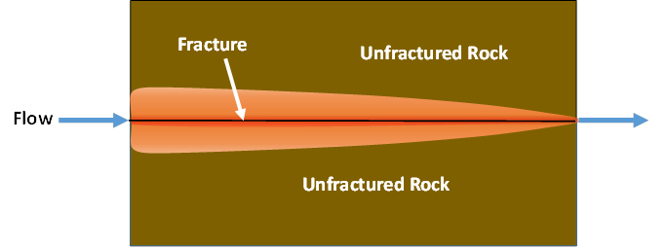

GMS 10.9

GMS 10.9 Tutorial

***MODFLOW-USG Transport – MDT Discrete Fracture***

Use the Matrix Diffusion Transport (MDT) package in GMS to simulate diffusion from a fracture using a semi-analytic approximation

Objectives

Learn how to use the Matrix Diffusion Transport (MDT) package with MODFLOW-USG Transport to simulate diffusion from a single fracture.

Time

* 15–30 minutes

Required Components

* GMS Core
* MODFLOW-USG Transport

Prerequisite Tutorials

* MODFLOW-USG Transport

|  |
| --- |
| 1 Introduction 2  2 Getting Started 3  3 Activating the MDT Package 4  4 Defining the MDT Package – Discrete Fracture Model 4  5 Saving and Running MODFLOW 5  6 Examining the Results 5  7 Conclusion 7 |

# Introduction

The Matrix Diffusion Transport (MDT) package enhances MODFLOW-USG Transport by incorporating matrix diffusion into existing flow and chemical transport models. It is based on the semi-analytic matrix diffusion method developed in the REMChlor-MD model[1], [2], [3]. This capability was created through a collaboration between Clemson University, GSI Environmental, and Aquaveo, with support from the Department of Defense Environmental Security Technology Certification Program (ESTCP).

The MDT method is conceptually similar to dual-porosity models, where each element is divided into mobile and immobile zones. Solute transport occurs by advection and dispersion in the mobile zone and by diffusion in the immobile zone. The MDT package dynamically estimates the concentration profile in the immobile zone using a function of distance from the mobile/immobile interface. This profile is updated at each time step using current and previous mobile concentrations, along with the integral of the immobile concentration profile. Mass transfer between zones is then computed as a linear, concentration-dependent source term.

This tutorial demonstrates how to use the MDT package with a MODFLOW-USG Transport simulation to model diffusion in a single fracture. The example is based on a benchmarking problem developed with REMChlor-MD. For a more detail on the semi-analytic method, see the REMChlor-MD user’s guide1 and related journal papers2, 3. MDT input parameters are described in the MDT Process for MODFLOW-USG Transport User’s Guide[4].

The problem in this tutorial consists of a single-layer, one-dimensional unstructured grid (UGrid) simulation with fixed head values. In this example, only the fracture is discretized, while matrix diffusion into the surrounding rock is handled analytically. This setup is based on a test case by Falta and Wang2 where water containing tritium is injected into a 100 µm-wide fracture at a pore velocity of 0.1 m/day. The tritium concentration is held constant for 30 years, followed by injection of clean water.

Additional model parameters are given in Table 1.

*Table 1. Parameters used in the fractured rock matrix diffusion comparison*

|  |  |  |
| --- | --- | --- |
| **Parameter** | **Fracture** | **Matrix** |
| Fracture aperture, μm | 100 |  |
| Porosity, *ϕ* | 1.0 | 0.01 |
| Tortuosity, *τ* | 1.0 | 0.1 |
| Retardation factor, *R* | 1.0 | 1.0 |
| Darcy velocity, *vx* (m/d) | 0.1 | 0 |
| Diffusion coefficient of tritium, *D*(m2/s) | 1.6E-9 | 1.6E-9 |
| tritium decay rate (1/yr) | 0.0561 | 0.0561 |
| Loading period, *t1*, (years) | 30 |  |

This tutorial will demonstrate the following topics:

1. Opening an existing MODFLOW-USG Transport simulation.
2. Activating the MDT package.
3. Running the simulation and examining the results.

# Getting Started

Do the following to get started:

1. If necessary, launch GMS.
2. If GMS is already running, select *File |* **New** to ensure that the program settings are restored to their default state.
3. Click **Open** File:Open Macro.svg (or *File |* **Open…**) to bring up the *Open* dialog.
4. Browse to the data files for *\MDT_DiscreteFracture\MDT_DiscreteFracture* and select “start.gpr”.
5. Click **Open** to import the file and close the *Open* dialog.

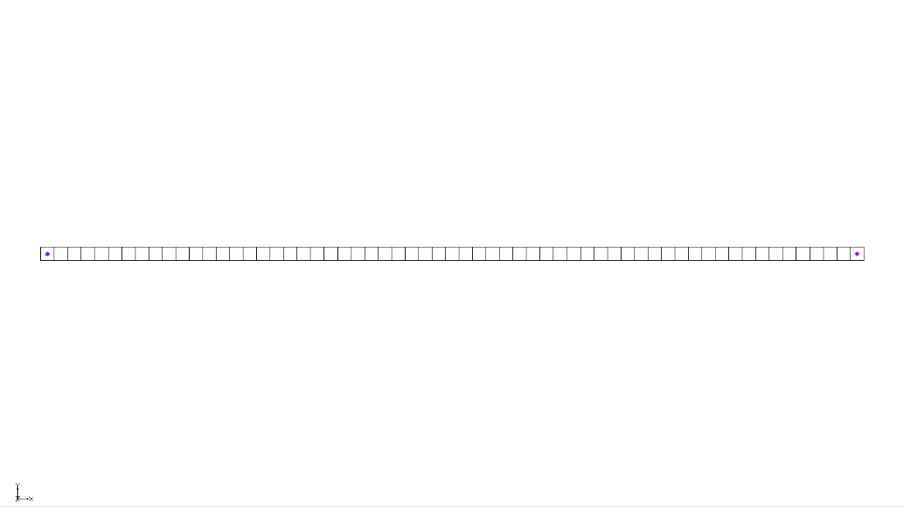

Figure 1 Imported MODFLOW-USG Transport model

The Graphics Window should appear similar to Figure 1. This model uses a single layer UGrid composed of 61 elements arranged in a 1D configuration. Each element measures 1 meter in the flow direction (x-direction), 1 meter perpendicular to the flow (y-direction), and 0.0001 meters vertically (z-direction), reflecting a fracture aperture of 100 µm.

Constant head boundaries (CHD) are assigned at both ends: the leftmost element is held at 11 meters, while the rightmost element is held at 10 meters. The horizontal hydraulic conductivity of 2,190 m/year produces a Darcy velocity of 36.5 m/yearr (about 0.1 m/day). Because the fracture porosity is set to 1 in the BCT package, the pore velocity is equal to the Darcy velocity.

Tritium (Species 1) is introduced at the upstream boundary using a transient concentration boundary (PCB package), set to a concentration of 1 for the first 30 years, followed by a concentration of 0 for the subsequent 30 years.

Before continuing, save the project with a new name.

1. Select *File* | **Save As…** to bring up the *Save As* dialog.
2. Enter “model-mdt.gpr” as the *File name*.
3. Select “Project Files (*.gpr)” from the *Save as type* drop-down.
4. Click **Save** to save the project file and close the *Save As* dialog.

# Activating the MDT Package

With the flow model set up, the MDT package can now be activated and added to the MODFLOW simulation. To activate the MDT package:

1. Switch to the **UGrid** File:UGrid Icon Unlocked.svg module.
2. Select *MODFLOW |* **Global Options…** to bring up the *MODFLOW Global/Basic Package* dialog.
3. Click **Packages…** to bring up the *MODFLOW Packages / Processes* dialog.
4. In the *Optional packages / processes* section, turn on *MDT – Matrix Diffusion Transport*.
5. Click **OK** to exit the *MODFLOW Packages / Processes* dialog.
6. Click **OK** to exit the *MODFLOW Global/Basic Package* dialog.

# Defining the MDT Package – Discrete Fracture Model

With the MDT package activated, the parameters for the MDT package can now be defined.

1. Select *MODFLOW | Optional Packages* | **MDT – Matrix Diffusion Transport…** to bring up the *MDT Package* dialog.
2. In the list on the left, select *Variables*.

Review the options here. For this example, the default settings will be used.

1. From the list on the left, select *Aquifer Properties*.
2. Enter the following for the *Constant Value* column:
   1. *MDFLAG*: “4.0”. Enables matrix diffusion from both the top and bottom into an infinite matrix. Used here since only the fracture is modeled.
   2. *VOLFRACMD*: “1.0”. Sets the volume fraction of high-permeability material. Since the fracture is the only domain, it’s 100%.
   3. *PORMD*: “0.01”. Porosity of the surrounding rock matrix.
   4. *RHOBMD*: “2.0”. Dry bulk density of the matrix (not used in this tritium simulation).
   5. *DIFFLENMD*: “1.0e-010”. Required placeholder value; not used with MDFLAG = 4
   6. *TORTMD*: “0.1”. Tortuosity of the matrix; affects the diffusion rate.
3. From the list on the left, select *Species Properties*.
4. Enter the following for the *Constant Value* column:
   1. DECAYMD: “0.0561”. Tritium decay rate (1/year).
   2. DIFFMD: “0.0504576”. Tritium molecular diffusion coefficient (m2/year).
5. Click **OK** to close the *MDT Package* dialog.

# Saving and Running MODFLOW

The changes should now be saved before running MODFLOW-USG Transport.

1. Click **Save** File:Save Macro.svg to save the project.
2. Click the **Run MODFLOW** File:Run MODFLOW Macro.svg macro in the toolbar to bring up the *MODFLOW* model wrapper dialog.
3. When MODFLOW finishes, check the *Read solution on exit* and *Turn on contours (if not on already)* boxes.
4. Click **Close** to close the *MODFLOW* model wrapper dialog.
5. Click **Save** File:Save Macro.svg to save the project with the new solution.

The solution set should appear in the Project Explorer.

# Examining the Results

To better evaluate the impact of the MDT package, generate a time series plot using the *Plot Wizard* tool to compare simulation.

1. In the Project Explorer, select the “File:Dataset Cells Active.svg Species 1” dataset to make it active.
2. Using the **Select Cells** File:Select UGrid Cell Tool.svg tool, select the first cell on the left.
3. Click the **Plot Wizard** File:Plot Wizard Macro.svg macro to open the *Plot Wizard* dialog.
4. Under *Plot Type*, select the *Active Dataset Time Series* option.
5. Click **Finish** to close the *Plot Wizard* dialog and generate the plot.

The *Active Dataset Time Series* plot should appear similar to Figure 2.

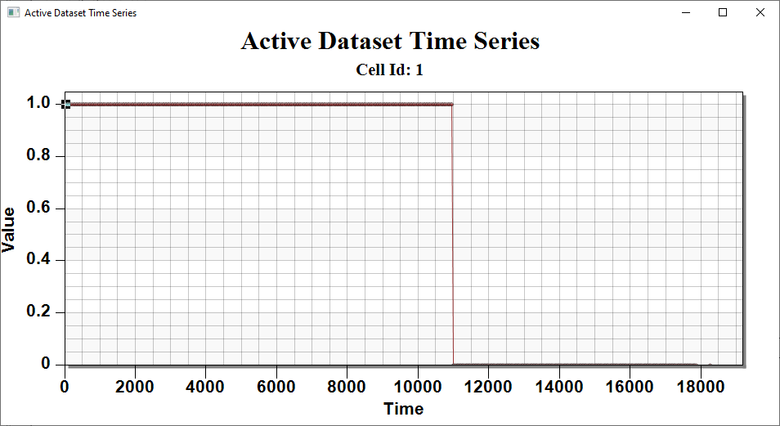

Figure 2 The Active Dataset Time Series for the first cell

1. Using the **Select Cells** File:Select UGrid Cell Tool.svg tool, select the second cell on the left.

The *Active Dataset Time* Series plot will update to look like Figure 3. Observe how the solution evolves. If desired, select cells while moving further to the right and view the solution changes.

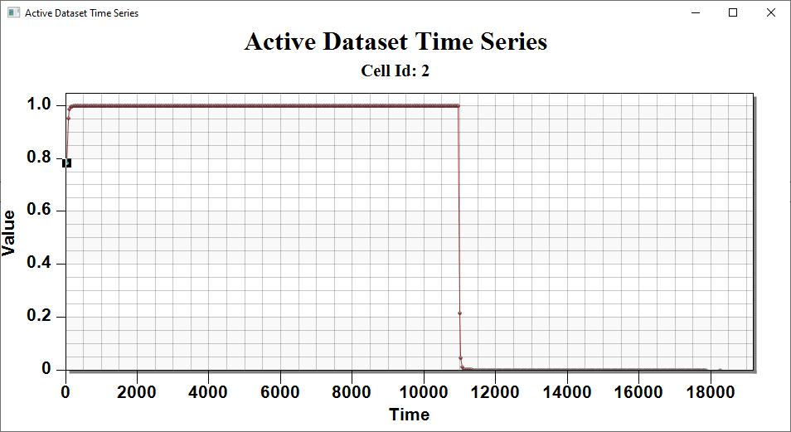

Figure 3 The Active Dataset Time Series for the second cell

Figure 4 compares the MDT Package results in MODFLOW-USG Transport4 with both an analytical solution and the REMChlor-MD solution. The MDT results match the REMChlor-MD results exactly and closely align with the analytical solution.



Figure 4 Comparison of MODFLOW-USG MDT Package output with REMChlor-MD (semi-analytical) and the analytical solution.

# Conclusion

This concludes the tutorial. Here are the key concepts from this tutorial:

* The MODFLOW-USG Transport MDT package simulates matrix diffusion from one or more fractures in fractured porous materials
* Two modeling approaches are supported:
  + The discrete fracture approach simulates the fractures directly, with matrix diffusion occurring into an infinite surrounding matrix
  + The equivalent porous media approach uses standard grid elements, with matrix diffusion occurring over a finite distance within the matrix material of each element

1. Farhat, S. K., Newell, C. J., Falta, R. W., & Lynch, K. (2018). *REMChlor-MD user’s manual*. Environmental Security Technology Certification Program (ESTCP). <https://www.serdp-estcp.org/Program-Areas/Environmental-Restoration/Contaminated-Groundwater/Persistent-Contamination/ER-201426>
2. Falta, R. W., & Wang, W. (2017). A semi-analytical method for simulating matrix diffusion in numerical transport models. *Journal of Contaminant Hydrology, 197*, 39–49.
3. Muskus, N., & Falta, R. W. (2018). Semi-analytical method for matrix diffusion in heterogeneous and fractured systems with parent-daughter reactions. *Journal of Contaminant Hydrology, 218*, 94–109.
4. Panday, S., Falta, R. W., Farhat, S., Pham, K., & Lemon, A. (2021). *Matrix Diffusion Transport (MDT) process for MODFLOW-USG Transport*. GSI Environmental. <https://www.gsienv.com/product/modflow-usg/>