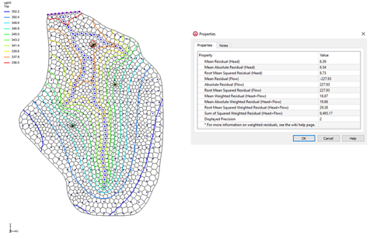

GMS 10.9

GMS 10.9 Tutorial

***MODFLOW-USG – PEST***

Model calibration with PEST

Objectives

This tutorial shows how to calibrate a MODFLOW-USG model using PEST.

Time

* 15–20 minutes

Required Components

* GMS Core
* MODFLOW Interface
* PEST

Prerequisite Tutorials

* MODFLOW – Model Calibration
* MODFLOW – Automated Parameter Estimation

|  |
| --- |
| 1 Introduction 2  1.1 Getting Started 2  1.2 Importing the Project 2  2 Converting to a MODFLOW-USG Model 4  2.1 Saving and Running MODFLOW-USG 4  2.2 Defining Observation Data 5  2.3 Resaving the Project and Running MODFLOW-USG 5  2.4 Running PEST 6  3 MODFLOW–USG with PEST 7  3.1 Importing a Project with Pilot Points 7  3.2 Running PEST 8  4 Importing a Project to Use with SVD Assist 9  4.1 Running PEST 10  5 Conclusion 11 |

# Introduction

This tutorial discusses and demonstrates opening a MODFLOW model and solution, converting it to a MODFLOW-USG model, running PEST, and loading optimal parameter values.

The “MODFLOW – Automated Parameter Estimation” tutorial should be completed prior to beginning this tutorial.

## Getting Started

Do the following to get started:

1. If necessary, launch GMS.
2. If GMS is already running, select *File |* **New** to ensure that the program settings are restored to their default state.

## Importing the Project

First to import the modeling project:

1. Click **Open** File:Open Macro.svg to bring up the *Open* dialog.
2. From the *Files of type* drop-down, select “Project Files (*.gpr)”.
3. Browse to the data file directory for this tutorial and select “mf2k_pest_zones.gpr”.
4. Click **Open** to import the project and exit the *Open* dialog.

The imported project should appear similar to Figure 1.

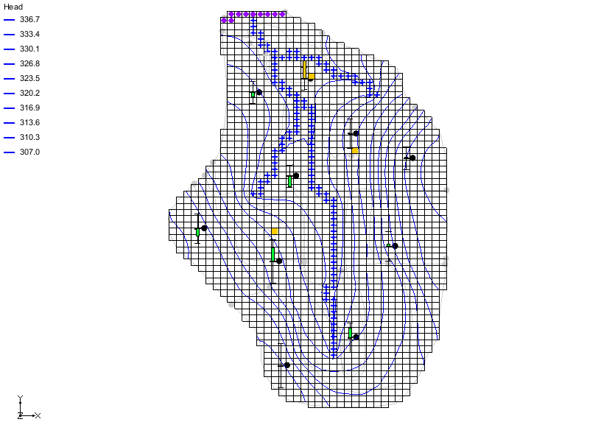

Figure 1 Initial screen after importing the project

Notice that there is now a MODFLOW model with a solution and a set of map coverages (Figure 2). Three of the coverages are the source/sinks, recharge, and hydraulic conductivity coverages used to define the conceptual model. The active coverage contains a set of observed head values from observation wells.

Feel free to switch to the “File:Coverage Active Icon.svg Sources & Sinks” coverage and use the **Select Arc Group** File:GMS Select Arc Group Tool.svg tool to select the stream network. This makes the observed flow value visible in the status bar. Switch back to the “File:Coverage Active Icon.svg Observation Wells” coverage when done.

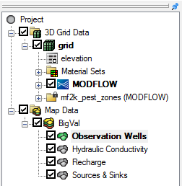

Figure 2 Initial appearance of the Project Explorer

# Converting to a MODFLOW-USG Model

The existing model is a MODFLOW-2000 model. This will be converted to a MODFLOW-USG model before running PEST.

1. Right-click on “File:MODFLOW Folder.svg MODFLOW” in the Project Explorer and select **Convert to MODFLOW-USG Simulation…** to bring up a prompt asking to include inactive cells in the new UGrid.
2. Click **No** to close the prompt.
3. Click **OK** to acknowledge that the PCG package is not supported by MODFLOW-USG.
4. Right-click on “File:3D Grid Folder.svg 3D Grid Data” in the Project Explorer and select **Delete** to remove the 3D grid from the project.
5. Select the “File:Dataset Cells Active.svg elevation” dataset.

The model should now appear similar to Figure 3.

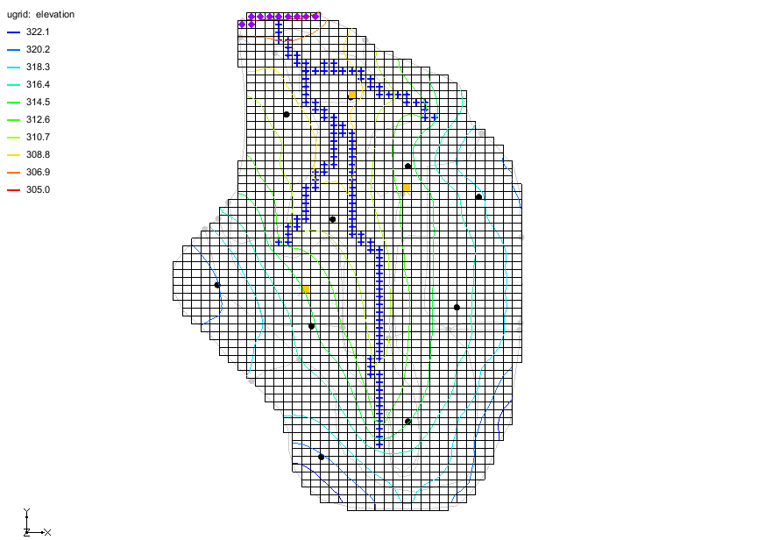

Figure 3 Model after conversion to MODFLOW-USG

## Saving and Running MODFLOW-USG

Next to save the project and run MODFLOW-USG:

1. Select *File* | **Save As…** to bring up the *Save As* dialog.
2. Enter “mfusg_pest.gpr” as the *File name*.
3. Click **Save** to save the project under the new name and close the *Save As* dialog.
4. Click **Run MODFLOW** File:Run MODFLOW Macro.svg to bring up the *MODFLOW* model wrapper dialog.
5. Once MODFLOW-USG has finished, turn on *Read solution on exit* and *Turn on contours (if not on already)*.
6. Click **Close** to import the solution and exit the *MODFLOW* dialog.

Notice that the contours for the computed MODFLOW heads are now visible (Figure 4), however, the targets for the MODFOW-USG observations wells are not displayed. The data for MODFLOW-USG observations must be generated and saved with the project for these calculations to occur.

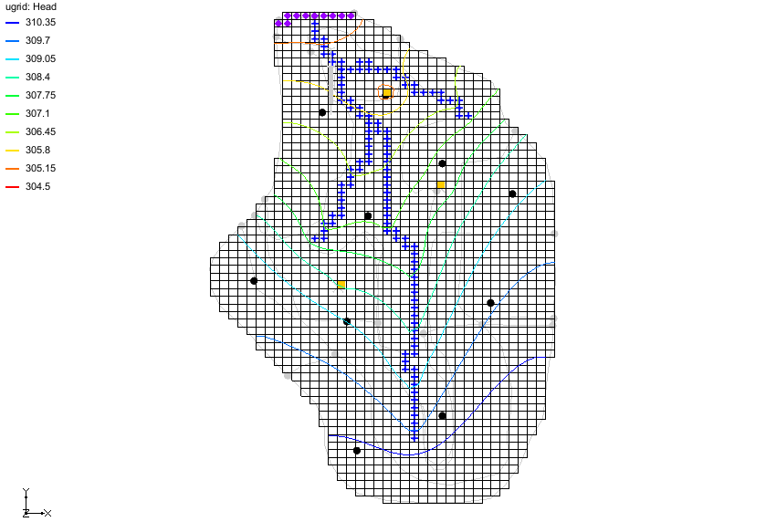

Figure 4 Imported solution after initial MODFLOW-USG run

## Defining Observation Data

To create the MODFLOW-USG observation input data, use the following steps:

1. Select *MODFLOW* | **Observations…** to bring up the *MODFLOW-USG Observations* dialog.
2. From the list on the left, select “Wells”.
3. Click **Generate PEST Obs. Data…** to bring up the *Generate Observations* dialog.
4. In the *Head Observation Coverages* section, turn on “Observation Wells”.
5. In the *Flow Observation Coverages* section, turn on “Sources & Sinks”.
6. Click **OK** to generate the observation input data and exit the *Generate Observations* dialog.
7. Click **OK** to exit the *MODFLOW-USG Observations* dialog.

## Resaving the Project and Running MODFLOW-USG

Now that the observation data is part of the model setup, save and rerun MODFLOW.

1. **Save** File:Save Macro.svg the project.
2. Click **Run MODFLOW** File:Run MODFLOW Macro.svg to bring up the *MODFLOW* model wrapper dialog.
3. Once MODFLOW-USG finishes running, turn on *Read solution on exit* and *Turn on contours (if not on already)*.
4. Click **Close** to import the solution and close the *MODFLOW* dialog.

Notice that the calibration targets now appear (Figure 5).

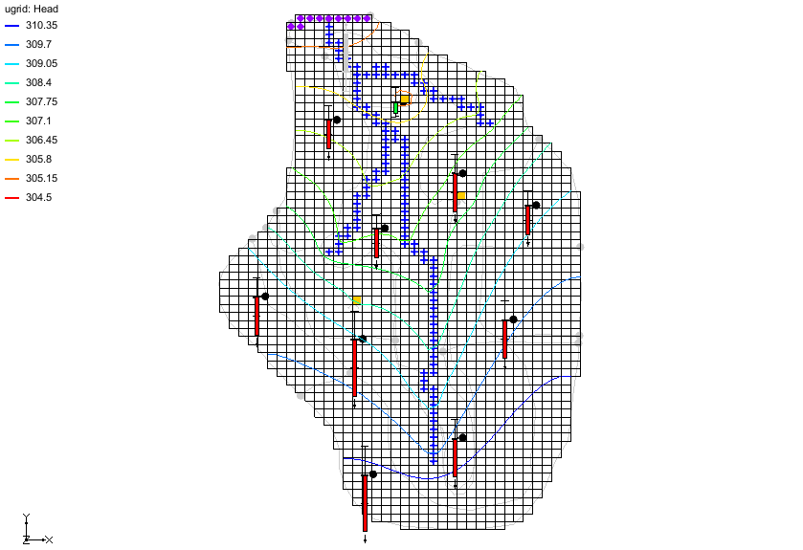

Figure 5 Calibration targets are now visible

## Running PEST

The original MODFLOW-2000 model included in the initial project had parameters defined. These parameters were copied to the MODFLOW-USG model. To run PEST, change the model run type to *Parameter Estimation*.

1. Select *MODFLOW* | **Global Options…** to bring up the *MODFLOW Global/Basic Package* dialog.
2. In the *Run options* section, select *Parameter Estimation*.
3. Click **OK** to exit the *MODFLOW Global/Basic Package* dialog.
4. **Save** File:Save Macro.svg the project.
5. Click **Run MODFLOW** File:Run MODFLOW Macro.svg to bring up the *MODFLOW/PEST Parameter Estimation* dialog.
6. Once PEST has finished, turn on *Read solution on exit* and *Turn on contours (if not on already).*
7. Click **Close** to import the solution and close the *MODFLOW/PEST Parameter Estimation* dialog.

In the interest of time, the maximum number of PEST iterations has been limited to 3. If the number of PEST iterations were increased to 10, the model error is less than 11.5. Notice that some of the observation well targets are yellow, indicating that the error has decreased. (Figure 6). The calculated error norms can now be inspected.

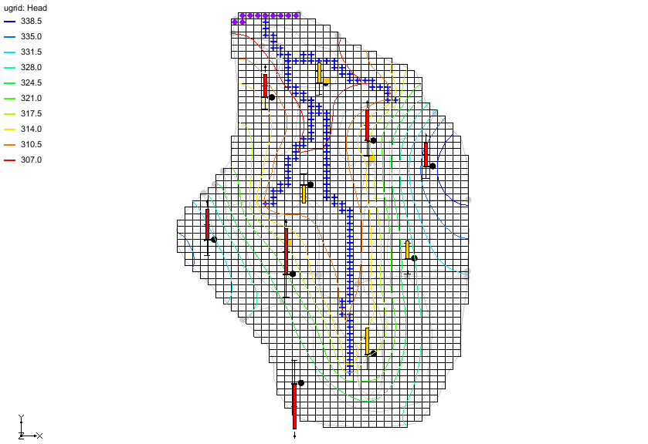

Figure 6 Some observation well targets are yellow

1. Right-click on “File:Generic Folder Locked.svg mfusg_pest (MODFLOW)” in the Project Explorer and select **Properties…** to bring up the *Properties* dialog.

This dialog displays the model residuals for head and flow as well as the weighted residuals for the combination of head and flow. The *Sum of Squared Weighted Residual (Head + Flow)* for this model should be approximately “554.0”.

1. Click **OK** to exit the *Properties* dialog.
2. **Save** File:Save Macro.svg the project.

# MODFLOW–USG with PEST

## Importing a Project with Pilot Points

Pilot points can also be used with MODFLOW-USG and PEST. For more information about pilot points, refer to the “MODFLOW – PEST Pilot Points” tutorial.

Now import a MODFLOW-USG model with pilot points and run PEST by doing the following:

1. Select *File |* **New** to reset GMS back to the default settings.
2. Click **Open** File:Open Macro.svg to bring up the *Open* dialog.
3. Select “Project Files (*.gpr)” from the *Files of type* drop-down.
4. Select “mfusg_pilot.gpr”.
5. Click **Open** to import the project and close the *Open* dialog.

The imported project should appear similar to Figure 7. This is a MODFLOW-USG model of the same area, but with a quadtree grid. The grid is refined around the pumping wells, river, and specified head boundary. The red points are 2D scatter points that will be used as pilot points to estimate the HK of the model.

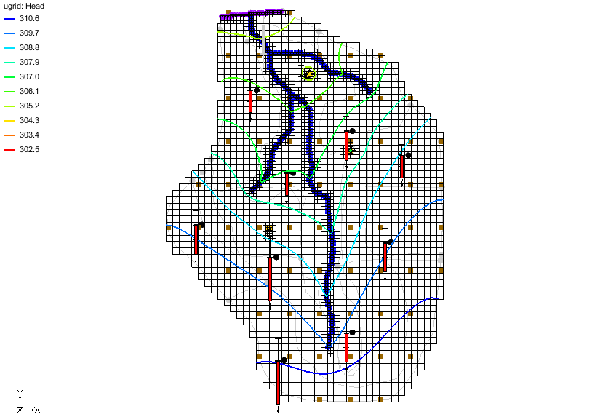

Figure 7 Quadtree model with pilot points

## Running PEST

The current model is a forward run and must be changed to the *Parameter Estimation* option to run PEST.

1. Select *MODFLOW* | **Global Options…** to bring up the *MODFLOW Global/Basic Package* dialog.
2. In the *Run options* section, select *Parameter Estimation*.
3. Click **OK** to exit the *MODFLOW Global/Basic Package* dialog.
4. Select *MODFLOW* | **Parameter Estimation…** to bring up the *PEST* dialog.

Notice the *Max number of iterations* is set to “2”. Now to save the project and run PEST:

1. Click **OK** to exit the *PEST* dialog.
2. Select *File* | **Save As…** to bring up the *Save As* dialog.
3. For the *File name,* enter “mfusg_pilot_pest.gpr”.
4. Click **Save** to save the project under the new name and close the *Save As* dialog.
5. Click **Run MODFLOW** File:Run MODFLOW Macro.svg to bring up the *MODFLOW/PEST Parameter Estimation* dialog.
6. Once parallel PEST finishes, turn on *Read solution on exit* and *Turn on contours (if not on already)*.
7. Click **Close** to import the solution and close the *MODFLOW/PEST Parameter Estimation* dialog.

In the interest of time, the maximum number of PEST iterations has been limited to 2. If the number of PEST iterations increased to 10, the model error is less than 1.0. Notice that a few of the observation well targets are yellow, indicating that the error has decreased (Figure 8).

The calculated error norms can now be inspected.

1. Right-click on “File:Generic Folder Locked.svg mfusg_pilot_pest (MODFLOW)” in the Project Explorer and select **Properties…** to bring up the *Properties* dialog.

This dialog shows the model residuals for head and flow as well as the weighted residuals for the combination of head and flow. The *Sum of Squared Weighted Residual (Head + Flow)* for this model should be approximately “2800.64”.

1. Select **OK** to exit the *Properties* dialog.
2. **Save** File:Save Macro.svg the project.

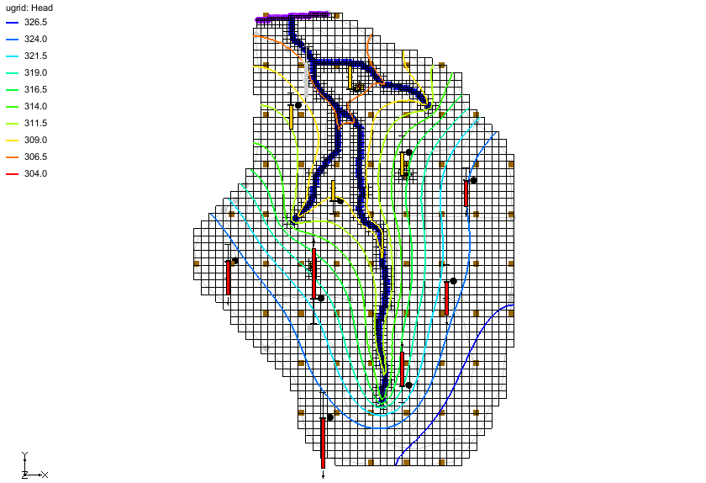

Figure 8 Observation well targets match the model outputs

# Importing a Project to Use with SVD Assist

PEST has tools for working with models that have hundreds of parameters. This PEST tool is called SVD Assist. SVD Assist can also be used with MODFLOW-USG models. The final step in this tutorial uses a model with over 200 parameters and use PEST SVD Assist to calibrate the model.

1. Select *File |* **New** to reset back to defaults.
2. Click **Open** File:Open Macro.svg to bring up the *Open* dialog.
3. From the *Files of type* drop-down, select “Project Files (*.gpr)”.
4. Select “mfusg_svda.gpr” and click **Open** to import the project and exit the *Open* dialog.

The imported project should appear similar to Figure 9.

This is a MODFLOW-USG model of the same area, but using a Voronoi grid. The grid is refined around the pumping wells, river, and specified head boundary. The observation well locations were used to generate the grid, and each observation well is placed at the center of a cell. The blue points are 2D scatter points that will be used as pilot points to estimate the HK of the model.

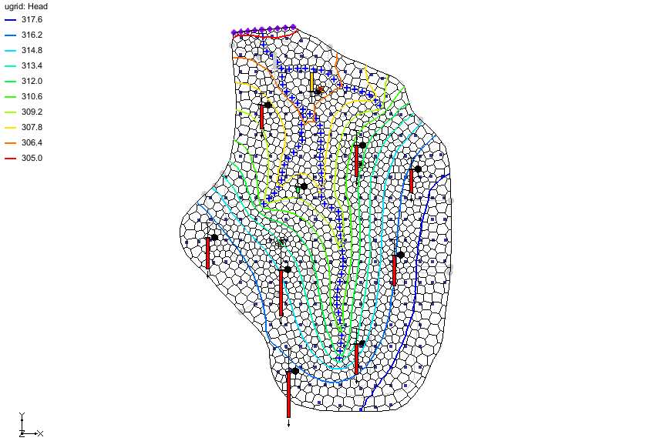

Figure 9 Voronoi grid with refinement

## Running PEST

The current model is a forward run and must be changed to the *Parameter Estimation* option to run PEST.

1. Select *MODFLOW* | **Global Options…** to bring up the *MODFLOW Global/Basic Package* dialog.
2. In the *Run options* section, select *Parameter Estimation*.
3. Click **OK** to exit the *MODFLOW Global/Basic Package* dialog.
4. Select *MODFLOW* | **Parameter Estimation…** to bring up the *PEST* dialog.

Notice that in the *Parallel PEST* section, *Use Parallel PEST* is turned on. Parallel PEST will be used to calibrate this model. Also notice that in the *SVD options* section, *Use SVD-Assist* is turned on.

Now to save the project and run PEST:

1. Click **OK** to exit the *PEST* dialog.
2. Select *File* | **Save As…** to bring up the *Save As* dialog.
3. For the *File name,* enter “mfusg_svda_pest.gpr”.
4. Click **Save** to save the project under the new name and close the *Save As* dialog.
5. Click **Run MODFLOW** File:Run MODFLOW Macro.svg to bring up the *MODFLOW/PEST Parameter Estimation* dialog.

When using SVD Assist, PEST will first run the model one time for every parameter. The information generated from that first run is used to make groups of super parameters that are then estimated by PEST. Notice that the first parameter estimation iteration required 235 model runs and that the subsequent iterations only require 11 model runs.

1. Once Parallel PEST finishes, turn on *Read solution on exit* and *Turn on contours (if not on already)*.
2. Click **Close** to import the solution and close the MODFLOW/PEST Parameter Estimation dialog.

In the interest of time, the maximum number of PEST iterations has been limited to 2. If the number of PEST iterations increased to 15, the model error is less than 2.0. Notice that a few of the observation well targets are yellow, indicating that the error has decreased (Figure 10). The calculated error norms can also be inspected.

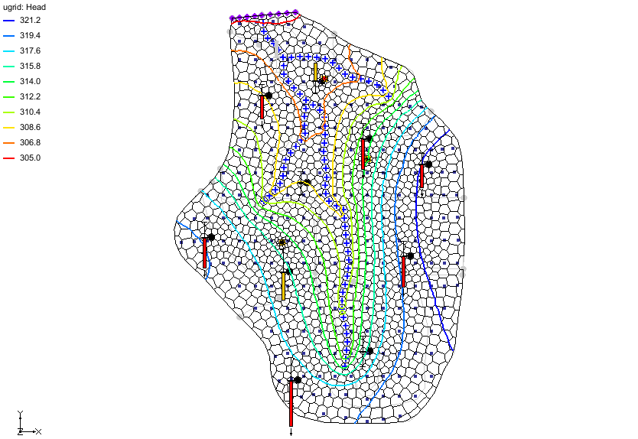

Figure 10 Observation well targets and model outputs match

1. Right-click on “File:Generic Folder Locked.svg mfusg_svda_pest (MODFLOW)” in the Project Explorer and select **Properties…** to bring up the *Properties* dialog.

This dialog shows the model residuals for head and flow as well as the weighted residuals for the combination of head and flow. The *Sum of Squared Weighted Residual (Head + Flow)* for this model should be approximately “5,088”.

1. Select **OK** to exit the *Properties* dialog.
2. **Save** File:Save Macro.svg the project.

# Conclusion

This concludes the “MODFLOW-USG *–* PEST” tutorial. The following key topics were discussed and demonstrated:

* PEST can be used with MODFLOW-USG.
* Parallel PEST, pilot points, and SVD Assist can also be used with MODFLOW-USG.