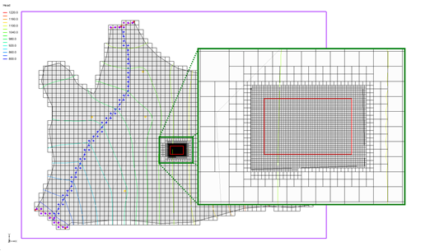

GMS 10.9

GMS 10.9 Tutorial

***MODFLOW-USG – Regional to Local Model Conversion***

Create a locally refined area in a regional model using MODFLOW-USG and GMS

Objectives

Use the tools provided in GMS to locally refine an area in a regional model.

Time

* 15–30 minutes

Required Components

* GMS Core
* Geostatistics
* MODFLOW Interface

Prerequisite Tutorials

* MODFLOW – Conceptual Model Approach I
* MODFLOW-USG – Quadtree
* UGrid Creation

|  |
| --- |
| 1 Introduction 2  2 Getting Started 3  2.1 Reading in the Regional Model 3  2.2 Saving with a Different Name 4  3 Creating a UGrid 4  3.1 Defining the Refined Area 6  3.2 Creating a 3D Refined UGrid 7  4 Converting the Layer Data to a Scatter Point Set 9  5 Creating a MODFLOW-USG Model 9  6 Interpolating Layer Elevations 9  7 Mapping to MODFLOW 10  8 Saving and Running MODFLOW 11  9 Conclusion 12 |

# Introduction

MODFLOW–USG (UnStructured Grid) was developed to support a wide variety of structured and unstructured grid types, including nested grids and grids based on prismatic triangles, rectangles, hexagons, and other cell shapes. Flexibility in grid design can be used to focus resolution along rivers and around wells, for example, or to subdiscretize individual layers to better represent hydrostratigraphic units.[1]

In Figure 1—taken from the MODFLOW-USG documentation[2]—notice the grid labeled “H”. This is an example of a nested grid. MODFLOW-USG allows a single MODFLOW simulation to have different levels of grid refinement within the same simulation. Other models, such as MODFLOW-LGR, require multiple nested grids with two or more coupled simulations.

In this tutorial, a regional MODFLOW 2000 model will be imported and a MODFLOW-USG model with local refinement will be created. A MODFLOW-USG simulation will be created, and the layer data will be converted to a scatter point dataset. The layer data will be interpolated and mapped from the conceptual model to MODFLOW. MODFLOW will then be run.

This tutorial assumes familiarity with conceptual modeling, MODFLOW-USG, and unstructured grid generation. The tutorials listed as prerequisites on the cover page of this document should be completed prior to starting this tutorial.



Figure 1 Examples of unstructured grids from the MODFLOW-USG documentation

# Getting Started

Do the following to get started:

1. If necessary, launch GMS.
2. If GMS is already running, select *File |* **New** to ensure that the program settings are restored to their default state.

## Reading in the Regional Model

The first step in the model conversion process is to build a regional model. Since the focus of this tutorial is primarily on the conversion process, import a previously constructed model.

1. Click **Open** File:Open Macro.svg to bring up the *Open* dialog.
2. Select “Project Files (*.gpr)” from the *Files of type* drop-down.
3. Browse to the *Reg2Loc* directory and select “regmod.gpr”.
4. Click **Open** to import the project and exit the *Open* dialog.

A model similar to Figure 2 should appear.

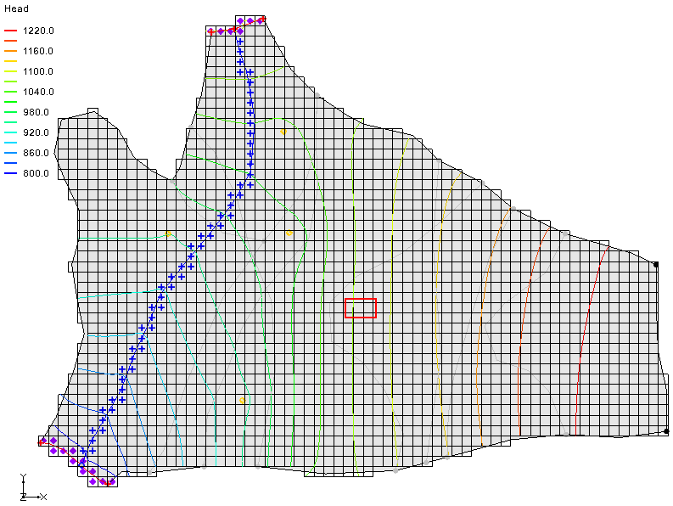

Figure 2 Regional MODFLOW 2000 model

This is the top layer of the two layer model. This model was constructed using the conceptual model approach. The boundary of the local site is indicated with a red rectangle. The imported project includes the solution for the regional MODFLOW 2000 model.

## Saving with a Different Name

Before making any changes, it is best to save the project under a new name.

1. Select *File |* **Save As…** to bring up the *Save As* dialog.
2. Select “Project Files (*.gpr)” from the *Save as type* drop-down.
3. For the *File name,* enter “refined.gpr”.
4. Click **Save** to save the project under the new name and close the *Save As* dialog.

Periodically **Save** File:Save Macro.svg as the model is developed.

# Creating a UGrid

Now to create a 3D UGrid. This grid needs to match the MODFLOW 2000 (mf2k) grid except the new grid will be refined around the local site using a grid frame with the same origin and extents as the mf2k grid. A map polygon will be used to define the refined area around the local site.

1. Right-click in a blank space in the Project Explorer and select *New |* **Grid Frame**.
2. Right-click on “File:Grid Frame Icon.svg Grid Frame” in the Project Explorer and select **Fit to Active Coverage**.
3. Fully expand “File:3D Grid Folder.svg 3D Grid Data”, then right-click on “File:3D Grid Icon.svg grid” and select **Properties…** to open the *Properties* dialog.
4. In the *Value* column, select the cell of the *X origin* row and while holding down the *Shift* key, in the *Value* column, select the cell of the *Length in Z* row.

This selects a total of six cells (Figure 3).

1. Right-click on one of the selected cells and select **Copy**.

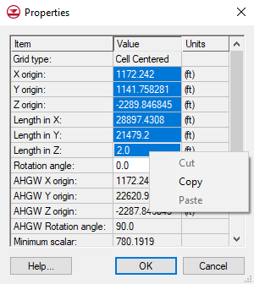

Figure 3 3D Grid Properties dialog

1. Click **Cancel** to exit the dialog.
2. Right-click on “File:Grid Frame Icon.svg Grid Frame” and select **Properties…** to open the *Grid Frame Properties* dialog.
3. In the *Value* column, select the cell of the *Origin X* row and while holding down the *Shift* key, in the *Value* column, select the cell of the *Dimension z* row.
4. Right-click on one of the selected cells and select **Paste**.

The values will change to what was copied from the 3D grid properties.

1. Click **OK** to exit the *Grid Frame Properties* dialog.
2. **Frame** File:Frame Macro.svg the project.

This displays the entire model area with the grid frame (Figure 4).

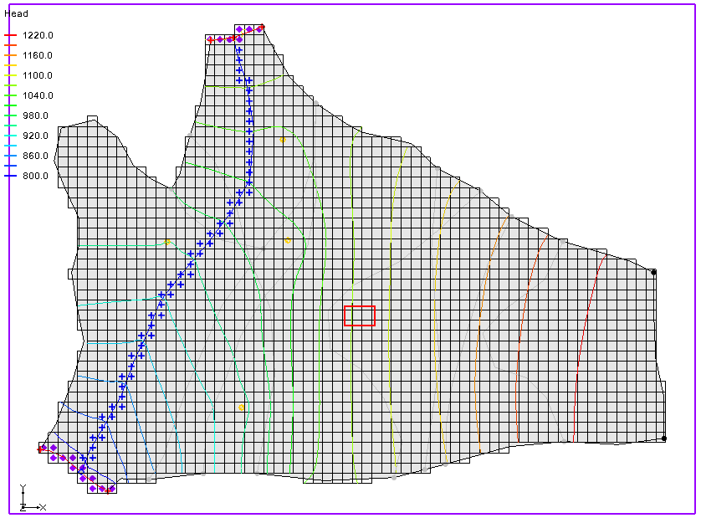

Figure 4 Framed view with copied properties

## Defining the Refined Area

It is now possible to define the refined area around the local site by editing the “File:Coverage Active Icon.svg ss” coverage.

1. In the Project Explorer, fully expand the “File:Conceptual Model Icon.svg Regional Model”.
2. Double-click on the “File:Coverage Active Icon.svg ss” coverage to bring up the *Coverage Setup* dialog.
3. In the *Sources/Sinks/BCs* column, turn on *Refinement*.
4. Click **OK** to exit the *Coverage Setup* dialog.
5. Turn off “File:3D Grid Icon.svg grid” in the Project Explorer to hide the 3D grid.
6. Using the **Create Arc** File:GMS Create Arc Tool.svg tool, click out an arc surrounding the local site (the red rectangle), clicking on the start point to close the arc.
7. Click **Build Polygons** File:Build Polygons Macro.svg to make the newly digitized arc into a polygon (see the black arc surrounding the red rectangle in Figure 5).

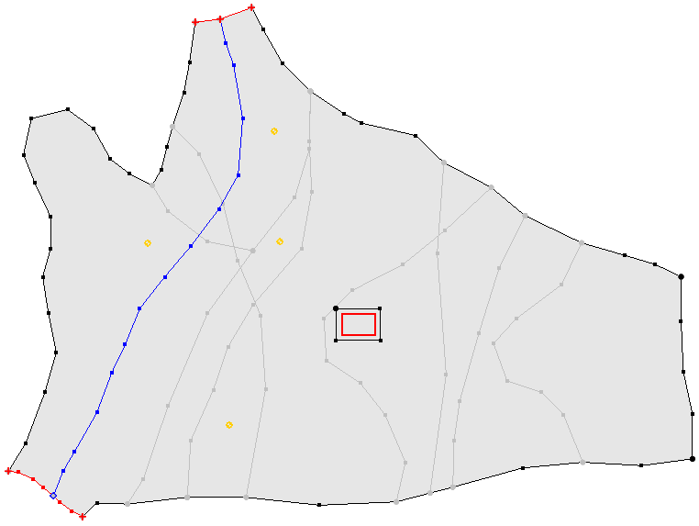

Figure 5 New polygon digitized around the local site

1. Using the **Select Polygon** File:GMS Select Polygon Tool.svg tool, double-click on the new polygon to bring up the *Attribute Table* dialog.
2. In the *Refine* column, check the box.
3. In the *Base size (ft)* column, enter “50.0”.
4. Click **OK** to exit the *Attribute Table* dialog.

## Creating a 3D Refined UGrid

Now to create the 3D refined UGrid.

1. Right-click on “File:Grid Frame Icon.svg Grid Frame” and select *Map to* **| UGrid** to bring up the *Map → UGrid* dialog.
2. From the *Dimension* drop-down, select “3D”.
3. From the *UGrid type* drop-down, select “Quadtree/Octree”.
4. In the *X-Dimension* section, for the *Number of cells,* enter “70”.
5. In the *Y-Dimension* section, for the *Number of cells,* enter “50”.
6. In the *Z-Dimension* section, for the *Number of cells,* enter “2”.
7. Click **OK** to exit the *Map → UGrid* dialog and create the UGrid.
8. Turn on “ugrid lock ugrid” in the Project Explorer.

A UGrid similar to Figure 6 should appear in the Graphics Window.

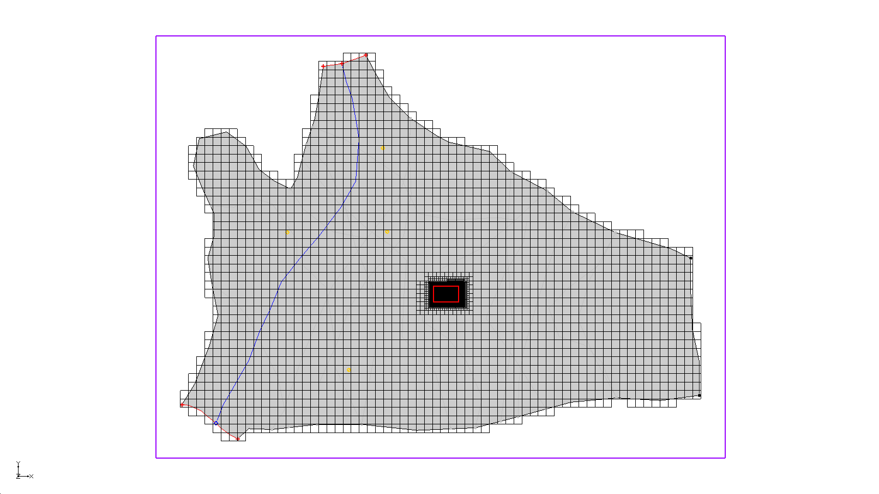

Figure 6 Locally refined UGrid

The larger cells in the UGrid exactly match the mf2k grid. The cells gradually become smaller around the area of interest.

1. **Zoom** File:Zoom Tool Icon.svg in on the local site to see something similar to Figure 7.

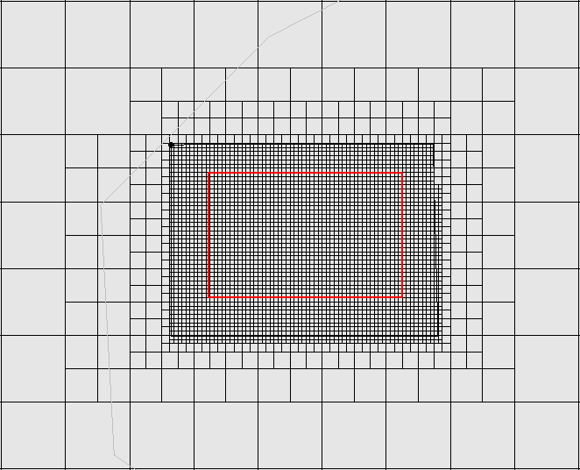

Figure 7 Local refinement of a 3D UGrid

1. **Frame** File:Frame Macro.svg the project to view the entire model area.

# Converting the Layer Data to a Scatter Point Set

Now to convert the MODFLOW 2000 layer elevation information to a scatter point set so that it is possible to interpolate the elevations to the UGrid. By default, this will create a new scatter set with the MODFLOW top and bottom elevations as datasets.

1. Select the “File:3D Grid Folder.svg 3D Grid Data” folder in the Project Explorer to make it active.
2. Select *Grid |* **MODFLOW Layers → 2D Scatter Points…** to open the *MODFLOW Layers → Scatter Points* dialog.
3. Accept the default parameters and click **OK** to exit the *MODFLOW Layers → 2D Scatter Points* dialog and create the layer elevation scatter points (Figure 8).

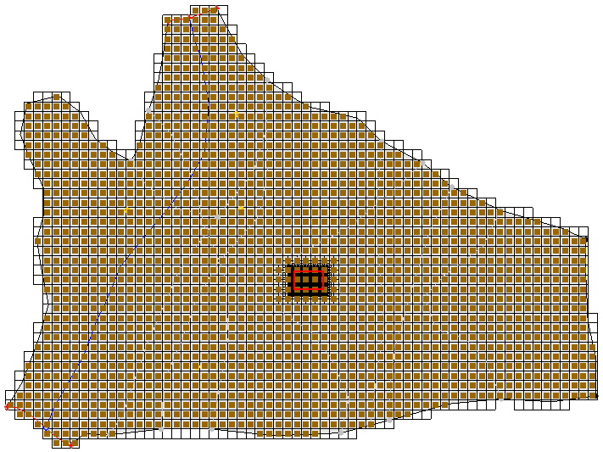

Figure 8 2D scatter points converted from MODFLOW layers

# Creating a MODFLOW-USG Model

Now it is necessary to create a MODFLOW-USG model on the UGrid before interpolating the elevations.

1. Right-click on “ugrid lock ugrid” in the Project Explorer and select **New MODFLOW…** to bring up the *MODFLOW Global/Basic Package* dialog.
2. Click **OK** to accept the default model settings and exit the *MODFLOW Global/Basic Package* dialog.

# Interpolating Layer Elevations

Next to interpolate the layer elevations directly to the MODFLOW arrays. The MODFLOW arrays can be automatically associated with appropriately named datasets. Just accept the defaults in the dialog and the layer elevations will be interpolated to the correct MODFLOW array.

1. Right-click on “File:2D Scatter Icon.svg Layers”in the Project Explorer and select *Interpolate To |* **MODFLOW Layers…** to bring up the *Interpolate to MODFLOW Layers* dialog.
2. Click **OK** to accept the defaults and exit the *Interpolate to MODFLOW Layers* dialog.
3. Turn off the “File:2D Scatter Icon.svg Layers” scatter set in the Project Explorer to hide it.

The Graphics Window should appear similar to Figure 9.

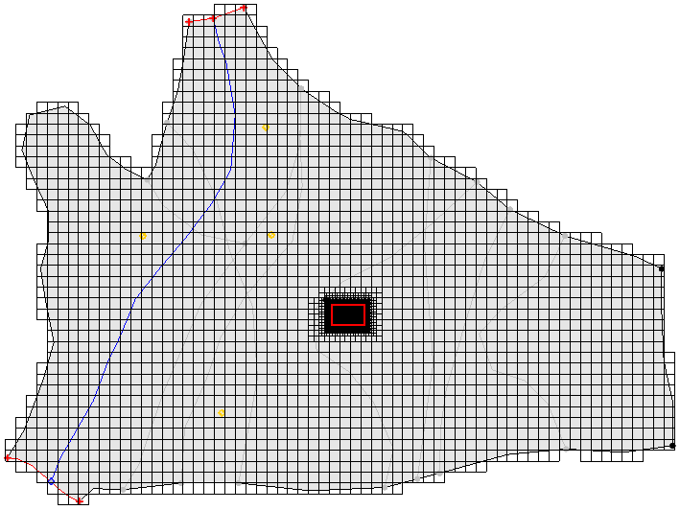

Figure 9 After the scatter set has been interpolated

# Mapping to MODFLOW

Now to assign the MODFLOW boundary conditions and the aquifer properties:

1. Right-click on “File:Conceptual Model Icon.svg Regional Model” in the Project Explorer and select *Map To |* **MODFLOW/MODPATH** to bring up the *Map → Model* dialog.
2. Click **OK** to accept the defaults and close the *Map → Model* dialog.

Boundary condition symbols for specified head, rivers, and wells should appear similar to Figure 10.

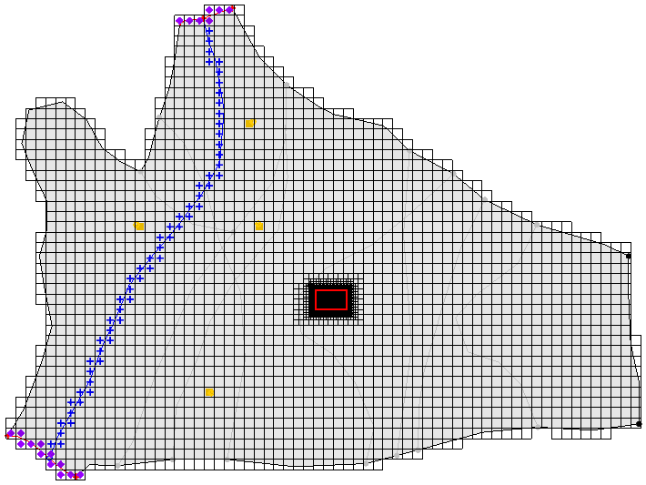

Figure 10 Boundary condition symbols are now visible

# Saving and Running MODFLOW

Now it is possible to run MODFLOW.

1. **Save** File:Save Macro.svg the project.
2. **Run MODFLOW** File:Run MODFLOW Macro.svg to bring up the *MODFLOW* model wrapper dialog.
3. When the model finishes, turn on *Read solution on exit* and *Turn on contours (if not on already)*.
4. Click **Close** to import the solution and close the *MODFLOW* dialog.

The contours should be similar to Figure 11.

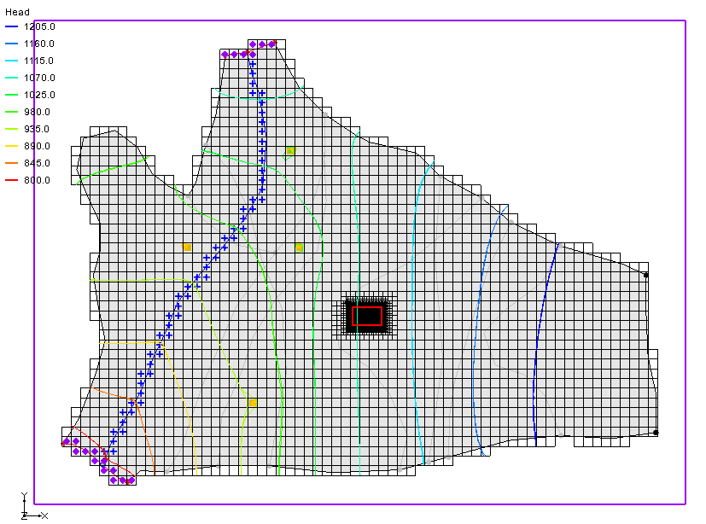

Figure 11 MODFLOW-USG Head Contours

# Conclusion

This concludes the *MODFLOW-USG* Regional to Local Model Conversion tutorial. The following key concepts were discussed and demonstrated in this tutorial:

* MODFLOW-USG supports locally refined grids.
* Creating locally refined UGrids in GMS.

1. Panday, Sorab; Langevin, Christian.D.; Niswonger, Richard G.; Ibaraki, Motomu; and Hughes, Joseph D., (2013). “MODFLOW–USG version 1: An Unstructured Grid Version of MODFLOW for Simulating Groundwater Flow and Tightly Coupled Processes Using a Control Volume Finite-Difference Formulation” in *Techniques and Methods 6–A45*,U.S. Geological Survey, 66 p.
2. Ibid, p. 9.