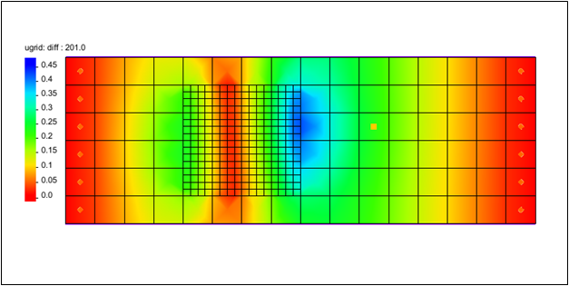

GMS 10.9

GMS 10.9 Tutorial

***MODFLOW-USG Transport – TVM Package***

Use the Time-Variant Materials package (TVM) in GMS

Objectives

Learn how to use the Time-Variant Materials package (TVM) with MODFLOW-USG Transport.

Time

* 20–30 minutes

Required Components

* GMS Core
* MODFLOW-USG Transport

Prerequisite Tutorials

* MODFLOW-USG Transport

|  |
| --- |
| 1 Introduction 2  2 Getting Started 2  3 Changing the Conductivity 3  4 Map to MODFLOW 4  5 Activating the TVM Package 5  6 Defining the TVM Package 5  7 Saving and Running MODFLOW 6  8 Examining the Results 6  9 Conclusion 7 |

# Introduction

The Time-Variant Materials package (TVM) works with MODFLOW-USG Transport. The TVM package allows hydraulic conductivity and storage values to be changed as a step function between stress periods or in a continuous manner through a transient simulation.

This tutorial demonstrates how the TVM package can be used with a MODFLOW-USG Transport simulation.

The problem in this tutorial consists of a two layer unstructured grid (UGrid) with a MODFLOW-USG Transport simulation. The UGrid contains a well on the second layer set with a constant pumping rate.

This tutorial will demonstrate the following topics:

1. Opening an existing MODFLOW-USG Transport simulation.
2. Creating a transient conductivity coverage and dataset.
3. Activating the TVM package.
4. Running the simulation and examining the results.

# Getting Started

Do the following to get started:

1. If necessary, launch GMS.
2. If GMS is already running, select *File |* **New** to ensure that the program settings are restored to their default state.
3. Click **Open** File:Open Macro.svg (or *File |* **Open…**) to bring up the *Open* dialog.
4. Browse to the data files for this tutorial and select “start.gpr”.
5. Click **Open** to import the file and close the *Open* dialog.
6. In the Project Explorer, select the “File:Dataset Cells Active.svg Head” dataset.

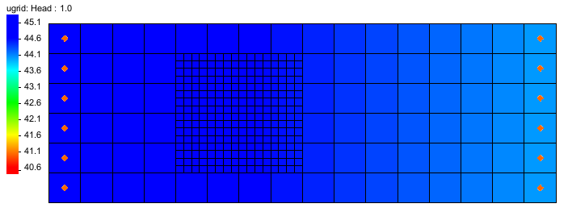

Figure 1 Imported MODFLOW-USG Transport model

The Graphics Window should appear as in Figure 1. This model has a two layer UGrid with a refined zone. General heads have been set at each end. There is a well on the second layer.

Before continuing, save the project with a new name.

1. Select *File* | **Save As…** to bring up the *Save As* dialog.
2. Browse to the directory for this tutorial.
3. Enter “model-tvm.gpr” as the *File name*.
4. Select “Project Files (*.gpr)” from the *Save as type* drop-down.
5. Click **Save** to save the project file and close the *Save As* dialog.

# Changing the Conductivity

Before activating the TVM package, start with creating a time-variant dataset for the refined area of the UGrid. This will be done using a separate map coverage which will then be added to the model.

1. Right-click on the “File:Conceptual Model Icon.svg model” conceptual model and select **New Coverage…** to bring up the *Coverage Setup* dialog.
2. Enter “tvm_hk” for the *Coverage name*.
3. In the *Areal Properties* column, turn on *Datasets*.
4. Click the **Datasets** button to open the *Datasets* dialog.
5. Click the **Insert Row** File:Insert Row Icon.svg button.
6. In the new row, enter “TVM_HK”.
7. Click **OK** to close the *Datasets* dialog.
8. Click **OK** to close the *Coverage Setup* dialog.

With the new “File:Coverage Active Icon.svg tvm-hk” coverage created, time-variant data needs to be added to the refined area of the UGrid.

1. Make certain the “File:Coverage Active Icon.svg tvm-hk” coverage is active in the Project Explorer.
2. Using the **Create Arc** File:GMS Create Arc Tool.svg tool, create four arcs around the refined area of the UGrid as in Figure 2 below.

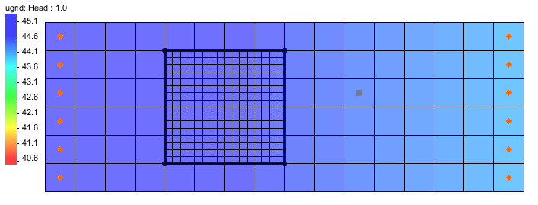

Figure 2 Arcs drawn around refined area of the UGrid

1. Select the **Build Polygons** File:Build Polygons Macro.svg macro.
2. Using the **Select Polygons** File:GMS Select Polygon Tool.svg tool, double-click on the polygon to open the *Attribute Table* dialog.
3. Using the drop-down, change the *TVM_HK* column to be “<transient>”.
4. Click the File:Attribute Table dialog dot dot dot ellipses button.png button in the *TVM_HK* column to open the *XY Series Editor*.
5. Enter the values in Table 1 below to create a time series:

|  |  |
| --- | --- |
| Time (d) | **TVM_HK** |
| 0.0 | 1.5 |
| 1.0 | 1.5 |
| 1.0 | 3.0 |
| 101.0 | 3.0 |
| 101.0 | 6.0 |
| 201.0 | 6.0 |

Table 1 Time series

1. Click **OK** to close the *XY Series Editor*.
2. Click **OK** to close the *Attribute Table* dialog.

The “tvm_hk” coverage now contains time-variant material data that can be added to the MODFLOW-USG Transport simulation.

# Map to MODFLOW

The data added in the conceptual model needs to be mapped to the UGrid model.

1. Right-click on the “File:Conceptual Model Icon.svg model” conceptual model and select *Map To* | **MODFLOW/MODPATH** to open the *Map → Model* dialog.
2. Check *All applicable coverages* and click **OK** to close the *Map → Model* dialog.

A new dataset, “File:Dataset Cells Active.svg TVM_HK”, should appear in the Project Explorer in the MODFLOW simulation.

# Activating the TVM Package

With the horizontal conductivity data available, the TVM package can now be activated and added to the MODFLOW simulation. To activate the TVM package:

1. Switch to the **UGrid** File:UGrid Icon Unlocked.svg module.
2. Select *MODFLOW |* **Global Options…** to bring up the *MODFLOW Global/Basic Package* dialog.
3. Click **Packages…** to bring up the *MODFLOW Packages / Processes* dialog.
4. In the *Optional packages / processes* section, turn on *TVM – Time* *Varying Materials*.
5. Click **OK** to exit the *MODFLOW Packages / Processes* dialog.
6. Click **OK** to exit the *MODFLOW Global/Basic Package* dialog.

# Defining the TVM Package

With the time-varying dataset mapped to the simulation and the TVM package activated, the parameters for the TVM package can now be defined.

1. Select *MODFLOW | Optional Packages* | **TVM – Time Varying Materials…** to bring up the *TVM Package* dialog.
2. In the list on the left, select *HK*.
3. Select **Dataset to Array** to bring up the *Select Dataset* dialog.
4. Under *Solution*, select “File:Dataset Cells Active.svg TVM_HK”.
5. Turn on *All time steps*.
6. Click **OK** to close the *Select Dataset* dialog.
7. Click **OK** to close the *TVM Package* dialog.

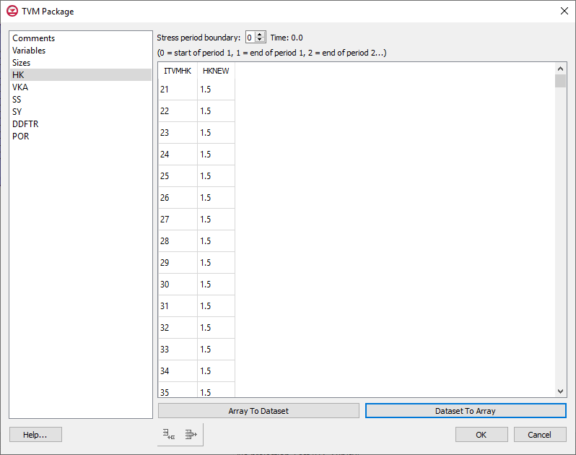

Figure 3 TVM Package dialog

# Saving and Running MODFLOW

The changes should now be saved before running MODFLOW-USG Transport.

1. Click **Save** File:Save Macro.svg to save the project.
2. Click the **Run MODFLOW** File:Run MODFLOW Macro.svg macro in the toolbar to bring up the *MODFLOW* model wrapper dialog.
3. When MODFLOW finishes, check on the *Read solution on exit* and *Turn on contours (if not on already)* boxes.
4. Click **Close** to close the *MODFLOW* model wrapper dialog.
5. Click **Save** File:Save Macro.svg to save the project with the new solution.

The solution set should appear in the Project Explorer.

# Examining the Results

In order to more clearly see how the TVM package impacted the simulation, compare the results. This can be done by using the *Data Calculator* to create a dataset that compares the solution set with the TVM package to the previous solution set.

1. Click the File:Data Calculator Macro.svg **Data Calculator** macro to open the *Data Calculator*.
2. In the *Datasets* section, select the “File:Dataset Cells Active.svg Head” dataset under the “File:Generic Folder Locked.svg start (MODFLOW)” folder.
3. Turn on *Use all time steps*.
4. Click **Add to Expression**.
5. Click the **minus (-)** button.
6. In the *Datasets* section, select the “File:Dataset Cells Active.svg Head” dataset under the “File:Generic Folder Locked.svg model-tvm (MODFLOW)” folder.
7. Click **Add to Expression**.
8. For *Result*, enter “diff”.
9. Click **Compute**.
10. Click **Done**.
11. Select the “File:Dataset Cells Active.svg diff” dataset in the Project Explorer.
12. In the *Time Steps* window, use the down arrow key to step through the time steps and watch how the contours change.

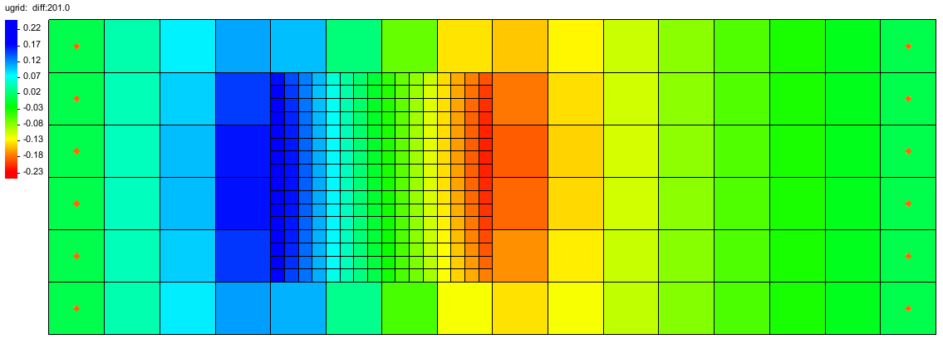

Figure 4 Last time step of the difference dataset showing the results of the TMV package.

# Conclusion

This concludes the tutorial. Here are the key concepts from this tutorial:

Using the TVM Package to add time-varying materials to a MODFLOW-USG Transport simulation.

Creating a time-variant dataset using the Map module.

Activating the TVM package for a MODFLOW simulation.