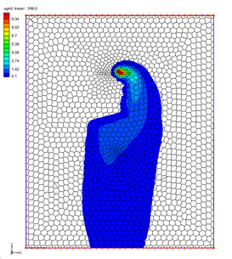

GMS 10.9

GMS 10.9 Tutorial

***MODFLOW-USG Transport – Grid Approach***

Creating a MODFLOW-USG Transport model using the grid approach

Objectives

Construct a MODFLOW-USG Transport model using the grid approach. Values are manually assigned to the grid. Simple models can be easily constructed using the grid approach.

Time

* 15–25 minutes

Required Components

* GMS Core
* MODFLOW-USG Transport

Prerequisite Tutorials

* MT3DMS – Grid Approach

|  |
| --- |
| 1 Introduction 2  2 Getting Started 3  2.1 The MT3DMS Model 3  2.2 Saving With a New Name 4  3 Switching to MODFLOW-USG Transport 4  3.1 Switching from Steady State to Transient 5  3.2 Saving and Running the Model 5  4 Enabling Transport 6  5 BCT Package Inputs 7  6 Injecting Contaminant at the Well 9  7 Output Control 11  8 Saving and Running MODFLOW-USG Transport 11  9 Setting Up an Animation 12  10 Using a Voronoi Grid 13  11 Conclusion 14 |

# Introduction

This tutorial describes how to perform a MODFLOW-USG Transport simulation within GMS. It builds on the MT3DMS – Grid Approach tutorial and converts the MT3DMS model created in that tutorial into a MODFLOW-USG Transport model. The MT3DMS and the MODFLOW-USG Transport models are then compared to see how closely they match.

The problem in this tutorial (Figure 1) corresponds to a sample problem described in the MT3DMS documentation.[1] The problem consists of a low K zone inside a larger zone. The sides of the region are no-flow boundaries. The top and bottom are constant head boundaries that cause the flow to move from the top to the bottom of the region. An injection well with a specified concentration provides the source of the contaminants. A pumping well serves to withdraw contaminated water migrating from the injection well. A steady-state flow solution will be computed, and a transient transport simulation will be performed over a one-year period.



Figure 1 Sample flow and transport problem

# Getting Started

Do the following to get started:

1. If necessary, launch GMS.
2. If GMS is already running, select *File |* **New** to ensure that the program settings are restored to their default state.

## The MT3DMS Model

Start with reading the MT3DMS model into GMS.

1. Click **Open** File:Open Macro.svg to bring up the *Open* dialog.
2. Select “Project Files (*.gpr)” from the *Files of type* drop-down.
3. Browse to the *\MODFLOW-USG-Transport\mt3dgrid* directory and select “mt3dgrid.gpr”.
4. Click **Open** to import the project and exit the *Open* dialog.
5. In the Project Explorer, under the “File:Generic Folder Locked.svg mt3dgrid (MT3DMS)” solution folder, select the “File:Dataset Cells Active.svg tracer” dataset.
6. In the *Time Steps* window at the bottom left of the screen, scroll to the bottom and select the last time step (13. 365.0).

The model should appear similar to Figure 2. Notice the contaminant injected at the well in the top of the model flows around the low conductivity area towards the bottom of the model. If desired, select different time steps to see how the plume changes over time.

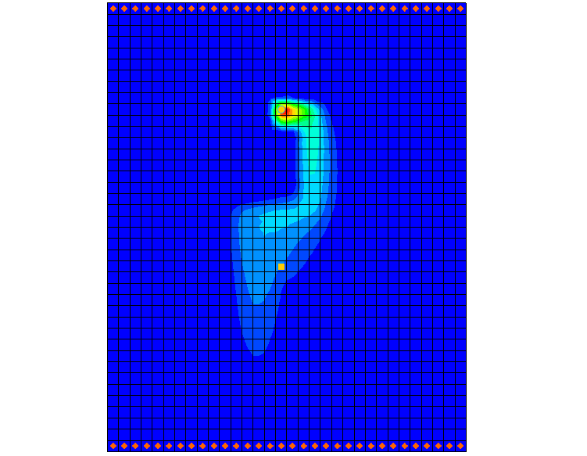

Figure 2 MT3D solution

## Saving With a New Name

Now to save the project under a new name:

1. Select *File* | **Save As…** to bring up the *Save As* dialog.
2. Select “Project Files (*.gpr)” from the *Save as type* drop-down.
3. Enter “usg-transport.gpr” as the *File name*.
4. Click **Save** to save the project with a new name and close the *Save As* dialog.

# Switching to MODFLOW-USG Transport

Now to create a flow solution, switch the model from using MODFLOW 2000 to MODFLOW-USG Transport.

1. Select *MODFLOW* | **Global Options…** to open the *MODFLOW Global/Basic Package* dialog.
2. In the *MODFLOW version* section, select the *USG Transport* option.

## Switching from Steady State to Transient

Contaminant transport modeling requires a transient simulation. The MT3DMS model used a steady state MODFLOW flow solution with a transient MT3DMS model. For this example, it is necessary to change the MODFLOW-USG Transport model to be transient.

### Stress Periods

Start with setting the stress period for the model.

1. Set the *Model type* to *Transient*.
2. Click on **Stress Periods** to open the *Stress Periods* dialog.
3. Change the *Number of stress* *periods* to “2”.
4. Change the *Length* of the second stress period to “365.0”.
5. Change the *Num Time Steps* on the second stress period to “20”.
6. Click **OK** to exit the *Stress Periods* dialog.
7. Click **OK** to exit the *MODFLOW Global/Basic Package* dialog.
8. Click **Yes** on the warning dialog about switching to USG Transport, if it appears.
9. Click **OK** on the warning dialog about the SMS solver, if it appears.

### Specific Yield

Now to set the specific yield parameters:

1. Select *MODFLOW* | **LPF – Layer Property Flow…** to open the *LPF Package* dialog.
2. Click **Specific Storage** to open the *Specific Storage* dialog.
3. Click **Constant → Grid** to open the *Grid Value* dialog.
4. Enter “1e-4” for the *Constant value for grid*.
5. Click **OK** to close the *Grid Values* dialog.
6. Click **OK** to close the *Specific Storage* dialog.
7. Click **OK** to close the *LPF Package* dialog.

## Saving and Running the Model

1. Click the **Save** https://www.xmswiki.com/images/thumb/0/00/Save_Macro.svg/53px-Save_Macro.svg.png macro.
2. Click the **Run MODFLOW** File:Run MODFLOW Macro.svg macro to bring up the *MODFLOW* model wrapper dialog.
3. When the model finishes, click **Close** to import the solution.

The flow solution should appear as shown in Figure 3.

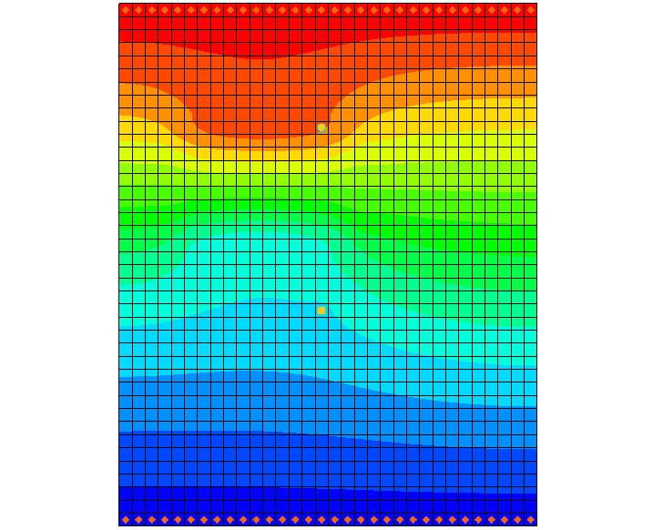

Figure 3 Model contours after MODFLOW-USG Transport run

# Enabling Transport

Now start adding contaminant transport to the model. The first process is to enable the main transport package in MODFLOW-USG Transport.

1. Select *MODFLOW* | **Global Options…** to open the *MODFLOW Global/Basic Package* dialog.
2. Click **Packages** to open the *MODFLOW Packages / Processes* dialog.
3. Under *Optional packages / processes*, turn on the *BCT – Block Centered Transport* option.

The BCT process is needed if transport or density dependent flow is to be included in the model. The packages/processes that only come with MODFLOW-USG Transport are:

BCT – Block Centered Transport

DDF – Density Driven Flow

DPT – Dual Porosity Transport

PCB – Prescribed Concentration Boundary

The DDF package only consists of a few values, so it is included with the BCT package and is not listed in the *MODFLOW Packages / Processes* dialog. The other packages/processes are listed.

For this model, only the BCT process needs to be added.

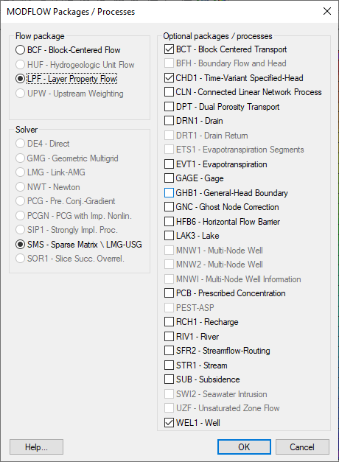

Figure 4 MODFLOW Packages / Processes dialog

1. Click **OK** to close the *MODFLOW Packages / Processes* dialog.
2. Click **OK** to close the *MODFLOW Global/Basic Package* dialog.

# BCT Package Inputs

Next, look at the BCT package:

1. Select *MODFLOW* | *Optional Packages* | **BCT – Block Centered Transport…** to open the *BCT Process* dialog.

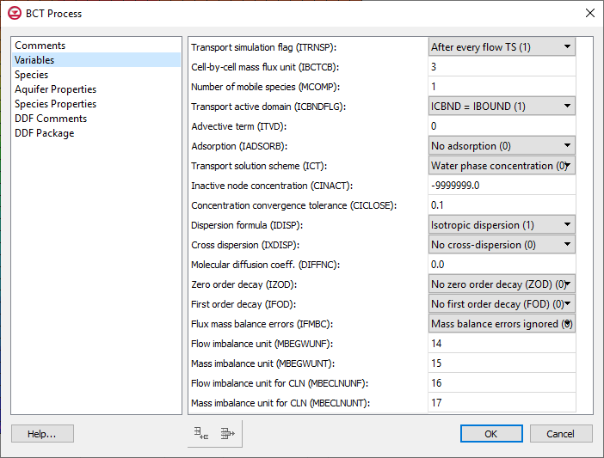

Figure 5 BCT Package dialog

The dialog is divided into two parts: one on the left that shows the main sections, and one on the right that shows the inputs for the current section. Here’s a brief explanation of each section:

|  |  |
| --- | --- |
| Section | Description |
| Comments | Comment lines can be added and will appear at the top of the BCT file. |
| Variables | Variables corresponding to item 1a in the BCT input file. |
| Species | The list of species. The number of species equals MCOMP in the Variables section. GMS allows the user to give each species a name. |
| Aquifer Properties | Cell-by-cell inputs independent of species, such as porosity. |
| Species Properties | Cell-by-cell inputs that depend on the species, such as adsorption. |
| DDF Comments | Comment lines can be added and will appear at the top of the DDF file. |
| DDF Package | Inputs corresponding to the DDF (Density Driven Flow) package. |

### Variables

It is necessary to turn on the dispersion option.

1. Select the *Variables* item on the left.
2. From the drop-down menu next to *Dispersion formula (IDISP)*, select “Isotropic dispersion (1)”.

### Species

1. Select the *Species* item on the left.
2. Under *Species Name*, change the name to “tracer”.

MODFLOW-USG Transport does not save the species name but GMS does.

### Aquifer Properties

1. Select the *Aquifer Properties* item on the left.

By default, the aquifer properties use a constant value for the entire grid, but values can be specified on a cell-by-cell basis. The ICBUND array, which specifies which cells will be active when modeling transport, will be ignored based on the *ICBNDFLG* value in the *Variables* section.

The value for bulk density (BULKD) is 0.0, which means that no sorption is being modeled. Now to change the dispersion parameters:

1. For *DL* (longitudinal dispersivity), change the *Constant Value* to “20.0”.
2. For *DT* (transverse dispersivity), change the *Constant Value* to “0.2”.

### Species Properties

1. Select *Species Properties* on the left.

In this example, the starting concentration should be set to a value slightly larger than zero.

1. For *CONC*, enter a *Constant Value* of “0.001”.

The values for adsorption (ADSORB) and the reaction terms (ZODRW, ZODRS) are all 0.0, which is correct for our simple model.

### DDF

The *DDF Comments* and *DDF Package* sections are for the Density Driven Flow package and are included in the *BCT Process* dialog in GMS. This example is not modeling density flow so ignore these sections.

1. Click **OK** to close the *BCT Process* dialog.

# Injecting Contaminant at the Well

In this model, a contaminant is injected into the aquifer via the well at the top of the model. To set this up:

1. Select *MODFLOW* | *Optional Packages* | **WEL – Well…** to open the *MODFLOW Well Package* dialog.
2. Click **Edit AUX…** to open the *AUX Variables* dialog.

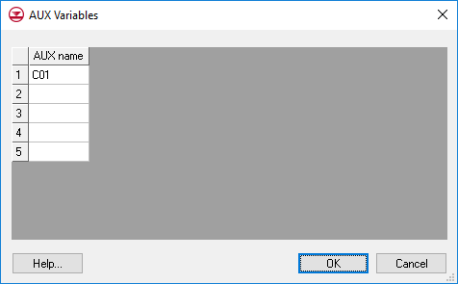

Figure 6 AUX Variables dialog

This dialog allows defining up to five auxiliary variables (or AUX variables) to be included in the well package. With MODFLOW-USG Transport, AUX variables can be used with the WEL, RIV, CHD, and GHB packages to specify a concentration for water entering the model via these boundary conditions. If multiple species are used, the concentration can be specified for each species (up to 5) using additional AUX variables. The AUX variables must be named following a specific pattern, which is a “C” followed by a two-digit number with a leading zero. For example, species 1 would use an AUX variable named “C01,” species 2 would use an AUX variable named “C02,” etc.

1. In the first row, enter “C01”.
2. Click **OK** to close the *AUX Variables* dialog.
3. In the first row, enter “57.87” in the *C01* column.
4. Click **OK** to close the *MODFLOW Well Package* dialog.

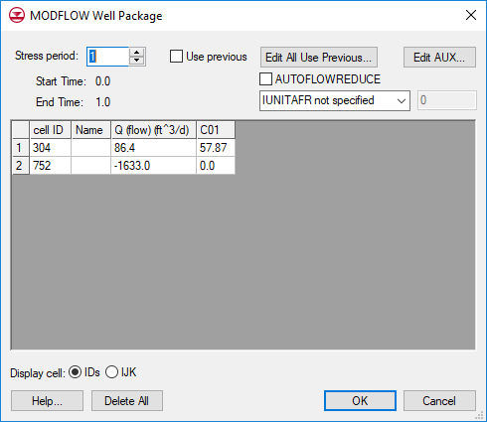

Figure 7 MODFLOW Well Package dialog

# Output Control

Next to specify the output options by doing the following:

1. Select MODFLOW | **OC** – **Output Control…** to open the *MODFLOW Output Control* dialog.
2. Turn on *Save concentrations to *.con file*.
3. Click **OK** to exit the *MODFLOW* *Output Control* dialog.

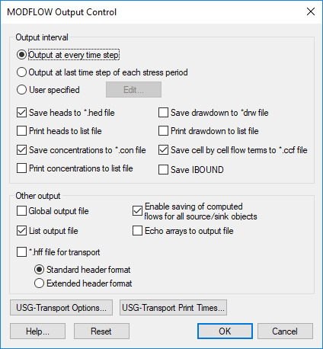

Figure 8 MODFLOW Output Control dialog

# Saving and Running MODFLOW-USG Transport

Now to save the simulation and run MODFLOW-USG Transport:

1. **Save** File:Save Macro.svg the project.
2. Click **Run MODFLOW** File:Run MODFLOW Macro.svg to bring up the *MODFLOW* model wrapper dialog.
3. When the simulation is finished, turn on *Read solution on exit*.
4. Click **Close** to import the solution and close the *MODFLOW* dialog.
5. In the Project Explorer, under the “File:Generic Folder Locked.svg usg-transport (MODFLOW)” solution, select the “File:Dataset Cells Active.svg tracer” dataset.
6. In the *Time Steps* window, select the last time step (21. 730.0).

The model should appear similar to Figure 9.

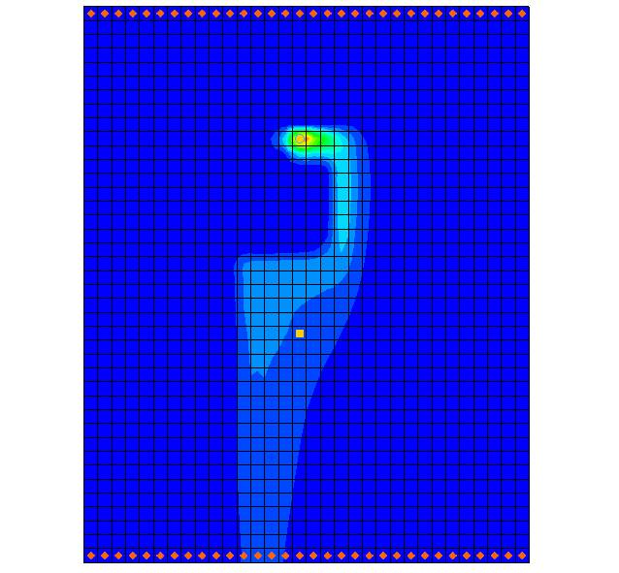

Figure 9 Contaminant plume from the MODFLOW-USG Transport solution

# Setting Up an Animation

Generating an animation facilitates observing how the solution changes over the one-year simulation. Do the following to set up the animation:

1. Select *Display |* **Animate…** to bring up the *Options* page of the *Animation Wizard* dialog.
2. Under *Options*, turn on *Dataset*.
3. Click **Next** to go to the *Datasets* page of the *Animation Wizard* dialog.
4. Below *Run simulation from time*, select *Use constant interval* and enter “36.5” as the *Time interval*.

This will result in 11 frames.

1. Turn on Display clock.
2. Click **Finish** to generate the animation and close the *Animation Wizard* dialog.

Now the animation can be opened in an external media player and viewed. If desired, outside of GMS, navigate to the directory for the animation and open the generated MP4 file in the desired media player. The directory where the animation was saved can be found and adjusted on the *Options* page of the *Animation Wizard* under the *File type* section.

# Using a Voronoi Grid

MODFLOW-USG Transport works with unstructured grids. To demonstrate this, open a project that models the same scenario but uses a Voronoi grid.

1. Select *File |* **New**. Save the current project if prompted.
2. Click **Open** File:Open Macro.svg to bring up the *Open* dialog.
3. Select “Project Files (*.gpr)” from the *Files of type* drop-down.
4. Browse to *\MODFLOW-USG-Transport\mt3dgrid* directory and select “voronoi.gpr”.
5. Click **Open** to import the project and exit the *Open* dialog.

Notice that this model uses an unstructured grid that contains Voronoi grid cells.

1. In the Project Explorer, under the “File:Generic Folder Locked.svg voronoi (MODFLOW)” solution folder, select the “File:Dataset Cells Active.svg tracer” dataset.
2. In the *Time Steps* window, scroll to the bottom and select the last time step (21. 366.0).

Notice that the contours of contaminant concentration are similar to those in the previous project (Figure 10).

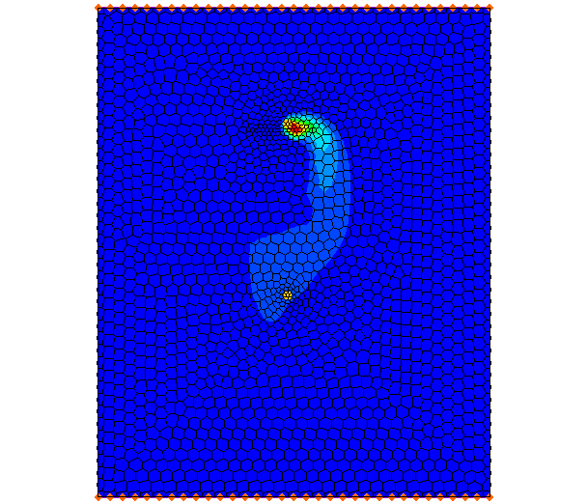

Figure 10 MODFLOW-USG Transport model using a Voronoi UGrid

# Conclusion

This concludes the “MODFLOW-USG Transport – Grid Approach” tutorial. The following key concepts were discussed and demonstrated in this tutorial:

* MODFLOW-USG Transport can solve for flow only or for coupled flow and transport.
* The main process used for transport is the BCT process. Other packages that can be used for transport include:

DDF – Density Driven Flow

DPT – Dual Porosity Transport

PCB – Prescribed Concentration Boundary

* It is possible to use the *Animation Wizard* to create an animation in GMS.
* Contaminant concentration can be added to the model by using AUX variables in the WEL, RIV, CHD, and GHB packages.
* The model will generate a cell-by-cell concentration file for each species if the option is turned on in the *Output Control* package.

1. Zheng, Chunmiao and Wang, P. Patrick (December 1999). “A Two-Dimensional Application Sample” in *MT3DMS: A Modular Three-Dimensional Multispecies Transport Model for Simulation of Advection, Dispersion, and Chemical Reactions of Contaminants in Groundwater Systems; Documentation and User’s Guide*, Strategic Environmental Research and Development Program (SERDP), U.S. Army Corps of Engineers, Contract Report SERDP-99-1, pp. 152–154. https://apps.dtic.mil/sti/tr/pdf/ADA373474.pdf