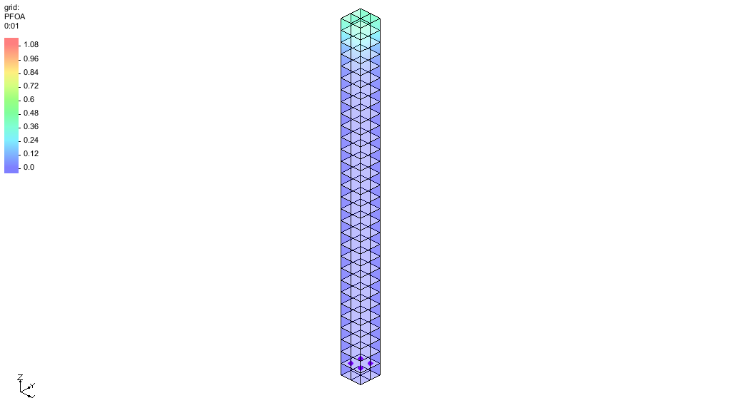

GMS 10.9

GMS 10.9 Tutorial

***MODFLOW-USG Transport – PFAS***

Applying PFAS to a MODFLOW-USG Transport model

Objectives

Apply PFAS parameters to a MODFLOW-USG Transport model.

Time

* 15–25 minutes

Required Components

* GMS Core
* MODFLOW-USG Transport

Prerequisite Tutorials

* MT3DMS – Grid Approach

|  |
| --- |
| 1 Introduction 2  2 Getting Started 3  2.1 The MT3DMS Model 3  2.2 Saving With a New Name 4  3 Switching to MODFLOW-USG Transport 4  3.1 Switching from Steady State to Transient 5  3.2 Saving and Running the Model 5  4 Enabling Transport 6  5 BCT Package Inputs 7  6 Injecting Contaminant at the Well 9  7 Output Control 11  8 Saving and Running MODFLOW-USG Transport 11  9 Setting Up an Animation 12  10 Using a Voronoi Grid 13  11 Conclusion 14 |

# Introduction

Per- and polyfluoroalkyl substances (PFAS) have emerged as a critical contaminant of concern in groundwater systems worldwide. These “forever chemicals” are highly mobile, resistant to natural degradation, and can persist in aquifers for decades, creating long-term challenges for drinking water supplies and environmental remediation. Understanding how PFAS migrate through complex hydrogeologic systems is essential for evaluating risks, designing monitoring networks, and developing effective remediation strategies.

This tutorial introduces the use of **MODFLOW-USG Transport** to simulate PFAS fate and transport in groundwater. The MODFLOW-USG Transport capabilities allow users to couple groundwater flow with solute transport, making it possible to model PFAS plume migration under realistic conditions.

This tutorial will demonstrate the process of adjusting parameters in an existing MOFLOW-USG Transport model. These parameters are located in the LPF Package and the BCT Process.

# Getting Started

Do the following to get started:

1. If necessary, launch GMS.
2. If GMS is already running, select *File |* **New** to ensure that the program settings are restored to their default state.

## Import the Starting Project

Start with reading the MODFLOW-USG Transport model into GMS.

1. Click **Open** File:Open Macro.svg to bring up the *Open* dialog.
2. Select “Project Files (*.gpr)” from the *Files of type* drop-down.
3. Browse to the *\MODFLOW-USG-Transport\PFAS* directory and select “start.gpr”.
4. Click **Open** to import the project and exit the *Open* dialog.
5. In the Project Explorer, under the “File:Generic Folder Locked.svg start (MODFLOW)” solution folder, select the “File:Dataset Cells Active.svg tracer” dataset.

The initial project should appear similar to Figure 1. The starting project has a steady state water flow time step with transient transport simulated over 1 hour. There is a recharge concentration of 1.0 applied to the top cells.

1. In the *Time Steps* window at the bottom left of the screen, scroll through the time steps.

When stepping through the time steps, note the tracer concentration almost immediately becomes 1.0 through the entire grid.

Figure 1 Initial project

## Saving With a New Name

Now to save the project under a new name:

1. Select *File* | **Save As…** to bring up the *Save As* dialog.
2. Select “Project Files (*.gpr)” from the *Save as type* drop-down.
3. Enter “C_of_1.gpr” as the *File name*.
4. Click **Save** to save the project with a new name and close the *Save As* dialog.

# Adapting the LPF Package

Now to define the unsaturated flow values for model by doing the following:

1. Select *MODFLOW* | **LPF – Layer Property Flow…** to open the *LPF Package* dialog.
2. Click the **Unsaturated Flow…** button to open the *Unsaturated Flow Setting* dialog.
3. Turn on the *Richards equation* option.

Set the ALPHA definitions by completing the following:

1. Click the **ALPHA…** button to open the *ALPHA* dialog.
2. Click the **Constant → Grid** button to open the *Grid Value* dialog.
3. For the *Constant value for grid*, enter “12.6”.
4. Click **OK** to close the *Grid Value* dialog.
5. Click **OK** to close the *ALPHA* dialog.

Set the BETA definitions by completing the following:

1. Click the **BETA…** button to open the *BETA* dialog.
2. Click the **Constant → Grid** button to open the *Grid Value* dialog.
3. For the *Constant value for grid*, enter “1.16”.
4. Click **OK** to close the *Grid Value* dialog.
5. Click **OK** to close the *BETA* dialog.

Set the SR definitions by completing the following:

1. Click the **SR…** button to open the *SR* dialog.
2. Click the **Constant → Grid** button to open the *Grid Value* dialog.
3. For the *Constant value for grid*, enter “0.22”.
4. Click **OK** to close the *Grid Value* dialog.
5. Click **OK** to close the *SR* dialog.

Set the BROOK definitions by completing the following:

1. Click the **BROOK…** button to open the *BROOK* dialog.
2. Click the **Constant → Grid** button to open the *Grid Value* dialog.
3. For the *Constant value for grid*, enter “4.0”.
4. Click **OK** to close the *Grid Value* dialog.
5. Click **OK** to close the *BROOK* dialog.
6. Click **OK** to close the *Unsaturated Flow Settings* dialog.
7. Click **OK** to close the *LPF Package* dialog.

# Adapting the BCT Process

Now to adapt the BCT Process for PFAS.

1. Select *MODFLOW | Optional Packages* | **BCT – Block Centered Transport…** to open the *BCT Process* dialog.
2. In the list on the left, select *Variables*.
3. Set *ITVD* to “9”.
4. Set *IADSORB* to “Linear Adsorption (1)”.
5. Set *DIFFNC* to “0.01944”.
6. Set *IAW_ADSORB* to “Air-water interface simulated (1)”.
7. In the list on the left, select *Species*.
8. Set the *Species Name* to “PFOA”.
9. In the list on the left, select *Aquifer Properties*.
10. Set *BULKD* to “1.5”.
11. Set *DL* to “0.7”.
12. Set *DT* to “0.0”.
13. Set *AWAAMAX* to “216.0”.
14. In the list on the left, select *Species Properties*.
15. Set *ADSORB* to “0.08”.
16. Set *ALANGAW* to “0.0021”.
17. Click **OK** to close the *BCT Process* dialog.

## Saving and Running the Model

1. Click the **Save** https://www.xmswiki.com/images/thumb/0/00/Save_Macro.svg/53px-Save_Macro.svg.png macro.
2. Click the **Run MODFLOW** File:Run MODFLOW Macro.svg macro to bring up the *MODFLOW* model wrapper dialog.
3. When the model finishes, click **Close** to import the solution.
4. In the Project Explorer, under the “File:Generic Folder Locked.svg C1_of_1 (MODFLOW)” solution folder, select the “File:Dataset Cells Active.svg PFOA” dataset
5. Step through the time steps and note the concentrations more slowly change through the domain.
6. Select the last time step and, using the **Select Cells** tool, select the closest bottom cell (Figure 2).

Note the concentration is 0.96.

Figure 2 The selected cell area.

# Reducing the Concentration

Now to adjust the BCT Process to reduce the concentration.

1. Select *File* | **Save As…** to bring up the *Save As* dialog.
2. Select “Project Files (*.gpr)” from the *Save as type* drop-down.
3. Enter “C_of_p1.gpr” as the *File name*.
4. Click **Save** to save the project with a new name and close the *Save As* dialog.
5. Select *MODFLOW | Optional Packages* | **BCT – Block Centered Transport…** to open the *BCT Process* dialog.
6. In the list on the left, select *Species Properties*.
7. Set *ALANGAW* to “0.004”.
8. Click **OK** to close the *BCT Process* dialog.

## Saving and Running MODFLOW-USG Transport

Now to save the simulation and run MODFLOW-USG Transport:

1. **Save** File:Save Macro.svg the project.
2. Click **Run MODFLOW** File:Run MODFLOW Macro.svg to bring up the *MODFLOW* model wrapper dialog.
3. When the simulation is finished, turn on *Read solution on exit*.
4. Click **Close** to import the solution and close the *MODFLOW* dialog.
5. In the Project Explorer, under the “File:Generic Folder Locked.svg C1_of_p1 (MODFLOW)” solution folder, select the “File:Dataset Cells Active.svg PFOA” dataset
6. Step through the time steps and note the concentrations more slowly change through the domain.
7. Select the last time step and the closest bottom cell.

Note the concentration is 0.83.

# Conclusion

This concludes the “MODFLOW-USG Transport – PFAS” tutorial. The following key concepts were discussed and demonstrated in this tutorial:

* Using MODFLOW-USG Transport to simulate PFAS fate and transport in groundwater.
* Setting the LPF Package for PFAS.
* Setting the BCT Process for PFAS.
* Adjusting the ALANGAW option in the BCT Process to adjust concetration.