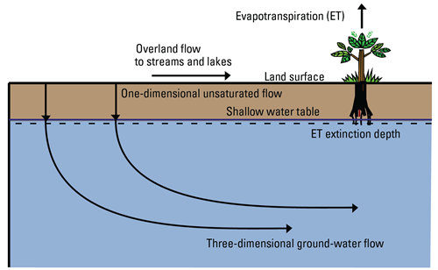

GMS 10.9

GMS 10.9 Tutorial

***MODFLOW – UZF Package***

The MODFLOW Unsaturated-Zone Flow (UZF) Package Interface

Objectives

This tutorial explains how to use the MODFLOW Unsaturated-Zone Flow (UZF) package and compares it to the RCH and EVT packages.

Time

* 35–50 minutes

Required Components

* GMS Core
* MODFLOW Interface

Prerequisite Tutorials

* MODFLOW – Conceptual Model Approach I

|  |
| --- |
| 1 Introduction 2  2 Getting Started 4  2.1 Importing the Existing Model 5  2.2 Saving the Model with a New Name 5  3 Viewing the UZF Boundary Conditions 6  3.1 The UZF Package Dialog 6  3.2 The Sources/Sinks Dialog 6  3.3 Running MODFLOW 7  3.4 Examining the Solution 8  4 Increasing the Infiltration Rate 9  4.1 Running MODFLOW 9  4.2 Examining the Solution 10  5 Using a Conceptual Model 11  5.1 Opening the Existing Conceptual Model 11  5.2 Examining the Existing Solution 11  5.3 Changing the Model to Use UZF 11  5.4 Changing to UZF 12  5.5 Examining and Configuring the UZF Package 12  5.6 Saving and Running MODFLOW 12  5.7 Examining the Solution 13  5.8 Adding Routing to Streams 13  5.9 Configuring the UZF Package 14  5.10 Saving and Running MODFLOW 14  5.11 Viewing the Changes 14  6 Conclusion 16 |

# Introduction

The Unsaturated-Zone Flow (UZF) package was developed by the USGS to more accurately model recharge of groundwater through an unsaturated zone. The package models percolation of precipitation through the unsaturated zone and can include storage in the unsaturated zone, groundwater recharge, evapotranspiration, and surface discharge. The surface discharge can be routed to streams or lakes, or, if a lake or stream is not specified, the discharge is removed from the model. The package was designed to be substituted for the EVT and RCH packages, although they can all be used at the same time. The UZF package is only available in MODFLOW-2005.

The problem in this tutorial is the same as the model used in the UZF documentation.[1] The model was first described in the SFR documentation.[2]

The hypothetical stream-aquifer interaction problem used in this simulation was developed for an alluvial basin in a semiarid region. The principal aquifer comprises unconsolidated deposits of mostly sand and gravel. Recharge to the aquifer primarily is leakage from the streams that enter the basin from the mountains on the northwest, northeast, and southwest. The main stream in the southern part of the valley is perennial, whereas all other streams in the valley are intermittent with small drainage areas.

Streamflow entering the model domain and diversions from streams were the same as that used by Prudic and others and remained the same for all stress periods. Different methods were used to represent the relations between width, depth and flow in the streams. Infiltration rates in the UZF1 Package file and pumping rates in the Well Package file were varied during 12 stress periods but the distribution of infiltration and pumping among grid cells did not change. The ET demand was specified as constant over the entire modeled area equal to 1.6 ft/yr to a maximum depth of 15 ft below land surface. The LPF Package was used to specify hydraulic properties for the aquifer. The hydraulic conductivity and specific yield were 173 ft/d and 0.2, respectively, in the vicinity of the stream channels and the hydraulic conductivity and specific yield were 35 ft/d and 0.1, respectively, elsewhere in the alluvial basin…

The model grid was divided into uniformly spaced cells 5,000 ft on each side. The strongly implicit procedure (SIP) was used to solve the flow equation for test simulation 2. The head-closure criterion was 0.0002. The option to add overland runoff to stream segments was specified in the UZF1 Package; however, no ground-water seepage to land surface was simulated in the test. The number of stress periods in the Discretization file was 12. Each stress period was 2.628×106 seconds or 30.42 days. The first stress period was steady state and had one time step. This allowed for the calculation of initial water contents for the unsaturated zone on the basis of the steady-state infiltration rate. The remaining 11 stress periods were transient and were divided into 15 time steps that increased sequentially by a factor of 1.1.[3]

This tutorial will discuss and demonstrate:

* Importing an existing MODFLOW simulation.
* Running the simulation.
* Examining the results to understand the UZF package options.
* Modifying a conceptual model to use UZF instead of the RCH and EVT packages.

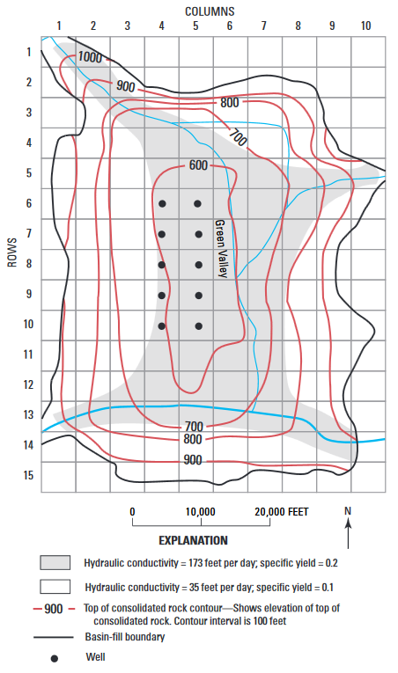

Figure 1 Flow model from UZF documentation[4]

# Getting Started

Do the following to get started:

1. If necessary, launch GMS.
2. If GMS is already running, select *File |* **New** to ensure that the program settings are restored to their default state.
3. If asked to save changes, click **Don’t Save** to close the dialog and restore GMS to a default state.

## Importing the Existing Model

To start with a MODFLOW model that has already been created:

1. Click **Open** File:Open Macro.svg to bring up the *Open* dialog.
2. Select “MODFLOW Name Files (*.mfn;*.nam)” from the *Files of type* drop-down.
3. Browse to the *uzf\uzf* folder and select “UZFtest2.nam”.
4. Click **Open** to exit the *Open* dialog and bring up the *MODFLOW Translator* dialog.
5. Click **OK** to accept the default settings and begin the translation.
6. When the dialog states that “MODFLOW 2005 terminated successfully”, click **Done** to finish importing the file and close the *MODFLOW Translator* dialog.

This imports a model showing a grid with symbols representing wells, streams, and general head boundary conditions (Figure 2).

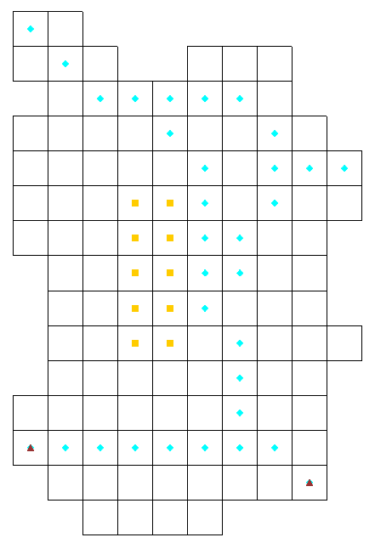

Figure 2 Imported MODFLOW model

## Saving the Model with a New Name

Now it is possible to start making changes, but first, it is recommended to save the model with a new name.

1. Select *File |* **Save As…** to bring up the *Save As* dialog.
2. Select “Project Files (*.gpr)” from the *Save as type* drop-down.
3. Enter “UZF.gpr” as the *File name*.
4. Click **Save** to save the project under the new name and close the *Save As* dialog.

# Viewing the UZF Boundary Conditions

Before running the simulation, view the UZF boundary conditions in the *UZF Package* dialog.

## The UZF Package Dialog

1. Select *MODFLOW | Optional Packages |* **UZF - Unsaturated Zone Flow…**to open the *MODFLOW* *UZF Package* dialog.

This dialog is used to edit existing UZF boundary conditions and to change options associated with the UZF package. The options located on the left of the dialog apply to the UZF package, while the spreadsheet on the right allows editing of the individual UZF boundary conditions. Instead of repeating all of the UZF documentation here, it is recommended to review the UZF documentation (found on the USGS website) for more information on each input option.

Now to examine the UZF boundary conditions. The boundary conditions for the UZF package can be edited in the spreadsheet on the right with the different boundary condition arrays selectable using the *View/Edit* drop-down. The first four arrays listed in the combo box can vary per stress period, including “Infiltration Rate”, “ET Demand Rate”, “ET Extinction Depth”, and “ET Water Content”.

1. Below the *Stress period* section, select “FINF. Infiltration Rate (ft/s)” from the *View/Edit* drop-down.
2. Enter “1.0e-09” as the *Multiplier*.
3. In the *Stress period* section, enter “2” as the current stress period.

Notice that the *Multiplier* field is now set to “8.0e-009”. For this simulation, the infiltration rate changes via the *Multiplier* field through most of the remaining stress periods. View the other arrays for additional UZF boundary conditions, if desired. Refer to the UZF documentation for a full explanation of each of the inputs to the UZF boundary conditions.

1. Click **OK** to close the *MODFLOW UZF Package* dialog.

## The Sources/Sinks Dialog

1. Switch to the **3D Grid** File:3D Grid Icon.svg module by selecting “File:3D Grid Folder.svg 3D Grid Data” in the Project Explorer.
2. Select *Edit* | **Select All** to select all of the cells in the 3D grid.
3. Right-click on one of the selected cells and select **Sources/Sinks…** to open the *MODFLOW* *Source/Sinks* dialog.
4. Select “Unsaturated Zone (UZF)” from the list at the left.

This dialog allows editing the properties of a selected boundary condition as well as adding additional source/sink boundary conditions in the selected cells. For the areal boundary conditions such as EVT, RCH, and UZF, the package has to be turned on before it becomes available. For UZF boundary conditions, the values associated with stress periods can be entered as a constant value for all stress periods or as a time-varying XY series.

1. Click **OK** to exit the *MODFLOW Sources/Sinks* dialog.
2. Click outside of the grid to unselect the cells.

## Running MODFLOW

Before running MODFLOW, it is necessary to change the output options to make it easier to see the results.

1. Select *MODFLOW |* **OC - Output Control…** to open the *MODFLOW Output Control* dialog.
2. In the *Output interval* section, select *Output at last time step of each stress period*.
3. Turn on *Save cell by cell flow terms to *.ccf file*.
4. Click **OK** to exit the *MODFLOW Output Control* dialog.

To save the changes and run MODFLOW:

1. **Save** File:Save Macro.svg the project.
2. Click **Run MODFLOW** Run MODFLOW to bring up the *MODFLOW* model wrapper dialog.
3. When MODFLOW finishes, turn on *Read solution on exit and Turn on contours (if not on already)*.
4. Click **Close** to import the solution and close the *MODFLOW* model wrapper dialog.

Block-fill contours should appear on the grid (Figure 3).

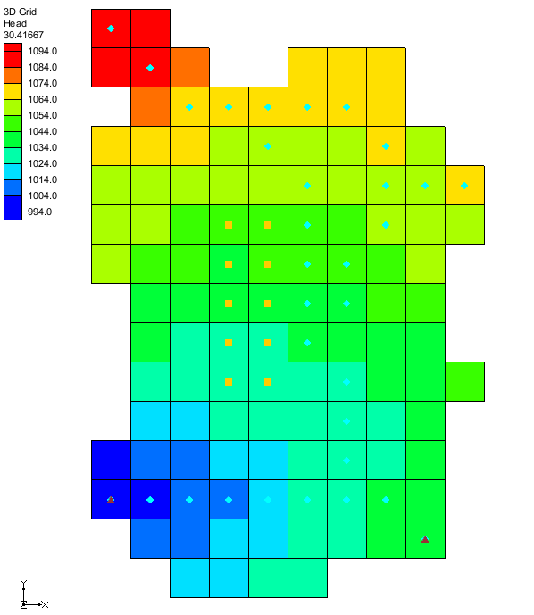

Figure 3 MODFLOW solution

1. **Save** File:Save Macro.svg the project with the new solution.

## Examining the Solution

Look more closely at the computed solution. The solution contours show that the potential for flow for this model is from the top left down toward the bottom left.

### The Flow Budget Dialog

To examine the flow budget for this simulation:

1. Click on the “File:Dataset Cells Active.svg Head” dataset to make the Time Step Window appear with the first stress period selected.
2. Click outside the grid to make sure none of the cells are selected and select *MODFLOW* | **Flow Budget…** to bring up the *Cells* tab of the *Flow Budget* dialog.

The flow budget for all cells for the time step at the end of the first stress period is shown. Note that the flow in for *UZF RECHARGE* is about “8.5” and the flow out for *GW ET* is about “-20.4”. Also note that, at the end of the first stress period, there is no *SURFACE LEAKAGE*.

1. On the *Zones* tab, turn on *Use all time steps*.

The generated spreadsheet shows the flow budget for the last time step of each stress period.

1. Scroll down through each time step on the spreadsheet and notice the flow budget values for the UZF package.

Notice the *SURFACE LEAKAGE* is “0.0” in all stress periods.

1. Click **OK** to exit the *Flow Budget* dialog.

### The OUT File

MODFLOW also generates a flow budget for the unsaturated zone in the MODFLOW list output file. Look at the flow budget for the unsaturated zone.

1. Double-click on “File:External Text File Icon.svg UZF.out” in the Project Explorer to bring up the *View Data File* dialog.

This dialog may not appear if the *Never ask this again* option had been previously turned on. If this is the case, skip to step 3.

1. Select the desired text editor from the *Open with* drop-down and click **OK** to open “UZF.out” in that text editor and close the *View Data File* dialog.
2. Search (usually *Ctrl+F*) for “Unsaturated Zone Package Volumetric Budget” to find the section for time step 1 stress period 1.
3. Review the data in this section and any of the other similar sections for other time steps and stress periods.
4. Once done reviewing them, close the “UZF.out” document in the text editor and return to GMS.

A UZF flow budget is printed to the out file at the end of each time step just like the volumetric flow budget for the entire model.

# Increasing the Infiltration Rate

To increase the infiltration rate to see what effect it has on the model.

1. Select *MODFLOW | Optional Packages |* **UZF - Unsaturated Zone Flow…**to open the *MODFLOW UZF Package* dialog.
2. In the *Stress period* section, enter “2” as the current stress period.
3. Select “FINF. Infiltration Rate (ft/s)” from the *View/Edit* drop-down.
4. Below the *Stress period* section, enter “8.0e-008” as the *Multiplier*.
5. Click **OK** to close the *MODFLOW UZF Package* dialog.

## Running MODFLOW

It is now time to run MODFLOW again to generate a new solution.

1. **Save** File:Save Macro.svg the project.
2. Click **Run MODFLOW** File:Run MODFLOW Macro.svg to bring up the *MODFLOW* model wrapper dialog.
3. When MODFLOW finishes, turn on *Read solution on exit* and *Turn on contours (if not on already)*.
4. Click **Close** to import the solution and exit the *MODFLOW* model wrapper dialog.
5. Select the “File:Dataset Cells Active.svg Head” dataset then select time step 2.

The model should appear similar to Figure 4.

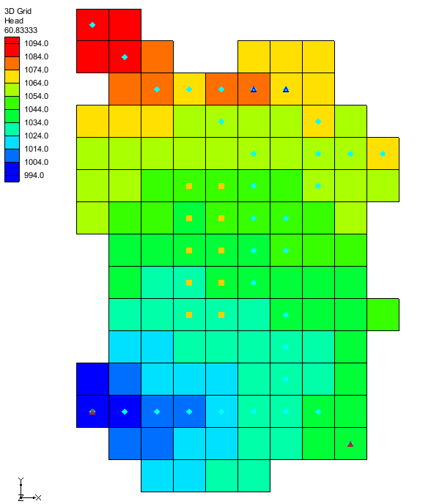

Figure 4 After MODFLOW run with changed infiltration rate

## Examining the Solution

To look at the solution to find out if increasing the infiltration rate caused any UZF surface leakage:

### The Flow Budget Dialog

1. Select the “File:Dataset Cells Active.svg Head” dataset to make the Time Step Window appear, with the first stress period selected.
2. Select the second time step.
3. Select *MODFLOW* | **Flow Budget…**to bring up the *Flow Budget* dialog.

The flow budget for all cells for the current time step is shown. Note that *SURFACE LEAKAGE* is about “-0.128” in the *Flow Out* column.

1. Click **OK** to exit the *Flow Budget* dialog.

### CCF Datasets

Now it is possible to investigate where the surface leakage is occurring.

1. Select and then right-click on “File:CCF Dataset Active.svg CCF (UZF.ccf)” in the Project Explorer and select the **CCF → Datasets** command.
2. Select “File:Dataset Cells Active.svg SURFACE LEAKAGE” to bring up the time steps for that dataset.
3. Select time step 2 to see an image similar to Figure 5.
4. **Save** File:Save Macro.svg the project.

Most of the grid should have a value of zero for the dataset. A few cells have negative values, indicating surface leakage.

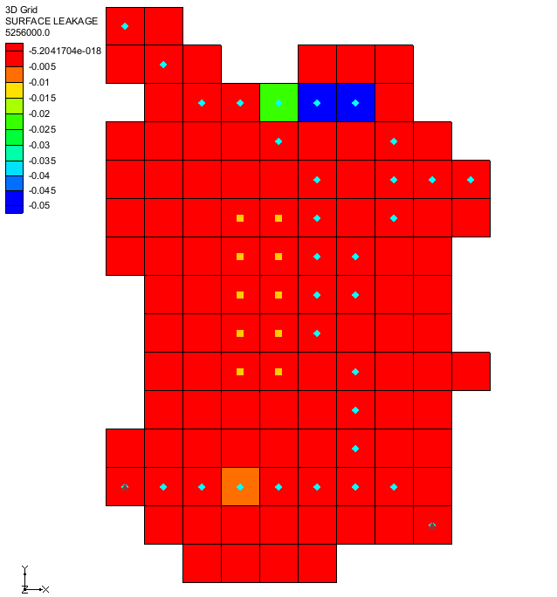

Figure 5 Surface leakage cells

# Using a Conceptual Model

The next step is to use a conceptual model with UZF data by taking a modified version of the finished model for the “MODFLOW – SFR Package” tutorial and changing it to use the UZF package.

## Opening the Existing Conceptual Model

1. Click **New** File:New Macro.svg to clear the project and reset to defaults.
2. Click **Open** File:Open Macro.svg to bring up the *Open* dialog.
3. Select “Project Files (*.gpr)” from the *Files of type* drop-down.
4. Browse to the *uzf\uzf* directory and select “SFRmap.gpr”.
5. Click **Open** to import the project and exit the *Open* dialog.

Before making any changes, it is best to save the project under a new name.

1. Select *File* | **Save As…** to bring up the *Save As* dialog.
2. Select “Project Files (*.gpr)” from the *Save as type* drop-down.
3. Enter “UZFmap.gpr” as the *File name*.
4. Click **Save** to save the project under the new name and close the *Save As* dialog.

## Examining the Existing Solution

Before changing to the UZF package, it is good to look at the flow budget for the existing solution.

1. Select *MODFLOW* | **Flow Budget…** to bring up the *Flow Budget* dialog.

Notice the flow budget for the *RECHARGE* package has a flow in rate of “145.0”, and the *ET* (evapotranspiration) package has a flow out rate of about “-46.09”.

1. Click **OK** to exit the *Flow Budget* dialog.

## Changing the Model to Use UZF

To change to the UZF package, it is first necessary to remove the RCH and EVT packages from MODFLOW.

1. Select *MODFLOW |* **Global Options…** command to bring up the *MODFLOW Global/Basic Packages* dialog.
2. Select *2005* in the *MODFLOW version* section.
3. Click **Packages…** to bring up the *MODFLOW Packages / Processes* dialog.
4. In the *Optional packages / processes* section, turn off *RCH1 - Recharge* and *EVT1 - Evapotranspiration*.
5. Click **OK** to exit the *MODFLOW Packages / Processes* dialog.
6. Click **OK** to exit the *MODFLOW Global/Basic Package* dialog.

## Changing to UZF

1. Fully expand the “File:Map Folder.svg Map Data” folder in the Project Explorer.
2. Right-click on “File:Coverage Active Icon.svg Recharge & ET” and select **Coverage Setup…** to open the *Coverage Setup* dialog.
3. In the *Areal Properties\** column, turn on *UZF FINF (Infiltration Rate)*, *UZF PET (ET Demand Rate)*, and *UZF EXTDP (ET Extinct. Depth)*.
4. Click **OK** to exit the *Coverage Setup* dialog.
5. Right-click on “File:Coverage Active Icon.svg Recharge & ET” and select **Attribute Table…**to open the *Attribute Table* dialog.
6. Select “Polygons” from the *Feature type* drop-down.
7. Enter “5.0e-008” in the *UZF FINF (Infiltration Rate) (ft/s)* column.
8. Enter “8.5e-008” in the *UZF PET* *(ET Demand Rate) (ft/s)* column.
9. Enter “15.0” in the *UZF EXTDP (ET Extinct. Depth) (ft)* column.

Notice that these values match the values for the recharge and evapotranspiration packages.

1. Click **OK** to exit the *Attribute Table* dialog.
2. Right-click on **“**File:Coverage Active Icon.svg Recharge & ET” and select **Coverage Setup…**to open the *Coverage Setup* dialog.
3. In the *Areal Properties\** column, turn off *Recharge rate,* *Max ET rate,* and *ET Extinction depth*.
4. Click **OK** to exit the *Coverage Setup* dialog.

The conceptual model is set up, so it can now be mapped to the MODFLOW grid.

1. Click the **Map → MODFLOW** File:Map to MODFLOW Macro.svg macro to bring up the *Map → Model* dialog.
2. Click **OK**to accept the defaults and close the *Map → Model* dialog.

## Examining and Configuring the UZF Package

Look at the data in MODFLOW that was mapped from the conceptual model.

1. Select *MODFLOW | Optional Packages |* **UZF - Unsaturated Zone Flow…**to bring up the *MODFLOW UZF Package* dialog.
2. Using the *View/Edit* drop-down, review the “FINF. Infiltration Rate (ft/s)”, “PET. ET Demand Rate (ft/s)”, and “EXTDP. ET Extinction Depth (ft)” values. They should be the values entered in the conceptual model.

The default settings for the UZF package have evapotranspiration disabled. This option must be turned on in this dialog.

1. On the left side of the dialog, turn on *Simulate ET (IETFLG)*.
2. Click **OK** to exit the *MODFLOW UZF Package* dialog.

## Saving and Running MODFLOW

The next step is to save the changes and run MODFLOW.

1. **Save** File:Save Macro.svg the project.
2. Click the **Run MODFLOW** File:Run MODFLOW Macro.svg macro to bring up the *MODFLOW* model wrapper dialog.
3. When MODFLOW finishes, turn on *Read solution on exit* and *Turn on contours (if not on already)*.
4. Click **Close** to import the solution and exit the *MODFLOW* model wrapper dialog.
5. **Save** File:Save Macro.svg the project with the new solution.

## Examining the Solution

To look at the flow budget for the new solution:

1. Fully expand the “File:3D Grid Folder.svg 3D Grid Data” folder and select “File:CCF Dataset Active.svg CCF (UZFmap.ccf)” in the Project Explorer.
2. Select *MODFLOW* **| Flow Budget…** to bring up the *Flow Budget* dialog.
3. Notice that the *UZF RECHARGE* package gives nearly the same flow rate as the *RCH* package with a flow in rate of about “144.7” for *UZF RECHARGE*.
4. Notice that the flow out for *GW ET* is now about “-56.6”.
5. Notice that the *SURFACE LEAKAGE* flow out is about “-8.84”. Since the routing to streams is not turned on, this amount is leaving the model.
6. Click **OK** to exit the *Flow Budget* dialog.

## Adding Routing to Streams

Next to add routing from the unsaturated zone to surface streams:

1. Turn off “File:3D Grid Folder.svg 3D Grid Data” and “File:GIS Folder.svg GIS Layers” in the Project Explorer.
2. Select “File:Coverage Active Icon.svg UZF Stream” in the Project Explorer.

This makes the coverage visible in the Graphics Window. The coverage is made up of the polygons labeled “Polygon 1” through “Polygon 8”. Each polygon is matched to a stream segment in the “File:Coverage Active Icon.svg Streams” coverage. Once set up, any UZF surface leakage in a given polygon routes to its associated stream segment.

1. Right-click on “File:Coverage Active Icon.svg UZF Stream” and select **Coverage Setup…**to open the *Coverage Setup* dialog.
2. In the *Areal Properties\** column, scroll down and turn on *UZF IRUNBND*.
3. Click **OK** to close the *Coverage Setup* dialog.
4. Right-click on “File:Coverage Active Icon.svg UZF Stream” and select **Attribute Table…** to open the *Attribute Table* dialog.
5. Select “Polygons” from the *Feature type* drop-down.
6. In the *UZF IRUNBND* column of the spreadsheet, change each value to match the polygon number found in the *Name* column.
7. Click **OK** to exit the *Attribute Table* dialog.

The conceptual model is now set up and can be mapped to the MODFLOW grid.

1. Click **Map → MODFLOW** File:Map to MODFLOW Macro.svg to bring up the *Map → Model* dialog.
2. Click **OK** to accept the defaults and close the *Map → Model* dialog.

## Configuring the UZF Package

To review the data in MODFLOW that was mapped from the conceptual model:

1. Select *MODFLOW | Optional Packages |* **UZF - Unsaturated Zone Flow…**to bring up the *MODFLOW UZF Package* dialog.
2. From the *View/Edit* drop-down, select “IRUNBND. Stream segments / Lakes”.

The values in the spreadsheet now match the values mapped from the conceptual model. One change is still needed to enable the routing of surface discharge to the streams.

1. On the left side of the dialog, turn on *Route surface discharge to streams / lakes (IRUNFLG)*.
2. Click **OK** to exit the *MODFLOW UZF Package* dialog.

## Saving and Running MODFLOW

To save the changes and run MODFLOW again:

1. Turn on “File:3D Grid Folder.svg 3D Grid Data” in the Project Explorer so the results are visible.
2. Select *File |* **Save As…** to bring up the *Save As* dialog.
3. Select “Project Files (*.gpr)” from the *Save as type* drop-down.
4. Enter “UZFmap2.gpr” as the *File name*.
5. Click **Save** to save the project under the new name and close the *Save As* dialog.
6. Click the **Run MODFLOW** File:Run MODFLOW Macro.svg macro to bring up the *MODFLOW* model wrapper dialog.
7. When MODFLOW finishes, turn on *Read solution on exit* and *Turn on contours (if not on already)*.
8. Click **Close** to import the solution and close the *MODFLOW* model wrapper dialog.

## Viewing the Changes

To view the changes to the output caused by turning on stream routing:

1. Right-click on “File:CCF Dataset Active.svg CCF (UZFmap2.ccf)” under the “File:Generic Folder Locked.svg UZFmap2 (MODFLOW)” solution and select **CCF → Datasets**.
2. Select the “File:Dataset Cells Active.svg SURFACE LEAKAGE” dataset.
3. Click the **Contours** File:Contour Options Macro.svg macro to open the *Dataset Contour Options - 3D Grid - SURFACE LEAKAGE* dialog.
4. In the *Contour method* section, select “Block Fill” from the first drop-down.
5. Click **OK** to exit the *Dataset Contour Options - 3D Grid - SURFACE LEAKAGE* dialog.

Notice that two of the cells toward the bottom left of the model show surface leakage (Figure 6).

1. Using **Select Cells** File:Select 3D Cell Tool.svg while holding down *Shift*, select the two cells with surface leakage.
2. Select *MODFLOW* | **Flow Budget…** to bring up the *Flow Budget* dialog.

Notice that the flow out rate for *STREAM LEAKAGE* is about “-3.21”. The flow out rate for *SURFACE LEAKAGE* is about “-9.09”.

1. Click **OK** to exit the *Flow Budget* dialog.
2. Select the “File:Dataset Cells Active.svg Head” dataset under the “File:Generic Folder Locked.svg UZFmap (MODFLOW)” solution.
3. With the same two cells still selected, select the *MODFLOW* | **Flow Budget…** menu command.

Notice that the flow out rates for *STREAM LEAKAGE* and *SURFACE LEAKAGE* are about “-3.44” and about “-8.84”, respectively. For this model, turning on stream routing caused a small change to the model in these cells.

1. Click **OK** to exit the *Flow Budget* dialog.

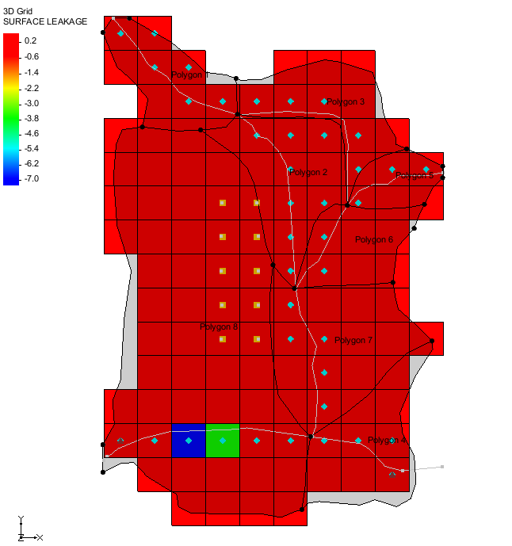

Figure 6 Block fill contours after final MODFLOW run

# Conclusion

This concludes the “MODFLOW – UZF Package” tutorial. The following key concepts were discussed and demonstrated:

* GMS supports the UZF package with MODFLOW-2005.
* The UZF package is meant to replace the RCH and EVT packages and provides additional functionality.
* UZF data can be viewed and edited in the *MODFLOW* *UZF Package* dialog.
* UZF data can be entered in a conceptual model and then mapped to MODFLOW.
* The settings in the UZF package may need to be adjusted to match the UZF properties selected in the Map module.

1. Niswonger, R.G.; Prudic, David E.; and Regan, R. Steven (2006). “Documentation of the Unsaturated-Zone Flow (UZF1) Package for modeling unsaturated flow between the land surface and the water table with MODFLOW-2005” in *Techniques and Methods Book 6, Modeling Techniques*, U.S. Geological Survey, chapter A19. <https://pubs.usgs.gov/tm/2006/tm6a19/pdf/tm6a19.pdf>.
2. Prudic, David E.; Konikow, Leonard F.; and Banta, Edward R. (2004). *A new stream-flow routing (SFR1) package to simulate stream-aquifer interaction with MODFLOW-2000*. U.S. Geological Survey Open-File Report 2004-1042. <https://water.usgs.gov/nrp/gwsoftware/modflow2000/ofr2004-1042.pdf>
3. Niswonger, et al (2006), p. 20, 23.
4. Niswonger, et al (2006), p. 20, 23.