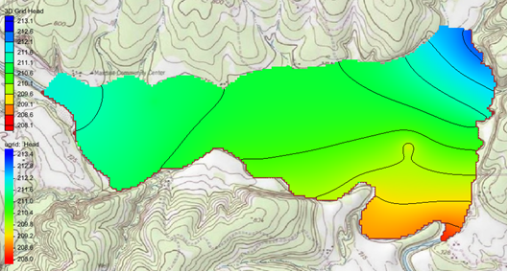

GMS 10.9

GMS 10.9 Tutorial

***MODFLOW 6 – Conceptual Approach***

Build a MODFLOW 6 model using the conceptual model approach

Objectives

This tutorial demonstrates converting an existing MODFLOW 2000 conceptual model to a MODFLOW 6 simulation using the conceptual model approach.

Time

* 25–45 minutes

Required Components

* GMS Core
* MODFLOW-USG Model & Interface

Prerequisite Tutorials

* Getting Started
* MODLFOW Conceptual Model Approach I

|  |
| --- |
| 1 Introduction 2  2 Getting Started 3  2.1 Opening the Existing Model 3  3 Saving the Project 4  4 Setting Up the Grid 4  5 Creating the Simulation 5  6 Mapping from Coverages 5  6.1 Mapping the Drain Package 6  6.2 Mapping the General Head Boundary 6  6.3 Mapping the Recharge Package 7  6.4 Mapping the Wells 7  6.5 Mapping the Hydraulic Conductivity 8  7 Setting the Starting Head 8  8 Saving the Data 9  9 Checking the Simulation 9  10 Mapping the DISV Package 9  11 Saving and Checking the Simulation 10  12 Running MODFLOW 10  13 Viewing the Solution 10  14 Conclusion 11 |

# Introduction

A simple MODFLOW 6 simulation can be built in GMS using the conceptual model approach. Refer to the *MODFLOW – Conceptual Model Approach 1* and *MODFLOW – Conceptual Model Approach 2* tutorials to learn how to create conceptual models for MODFLOW.

In this tutorial, an existing MODFLOW 2000 simulation will be converted to a MODFLOW 6 simulation. The existing conceptual model will be used to generate an unstructured grid (UGrid). A MODFLOW 6 simulation will be created and linked to the UGrid. Then, the conceptual model approach will be used to create MODFLOW 6 inputs on the UGrid. Then the simulation will be checked and run.

The problem solved in this tutorial is illustrated in Figure 1.

This tutorial models the groundwater flow in the valley sediments bounded by the hills to the north and the two converging rivers to the south of a site in eastern Texas in the United States. The boundary to the north will be a no-flow boundary and the remaining boundary will be a general head boundary corresponding to the average stage of the rivers.

It is necessary to assume that the influx to the system is primarily through recharge due to rainfall. There are some creek beds in the area which are sometimes dry but occasionally fill up due to influx from the groundwater. These creek beds will be represented using drains. Two production wells in the area will also be included in the model.



Figure Plan view of site to be modeled

This tutorial discusses and demonstrates the following key concepts:

* Generating a 3D UGrid
* Creating a MODFLOW 6 simulation
* Mapping the coverages to a MODFLOW 6 simulation

# Getting Started

Do as follows to get started:

1. If necessary, launch GMS.
2. If GMS is already running, select the *File |* **New** command to ensure that the program settings are restored to their default state.

## Opening the Existing Model

Start with a previously-created project.

1. Click **Open** File:Open Macro.svg to bring up the *Open* dialog.
2. Select “Project Files (*.gpr)” from the *Files of type* drop-down.
3. Browse to the *mf6_conceptual* folder and select “start.gpr”.
4. Click **Open** to import the project and exit the *Open* dialog.

The project should be visible in the Graphics Window (Figure 2). The project contains a MODFLOW 2000 simulation along with a 3D grid, map coverages, and a background map.

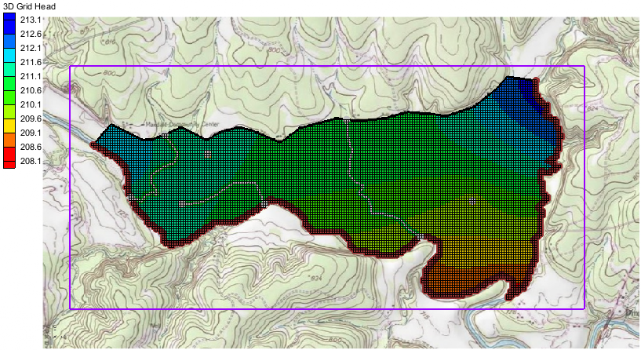

Figure Initial project

# Saving the Project

Before making any changes, save the project under a new name.

1. Select *File* | **Save As…** to bring up the *Save As* dialog.
2. Select “Project Files (*.gpr)” from the *Save as type* drop-down.
3. Enter “easttex.gpr” for the *File name*.
4. Click **Save** to save the project under the new name and close the *Save As* dialog.

It is recommended to periodically **Save** File:Save Macro.svg while working through the tutorial and while working on any project.

# Setting Up the Grid

MODFLOW 6 requires a 3D UGrid before the simulation can be started. Using the existing coverages, a UGrid can be generated. To do this:

1. In the Project Explorer, right-click on “File:Coverage Active Icon.svg Rivers” and select *Map To* | **UGrid** to bring up the *Map → UGrid* dialog.
2. For both the *X-Dimension* and the *Y-Dimension*, set the *Cell size method* to *Cell size*.
3. For both the *X-Dimension* and the *Y-Dimension*, set the *Cell size* to “20”.
4. For the *Z-Dimension*, set the *Cell size method* to *Number of cells* and set *Number of cells* to “1”.
5. Click **OK** to close the *Map → UGrid* dialog.

The 3D UGrid matches the 3D grid. To see this:

1. In the Project Explorer, turn off “File:3D Grid Icon.svg grid”.
2. Turn off the “File:Grid Frame Icon.svg Grid Frame”.

The 3D UGrid is now clearly visible in the Graphics Window (Figure 3).

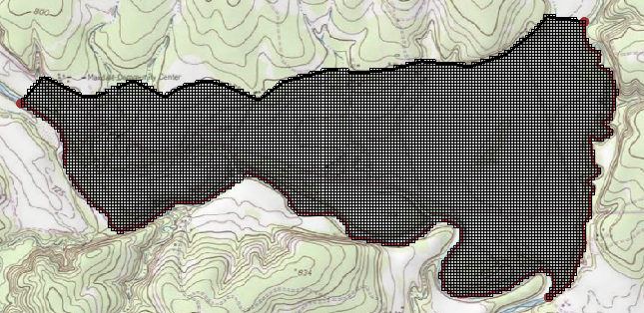

Figure The generated UGrid

# Creating the Simulation

The next step is to initialize the MODFLOW 6 simulation.

1. In the Project Explorer, right-click on “File:Project Icon.svg Project” and select *New Simulation* | **MODFLOW 6** to bring up the *New MODFLOW 6 Simulation* dialog.
2. For the *Simulation name* enter “Easttex”.
3. In the *Select UGrid* section, make sure the box next to “File:UGrid Module Icon.svg ugrid” is checked.

Now select the packages. The input to MODFLOW6 is subdivided into packages. Packages can be selected when setting up the simulation. If needed, packages can also be added to the simulation later. For now, select the following packages:

1. In the *GWF – Groundwater Flow Model* section, select the following:

* *DRN – Drain*
* *GHB – General Head Boundary*
* *RCH – Recharge*
* *WEL – Well*

1. Click **OK** to exit the *New MODFLOW 6 Simulation* dialog.

A new simulation (“File:MODFLOW Folder.svg Easttex”) will appear in the Project Explorer. Also in the Project Explorer, the different packages are listed under the simulation (expanding the “File:MF6 GWF Model.svgflow” package may be necessary to see all the packages). Along with the optional packages that were selected, the standard TDIS, IMS, DISV, IC, NPF, and OC packages are listed. These are the default names given by GMS. The names of the packages can be changed if desired.

# Mapping from Coverages

The next process is to map the coverages over to MODFLOW 6. Unlike with other versions of MODFLOW, MODFLOW 6 does not use the **Map → MODFLOW** command. Instead, the **Map from Coverage** command will be used.

## Mapping the Drain Package

To see how the new **Map from Coverage** command works, do the following:

1. In the Project Explorer, double-click on “240px-Mf6package DRN” to open the *Drain (DRN) Package* dialog.

Notice that no drain values have been entered into the DRN package. The drain values need to be applied from the drain coverage. To do this:

1. Click **OK** to close the *Drain (DRN) Package* dialog.
2. Right-click on “240px-Mf6packageDRN” and select **Map from Coverage…** to bring up the *Select Coverage* dialog.
3. Select the “File:Coverage Active Icon.svg Drains” coverage.
4. Click **OK** to close the *Select Coverage* dialog and bring up the *Map from Coverage* dialog.
5. When the mapping process is complete, click **OK** to close the *Map from Coverage* dialog.

The Graphics Window should appear similar to Figure 4. The drain values have now been mapped over to the UGrid and added to the drain package.

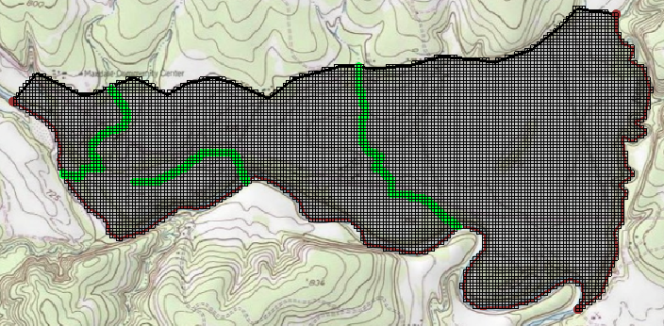

Figure Drains added to model

## Mapping the General Head Boundary

The General Head Boundary (GHB) package will be used to simulate the rivers in this example. Map over the GHB package by doing the following:

1. Right-click on “240px-Mf6packageGHB” and select **Map from Coverage…** to bring up the *Select Coverage* dialog.
2. Select the “File:Coverage Active Icon.svg Rivers” coverage.

Although the coverage is named “Rivers” it includes only the general head boundary conditions, which are used to model the rivers.

1. Click **OK** to close the *Select Coverage* dialog and bring up the *Map from Coverage* dialog.
2. When the mapping process is complete, click **OK** to close the *Map from Coverage* dialog.

The GHB values have now been added to the UGrid causing the Graphics Window to display similar to Figure 5.

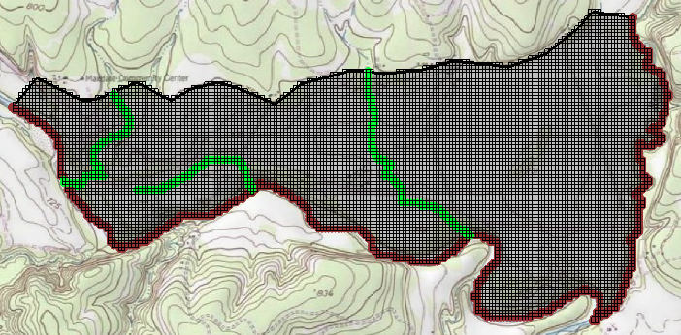

Figure General head cells added to model

## Mapping the Recharge Package

For recharge that varies from cell to cell, using the conceptual model approach can save time.

The recharge for this example is a constant value of 0.0003 m/d for the entire domain. It would be just as easy to enter the value manually on the grid as it would be to map over the value.

For the sake of showing how to map recharge values, the conceptual model approach will still be used.

1. Right-click on “240px-Mf6packageRCH” and select **Map from Coverage**… to bring up the *Select Coverage* dialog.
2. Select the “File:Coverage Active Icon.svg Recharge” coverage.
3. Click **OK** to close the *Select Coverage* dialog and bring up the *Map from Coverage* dialog.
4. When the mapping process is complete, click **OK** to close the *Map from Coverage* dialog.

The recharge value has been added to the MODFLOW 6 simulation.

## Mapping the Wells

Now add the wells by doing the following:

1. Right-click on “240px-Mf6packageWEL” and select **Map from Coverage**… to bring up the *Select Coverage* dialog.
2. Select the “File:Coverage Active Icon.svg Wells” coverage.
3. Click **OK** to close the *Select Coverage* dialog and bring up the *Map from Coverage* dialog.
4. When the mapping process is complete, click **OK** to close the *Map from Coverage* dialog.

The wells should appear in the Graphics Window as seen in Figure 6.

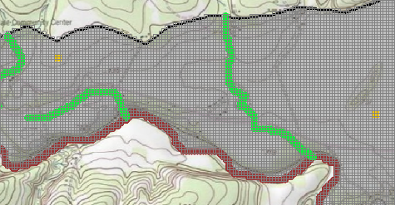

Figure Wells added to model

## Mapping the Hydraulic Conductivity

When there are zones with different hydraulic conductivity values, the conceptual model approach is ideal. These zones can be represented as separate polygons.

For this example, a constant value of 5.5 m/d is used; therefore it would be just as easy to apply the value directly to the UGrid. However, for the sake of demonstration, use the conceptual model approach by doing the following:

1. Right-click on “240px-Mf6packageNPF” and select **Map from Coverage…** to bring up the *Select Coverage* dialog.
2. Select the “File:Coverage Active Icon.svg Aquifer Layer 1” coverage.
3. Click **OK** to close the *Select Coverage* dialog and bring up the *Map from Coverage* dialog.
4. When the mapping process is complete, click **OK** to close the *Map from Coverage* dialog.

The hydraulic conductivity has now been set.

# Setting the Starting Head

The next step is to enter a constant value for the initial condition of the starting head. This will be done using the Initial Condition package, as GMS currently does not allow this to be done via the conceptual model.

To set the starting head, do the following:

1. In the Project Explorer, right-click on “Thumbnail for version as of 22:49, February 4, 2020IC” and select **Open…** to bring up the *Initial Conditions (IC) Package* dialog.
2. Turn off *Set starting heads equal to cell top elevations.*
3. In the *Constant* field, enter “230.0”.
4. Click **OK** to close the *Initial Conditions (IC) Package* dialog.

The starting head has now been set.

# Saving the Data

Before running the model simulation, the data needs to be saved. Start with saving the project file.

1. Click the **Save** File:Save Macro.svg macro to save the project.

The project file has now been saved. However, the simulation files needed to run MODFLOW 6 have not yet been exported. To export these files, do the following:

1. In the Project Explorer, right-click on “File:MODFLOW Folder.svg Easttex” and select **Save Simulation**.

The files for the simulation have now been exported.

# Checking the Simulation

With the simulation files exported, the simulation can now be checked. The exported files are required in order to perform a model check. When performing the model check, GMS will run MODFLOW 6 in “validate” mode where model inputs are checked but no equations are solved.

1. In the Project Explorer, right-click on “File:MODFLOW Folder.svg Easttex” and select **Check Simulation…** to bring up the *Check MODFLOW 6 Simulation* dialog.

Notice that the dialog shows errors about DRN elevations being less than the cell bottom.

1. Click **OK** to close the *Check MODFLOW 6 Simulation* dialog.

To fix the errors, the top and bottom elevations of the model grid need to be set.

# Mapping the DISV Package

To fix the top and bottom elevation, the DISV package will be used. First, review the elevation data in the conceptual model.

1. Select the “File:Coverage Active Icon.svg Aquifer Layer 1” coverage to make it active.
2. Using the File:GMS Select Polygon Tool.svg **Select Polygons** tool, double-click on the polygon to open the *Attribute Table* dialog.

Notice the values set for the top and bottom grid elevations (230 and 175).

1. Click **Cancel** to close the *Attribute Table* dialog.

Now to map over the top and bottom elevation values:

1. Right-click on “240px-Mf6packageDISV” and select **Map from Coverage…** to bring up the *Select Coverage* dialog.
2. Select the “File:Coverage Active Icon.svg Aquifer Layer 1” coverage.
3. Click **OK** to close the *Select Coverage* dialog and bring up the *Map from Coverage* dialog.
4. When the mapping process is complete, click **OK** to close the *Map from Coverage* dialog.

If desired, view the DISV package attributes to verify that the top and bottom values were mapped over correctly.

# Saving and Checking the Simulation

With the errors fixed, now check the model again. The files for the simulation will need to be exported again before running the model check. To export the simulation and check the model, complete the following:

1. Click the **Save** File:Save Macro.svg macro to save the project.
2. In the Project Explorer, right-click on “File:MODFLOW Folder.svg Easttex” and select **Save Simulation**.
3. Right-click on “File:MODFLOW Folder.svg Easttex” and select **Check Simulation…** to bring up the *Check MODFLOW 6 Simulation* dialog.

No errors should be reported.

1. Click **OK** to close the *Check MODFLOW 6 Simulation* dialog.

# Running MODFLOW

It is now possible to run MODFLOW:

1. Right-click on “File:MODFLOW Folder.svg Easttex” and select **Run Simulation** to bring up the *Simulation Run Queue* model wrapper dialog.

The *Simulation Run Queue* shows all simulation model runs currently in progress. Since this project only has one simulation, only one is shown.

1. When MODFLOW 6 finishes, click **Load Solution**.
2. Click **Close** to exit the *Simulation Run Queue* dialog.
3. Make sure the “File:Dataset Cells Active.svg Head” dataset is active in the Project Explorer.
4. Click **Display Options** File:Display Options Macro.svg to bring up the *Display Options* dialog.
5. Select “UGrid: ugrid – [Active]” from the list on the left.
6. Turn on *Define UGrid specific options.*
7. Turn off *Cell Edges*.
8. Turn on *Face contours* and click **Options…** to open the *Dataset Contour Options– UGrid – Head* dialog.
9. Change the *Contour Method* to “Color Fill and Linear”.
10. Click **OK** to close the *Dataset Contour Options– UGrid – Head* dialog.
11. Click **OK** to close the *Display Options* dialog.

# Viewing the Solution

After the solution has been loaded and contours set, the Graphics Window should appear as in Figure 7.

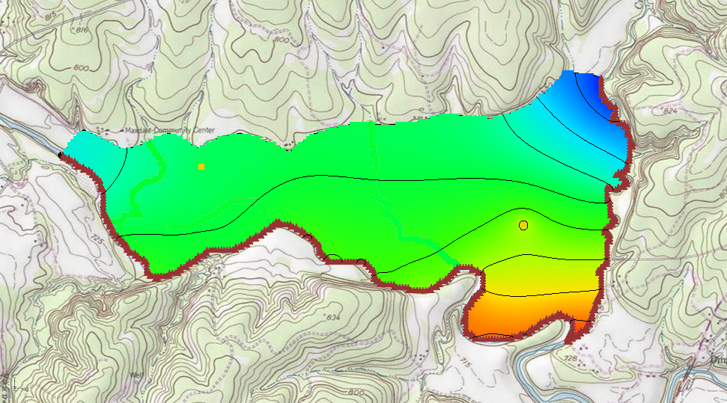

Figure Head values from MODFLOW 6 SIMULATION

Compare the head values from MODFLOW 6 to those obtained from running MODFLOW 2000 by doing the following:

1. In the Project Explorer, turn on “File:3D Grid Icon.svg grid”.
2. Click **Display Options** File:Display Options Macro.svg to bring up the *Display Options* dialog.
3. Select “3D Grid Data” from the list on the left.
4. Turn off *Cell Edges*.
5. Next to *Contours,* click **Options…** to open the *Dataset Contour Options– 3D Grid – Head* dialog.
6. Change the *Contour Method* to “Color Fill and Linear”.
7. Click **OK** to close the *Dataset Contour Options– 3D Grid – Head* dialog.
8. Click **OK** to close the *Display Options* dialog.
9. In the Project Explorer, turn on and off “ugrid” to compare the head datasets.

The head datasets should be similar between the MODFLOW 6 simulation and the MODFLOW 2000 simulation.

# Conclusion

This concludes the “MODFLOW 6 – Conceptual Model Approach” tutorial. The following topics were discussed and demonstrated:

* Generally, the same conceptual models that have been used in the past can be used with MODFLOW 6.
* Conceptual models can be mapped to the simulation using the **Map from Coverage**… command.
* The MODFLOW 6 model checker is different from the model checker for older versions of MODFLOW in that it runs MODFLOW in validate mode.
* The model native files must be saved before the model checker can be run.