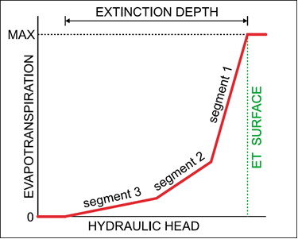

GMS 10.9

GMS 10.9 Tutorial

***MODFLOW 6 – Evapotranspiration Package***

Build a MODFLOW 6 model using the Evapotranspiration (EVT) package

Objectives

This tutorial demonstrates adding evapotranspiration data to a MODFLOW 6 simulation.

Time

* 25–45 minutes

Required Components

* GMS Core
* MODFLOW-USG Model & Interface

Prerequisite Tutorials

* Getting Started
* MODLFOW 6 Grid Approach

|  |
| --- |
| 1 Introduction 2  2 Getting Started 3  2.1 Opening the Existing Model 3  3 Saving the Project 4  4 Adding Array-Based EVT 4  4.1 SURFACE 4  4.2 RATE 4  4.3 DEPTH 5  4.4 IEVT 5  5 Change IMS Solver Complexity 5  6 Saving the Simulation 5  7 Checking the Simulation 6  8 Running MODFLOW 6 6  9 Viewing the Flow Budget 6  10 Using List-Based EVT 6  10.1 Adding EVT via Cell Properties 7  11 Saving the Simulation 7  12 Checking the Simulation 7  13 Running MODFLOW 6 7  14 Viewing the Flow Budget 8  15 Using Segments 8  15.1 Changing NSEG 8  15.2 Defining the PXDP Data 9  15.3 Defining the PETM Data 9  16 Saving and Checking the Simulation 10  17 Running MODFLOW 10  18 Viewing the Flow Budget 10  19 Conclusion 10 |

# Introduction

Evapotranspiration is the moving of water from the ground surface to the atmosphere through evaporation and transpiration. MODFLOW 6 uses the EVT package for model evapotranspiration.

The EVT package requires three parameters to determine evapotranspiration: the evapotranspiration (ET) surface elevation, the maximum ET rate, and the extinction depth. When the head in a cell is at or above the ET surface, ET occurs at the maximum ET rate. When the head is below the extinction depth, ET is zero. In between these two points, the ET varies linearly (Figure 1).

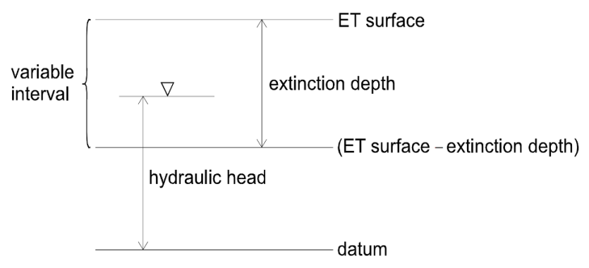

Figure 1 ET model, from Banta (2000)[1]

This tutorial explains how to use the EVT package. It uses a grid-based model (no conceptual model) with one layer, some wells and drains, recharge, and constant head cells.

This tutorial discusses and demonstrates:

* Defining an array-based EVT package.
* Defining a list-based EVT package.

# Getting Started

Do as follows to get started:

1. If necessary, launch GMS.
2. If GMS is already running, select *File |* **New** to ensure that the program settings are restored to their default state.

## Opening the Existing Model

Start with a previously-created project.

1. Click **Open** File:Open Macro.svg to bring up the *Open* dialog.
2. Select “Project Files (*.gpr)” from the *Files of type* drop-down.
3. Browse to the *mf6_evt* folder and select “start.gpr”.
4. Click **Open** to import the project and exit the *Open* dialog.

The project should be visible in the Graphics Window (Figure 2). The project contains a MODFLOW 6 simulation along with a 3D UGrid. Wells, drains, recharge, and constant head boundary conditions have already been defined. A solution also exists.

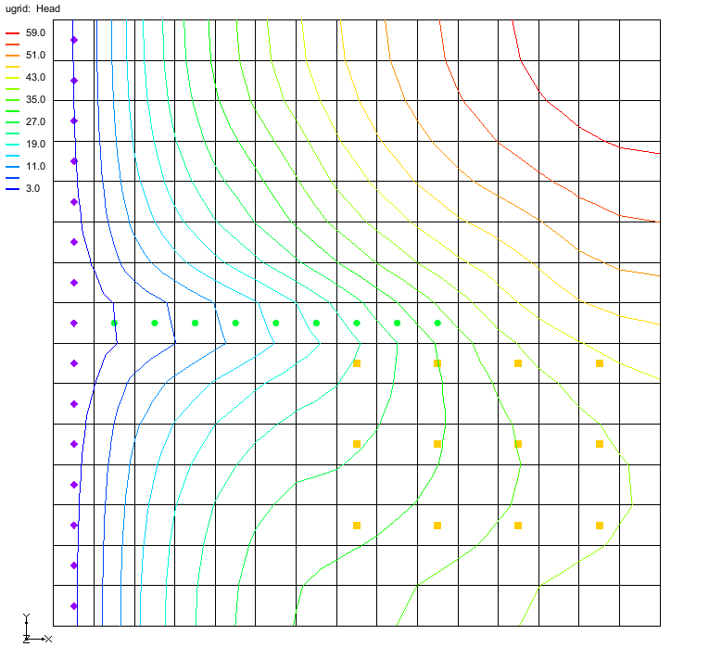

Figure Initial project

Currently the head in the top right corner of the model is above the ground surface. This can be seen by moving the mouse over the top right corner or looking at the dataset values. After adding EVT, the head should end up below the surface.

# Saving the Project

Before making any changes, save the project under a new name.

1. Select *File* | **Save As…** to bring up the *Save As* dialog.
2. Select “Project Files (*.gpr)” from the *Save as type* drop-down.
3. Enter “evt.gpr” for the *File name*.
4. Click **Save** to save the project under the new name and close the *Save As* dialog.

It is recommended to periodically **Save** File:Save Macro.svg while working through the tutorial and while working on any project.

# Adding Array-Based EVT

The EVT package has not been added to the simulation. To add this data, the EVT package needs to first be added to the MODFLOW 6 simulation.

To do this:

1. Right-click on the “16-mf6flow” model and select *New Package* | **EVT**.

A new package “Thumbnail for version as of 22:49, February 4, 2020EVT” is now visible in the Project Explorer under the MODFLOW 6 simulation.

1. Right-click on “Thumbnail for version as of 22:49, February 4, 2020EVT” and select **Open…** to bring up the *Evapotranspiration (EVT) Package* dialog.

Start with reviewing the EVT options:

1. Under *Sections*, turn on *OPTIONS*.

Under *OPTIONS*, notice the *READASARRAYS* option is on. EVT can be specified using lists or arrays, unless the DISU package is used, in which case list-based input must be used.

1. Under *Sections*, turn off *OPTIONS*.

## SURFACE

SURFACE is the elevation of the ET surface (L). To set this:

1. Select the *SURFACE* tab.
2. Ensure “CONSTANT” is selected in the drop-down.
3. In the *Constant* field, enter a value of “59.0”.

This puts the surface a little bit under that top of the grid which is 60.

## RATE

RATE is the maximum ET flux rate (LT-1). To set this:

1. Select the *RATE* tab.
2. Ensure “CONSTANT” is selected in the drop-down.
3. In the *Constant* field, enter a value of “0.01”.

## DEPTH

DEPTH is the ET extinction depth (L). To set this:

1. Select the *DEPTH* tab.
2. Ensure “CONSTANT” is selected in the combo box.
3. In the *Constant* field, enter a value of “6.0”.

## IEVT

Per USGS’s documentation: “IEVT is the layer number that defines the layer in each vertical column where evapotranspiration is applied. If IEVT is omitted, evapotranspiration by default is applied to cells in layer 1.”[2] If the cell is inactive or goes dry then the EVT will be assigned the cell below unless the user has turned on the “FIXED_CELL” option. To access the IEVT settings:

1. Select the *IEVT* tab

For now leave the IEVT as undefined

1. Click **OK** to close the *Evapotranspiration (EVT) Package* dialog.

# Change IMS Solver Complexity

The default settings for the IMS package are now inadequate. Change these settings by doing the following:

1. If necessary, right-click on “Thumbnail for version as of 22:49, February 4, 2020IMS” and select **Unlock**.
2. Right-click on “Thumbnail for version as of 22:49, February 4, 2020IMS” and select **Open…** to bring up the *Iterative Model Solution (IMS)* dialog.
3. Under *Sections*, turn on *OPTIONS*.
4. Under *OPTIONS*, change *COMPLEXITY* from “SIMPLE” to “COMPLEX”.
5. Click **OK** to close the *Iterative Model Solution (IMS)* dialog.

# Saving the Simulation

Before running the model simulation, the data needs to be saved out. Start with saving the project file.

1. Click the **Save** File:Save Macro.svg macro to save the project.

The project file has now been saved. However, the simulation files needed to run MODFLOW 6 have not yet been exported. To export these files, do the following:

1. In the Project Explorer, right-click on “File:MODFLOW Folder.svg sim” and select **Save Simulation**.

The files for the simulation have now been exported.

# Checking the Simulation

With the simulation files exported, the simulation can now be checked. The exported files are required in order to perform a model check. When performing the model check, GMS will run MODFLOW 6 in “validate” mode where model inputs are checked but no equations are solved.

1. In the Project Explorer, right-click on “File:MODFLOW Folder.svg sim” and select **Check Simulation…** to bring up the *Check MODFLOW 6 Simulation* dialog.

There should be no errors.

1. Click **OK** to close the *Check MODFLOW 6 Simulation* dialog.

# Running MODFLOW 6

It is now possible to run MODFLOW:

1. Right-click on “File:MODFLOW Folder.svg sim” and select **Run Simulation** to bring up a warning message.

Because a solution was already loaded into the project, this solution will have to be unloaded in order for MODFLOW 6 to run.

1. Click **OK** to close the warning dialog and start the *Simulation Run Queue* model wrapper dialog.

The *Simulation Run Queue* shows all simulation model runs currently in progress. Since this project only has one simulation, only one is shown.

1. When MODFLOW 6 finishes, click **Load Solution**.
2. Click **Close** to exit the *Simulation Run Queue* dialog.

# Viewing the Flow Budget

Review the flow budget from the solution by doing the following:

1. In the Project Explorer, double-click the “File:External text MF6.png model.lst” item to open a text editor.
2. Scroll to the bottom of the file.
3. In the *VOLUME BUDGET…* section, notice there is some water leaving the model due to EVT.

# Using List-Based EVT

A list can also be used in defining the EVT package.

To do this:

1. Right-click on “Thumbnail for version as of 22:49, February 4, 2020EVT” and select **Open…** to bring up the *Evapotranspiration (EVT) Package* dialog.
2. Under *Sections*, turn on *OPTIONS*.
3. Under *Options*, turn off the *READASARRAYS* option.

Notice how the dialog changed. Now the EVT data is specified using a list of cells. Since the whole top of the grid should have EVT, it will be easier to select the cells first instead of manually entering the list of cells now.

1. Click **OK** to close the *Evapotranspiration (EVT) Package* dialog.

## Adding EVT via Cell Properties

To add EVT to the cell properties, complete the following:

1. In the *UGrid Single Layer* toolbar (Figure 3), make sure the *Single layer* option is checked and the *Layer* is set to “1”.



Figure UGrid Single Layer toolbar

1. Using the **Select Cells** File:Select UGrid Cell Tool.svg tool, select all the cells in the top layer by dragging a box around them all.

This can be also be done by typing *CTRL+A*, or using *Edit* | **Select All** command.

1. Right-click on any selected cell and select **Cell Properties** to open the *Cell Properties Dialog*.
2. In the *Packages* list, select *EVT*.
3. Click the **Define Period** File:Add Note Icon.svg button to define stress period 1.
4. Click the **Add Rows** File:GMS MODFLOW 6 - Add Row button.png button bring up the *Add Stresses* dialog.
5. For the *SURFACE*, enter “59”.
6. For the *RATE*, enter “0.01”.
7. For the *DEPTH*, enter “6”.
8. Click **OK** to close the *Add Stresses* dialog.

The *Cell Properties Dialog* is now populated with a list of EVT data.

1. Click **OK** to close the *Cell Properties Dialog*.

# Saving the Simulation

Before running the model simulation, the data needs to be saved out.

1. Click the **Save** File:Save Macro.svg macro to save the project.
2. In the Project Explorer, right-click on “File:MODFLOW Folder.svg sim” and select **Save Simulation**.

The files for the simulation have now been exported.

# Checking the Simulation

Now check the simulation again before running MODFLOW 6.

1. In the Project Explorer, right-click on “File:MODFLOW Folder.svg sim” and select **Check Simulation…** to bring up the *Check MODFLOW 6 Simulation* dialog.

There should be no errors.

1. Click **OK** to close the *Check MODFLOW 6 Simulation* dialog.

# Running MODFLOW 6

It is now possible to run MODFLOW:

1. Right-click on “File:MODFLOW Folder.svg sim” and select **Run Simulation** to bring up a warning message.

Because a solution was already loaded into the project, this solution will have to be unloaded in order for MODFLOW 6 to run.

1. Click **OK** to close the warning dialog and start the *Simulation Run Queue* model wrapper dialog.

The *Simulation Run Queue* shows all simulation model runs currently in progress. Since this project only has one simulation, only one is shown.

1. When MODFLOW 6 finishes, click **Load Solution**.
2. Click **Close** to exit the *Simulation Run Queue* dialog.

# Viewing the Flow Budget

Review the flow budget from the solution by doing the following:

1. In the Project Explorer, double-click the “File:External text MF6.png model.lst” item to open a text editor.
2. Scroll to the bottom of the file.

In the *VOLUME BUDGET…* section, notice the water loss is the same.

# Using Segments

The next steps will take advantage of the extra functionality in the EVT package by specifying a nonlinear curve, such as the one in Figure 4.



Figure Nonlinear ET curve with three segments

The segments for the curve are defined in the Evapotranspiration (EVT) Package dialog.

1. Right-click on “Thumbnail for version as of 22:49, February 4, 2020EVT” and select **Open…** to bring up the *Evapotranspiration (EVT) Package* dialog.
2. Under *Sections*, turn on *DIMENSIONS*.

## Changing NSEG

To change the number of segments:

1. Under the *DIMENSIONS* section, next to *Number of ET segments (NSEG)*, click the **Change...** button to open the *NSEG* dialog.
2. In the *New number of ET segments (NSEG)* field, enter “3”.
3. Click **OK** to close the *NSEG* dialog.

Scrolling to the right of the table will now show that new columns were added.

## Defining the PXDP Data

The order of entering the values for PXDP and PETM is important, as explained in the package documentation:

PXDP is a proportion of the extinction depth (dimensionless), measured downward from the ET surface, which, with PETM, defines the shape of the relation between the evapotranspiration rate and head. The value of PXDP must be between 0.0 and 1.0, inclusive. Repetitions of PXDP and PETM are read in sequence such that the first occurrence represents the bottom of the first segment, and subsequent repetitions represent the bottom of successively lower segments. *Accordingly, PXDP values for later repetitions (representing lower segments) should be greater than PXDP values for earlier repetitions.*

PETM is a proportion of the maximum evapotranspiration rate (dimensionless) which, with PXDP, defines the shape of the relation between the evapotranspiration rate and head. The value of PETM should be between 0.0 and 1.0, inclusive. Repetitions of PXDP and PETM are read in sequence such that the first occurrence represents the bottom of the first segment, and subsequent repetitions represent the bottoms of successively lower segments. *Accordingly, PETM values for later repetitions (representing lower segments) generally would be less than PETM values for earlier repetitions.[3]*

Define the PXDP values for both points, and apply the same curve to all the cells in the grid. Note that it is possible to have different curves for each cell.

1. In the table, scroll to the right to locate the *PXDP1* column.
2. For all rows in the *PXDP1* column, enter “0.5”.
3. Repeat steps 1–2 for the *PXDP2* column but enter a value of 0.75.

***Note:*** To speed the process for 15.2 and 15.3, open an external spreadsheet program, enter the data in the columns, copying the necessary number of rows, then copy/paste the data back into the *Evapotranspiration (EVT) Package* dialog.

## Defining the PETM Data

Next, define the PETM data for both points. Make the same curve applies to all the cells in the grid.

1. In the table, scroll to the right to locate the *PETM1* column.
2. For all rows in the *PETM1* column, enter “0.8”.
3. In the table, scroll to the right to locate the *PETM2* column.
4. For all rows in the *PETM2* column, enter “0.5”.
5. Click **OK** to close the *Evapotranspiration (EVT) Package* dialog.

# Saving and Checking the Simulation

The files for the simulation will need to be exported again before running the model check. To export the simulation and check the model, complete the following:

1. Click the **Save** File:Save Macro.svg macro to save the project.
2. In the Project Explorer, right-click on “File:MODFLOW Folder.svg sim” and select **Save Simulation**.
3. Right-click on “File:MODFLOW Folder.svg sim” and select **Check Simulation** to bring up the *Check MODFLOW 6 Simulation* dialog.

No errors should be reported

1. Click **OK** to close the *Check MODFLOW 6 Simulation* dialog.

# Running MODFLOW

It is now possible to run MODFLOW:

1. Right-click on “File:MODFLOW Folder.svg sim” and select **Run Simulation** to bring up a warning message.

Because a solution was already loaded into the project, this solution will have to be unloaded in order for MODFLOW 6 to run.

1. Click **OK** to close the warning dialog and start the *Simulation Run Queue* model wrapper dialog.

The *Simulation Run Queue* shows all simulation model runs currently in progress. Since this project only has one simulation, only one is shown.

1. When MODFLOW 6 finishes, click **Load Solution**.
2. Click **Close** to exit the *Simulation Run Queue* dialog.
3. Make sure the “File:Dataset Cells Active.svg Head” dataset is active in the Project Explorer.

# Viewing the Flow Budget

Review the flow budget from the solution by doing the following:

1. In the Project Explorer, double-click the “File:External text MF6.png model.lst” item to open a text editor.
2. Scroll to the bottom of the file to review the volume budget.

# Conclusion

This concludes the “MODFLOW 6 – Evapotranspiration (EVT) Package” tutorial. EVT can be entered using a conceptual model, but that is beyond the scope of this tutorial. The following topics were discussed and demonstrated:

* EVT can be entered as arrays or lists with MODFLOW 6.
* Selecting cells and then using the Cell Properties dialog is a convenient way to specify EVT values at specific cells.
* A nonlinear curve can be defined for EVT by increasing NSEG and specifying the PXDP and PETM values.

1. Banta, Edward R. (2000), *MODFLOW-2000, The U.S. Geological Survey Modular Ground-Water Model—Documentation of Packages for Simulating Evapotranspiration with a Segmented Function (ETS1) and Drains with Return Flow (DRT1)*. Open-File Report 00-466, Denver, Colorado, p.3. <http://pubs.usgs.gov/of/2000/0466/report.pdf> .
2. Langevin, C.D., Hughes, J.D., Banta, E.R., Niswonger, R.G., Panday, Sorab, and Provost, A.M., 2017, *Documentation for the MODFLOW 6 Groundwater Flow Model: U.S. Geological Survey Techniques and Methods*, book 6, chap. A55, 197 p., https://doi.org/10.3133/tm6A55.
3. Banta (2000), p.8. Emphasis added.