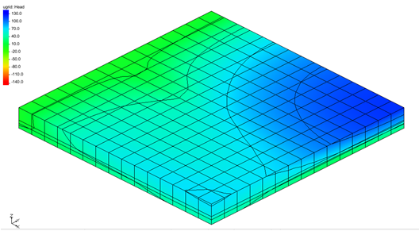

GMS 10.9

GMS 10.9 Tutorial

***MODFLOW 6 – Grid Approach***

Build a MODFLOW 6 model using a 3D UGrid

Objectives

This tutorial describes the grid approach to MODFLOW 6 pre-processing.

Time

* 25–35 minutes

Required Components

* GMS Core
* MODFLOW-USG Model & Interface

Prerequisite Tutorials

* Getting Started

|  |
| --- |
| 1 Introduction 2  2 Getting Started 3  2.1 Creating the UGrid 3  3 Creating the MODFLOW 6 Simulation 4  4 Temporal Discretization 5  5 Constant Head Package 5  6 The NPF Package 6  6.1 Options 7  6.2 ICELLTYPE 7  6.3 K 7  6.4 K33 7  7 The Recharge Package 8  8 The Drain Package 8  9 The Well Package 10  10 Discretization 11  11 Initial Conditions 12  12 Output Control 12  13 Saving the Simulation 12  14 Running MODFLOW 13  15 Viewing the Solution 13  15.1 Changing Layers 14  15.2 Color Fill Contours and Color Legend 14  16 Conclusion 14 |

# Introduction

A simple MODFLOW 6 simulation can be built in GMS using the grid approach. The grid approach involves working directly with the 3D grid to apply sources/sinks and other model parameters on a cell-by-cell basis. The grid approach is useful for simple problems or academic exercises where cell-by-cell editing is necessary.

In GMS, multiple MODFLOW 6 simulations can be created in a single project. This makes creating and comparing variations of the same model simple.

This tutorial uses the first example model that is distributed with MODFLOW 6 (Figure 1). Three aquifers will be simulated using three layers in the computational grid. The grid covers a square region measuring 75000 feet by 75000 feet.

The grid will consist of 15 rows and 15 columns, each cell measuring 5000 feet by 5000 feet in plan view. For simplicity, the elevation of the top and bottom of each layer will be flat. The hydraulic conductivity values shown are for the horizontal direction. For the vertical direction, the tutorial will use some fraction of the horizontal hydraulic conductivity.

Flow into the system is due to infiltration from precipitation and is defined as recharge in the input. Flow out of the system is due to buried drain tubes, discharging wells (not shown on the diagram), and a lake, which is represented by a constant head boundary on the left. Starting heads will be set equal to zero, and a steady state solution will be computed.

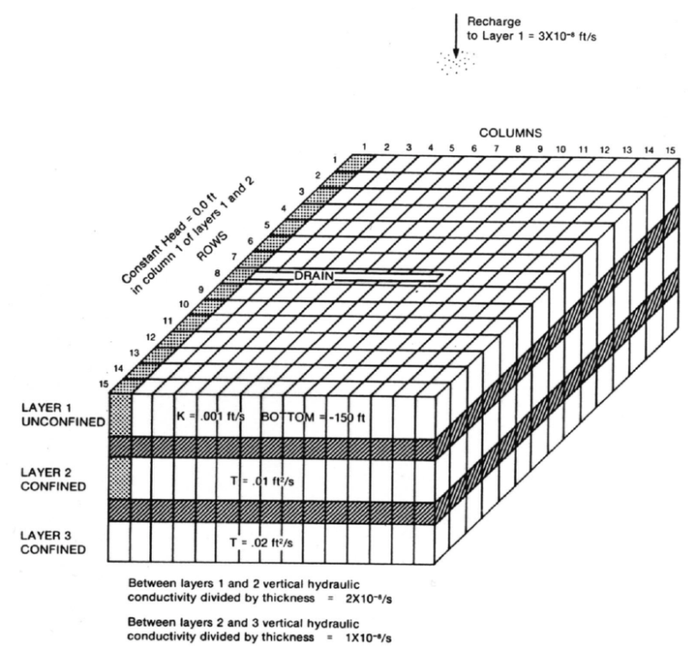

Figure Sample problem to be solved

This tutorial discusses and demonstrates the following:

* Setting up a MODFLOW 6 simulation
* Running MODFLOW 6
* Viewing the solution

# Getting Started

Do as follows to get started:

1. If necessary, launch GMS.
2. If GMS is already running, select *File |* **New** command to ensure that the program settings are restored to their default state.

## Creating the UGrid

The first step is to create the UGrid.

1. Right-click in the Graphics Window or Project Explorer and select *New* | **UGrid 3D…** to open the *New UGrid* dialog.
2. In the *New UGrid* dialog, in the *X-Dimension* and *Y-Dimension* sections, change *Length* to “75000”.
3. In the *X-Dimension* and *Y-Dimension* sections, change *Number cells* to “15”.
4. In the *Z-Dimension* section, change *Number cells* to “5”.
5. Make certain all of the *Origin* fields are set to “0”.
6. Click **OK** to close the *New UGrid* dialog.

A UGrid should be visible in the Graphics Window (Figure 2).



Figure Initial project

# Creating the MODFLOW 6 Simulation

The next step is to initialize the MODFLOW6 simulation.

1. In the Project Explorer, right-click on “File:Project Icon.svg Project” and select *New Simulation* | **MODFLOW 6** to bring up the *New MODFLOW 6 Simulation* dialog.

First, select the UGrid. If multiple UGrids were available, the selected one becomes associated with the simulation. Since this project only has one UGrid available, use that one.

1. In the *Select UGrid* section, verify the box next to “File:UGrid Module Icon.svg ugrid” is checked.

Now select the packages. The input to MODFLOW6 is subdivided into packages. Packages can be selected when setting up the simulation. If needed, packages can also be added to the simulation later. For now, select the following packages:

1. In the *GWF – Groundwater Flow Model* section, select the following:

* *CHD – Constant Head*
* *DRN – Drain*
* *RCH – Recharge*
* *WEL – Well*

1. Click **OK** to exit the *New MODFLOW 6 Simulation* dialog.

A new simulation (“File:MODFLOW Folder.svg sim”) will appear in the Project Explorer. Also in the Project Explorer, the different packages are listed under the simulation.

1. Expand the new simulation “File:MODFLOW Folder.svg sim” and the “File:MF6 GWF Model.svgflow” package under it.

Along with the optional packages that were selected, the standard TDIS, IMS, DIS, IC, NPF, and OC packages are listed. These are the default names given by GMS. The names of the packages can be changed if desired.

# Temporal Discretization

Review the temporal discretization for the simulation in the TDIS package. This package controls the timing for the simulation.

1. In the Project Explorer, right-click on “Thumbnail for version as of 22:49, February 4, 2020TDIS” and select **Open…** to bring up the *Temporal Discretization (TDIS) Package* dialog.
2. Turn on *OPTIONS* in the *Sections* area.
3. Change the *TIME_UNITS* to “SECONDS” to match the example.
4. Under *PERIODDATA*, change the *PERLEN* in the first row to “86400”.
5. Click **OK** to close the *Temporal Discretization (TDIS) Package* dialog.

# Constant Head Package

The next step is to define the head boundary along the west sides of the model. In some cases, it is easier to assign values directly to cells. This can be accomplished by editing the properties of the cells. Before using the command, it is necessary to first select the cells in the leftmost column.

Do the following to select the cells:

1. Select the **Select Cells** File:Select UGrid Cell Tool.svg tool.
2. Drag a box around all of the cells in the leftmost column of the grid to highlight them (Figure 3).

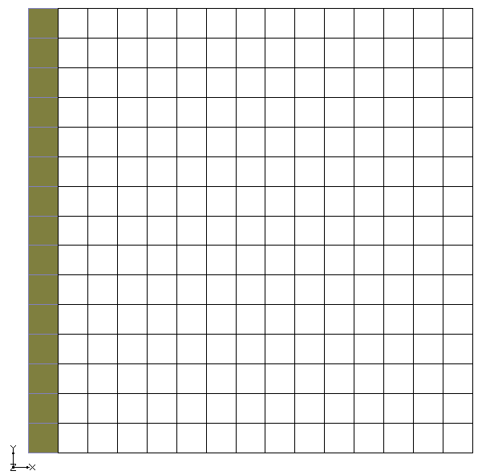

Figure Highlight the leftmost column

To edit the head value:

1. Right-click on one of the selected cells and select **Cell Properties…** to bring up the *Cell Properties Dialog*.
2. Select “CHD” from the *Packages* list on the left.
3. Click the **Add Rows** Thumbnail for version as of 21:35, February 6, 2020 button to open the *Add Stresses* dialog.
4. On the *HEAD* row, in the *Value* column, enter “0.0”.
5. Click **OK** to exit the *Add Stresses* dialog.
6. Click **OK** to close the *Cell Properties Dialog*.

Notice that a diamond symbol is displayed in the cells that were edited, indicating they are constant head cells (Figure 4).

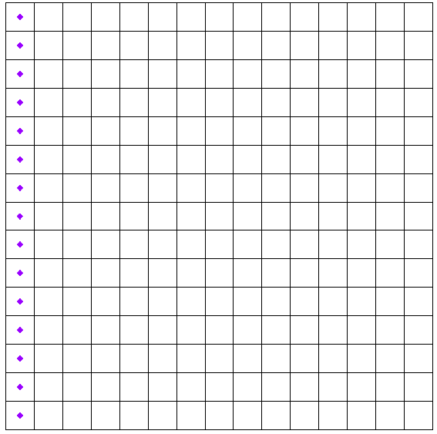

Figure Constant head cells marked on the left

# The NPF Package

The next step is to enter the data for the Node Property Flow (NPF) package. The NPF package computes the conductance between each of the grid cells and sets up the finite difference equations for the cell-to-cell flow.

To enter the NPF data:

1. In the Project Explorer, right-click on “Thumbnail for version as of 22:49, February 4, 2020NPF” and select **Open…** to bring up the *Node Property Flow (NPF) Package* dialog.

The options in the *Node Property Flow (NPF) Package* are used to define the cell type, hydraulic conductivity, and wetting and drying options for every cell in the model. This problem has five layers. The top layer is convertible, and the other layers are confined.

## Options

Start by adjusting the options:

1. In the *Sections* list on the left, select *OPTIONS*.
2. Turn on the *VARIABLECV* option.
3. Turn on the *DEWATERED* option.
4. Turn on the *PERCHED* option.

These options adjust how vertical conductance and head are calculated.

## ICELLTYPE

Now, enter the data for the ICELLTYPE:

1. If necessary, select *GRIDDATA* from the *Sections* list on the left, and deselect *OPTIONS*.
2. Select the *ICELLTYPE* tab.
3. Turn on *Layered* and make certain it is set to layer “1”.
4. For *Constant,* enter “1”.
5. Change the layer to “2”.
6. For *Constant,* enter “0”.
7. Similarly set the remaining layers (3–5) to 0.

## K

Next, enter the data for the hydraulic conductivity (K):

1. Select the *K* tab.
2. Turn on *Layered* and make certain it is set to layer “1”.
3. For *Constant,* enter “1e-3”.
4. Change the layer to layer “2”.
5. For *Constant,* enter “1e-8”.
6. Change the layer to “3”.
7. For *Constant,* enter “1e-4”.
8. Change the layer to “4”.
9. For *Constant,* enter “5e-7”.
10. Change the layer to “5”.
11. For *Constant,* enter “2e-4”.

## K33

Finally, enter the data for vertical hydraulic conductivity (K33):

1. Select the *K33* tab.
2. Turn on the *Define* option.
3. Turn on *Layered* and make certain it is set to layer “1”.
4. For *Constant,* enter “1e-3”.
5. Change the layer to “2”.
6. For *Constant,* enter “1e-8”.
7. Change the layer to “3”.
8. For *Constant,* enter “1e-4”.
9. Change the layer to “4”.
10. For *Constant,* enter “5e-7”.
11. Change the layer to “5”.
12. For *Constant,* enter “2e-4”.
13. Click **OK** to close the *Node Property Flow (NPF) Package* dialog.

# The Recharge Package

Entering data in the recharge package allows simulation of the recharge to an aquifer due to rainfall and infiltration. The Recharge and Evapotranspiration packages can use lists or arrays to define the data, unless the DISU package is used, in which case only lists can be used. The *READASARRAY* option in the *Options* section switches between the two modes.

To enter the recharge data, do the following:

1. In the Project Explorer, right-click on “Thumbnail for version as of 22:49, February 4, 2020RCH” and select **Open…** to bring up the *Recharge (RCH) Package* dialog.
2. If necessary, select *PERIODS* from the *Sections* list on the left.
3. Select the *RECHARGE* tab.
4. For *Constant,* enter “3e-8”.
5. Click **OK** to exit the *Recharge (RCH) Package* dialog.

# The Drain Package

The next step is to define the row of drains in the top layer of the model. To define the drains, first select the cells where the drains will be located, and then select the **Cell Properties…** command.

The drains are located in the top layer (Figure 5).

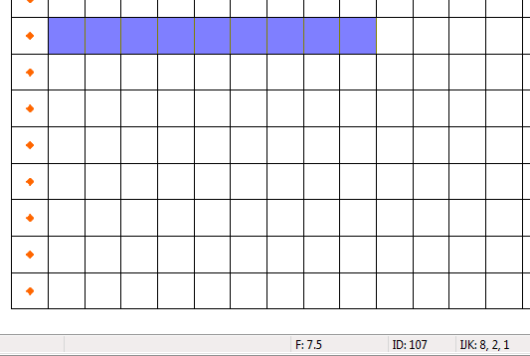

Figure Cells to be selected

To select the cells, do the following:

1. In the *UGrid Single Layer* toolbar, select the *Single layer* checkbox.
2. Enter “1” for the *Layer* then press the *Tab* key.



Figure UGrid Single Layer toolbar

1. Using the **Select Cells** File:Select UGrid Cell Tool.svg tool, draw a box around cells 2–10 on row 8 (Figure 5).

To assign drains to the cells:

1. Right-click on one of the selected cells and select **Cell Properties…** to bring up the *Cell Properties Dialog*.
2. Select “DRN” from the *Packages* list on the left.
3. Click the **Add Rows** Thumbnail for version as of 21:35, February 6, 2020 button to open the *Add Stresses* dialog.
4. Accept the defaults and click **OK** to exit the *Add Stresses* dialog.

At this point, enter an elevation and a conductance for the selected drains. The drains all have the same conductance, but the elevations are not all the same.

1. Adjust the values in the *ELEV* column in the list of drains so the values match this table. All other values should already match the table:

|  |  |  |  |  |
| --- | --- | --- | --- | --- |
| LAY | ROW | COL | ELEV | COND |
| 1 | 8 | 2 | 0.0 | 1.0 |
| 1 | 8 | 3 | 0.0 | 1.0 |
| 1 | 8 | 4 | 10.0 | 1.0 |
| 1 | 8 | 5 | 20.0 | 1.0 |
| 1 | 8 | 6 | 30.0 | 1.0 |
| 1 | 8 | 7 | 50.0 | 1.0 |
| 1 | 8 | 8 | 70.0 | 1.0 |
| 1 | 8 | 9 | 90.0 | 1.0 |
| 1 | 8 | 10 | 100.0 | 1.0 |

1. Click **OK** to close the *Cell Properties Dialog*.
2. Deselect the cells by clicking anywhere outside the grid.

The drains should now be marked by circles (Figure 7).

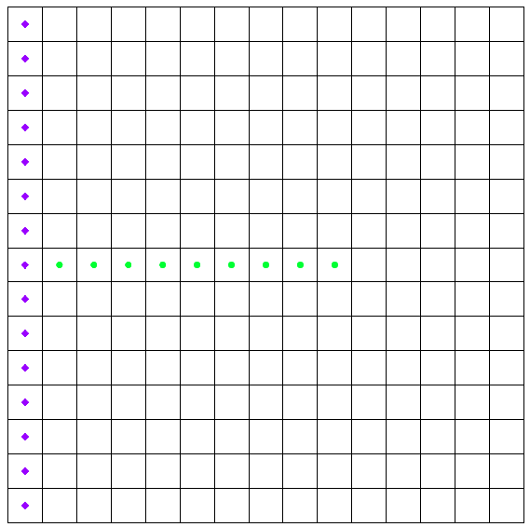

Figure Location of drain cells (green circles)

# The Well Package

Several wells need to be defined. Most of the wells are in the top layer but some are in the middle and bottom layers. Wells can be defined by selecting cells and entering data as was done with the drain package. However, for this exercise, define all the wells directly using the *Well (WEL) Package* dialog.

1. In the Project Explorer, right-click on “Thumbnail for version as of 22:49, February 4, 2020WEL” and select **Open…** to bring up the *Well (WEL) Package* dialog.
2. Click the **Add Rows** Thumbnail for version as of 21:35, February 6, 2020 button to open the *Add Stresses* dialog.
3. Change the *Number of rows to add* to be “15”.
4. Click **OK** to close the *Add Stresses* dialog.
5. Define the wells using the values in the following table:

|  |  |  |  |
| --- | --- | --- | --- |
| LAY | ROW | COL | Q |
| 5 | 5 | 11 | -5 |
| 3 | 4 | 6 | -5 |
| 3 | 6 | 12 | -5 |
| 1 | 9 | 8 | -5 |
| 1 | 9 | 10 | -5 |
| 1 | 9 | 12 | -5 |
| 1 | 9 | 14 | -5 |
| 1 | 11 | 8 | -5 |
| 1 | 11 | 10 | -5 |
| 1 | 11 | 12 | -5 |
| 1 | 11 | 14 | -5 |
| 1 | 13 | 8 | -5 |
| 1 | 13 | 10 | -5 |
| 1 | 13 | 12 | -5 |
| 1 | 13 | 14 | -5 |

A copy of this table can be found as a spreadsheet file, named “wellpackage.xls”, included with the tutorial files. This table can be copied into the dialog using the copy (*Ctrl+C*) and paste (*Ctrl+V*) commands.

1. Click **OK** to close the *Well (WEL) Package* dialog.

Now that all of the wells have been defined, it is possible to see them in the Graphics Window (Figure 8).

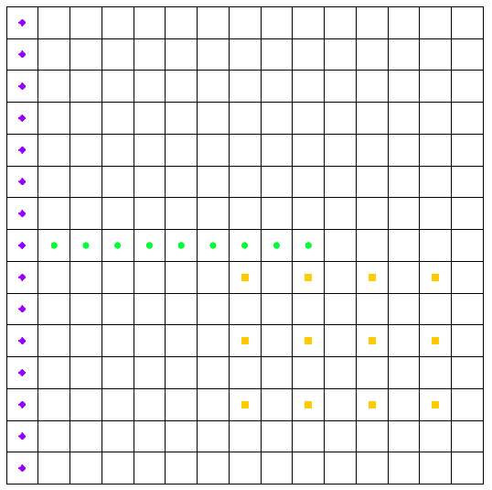

Figure Wells added to the simulation

# Discretization

Discretization information is set through the DIS package:

1. In the Project Explorer, right-click on “Thumbnail for version as of 22:49, February 4, 2020DIS” and select **Open…** to bring up the *Structured Discretization (DIS) Package* dialog.
2. If necessary, select “GRIDDATA” from the *Sections* list on the left.
3. Select the *TOP* tab.
4. For *Constant*, enter “200”.
5. Select the *BOTM* tab.
6. Verify that the *Layered* option is on and set to layer “1”.
7. For *Constant*, enter “-150”.
8. Change the layer to “2”.
9. For *Constant*, enter “-200”.
10. Change the layer to “3”.
11. For *Constant*, enter “-300”.
12. Change the layer to “4”.
13. For *Constant*, enter “-350”.
14. Change the layer to “5”.
15. For *Constant*, enter “-450”.
16. Click **OK** to close the *Structured Discretization (DIS) Package* dialog.

# Initial Conditions

Review the initial conditions before running the simulation. To do this:

1. In the Project Explorer, right-click on “Thumbnail for version as of 22:49, February 4, 2020IC” and select **Open…** to bring up the *Initial Conditions (IC) Package* dialog.
2. Verify that *Set starting heads equal to cell top elevations* is turned on.
3. Click **OK** to close the *Initial Conditions (IC) Package* dialog.

# Output Control

Before running the simulation, the output needs to be defined. To do this:

1. In the Project Explorer, right-click on “Thumbnail for version as of 22:49, February 4, 2020OC” and select **Open…** to bring up the *Output Control (OC) Dialog*.
2. Verify that the *Preset output* is set to “At every time step”.
3. Click **OK** to close the *Output Control (OC) Dialog*.

This dialog also contains an *Options* section. There are two options for the budget file output and the head file output. The *BUDGET FILEOUT* option specifies a file to which desired flow terms can be written. The *HEAD FILEOUT* option specifies a file for head information.

# Saving the Simulation

At this point, the MODFLOW 6 data is completely defined and ready for the simulation run. Before running MODFLOW 6, save the simulation as a new project:

1. Select *File* | **Save As…** to bring up the *Save As* dialog.
2. Browse to the *mf6_grid* directory.
3. Select “Project Files (*.gpr)” from the *Save as type* drop-down.
4. Enter “mf6.gpr” as the *File name*.
5. Click **Save** to save the project and close the *Save As* dialog.

# Running MODFLOW

It is now possible to run MODFLOW:

1. In the Project Explorer, right-click on “File:MODFLOW Folder.svg sim” and select **Save Simulation**.
2. In the Project Explorer, right-click on “File:MODFLOW Folder.svg sim” and select **Run Simulation** to bring up the *Simulation Run Queue* model wrapper dialog.

The **Save Simulation** command exports all of the MODFLOW 6 files necessary for the model run. The *Simulation Run Queue* shows all simulation model runs currently in progress. Since this project only has one simulation, only one is shown.

1. When MODFLOW 6 finishes, click **Load Solution**.
2. Click **Close** to exit the *Simulation Run Queue* dialog.
3. Make sure the “File:Dataset Cells Active.svg Head” dataset is active in the Project Explorer.
4. Click **Display Options** File:Display Options Macro.svg to bring up the *Display Options* dialog.
5. Select “UGrid: ugrid – [Active]” from the list on the left.
6. Turn on *Define UGrid specific options.*
7. Turn on *Face contours* and click **Options…** to open the *Dataset Contour Options – UGrid – Head* dialog.
8. Change the *Contour Method* to “Block Fill”.
9. Click **OK** to close the *Dataset Contour Options – UGrid – Head* dialog.
10. Click **OK** to close the *Display Options* dialog.

# Viewing the Solution

After the solution has been loaded and contours set, the Graphics Window should appear as in Figure 9.

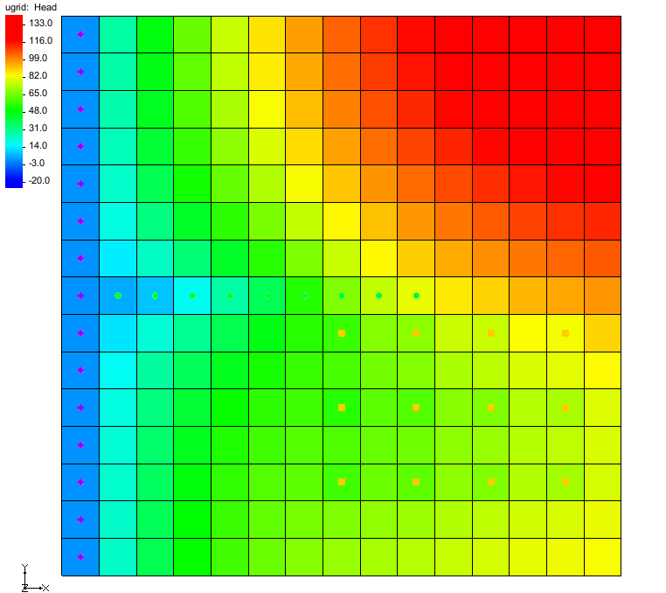

Figure Contours of MODFLOW 6 solution

## Changing Layers

View the solutions on the middle and bottom layers by doing the following:

1. In the *UGrid Single Layer* toolbar, click the up arrow up to go to layer 3 (two clicks) or layer 5 (four clicks).
2. When finished viewing the middle and bottom layer solutions, use the down arrow down to return to layer 1.

## Color Fill Contours and Color Legend

It is also possible to display the contours using a color fill option.

1. Select *Display* | **Contour Options…** to bring up the *Dataset Contour Options – UGrid – Head* dialog.
2. In the *Contour method* section, select “Color Fill” from the top drop-down.
3. At the bottom left, turn on *Legend* if it is not already on.
4. Click **OK** to close the *Dataset Contour Options – UGrid – Head* dialog.

The Graphics Window should appear similar to Figure 10.

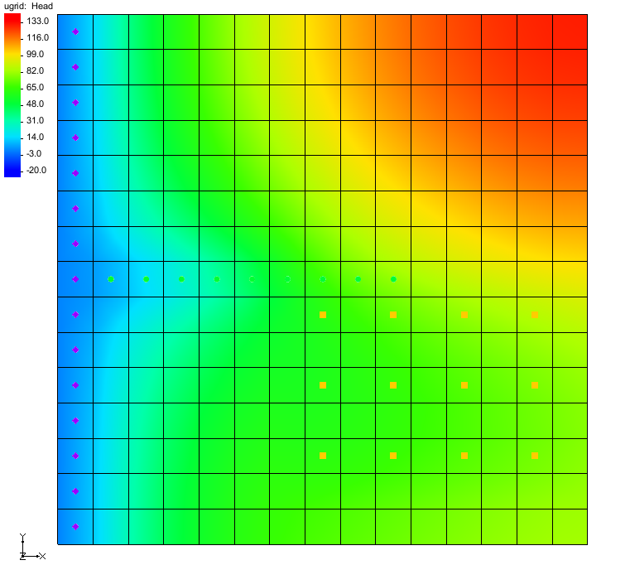

Figure Color fill contours with a legend

# Conclusion

This concludes the “MODFLOW 6 – Grid Approach” tutorial. The following topics were discussed and demonstrated:

* Creating a MODFLOW 6 simulation.
* Assigning simulation properties to cells in a UGrid.
* Defining package parameters.
* Running the simulation and using the *Simulation Run Queue*.