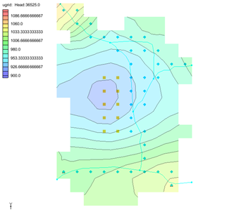

GMS 10.9

GMS 10.9 Tutorial

***MODFLOW 6 – Stream Package***

Build a MODFLOW 6 model using the Stream (SFR) package

Objectives

This tutorial demonstrates adding stream data to a MODFLOW 6 simulation using the conceptual model approach.

Time

* 25–45 minutes

Required Components

* GMS Core
* MODFLOW-USG Model & Interface

Prerequisite Tutorials

* Getting Started
* MODLFOW 6 Conceptual Model Approach

|  |
| --- |
| 1 Introduction 2  2 Getting Started 3  2.1 Opening the Existing Model 3  3 Saving the Project 4  4 Mapping from Coverages 4  5 Saving the Data 6  6 Checking the Simulation 6  7 Adapt the Stream Coverage to MODFLOW 6 6  8 Saving and Checking the Simulation 7  9 Running MODFLOW 7  10 Conclusion 9 |

# Introduction

The MODFLOW 6 SFR package is used to model streamflow routing and flow beneath streams.

This tutorial illustrates how to add SFR stream data to a MODFLOW 6 simulation by mapping a coverage containing streamflow data. The problem is a hypothetical one “developed for an alluvial basin in a semiarid region in which recharge to the aquifer is primarily leakage from streams that enter the basin from mountains on the northwest, northeast, and southeast”.

The tutorial uses one grid layer. An initial MODFLOW 6 simulation has already been created for the grid. An existing coverage contains stream data. The existing stream coverage will be modified to work with MODFLOW 6.

To learn how to create conceptual models, refer to the “MODFLOW 6 – Conceptual Model Approach” tutorial.

This tutorial discusses and demonstrates the following key concepts:

* Mapping the coverages to a MODFLOW 6 simulation.
* Adapting the stream coverage for MODFLOW 6.
* Saving and running the MODFLOW 6 simulation.

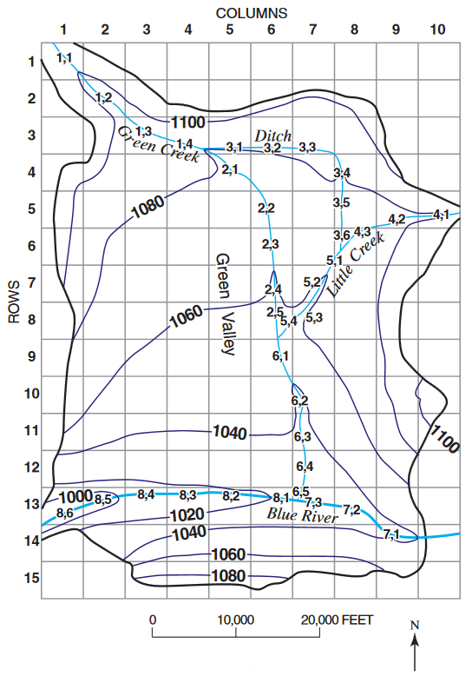

Figure Plan view of site to be modeled

# Getting Started

Do as follows to get started:

1. If necessary, launch GMS.
2. If GMS is already running, select *File |* **New** command to ensure that the program settings are restored to their default state.

## Opening the Existing Model

Start with a previously-created project.

1. Click **Open** File:Open Macro.svg to bring up the *Open* dialog.
2. Select “Project Files (*.gpr)” from the *Files of type* drop-down.
3. Browse to the *mf6_sfr* folder and select “start.gpr”.
4. Click **Open** to import the project and exit the *Open* dialog.

The project should be visible in the Graphics Window (Figure 2). The project contains a MODFLOW 6 simulation along with a 3D UGrid, map coverages, and a background map. Wells, recharge, evaporation, and general head boundary conditions have already been defined. A solution also exists. But there is no stream package.

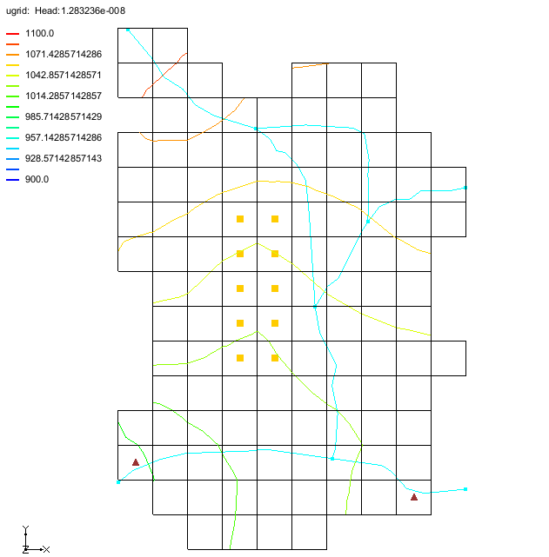

Figure Initial project

# Saving the Project

Before making any changes, save the project under a new name.

1. Select *File* | **Save As…** to bring up the *Save As* dialog.
2. Select “Project Files (*.gpr)” from the *Save as type* drop-down.
3. Enter “mf6-sfr.gpr” for the *File name*.
4. Click **Save** to save the project under the new name and close the *Save As* dialog.

It is recommended to periodically **Save** File:Save Macro.svg while working through the tutorial and while working on any project.

# Mapping from Coverages

The stream data on the “File:Coverage Active Icon.svg Streams” coverage has not been added to the MODFLOW 6 simulation. To add this data, the SFR package needs to first be added to the MODFLOW 6 simulation.

To do this:

1. Right-click on the “File:MF6 GroundwaterModel Icon.png GWF_Model” and select *New Package* | **SFR**.

A new package “Thumbnail for version as of 22:49, February 4, 2020SFR” is now visible in the Project Explorer under the MODFLOW 6 simulation.

1. Right-click on “Thumbnail for version as of 22:49, February 4, 2020SFR” and select **Open** to bring up the *Streamflow Routing (SFR) Package* dialog.

Notice that the dialog does not contain any stream data. To add this data:

1. Click **OK** to close the *Streamflow Routing (SFR) Package* dialog.
2. Right-click on “Thumbnail for version as of 22:49, February 4, 2020SFR” and select **Map from Coverage…** to open the *Select Coverage* dialog.
3. Select the “File:Coverage Active Icon.svg Streams” coverage.
4. Click **OK** to close the *Select Coverage* dialog and bring up the *Map from Coverage* dialog.
5. When the dialog states it has successfully mapped the coverage to the package, click **OK** to close the *Map from Coverage* dialog.

The stream symbols will appear in the cells where the stream arcs are located (Figure 3). If desired, the *Streamflow Routing (SFR) Package* dialog can be opened again to verify the values have been added to the SFR package.

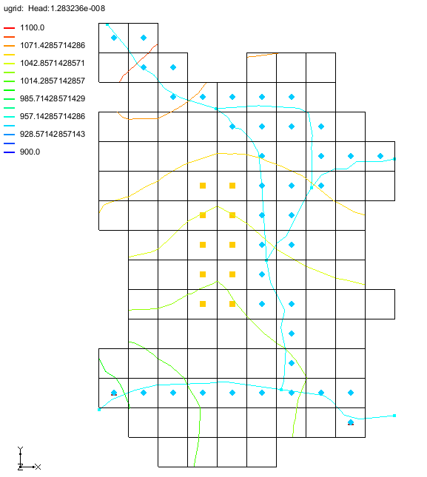

Figure The stream data mapped from the coverage to the SFR package

# Saving the Data

Before running the model simulation, the data needs to be saved out. Start with saving the project file.

1. Click the **Save** File:Save Macro.svg macro to save the project.

The project file has now been saved. However, the simulation files needed to run MODFLOW 6 have not yet been exported. To export these files, do the following:

1. In the Project Explorer, right-click on “File:MODFLOW Folder.svg Sim” and select **Save Simulation**.

The files for the simulation have now been exported.

# Checking the Simulation

With the simulation files exported, the simulation can now be checked. The exported files are required in order to perform a model check. When performing the model check, GMS will run MODFLOW 6 in “validate” mode where model inputs are checked but no equations are solved.

1. In the Project Explorer, right-click on “File:MODFLOW Folder.svg Sim” and select **Check Simulation** to bring up the *Check MODFLOW 6 Simulation* dialog.

Notice there are lots of errors about the stream package. These errors are due to the stream coverage being designed for the SFR2 package in MODFLOW 2000.

1. Click **OK** to close the *Check MODFLOW 6 Simulation* dialog.

The coverage needs to be adapted to work with MODFLOW 6.

# Adapt the Stream Coverage to MODFLOW 6

In order to get MODFLOW 6 to successfully run, the values in the “File:Coverage Active Icon.svg Streams” coverage need to be adjusted.

Start with adjusting the display to make the stream segments more identifiable.

1. Select the “File:Coverage Active Icon.svg Streams” coverage to make it active.
2. Click **Display Options** File:Display Options Macro.svg to bring up the *Display Options* dialog.
3. Select *Map Data* from the list on the left.
4. Turn on the *Segment ID* option.
5. Click the button next to the *Segment ID* option to open the *Font* dialog.
6. In the *Size* section, select “16” to change the font size.
7. Click **OK** to close the *Font* dialog.
8. Click **OK** to close the *Display Options* dialog.

With the segment IDs clearly visible, start editing the attributes for each segment by doing the following:

1. Using the **Select Arcs** File:GMS Select Arc Tool.svg tool, double-click on the arc segment labeled “1” to open the *Attribute Table* dialog.
2. Change *ICALC* to “wide channel (1)”. MODFLOW 6 assumes wide rectangular channels.
3. For *ROUGHCH*, enter “0.03”.
4. For *WIDTH1* and *WIDTH2*, enter “12”.
5. Click **OK** to close the *Attribute Table* dialog.
6. Repeat steps 9–13 for arc segments 3, 4, 6, and 8 using the values in the table below.

|  |  |  |
| --- | --- | --- |
| **Segment** | **ROUGHCH** | **WIDTH1 and WIDTH2** |
| 1 | .03 | 12 |
| 3 | .03 | 12 |
| 4 | .025 | 55 |
| 6 | .03 | 15 |
| 8 | .025 | 40 |

Now that the attributes have been defined, they need to be mapped again to the MODFLOW 6 simulation. To do this:

1. Right-click on “Thumbnail for version as of 22:49, February 4, 2020SFR” and select **Map from Coverage** to open the *Select Coverage* dialog.
2. Select the “File:Coverage Active Icon.svg Streams” coverage.
3. Click **OK** to close the *Select Coverage* dialog and bring up the *Map from Coverage* dialog.
4. When the dialog states it has successfully mapped the coverage to the package, click **OK** to close the *Map from Coverage* dialog.

The stream data has now been set.

# Saving and Checking the Simulation

With the errors fixed, now to check the model again. The files for the simulation will need to be exported again before running the model check. To export the simulation and check the model, complete the following:

1. Click the **Save** File:Save Macro.svg macro to save the project.
2. In the Project Explorer, right-click on “File:MODFLOW Folder.svg Sim” and select **Save Simulation**.
3. Right-click on “File:MODFLOW Folder.svg Sim” and select **Check Simulation** to bring up the *Check MODFLOW 6 Simulation* dialog.

No errors should be reported

1. Click **OK** to close the *Check MODFLOW 6 Simulation* dialog.

# Running MODFLOW

It is now possible to run MODFLOW:

1. Right-click on “File:MODFLOW Folder.svg Sim” and select **Run Simulation** to bring up a warning message.

Because a solution was already loaded into the project, this solution will have to be unloaded in order for MODFLOW 6 to run.

1. Click **OK** to close the warning dialog and start the *Simulation Run Queue* model wrapper dialog.

The *Simulation Run Queue* shows all simulation model runs currently in progress. Since this project only has one simulation, only one is shown.

1. When MODFLOW 6 finishes, click **Load Solution**.
2. Click **Close** to exit the *Simulation Run Queue* dialog.
3. Make sure the “File:Dataset Cells Active.svg Head” dataset is active in the Project Explorer.
4. Click **Display Options** File:Display Options Macro.svg to bring up the *Display Options* dialog.
5. Select “UGrid: ugrid – [Active]” from the list on the left.
6. Ensure *Define UGrid specific options* is turned on.
7. Turn off *Cell Edges*.
8. Turn on *Face Contours* and click **Options** to open the *Dataset Contour Options– UGrid – Head* dialog.
9. Change the *Contour Method* to “Color Fill and Linear”.
10. Click **OK** to close the *Dataset Contour Options – UGrid – Head* dialog.
11. Click **OK** to close the *Display Options* dialog.
12. Scroll through the time steps.

After the solution has been loaded and contours set, the Graphics Window should appear as in Figure 4.

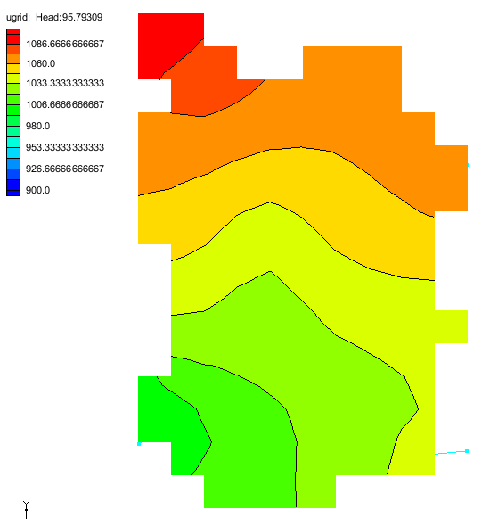

Figure Head dataset at the first time step

# Conclusion

This concludes the “MODFLOW 6 – Stream Package” tutorial. The following topics were discussed and demonstrated:

* Adding the SFR package to a MODFLOW 6 simulation.
* Conceptual model objects can be mapped to the model using the **Map from Coverage…** command.
* Updating attributes in the conceptual model.