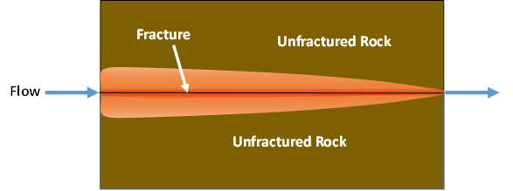

GMS 10.9

GMS 10.9 Tutorial

***MODFLOW 6 – MDT Discrete Fracture***

Use the Matrix Diffusion Transport package (MDT) in GMS to simulate diffusion from a fracture using a semi-analytic approximation

Objectives

Learn how to use the Matrix Diffusion Transport package (MDT) with MODFLOW 6 to simulate diffusion from a single fracture.

Time

* 20–30 minutes

Required Components

* GMS Core
* MODFLOW Interface

Prerequisite Tutorials

* Getting Started
* MODFLOW 6 – Conceptual Model Approach
* MODFLOW 6 – Grid Transport

|  |
| --- |
| 1 Introduction 2  2 Opening a MODFLOW 6 Simulation 3  3 Adding the MDT Package 4  4 Defining the MDT Package 4  5 Saving and Running the Simulation 5  6 Examining the Solution 5  7 Conclusion 6 |

# Introduction

The Matrix Diffusion Transport (MDT) package is designed for use with MODFLOW 6 and allows existing flow and chemical transport models to incorporate the effects of matrix diffusion. MDT is based on the semi-analytic matrix diffusion method implemented in the REMChlor-MD model[1], [2], [3]. This capability was developed with support from the Department of Defense Environmental Security Technology Certification Program (ESTCP) through a collaboration between Clemson University, GSI Environmental, and Aquaveo.

The MDT method is conceptually similar to dual-porosity methods, where each model cell is divided into mobile and immobile zones. Solute transport occurs via advection and dispersion in the mobile zone, and by diffusion in the immobile zone. MDT approximates the concentration profile in the immobile zone using a dynamic function that estimates concentration as a function of distance from the mobile-immobile interface. This function is recalculated at each time step using the current and previous concentrations in the mobile zone, along with the integral of the concentration profile in the immobile zone. The mass transfer between zones is calculated as a linear, concentration-dependent source term.

This tutorial demonstrates how the MDT package can be used with a MODFLOW 6 simulation to model diffusion in a single fracture. The example is based on a benchmark problem developed with REMChlor-MD. For a more detailed explanation of the semi-analytic method used in MDT, refer to the REMChlor-MD user guide1 and related journal articles2, 3.

The tutorial problem uses a one-layer, one-dimensional unstructured grid (UGrid) with a MODFLOW 6 simulation. Head values are predefined. In this example, only the fracture itself is explicitly modeled; the MDT method simulates matrix diffusion from the fracture into the surrounding rock.

This case follows a test problem presented by Falta and Wang2, where water containing tritium is injected into a 100 µm fracture at a pore velocity of 0.1 m/day. The tritium concentration is maintained at the upstream end of the grid for a period of 30 years, followed by injection of clean water. Additional model parameters are given in Table 1.

*Table 1. Parameters used in the fractured rock matrix diffusion comparison*

|  |  |  |
| --- | --- | --- |
| **Parameter** | **Fracture** | **Matrix** |
| Fracture aperture, μm | 100 |  |
| Porosity, *ϕ* | 1.0 | 0.01 |
| Tortuosity, *τ* | 1.0 | 0.1 |
| Retardation factor, *R* | 1.0 | 1.0 |
| Darcy velocity, *vx* (m/d) | 0.1 | 0 |
| Diffusion coefficient of tritium, *D*(m2/s) | 1.6E-9 | 1.6E-9 |
| tritium decay rate (1/yr) | 0.0561 | 0.0561 |
| Loading period, *t1*, (years) | 30 |  |

This tutorial will demonstrate the following topics:

1. Opening an existing MODFLOW 6 simulation.
2. Activating the MDT package.
3. Running the simulation and examining the results.

# Opening a MODFLOW 6 Simulation

Start with opening a MODFLOW 6 model:

1. If necessary, launch GMS.
2. If GMS is already running, select the *File |* **New** command to ensure that the program settings are restored to their default state.

Start with a previously created project.

1. Click **Open** File:Open Macro.svg to bring up the *Open* dialog.
2. Select “Project Files (*.gpr)” from the *Files of type* drop-down.
3. Browse to the *mf6_mdt_discrete*\*mf6_mdt_discrete* folder and select “start.gpr”.
4. Click **Open** to import the project and exit the *Open* dialog.

The project should be visible in the Graphics Window (Figure 1).



Figure 1 Initial project for the MODFLOW 6 model

The 1D grid consists of 61 elements. Each element measures 1 meter in the flow direction (x-direction), 1 meter perpendicular to flow (y-direction), and 0.0001 meters vertically (z-direction). The very small vertical dimension corresponds to the 100 µm fracture aperture.

The hydraulic head in the leftmost element is held constant at 11 meters using the CHD package, while the rightmost element is maintained at 10 meters. The horizontal hydraulic conductivity is set to a value of 2190 m/year, resulting in a Darcy velocity of 36.5 m/year, or 0.1 m/day. Because the fracture porosity is set to 1 in the MST package, the pore velocity equals the Darcy velocity in this example.

Before proceeding, save the project with a new name.

1. Select *File* | **Save As…** to bring up the *Save As* dialog.
2. Enter “discrete_fracture.gpr” as the *File name*.
3. Select “Project Files (*.gpr)” from the *Save as type* drop-down.
4. Click **Save** to save the project file and close the *Save As* dialog.

# Adding the MDT Package

The MODFLOW 6 simulation is currently set up without the MDT package. It includes both a groundwater flow model and a groundwater transport model. To add the MDT package, follow these steps:

1. In the Project Explorer, right-click on “File:MODFLOW Folder.svg model-mdt” and select **Unlock All**.
2. Right-click on “File:MF6 GWT Model.svg trans” and select *New Package* | **MDT** to add the package.

Note that the “File:Mf6package.svg MDT” package now appears in the Project Explorer under the groundwater transport model.

# Defining the MDT Package

The MDT package can be configured either during the initial setup of the Groundwater Transport (GWT) model or afterward, as is the case here. To define the MDT package, follow these steps:

1. Double-click on the “File:Mf6package.svg MDT” package to bring up the *Matrix Diffusion Transport (MDT) Package* dialog.
2. Under the *MD_TYPE_FLAG* tab, set the *Constant* value to “4”.

This flag controls how matrix diffusion is handled. A value of “4” allows diffusion from the top and bottom into an infinite matrix—appropriate here since only the fracture is modeled.

Under the *MD_FRACTION* tab, set the *Constant* value to “0.0”.

This parameter defines the volume fraction of low-permeability material. Since only the fracture is modeled here, the value is 0. Note that, unlike REMChlor-MD and MODFLOW-USG MDT, which use the high-permeability fraction, GMS uses the low-permeability fraction.

1. On the *MD_POROSITY* tab, set the *Constant* value to “0.01”.
2. On the *BULK_DENSITY* tab, set the *Constant* value to “2.0”.
3. On the *MD_DIFF_LENGTH* tab, set the *Constant* value to “1.0e-10”.
4. On the *MD_TORTUOSITY* tab, set the *Constant* value to “0.1”.
5. On the *MD_DIST_COEFF* tab, set the *Constant* value to “0.0”.
6. On the *MD_DECAY* tab, set the *Constant* value to “0.0561”.
7. On the *MD_DIFF_COEFF* tab, set the *Constant* value to “0.05046”.
8. Click **OK** to close the *Matrix Diffusion Transport (MDT) Package* dialog.

The MDT Package is now set up for the discrete fracture and ready for the simulation run.

# Saving and Running the Simulation

Save and run the simulation by doing the following:

1. Right-click on “File:MODFLOW Folder.svg model-mdt” and select **Save Project, Simulation and Run** to start the *Simulation Run Queue*.
2. If it appears, click **OK** on the *Info* dialog to unload the previous solution.
3. Click **Load Solution** to import the solution files.
4. Click **Close** to exit the *Simulation Run Queue*.

# Examining the Solution

Now examine the results of the MDT package being included in the transport model.

1. Switch to the **UGrid** File:UGrid Icon Unlocked.svg module.
2. In the Project Explorer, under the “File:Generic Folder.svg model-mdt (MODFLOW 6)” folder, open the “File:Generic Folder.svg trans” folder and select the “File:Dataset Cells Active.svg Concentration” dataset.
3. Using the **Select Cells** File:Select UGrid Cell Tool.svg tool, select cell 2 (the second cell on the left).
4. Click the **Plot Wizard** File:Plot Wizard Macro.svg macro to open the *Plot Wizard* dialog.
5. Under *Plot Type*, select “Active Dataset Time Series”.
6. Click **Finish** to close the *Plot Wizard* and generate the plot.

The generated plot should appear similar to Figure 2.

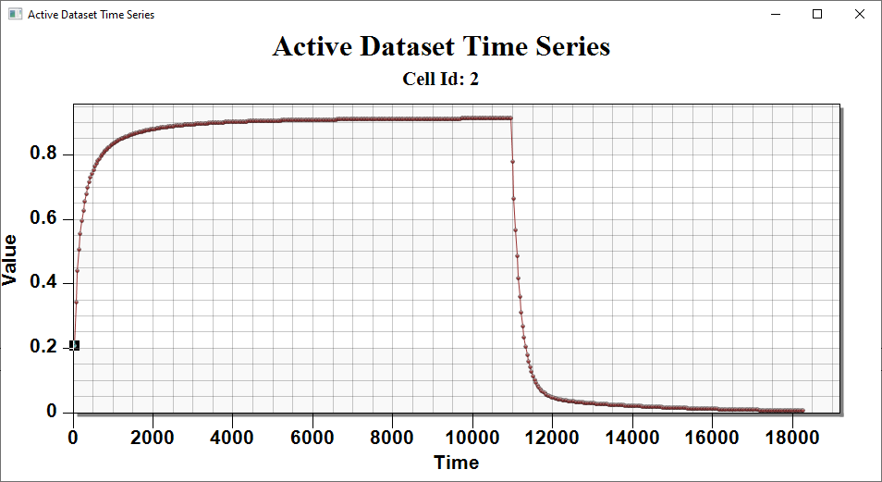

Figure 2 The active dataset time series plot

# Conclusion

This concludes the “MODFLOW 6 – MDT Discrete Fracture” tutorial. The following topics were discussed and demonstrated:

* Adding the MDT Package to MODFLOW 6
* Defining the MDT Package
* Running MODFLOW 6
* Reviewing the MODFLOW 6 solution

1. Farhat, S. K., Newell, C. J., Falta, R. W., & Lynch, K. (2018). *REMChlor-MD user’s manual*. Clemson University & GSI Environmental. <https://www.serdp-estcp.org/Program-Areas/Environmental-Restoration/Contaminated-Groundwater/Persistent-Contamination/ER-201426>
2. Falta, R. W., & Wang, W. (2017). A semi-analytical method for simulating matrix diffusion in numerical transport models. *Journal of Contaminant Hydrology, 197*, 39–49. <https://doi.org/10.1016/j.jconhyd.2016.12.002>
3. Muskus, N., & Falta, R. W. (2018). Semi-analytical method for matrix diffusion in heterogeneous and fractured systems with parent-daughter reactions. *Journal of Contaminant Hydrology, 218*, 94–109. <https://doi.org/10.1016/j.jconhyd.2018.10.004>