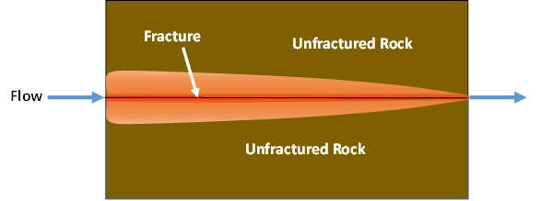

GMS 10.9

GMS 10.9 Tutorial

***MODFLOW 6 – MDT Equivalent Porous***

Use the Matrix Diffusion Transport package (MDT) in GMS to simulate matrix diffusion from fractures using a semi-analytic approximation

Objectives

Learn how to use the Matrix Diffusion Transport package (MDT) with MODFLOW 6 to simulate diffusion from a set of parallel fractures.

Time

* 20–30 minutes

Required Components

* GMS Core
* MODFLOW Interface

Prerequisite Tutorials

* Getting Started
* MODFLOW 6 – Conceptual Model Approach
* MODFLOW 6 – Grid Transport

|  |
| --- |
| 1 Introduction 2  2 Opening a MODFLOW 6 Simulation 3  3 Adding the MDT Package 4  4 Defining the MDT Package 4  5 Saving and Running the Simulation 5  6 Examining the Solution 5  7 Conclusion 6 |

# Introduction

The Matrix Diffusion Transport (MDT) package is designed for use with MODFLOW 6, allowing existing groundwater flow and transport models to be upgraded to include a matrix diffusion effects. MDT is based on the semi-analytic matrix diffusion method implemented in the REMChlor-MD model[1], [2], [3]. This capability was developed through support from the Department of Defense Environmental Security Technology Certification Program (ESTCP), in collaboration with Clemson University, GSI Environmental, and Aquaveo.

The MDT method is conceptually similar to dual-porosity approaches, where each model element is divided into a mobile and immobile zone. In the mobile zone, solute transport occurs via advection and dispersion, while in the immbolie zone, transport occurs only through diffusion. MDT uses a dynamic function to approximate the concentration profile within the immobile zone as a function of distance from the mobile/immobile interface. This profile is updated at every time step using current and previous concentrations in the mobile zone, along with the integral of the immobile zone profile. The resulting mass exchange between zones is treated as a concentration-dependent source/sink term.

This tutorial demonstrates how to use the MDT package within a MODFLOW 6 simulation to model matrix diffusion in a system of parallel fractures. The example is adapted from a benchmarking problem orginally developed using REMChlor-MD. For more details on the semi-analytic method, refer to the *REMChlor-MD user’s guide*1 and related journal p2, 3.

This tutorial will demonstrate the following topics:

1. Opening an existing MODFLOW 6 simulation.
2. Activating the MDT package.
3. Running the simulation and examining the results.

# Opening a MODFLOW 6 Simulation

Start with opening a MODFLOW 6 model:

1. If necessary, launch GMS.
2. If GMS is already running, select the *File |* **New** command to ensure that the program settings are restored to their default state.

Start with a previously created project.

1. Click **Open** File:Open Macro.svg to bring up the *Open* dialog.
2. Select “Project Files (*.gpr)” from the *Files of type* drop-down.
3. Browse to the *mf6_mdt_equivalent_porous*\*mf6_mdt_equivalent_porous* folder and select “start.gpr”.
4. Click **Open** to import the project and exit the *Open* dialog.

The project should be visible in the Graphics Window (Figure 1).



Figure 1 Initial project for the MODFLOW 6 model

This model uses a single-layer unstructured grid (UGrid) with 61 one-dimensional elements. Each element is 1 meter long (x-direction), 1 meter wide (y-direction), and 1 meter high (z-direction). Specified head (CHD) conditions are applied at both ends: the leftmost element is sent to 11 meters and the rightmost to 10 meters.

To simulate matrix diffusion in a system of parallel fractures, this example adopts an equivalent porous media approach, as described by Muskus and Falta². In this method, full-sized grid elements are used, and fractures are modeled as embedded features. The hydraulic conductivity is averaged over the entire volume, representing the Darcy velocity. However, since fractures occupy only a small portion of the volume, the pore velocity within the fractures is much higher.

The MDT package supports this approach by allowing matrix diffusion to be simulated in embedded fracture systems. To do so, the user must define fracture properties:

* Fracture spacing
* Fracture aperture

From these, the volume fraction of the fractures is computed as:

VOLFRACMD = fracture aperture / fracture spacing

In REMChlor-MD and the MODFLOW-USG MDT package, this volume fraction is directly specified as VOLFRACMD. However, MODFLOW 6 uses a different convention, where the volume fraction of low permeability material is defined instead as:

\text{MD_FRACTION} = 1 - \text{VOLFRACMD}

Additionally, the characteristic diffusion length, MD_DIFF_LENGTH, is equal to half the fracture spacing.

This tutorial follows an example from Muskus and Falta3, with:

* Fracture spacing = 0.5 m
* Fracture aperture = 100 µm (0.0001 m)
* Thus, VOLFRACMD = 0.0001 / 0.5 = 0.0002
* So, MD_FRACTION = 1 - 0.0002 = 0.9998
* And MD_DIFF_LENGTH = 0.25 m

To achieve a pore velocity of 100 m/yr in the fractures (as in the example), and assuming a hydraulic gradient of 1/60, the required bulk Darcy velocity is 0.02 m/yr. This gives a corresponding hydraulic conductivity (HK) of 1.2 m/yr.

Additional model parameters are listed in Table 1.

Table 1. Parameters used in the fractured rock matrix diffusion comparison.

|  |  |  |
| --- | --- | --- |
| **Parameter** | **Fracture** | **Matrix** |
| Fracture aperture, μm | 100 |  |
| Porosity, *ϕ* | 1.0 | 0.1 |
| Tortuosity, *τ* | 1.0 | 0.1 |
| Retardation factor, *R* | 1.0 | 2.0 |
| Pore velocity, (m/yr) | 100 | 0 |
| Diffusion coefficient, *D*(m2/s) | 1.0E-9 | 1.0E-9 |
| decay rate (1/yr) | 0.0 | 0.0 |
| Loading period, *t1*, (years) | 50 |  |

Before continuing, save the project with a new name.

1. Select *File* | **Save As…** to bring up the *Save As* dialog.
2. Enter “equivalent_porous.gpr” as the *File name*.
3. Select “Project Files (*.gpr)” from the *Save as type* drop-down.
4. Click **Save** to save the project file and close the *Save As* dialog.

# Adding the MDT Package

The MODFLOW 6 simulation has been set up without the MDT package. It currently includes both a groundwater flow model and a groundwater transport (GWT) model. To add the MDT package, follow these steps:

1. In the Project Explorer, right-click on “File:MODFLOW Folder.svg model_mdt_parallel” and select **Unlock All**.
2. Right-click on “File:MF6 GWT Model.svg trans” and select *New Package* | **MDT** to add the package.

Note that the “File:Mf6package.svg MDT” package now appears in the Project Explorer under the groundwater transport model.

# Defining the MDT Package

The MDT package can be defined either during the initial setup of the GWT model or afterward, as in this case. To define the MDT package, follow these steps:

1. Double-click on the “File:Mf6package.svg MDT” package to bring up the *Matrix Diffusion Transport (MDT) Package* dialog.
2. Under the *MD_TYPE_FLAG* tab, set the *Constant* value to “2”.

This option enables matrix diffusion into embedded matrix blocks with a finite diffusion length, which is appropriate for an equivalent porous media approach.

1. Under the *MD_FRACTION* tab, set the *Constant* value to “0.9998”.

This represents the volume fraction of the low permeability material. Note that this differs from the VOLFRACMD variable used in REMChlor-MD and the MODFLOW-USG MDT package. Here, MD_FRACTION = 1 – VOLFRACMD.

1. Under the *MD_POROSITY* tab, set the *Constant* value to “0.1”.
2. Under the *BULK_DENSITY* tab, set the *Constant* value to “2.0”.
3. Under the *MD_DIFF_LENGTH* tab, set the *Constant* value to “0.25”.
4. Under the *MD_TORTUOSITY* tab, set the *Constant* value to “0.1”.

Under the *MD_DIST_COEFF* tab, set the *Constant* value to “0.05”.

This is the distribution coefficient (Kd) for the chemical. With a bulk density of 2.0 and porosity of 0.1, this produces a retardation factor of 2.

1. Under the *MD_DECAY* tab, set the *Constant* value to “0.0”.
2. Under the *MD_DIFF_COEFF* tab, set the *Constant* value to “0.03159”.
3. Click **OK** to close the *Matrix Diffusion Transport (MDT) Package* dialog.

The MDT Package is now set up for the parallel fracture system and ready for the simulation run.

# Saving and Running the Simulation

Save and run the simulation by doing the following:

1. Right-click on “File:MODFLOW Folder.svg model_mdt_parallel” and select **Save Project, Simulation and Run** to start the *Simulation Run Queue*.
2. If it appears, click **OK** on the *Info* dialog to unload the previous solution.
3. Click **Load Solution** to import the solution files.
4. Click **Close** to exit the *Simulation Run Queue*.

# Examining the Solution

Now examine the results of the MDT package being included in the transport model.

1. Switch to the **UGrid** File:UGrid Icon Unlocked.svg module.
2. In the Project Explorer, under the “File:Generic Folder.svg model_mdt_parallel (MODFLOW 6)” folder, open the “File:Generic Folder.svg trans” folder and select the “File:Dataset Cells Active.svg Concentration” dataset.
3. Using the **Select Cells** File:Select UGrid Cell Tool.svg tool, select cell 2 (the second cell on the left).
4. Click the **Plot Wizard** File:Plot Wizard Macro.svg macro to open the *Plot Wizard* dialog.
5. Under *Plot Type*, select “Active Dataset Time Series”.
6. Click **Finish** to close the *Plot Wizard* and generate the plot.

The generated plot should appear similar to Figure 2.

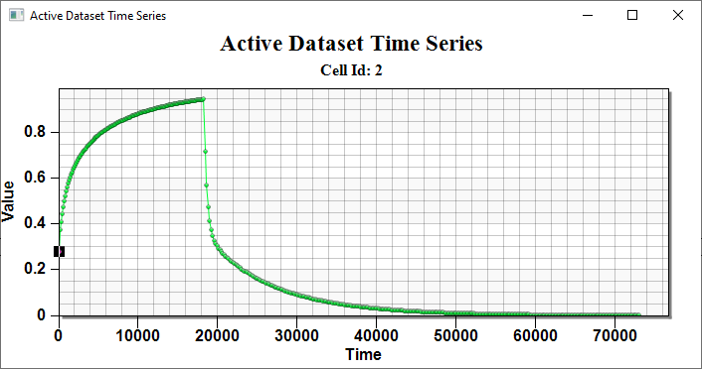

Figure 2 The active dataset time series plot

# Conclusion

This concludes the “MODFLOW 6 – MDT Equivalent Porous” tutorial. The following topics were discussed and demonstrated:

* The MODFLOW 6 MDT package can be used to simulate matrix diffusion from multiple fractures in fractured porous materials.
* The MDT package supports an equivalent porous media approach, using standard grid elements to simulate matrix diffusion over a finite distance within the surrounding matrix material.

1. Farhat, S. K., Newell, C. J., Falta, R. W., & Lynch, K. (2018). *REMChlor-MD user’s manual*. Developed for the Environmental Security Technology Certification Program (ESTCP) by Clemson University and GSI Environmental Inc. <https://www.serdp-estcp.org/Program-Areas/Environmental-Restoration/Contaminated-Groundwater/Persistent-Contamination/ER-201426>
2. Falta, R. W., & Wang, W. (2017). A semi-analytical method for simulating matrix diffusion in numerical transport models. *Journal of Contaminant Hydrology, 197*, 39–49. <https://doi.org/10.1016/j.jconhyd.2016.12.002>
3. Muskus, N., & Falta, R. W. (2018). Semi-analytical method for matrix diffusion in heterogeneous and fractured systems with parent-daughter reactions. *Journal of Contaminant Hydrology, 218*, 94–109. <https://doi.org/10.1016/j.jconhyd.2018.10.004>