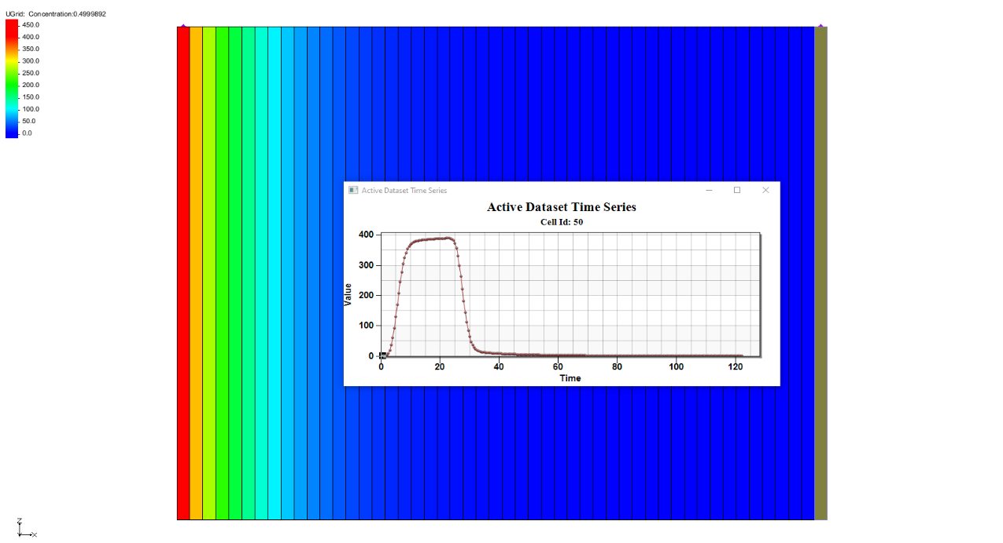

GMS 10.9

GMS 10.9 Tutorial

***MODFLOW 6 – MDT Sand Tank***

Use the Matrix Diffusion Transport package (MDT) in GMS to simulate matrix diffusion in a heterogeneous sand/clay system using a semi-analytic approximation

Objectives

Learn how to use the Matrix Diffusion Transport package (MDT) with MODFLOW 6 to simulate matrix diffusion in a heterogeneous sand/clay system.

Time

* 20–30 minutes

Required Components

* GMS Core
* MODFLOW-USG Model & Interface

Prerequisite Tutorials

* Getting Started
* MODFLOW 6 – Conceptual Model Approach
* MODFLOW 6 – Grid Transport

|  |
| --- |
| 1 Introduction 2  2 Opening a MODFLOW 6 Simulation 4  3 Adding a New GWT Model 5  3.1 The TDIS Package 5  3.2 The ADV Package 5  3.3 The CNC Package 5  3.4 The DSP Package 6  3.5 The IC Package 6  3.6 The MST Package 6  3.7 The SSM Package 6  4 The MDT Package 7  5 Output Control 7  6 Adding a Second IMS Package 7  7 Adding a GWF-GWT Exchange 8  8 Saving and Running the Simulation 8  9 Examining the Solution 9  10 Conclusion 10 |

# Introduction

The Matrix Diffusion Transport (MDT) package is compatible with MODFLOW 6. This package enables existing flow and chemical transport models to be upgraded to include a comprehensive accounting of matrix diffusion effects. MDT is based on the semi-analytic matrix diffusion method originally implemented in the REMChlor-MD model[1], [2], [3]. Development of this simulation capability has been supported by the Department of Defense Environmental Security Technology Certification Program (ESTCP) and represents a collaborative effort between Clemson University, GSI Environmental, and Aquaveo.

Conceptually similar to dual-porosity models, MDT divides each element’s volume into “mobile” and “immobile” fractions. Solute transport occurs via advection and dispersion in the mobile fraction and by diffusion only in the immobile fraction. The concentration profile in the immobile zone is approximated by a dynamic function dependent on distance from the mobile/immobile interface. This function is updated at each time step using concentrations from the mobile fraction and the integral concentration profile in the immobile fraction. Mass transfer is then calculated as a linear concentration-dependent source term.

This tutorial demonstrates MDT’s use with MODFLOW 6 to simulate diffusion in a heterogeneous porous medium with sub-grid-scale heterogeneity. The example is based on a benchmarking problem developed with REMChlor-MD. For further detail on the semi-analytic method, refer to the REMChlor-MD user’s guide1 and related publications2, 3. MDT input variables are described in the *MDT Process for MODFLOW-USG Transport User’s Guide*[4].

This examples models the Doner[5] (2008) laboratory matrix diffusion experiment, conducted in a 1.07 x 0.03 x 0.84 meter tank filled with sand and four embedded clay lenses. A fluorescein tracer (400 mg/L) was injected into the sand box for 22 days, followed by 100 days of clean water. Diffusion into the clay lenses caused extensive back diffusion during flushing. Chapman[6] et al. (2012) simulated this experiment with high resolution 2-D models with 9,000 to 24,000 elements.

Using MDT’s semi-analytic method, the experiment is simulated on a one-dimensional unstructured grid (UGrid) with only 50 elements. Flow and transport in the sand are modeled with localized matrix diffusion to and from the clay lenses, which are not explicitly discretized but represented by sand volume fraction (VOLFRACMD) and clay diffusion length (DIFFLENMD). This example follows a test problem by Muskus and Falta3. Additional parameters are listed in Table 1.

Table 1. Input parameters used to simulate Doner5 (2008) experiment.

|  |  |
| --- | --- |
| **Parameter** | **Value** |
| Darcy velocity, *vx* (m/yr) | 31.29 |
| Sand porosity, *ϕ* | 0.45 |
| Matrix porosity, *ϕl* | 0.6 |
| Sand retardation (fl), *R* | 1.39 |
| Matrix retardation, *Rl* | 1 |
| Matrix tortuosity, *τl* | 0.3 |
| Diffusion coefficient (fl), *D* (m2/yr) | 1.73E-02 |
| Source concentration (fl), *C0* (mg/L) | 400 |
| Δ*x* (m) | 0.0214 |
| Δ*y* (m) | 0.03 |
| Δ*z* (m) | 0.84 |
| Sand volume fraction, *Vf* | 0.711 |
| Characteristic diffusion length, *L* (m) | 0.0405 |
| Number of elements (*x*-dir) | 50 |
| Δ*t* (d) | 0.5 |
| Number of time steps | 244 |

This tutorial will demonstrate the following topics:

1. Opening an existing MODFLOW 6 simulation.
2. Activating the MDT package.
3. Running the simulation and examining the results.

# Opening a MODFLOW 6 Simulation

Start with opening a MODFLOW 6 model:

1. If necessary, launch GMS.
2. If GMS is already running, select the *File |* **New** command to ensure that the program settings are restored to their default state.

Start with a previously created project.

1. Click **Open** File:Open Macro.svg to bring up the *Open* dialog.
2. Select “Project Files (*.gpr)” from the *Files of type* drop-down.
3. Browse to the *mf6_mdt_sank_tank*\*mf6_mdt_sank_tank* folder and select “start.gpr”.
4. Click **Open** to import the project and exit the *Open* dialog.

The project should be visible in the Graphics Window (Figure 1). The project contains a MODFLOW 6 simulation that has observation data.

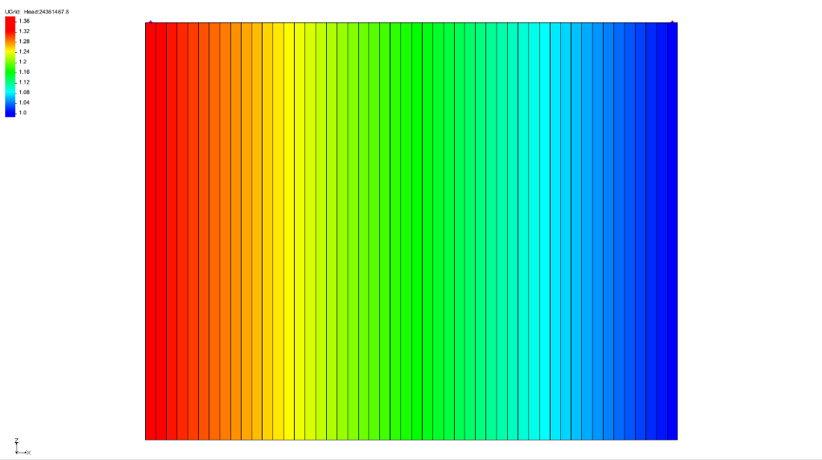

Figure 1 Initial project for the MODFLOW 6 model

The model uses a single-layer UGrid with 50 elements arranged in a one-dimensional grid. Each element measures 0.0214 meters in the flow direction (x-direction), 0.03 meters perpendicular to the flow (y-direction), and 0.84 m vertically (z-direction). Specified heads (CHD are applied to both ends: the left-most element is held at a constant head of 1.3281 meters, while the right-most element is set to 1 meter. The horizontal hydraulic conductivity is 100 m/yr, producing a Darcy velocity of 31.29 m/year.

Before continuing, save the project with a new name.

1. Select *File* | **Save As…** to bring up the *Save As* dialog.
2. Enter “sand_tank.gpr” as the *File name*.
3. Select “Project Files (*.gpr)” from the *Save as type* drop-down.
4. Click **Save** to save the project file and close the *Save As* dialog.

# Adding a New GWT Model

With the MODFLOW 6 open, a groundwater transport (GWT) model is necessary to use the MDT package. The GWT model can be added by doing the following:

1. Switch to the **UGrid** File:UGrid Icon Unlocked.svg module.
2. Right-click on “File:MODFLOW Folder.svg sand_tank” and select *New Package* | **GWT** to bring up the *New Groundwater Transport (GWT) Model* dialog.
3. In the *Select UGrid* section, turn on the “ UGrid” grid.
4. In the *GWT – Groundwater Transport Model* section, turn on the following packages:
5. *ADV – Advection*
6. *CNC – Constant Concentration*
7. *DSP – Dispersion*
8. *MDT – Matrix Diffusion*
9. *SSM – Source and Sink Mixing*.
10. Click **OK** to close the *New Groundwater Transport (GWT) Model* dialog.

Notice the “File:MF6 GWT Model.svg trans” model is now shown in the Project Explorer along with the selected packages.

1. In the Project Explorer, right-click on “File:MODFLOW Folder.svg sand_tank” and select **Unlock All**.

## The TDIS Package

The TDIS package defines the temporal discretization for the groundwater transport model. In this example, the package has already been configured.

## The ADV Package

Review the ADV package before continuing.

1. Double-click on the “File:Mf6package.svg ADV” package to bring up the *Advection (ADV) Package* dialog.
2. Check that the *SCHEME – Scheme used to solve the advection term* option is turned on.
3. Click **OK** to close the *Advection (ADV) Package* dialog.

## The CNC Package

Define the constant concentration by doing the following.

1. Double-click on the “File:Mf6package.svg CNC” package to bring up the *Constant Concentration (CNC) Package* dialog.
2. Click **Add Rows** File:Row-add.svg to bring up the *Add Stresses* dialog.
3. Accept the default settings and click **OK** to close the *Add Stresses* dialog.
4. In row *1*, enter the following:

* Set *LAY* to “1”
* Set *CELL2D* to “1”
* Set *CONC* to “400.0”

1. Change the *Period* to “2”.
2. Click **Define Period** File:Add Note Icon.svg to bring up the *Define Period* dialog.
3. Ensure that *Copy from previous period (1)* is selected and click **OK** to close the *Define Period* dialog.
4. Change the *CONC* column to be “0.0”.
5. Click **OK** to close the *Constant Concentration (CNC) Package* dialog.

## The DSP Package

Define the dispersion by doing the following:

1. Double-click on the “File:Mf6package.svg DSP” package to bring up the *Dispersion (DSP) Package* dialog.
2. Under the *DIFFC* tab, turn on the *Define* option and set the *Constant* value to “0.03844444”.
3. Under *Sections*, turn on *OPTIONS.*
4. Turn on the *XT3D_OFF – Deactivate the xt3d method* option.
5. Click **OK** to close the *Dispersion (DSP) Package* dialog.

## The IC Package

The default settings in the IC package are sufficient for this example. No modifications are required, though the settings may be reviewed if desired.

## The MST Package

Define the mobile storage and transfer by doing the following:

1. Double-click on the “File:Mf6package.svg MST” package to bring up the *Mobile Storage and Transfer (MST) Package* dialog.
2. Under the *POROSITY* tab, set the *Constant* value to “0.45”.
3. Under the *BULK_DENSITY* tab, turn on the *Define* option and set the *Constant* value to “1.6”.
4. Under the *DISTCOEF* tab, turn on the *Define* option and set the *Constant* value to “0.109693”.
5. Under *Sections*, turn on *OPTIONS.*
6. Turn on the *SORPTION – Sorption will be activated* option.
7. Click **OK** to close the *Mobile Storage and Transfer (MST) Package* dialog.

## The SSM Package

Define the source mixing for this example by doing the following:

1. Double-click on the “File:Mf6package.svg SSM” package to bring up the *Source and Sink Mixing (SSM) Package* dialog.
2. Under *Sections*, turn on *OPTIONS.*
3. Turn on the *SAVE_FLOWS – Save flows to budget file* option.
4. Click **OK** to close the *Source and Sink Mixing (SSM) Package* dialog.

# The MDT Package

The MDT package can be defined during the process of setting up the GWT model.

1. Double-click on the “File:Mf6package.svg MDT” package to bring up the *Matrix Diffusion Transport (MDT) Package* dialog.
2. Under the *MD_TYPE_FLAG* tab, set the *Constant* value to “2”.
3. Under the *MD_FRACTION* tab, set the *Constant* value to “0.289”.
4. Under the *MD_POROSITY* tab, set the *Constant* value to “0.6”.
5. Under the *BULK_DENSITY* tab, set the *Constant* value to “1.6”.
6. Under the *MD_DIFF_LENGTH* tab, set the *Constant* value to “0.04052”.
7. Under the *MD_TORTUOSITY* tab, set the *Constant* value to “0.3”.
8. Under the *MD_DIST_COEFF* tab, set the *Constant* value to “9.330e-09”.
9. Under the *MD_DIFF_COEFF* tab, set the *Constant* value to “0.0173”.
10. Under *Sections*, turn on *OPTIONS.*
11. Turn on the *SORPTION* option.
12. Click **OK** to close the *Matrix Diffusion Transport (MDT) Package* dialog.

The MDT Package is now set and ready for the simulation run.

# Output Control

Before running the MODFLOW 6 simulation, set the output option for the GWT model.

1. Under the “File:MF6 GWT Model.svg trans” model, double-click on the “File:Mf6package.svg OC” package to bring up the *Output Control (OC) Dialog*.
2. Change the *Preset output* to be “At every time step”.
3. Click **OK** to close the *Output Control (OC) Dialog*.

# Adding a Second IMS Package

A second iterative model solution package will be used in this example.

1. Right-click on “File:MODFLOW Folder.svg sand_tank” and select *New Package* | **IMS**.
2. Double-click on the “File:Mf6package.svg IMS (2)” package to bring up the *Iterative Model Solution (IMS)* dialog.
3. Under *Sections*, turn on *OPTIONS*.
4. Turn on the *COMPLEXITY – Default solver parameters* option and select “COMPLEX” from the drop-down.
5. Click **OK** to close the *Iterative Model Solution (IMS)* dialog.

# Adding a GWF-GWT Exchange

A GWF-GWT exchange establishes a link in which the GWF model supplies flow data that informs the GWT model. To set up this exchange, do the following:

1. Right-click on “File:MODFLOW Folder.svg sand_tank” and select *New Package* | **GWF-GWT**.
2. Double-click on “File:MODFLOW Folder.svg sand_tank” to open the *Simulation Options* dialog.
3. Under *Sections*, turn on *EXCHANGES.*
4. In the *EXCHANGES* table, click the blank cell under the *EXGMNAMEA* column to bring up the *Select Model* dialog.
5. Check the “ flow_model” model and click **OK** to close the *Select Model* dialog.
6. Click the blank cell under the *EXGMNAMEB* column to bring up the *Select Model* dialog.
7. Check the “ trans” model and click **OK** to close the *Select Model* dialog.
8. Under *Sections*, turn on *SOLUTIONGROUPS.*
9. In the *SOLUTIONGROUPS* table, click the empty cell in the second row under the *SLNMNAMES* column to open the *Select Model(s)* dialog.
10. Check the “ trans” model and click **OK** to close the *Select Model(s)* dialog.
11. Click **OK** to close the *Simulation Options* dialog.

# Saving and Running the Simulation

Now save and run the simulation:

1. Right-click on “File:MODFLOW Folder.svg sand_tank” and select **Save Project, Simulation and Run** to start the *Simulation Run Queue*.
2. If it appears, click **OK** on the *Info* dialog to unload the previous solution.
3. Click **Load Solution** to import the solution files.
4. Click **Close** to exit the *Simulation Run Queue*.

Figure 2 Model after the simulation is run

# Examining the Solution

Now examine the results of the MDT package being included in the transport model.

1. Switch to the **UGrid** File:UGrid Icon Unlocked.svg module.
2. In the Project Explorer, expand the “File:Generic Folder.svg sand_tank (MODFLOW 6)” folder, then open the “File:Generic Folder.svg trans” folder and select the “File:Dataset Cells Active.svg Concentration” dataset.
3. Using the **Select Cells** File:Select UGrid Cell Tool.svg tool, select cell 50 (the last cell on the right).
4. Click the **Plot Wizard** File:Plot Wizard Macro.svg macro to open the *Plot Wizard* dialog.
5. Under *Plot Type*, select “Active Dataset Time Series”.
6. Click **Finish** to close the *Plot Wizard* and generate the plot.

The generated plot should appear similar to Figure 3.

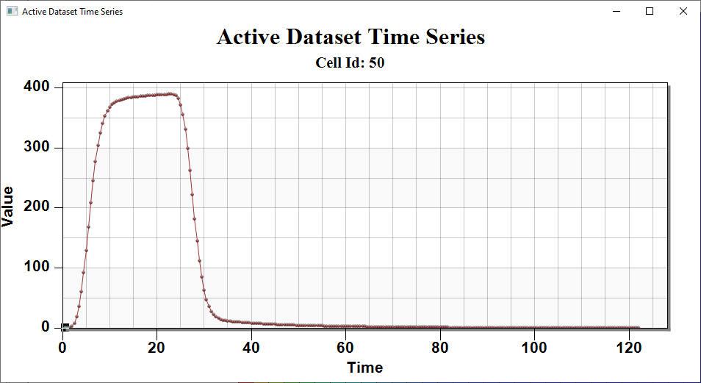

Figure 3 The active dataset time series plot

# Conclusion

This concludes the “MODFLOW 6 – MDT Sand Tank” tutorial. The following topics were discussed and demonstrated:

* Creating a MODFLOW 6 transport model
* Adding the MDT Package to MODFLOW 6
* Running MODFLOW 6
* Reviewing the MODFLOW 6 solution

1. Farhat, S. K., Newell, C. J., Falta, R. W., & Lynch, K. (2018). *REMChlor-MD user’s manual* (Report No. ER-201426). Clemson University & GSI Environmental Inc. <https://www.serdp-estcp.org/Program-Areas/Environmental-Restoration/Contaminated-Groundwater/Persistent-Contamination/ER-201426>
2. Falta, R. W., & Wang, W. (2017). A semi-analytical method for simulating matrix diffusion in numerical transport models. *Journal of Contaminant Hydrology, 197*, 39–49.
3. Muskus, N., & Falta, R. W. (2018). Semi-analytical method for matrix diffusion in heterogeneous and fractured systems with parent-daughter reactions. *Journal of Contaminant Hydrology, 218*, 94–109.
4. Panday, S., Falta, R. W., Farhat, S., Pham, K., & Lemon, A. (2021). Matrix Diffusion Transport (MDT) process for MODFLOW-USG transport. GSI Environmental. <https://www.gsienv.com/product/modflow-usg/>
5. Doner, L. A. (2008). *Tools to resolve water quality benefits of upgradient contaminant flux reduction* (Master’s thesis, Colorado State University).
6. Chapman, S. W., Parker, B. L., Sale, T. C., & Doner, L. A. (2012). Testing high resolution numerical models for analysis of contaminant storage and release from low permeability zones. *Journal of Contaminant Hydrology, 136–137*, 106–116.