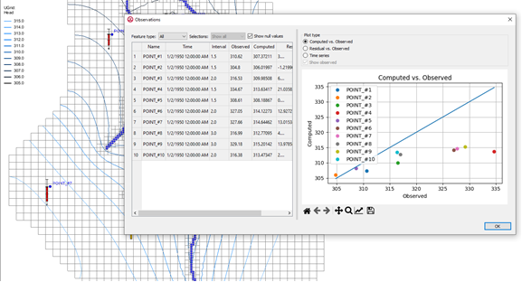

GMS 10.9

GMS 10.9 Tutorial

***MODFLOW 6 – PEST Observations, Steady State***

Use PEST Observations with a Steady State MODFLOW 6 Simulation

Objectives

Learn how to use PEST observations with a steady-state MODFLOW 6 simulations.

Time

* 15–25 minutes

Required Components

* GMS Core
* MODFLOW-USG Model & Interface

Prerequisite Tutorials

* Getting Started
* MODFLOW 6 – Grid Approach
* MODFLOW 6 – Conceptual Model Approach

|  |
| --- |
| 1 Introduction 2  2 Converting a MODFLOW-USG Simulation 2  2.1 Opening the Existing MODFLOW-USG Model 3  2.2 Save MODFLOW 6 Copy 3  3 Importing the MODFLOW 6 Simulation 4  4 Fixing CHD Package Errors 5  5 Creating the PEST Observations Package 5  6 Map from Coverage 6  7 Regenerating the PEST Observation Files 6  8 Saving and Running the Simulation 7  9 Examining the Solution 7  9.1 Statistics 7  9.2 Solution Coverages and Whisker Plots 7  9.3 Observation Plots 8  10 Conclusion 8 |

# Introduction

MODFLOW 6 includes an observation utility (OBS) which is used to output the computed head, drawdown, and/or flow at specific cells at all output times.

GMS includes additional observation features beyond what comes with MODFLOW 6, including observations at arbitrary locations and times, comparison of observed and computed values, whisker plots, and other plots. This functionality is done with the help of utility programs that come with PEST, and is very similar to the observation functionality GMS provides for MODFLOW-USG. GMS prepares the input files needed by the PEST utilities to determine the computed values from the model solution. For more information about using PEST with MODFLOW-USG, refer to the “MODFLOW-USG – Calibration” tutorial.

PEST can be used for observations and calibration. This tutorial only covers observations. This tutorial will convert an existing MODFLOW-USG simulation that uses PEST observations to a MODFLOW 6 simulation with PEST observations.

This tutorial discusses and demonstrates:

* Converting a MODFLOW-USG simulation that uses PEST to a MODFLOW 6 simulation.
* Importing MODFLOW 6 files.
* Defining the PEST observation package.
* Regenerating the PEST observation files.
* Saving and running the MODFLOW 6 simulation.
* Reviewing the solution.

# Converting a MODFLOW-USG Simulation

Start with opening a MODFLOW-USG model:

1. If necessary, launch GMS.
2. If GMS is already running, select the *File |* **New** command to ensure that the program settings are restored to their default state.

## Opening the Existing MODFLOW-USG Model

Start with a previously created project.

1. Click **Open** File:Open Macro.svg to bring up the *Open* dialog.
2. Select “Project Files (*.gpr)” from the *Files of type* drop-down.
3. Browse to the *mf6_pest_obs_ss* folder and select “start.gpr”.
4. Click **Open** to import the project and exit the *Open* dialog.

The project should be visible in the Graphics Window (Figure 1). The project contains a MODFLOW-USG simulation that has observation data.

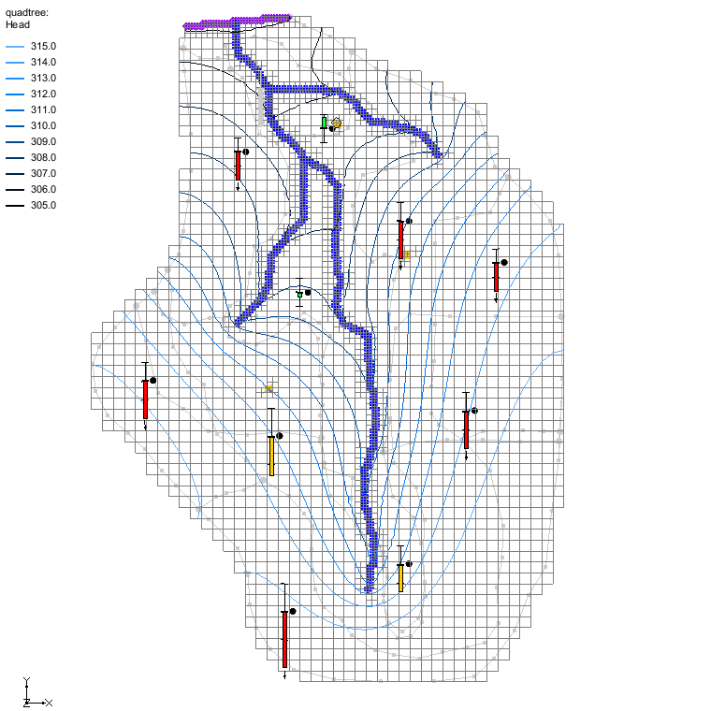

Figure Initial project for the MODFLOW-USG model

## Save MODFLOW 6 Copy

Now create a MODFLOW 6 simulation from the MODFLOW-USG simulation:

1. Select *MODFLOW* | **Global Options…** to open the *MODFLOW Global/Basic Package* dialog.
2. Turn on the *Save MODFLOW 6 copy* option.
3. Click **OK** to close the *MODFLOW Global/Basic Package* dialog.
4. Select *File* | **Save As…** to open the *Save As* dialog.
5. For the *File Name*, enter “pest_obs_ss”.
6. Click **Save** to close the *Save As* dialog and save the new files.

GMS just saved the MODFLOW-USG simulation files and then ran a conversion program on the files to create a MODFLOW 6 simulation.

# Importing the MODFLOW 6 Simulation

With the MODFLOW 6 files created, they can now be imported back into GMS:

1. Click **Open** File:Open Macro.svg to bring up the *Open* dialog.
2. Select “All Files (*.*)” from the *Files of type* drop-down.
3. Browse to the mf6_pest_obs_ss/pest_obs_ss_MODFLOW_quadtree_mf6 folder and select “mfsim.nam”.
4. Click **Open** to import the project and exit the *Open* dialog.
5. Turn off and collapse the “ quadtree” item in the Project Explorer.

The project should be visible in the Graphics Window (Figure 2). The MODFLOW 6 simulation will be visible in the Project Explorer.

1. Right-click on “File:MODFLOW Folder.svg pest_obs_ss” and select **Save Project, Simulation and Run** to start the *Simulation Run Queue*.

Notice the error in the CHD package “Cell is already a constant head ((1,32))”. Converting a MODFLOW-USG model to MODFLOW 6 is often an imperfect process. In this case, MODFLOW 6 does not allow multiple CHD boundary conditions in the same cell whereas in MODFLOW-USG this was allowed.

1. Click **Remove** to remove the model run.
2. Click **Close** to exit the *Simulation Run Queue*.

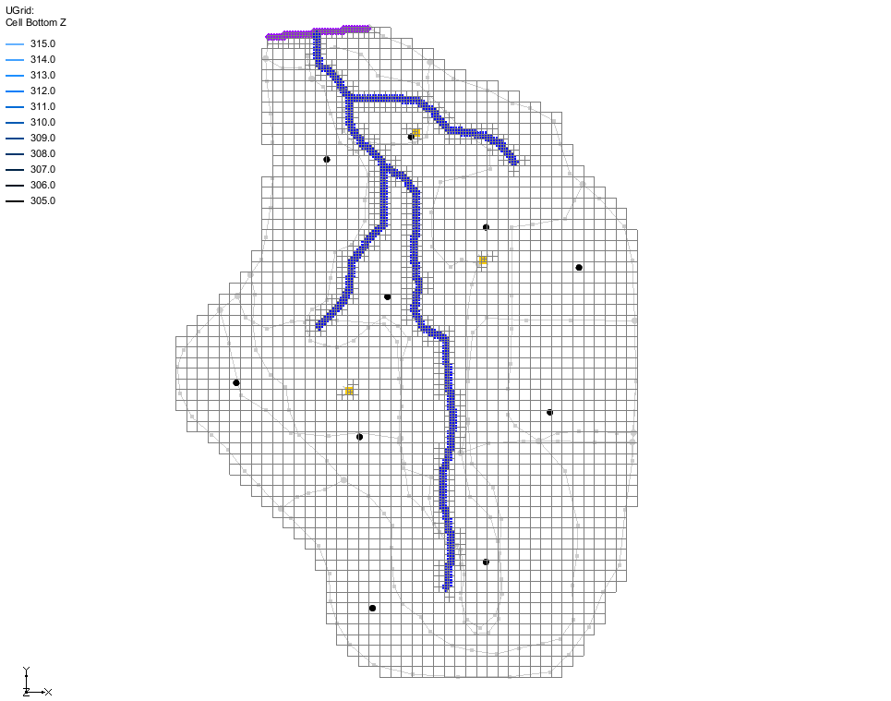

Figure MODFLOW 6 model

# Fixing CHD Package Errors

The CHD error can be fixed by recreating the CHD boundary conditions by mapping from the conceptual model. To do this:

1. In the Project Explorer under “https://www.xmswiki.com/images/thumb/0/0a/MODFLOW_Folder.svg/60px-MODFLOW_Folder.svg.png pest_obs_ss” and “16-mf6 GWF_Model”, right-click on the “File:Mf6package.svg CHD” package and select **Map from coverage** to open a *Select Coverage* dialog.
2. Select the “File:Coverage Active Icon.svg Sources & Sinks” coverage and check that the *Replace all package data* option has been turned on.
3. Click **OK** to close the *Select Coverage* dialog and open the *Map from Coverage* dialog.
4. When it has finished running, click **OK** to close the *Map from Coverage* dialog.
5. Right-click on “File:MODFLOW Folder.svg pest_obs_ss” and select **Save Project, Simulation and Run** to start the *Simulation Run Queue*.

This time there are no errors.

1. Click **Load Solution** to import the solution files.
2. Click **Close** to exit the *Simulation Run Queue*.
3. Turn the “ quadtree” UGrid off and on.

Notice the old and new solutions (based on the contours) are virtually identical.

1. Turn off the “ quadtree” UGrid.
2. **Save** File:Save Macro.svg the project.

The CHD error has now been resolved.

# Creating the PEST Observations Package

The observation data from the MODFLOW-USG model was not preserved when the model was converted to a MODFLOW 6 simulation. To add the observation data to the MODFLOW 6 model, complete the following:

1. Right-click “File:MF6 GWF Model.svg GWF_Model” and select the *New Package* | **PEST Observations** command.

This adds a new component in the Project Explorer. It is not a MODFLOW 6 package, but a GMS component that uses PEST with MODFLOW 6 to determine computed values.

1. Double-click on the “File:Mf6package.svgPEST Observations” package item to open the *MODFLOW 6 PEST Observations* dialog.

This dialog is somewhat similar to the *MODFLOW-USG Observations* dialog. Here the PEST input files are created for the MODFLOW 6 simulation.

1. Click the **Generate PEST Observation Data** button to open the *Generate Observations* dialog.
2. For the *Head observation coverages*, turn on “Observation Wells”.
3. For the *Flow observation coverages*, turn on “Sources & Sinks”.
4. Click **OK** to close the *Generate Observations* dialog.
5. Click **OK** to close the error message that appears.
6. In the *Errors* tab of the *MODFLOW 6 PEST Observations* dialog, review the errors.

The important thing to note is that GMS says: “You may need to execute “Map from Coverage”.” The error is associated with an arc group. The arc group consists of multiple arcs representing the river system in the “File:Coverage Active Icon.svg Sources & Sinks” coverage. Because the MODFLOW 6 model was created from a MODFLOW-USG model and then imported, GMS does not recognize the connection between the feature objects in the coverages and the model boundary conditions. Using the **Map from Coverage** command will associate the RIV package boundary conditions with the arc group.

1. Click **OK** to exit the *MODFLOW 6 PEST Observations* dialog.

# Map from Coverage

The RIV package needs to be associated with the arc group on the “File:Coverage Active Icon.svg Sources & Sinks” coverage. To do this:

1. In the Project Explorer, right-click on the “File:Mf6package.svg RIV” package and select **Map from Coverage** to open a *Select Coverage* dialog.
2. Select the “File:Coverage Active Icon.svg Sources & Sinks” coverage and check that the *Replace all package data* option has been turned on.
3. Click **OK** to close the *Select Coverage* dialog and open the *Map from Coverage* dialog.
4. When it has finished running, click **OK** to close the *Map from Coverage* dialog.

# Regenerating the PEST Observation Files

Now generate the PEST observation files by doing the following:

1. **Save** File:Save Macro.svg the project
2. Double-click on the “File:Mf6package.svgPEST Observations” package item to open the *MODFLOW 6 PEST Observations* dialog.
3. Click the **Generate PEST Observation Data** button to open the *Generate Observations* dialog.
4. For the *Head observation coverages*, turn on “Observation Wells”.
5. For the *Flow observation coverages*, turn on “Sources & Sinks”.
6. Click **OK** to close the *Generate Observations* dialog.

Take a moment to click on the different files in the list of files on the left and examine what they are and the file contents. These are the files that PEST uses to calculate the observed values. The files can be edited but it is almost never necessary to do so.

The “model.bsamp” file lists all the head observations. There are ten locations where we have observed values.

The “model.fsamp” file lists all the flow observations. There is one flow observation and it is on the arc group which is used to model the river system.

1. When done, click **OK** to exit the *MODFLOW 6 PEST Observations* dialog.

# Saving and Running the Simulation

Now save and run the simulation again:

1. Right-click on “File:MODFLOW Folder.svg pest_obs_ss” and select **Save Project, Simulation and Run** to start the *Simulation Run Queue*.
2. If it appears, click **OK** on the *Info* dialog to unload the previous solution.
3. Click **Load Solution** to import the solution files.
4. Click **Close** to exit the *Simulation Run Queue*.

Several things just happened:

* When the simulation was saved, GMS saved the PEST input files with the simulation along with some batch files used to run PEST.
* When the simulation was run, MODFLOW calculated the head and flow solutions.
* When the solution was read, GMS ran some PEST utilities using the input files and batch files. PEST used the model solution to determine the computed values at the observation points. GMS read the PEST output and added the data to the solution as it was imported.

# Examining the Solution

Now examine the results of the PEST observations using statistics tools, whisker plots, and observation plots.

## Statistics

Notice that in addition to the Head dataset, there are some PEST related items including links to three coverages and a “pest_obs_stats.txt” file.

1. In the Project Explorer under “File:Generic Folder.svg GWF_Model”, double-click the “ pest_obs_stats.txt” file to open the file in a text editor.

This file contains observation statistics similar to the statistics that can be found by right-clicking on a MODFLOW-USG solution. In fact, let’s compare them.

1. Under “ quadtree”, right-click on the “File:Generic Folder.svg start (MODFLOW)” solution folder and select **Properties** to open the *Properties* dialog.

Compare the values to those in the “ pest_obs_stats.txt” file. They should be similar.

1. Click **OK** to close the *Properties* dialog.

## Solution Coverages and Whisker Plots

Now look at the solution coverages and whisker plots:

1. In the Project Explorer, turn off the “File:Ugrid-icon.png UGrid” to see the coverages better.
2. Under “File:Map Folder.svg Map Data”, expand both the “File:Generic Folder.svg pest_obs_ss (MODFLOW 6)” item and the “File:Generic Folder.svg GWF_Model” item.
3. Select the “File:Coverage Active Icon.svg PEST obs arc_groups” coverage to make it active.

The whisker plot gives an indication of how well the observed flow to or from the river system matches the computed value. The “MODFLOW – Model Calibration” tutorial explains whisker plots.

1. Using the **Select Arc Groups** File:GMS Select Arc Group Tool.svg tool, click anywhere on the arc group to select it.

Notice the data in the status bar at the bottom of the GMS window.

1. Select the “File:Coverage Active Icon.svg PEST obs points” coverage.

Again, the whisker plots indicate how well the computed and observed values match.

There is also a “File:Coverage Active Icon.svg PEST obs arcs” coverage that includes the arcs that make up the arc group, but there are no observations on the arcs so it can be ignored.

## Observation Plots

To view an observation plot from the calibration data, complete the following:

1. Right-click the “File:Coverage Active Icon.svg PEST obs points” coverage and select the **Observations** command to open the *Observations* dialog.

In the *Observations* dialog (Figure 3) the observation data is shown on the left, and a plot of the data is shown on the right.

1. Select the different plot types and examine the plots.

The “Time Series” plot is not applicable because the model is steady-state.

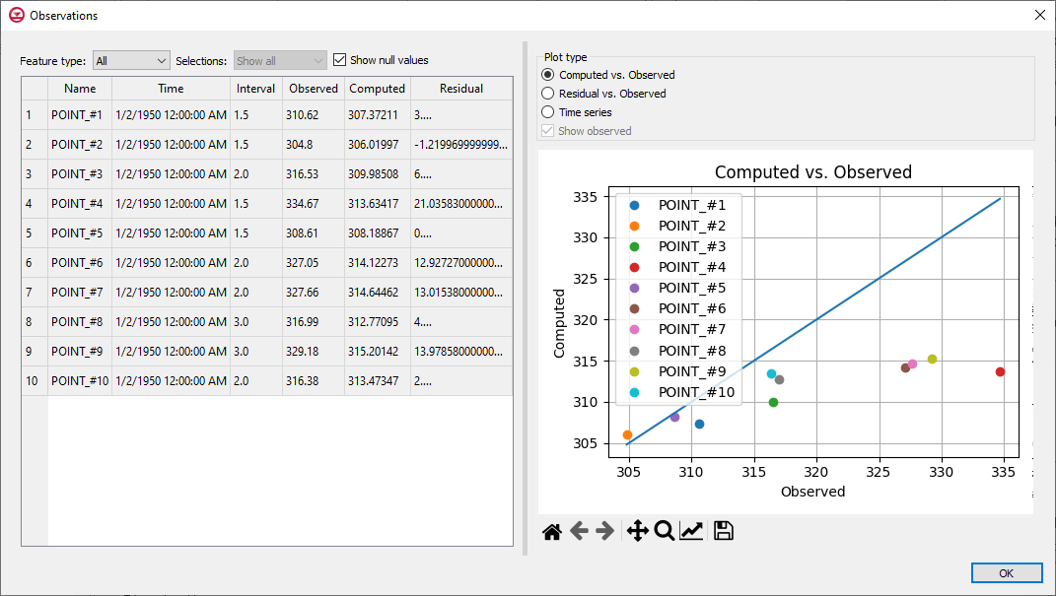

Figure The Observations dialog

# Conclusion

This concludes the “MODFLOW 6 – PEST Observations, Steady State” tutorial. The following topics were discussed and demonstrated:

* Converting a MODFLOW-USG project to MODFLOW 6.
* Adding the PEST Observation Package to MODFLOW 6.
* Running MODFLOW 6 with PEST.
* Reviewing the PEST solution.