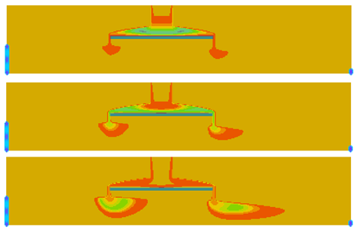

GMS 10.9

GMS 10.9 Tutorial

***MT3D-USGS – Keating Example***

Create an MT3D-USGS model using the Keating Example Problem

Objectives

This tutorial will show constructing a MT3D-USGS model using the Keating example problem from the MT3D-USGS documentation.

Time

* 15–25 minutes

Required Components

* GMS Core
* MODFLOW Interface
* MT3D

Prerequisite Tutorials

* MT3DMS – Grid Approach

|  |
| --- |
| 1 Introduction 2  1.1 Getting Started 3  2 The Flow Model 3  3 MT3DMS Transport Simulation 4  4 Mt3d-USGS Transport Simulation 5  5 Conclusion 6 |

# Introduction

This tutorial describes how to perform a MT3D-USGS simulation within GMS. It is highly recommended to have completed the “MT3DMS – Grid Approach” tutorial prior to starting this tutorial in order to understand how to create a transport simulation in GMS.

The problem in this tutorial (Figure 1) corresponds to a sample problem described in the MT3D-USGS documentation.[1] The following is a description of the problem from the document:

The model first published in Keating and Zyvoloski (2009) and described under the heading, “Extension to Mixed Vadose/Saturated Zone Simulations,” is solved with MODFLOW-NWT and MT3D-USGS to demonstrate the routing of solute mass through dry cells. In this problem, an aquitard above the underlying regional flow intercepts recharge and forms a perched aquifer. Under steady-state flow conditions, perched groundwater flows over the edges of the aquitard, and MODFLOW-NWT instantaneously applies this water to the top of the underlying aquifer. In the transport problem, the initial concentration is zero throughout the entire domain. Water entering and exiting the domain through the left and right boundaries, respectively, are assigned a concentration of 0. Only the recharge, specified in layer 1 (note that the highest active layer is 8) is specified with a non-zero concentration equal to 100 mg/L for the first 730 days of the simulation. Thus, the solute arrives first in the perched aquifer before eventually spilling over the sides of the aquitard and entering the lower aquifer. It is the new DRYCELL keyword functionality in MT3D-USGS that makes this type of simulation possible. Once in the lower aquifer, the solute is transported toward the right boundary in response to groundwater flow patterns and in this way is routed through the perched and lower regional aquifers.

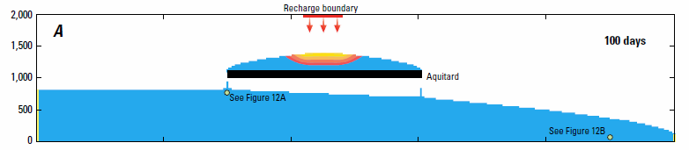

Figure 1 Keating Example Problem from MT3D-USGS Documentation

This tutorial will illustrate functionality in MT3D-USGS that does not exist in MT3DMS. MT3D-USGS can route concentrations through “dry cells” from a MODFLOW-NWT simulation. The tutorial will demonstrate the following:

* Importing a project with an existing MODFLOW-NWT simulation.
* Examining the outputs of the simulation.
* Using MT3DMS to simulate transport and examine the results.
* Using MT3D-USGS to simulate transport and examine the results.

## Getting Started

Do the following to get started:

1. If necessary, launch GMS.

If GMS is already running, select *File |* **New** to ensure that the program settings are restored to their default state.

# The Flow Model

To start the tutorial, import an existing MODFLOW-NWT project by doing the following:

1. Click **Open** File:Open Macro.svg to bring up the *Open* dialog.
2. Select “Project Files (*.gpr)” from the *Files of type* drop-down.

Browse to the *keating* directory and select “start.gpr”.

Click **Open** to import the project and exit the *Open* dialog.

The display should look like Figure 2.

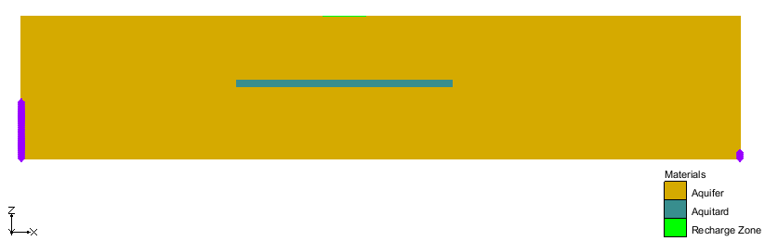

Figure View of initial model

Select the “File:Dataset Cells Active.svg Head” dataset under the “File:Generic Folder Locked.svg start (MODFLOW)” item in the Project Explorer.

The display should match Figure 3. Notice that the computed heads show a perched aquifer above regional groundwater flowing from left to right.



Figure Computed Head from MODFLOW-NWT model

1. Select “File:Dataset Cells Active.svg elevation” from the Project Explorer to return the display to the full grid with the materials visible.

# MT3DMS Transport Simulation

The next step is to simulate transport with MT3DMS. To save time, this tutorial starts with an existing MT3DMS model.

1. Click **Open** File:Open Macro.svg to bring up the *Open* dialog.

Select “Model Super Files (*.mfs;*.rsp;*.mts;*.rts;*.sms; *.fws; *.sps)” from the *Files of type* drop-down.

Browse to the *keating\mt3dms* directory and select “mt3dms.mts”.

Click **Open** to import the project and exit the *Open* dialog.

A MT3DMS simulation should now appear in the Project Explorer below the MODFLOW item. This model should simulate concentration entering the model from the recharge zone near the top middle of the grid. The simulation includes advection and dispersion; the properties for these packages can be examined by opening the package dialogs.

Before running MT3DMS, the MT3DMS model run options need to be set.

1. Select the *MT3DMS* | **Run Options…** command to open the *Run Options* dialog.

Select the *Single run with selected MODFLOW solution* option.

Select **OK** to exit the *Run Options* dialog.

With the run option for MT3DMS specified, it is now possible to save a copy of the project.

1. Select the *File* | **Save As…** command to open the *Save As* dialog.

Select “Project Files (*.gpr)” for *Save as type*.

Enter “mt3d” as the *File name*.

Select the **Save** button to close the *Save As* dialog and save a new project file.

The MT3DMS model can now be run.

1. Select the *MT3DMS* | **Run MT3DMS…** command to bring up the *MT3DMS* model wrapper.

When the simulation finishes running, make certain *Read solution on exit* is turned on.

Select the **Close** button to exit the *MT3DMS* model wrapper.

The solution from the model run will automatically be loaded into the project.

Select the “File:Dataset Cells Active.svg tracer” dataset under the “File:Generic Folder Locked.svg mt3d (MT3DMS)” folder in the Project Explorer.

The display will update to the computed concentrations from MT3DMS (Figure 4).

Notice the values are 0.0 everywhere in the grid for every time step of the “File:Dataset Cells Active.svg tracer” dataset. MT3DMS is unable to simulate transport with dry cells from MODFLOW-NWT. The concentrations that come from the recharge area never enter the MT3DMS model.



Figure Concentrations from MT3DMS Simulation (all values are 0.0)

# Mt3d-USGS Transport Simulation

Next to change the transport model to be MT3D-USGS and use the DRYCELL option so that transport will occur with dry cells from the MODFLOW simulation. To do this, use the following steps:

1. Select *MT3DMS* | **Basic Transport Package** to open the *Basic Transport Package* dialog.

Under the *Model* section, select *MT3D-USGS* as the model.

Select the check box next to the *DRYCELL: MT3D-USGS mass transfer through dry cells* item to turn it on.

Click **OK** to close the *Basic Transport Package* dialog.

With the transport model changed to MT3D-USGS, the *MT3DMS* menu has changed to the *MT3D-USGS* menu. Before continuing, it is recommended to save the project.

1. Select the *File* | **Save As…** command to open the *Save As* dialog.

Select “Project Files (*.gpr)” for *Save as type*.

Enter “mt3d_usgs” as the *File name*.

Select the **Save** button to close the *Save As* dialog and save a new project file.

Now to run the MT3D-USGS simulation:

1. Select *MT3D-USGS* | **Run MT3D-USGS…** to launch the *MT3D-USGS* model wrapper dialog.

When the simulation finishes running, make certain *Read solution on exit* is turned on.

Select the **Close** button to exit the *MT3D-USGS* model wrapper.

The display will update to the computed concentrations from MT3D-USGS.

1. Select the “File:Dataset Cells Active.svg tracer” dataset under the “File:Generic Folder Locked.svg mt3d_usgs (MT3D-USGS)” folder from the Project Explorer.

Change the selected time step to 10730.0 in the Time Step window below the Project Explorer.

Cycle through the time steps to step how the plume migrates.

At time step 12500.0 the display will look like Figure 5.



Figure Plume at time step 12500.0

# Conclusion

This concludes the “MT3D-USGS – Keating Example” tutorial. The following key concepts were discussed and demonstrated in this tutorial:

* MT3D-USGS has all of the simulation capabilities of MT3DMS plus additional capabilities.
* MT3D-USGS can simulate transport in MODFLOW-NWT models with dry cells.

1. Bedekar, V., Morway, E.D., Langevin, C.D., and Tonkin, M., 2016, *MT3D-USGS version 1: A U.S. Geological Survey Release of MT3DMS Updated with New and Expanded Transport Capabilities for Use with MODFLOW* (No. 6-A53)*.* U.S. Geological Survey, pp. 36–37. Available at: <http://dx.doi.org/10.3133/tm6A53>

   This is the initial report that describes the theory and use of MT3D-USGS.