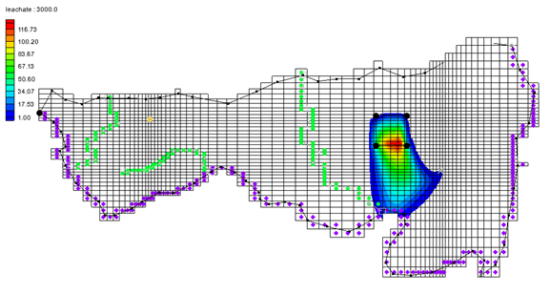

GMS 10.9

GMS 10.9 Tutorial

***MT3DMS – Conceptual Model Approach***

Using MT3DMS with a conceptual model

Objectives

Learn how to use a conceptual model when using MT3DMS. Perform two transport simulations, analyzing the long-term potential for migration of leachate from a landfill.

Time

* 30–50 minutes

Required Components

* GMS Core
* MODFLOW Interface
* MT3D

Prerequisite Tutorials

* MODFLOW – Conceptual Model Approach I
* MT3DMS – Grid Approach

|  |
| --- |
| 1 Introduction 2  2 Getting Started 3  2.1 Importing the Project 3  2.2 Defining the Units 3  3 Initializing the MT3DMS Simulation 4  3.1 Defining the Species 4  3.2 Defining the Stress Periods 4  3.3 Setting the Output Control 4  3.4 Selecting the Packages 5  4 Assigning the Aquifer Properties 5  4.1 Turning on Transport 5  4.2 Assigning the Parameters to the Polygons 6  4.3 Assigning the Parameters to the Polygons 6  5 Converting the Conceptual Model 7  6 Additional Options for MT3DMS 7  6.1 Layer Thicknesses 7  6.2 The Advection Package 7  6.3 The Dispersion Package 7  6.4 The Transport Observation Package 7  6.5 The Source/Sink Mixing Package Dialog 8  7 Saving and Running MODFLOW and MT3DMS 8  7.1 Running MODFLOW 8  7.2 Running MT3DMS 8  8 Viewing the Solution 8  8.1 Generating a Mass vs Time Plot 9  8.2 Viewing an Animation 10  9 Modeling Sorption and Decay 10  9.1 Turning on the Chemical Reactions Package 10  9.2 Entering the Sorption and Biodegradation Data 11  9.3 Run Options 11  10 Saving and Running MT3DMS 11  11 Viewing the Solution 12  11.1 Run Options 12  12 Conclusion 13 |

# Introduction

MT3DMS simulations can be constructed using the grid approach, where data are entered on a cell-by-cell basis. They can also be constructed using the conceptual model approach, where the data are entered via points, arcs, and polygons. This tutorial describes how to use the conceptual model approach.

The problem for this tutorial is an extension of the problem described in the tutorial entitled “MODFLOW – Conceptual Model Approach I”. It is recommended that tutorial be completed before continuing.

In that tutorial, a site in East Texas was modeled. This tutorial uses the solution from that model as the flow field for the transport simulation. This model included a proposed landfill. For this tutorial, two transport simulations will be run to analyze the long-term potential for migration of leachate from the landfill. The first simulation will be modeling transport due to advection and dispersion only. The second simulation will include sorption and decay in addition to advection.

This tutorial will discuss and demonstrate opening a MODFLOW model and solution, defining conditions for an MT3DMS simulation, converting the conceptual model to MT3DMS, running MODFLOW, and running MT3DMS. It will then demonstrate creating an animation, defining additional parameters and rerunning MT3DMS, and creating a time series plot.

# Getting Started

Do the following to get started:

1. If necessary, launch GMS.
2. If GMS is already running, select *File |* **New** to ensure that the program settings are restored to their default state.

## Importing the Project

The first step is to import the East Texas project, which includes the MODFLOW model and solution and all other files associated with the model.

1. Click **Open** File:Open Macro.svg to bring up the *Open* dialog.
2. Select “Project Files (*.gpr)” from the *Files of type* drop-down.
3. Browse to the *mt3dmap\mt3dmap* directory and select “start.gpr”.
4. Click **Open** to import the project and exit the *Open* dialog.

The imported model should appear similar to Figure 1.

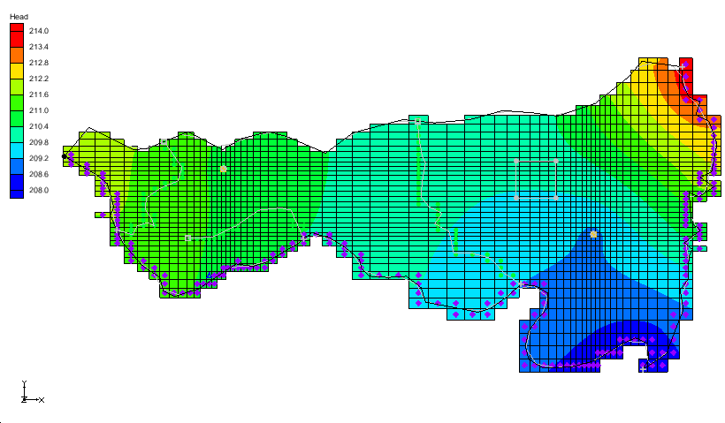

Figure 1 Initial model after importing

## Defining the Units

Next, define the units for mass and concentration. Do not change the length and time units as these must be consistent with the flow model.

1. Select *Edit* | **Units…** to open the *Units* dialog.
2. Select “kg” from the *Mass* drop-down.
3. Select “ppm” from the *Concentration* drop-down.
4. Click **OK** to close the *Units* dialog.

# Initializing the MT3DMS Simulation

Now that the MODFLOW model imported, initialize the MT3DMS simulation.

1. Fully expand the “File:3D Grid Folder.svg 3D Grid Data” folder if necessary.

Right-click on “File:3D Grid Icon.svg grid” and select **New MT3DMS*…*** to open the *Basic Transport Package* dialog.

## Defining the Species

MT3DMS is a multi-species model, so define the number of species and name each one. In this case, there is only one species.

1. Click **Define Species…** to open the *Define Species* dialog.
2. Click **New** to add a new species to the spreadsheet.
3. Enter “leachate” in the *Name* column.
4. Click **OK** to close the *Define Species* dialog.

## Defining the Stress Periods

Next, define the stress periods.

1. Click **Stress Periods…** to open the *Stress Periods* dialog.

In this case, the flow solution computed by MODFLOW is steady state. Therefore, any desired sequence of stress periods and time steps could be defined. For this tutorial, only one stress period is needed because the leachate from the landfill will be released at a constant rate. Enter the length of the stress period (i.e., the length of the simulation) and let MT3DMS compute the appropriate transport time step length by leaving the transport step size at zero.

1. On row *1*, enter “15000.0” in the *Length* column.
2. Enter “10” in the *Num Time Steps* column.

Click **OK** to exit the *Stress Periods* dialog.

## Setting the Output Control

By default, MT3DMS outputs a solution at every transport step. This results in a large output file, so change the output to write a solution every time step (every 300 days).

1. Click **Output Control…** to open the *Output Control* dialog.
2. Select Print or save at specified times.
3. Click **Times…** to open the *Variable Time Steps* dialog.
4. Click **Initialize Values…** to open the *Initialize Time Steps* dialog.
5. Enter “500.0” as the *Initial time step size*.
6. Enter “1.0” as the *Bias*.
7. Enter “500.0” as the *Maximum time step size*.
8. Enter “15000.0” as the *Maximum simulation time*.
9. Click **OK** to close the *Initialize Time Steps* dialog.
10. Click **OK** to close the *Variable Time Steps* dialog.
11. Click **OK** to close the *Output Control* dialog.

## Selecting the Packages

Next, specify which of the MT3DMS packages to use.

1. Click **Packages…** to open the *MT3DMS/RT3D Packages* dialog.
2. Turn on Advection package, Dispersion package, Source/sink mixing package, and Transport observation package.
3. Click **OK** to close the *MT3DMS/RT3D Packages* dialog.

Note that the *Basic Transport Package* dialog also includes some layer data. This tutorial will address the data for these arrays at a latter point.

1. Click **OK** to exit the *Basic Transport Package* dialog.

# Assigning the Aquifer Properties

MT3DMS requires that a porosity and dispersion coefficient be defined for each of the cells in the grid. While these values can be assigned directly to the cells, it is sometimes convenient to assign the parameters using polygonal zones defined in the conceptual model. The parameters are converted to the grid cells using the **Map → MT3DMS**command.

## Turning on Transport

Do the following to assign the porosities and dispersion coefficients to the polygons:

1. Fully expand the “File:Map Folder.svg Map Data” folder, if necessary.
2. Right-click on the “File:Conceptual Model Icon.svg East Texas” conceptual model and select **Properties…** to open the *Conceptual Model Properties* dialog.
3. In the spreadsheet, check the box to the right of *Transport*.
4. Select “MT3DMS / MT3D-USGS” from the *Transport model* drop-down.
5. Click **Define Species…** on the *Species* row to open the *Define Species* dialog.
6. Click **New** to create a new species.
7. Enter “leachate” in the *Name* column.
8. Click **OK** to close the *Define Species* dialog.
9. Click **OK** to exit the *Conceptual Model Properties* dialog.
10. Right-click on “File:Coverage Active Icon.svg Layer 1” and select **Coverage Setup…** to open the *Coverage Setup* dialog.
11. In the Areal Properties section, turn on Porosity and Long. dispersivity.
12. Click **OK** to close the *Coverage Setup* dialog.
13. Repeat steps 10–12 for the “File:Coverage Active Icon.svg Layer 2” coverage.

## Assigning the Parameters to the Polygons

To assign the porosities and dispersion coefficients to the polygons:

1. Select “File:Coverage Active Icon.svg Layer 1” to make it active.
2. Using the **Select Polygons** File:GMS Select Polygon Tool.svg tool, double-click on the layer polygon to open the *Attribute Table* dialog.
3. On row *1*, enter “0.3” in the *Porosity* column.
4. Enter “20.0” in the *Long. disp.* column.
5. Click **OK** to close the *Attribute Table* dialog.
6. Select “File:Coverage Active Icon.svg Layer 2” to make it active.
7. Repeat steps 2–5, but enter “0.2” in the *Porosity* column.

Click anywhere outside the model to deselect the highlighted polygon.

## Assigning the Parameters to the Polygons

The purpose of this model is to simulate the transport of contaminants emitted from the landfill. When the flow model was constructed, a separate, reduced value of recharge was assigned to the landfill site. This recharge represents leachate from the landfill, and a concentration needs to be assigned to this recharge. The concentration can be assigned directly to the recharge polygon in the conceptual model.

1. Right-click on the “File:Coverage Active Icon.svg Recharge” coverage and select **Coverage Setup…** to open the *Coverage Setup* dialog.
2. In the Areal Properties column, turn on Recharge conc.
3. Click **OK** to close the *Coverage Setup* dialog.
4. Select “File:Coverage Active Icon.svg Recharge” to make it active.
5. Using the **Select Polygons** File:GMS Select Polygon Tool.svg tool, double-click on the landfill polygon (shown in Figure 2 below) to open the *Attribute Table* dialog.

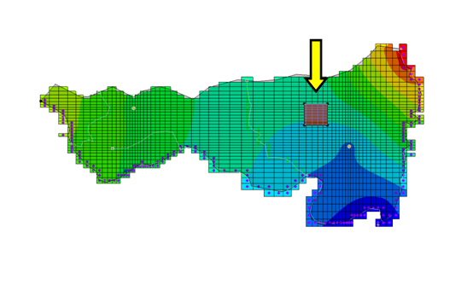

Figure 2 Landfill polygon selected

1. Enter “20000.0” in the *leachate Recharge conc.* column.
2. Click **OK** to close the *Attribute Table* dialog.

Click anywhere outside the model to deselect the polygon.

# Converting the Conceptual Model

At this point, it is possible to assign the aquifer parameters and the recharge concentration to the cells using the conceptual model.

1. Select *Feature Objects |* **Map → MT3DMS** to bring up the *Map → Model* dialog.
2. Select *All applicable coverages* and click **OK** to close the *Map → Model* dialog.

# Additional Options for MT3DMS

## Layer Thicknesses

MT3DMS requires an HTOP array defining the top elevations of the uppermost aquifer to define the aquifer geometry. A thickness array must then be entered for each layer. With the layer geometry defined in the MODFLOW model, no further input is necessary.

## The Advection Package

This tutorial uses the Third Order TVD scheme (ULTIMATE) solver for the Advection package. This is the default, so nothing needs to be done.

## The Dispersion Package

The longitudinal dispersivity values were automatically assigned from the conceptual model. Only the remaining three parameters need to be entered.

1. Select MT3DMS | **Dispersion Package…** to open the *Dispersion Package* dialog.
2. On both rows *1* and *2*, enter “0.2” in the TRPT column.
3. On both rows *1* and *2*, enter “0.1” in the TRVT column.
4. On both rows *1* and *2*, enter “0.0” in the DMCOEF column.
5. Click **OK** to exit the Dispersion Package dialog.

## The Transport Observation Package

This package determines the mass flux into the river source/sink.

1. Select MT3DMS | **Transport Observation Package…** to open the Transport Observation Package dialog.
2. Turn off *Compute concentrations at observation points*.
3. Turn on *Compute mass flux at source/sinks*.
4. Click **OK** to exit the Transport Observation Package dialog.

## The Source/Sink Mixing Package Dialog

The only data for the source/sink mixing package required in this package for this simulation are the concentrations assigned to the recharge from the landfill. These values were automatically assigned to the appropriate cells from the conceptual model, so the input data for this package are complete.

# Saving and Running MODFLOW and MT3DMS

Now that the MT3DMS data has been completely entered, save the model before running the simulations.

1. Select *File* | **Save As…** to bring up the *Save As* dialog.
2. Select “Project Files (*.gpr)” from the *Save as type* drop-down.
3. Enter “run1.gpr” as the *File name*.
4. Click **Save** to save it under the new name and close the *Save As* dialog.

## Running MODFLOW

MT3DMS requires the HFF file generated by MODFLOW. Because the project was saved in a different folder than the one where the MODFLOW simulation was opened, the HFF file does not exist in the new location. MODFLOW must be rerun to create the HFF file in the current folder.

To run MODFLOW, do the following:

1. Click Run MODFLOW http://www.xmswiki.com/images/thumb/a/ab/Run_MODFLOW_Macro.svg/60px-Run_MODFLOW_Macro.svg.png to bring up the *MODFLOW* model wrapper dialog.
2. When the simulation finishes, turn on Read solution on exit and Turn on contours (if not on already).
3. Click **Close** to import the solution and close the *MODFLOW* dialog.
4. **Save** File:Save Macro.svg the project.

## Running MT3DMS

Now to run MT3DMS:

1. Click **Run MT3DMS** File:Run MT3DMS Macro.svg to bring up the *MT3DMS* model wrapper dialog.
2. When the simulation is finished, turn on *Read solution on exit*.
3. When the simulation is finished, click **Close** to import the solution and close the *MT3DMS* dialog.
4. **Save** File:Save Macro.svg the project.

# Viewing the Solution

Now view the results of the MT3DMS model run.

1. Expand “File:Generic Folder Locked.svg run1 (MT3DMS)” and select the “File:Dataset Cells Active.svg leachate” dataset.
2. Select time step “30 (15000.0)” in the Time Step Window.

A display of color-shaded contours confined to the area adjacent to the landfill should be visible (Figure 3).

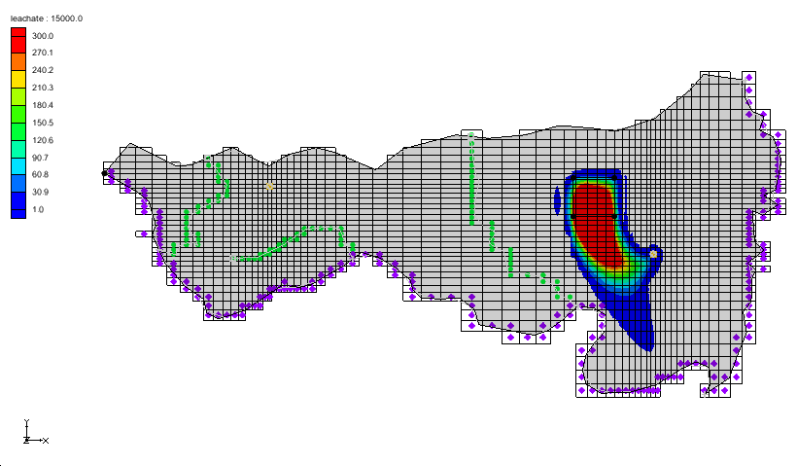

Figure 3 Leachate dispersion from the landfill at the end of the simulation

Do the following to view the solution for layer two in cross section view:

1. Select a cell that has some leachate dispersion in the vicinity of the landfill.
2. Switch to **Side View**File:Side View Macro.svg.
3. Use the up and down arrows in the Mini Grid Toolbar to view the solution along different columns.
4. When finished, switch to **Plan View** File:Plan View Macro.svg.

Note that the leachate eventually reaches the river and the well. Now view the mass flux of leachate into the river that was computed with the transport observation package.

1. Select the “File:Coverage Active Icon.svg Sources&Sinks” coverage to make it active.
2. Using the **Select Arcs** File:GMS Select Arc Tool.svg tool, select the specified head arc along the bottom of the model. The computed mass flux is reported along the bottom of the window.

## Generating a Mass vs Time Plot

A plot of Mass vs. Time for a selected feature object can be created and viewed by doing the following:

1. Make sure that you still have the head arc at the bottom-right of the model selected. If it is not selected, use the Select Arcs File:GMS Select Arc Tool.svg tool to select it.
2. Click **Plot Wizard** File:Plot Wizard Macro.svg to bring up the *Step 1 of 2* page of the *Plot Wizard* dialog.
3. Select “Mass vs. Time” from the list on the left.
4. Click **Finish** to create the plot and close the *Plot Wizard* dialog.

The plot shows the mass flux that leaves the model through the selected river arc.

1. Close Windows - Close button.png the plot window and maximize Windows - Maximize button.png the GMS Graphics Window.
2. **Frame** File:Frame Macro.svg the project to resize the view of the model grid.

## Viewing an Animation

Next, observe how the solution changes over the course of the simulation by generating an animation. Do the following to set up the animation:

1. Select the “File:Dataset Cells Active.svg leachate” dataset in the Project Explorer.
2. Select Display | **Animate…** to bring up the *Options* page of the *Animation Wizard* dialog.
3. In the *Options* section, turn on *Dataset*.
4. Next to *Animation file*, click the browser button [File:Open macro icon.png](https://www.xmswiki.com/images/b/b9/Open_macro_icon.png) to open the *Save* dialog.
5. Enter “run1.mp4” as the *File name*.
6. Make certain the *Save as type* is set to “Animation files (*.mp4,8.avi)”.
7. Select **Save** to exit the *Save* dialog.
8. Click **Next** to go to the *Datasets* page of the *Animation Wizard* dialog.
9. Turn on Display clock.
10. Click **Finish** to close the *Animation Wizard* dialog

If desired, open the MP4 file in an media player application outside of GMS.

# Modeling Sorption and Decay

The solution that was just computed can be thought of as a worst-case scenario because sorption and decay were neglected. Sorption will retard the movement of the plume and decay (due to biodegradation) will reduce the concentration. For the second part of the tutorial, modify the model so that sorption and decay are simulated. Then compare this solution with the first solution.

## Turning on the Chemical Reactions Package

Sorption and decay are simulated in the *Chemical Reactions Package*. This package must be turned on before it can be used.

1. Select *MT3DMS |* Basic Transport Package… to open the *Basic Transport Package* dialog.
2. Click **Packages…** to open the *MT3DMS/RT3D Packages* dialog.
3. Turn on Chemical reaction package.
4. Click **OK** to exit the *MT3DMS/RT3D Packages* dialog.
5. Click **OK** to exit the *Basic Transport Package* dialog.

## Entering the Sorption and Biodegradation Data

Next, enter the sorption and biodegradation data in the *Chemical Reactions* *Package* dialog.

1. Select *MT3DMS |* Chemical Reaction Package… to bring up the *Chemical Reaction Package* dialog.
2. From the *Sorption* drop-down, select “Linear isotherm”.
3. Select “First-order irreversible kinetic reaction” from the *Kinetic rate reaction* drop-down.
4. For the *Layer,* enter “1”.
5. For the *Bulk density,* enter “53500.0”.
6. In the spreadsheet, enter “5.85e-006” in the *leachate* column of the *1st sorption const.* row.
7. Enter “0.0001” in the *leachate* column on both the *Rate const. (dissolved)* and the *Rate const. (sorbed)* rows.
8. For the *Layer,* enter “2”.
9. For the *Bulk density,* enter “51500.0”.
10. In the spreadsheet, enter “5.85e-006” in the *leachate* column of the *1st sorption const.* row.
11. Enter “0.00005” in the *leachate* column on both the *Rate const. (dissolved)* and the *Rate const. (sorbed)* rows.
12. Click **OK** to exit the *Chemical Reaction Package* dialog.

## Run Options

It is nearly time to save the project under a new file name. However, the problem described earlier with the HFF file will be an issue because MT3DMS will look for a HFF file with the same name as the one about to be used to save the project. Because that file does not exist, MODFLOW could be rerun to create it. Another way to address the issue is by doing the following:

1. Select *MT3DMS |* **Run Options…** to bring up the *Run Options* dialog.
2. Select Single run with selected MODFLOW solution.
3. Select “run1 (MODFLOW)” from the drop-down.
4. Click **OK** to close the *Run Options* dialog

With this option, GMS tells MT3DMS to use the HFF file that was generated previously.

# Saving and Running MT3DMS

It is now possible to save the new simulation.

1. Select *File |* **Save As…** to bring up the *Save As* dialog.
2. Select “Project Files (*.gpr)” from the *Save as type* drop-down.
3. Enter “run2.gpr” as the *File name*.
4. Click **Save** to save the project with the new name and close the *Save As* dialog.
5. Select *MT3DMS |* **Run MT3DMS…**to bring up the *MT3DMS* model wrapper dialog.
6. When the simulation is finished, turn on *Read solution on exit*.
7. Click **Close** to import the solution and close the *MT3DMS* dialog.

Notice again that it is possible to view the sorbed dataset.

# Viewing the Solution

After the simulation finishes and the solution is read into GMS:

1. Select the “File:Dataset Cells Active.svg leachate” dataset under the “File:Generic Folder Locked.svg run2 (MT3DMS)” in the Project Explorer.
2. In the Time Step list below the Project Explorer, select the last time step.

Notice that at the end of the simulation the plume is smaller and less advanced than the same time step in the first simulation (Figure 4).

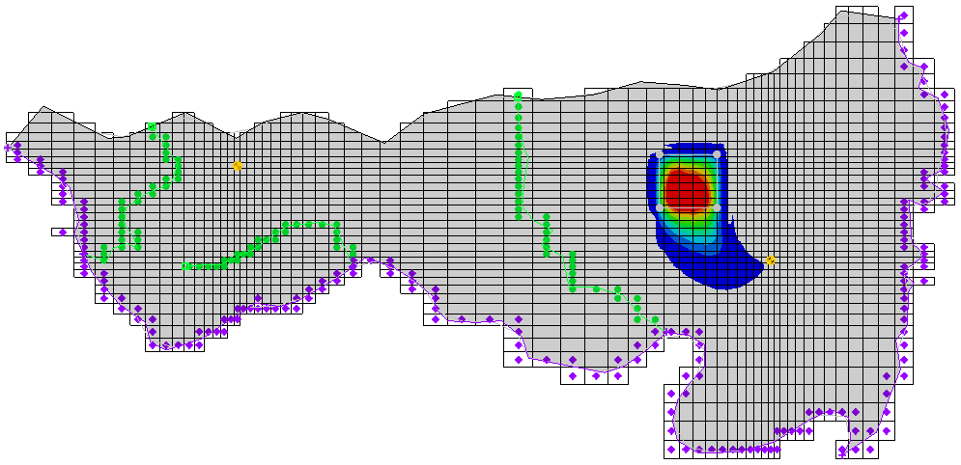

Figure 4 Last time step in run2

## Run Options

A useful way to compare two transient solutions is to generate a time history plot. The fastest way to do this is to create an “Active Dataset Time Series” plot.

1. Click Plot Wizard File:Plot Wizard Macro.svg to bring up the *Step 1 of 2* page of the *Plot Wizard* dialog.
2. Select “Active Dataset Time Series” from the list on the left.
3. Click **Finish** to generate the plot and close the *Plot Wizard* dialog.
4. Move the *Active Dataset Time Series* window so the main GMS window is not hidden.
5. Select a cell in the grid near the landfill. Notice that the plot shows the concentration v. time.
6. Select a different cell and notice that the plot updates. If no cell is selected, then the plot will not show any data. However, if a selection was made and then is deselected, the data for the last selection will remain in the plot.

To export the plot data and put it into a spreadsheet program:

1. Right-click on the plot and select **View Values…** to bring up the *View Values* dialog.
2. Select the desired data and press *Ctrl-C*.
3. Go into the desired spreadsheet program, select a cell, and press *Ctrl-V* to paste the copied data.
4. Back in GMS, click **Close** to exit the *View Values* dialog.

# Conclusion

This concludes the “MT3DMS – Conceptual Model Approach” tutorial. The following key concepts were discussed and demonstrated in this tutorial:

* If starting with a MODFLOW conceptual model and wanting to do a transport model, first turn on transport in the conceptual model properties.
* It is possible to use the *MT3DMS |* **Run Options…** command to tell MT3DMS which MODFLOW solution to use.

Continue experimenting with MT3DMS or close the program.