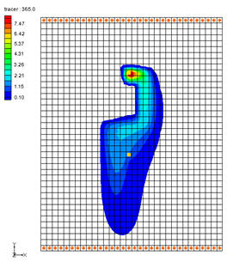

GMS 10.9

GMS 10.9 Tutorial

***MT3DMS – Grid Approach***

Create an MT2DMS model using the grid approach

Objectives

Construct a MT3DMS model using the grid approach. Values are manually assigned to the grid. Simple models can be easily constructed using the grid approach.

Time

* 15–25 minutes

Required Components

* GMS Core
* MODFLOW Interface
* MT3D

Prerequisite Tutorials

* MODFLOW – Grid Approach

|  |
| --- |
| [1 Introduction 2](#_Toc110861089)  [2 Getting Started 3](#_Toc110861090)  [2.1 The Flow Model 3](#_Toc110861091)  [3 The MT3DMS Basic Transport Package 4](#_Toc110861092)  [3.1 Species 5](#_Toc110861093)  [3.2 Packages 5](#_Toc110861094)  [3.3 Stress Periods 5](#_Toc110861095)  [3.4 Output Control 5](#_Toc110861096)  [3.5 ICBUND Array 6](#_Toc110861097)  [3.6 Starting Concentration Array 6](#_Toc110861098)  [3.7 HTOP and Thickness Arrays 6](#_Toc110861099)  [3.8 Porosity Array 6](#_Toc110861100)  [4 Setting up the Packages 6](#_Toc110861101)  [4.1 The Advection Package 6](#_Toc110861102)  [4.2 The Dispersion Package 6](#_Toc110861103)  [4.3 The Source/Sink Mixing Package 7](#_Toc110861104)  [5 Saving and Running MT3DMS 7](#_Toc110861105)  [6 Viewing the Solution 8](#_Toc110861106)  [6.1 The Source/Sink Mixing Package 8](#_Toc110861107)  [6.2 Setting Up an Animation 9](#_Toc110861108)  [6.3 Calculating the Mass of the Contaminant 10](#_Toc110861109)  [7 Conclusion 10](#_Toc110861110) |

# Introduction

This tutorial describes how to perform an MT3DMSsimulation within GMS. An MT3DMS model can be constructed in GMS using one of two approaches: the conceptual model approach or the grid approach.

With the conceptual model approach, the sources/sinks and zones in the model are defined with GIS objects and automatically assigned to the grid. With the grid approach, values are manually assigned to the grid. While the conceptual model approach is generally preferable for large, complicated models, simple models can be easily constructed using the grid approach. The grid approach is described in this tutorial.

The problem in this tutorial (Figure *1*) corresponds to a sample problem described in the MT3DMS documentation.[[1]](#footnote-1) The problem consists of a low K zone inside a larger zone. The sides of the region are no flow boundaries. The top and bottom are constant head boundaries that cause the flow to move from the top to the bottom of the region. An injection well with a specified concentration provides the source of the contaminants. A pumping well serves to withdraw contaminated water migrating from the injection well. A steady state flow solution will be computed, and a transient transport simulation will be performed over a one-year period.

This tutorial discusses and demonstrates opening a MODFLOW simulation and running MODFLOW, initializing MT3DMS and entering the data for several MT3DMS packages, running MT3DMS and importing the solution, setting up an animation to visualize the solution, and calculating the mass of the contaminant.



Figure 1 Sample flow and transport problem

# Getting Started

Do the following to get started:

1. If necessary, launch GMS.

If GMS is already running, select *File |* **New** to ensure that the program settings are restored to their default state.

## The Flow Model

Before setting up an MT3DMS simulation, a MODFLOW simulation must exist. The MODFLOW solution is used as the flow field for the transport simulation. In the interest of time, import a previously created MODFLOW simulation.

1. Click **Open** File:Open Macro.svg to bring up the *Open* dialog.
2. Select “Project Files (\*.gpr)” from the *Files of type* drop-down.

Browse to the *mt3dgrid\mt3dgrid\* directory and select “mt3dgrid.gpr”.

Click **Open** to import the project and exit the *Open* dialog.

Now save the project under a new name. Because the name is changing, MODFLOW must be run again to compute solution files with the new name. Otherwise, when MT3DMS runs, it will look for solution files with the new name and not find any.

Select *File* | **Save As…** to bring up the *Save As* dialog.

Select “Project Files (\*.gpr)” from the *Save as type* drop-down.

Enter “transport.gpr” as the *File name*.

Click **Save** to save the project with a new name and close the *Save As* dialog.

In the Project Explorer, select “File:3D Grid Folder.svg 3D Grid Data” to make it active.

Click **Run MODFLOW** File:Run MODFLOW Macro.svg to bring up the *MODFLOW* model wrapper dialog.

When it finishes running, turn on *Read solution on exit* and *Turn on contours (if not on already)*.

1. Click **Close** to import the solution and exit the *MODFLOW* dialog.
2. Click **Contour Options** File:Contour Options Macro.svg to open the *Dataset Contour Options – 3D Grid – tracer* dialog.

Select “Linear” from the first drop-down in the *Contour method* section.

The model should appear similar to Figure 2.

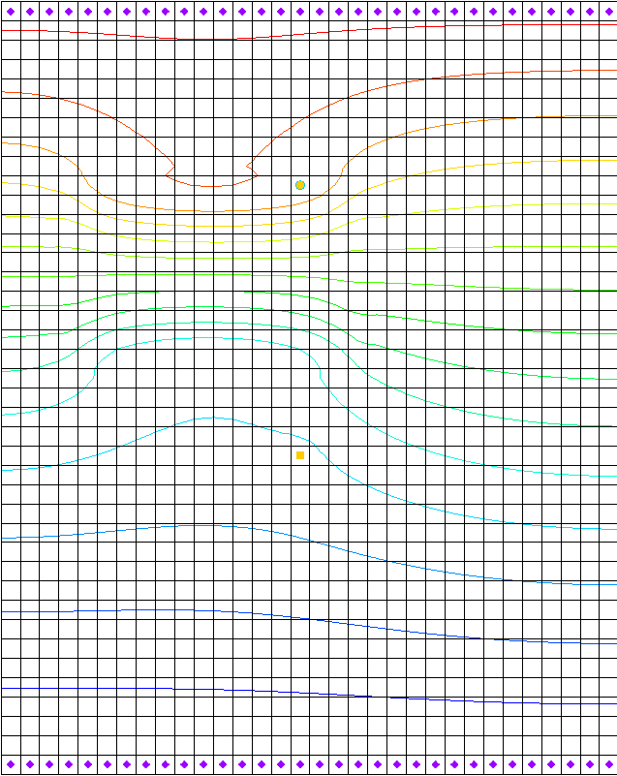

Figure 2 Model contours after MODFLOW run

# The MT3DMS Basic Transport Package

With a flow solution, it is possible to set up the MT3DMS transport simulation. Like MODFLOW,MT3DMS is structured in a modular fashion and uses a series of packages as input. Consequently, the GMS interface to MT3DMS is similar to the interface to MODFLOW and will follow a similar sequence of steps to enter the input data.

First, initialize the MT3DMS simulation.

1. Fully expand the “File:3D Grid Folder.svg 3D Grid Data” folder.

Right-click on “File:3D Grid Icon.svg grid”and select **New MT3DMS*…*** to open the *Basic Transport Package* dialog.

A warning dialog will appear saying, that this action will delete all current MT3DMS data. Select **OK**.

The MT3DMS options in the *Basic Transport Package* dialog are always required to be set. They define basic information such as stress periods, active/inactive regions, and starting concentration values.

## Species

Since MT3DMS is a multi-species model, it is necessary to define the number of species and name each species.

1. Click **Define Species…** to open the *Define Species* dialog.

Click **New** to create a new species.

In the *Name* column, enter “tracer”.

Click **OK** to close the *Define Species* dialog.

## Packages

Next, select which packages to use.

1. Click **Packages…** to open the *MT3DMS/RT3D Packages* dialog.

Turn on Advection package, Dispersion package, and Source/sink mixing package.

Click **OK** to close the *MT3DMS/RT3D Packages* dialog.

## Stress Periods

The next step is to set up the stress periods. The flow simulation was steady state, but the transport simulation will be transient and will run for a one-year period. To do this, use a single stress period (since the input values are constant) and allow MT3DMS to determine the appropriate transport step size.

1. Click **Stress Periods…** to open the *Stress Periods* dialog.

In row *1 of* the Length column, enter “365.0”.

In the Trans. step size column, enter “0.0”.

A value of zero signifies that MT3DMS will automatically compute the appropriate transport step size.

1. Click **OK** to exit the Stress Periods dialog.

## Output Control

Next, specify the output options.

1. Click **Output Control…** to open the *Output Control* dialog.

Select *Print or save at specified interval* and enter “10” in that field.

This outputs a solution at every tenth transport step.

1. Click **OK** to exit the *Output Control* dialog.

## ICBUND Array

The ICBUND array is similar to the IBOUND array in MODFLOW. The ICBUND array is used to designate active transport cells (ICBUND>0), inactive transport cells (ICBUND=0), and constant concentration cells (ICBUND<0). For this problem, all the cells are active, therefore, no changes are necessary. It is accessible via the **ICBUND…** button.

## Starting Concentration Array

The starting concentration array defines the initial condition for the contaminant concentration. In the current problem, the starting concentrations are all zero, so the default is adequate. It is accessible via the http://www.xmswiki.com/images/f/fc/Dot_dot_dot_button.png button in the *Starting Conc. Per Cell* column in the spreadsheet to the right of the *Starting Conc. (mg/l)* column.

## HTOP and Thickness Arrays

MT3DMS uses the HTOP array and a thickness array to determine the layer geometry. However, the values for these arrays are determined by GMS automatically from the MODFLOW layer data, so no input is necessary. They are accessible via the **HTOP…** button.

## Porosity Array

Finally, define the porosity for the cells. This problem has a constant porosity of 0.3. This is the default value in GMS, so no changes need to be made. It is accessible via the **Porosity…** button.

This completes the definition of the Basic Transport package data.

1. Click **OK** to exit the Basic Transport Package dialog.

# Setting up the Packages

## The Advection Package

The next step is to enter the data for the Advection package. This tutorial will use the Third Order TVD scheme (ULTIMATE) solution scheme. This is the default, so nothing needs to be done.

## The Dispersion Package

Next, enter the data for the Dispersion package.

1. Select MT3DMS | **Dispersion Package…** to open the *Dispersion Package* dialog.

Click **Longitudinal Dispersivity…** to bring up the *Longitudinal Dispersivity* dialog.

Click **Constant → Grid…** to open the *Grid Value* dialog.

For the *Constant value for grid,* enter “20.0”.

Click **OK** to close the *Grid Value* dialog.

Click **OK** to exit the Longitudinal Dispersivity dialog.

In the *TRPT* column of the spreadsheet, enter “0.2”.

Click **OK** to exit the Dispersion Package dialog.

## The Source/Sink Mixing Package

Finally, define the data for the Source/Sink Mixing package. For this problem, only one source/sink exists: the injection well. To define the source at the injection well, select the well and assign a concentration.

1. Using the **Select Cells** File:Select 3D Cell Tool.svg tool, select the cell containing the injection well (the upper well, cell ID 304).

Right-click on the selected cell and select **Sources/Sinks…** to bring up the *MODFLOW/MT3DMS Sources/Sinks* dialog.

Select “MT3DMS: Point SS” from the list on the left.

Click **Add BC** to create a new entry in the spreadsheet.

In the *Type (ITYPE)* column, select “well (WEL)” from the drop-down.

In the *tracer* column, enter “57.87”.

This is the concentration of the tracer species in that cell.

Click **OK** to exit the *MODFLOW/MT3DMS Sources/Sinks* dialog.

Click anywhere outside the grid to deselect the cell.

# Saving and Running MT3DMS

Now save the simulation and run MT3DMS.

1. **Save** File:Save Macro.svg the project.

Click **Run MT3DMS** File:Run MT3DMS Macro.svg to bring up the *MT3DMS* model wrapper dialog.

When the simulation is finished, turn on *Read solution on exit*.

Click **Close** to import the solution and close the *MT3DMS* dialog.

The model should appear similar to Figure 3.

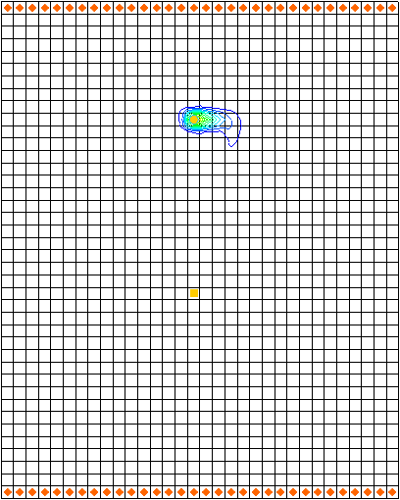

Figure After MT3DMS is run

# Viewing the Solution

## The Source/Sink Mixing Package

When displaying plume data, the color fill option often provides excellent results.

1. Click **Contour Options** File:Contour Options Macro.svg to open the *Dataset Contour Options – 3D Grid – tracer* dialog.

Select “Color Fill” from the first drop-down in the *Contour method* section.

Click **OK** to close the *Dataset Contour Options – 3D Grid – tracer* dialog.

The model should appear similar to Figure 4.

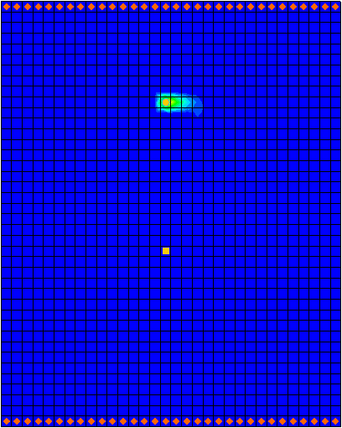

Figure Using color fill contours

## Setting Up an Animation

Observe how the solution changes over the one-year simulation by generating an animation. Do the following to set up the animation:

1. Select *Display |* **Animate…** to bring up the *Options* page of the *Animation Wizard* dialog.
2. Next to *Animation file*, click on the browser 16px-Open_Macro button to open the *Save* dialog.
3. Enter “transport.mp4” as the *File name*.
4. Be certain that the *Save as type* is set to “Animation (\*.mp4, \*.avi)”.
5. Select **Save** to close the *Save* dialog.

Turn on *Dataset* and click **Next** to go to the *Datasets* page of the *Animation Wizard* dialog.

Select *Use constant interval* and enter “36.5” as the *Time interval*.

This will result in 11 frames.

Turn on Display clock.

Click **Finish** to generate the animation, close the *Animation Wizard* dialog.

To view the animalion, launch an animation application of your choice outside of GMS.

The frames of the animation which are being generated will appear.

1. When finished, close the *animation application* window and return to GMS.

## Calculating the Mass of the Contaminant

Finally, calculate the mass of the contaminant in the aquifer at various times during the simulation.

1. Using the **Select Cells** File:Select 3D Cell Tool.svg tool, select the cell containing the well in the lower portion of the model (cell ID 752).

Select *MT3DMS |* **Calculate Mass…** to open the *Calculate Mass* dialog.

This dialog allows calculation of the mass of a contaminant in the entire model domain or in the selected cell(s). The *Definition* section of the dialog explains the formula that is used to calculate the mass. Basically, the volume of water in each cell is calculated and then multiplied by the concentration computed by MT3DMS. Simply supply a conversion factor so that the calculated mass will be computed in the correct units. The *Unit conversion factor* section shows an example of a conversion factor. The *Concentration range* section allows specifying a range over which the mass will be calculated. This is most useful to ignore negative concentrations that result in MT3DMS simulations.

In the *Concentration range* section, turn on *Specify range in calculation*.

For *Min,* enter “0.0”.

For *Max,* enter “9.0”.

In the *Unit conversion factor* section, enter “0.0283” as the *Factor.*

This means the resulting mass will be displayed in units of grams.

Select *Use only selected cells in calculation*.

Click **Calculate.**

Notice that the mass values are shown in the spreadsheet on the right side of the dialog.

Now select *Use all cells in calculation* and click **Calculate** again.

The total mass in the aquifer for each time step of the solution should now be visible. Review the results in the spreadsheet.

1. When finished, select **Done** to close the *Calculate Mass* dialog

# Conclusion

This concludes the “MT3DMS – Grid Approach” tutorial. The following key concepts were discussed and demonstrated in this tutorial:

* MT3DMS is available only if a MODFLOW model HFF file is in the current location of the project files. If MODFLOW files are moved or renamed, they will need to be regenerated by running MODFLOW to create the solution files so that MT3DMS can find them.
* GMS gives MT3DMS the top and bottom elevation data it requires for each layer from the MODFLOW model.
* It is possible to use the *Animation Wizard* to create an animation in GMS.
* It is possible to calculate the mass of a contaminant in the 3D grid using the *MT3DMS |* **Calculate Mass…** command.

1. Zheng, Chunmiao and Wang, P. Patrick (December 1999). “A Two-Dimensional Application Sample” in *MT3DMS: A Modular Three-Dimensional Multispecies Transport Model for Simulation of Advection, Dispersion, and Chemical Reactions of Contaminants in Groundwater Systems; Documentation and User’s Guide*, Strategic Environmental Research and Development Program (SERDP), U.S. Army Corps of Engineers, Contract Report SERDP-99-1, pp. 152-154. <http://hydro.geo.ua.edu/mt3d/mt3dmanual.pdf> [↑](#footnote-ref-1)