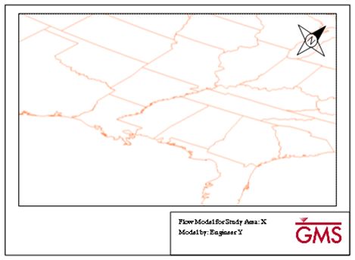

GMS 10.9

GMS 10.9 Tutorial

***GMS Layout Editor***

Create and save layouts for printing model data from GMS

Objectives

Learn how to use the Layout Editor to create printed reports from GMS.

Time

* 15–30 minutes

Required Components

* None

Prerequisite Tutorials

* Getting started

|  |
| --- |
| 1 Introduction and Getting Started 2  2 GMS User Interface 2  3 Creating a Layout 3  3.1 Inserting a Map 4  3.2 Inserting a Scale Bar 5  3.3 Inserting a North Arrow 7  4 Adding Another Map to the Layout 9  5 Printing the Layout 11  6 Exporting and Importing Layouts 12  7 Conclusion 13 |

# Introduction and Getting Started

The Layout tool can be used to create print layouts of GMS project data. Layouts may contain multiple maps/views of project data as well as annotations, north arrows, and scale bars. The layout tool provides a mechanism for quickly preparing model outputs for reports. A layout template can also be created and used in multiple projects. This tutorial goes over the options available for creating layouts in GMS.

This tutorial will discuss the following:

* Importing a GMS project
* Creating a layout
* Printing that layout
* Exporting a layout template for use in other projects
* Importing and using a previously-exported layout template.

To get started:

1. If necessary, launch GMS.
2. If GMS is already running, select *File |* **New** to ensure that the program settings are restored to their default state.

# GMS User Interface

Begin by importing a GMS project.

1. Click **Open** File:Open Macro.svg to bring up the *Open* dialog.
2. Browse to the *PrintLayout* folder and select “start.gpr”*.*
3. Click **Open** to import the file and close the *Open* dialog.

The GMS graphics window should look similar to Figure 1. This project contains a single shapefile of the United States of America.

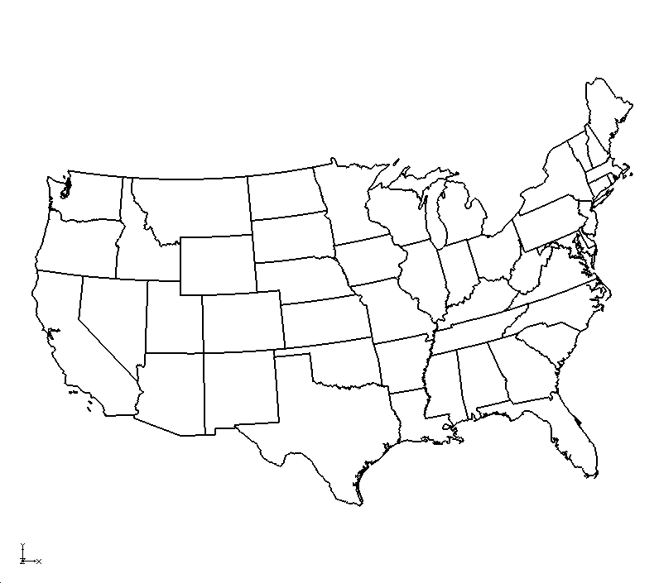

Figure 1 Shapefile loaded into GMS

# Creating a Layout

To create a print layout, do the following:

1. Select *File |* **Layout (Beta)…** to bring up the *Layout Editor* dialog (Figure 2).

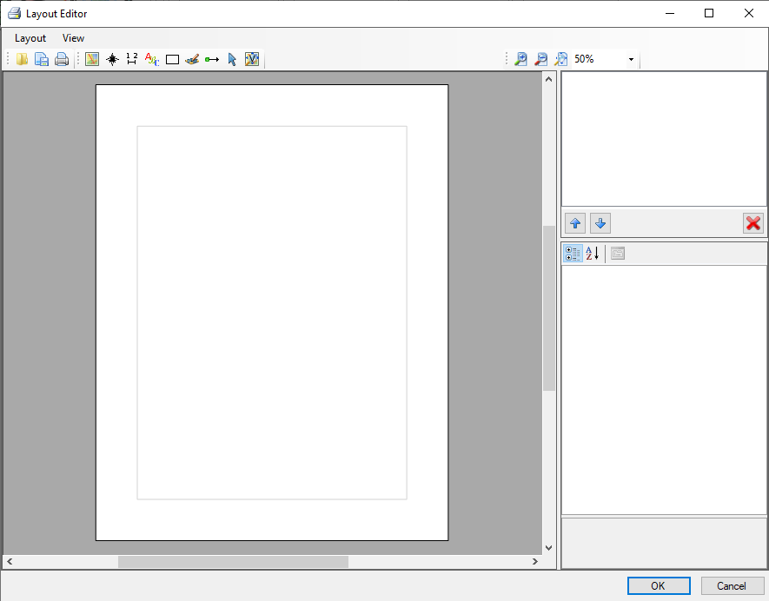

Figure 2 Layout Editor dialog

The *Layout Editor* dialog is similar to the page setup in a word processor. The default page is the typical 8” X 11” in portrait. Choose a different paper size or use landscape by changing the settings through *File |* **Page Setup…** and the *Page Setup* dialog. The tutorial uses the default settings for this exercise.

There are 5 basic components that can be added to a layout:

* **Map** http://www.xmswiki.com/w/images/7/7b/InsertMap.png – A view of the GMS data. Multiple maps (different views) may be inserted into a layout.
* **North Arrow** http://www.xmswiki.com/w/images/d/d6/InsertNorthArrowIcon.png – A north arrow associated with a particular map.
* **Scale Bar** http://www.xmswiki.com/w/images/0/0b/InsertScaleBarIcon.png – A scale bar associated with a particular map.
* **Text** http://www.xmswiki.com/w/images/1/14/InsertTextIcon.png – A text box for adding textual information to the layout; multiple text items may be included in a layout.
* **Rectangle** http://www.xmswiki.com/w/images/2/20/InsertRectangleIcon.png – Multiple rectangles may be included in a layout.
* **Bitmap** http://www.xmswiki.com/w/images/8/83/InsertBitmapIcon.png – A bitmap to insert an image into the layout.

## Inserting a Map

Begin by inserting a map into the layout.

1. Select the **Insert Map** http://www.xmswiki.com/w/images/7/7b/InsertMap.png tool from the toolbar.
2. Click and drag a rectangle as shown in Figure 3.

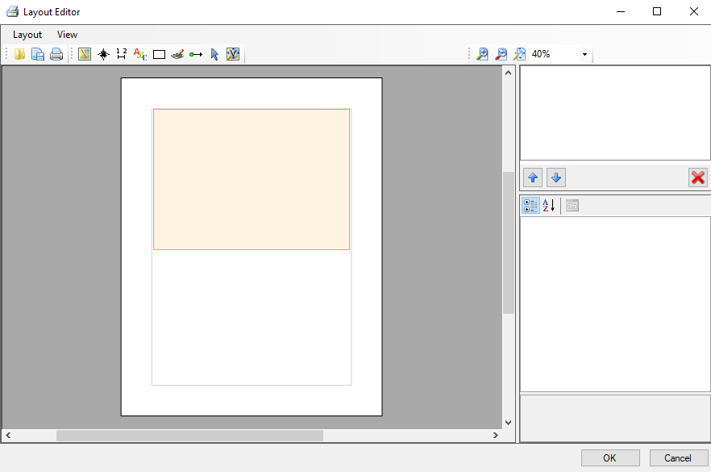

Figure 3 Location of inserted map in Layout Editor dialog

After inserting the map, the layout should look similar to Figure 4.

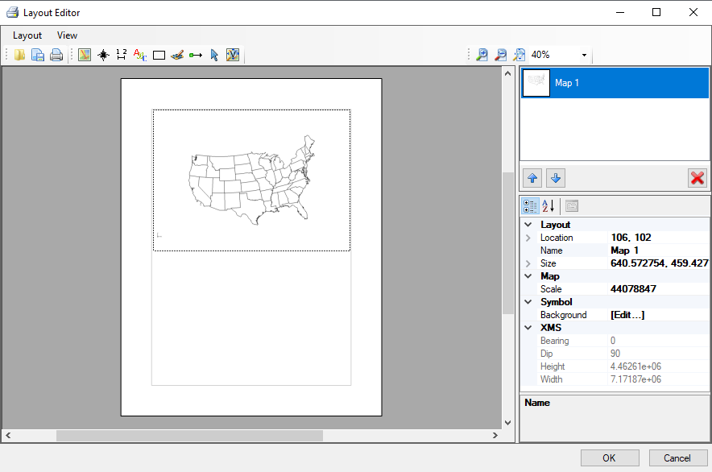

Figure 4 Layout Editor dialog with newly inserted map

On the upper right side of the *Layout Editor* dialog is a thumbnail of the map image labelled “Map 1”. This objects list will show all of the items that are inserted into the layout. Below the objects list is the properties section, showing the properties for the item selected in the objects list. In this case, the field shows the properties of “Map 1”: *Location*, *Name*, *Size*, *Scale*, and *XMS*.

1. In the properties section, enter “US Extents” in the field to the right of *Name*.
2. Select “Map 1” in the objects list above the properties window to update the name.

This map stores the view from GMS in the *View Properties* portion of the properties. This includes the zoom level and maximum/minimum coordinates that are visible in the current GMS view.

## Inserting a Scale Bar

Now, insert a scale bar that will be associated with the “US Extents” map.

1. Select the **Insert Scale Bar** http://www.xmswiki.com/w/images/0/0b/InsertScaleBarIcon.png tool, then click and drag a rectangle as shown in Figure 5.

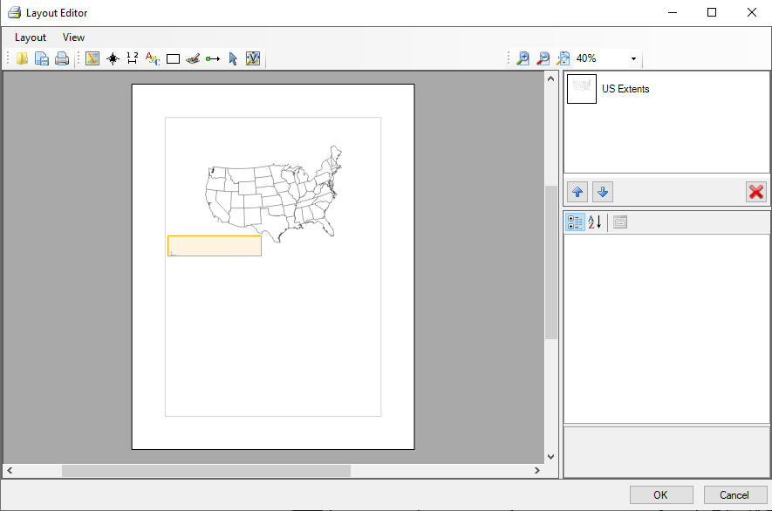

Figure 5 Inserting a scale bar

Once the scale bar is created, the layout should appear similar to Figure 6:

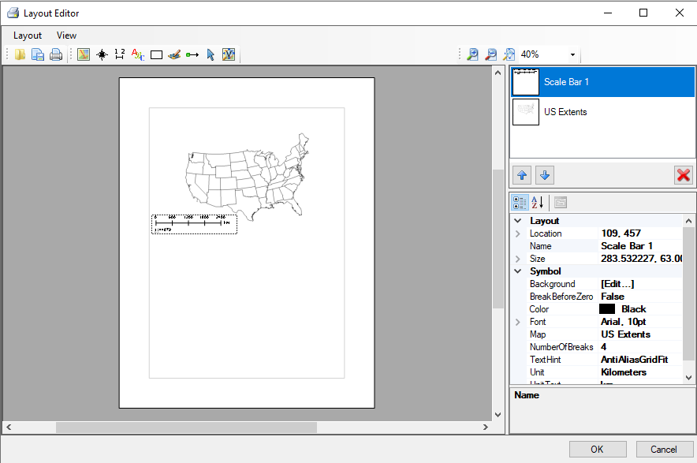

Figure 6 Scale bar inserted into layout

Look at the properties for the scale bar. Notice that one of the properties is *Map*. This indicates that the scale bar is associated with the “US Extents” map. When more than one map is included in the layout, this property is used to assure that the scale bar is associated with the appropriate map. Another important property for the scale bar is the *Unit*. Currently the *Unit* is set to “Kilometers”. To see the effect on the scale bar, change the unit to miles.

1. Select “Scale Bar 1” in the objects section.
2. Select “Miles” from the *Unit* drop-down in the properties section.
3. Enter “miles” in the *Unit Text* field.

The scale bar also has options for changing the color, font and adjusting the background. Feel free to explore those options.

## Inserting a North Arrow

To insert a north arrow into the layout, do the following:

1. Select the **Insert North Arrow** http://www.xmswiki.com/w/images/d/d6/InsertNorthArrowIcon.png tool, then click and drag a rectangle as shown in Figure 7.

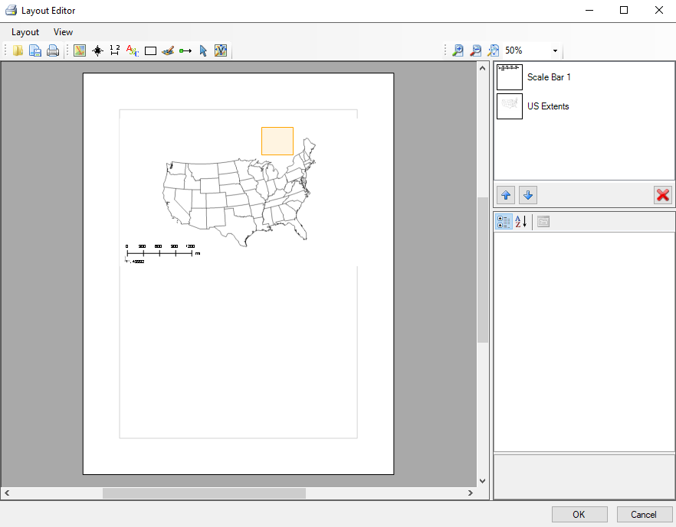

Figure 7 Inserting a north arrow

Once the north arrow is created, the layout should appear similar to Figure 8. Like the scale bar, the north arrow is associated with a particular map, where *Map* is one of the properties of the north arrow. The style of north arrow can be changed by selecting the *NorthArrowStyle* property and choosing one of the items in the list.

1. Select “North Arrow 1” in the objects section.
2. Select “CenterStar” from the *NorthArrowStyle* drop-down in the properties section.

If the north arrow is on top of part of the map, it may be hard to see. The background color for the arrow can be changed using the  button to the right of *Background* in the properties section. The color and pattern style of the background, as well as the opacity of the background and outline, can be adjusted in the *Polygon Symbolizer Properties* dialog that appears when the  button is clicked.

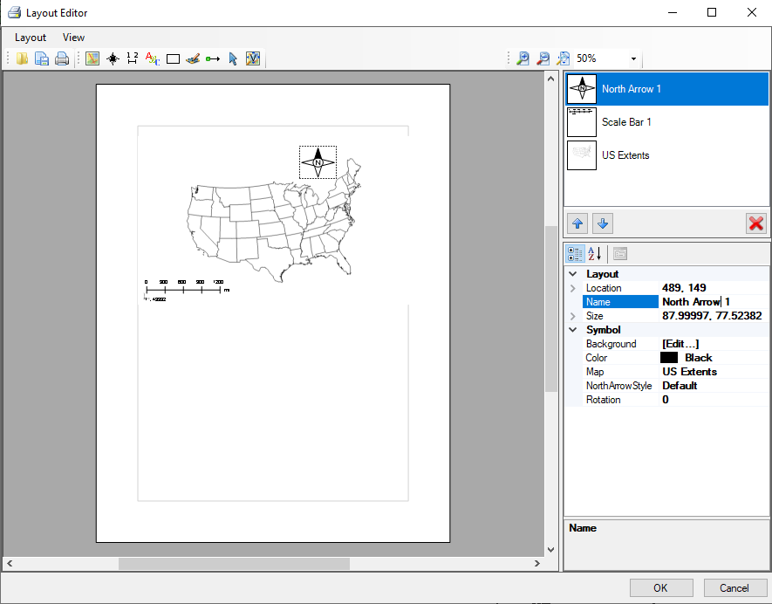

Figure 8 North arrow inserted into layout

1. Click in the *Background* property field, then click on the  button to bring up the *Polygon Symbolizer Properties* dialog.
2. On the *Simple* tab under the *Pattern Type* drop-down, click the large colored button to bring up the *Color* dialog.
3. Select cyan (the top color in the blue column) and click **OK** to close the *Color* dialog.
4. Move the *Fill Color* slider all the way to the right to make the color fully opaque (Figure 9).
5. Click **OK** to exit the *Polygon Symbolizer Properties* dialog.

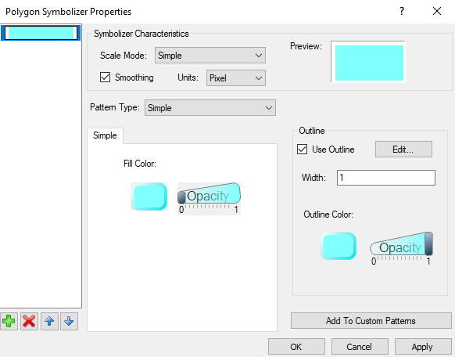

Figure 9 Polygon Symbolizer Properties dialog

Notice that the north arrow now has a cyan background. Inserting text boxes, rectangles, and bitmaps is very similar to the steps described above for north arrows and scale bars, so this tutorial will not go through those steps. Feel free to explore those options later.

1. Click **OK** to close the *Layout Editor* dialog.

# Adding Another Map to the Layout

Before adding a second map to the layout, some of the view and display options should be changed. Choosing a different Display Theme will change the view and display options quickly.

1. Expand the “ Display Themes” folder in the Project Explorer and select “Oblique View”. The Graphics Window should appear similar to Figure 10.

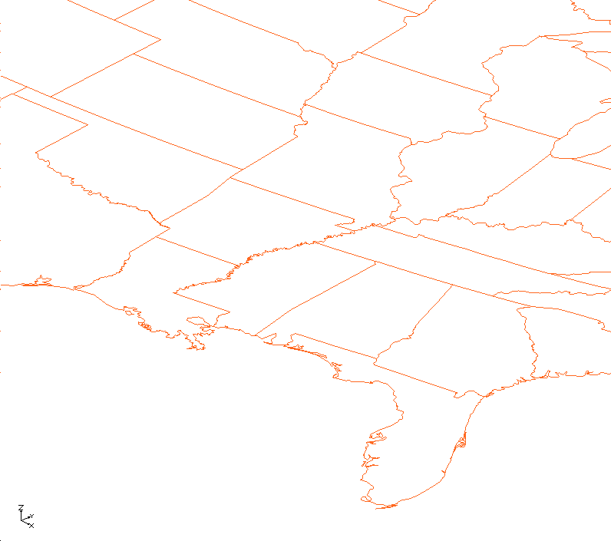

Figure 10 Oblique view of shapefile with new display options

1. Select *File* | **Layout (Beta)…** to bring up the *Layout Editor* dialog.

The layout will now look similar to Figure 10. Notice that the shapefile is now displayed in an orange color in the existing map in the layout. Any map saved in the layout is updated with the current display options.

To add another map to the layout:

1. Select the **Insert Map**  tool from the toolbar.
2. Click and drag a rectangle as shown in Figure 11. There are now two maps included in the layout.

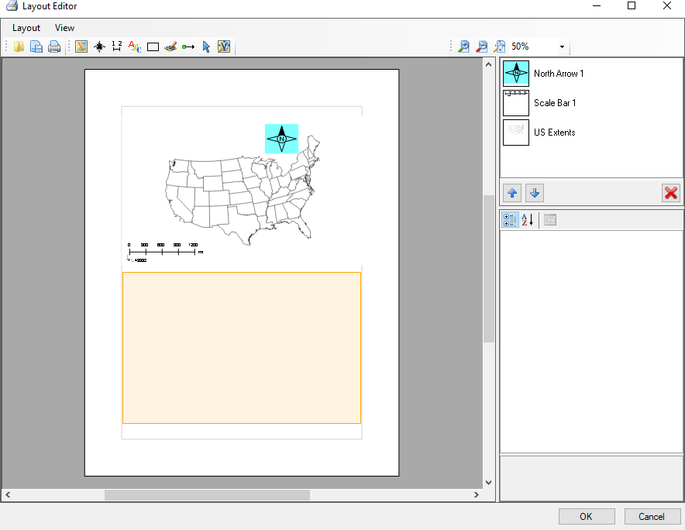

Figure 11 Creating a second map

After the new map is inserted, the *Layout Editor* window will look like Figure 12:

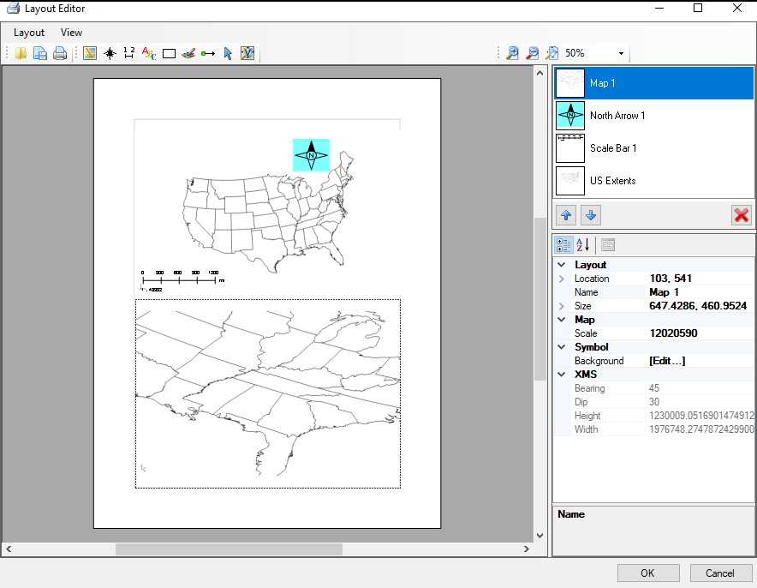

Figure 12 Layout with two maps

1. Select the **Insert Scale Bar** http://www.xmswiki.com/w/images/0/0b/InsertScaleBarIcon.png tool.

An error message displays stating that scale bars are only supported for plan view maps. However, a north arrow can be inserted with this map control.

1. Select **OK** to close the error message.
2. Select the **Insert North Arrow** http://www.xmswiki.com/w/images/d/d6/InsertNorthArrowIcon.png tool then click and drag a rectangle as shown in Figure 13.

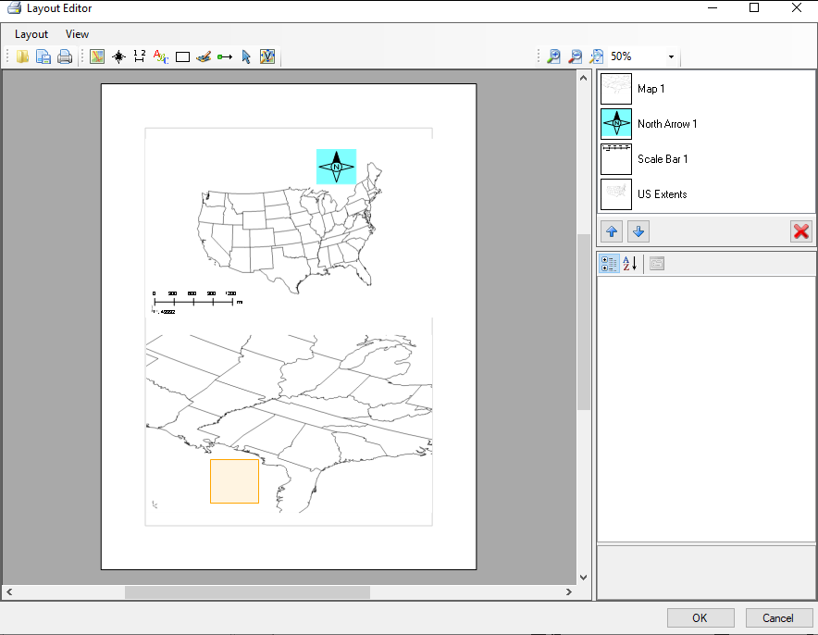

Figure 13 Inserting a north arrow for the second map

After inserting the north arrow the layout should look similar to Figure 14. Notice that the north arrow is rotated to match the north direction in the map.

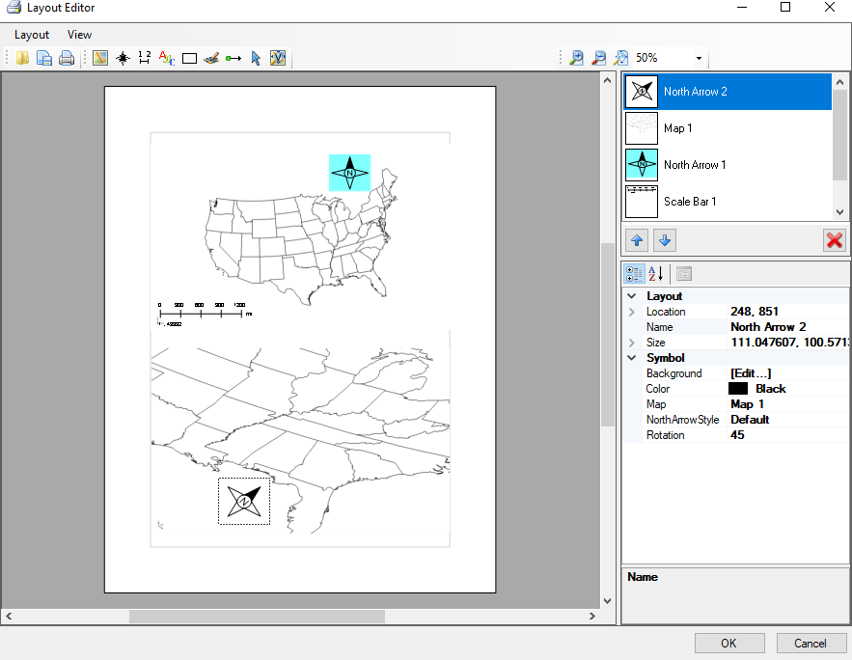

Figure 14 North arrow with oblique view map

# Printing the Layout

To print the layout, do the following:

1. Select *Layout* | **Print…** to bring up the *Print* dialog.
2. In the *Print* section, select the desired printer from the *Name* drop-down menu.
3. Click **OK** to print the layout and close the *Print* dialog.

# Exporting and Importing Layouts

Layouts can be reused in different projects. Exporting a layout allows it to be used later or in other projects. To export a layout:

1. Select *Layout* | **Export…** to bring up the *Export Layout* dialog.
2. Browse to the *PrintLayout* directory.
3. Enter “Demo.mwl” in the *File name* field.
4. Click **Save** to export the layout and close the *Export Layout* dialog.

To import a previously-created layout:

1. Select *Layout* | **Import…** to bring up the *Load Print Layout* dialog.
2. Select **No** if the *DotSpatial Print Layout* dialog pops up.
3. Browse to the *PrintLayout* directory and select “TemplateLayout.mwl”.
4. Click **Open** to import the layout and close the *Load Print Layout* dialog.

The layout should appear as in Figure 15.

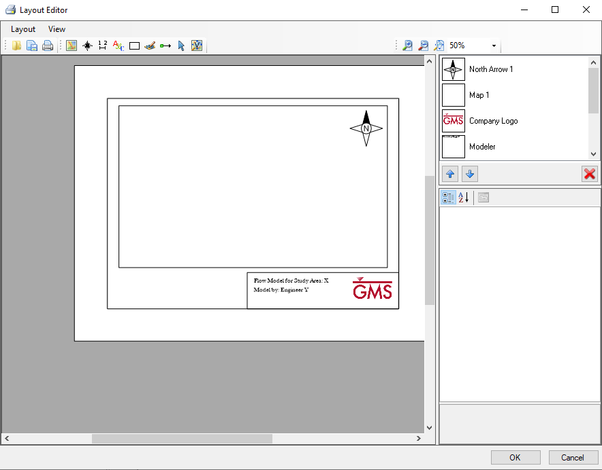

Figure 15 Imported layout

This layout contains a title block with text and a logo as well as a map and a north arrow. To update the map to match the current view in GMS, do the following:

1. Select “Map 1” from the objects list and click the **Update Current View** http://www.xmswiki.com/w/images/4/4c/UpdateViewIcon.png tool.

The layout should now look like Figure 16. Notice that the north arrow updated to reflect the changes made to the map.

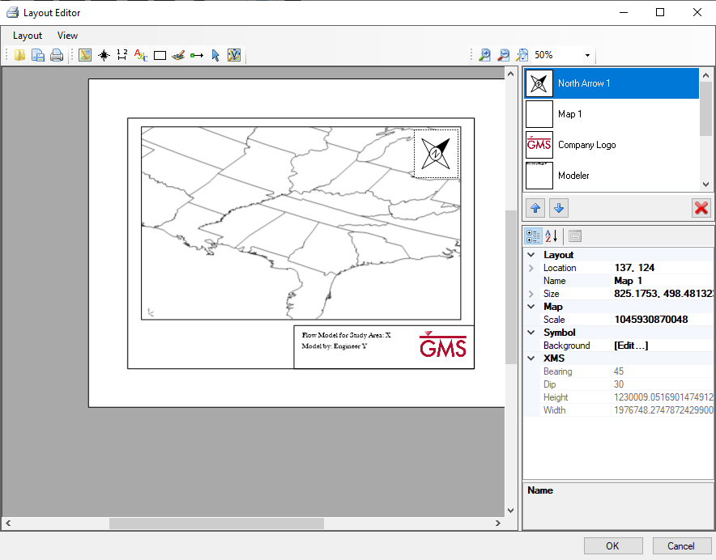

Figure 16 Updated map with north arrow updated

1. Click **OK** to close the *Layout Editor* window and return to the Main Graphics Window in GMS.

# Conclusion

This concludes the “Layout Editor” tutorial. The following topics were discussed:

* How to create print layouts in GMS.
* Inserting multiple maps into a layout.
* Inserting scale bars and north arrow objects in a layout, including that scale bars can only be used with maps in Plan view.
* Exporting layouts for use in other GMS projects.