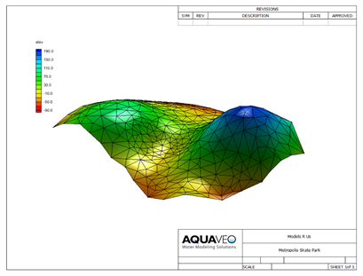

GMS 10.9

GMS 10.9 Tutorial

***Printing and Exporting Images***

Print and export images for use in reports and presentations

Objectives

GMS has a number of ways to print or export images for use in reports and presentations. This tutorial teaches about these different options.

Time

* 10–15 minutes

Required Components

* None

Prerequisite Tutorials

* None

|  |
| --- |
| 1 Introduction and Getting Started 2  2 Graphical Output 2  2.1 Printing 2  2.2 Saving Images 4  2.3 Completing a Screen Capture 5  3 Conclusion 6 |

# Introduction and Getting Started

This GMS tutorial discusses printing, exporting an image to a file, and copying the GMS screen to the clipboard and pasting it into another program

To get started, do the following:

1. If necessary, launch GMS.
2. If GMS is already running, select *File |* **New** to ensure that the program settings are restored to their default state.

# Graphical Output

After creating a GMS project, the user may want to include some images of the project in a printed report or on a web site. Graphical output can be obtained from GMS in multiple ways. Users will often want to export graphics from GMS and import them into another program in order to add things like titles, borders, and other embellishments.

## Printing

Printing from GMS can require multiple steps, all of which are described here. The *File* menu has two commands related to printing: **Print** and **Page Setup**. These two commands can be used to send whatever is currently displayed in the Graphics Window to a printer.

### Page Setup Dialog

1. Select *File* | **Page Setup…**to bring up the *Page Setup* dialog (Figure 1).
2. On the *Margins* tab, make any necessary adjustments to the top, bottom, left, and right margins of the document before printing.
3. On the *Paper* Size tab, choose the desired size of paper (letter, legal, etc.) on which to print.
4. If the printer has multiple paper sources, select the desired source from the *Paper Source* drop-down.
5. In the *Orientation* section, choose either *Portrait* or *Landscape* for the page orientation.
6. On the *Options* tab in the *Scale/Legend* section, set the scale of the image, whether to display a scale legend, and which font and font color are to be used for the legend.
7. The *Units* section allows setting of the units to be used for the scale and legend.
8. Click **OK** to close the *Page Setup* dialog**.**

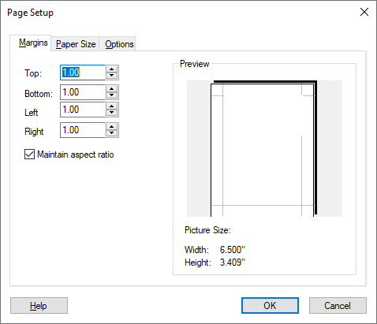

Figure Page Setup dialog on the Margins tab

### Print Dialog

1. Select *File* | **Print…** to bring up the *Print* dialog (Figure 2)*.*
2. From the *Name* drop-down, select the desired printer.
3. In the *Print Range* section, specify how many pages of the document should be printed. Choosing the *Selection* radio button will print only what is selected in the Graphics Window.
4. In the *Copies* section, specify the number of copies and whether or not those copies should be collated.
5. Click on the **Properties** button to bring up the *Document Properties* dialog for the selected printer. Different tabs and options will be available depending on the selected printer. Common options include page orientation (portrait or landscape), paper size, and others. Make any desired changes.
6. Click **OK** to close the *Document* *Properties* dialog.
7. Click **OK** to print the document or selection, or **Cancel** to close the *Print* dialog without printing.

The defaults in the *Print* dialog will often be the desired settings. This simplifies the process of printing a document or selection.

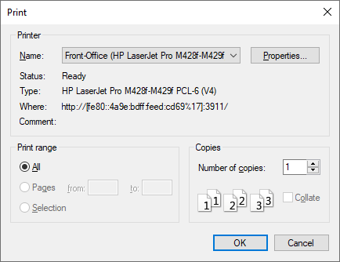

Figure Print dialog

## Saving Images

GMS allows exporting the current display as one of the following types of image file:

* BMP
* JPG/JPEG
* KMZ (raster or vector)
* PNG
* TIF/TIFF

First, import a project file:

1. Click **Open**File:Open Macro.svg to bring up the *Open* dialog.
2. Browse to the *basics* directory and select “surface.gpr”.
3. Click **Open** to import the project and close the *Open* dialog.

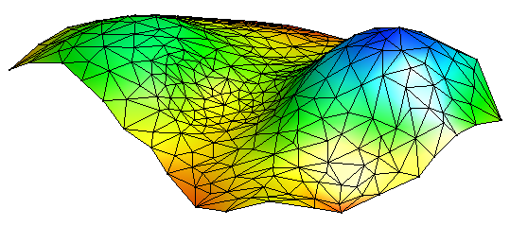

Figure The TIN contained in the "surface.gpr" project file

To export the screen as an image, do the following:

1. Select *File |* **Save As…** to bring up the *Save As* dialog.
2. Select “Bitmap Files (*.bmp)” from the *Save as type* drop-down.
3. Click **Options** to bring up the *Save Options* dialog.

By default, the image scale factor is “1.0”, meaning the size of the bitmap is the same as the current size of the graphics window. Depending on the use for the image, this may be adequate; however, if the image is to be used on a large poster, for instance, then the individual pixels will become apparent and distracting.

Improve the quality of the image by increasing the size of the window to which the image is pasted. To do that, either increase the resolution of the computer screen or increase the bitmap scale factor in this dialog. The following step will accomplish the latter option.

1. Enter “1.5” in the *Image scale factor* field.

A value of “1.5” instructs GMS to scale the exported image to a size one-and-a-half times larger than what is visible in the Graphics Window.

1. Click **OK** to close the *Save Options* dialog.
2. Enter “BiggerSurface.bmp” in the *File name* field.
3. Click **Save**to export the image and close the *Save As* dialog.

The “BiggerSurface.bmp” file can now be opened in another program.

## Completing a Screen Capture

GMS includes a screen capture command that takes whatever is currently displayed in the Graphics Window and copies it as a bitmap to the clipboard. The image can then be pasted into another program.

1. Select *Edit |* **Screen Capture…** to bring up the *Copy to Clipboard* dialog.

Notice that it is possible to specify a *Bitmap scale factor* here also. However, the clipboard has a limited amount of memory available to it; thus, GMS may not be able to scale the image up as much as it could when saving the file to disk. If a screen capture will not paste into another program, try reducing the scale factor.

1. Enter “1.0” in the *Bitmap scale factor* field.
2. Click **OK** to finish the screen capture and close the *Copy to Clipboard* dialog.
3. Open a word processing program and paste (usually accomplished by pressing *Ctrl-V*) the image from the clipboard into the program.

In this example, a word processing document was used to show how to paste from the clipboard. These same instructions can be generally applied to any program which allows pasting of images from the clipboard. Please refer to the documentation for the program being used for more specific instructions.

# Conclusion

This concludes the GMS “Printing and Exporting Images” tutorial. The following topics were discussed in this tutorial:

* GMS allows printing and exporting images in a number of ways.
* Bitmaps and other types of image files can be saved at various resolutions using the scale factor options.
* The Graphics Window can be copied at various resolutions to the clipboard and pasted into other programs.