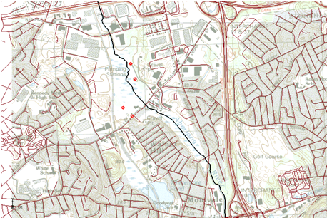

GMS 10.9

GMS 10.9 Tutorial

***Projections / Coordinate Systems***

Working with map projections in GMS

Objectives

Learn how to work with projections in GMS, and how to combine data from different coordinate systems into the same GMS project.

Time

* 20–30 minutes

Required Components

* GMS Core

Prerequisite Tutorials

* Feature Objects
* Rasters

|  |
| --- |
| [1 Introduction 2](#_Toc109982051)  [2 Getting Started 3](#_Toc109982052)  [3 Importing an Image 3](#_Toc109982053)  [3.1 Setting the Projection 3](#_Toc109982054)  [3.2 Setting Transparency 4](#_Toc109982055)  [4 Importing a CAD File 5](#_Toc109982056)  [5 Importing a Shapefile 7](#_Toc109982057)  [6 Importing Elevation Data 8](#_Toc109982058)  [6.1 Editing the Scatter Points 10](#_Toc109982059)  [7 Creating a Coverage 10](#_Toc109982060)  [8 Creating a 3D Grid 10](#_Toc109982061)  [9 Conclusion 11](#_Toc109982062) |

# Introduction

Coordinate systems and map projections provide information for locating data on the Earth (georeferencing). There are two types of coordinate systems: geographic and projected.

A geographic coordinate system uses a three-dimensional sphere to locate data on the Earth. Data in a geographic coordinate system is referenced using latitude and longitude. Latitude and longitude are angles measured from the Earth's center to a point on the Earth's surface.

A projected coordinate system is two dimensional based on a sphere or spheroid. Unlike a geographic coordinate system, projected coordinate systems have constant lengths, angles, and areas across the two dimensions.[[1]](#footnote-1)

A PRJ file is a text file containing information describing the type of coordinate system and other relevant data to position the related data on the Earth. This tutorial provides an overview of working with projected data in GMS through the following steps:

* Importing a TIFF file and assigning a projection
* Learning about the Display Projection
* Importing a CAD file and assigning a different projection
* Learning about “Project on the fly”
* Importing a shapefile with an associated projection
* Importing elevation data and edit points
* Creating a coverage and a 3D grid

# Getting Started

To get started, do the following:

1. If necessary, launch GMS.
2. If GMS is already running, from the menu bar, select *File |* **New** to ensure that the program settings are restored to their default state.

# Importing an Image

Start by importing an image of an area where the model will be built. The image was downloaded from the state of Massachusetts.

1. Click the **Open** File:Open Macro.svg macro to bring up the *Open* dialog.
2. Navigate to the *Projections* folder for this tutorial.
3. From the *Files of type* drop-down, select “Images (\*.tif, \*.tiff;…)”.
4. Select “q233914.tif” and click the **Open** button to import the image and close the *Open* dialog.
5. Move the mouse around in the Graphics Window.

This raster image came with a TFW (TIFF world) file. The world file is a representation of map data, focused on the location of the image, and pixel size and rotation. Notice that the lower right corner of the image is at x=233,000 and y=914,000. The world file contains enough information for GMS to position the image at the correct coordinates.

However, this raster image did not come with a PRJ (projection) file. Notice in the bottom right corner of the GMS window the text “No projection, Feet (U.S. Survey)” (Figure 1).

Without projection information GMS is not able to properly project the image onto the Earth’s spheroid. A projection must be specified to allow GMS to georeference the image and provide a consistent coordinate system.

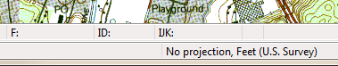

Figure 1 Projection information from GMS Window

## Setting the Projection

To set the projection in GMS:

1. In the *Project Explorer*, right-click on “http://www.xmswiki.com/images/thumb/4/4f/GIS_Raster_Icon.svg/60px-GIS_Raster_Icon.svg.png q233914.tif” and select *Projection* | **Projection…** from the context menu to bring up the *Projection* dialog.
2. In the *Horizontal* section, select *Global projection* to bring up the *Horizontal Projection* dialog.

This dialog is used to select a projection and can also be used to export or import PRJ files.

1. In the *Filter strings* field, enter “1983 Meters Massachusetts”.
2. Select “NAD 1983 StatePlane Massachusetts FIPS 2001 (Meters)” from the list.
3. Click the **OK** button to exit the *Horizontal Projection* dialog.
4. Click the **OK** button to exit the *Projection* dialog.
5. At the prompt explaining that a new TIFF file will be created, click the **OK** button to bring up the *Save As* dialog.
6. Click the **Save** button to accept the default *File name* and close the *Save As* dialog.
7. If an error comes up advising that the global projection needs to be set, continue to step 10. Otherwise, skip to step 15.
8. Click the **OK** button to close the error message and bring up the *Display Projection* dialog.
9. Click the **Set Projection…** button to bring up the *Display Projection* dialog.
10. From the list at the top, select “NAD 1983 StatePlane Massachusetts FIPS 2001 (Meters)”.
11. In the *Vertical* section, from the *Units* drop-down, select “Meters”.
12. Click the **OK** button to close the *Display Projections* dialog.

A new TIFF file named “q233914\_exported.tif” is created in the same directory as the “q233914.tif” file, then imported into GMS, replacing “q233914.tif” in the Project Explorer.

The projection information is saved inside the new TIFF file. Any time this TIFF file is imported into GMS (or any GIS application) the image will be georeferenced.

|  |  |
| --- | --- |
| Desc-i_gray 100px | Any time the projection is set on an image, a new image will be exported from GMS with the projection information stored in that image. |

1. Move the mouse around the Graphics Window.

Notice that the coordinates are the same as before, but now the latitude and longitude are displayed as the mouse moves. The current projection, also called the “display projection”, is visible in the bottom right corner of the GMS window (Figure 2).

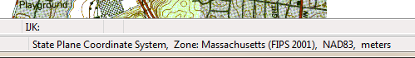

Figure 2 GMS Window with georeferenced data

When data that includes projection information is imported GMS, it will set the display projection to match the information in the file. The display projection can be changed to any supported projection, though some projections are not compatible. For example, data in State Plane, Massachusetts Mainland will not display in the Philippines Grid.

## Setting Transparency

The transparency of the image must now be changed so that the other data brought into the project will be easier to see.

To do this:

1. In the *Project Explorer*, right-click on “http://www.xmswiki.com/images/thumb/4/4f/GIS_Raster_Icon.svg/60px-GIS_Raster_Icon.svg.png q233814\_exported.tif” and select **Transparency…** from the context menu to bring up the *Layer Transparency* dialog.
2. Use the slider to set *Transparency* to “60%”.
3. Click the **OK** button to exit the *Layer Transparency* dialog.

The project should appear similar to Figure 3.

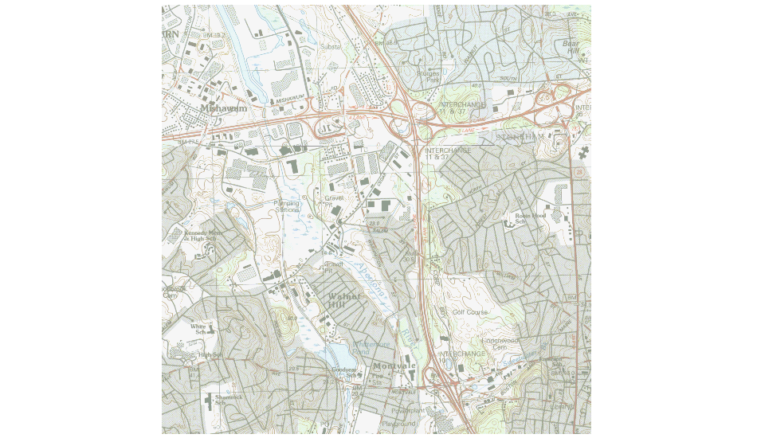

Figure 3 Map image with 60% transparency applied

# Importing a CAD File

To import a CAD file with the roads in the study area, do the following:

1. Click the **Open** File:Open Macro.svg macro to bring up the *Open* dialog.
2. From the *Files of type* drop-down, select “DWG/DXF Files (\*.dwg, \*.dxf)”.
3. Select “roads.dwg” and click the **Open** button to import the file and close the *Open* dialog.
4. A warning may appear that a projection for the imported data will need to be specified. Click the **OK** button to continue and the *Projection* *– Project\CAD\roads.dwg* dialog will open.
5. In the Horizontal section, the Global projection previously set should be selected. Click the **OK** button to close the *Projection* dialog.
6. If the window now appears blank, in the *Project Explorer*, right-click on “roads.dwg” and select the **Zoom To Extents** context menu item**.**

After importing the CAD file, the Graphics Window should appear similar to Figure 4.

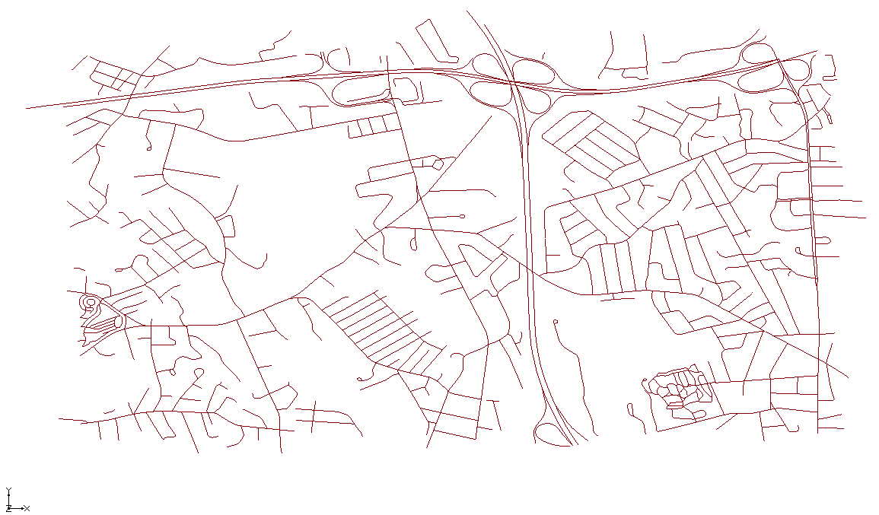

Figure 4 Imported CAD data

Notice that the background image has disappeared. By moving the mouse around in the Graphics Window, the displayed coordinates vary from (-71.15, 42.46) to (-71.09, 42.52), and the latitude/longitude values have changed.

Because there was no PRJ file associated with this CAD file, the data is drawn at the coordinates specified in the file. A projection for the CAD data must be specified so that it will be drawn in the correct location. This particular file has coordinates in latitude/longitude.

To set the projection:

1. In the *Project Explorer*, right-click on “http://www.xmswiki.com/images/thumb/0/0b/Convert_to_CAD_Icon.svg/60px-Convert_to_CAD_Icon.svg.png roads.dwg” and select *Projection* | **Projection…** context menu item to bring up the *Projection* dialog.
2. In the *Horizontal* section, select *Global projection* and click the **Set Projection…** button to bring up the *Horizontal Projection* dialog.

When opening the *Horizontal Projection* dialog, notice that a list of recently used projections is shown. This can be useful when assigning the same projections to multiple objects. Likewise, frequently used projections can be saved by right-clicking on the projection and selecting **Add to Favorites** which will then show the projection under the favorite projections folder.

Instead of searching the tree for the correct projection, enter the EPSG code to assign a geographic projection to the CAD data.

1. In the *Add projection from:* section, click the **EPSG code…** button to open the *Projection from EPSG code* dialog.
2. For the *New EPSG code*, enter “4269”.
3. Click the **OK** button to exit the *Projection from EPSG code* dialog.
4. Click the **OK** button to exit the *Horizontal Projection* dialog.
5. Click the **OK** button to exit the *Projection* dialog.
6. Click the **OK** button at the warning about changing projections.
7. In the Project Explorer, right-click on “http://www.xmswiki.com/images/thumb/0/0b/Convert_to_CAD_Icon.svg/60px-Convert_to_CAD_Icon.svg.png roads.dwg”, and select the **Zoom to Extents** context menu item.

The image should now be visible behind the CAD data (Figure 5). Even though the CAD data is in a different projection from the display projection, it is positioned in the correct location. The image and the CAD data are now georeferenced. The CAD data is “projected on the fly”, which involves transforming the coordinates of the CAD data from latitude and longitude to State Plane meters.

|  |  |
| --- | --- |
| Desc-i_gray 100px | Items with a projection different from the display projection are “projected on the fly” so that they are positioned correctly. |

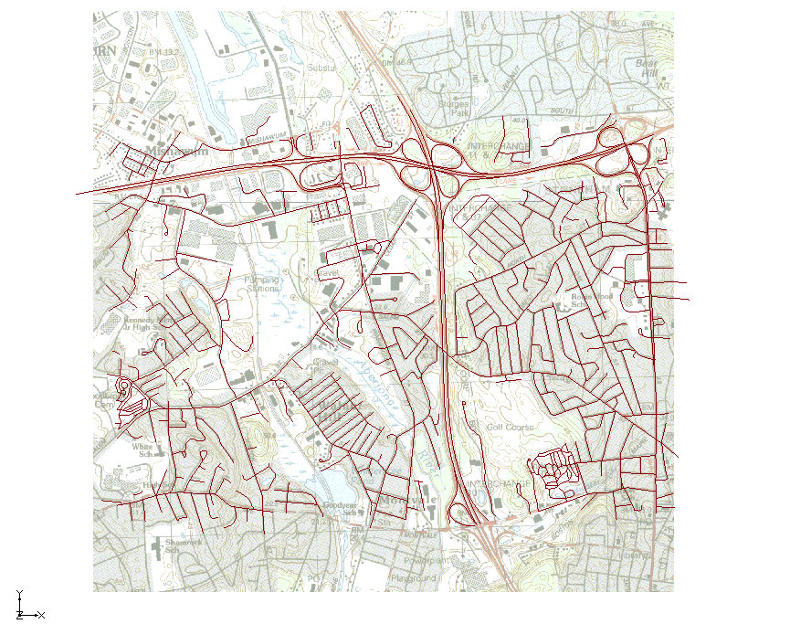

Figure 5 CAD data correctly positioned after specifying the projection

If the CAD file had initially had an associated PRJ file, then the data would have already been correctly positioned in the current display projection.

# Importing a Shapefile

A shapefile of the Aberjona River will now be imported. This shapefile uses a different projection than the display projection.

To import the shapefile:

1. Click the **Open** File:Open Macro.svg macro to bring up the *Open* dialog.
2. From the *Files of type* drop-down, select “Shapefiles (\*shp)”.
3. Select “AberjonaRiver\_Clip.shp” and click the **Open** button to import the file and close the *Open* dialog.

The Graphics Window should appear similar to Figure 6.

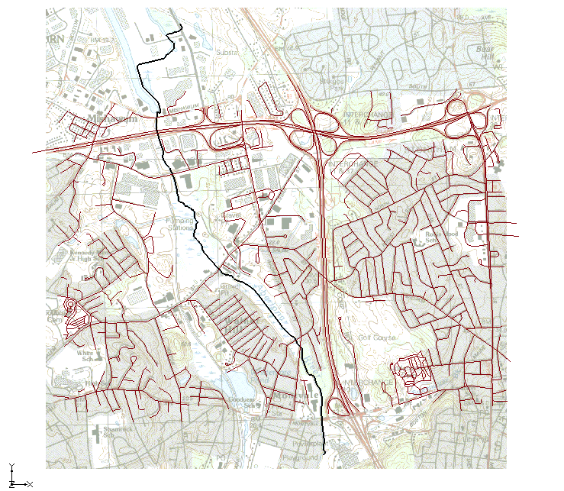

Figure 6 Aberjona River shapefile

1. In the *Project Explorer*, right-click on “File:GIS Stream Data Shapefile.svg AberjonaRiver\_Clip.shp” and select the *Projection* | **Projection…** context menu item to bring up the *Projection* dialog.

Note the horizontal projection is “NAD\_1983\_2011\_UTM\_Zone\_18N”, which was imported from the PRJ file associated with the shapefile. This allowed GMS to place the shapefile in the correct location.

1. Click the **Cancel** button to exit the *Projection* dialog.

|  |  |
| --- | --- |
| Desc-i_gray 100px | If a file is imported into GMS, and the file has an associated PRJ, then the projection is imported with the file. |

# Importing Elevation Data

Next, import surface elevations into the project from a text file by doing the following:

1. Click the **Open** File:Open Macro.svg macro to bring up the *Open* dialog.
2. From the *Files of type* drop-down, select “Text Files (\*.txt, \*.csv)”.
3. Select “elev.txt” and click the **Open** button to close the *Open* dialog and open the *Step 1 of 2* page of the *Text Import Wizard* dialog.
4. Below the *File import options* section, turn on *Heading row*.
5. Click the **Next** button to go to the *Step 2 of 2* page of the *Text Import Wizard* dialog.
6. From the *GMS data type* dropdown list, select “2D scatter points”.
7. Click the **Finish** button to close the *Text Import Wizard* dialog.
8. Click the **OK** button at the prompt that says that a projection must be specified for the imported data to bring up the *Projection – Project\2D Scatter Data\elev* dialog.
9. In the *Horizontal* section, select *Global projection* and click the **Set Projection…** button to bring up the *Horizontal Projection* dialog.
10. Click the **.prj file…** button to bring up the *Projection from .prj File* dialog.
11. Select “elev.prj” and click the **Open** button to exit the *Open* dialog.
12. Click the **OK** button to close the *Horizontal Projection* dialog.
13. Click the **OK** button to close the *Projection – Project\2D Scatter Data\elev* dialog.
14. Click the **Display Options** File:Display Options Macro.svg macro to bring up the *Display Options* dialog.
15. From the list on the left, select “2D Scatter Data”.
16. On the *2D Scatter Point Set* tab, in the table, to the right of the *Name* “elev”, under the *Symbol* column, click on the **Color Selector** button to bring up the *Symbol Attributes* dialog. See Figure 7.A screenshot of a computer

    AI-generated content may be incorrect.

Figure 7: 2D Scatter Point Set Symbol Attributes

1. Enter “2” in the *Size* field and click the **OK** button to close the *Symbol Attributes* dialog.
2. Click the **OK** button to close the *Display Options* dialog.

The Graphics Window should appear as in Figure 7.

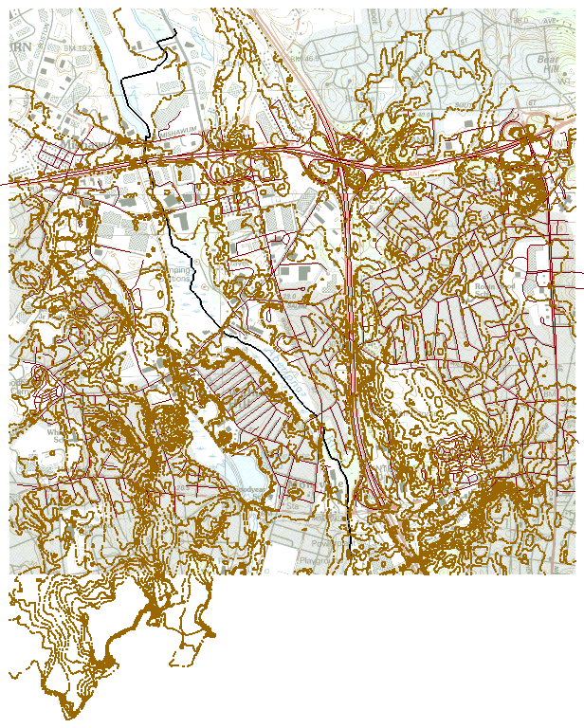

Figure 8 Imported elevation data

## Editing the Scatter Points

The elevations that are in the project can be edited as follows:

1. In the *Project Explorer*, select the “http://www.xmswiki.com/images/thumb/2/29/2D_Scatter_Icon.svg/60px-2D_Scatter_Icon.svg.png elev” scatter data projection to make it active.
2. Using the **Select Scatter Point** File:Select Point Tool.svg tool, select one of the scatter points in the Graphics Window by clicking on it.
3. Press the **Delete** key to delete the selected point.

A prompt appears that explains that the projection of the “elev” scatter set does not match the display projection. In order to edit the points, the scatter set’s projection must be the same as the display projection.

1. Select the **Yes** button at the prompt to change the display projection to match that of the “http://www.xmswiki.com/images/thumb/2/29/2D_Scatter_Icon.svg/60px-2D_Scatter_Icon.svg.png elev” scatter set projection.
2. Click the **Frame** File:Frame Macro.svg macro to zoom to the extents of the project.
3. Press the **Delete** key again to delete the selected point.

|  |  |
| --- | --- |
| Desc-i_gray 100px | An item in a project can be edited only if its projection matches the display projection. |

# Creating a Coverage

A coverage can be created by doing the following:

1. In the *Project Explorer*, right-click in a blank space and select the *New* | **Coverage…** context menu item to add a “http://www.xmswiki.com/images/thumb/7/71/Coverage_Active_Icon.svg/56px-Coverage_Active_Icon.svg.png new coverage” under the “Map Data folder Map Data” folder.
2. Right-click on “http://www.xmswiki.com/images/thumb/7/71/Coverage_Active_Icon.svg/56px-Coverage_Active_Icon.svg.png new coverage” and select the **Coverage Setup…** context menu item to bring up the *Coverage Setup* dialog.

Notice that this is where *Sources/Sinks/BCs*, *Areal Properties*, and *Observation Points* attributes can be turned on and off. For this project, all options should be grayed out.

1. Click the **Cancel** button to close the *Coverage Setup* dialog and retain the default settings. The use of this dialog is not needed for this tutorial.
2. Right-click on “http://www.xmswiki.com/images/thumb/7/71/Coverage_Active_Icon.svg/56px-Coverage_Active_Icon.svg.png new coverage” and select the *Projection* | **Projection…** context menu item to bring up the *Projection* dialog.
3. Notice that the projection for this coverage is the same as the display projection. Click the **OK** button to exit the *Projection* dialog.

|  |  |
| --- | --- |
| Desc-i_gray 100px | When a new item is created in a GMS project, the projection of the new item will be set to match the Display Projection. |

# Creating a 3D Grid

MODFLOW simulations are common components of GMS projects. Some versions of MODFLOW use a structured grid for computations. 2D and 3D grids and grid frames in GMS are not “projected on the fly” because they must retain their rectilinear shape and cannot be warped.

Therefore, when a grid is created in a GMS project, the grid will be set to use the display projection; as long as the grid is part of the project, the display projection cannot be different than the grid’s projection.

To create the 3D grid, do the following:

1. In the *Project Explorer*, right-click in a blank space and select the *New* | **3D Grid…** context menu item to bring up the *Create Finite Difference Grid* dialog.
2. Click the **OK** button to accept the defaults and exit the *Create Finite Difference Grid* dialog.

A grid will appear over the other items in the Graphics Window.

1. In the *Project Explorer*, right-click on “File:2D Grid Icon.svg grid” and select the *Projection* | **Projection…** context menu item to bring up the *Projection* dialog.
2. Notice that the projection for this grid is the same as the Display Projection. Click the **OK** button to exit the *Projection* dialog.
3. In the *Project Explorer*, right-click on “File:GIS Stream Data Shapefile.svg AberjonaRiver\_Clip.shp” and select the *Projection* | **Set As Display Projection** context menu item.
4. An *Error* dialog appears explaining that the display projection must match the grid projection. Click the **OK** button to close the dialog.

|  |  |
| --- | --- |
| Desc-i_gray 100px | If a grid is included in a project, the display projection must match the grid’s projection. |

# Conclusion

This concludes the “GMS Projections / Coordinates Systems” tutorial. The following items were discussed in the tutorial:

* GMS supports many different projections.
* GMS has a user-defined display projection.
* An item’s projection can be specified in GMS and a PRJ file will be created or overwritten.
* All georeferenced data in a GMS project is drawn in the display projection; this requires “Projecting on the fly”.
* Newly created items in a GMS project are assigned to the display projection by default.
* To edit an item in a GMS project, the item’s projection must match the display projection.
* If a grid is included in a GMS project, then the display projection must match the grid’s projection.

1. Information summarized from ESRI:  
   http://webhelp.esri.com/arcgisdesktop/9.2/index.cfm?TopicName=projection\_basics\_the\_gis\_professional\_needs\_to\_know [↑](#footnote-ref-1)