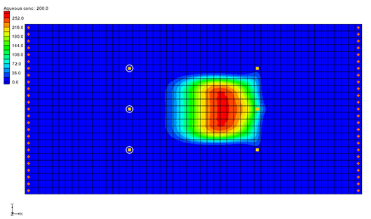

GMS 10.9

GMS 10.9 Tutorial

***RT3D – Rate-Limited Sorption Reaction***

Objectives

This tutorial illustrates the steps involved in using GMS and RT3D to model sorption reactions under mass-transfer limited conditions.

Time

* 35–50 minutes

Required Components

* GMS Core
* MODFLOW Interface
* RT3D

Prerequisite Tutorials

* RT3D – Instantaneous Aerobic Degradation

|  |
| --- |
| [1 Introduction 2](#_Toc110864823)  [1.1 Description of the Reaction Model 2](#_Toc110864824)  [1.2 Description of Problem 4](#_Toc110864825)  [1.3 Getting Started 5](#_Toc110864826)  [2 Building the Flow Model 5](#_Toc110864827)  [2.1 Reading in the Map File 5](#_Toc110864828)  [2.2 Units 5](#_Toc110864829)  [2.3 Creating the Grid 6](#_Toc110864830)  [2.4 Initializing the MODFLOW Data 6](#_Toc110864831)  [2.5 The Global Package 6](#_Toc110864832)  [2.6 Specified Head Boundaries 7](#_Toc110864833)  [2.7 The LPF Package 7](#_Toc110864834)  [2.8 Creating the Wells 8](#_Toc110864835)  [2.9 Saving and Running the Flow Model 9](#_Toc110864836)  [3 Building the Transport Model 9](#_Toc110864837)  [3.1 Initializing the Model 9](#_Toc110864838)  [3.2 The Basic Transport Package 9](#_Toc110864839)  [3.3 The Advection Package 11](#_Toc110864840)  [3.4 The Dispersion Package 11](#_Toc110864841)  [3.5 The Source/Sink Mixing Package 12](#_Toc110864842)  [3.6 The Reaction Package 12](#_Toc110864843)  [3.7 Saving and Running the Simulation 13](#_Toc110864844)  [3.8 Viewing the Solution 13](#_Toc110864845)  [4 Comparison to Other Solutions 14](#_Toc110864846)  [4.1 Importing the Solutions 14](#_Toc110864847)  [4.2 MT3DMS Solution 14](#_Toc110864848)  [4.3 Comparing the Solid Phase Concentrations 15](#_Toc110864849)  [5 Conclusion 15](#_Toc110864850) |

# Introduction

This tutorial will start by building a MODLFLOW model by using a map file, creating a 3D grid, defining the MODFLOW inputs and boundary conditions, and finally running MODFLOW. After the MODFLOW model solutions have been created, the RT3D inputs and boundary condition will be entered and the RT3D model will be executed. Finally, the solutions from the RT3D model run will be imported and compared.

## Description of the Reaction Model

The fate and transport of an organic pollutant in subsurface environments is often highly dependent on its sorption characteristics. Under most natural groundwater flow conditions, the partitioning of contaminants between the solid and aqueous phases can be assumed to be at a local equilibrium. Thus, the more widely used retardation approach for modeling sorption may provide an adequate description for the overall transport. However, the equilibrium assumption may fail when external pumping and injection stresses are imposed on an aquifer (e.g. using a pump-treat system). This would lead to some well-known conditions such as the plume tailing effect (i.e., low contaminant levels always observed at the extraction well) and/or the rebounding effect (i.e., the aquifer seems to be clean but the aqueous concentrations start to increase immediately after stopping the treatment system). These conditions cannot be simulated using the standard linear retardation approach since they require a mass-transfer description for the sorption reactions.

In the mass-transfer limited sorption model, the exchange of contaminants between the soil and groundwater is assumed to be rate limited. The rate of exchange is dictated by the value of the mass-transfer coefficient. When the mass-transfer rate is high (relative to the overall transport), the rate-limited model relaxes to the retardation model. On the other end of the spectrum, a very low mass-transfer coefficient would mimic fully sequestered conditions where the contaminants in the soil phase are assumed to be irreversibly adsorbed and trapped into the soil pores. Under this extreme condition, it might be possible to simply clean the groundwater plume and leave the sequestered soil contaminant in the aquifer because the sorbed contaminants may not pose any potential risk to the environment. In either of the extreme conditions, pump-and-treat is the best option to remediate the groundwater plume. Unfortunately, in most instances, the mass-transfer coefficient is expected to lie in an intermediate range, causing the well-known limitations to the pump-and-treat system.

When sorption is assumed to be rate limited, it is necessary to track contaminant concentrations in both mobile (groundwater) and immobile (soil) phases. Following Haggerty and Gorelick’s (1994) approach,[[1]](#footnote-1) the fate and transport of a sorbing solute at aqueous and soil phases can be predicted using the following transport equations:

 (1)

 (2)

Where:

* C is the concentration of the contaminant in the mobile-phase [ML-3],
* ** is the concentration of the contaminant in the immobile phase (mass of the contaminants per unit mass of porous media,
* [MM-1]), r is the bulk density of the soil matrix,  is the soil porosity,
* ξ is the first-order, mass-transfer rate parameter [T-1]
* λ is the linear partitioning coefficient (which is equal to the linear, first-order sorption constant Kd) [L3M-1].

It can be mathematically shown that the above model formulation relaxes to the retardation model when the value of ξ becomes high.[[2]](#footnote-2)

The mass-transfer model discussed above has been implemented as an RT3D reaction package (one mobile species and one immobile species). After employing reaction-operator splitting, the reaction package for the problem reduces to the following:

 (3)

 (4)

These two differential equations are coded into the model #4 designated as the rate-limited sorption reaction module.

## Description of Problem

The example problem in this tutorial is shown in Figure 1. The site is a 304 m x 152 m section of an unconfined aquifer with flow gradient from left to right. A spill at the center of the site has created a contaminant plume as shown in the figure. A pump-and-treat system, using three injection wells and three extraction wells at the constant rate of 115 m3/day, will be used to clean the contaminant plume. The aqueous concentration of contaminant level throughout the plume is assumed to be at 300 mg/L. The linear partitioning coefficient (Kd or λ) for the contaminant is assumed to be 1.0x10-7 (L/mg), soil dry bulk density, ρ, is assumed to be 1.5x106 (mg/L), and porosity is assumed to be 0.3. Note these parameters yield an effective retardation coefficient value of 1.5 (**). Assuming equilibrium conditions exist before starting the pump-and-treat system, the initial soil-phase contaminant concentration levels, **, can be estimated to be at 3x10-5 (mg of contaminant / mg of soil). The objective of the treatment system is to clean both dissolved and soil-phase contamination. The model will simulate the effectiveness of the system under different mass transfer conditions. A 3000 day simulation will be performed. The mass-transfer coefficient values will be varied to simulate retardation conditions (using ξ = 0.1 day-1), intermediate conditions (using ξ = 0.002 day-1), and sequestered conditions (using 0.0001 day-1). Time series plots and contour plots will be used to visualize the treatment scenarios under different field conditions.



Figure 1 Sample problem

## Getting Started

Do the following to get started:

1. If GMS is not running, launch GMS.
2. If GMS is already running, select the *File |* **New** command to ensure the program settings are restored to the default state.

# Building the Flow Model

The first step in setting up the problem is to build the MODFLOW flow model. The model will be a steady state, one-layer unconfined model with 6.1 m x 6.1 m cells. The flow solution will then be used to drive the transport model.

## Reading in the Map File

Before creating the flow model, first import a map file that contains some drawing objects for background display that will aid in building the model.

1. Select the *File* | **Open** command to bring up the *Open* dialog.
2. Locate and open the directory entitled *\rlimsorp\rlimsorp*.
3. Select the file entitled “site.gpr”.
4. Click **Open** to import the file.

The blue rectangle is the model boundary and the red rectangle is the spill location.

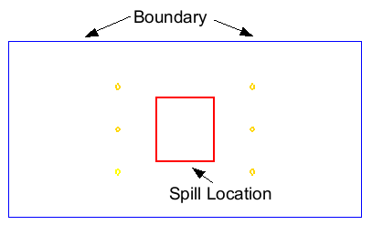

Figure 2 The site boundary and spill location

## Units

To define the units:

1. Select the *Edit* | **Units** command to open the *Units* dialog.
2. For the *Length* units, select theDot dot dot button.png button to the right of the length field to open the *Display Projection* dialog.
3. Change the *Unit* for both *Vertical* and *Horizontal* to “Meters”.
4. Click **OK** to close the *Display Projection* dialog.
5. For the *Time* units, ensure that “d” is selected.
6. For the *Mass* units, ensure that “mg” is selected.
7. For the *Force* units, ensure that “lb” is selected.
8. For the *Concentration* units, ensure that “mg/l” is selected.
9. Select **OK** to close the *Units* dialog.

## Creating the Grid

To create the grid:

1. In the Project Explorer, right-click on the empty space and select *New |* **3D Grid…** to open the *Create Finite Difference Grid*.
2. Change the values to match the following table.

|  |  |  |  |
| --- | --- | --- | --- |
|  | *X-Dimension* | *Y-Dimension* | *Z-Dimension* |
| *Origin* | 0.0 | 0.0 | 0.0 |
| *Length* | 300.0 | 150.0 | 10.0 |
| *Number cells* | 50 | 25 | 1 |

1. Select **OK** to close the *Create Finite Difference Grid* dialog and create the grid.

The grid should line up with the image imported earlier.

## Initializing the MODFLOW Data

To initialize the MODFLOW data:

In the Project Explorer, right-click “File:3D Grid Icon.svggrid” and select **New MODFLOW…**to bring up the *MODFLOW Global/Basic Package* dialog.

## The Global Package

Next to review the data in the Global package.

### IBOUND

The IBOUND array is used to designate the constant head boundaries. However, the boundaries will be marked later in the tutorial by directly selecting the cells.

### Starting Head

A starting head of 10 m will be assigned everywhere in the grid. Since the top grid elevation is 10, it is possible to simply make sure that the *Starting heads equal grid top elevations* toggle is on, which will automatically set a constant of 10 for the starting head.

### Grid Elevations

The top elevation is a constant value of 10 m throughout the grid; the bottom elevation is a constant value of zero throughout the grid. The grid that was created already has these values, so no changes need to be made.

1. Select **OK** to exit the *MODFLOW Global/Basic Package* dialog.

## Specified Head Boundaries

Next to define the specified head boundaries.

1. Using the **Select j** File:Select J Tool.svg tool, select the leftmost column of cells in the grid.
2. Right-click on any of the highlighted cells and select **Properties*…*** to open the *3D Grid Cell Properties* dialog.

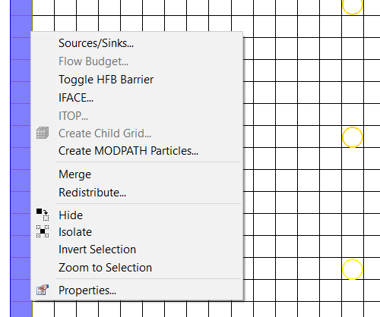

Figure 3 Changing the properties of the cells on the left of the grid

1. In the *IBOUND* row, from the drop-down menu, select “Specified Head”.
2. Change the *Starting head* value to “8”.
3. Select **OK** to close the *3D Grid Cell Properties* dialog.
4. Using the **Select j** File:Select J Tool.svg tool, select the rightmost column of cells.
5. Right-click any of the highlighted cells and select **Properties*…*** to open the *3D Grid Cell Properties* dialog.
6. In the *IBOUND* row, from the drop-down menu, select “Specified Head”.
7. Change the *Starting head* value to “7”.
8. Select **OK** to close the *3D Grid Cell Properties* dialog.
9. Click anywhere outside the grid to unselect the cells.

## The LPF Package

Next to define the input for the LPF package. Enter a hydraulic conductivity that is constant throughout the grid.

1. In the Project Explorer, expand the “File:MODFLOW Folder.svg MODFLOW” item.
2. Expand the “File:MODFLOW Package Icon.svg LPF Package”.
3. Right-click on the “File:Dataset Cells Active.svg HK” dataset and select the **Properties…**command to open the *Horizontal Hydraulic Conductivity* dialog.
4. Select **Constant → Layer** to open the *Layer Value* dialog.
5. Enter a value of “3.0”.
6. Click **OK** to close the *Layer Value* dialog.
7. Select **OK** to close the *Horizontal Hydraulic Conductivity* dialog.

## Creating the Wells

Do the following to create the injection wells:

1. Using the **Select Cell** File:Select 3D Cell Tool.svg tool and holding down the *Ctrl* key, select the cells on the left side of the model with the three yellow circles.

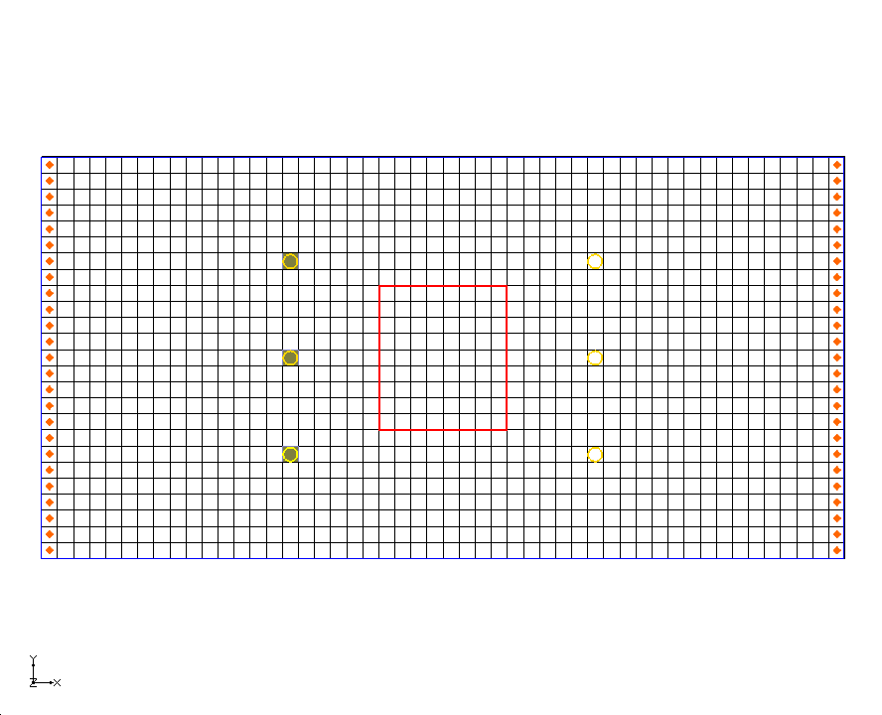

Figure 4 Location of injection and extraction well cells

1. Right-click one of the selected cells and select the **Sources/Sinks*…*** command to open the *MODFLOW Sources/Sinks* dialog.
2. Make sure that *Wells (WEL)* is selected in the list box on the left of the dialog.
3. Select the **Add BC** button.
4. For each well, for the *Q (Flow),* enter “25”.
5. Select **OK** to close the *MODFLOW Sources/Sinks* dialog.
6. Click anywhere outside the grid to unselect the cells.

To create the extraction wells:

1. While holding down the *Ctrl* key, select the cells on the right side of the model with the three yellow circles.
2. Right-click one of the selected cells and select the **Sources/Sinks…** command.
3. Make sure that *Wells (WEL)* is selected in the list box on the left of the dialog.
4. Select the **Add BC** button.
5. For each well, for the *Q (Flow),* enter “-25.5”.
6. Select **OK** to close the *MODFLOW Sources/Sinks* dialog.
7. Click anywhere outside the grid to unselect the cells.

## Saving and Running the Flow Model

At this point, it is possible to save the model and run MODFLOW.

1. Select the *File* | **Save As…** command to open the *Save As* dialog.
2. Make sure the path is still set to *\rlimsorp\rlimsorp*.
3. Enter “rlimsorp” for the *File name*.
4. Select **Save**.

To run MODFLOW:

1. Select the *MODFLOW* | **Run MODFLOW** command to launch the *MODFLOW* simulation.
2. When the *MODFLOW* simulation is finished, select **Close**.

GMS will automatically read in the solution and display a series of contours indicating a flow from left to right with mounds around the injection wells and cones of depression around the extraction wells.

# Building the Transport Model

Next to build the RT3D transport model that simulates retardation conditions. Then compare that solution to a solution from MT3DMS. Finally, compare the retardation solution to a solution representing intermediate and sequestered conditions.

## Initializing the Model

To initialize the RT3D model:

1. In the Project Explorer, right-click on “File:3D Grid Icon.svg grid” and select **New MT3DMS…**to open the *Basic Transport Package* dialog.

## The Basic Transport Package

First, define the data for the Basic Transport package:

1. In the *Model* section, select *RT3D*.

### Packages

Next to select which packages to use:

1. Select **Packages…** to open the *MT3DMS/RT3D Packages* dialog.
2. Turn on the following packages:

*Advection package*

*Dispersion package*

*Source/sink mixing package*

*Chemical reaction package*

1. In the *RT3D Reactions* drop-down menu, select “Rate-Limited Sorption Reactions”.
2. Select **OK** to exit the *MT3DMS/RT3D Packages* dialog.

### Stress Periods

Next to define a single stress period with a length of 3000 days.

1. Select **Stress Periods…** to open the *Stress Periods* dialog.
2. Change *Length* to “3000.0”.
3. Select **OK** to close the *Stress Periods* dialog.

### Output Control

By default, RT3D outputs a solution at every transport step. Change this so that a solution is output every 200 days.

1. Select **Output Control…** to open the *Output Control* dialog.
2. Select the *Print or save at specified times* option.
3. Select **Times…** to open the *Variable Time Steps* dialog.
4. Select the **Initialize Values…** button to open the *Initialize Time Steps* dialog.
5. For the *Initial time step size,* enter “200.0”.
6. For the *Maximum time step size,* enter “200.0”.
7. For the *Maximum simulation time,* enter “3000.0”.
8. Select **OK** to exit the *Initialize Time Steps* dialog.
9. Select **OK** to exit the *Variable Time Steps* dialog.
10. Select **OK** to exit the *Output Control* dialog.

### Porosity

Next, consider the porosity, which should be set as 0.3. Since this is the default supplied by GMS, no changes need to be made.

### Starting Concentrations

A starting concentration must be defined for both the aqueous phase concentration and the solid phase concentration. The default starting concentrations are zero. It is necessary to change the starting concentrations at the plume location. While this can be accomplished with the *Starting Concentration* dialog, it is more convenient to select the cells and directly assign the values.

1. Select **OK**to exit the *Basic Transport Package* dialog.
2. Using the **Select Cell** File:Select 3D Cell Tool.svg tool, drag a box that just encloses the red rectangle defining the spill location.

Before assigning the values, unselect the cells in the four corners of the grid. This will give the plume a slightly more rounded shape.

1. While holding down the *Ctrl* key, select each of the cells in the four corners of the spill location to unselect them.

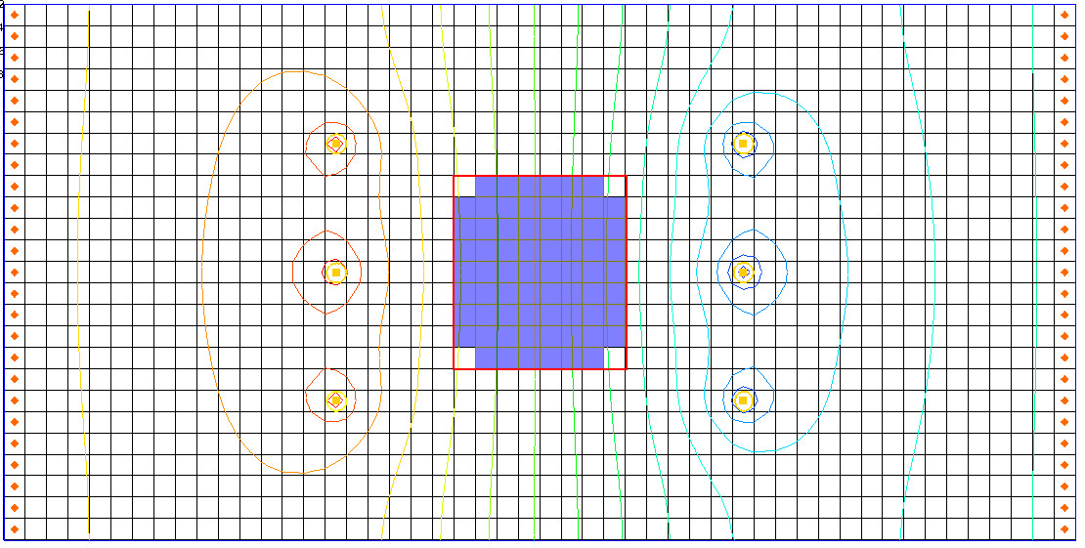

Figure 5 Cells where starting concentration will be assigned

1. Select the *RT3D* | **Cell Properties…** command to open the *3D Grid Cell Properties* dialog.
2. On the *Starting conc.* row, in the *Aqueous conc. (mobile)* column, enter “300”.
3. On the *Starting conc.* row, in the *Solid conc. (immobile)* column, enter “3e-5”.
4. Select **OK** to close the *3D Grid Cell Properties* dialog.
5. Click anywhere outside the grid to unselect the cells.

This completes the input for the Basic Transport package.

## The Advection Package

Next to define the input data for the Advection package.

1. Select the *RT3D* | **Advection Package…** command to open the *Advection Package* dialog.
2. For the *Solution scheme* drop-down menu, select the “Modified method of characteristics (MMOC)”.
3. Select **Particles…** to open the *Particles* dialog.
4. At the top of the dialog, change the *Max. number of cells any particle will be allowed to move per transport step (PERCEL)* value to “2”.
5. Select **OK** to exit the *Particles* dialog.
6. Select **OK** to exit the *Advection Package* dialog.

## The Dispersion Package

Next to enter the data for the Dispersion package.

1. Select the *RT3D* | **Dispersion Package…** command to open the *Dispersion Package* dialog.
2. For *TRPT*, enter “0.1”.
3. Select **Longitudinal Dispersivity…** to open the *Longitudinal Dispersivity* dialog.
4. Select **Constant → Layer** to open the *Layer Value* dialog.
5. Enter a value of “3.0”.
6. Select **OK** to exit the *Layer Value* dialog.
7. Select **OK** to exit the *Longitudinal Dispersivity* dialog.
8. Select **OK** to exit the *Dispersion Package* dialog.

## The Source/Sink Mixing Package

For the Source/Sink Mixing package, assign a zero concentration to the incoming fluid from the injection wells.

1. Using the **Select Cell** File:Select 3D Cell Tool.svg tool and holding the *Ctrl* key, select each of the three injection wells (the wells on the left).
2. Right-click on a selected cell and select **Sources/Sinks…** . to open the *MODFLOW/RT3D Sources/Sinks* dialog.
3. On the left side of the dialog, select the *RT3D: Point SS* item.
4. Click the **Add BC** button near the bottom of the dialog.
5. On the *All* row, change the *Type (ITYPE)* to “well (WEL)”.
6. Make sure that both concentration columns are “0.0”.

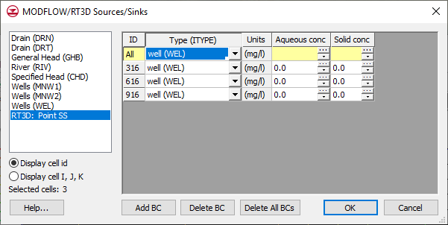

Figure 6 Point Source/Sink BC dialog

1. Select **OK** to exit the *MODFLOW/RT3D Sources/Sinks* dialog.
2. Click anywhere outside the grid to unselect the cells.

## The Reaction Package

The last step in setting up the transport model is to enter the data for the Reaction package.

1. Select the *RT3D |* **Chemical Reaction Package…** command to open the *RT3D Chemical Reaction Package* dialog.
2. For *Bulk Density* enter “1.5e6”.
3. In the *Reaction Parameters* section, for *mass transfer coeff,* enter “0.1”.
4. For the *partitioning coeff,* enter “1e-7”.
5. Select **OK** to exit the *RT3D Chemical Reaction Package* dialog.

## Saving and Running the Simulation

At this point, it is time to save the model and run RT3D.

1. Select the *File* | Save Macro.svg **Save**command.

To run RT3D:

1. Select the *RT3D* | **Run RT3D…** command to launch the *RT3D* simulation.
2. When the *RT3D* simulation is finished, select **Close**.

## Viewing the Solution

First to view the solid phase concentration solution at 600 days:

1. In the Project Explorer, expand the “File:Generic Folder Locked.svg rlimsorp (RT3D)” solution.
2. Select the “File:Dataset Cells Active.svg Solid conc” dataset to make it active.
3. In the *Time Steps* window, select “600.0”.

To better illustrate the variations, turn on the color ramp.

1. Select the **Contour Options** File:Contour Options Macro.svg macro to open the *Dataset Contour Options – 3D Grid – Solid conc* dialog.
2. Change the *Contour method* to “Color Fill”.
3. Select **OK** to exit the *Dataset Contour Options – 3D Grid – Solid conc* dialog.
4. Turn off “16px-Annotations_Folder Annotation Data”.

Next to view the aqueous phase concentration solution at 600 days.

1. In the Project Explorer, select the “File:Dataset Cells Active.svg Aqueous conc” dataset.

Notice that, although the magnitudes of the concentration values are different, the spatial distribution of the plume is identical for the solid and aqueous phase.

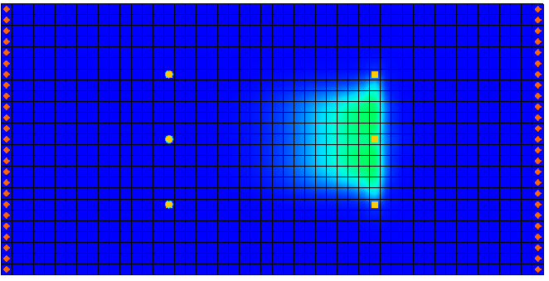

Figure 7 Solid conc solution at 600 days

# Comparison to Other Solutions

Next to compare the initial solution to other solutions with different mass transfer coefficients. To save time, these solutions have already been computed. Simply import them into GMS.

## Importing the Solutions

Although the solutions were originally created as separate solutions, the solutions have been combined into a single solution set for convenience.

1. Select the *RT3D* | **Read Solution…** command to bring up the *Open* dialog.
2. Go to the *\rlimsorp\rlimsorp* directory.
3. Select the file entitled “othersol.rts”.
4. Select **Open** to import the solution file.

The solution just imported contains the following datasets:

|  |  |
| --- | --- |
| **Name** | **Description** |
| Aqueous (mt3d) | Solution from an MT3DMS simulation |
| Solid (interm) | Solution from an RT3D simulation with the mass transfer coeff. = 0.002. This represents an intermediate condition between the retardation condition and the sequestered condition. |
| Solid (Sequest) | Solution from an RT3D simulation with the mass transfer coeff. = 0.0001. This represents the sequestered condition. |

## MT3DMS Solution

First to examine the MT3DMS simulation. The solution that has been computed has a large mass transfer rate and simulates retardation conditions. Therefore, it should be very similar to a solution computed using MT3DMS. To confirm this, do the following:

1. In the Project Explorer, select “File:Dataset Cells Active.svg Aqueous (mt3d)”.
2. In the *Time Steps* window, select **Options…** to open the *Time Settings* dialog.
3. Change *Relative* to be “days(decimal)”.
4. Click **OK** to close the *Time Settings* dialog.
5. In the *Time Steps* window, select “600.0”.

Note that the spatial distribution of the plume appears to be identical to the plume computed earlier by RT3D; however, the concentration is much lower.

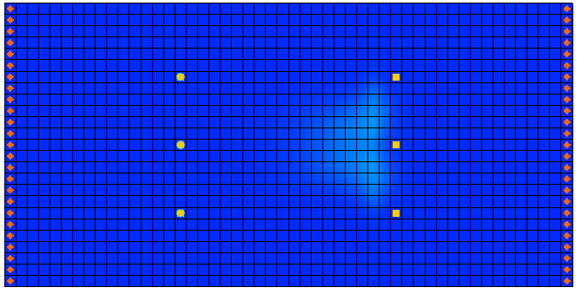

Figure 8 Aqueous (mt3d) solution at 600 days

## Comparing the Solid Phase Concentrations

Next to look at the solid phase concentrations and analyze the effect of the mass transfer coefficients.

1. If necessary, in the Project Explorer, expand the “File:Generic Folder Locked.svg rlimsorp (RT3D)”solution.
2. Select the “File:Dataset Cells Active.svg Solid conc” dataset and use the arrow keys to scroll through the time steps.

Notice that after 600 days the bulk of the sorbed plume has moved over to the vicinity of the extraction wells.

Next, look at the intermediate solution. This solution was computed using a mass transfer coefficient of 0.002. This is partway between the retarded condition and the sequestered condition.

1. If necessary, in the Project Explorer, expand the “File:Generic Folder Locked.svg othersol (RT3D)”solution.
2. Select the“File:Dataset Cells Active.svg Solid (interm)”dataset and use the arrow keys to scroll through the time steps.

Notice that some of the sorbed plume has moved toward the extraction wells but much of the plume is still in the original location.

Next, examine the sequestered solution. This solution was computed using a mass transfer coefficient of 0.0001.

1. In the Project Explorer, select the “File:Dataset Cells Active.svg Solid (Sequest)” dataset and use the arrow keys to scroll through the time steps.

Notice that the sorbed contaminants are still in the original location.

# Conclusion

This concludes the “RT3D – Rate-Limited Sorption Reaction” tutorial. Continue to explore the RT3D model or exit the program.

1. Haggerty, R., and Gorelick, S.M. (1994). Design of Multiple Contaminant Remediation: Sensitivity to Rate-Limited Mass Transport. *Water Resource Research*, 30(2), 435–446. [↑](#footnote-ref-1)
2. See Clement, T.P., Sun., Y., Hooker, B.S., and Petersen, J.N. (Spring 1998). Modeling Multi-species Reactive Transport in Groundwater Aquifers, *Groundwater Monitoring & Remediation Journal*, 18(2), 79–92. [↑](#footnote-ref-2)