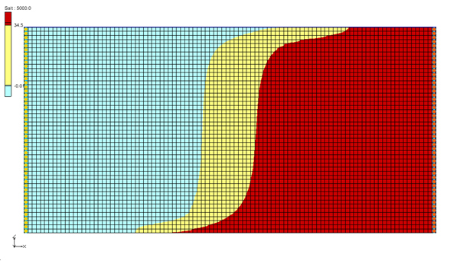

GMS 10.9

GMS 10.9 Tutorial

***SEAWAT – Concentration and Temperature Effects***

Examine Concentration and Temperature Impacts on Fluids Density with SEAWAT

Objectives

The tutorial demonstrates how to simulate the effects of concentration and temperature on fluid density with SEAWAT.

Time

* 15–25 minutes

Required Components

* GMS Core
* MODFLOW Interface
* MT3D
* SEAWAT

Prerequisite Tutorials

* MODFLOW – Grid Approach
* MT3DMS – Grid Approach

|  |
| --- |
| 1 Introduction 2  2 Getting Started 3  2.1 Importing the Existing Model 3  3 First SEAWAT Scenario 3  3.1 Initializing the SEAWAT Simulation 3  3.2 Saving the Model with a New Name and Running SEAWAT 4  3.3 Viewing the Solution 5  4 Second SEAWAT Scenario 5  4.1 Saving the model with a new name 5  4.2 Adding Temperature Effects on Fluid Density 6  4.3 Saving and running SEAWAT 6  4.4 Viewing the Solution 6  5 Conclusion 7 |

# Introduction

This tutorial describes how to simulate the effects of concentration and temperature on fluid density using SEAWAT. This problem is shown in Figure 1. This problem has a confined aquifer with an initial temperature of 5˚C. Warm freshwater is injected from the west side of the model at a 1 m3/day. The initial concentration of salt in the model is 35 kg/m3. This example problem is very similar to the problem described in the SEAWAT documentation.[1]

This tutorial demonstrates and discusses:

* Importing an existing MODFLOW/MT3D simulation.
* Setting up a SEAWAT simulation.
* Running SEAWAT with different scenarios.
* Comparing SEAWAT results for density effects caused by concentration and temperature.

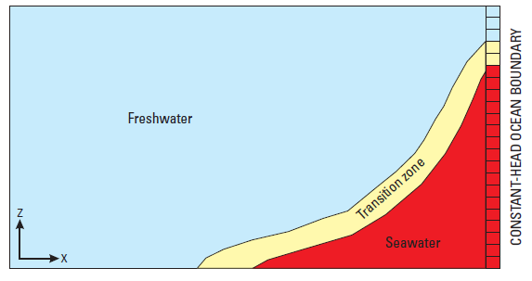

Figure 1 Site to be modeled with SEAWAT

# Getting Started

Do the following to get started:

1. If GMS is not running, launch GMS.
2. If GMS is already running, select *File* | **New** to ensure the program settings are restored to the default state.

## Importing the Existing Model

Start with a model that has already been created.

1. Click **Open** File:Open Macro.svg to bring up the *Open* dialog.
2. Select “Project Files (*.gpr)” from the *Files of type* drop-down.
3. Browse to the *Case_Studies* folder and select “start.gpr”.
4. Click **Open** to import the project and exit the *Open* dialog.

A grid similar to Figure 2 should appear. Notice the symbols representing well and specified head boundary conditions on the left and right sides of the model.

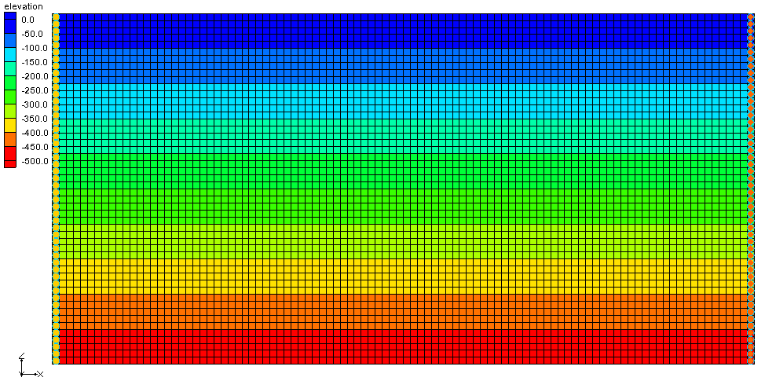

Figure 2 Initial model

# First SEAWAT Scenario

## Initializing the SEAWAT Simulation

SEAWAT uses a combination of MODFLOW and MT3DMS. Start with turning on the SEAWAT menu.

1. In the Project Explorer, fully expand the “File:3D Grid Folder.svg 3D Grid Data” folder.
2. Right-click on “File:3D Grid Icon.svg grid” and select **New SEAWAT…** to bring up the *Global Options* dialog.
3. Turn on *Include transport in simulation*.
4. In the *Packages* section, turn on *Variable-Density Flow (VDF)*.
5. Click **OK** to exit the *Global Options* dialog.

### Modifying the VDF Package

The first scenario will simulate the effect of salinity on the fluid density.

1. Select *SEAWAT |* **VDF Package…** to open the *SEAWAT VDF Package* dialog.
2. In the *Fluid density calculation* section, for *Fluid density calc (MT3DRHOFLG)*, enter “1”.

This indicates that the fluid density calculation will be done using the salt species.

1. For *Reference fluid density (DENSEREF)*, enter “1000.0”.

This indicates that the reference fluid density (freshwater, in this case) at 25˚C is 1000 kg/m3.

1. For *Density/conc. Slope (DRHODC)*, enter “0.7”.

This *DRHODC* value indicates that the density will vary linearly between 1000 kg/m3 for freshwater and 1024.5 kg/m3 for saltwater. DRHODC can be estimated by dividing the density difference by the concentration difference. In this case, the result is the following:

|  |  |
| --- | --- |
| 1024.5(kg/m3) – 1000(kg/m3) | = 0.7 |
| 35(kg/m3) – 0(kg/m3) |

This means that 35 kg/m3 is the concentration of salt in saltwater and 0 kg/m3 is the concentration of salt in freshwater.

1. Click **OK**to close the *SEAWAT VDF Package* dialog.

## Saving the Model with a New Name and Running SEAWAT

Now to save the changes and run SEAWAT:

1. Select *File |* **Save As…** to bring up the *Save As* dialog.
2. Select “Project Files (*.gpr)” from the *Save as type* drop-down.
3. Enter “case1.gpr” as the *File name*.
4. Click **Save** to save the project under the new name and close the *Save As* dialog.
5. Click *SEAWAT |* **Run SEAWAT…** to bring up the *SEAWAT* model wrapper dialog.
6. When SEAWAT finishes, turn on *Read solution on exit* and *Turn on contours (if not on already)*.
7. Click **Close** to import the solution and close the *SEAWAT* model wrapper dialog.

## Viewing the Solution

Now to view the results of the SEAWAT model run:

1. In the Project Explorer, under “File:Generic Folder Locked.svg case1 (MT3DMS)”, select “File:Dataset Cells Active.svg Salt”.

The contour options will change because a display theme has been associated with the salt species. To learn more about display themes, see the “Display Themes” tutorial.

1. In the *Time Steps* window, select various time steps to compare them.

Notice the movement of the freshwater (the light blue section).

1. Select time step “10” (value of “5000.0”).

The model should appear similar to the one in Figure 3.

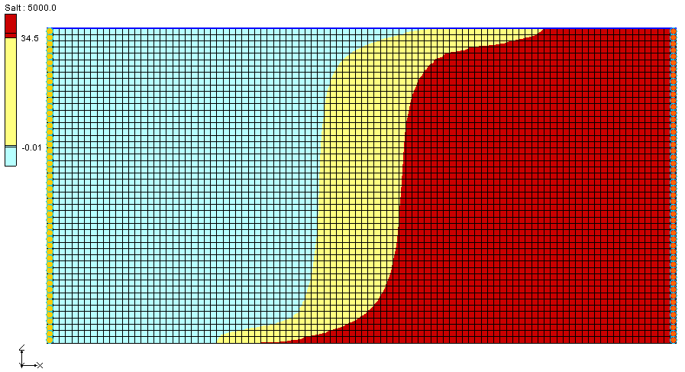

Figure 3 Concentration of salt species at 5000 days

This simulation also includes a temperature species. The “File:Dataset Cells Active.svg Temperature”dataset has no effect on the salinity in this scenario. The effect of temperature on the model is examined in the next scenario.

# Second SEAWAT Scenario

## Saving the model with a new name

First, save the model with a new name:

1. Select *File |* **Save As…** to bring up the *Save As* dialog.
2. Select “Project Files (*.gpr)” from the *Save as type* drop-down.
3. Enter “case2.gpr” as the *File name*.
4. Click **Save** to save the project under the new name and close the *Save As* dialog.

## Adding Temperature Effects on Fluid Density

Now, look at the effect of temperature on the density for this case.

### Modifying the VDF Package

The temperature effects can be activated in the VDF Package*.*

1. Select *SEAWAT |* **VDF Package…** to open the *SEAWAT VDF Package* dialog.
2. In the *Fluid density calculation* section, for *Fluid density calc. (MT3DRHOFLG),* enter “-1”.

This value means that the fluid density will be calculated using one or more MT3DMS species. In this case, they are *Salt* and *Temperature*.

1. Below the spreadsheet at the bottom, click **Insert Row** File:Insert Row Icon.svg twice to generate two species in the spreadsheet.
2. In the *Species ID* column, enter “1” in the top row and “2” in the bottom row.

Notice that the species names have changed to “Salt” and “Temperature”, respectively.

1. On the *Salt* row, for *DRHODC*, enter “0.7” and for *CRHOREF*, enter “0.0”.
2. On the *Temperature*, for *DRHODC*, enter “-0.375” and for *CRHOREF,* enter “25.0”

The negative value for *DRHODC* means that the fluid density decreases as the temperature increases. *CRHOREF* is the reference (freshwater) concentration/temperature for the species. The reference concentration of *Salt* in freshwater is “0.0” and the reference *Temperature* of freshwater is “25.0”.

1. Click **OK** to exit the *SEAWAT VDF Package* dialog.

## Saving and running SEAWAT

Now to save the changes and run SEAWAT:

1. **Save** File:Save Macro.svg the project.
2. Select *SEAWAT |* **Run SEAWAT…** to bring up the *SEAWAT* model wrapper dialog.
3. When SEAWAT finishes, turn on *Read solution on exit* and *Turn on contours (if not on already)*.
4. Click **Close** to import the solution and close the *SEAWAT* dialog.

## Viewing the Solution

Next to compare the differences between two scenarios:

1. Under “File:Generic Folder Locked.svg case1 (MT3DMS)”, in the “File:Dataset Cells Active.svg Salt” dataset, view time step 16 (value of “8000”) (Figure 4).
2. Under “File:Generic Folder Locked.svg case2 (MT3DMS)”, view the “File:Dataset Cells Active.svg Salt” dataset, time step 16 (Figure 5).

The light blue portion in the figures represents fresh water and the dark red represents salt water. In “File:Generic Folder Locked.svg case2 (MT3DMS)”, notice that the salt water is slightly lower from the top along the left boundary (by about one grid row) and slightly closer to the right boundary along the bottom of the model (by about 10 grid columns). More of the fresh water is “floating” on top of the salt water in “case2” because the fresh water is less dense. This is because SEAWAT is considering temperature in the density calculations.

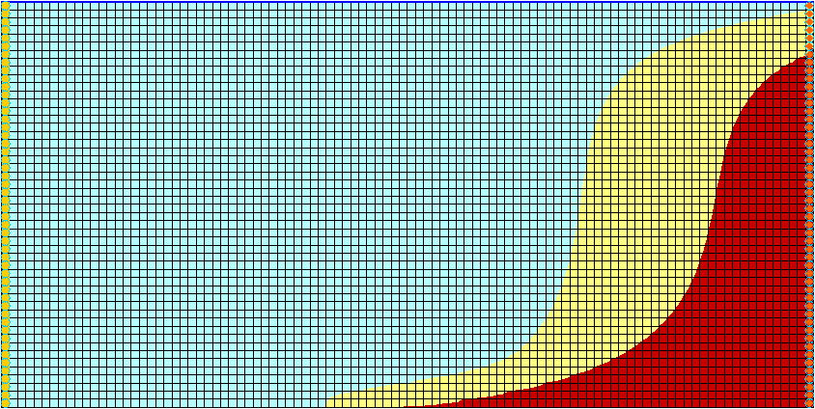

Figure 4 Case1 salt concentration – time step 16

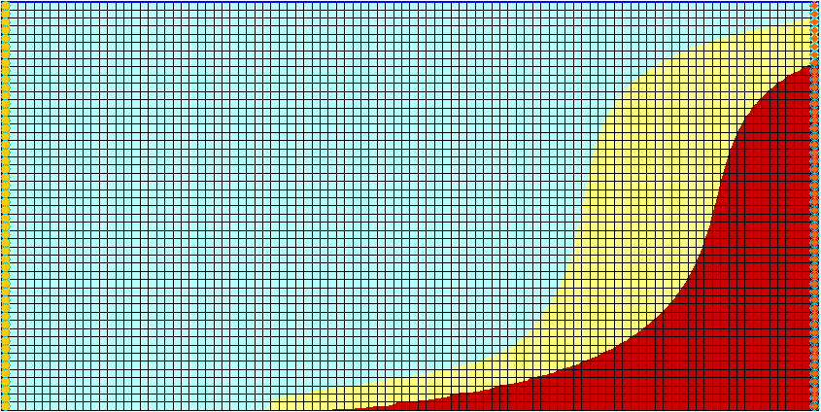

Figure 5 Case2 salt concentration – time step 16

# Conclusion

This concludes the “SEAWAT – Concentration and Temperature Effects” tutorial. The following key concepts were discussed and demonstrated in this tutorial:

* SEAWAT combines MODFLOW and MT3DMS to solve variable density groundwater flow and solute transport problems.
* SEAWAT simulates the effect of concentration and temperature on fluid density.

1. Langevin, Christian. D.; Thorne, Daniel T., Jr.; Dausman, Alyssa M.; Sukop, Michael C.; and Guo, Weixing. (2007). “SEAWAT Version 4: A Computer Program for Simulation of Multi-Species Solute and Heat Transport” in U.S. Geological Survey *Techniques and Methods Book 6*, Chapter A22, 39 p. <https://pubs.usgs.gov/tm/tm6a22/pdf/tm6A22.pdf>.