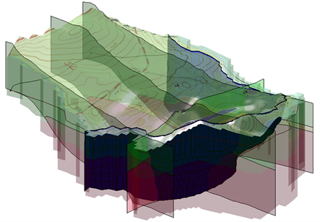

GMS 10.9

GMS 10.9 Tutorial

***SEAWAT – Conceptual Model Approach***

Create a SEAWAT model in GMS using the conceptual model approach

Objectives

This tutorial demonstrates how to create a SEAWAT model in GMS using the conceptual model approach. It will use the GIS tools in the Map module to develop a conceptual model of the site being modeled, including sources/sinks, layer parameters (such as hydraulic conductivity), model boundaries, and all other data necessary for the simulation. Finally it will generate a grid.

Time

* 25–40 minutes

Required Components

* GMS Core
* MODFLOW Interface
* MT3D
* SEAWAT

Prerequisite Tutorials

* MODFLOW – Conceptual Model Approach
* MT3DMS – Conceptual Model Approach

|  |
| --- |
| [1 Introduction 2](#_Toc110593876)  [2 Getting Started 4](#_Toc110593877)  [2.1 Importing an Existing MODFLOW Model 4](#_Toc110593878)  [2.2 Viewing the Initial Concentration 4](#_Toc110593879)  [2.3 Saving the Project 6](#_Toc110593880)  [3 Setting Up the SEAWAT Simulation 6](#_Toc110593881)  [3.1 Editing the MODFLOW simulation 6](#_Toc110593882)  [3.2 Initializing MT3DMS 7](#_Toc110593883)  [3.3 Initializing SEAWAT Simulation 8](#_Toc110593884)  [3.4 Editing the Conceptual Model 9](#_Toc110593885)  [3.5 Saving and Running SEAWAT 10](#_Toc110593886)  [4 Viewing the Solution 11](#_Toc110593887)  [4.1 Creating an Animation 12](#_Toc110593888)  [4.2 Creating a Time Series Plot of Concentration 12](#_Toc110593889)  [4.3 Animating the Fresh-Water Surface 13](#_Toc110593890)  [5 Conclusion 14](#_Toc110593891)  [5.1 Further Reading 14](#_Toc110593892) |

# Introduction

SEAWAT is described on the official website as:

“…a generic MODFLOW/MT3DMS-based computer program designed to simulate three-dimensional variable-density groundwater flow coupled with multi-species solute and heat transport. The program has been used for a wide variety of groundwater studies including those focused on brine migration in continental aquifers as well as those focused on saltwater intrusion in coastal aquifers. SEAWAT uses the familiar structure of MODFLOW and MT3DMS.”[[1]](#footnote-1)

This model is used to simulate the effect of the pumping wells on salt water intrusion. The initial heads and concentrations were created by running a SEAWAT model for a very long time with a steady state flow model.

The site in this model is a small coastal aquifer with three production wells with variable pumping rates (Figure 1). The no-flow boundary on the upper left corresponds to a parallel flow boundary, and the no-flow boundary on the left corresponds to a thinning of the aquifer due to a high bedrock elevation. A stream provides a specified head boundary on the lower left. The remaining boundary is a coastal boundary simulated with a specified head boundary condition.

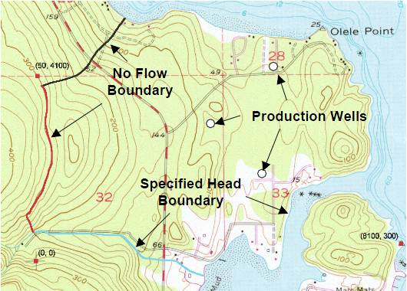

Figure 1 Site map of SEAWAT model

The stratigraphy of the site (Figure 2) consists mainly of an upper and lower aquifer. The upper aquifer has a hydraulic conductivity of 1.5 m/day, and the lower aquifer has a hydraulic conductivity of 5.0 m/day. The model also has some areas with confining units. The production wells extend to the lower aquifer.

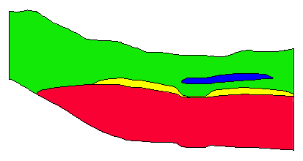

Figure 2 Cross section through model domain

This tutorial explains how to perform a SEAWAT simulation within GMS using the conceptual model approach. The tutorial demonstrates:

* Importing an existing MODFLOW simulation and conceptual model.
* Creating a SEAWAT model to simulate the effects of pumping on salt water intrusion.
* Running the simulation.
* Viewing the results in 3D.

It is recommended to complete the “MODFLOW – Conceptual Model Approach 1” and the “MT3DMS – Conceptual Model Approach” tutorials prior to beginning this tutorial.

# Getting Started

Do the following to get started:

1. If necessary, launch GMS.
2. If GMS is already running, select *File |* **New** to ensure that the program settings are restored to their default state.

## Importing an Existing MODFLOW Model

This tutorial will start with an existing MODFLOW model then make the necessary modifications to run SEAWAT.

1. Click **Open** File:Open Macro.svg to bring up the *Open* dialog.
2. Select “Project Files (\*.gpr)” from the *Files of type* drop-down.
3. Browse to the *coastal* directory and select “coastal.gpr”.
4. Click **Open** to import the project and exit the *Open* dialog.

The imported model shows a MODFLOW grid on top of a background topographic map (Figure 3). The contours on the grid are the heads computed by the long SEAWAT run with a steady state flow model.

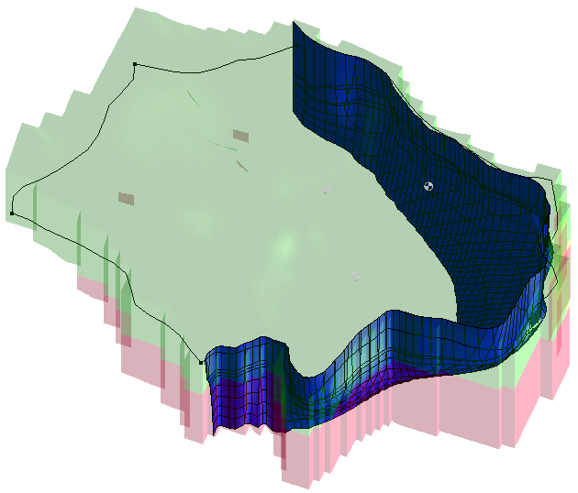

Figure 3 Initial model

## Viewing the Initial Concentration

Now to view the initial concentration that will be assigned to the SEAWAT model.

1. Right-click on “File:3D Grid Folder.svg 3D Grid Data”and select **Expand All**.
2. Under “File:3D Grid Icon.svg grid”, select “File:Dataset Cells Active.svg Salt Initial Concentration”.
3. Right-click on “File:Display Theme Folder.svg Display Themes” and select **Expand All**.
4. Select “File:Display Theme Icon.svg Fresh-water Isosurface”.

Cross sections should be visible through the stratigraphy at the site (Figure 4).

1. Use the **Rotate** File:Rotate Tool.svg tool to see different angles of the fresh water interface.

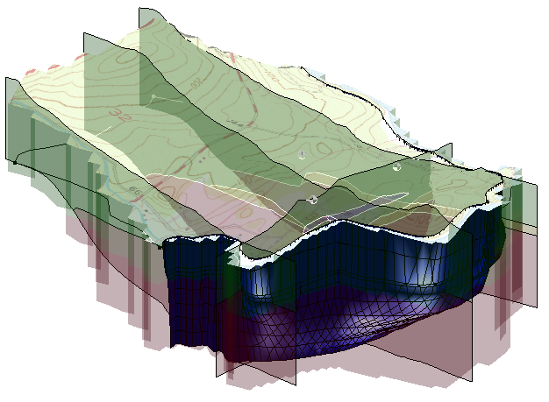

Figure 4 Display of the fresh-water isosurface

1. Select “ Isosurface Animation”.

This theme only shows the isosurface and the 3D grid faces (Figure 5).

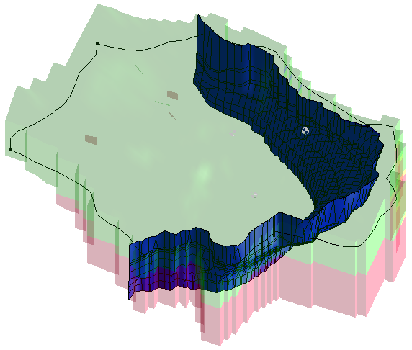

Figure 5 Isosurface and 3D grid faces are visible

1. Select the “File:Display Theme Icon.svg Head Contours” display theme.

This theme shows the model in **Plan View** File:Plan View Macro.svg (Figure 6).

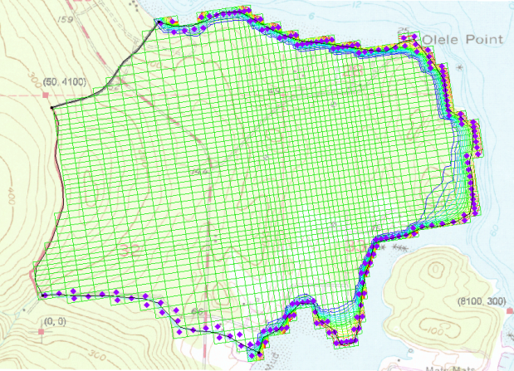

Figure 6 View using Head Contours display theme

## Saving the Project

It is a good idea to save often. Save the project under a new name so that it can be saved periodically.

1. Select *File |* **Save As…** to bring up the *Save As* dialog.
2. Select “Project Files (\*.gpr)” from the *Save as type* drop-down.
3. Enter “seawat.gpr” as the *File name*.
4. Click **Save** to save the project under the new name and close the *Save As* dialog.

# Setting Up the SEAWAT Simulation

Now, create a SEAWAT model by modifying the existing MODFLOW model. Do this by editing the conceptual model as well as setting up some options in the MODFLOW, MT3D, and SEAWAT interfaces.

## Editing the MODFLOW simulation

The heads computed by SEAWAT simulation are different than the heads computed by a MODFLOW simulation.[[2]](#footnote-2) The SEAWAT simulation will be transient, so set the starting heads to be those computed by the prior long-term SEAWAT run. It is also necessary to change the MODFLOW model to be transient and to set up the stress periods. The model will run for 730 days, and each stress period will be 10 days long.

1. Select *MODFLOW |* **Global Options…** to open the *MODFLOW Global/Basic Package* dialog.
2. Below the *Run options* section, turn off *Starting heads equal grid top elevation*.
3. Click **Starting Heads…** to open the *Starting Heads* dialog.
4. Click **3D Dataset → Grid…** to open the *Select Dataset* dialog.
5. In the *Solution* section, select “File:Dataset Cells Active.svg Starting Heads”, then click **OK** to close the *Select Dataset* dialog.
6. Click **OK** to exit the *Starting Heads* dialog.
7. In the *Model type* section, select *Transient*.
8. Click **Stress Periods…** to open the *Stress Periods* dialog.
9. Click the **Initialize…** button.
10. When asked to overwrite all current MODFLOW boundary condition data assigned to stress periods, click **Yes** to bring up the *Initialize Stress Periods* dialog.
11. For *Number of stress periods,* enter “15”.
12. For *Length,* enter “10.0”.
13. For *Number of time steps,* enter “1”.

Settings should look like Figure 7.

1. Click **OK** to close the *Initialize Stress Periods* dialog.
2. Click **OK** to exit the *Stress Periods* dialog.
3. Click **OK** to exit the *MODFLOW Global/Basic Package* dialog.

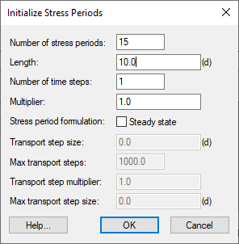

Figure 7 Initialize Stress Periods dialog

## Initializing MT3DMS

As stated earlier, SEAWAT uses a combination of MODFLOW and MT3DMS. It is necessary to turn on the MT3DMS and SEAWAT menus, then initialize MT3DMS.

1. Right-click on “File:3D Grid Icon.svg grid” and select **New MT3DMS…** to bring up the *Basic Transport Package* dialog.
2. Click **Output Control…** to open the *Output Control* dialog.
3. For *Print or save at specified interval*, enter “40”.
4. Click **OK** to exit the *Output Control* dialog.
5. Click **Packages…** to open the *MT3DMS/RT3D Packages* dialog.
6. Turn on *Advection package* and *Source/sink mixing package.*
7. Click **OK** to exit the *MT3DMS/RT3D Packages* dialog.

Now to define a species and set the starting concentration for the salt species:

1. Click **Define Species…** to open the *Define Species* dialog.
2. Click **New** to create a new species in the spreadsheet on the left.
3. In the *Name* column, enter “Salt”.
4. Click **OK** to exit the *Define Species* dialog.
5. Above the spreadsheet on the right bottom of the dialog, turn on *Use materials for porosity and long. dispersivity*.
6. In the spreadsheet, on the *Salt* row, check *Edit Per Cell*.
7. In the *Starting Conc. Per Cell* column, click the http://www.xmswiki.com/w/images/f/fc/Dot_dot_dot_button.png button to open the *Starting Concentrations – Salt* dialog.
8. Click **3D Dataset → Grid** to open the *Select Dataset* dialog.
9. In the *Solution* section, select “File:Dataset Cells Active.svg Salt Initial Concentration” and click **OK** to close the *Select Dataset* dialog.
10. Click **OK** to exit the*Starting Concentrations – Salt* dialog.
11. Click **OK** to exit the *Basic Transport Package* dialog.

## Initializing SEAWAT Simulation

With the MODFLOW and MT3DMS models ready, it is possible to initialize the SEAWAT simulation

1. Right-click on “File:3D Grid Icon.svg grid” and select **New SEAWAT*…***to open the *Global Options* dialog.
2. Turn on *Include transport in simulation*.
3. In the *Packages* section, turn on *Variable-Density Flow (VDF)*.
4. Click **OK** button to exit the *Global Options* dialog.

### Modifying the VDF Package

Now, enter the data necessary for the VDF package. The inputs to the VDF package control the density calculations performed by SEAWAT. In the example problem, the concentration of seawater was defined as 19 g/l. Based on the units of the MODFLOW model, the reference density will be 1000 kg/m3. If the density of seawater is 1025 kg/m3, then the linear relationship between concentration and density is defined with a factor of 1.315.[[3]](#footnote-3)

1. Select *SEAWAT |* **VDF Package…** to open the *SEAWAT VDF Package* dialog.
2. For *Length of first transport time step (FIRSTDT),* enter “10.0”.
3. In the *Fluid density calculation* section, for *Reference fluid density (DENSEREF),* enter “1000.0”.
4. For *Density/conc. slope (DRHODC), e*nter “1.315”.

The dialog should appear as in Figure 8.

1. Click **OK** to exit the *SEAWAT VDF Package* dialog.

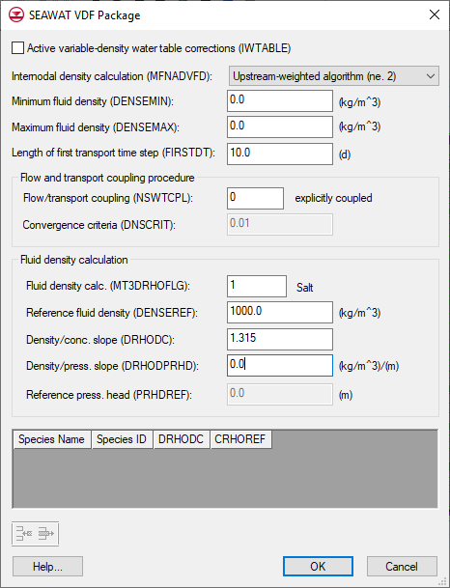

Figure 8 SEAWAT VDF Package inputs

## Editing the Conceptual Model

Now, adjust the conceptual model by assigning a concentration to the arc defining the coastline. In order to assign concentrations in the conceptual model, it’s necessary to turn on the transport option and define a species.

1. In the Project Explorer, fully expand the “File:Map Folder.svg Map Data”folder.
2. Right-click on “File:Conceptual Model Icon.svg MODFLOW\_SEAWAT” and select **Properties…** to open the *Conceptual Model Properties* dialog.
3. In the lower section, turn on *Transport*.
4. Select “MT3DMS / MT3D-USGS” from the *Transport model* drop-down.
5. Click **Define Species…** to open the *Define Species* dialog.
6. Click **New** to create a new species in the spreadsheet.
7. In the *Name* column, enter “Salt” and click **OK** to close the *Define Species* dialog.
8. Click **OK** to exit the *Conceptual Model Properties* dialog.

### Assigning Salt Concentration at the Coastline

Now that a species has been defined, assign a concentration to the coast line arc.

1. In the Project Explorer, select “File:Coverage Active Icon.svg Sources & Sinks” to make it active.
2. Using the **Select Arcs** File:GMS Select Arc Tool.svg tool, double-click on the coastline arc to bring up the *Attribute Table* dialog.
3. For *Salt conc (g/l),* enter “19.0”.
4. Click **OK** to exit the *Attribute Table* dialog.

### Mapping to MT3DMS

Now to convert the conceptual model to the numerical model:

1. Select *Feature Objects |* **Map → MT3DMS** to bring up the *Map → Model* dialog.
2. Click **OK** to accept the defaults and close the *Map → Model* dialog.
3. Click **Display Options** File:Display Options Macro.svg to open the *Display Options* dialog.
4. From the list on the left, select “3D Grid Data”.
5. On the *MODFLOW* tab, turn on *Transient head (CHD)*.
6. Click **OK** to close the *Display Options* dialog.

Notice that all the cells at the coastline now have new symbols representing the boundary condition in the MT3DMS source/sink mixing package (detail in Figure 9).

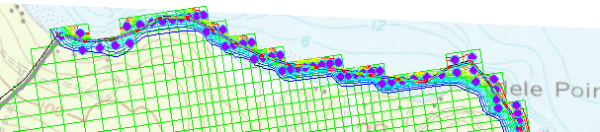

Figure 9 Detail showing the new boundary condition symbols

### Mapping to MODFLOW

At this point, it is also necessary to map over the wells and their pumping schedules.

1. Select the “File:Coverage Active Icon.svg Wells” coverage to make it active.
2. Right-click on “File:Coverage Active Icon.svg Wells” and select *Map To* **| MODFLOW/MODPATH**.

## Saving and Running SEAWAT

Now to save the changes and run SEAWAT:

1. **Save** File:Save Macro.svg the project.
2. Select *SEAWAT |* **Run SEAWAT…** to bring up the *SEAWAT* model wrapper dialog.
3. When SEAWAT finishes, turn on *Read solution on exit* and *Turn on contours (if not on already)*.
4. Click **Close** to import the solution and close the *SEAWAT* dialog.

# Viewing the Solution

Now, view the results of the SEAWAT model run. Examine how the fresh-water contour line changes with time.

1. Select the “File:Display Theme Icon.svg MCL contour” display theme.

This display theme is set up to show one contour at a value of 0.25 g/l (Figure 10).

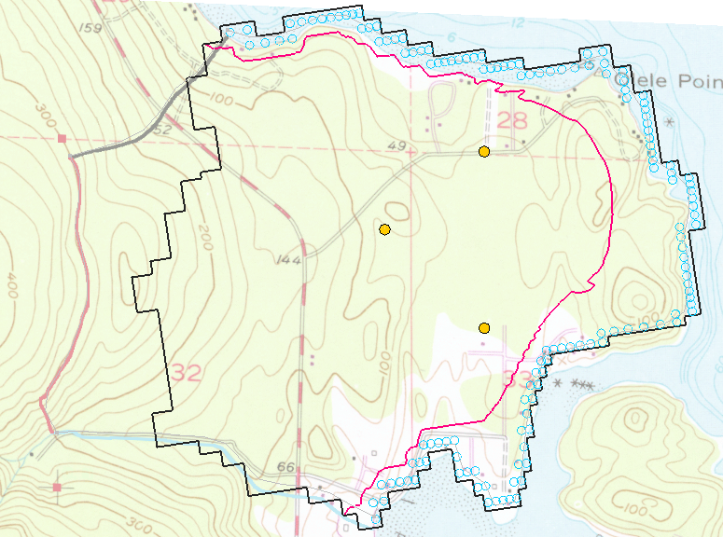

Figure 10 Initial appearance after turning on MCL contour display theme

1. In the Project Explorer, under “File:Generic Folder Locked.svg seawat (MT3DMS)”, select “File:Dataset Cells Active.svg Salt”.
2. In the *Time Steps* window, select time step 12 (value of “120.0”).

Notice that the MCL contour moves inland slightly from time step 1 to time step 12 (Figure 11).

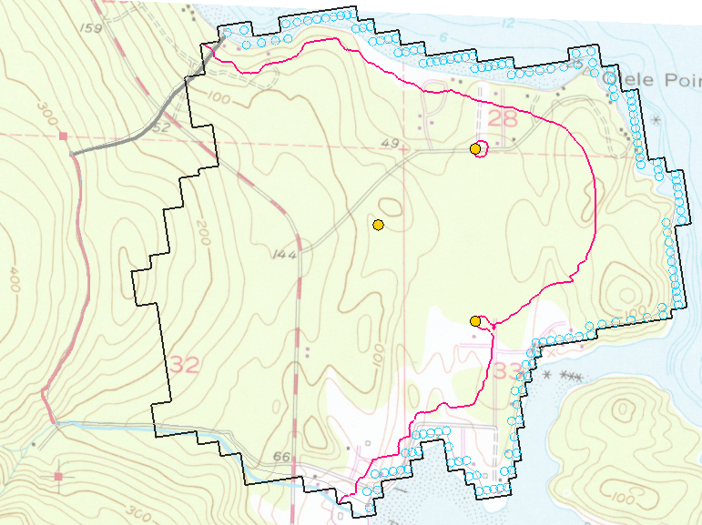

Figure 11 Time step 12

## Creating an Animation

Next to create an animation of the change in concentration over time. This helps show when the northernmost well begins pumping lower quality water.

1. Select *Display |* **Animate…** to bring up the *Animation Wizard – Options* dialog.
2. Click on the Browser 16px-Open_Macro button.
3. Enter “seawat.mp4” as the *File name*.
4. Be certain that *Save as type* is set to “Animation files (\*.mp4, \*.avi)”.
5. Select **Save**.

The defaults work fine for this animation.

1. Click **Next>** to go to the *Animation Wizard* – *Datasets* dialog.
2. Click **Finish** to close the *Animation Wizard* dialog.
3. Open an external animation application.

An animation should begin playing after a few moments (depending on the speed of the computer being used). Notice how the MCL contour line eventually surrounds the northernmost pumping well. Also see how the MCL contour line is moving near the southernmost well.

1. When finished viewing the animation, close File:Windows10 Close button.png the Animation and return to GMS.

## Creating a Time Series Plot of Concentration

Next to make a plot of concentration versus time at the northernmost well.

1. **Zoom** File:Zoom Tool Icon.svg in around the northernmost well.
2. In the Project Explorer, select “File:3D Grid Icon.svg grid”to make it active.
3. Using the **Select Cell** File:Select 3D Cell Tool.svg tool, click on the cell containing the well.

Notice that the selected cell number is indicated in the status bar at the bottom left of the GMS window (“Cell ID: 13035”).

1. Click **Plot Wizard** File:Plot Wizard Macro.svg to bring up the *Step 1 of 2* page of the *Plot Wizard* dialog.
2. From the *Plot Type* list on the left, select “Active Dataset Time Series”.
3. Click **Finish** to close the *Plot Wizard* dialog.

A plot similar to Figure 12 should appear. See how the concentration increases when the well is pumping and then drops off when the well is turned off.

1. Close File:Windows10 Close button.png the plot window and maximize the Graphics Window before continuing.

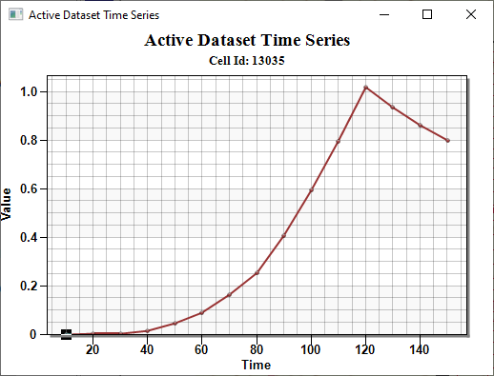

Figure 12 Time series plot of concentration

## Animating the Fresh-Water Surface

Now to animate the fresh-water isosurface over time:

1. Select the “File:Display Theme Icon.svg Isosurface Animation”display theme.
2. Select the **Select Material Zones** File:Select Material Zones Tool.svg tool.
3. Select *Edit |* **Select From List** to bring up the *Select* dialog.
4. Turn on “lower\_aquifer” and click **OK** to close the *Select* dialog.

The lower aquifer and the fresh-water isosurface should now be visible. There will also be some circles that are visible. Those can be used to select material zones. To avoid having the circles in the animation, change the tool.

1. Select the **Select Cell** File:Select 3D Cell Tool.svg tool.
2. Select *Display* | **Animate…** to bring up the *Animation Wizard – Options* dialog.
3. Click on the browser 16px-Open_Macro button to open the *Save* dialog.
4. Enter “loweraquifer.mp4” as the *File name*.
5. Be certain that the *Save as type* is set to “Animation file (\*.mp4, \*.avi)”.
6. Select **Save** to close the *Save* dialog.

The defaults will work fine for this animation.

1. Click **Next>** to go to the *Animation Wizard* – *Datasets* dialog.
2. Click **Finish** to close the *Animation Wizard* dialog.

View the animation file in an external media player application. An animation should begin playing after a few moments. Notice how the fresh-water surface is affected by the pumping wells. See how the fresh-water surface passes the northernmost well.

# Conclusion

This concludes the “SEAWAT – Conceptual Model Approach” tutorial. The following key concepts were discussed and demonstrated in this tutorial:

* SEAWAT combines MODFLOW and MT3DMS to solve variable density groundwater flow and solute transport problems.
* Use the conceptual model approach with SEAWAT models.
* SEAWAT results can be visualized three dimensionally in GMS.

## Further Reading

Langevin, Christian D.; Shoemaker, W. Barclay; and Guo, Weixing (2003). “MODFLOW-2000, the U.S. Geological Survey Modular Ground-Water Model–Documentation of the SEAWAT-2000 Version with the Variable-Density Flow Process (VDF) and the Integrated MT3DMS Transport Process (IMT)”: *U.S. Geological Survey Open-File Report 03-426*, 43 p. <http://fl.water.usgs.gov/PDF_files/ofr03_426_langevin.pdf>.

1. *SEAWAT: A Computer Program for Simulation of Three-Dimensional Variable-Density Ground-Water Flow and Transport*. U.S. Geological Survey. October 7, 2015. <http://water.usgs.gov/ogw/seawat/>. Accessed July 6, 2017. (Archived by WebCite at <http://www.webcitation.org/6ioGQwVBw>) [↑](#footnote-ref-1)
2. For more details, see Langevin, Christian. D.; Thorne, Daniel T., Jr.; Dausman, Alyssa M.; Sukop, Michael C.; and Guo, Weixing. (2007). “SEAWAT Version 4: A Computer Program for Simulation of Multi-Species Solute and Heat Transport” in U.S. Geological Survey *Techniques and Methods Book 6*, Chapter A22, p. 13. <https://pubs.usgs.gov/tm/tm6a22/pdf/tm6A22.pdf>. [↑](#footnote-ref-2)
3. For more information, see Langevin, et al (2007), pp. 20–21. [↑](#footnote-ref-3)