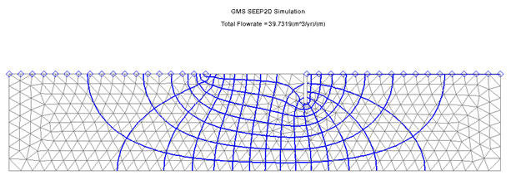

GMS 10.9

GMS 10.9 Tutorial

***SEEP2D – Sheet Pile***

Use SEEP2D to create a flow net around a sheet pile

Objectives

This tutorial shows how to set up and solve a seepage problem involving flow around a sheet pile using the SEEP2D interface in GMS.

Time

* 30–45 minutes

Required Components

* GMS Core
* SEEP2D

Prerequisite Tutorials

* Feature Objects

|  |
| --- |
| 1 Introduction 2  2 Setup 3  2.1 Program Mode 3  2.2 Getting Started 3  2.3 Setting the Units 4  2.4 Saving the Project 4  3 Creating the Conceptual Model Features 4  3.1 Defining a Coordinate System 4  3.2 Creating the Corner Points 5  3.3 Creating the Arcs 6  3.4 Creating the Polygons 7  3.5 Assigning the Material Properties and Zones 8  4 Assigning Boundary Conditions 9  4.1 Constant-Head Boundaries 9  4.2 Building the Finite-Element Mesh 10  5 Running SEEP2D 11  6 Conclusion 12 |

# Introduction

SEEP2D is a two-dimensional, finite-element, steady-state flow model. It is commonly used for profile models—cross-sectional representions of flow systems that are assumed to be symmetric in the third dimension. Typical applications include earth dams, levees, and sheet pile structures.

This tutorial focuses on a confined flow problem involving a partially penetrating sheet pile wall with an impervious clay blanket on the upstream side (Figure 1). The sheet pile is embedded in a silty sand deposit, which is underlain by bedrock at a depth of 10 meters.



Figure 1 Confined flow problem

From a SEEP2D perspective, the problem is classified as “confined” because the flow domain is entirely saturated. In contrast, unconfined problems involve partially saturated zones.

This tutorial demonstrates the process of creating a SEEP2D conceptual model, mapping it to a two-dimensional mesh, running the SEEP2D simulation, and viewing the resulting solution.

# Setup

## Getting Started

Do the following to get started:

1. If necessary, launch GMS.

If GMS is already running, select *File |* **New** to ensure that the program settings are restored to their default state.

Right-click in the Project Explorer and select *New* | **Conceptual Model…** to open the *Conceptual Model Properties* dialog.

For the *Name*, enter “Sheetpile Model”.

From the *Type* drop-down, select “SEEP2D”.

Note: If the “SEEP2D” option does not appear, naviate to *Edit* | **Model Interfaces…** and select “SEEP2D” from the list on the left.

Click **OK** to close the *Conceptual Model Properties* dialog.

A new “File:Conceptual Model Icon.svg Sheetpile Model” conceptual model object should appear in the Project Explorer.

## Setting the Units

Before proceeding, the unit system to be used must be established. GMS displays unit labels next to each input field as a reminder for maintaining consistency throughout the model setup.

1. Select *Edit* | **Units…** to open the *Units* dialog.
2. To the right of the *Length\** option, click the http://www.xmswiki.com/w/images/f/fc/Dot_dot_dot_button.png button to bring up the *Display Projection* dialog.
3. In both the *Horizontal* and *Vertical* sections, select “Meters” from the *Units* drop-down.
4. Click **OK** to close the *Display Projection* dialog.
5. From the *Time* drop-down, select “yr”.
6. From the *Mass* drop-down, select “kg”.
7. Click **OK** to close the *Units* dialog.

## Saving the Project

Before continuing, it is best to save the project to a GMS project file.

1. Select *File |* **Save As…** to bring up the *Save As* dialog.

Browse to the *s2con\s2con\sample* directory.

Select “Project Files (*.gpr)” from the *Save as type* drop-down.

Enter “s2con.gpr” as the *File name*.

Click **Save** to create the project file and close the *Save As* dialog.

It is recommended to use the **Save** File:Save Macro.svg macro frequently while working on any project.

# Creating the Conceptual Model Features

The first step in setting up the model is to create the GIS features that define the problem geometry. Begin by entering a set of points representing key locations within the geometry. These points are then connected with arcs to outline the problem domain. Once the outline is complete, the arcs are converted into a closed polygon. This polygon, along with the arcs, will be used to generate the finite element mesh and assign boundary conditions for the SEEP2D simulation.

## Defining a Coordinate System

Before constructing the conceptual model features, a coordinate system must be established. In this tutorial, the origin is set to 30 meters upstream of the sheet pile, at the top of the bedrock, as shown in Figure 2.

Figure 2 Coordinate system

## Creating the Coverage

The next step is to create a coverage that will be used to define the model boundary conditions and material zones:

1. In the Project Explorer, right-click on the “File:Conceptual Model Icon.svg Sheetpile Model” model and select **New Coverage…** to open the *Coverage Setup* dialog.
2. For the *Coverage name*, enter “Profile lines”.
3. In the *Sources/Sinks/BCs* section, enable the “Head” and “Single Head Value for Arcs” options.
4. In *the Areal Properties* section, enable the “All” option.
5. Click **OK** to exit the *Coverage Setup* dialog.

A new “File:Coverage Active Icon.svg Profile lines” coverage should appear in the Project Explorer.

## Creating the Corner Points

With the coverage active, points can now be created at key corner locations. These points will serve as references for constructing arcs that define the model boundary.

|  |  |  |
| --- | --- | --- |
| Name | X | Y |
| new_point_1 | 0.0 | 0.0 |
| new_point_2 | 0.0 | 10.0 |
| new_point_3 | 20.0 | 10.0 |
| new_point_4 | 30.0 | 10.0 |
| new_point_5 | 30.0 | 7.0 |
| new_point_6 | 30.3 | 10.0 |
| new_point_7 | 30.3 | 7.0 |
| new_point_8 | 50.0 | 10.0 |
| new_point_9 | 50.0 | 0.0 |

1. Right-click on the “File:Coverage Active Icon.svg Profile lines” coverage and select **Attribute Table…** to open the *Attribute Table* dialog.
2. Ensure that the “Points” option is selected from the *Feature type* drop-down.
3. Enter the coordinates as shown in the spreadsheet to the right.
4. Click **OK** to exit the *Attribute Table* dialog.
5. Click **Frame Image** File:Frame Macro.svg to center the view on the new points (Figure 3).

The points at (30, 10) and (30.3, 10) define the sheet pile, which is approximately 0.3 meters thick. To edit a point’s coordinates, use the **Select Points/Nodes** File:GMS Select Node Tool.svg tool and double-click on the point to open the *Attribute Table* dialog. Points can be deleted by selecting them and pressing the *Delete* key.



Figure 3 Points created in the profile lines coverage

## Creating the Arcs

With the corner nodes defined, the next step is to create arcs to outline the model geometry. This can be done as follows:

1. Click on the “File:Coverage Active Icon.svg Profile lines” coverage to make it active.
2. Using the **Create Arc** File:GMS Create Arc Tool.svg tool, create the arcs as they are shown in Figure 4.

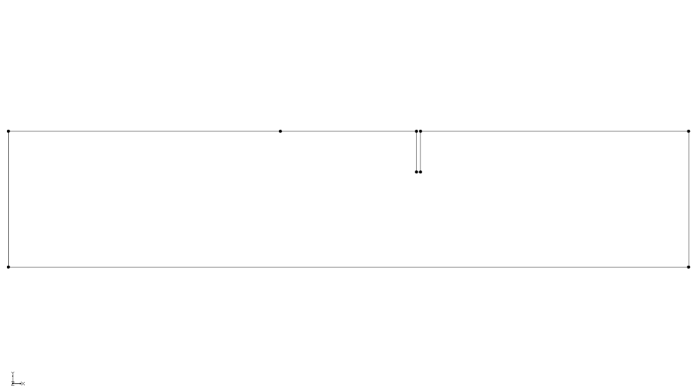

Figure 4 Final view with all the arcs created

## Creating the Polygons

With the arcs defined, a polygon can now be created to represent the region enclosed by the model boundary. For models with multiple materials, polygons are used to assign different material zones. Although this example includes only one material, a polygon is still required. To create the polygon, complete the following step:

1. Select the**Build Polygons** macro.

The polygon will have a colored background (Figure 5).

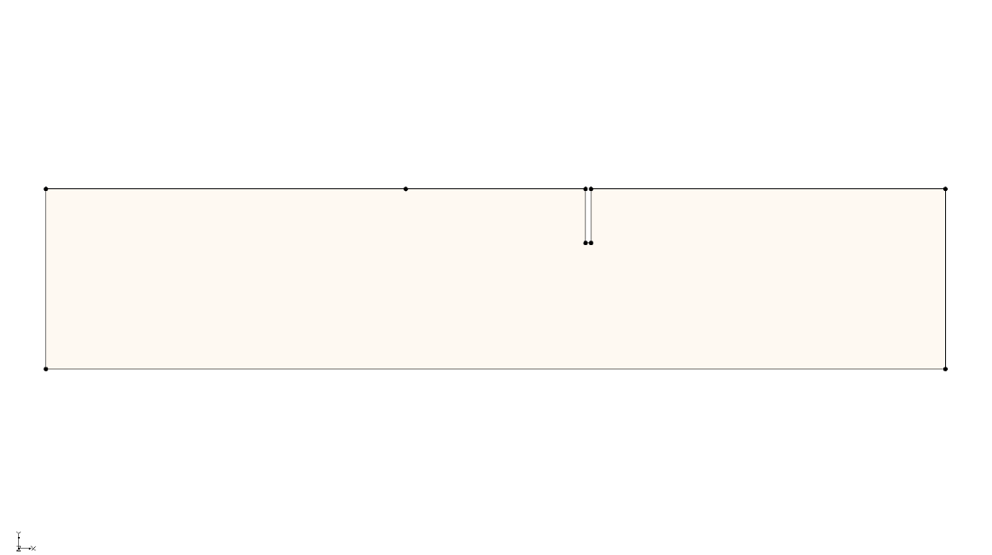

Figure 5 The polygon is indicated by its background (exact color may vary)

## Assigning the Material Properties and Zones

The next step is to assign the material properties and zones. To edit the material properties:

1. Click the **Materials** File:GMS Materials Macro.svg macro bring up the *Materials* dialog.
2. Select the *SEEP2D* tab.

At this stage, a separate material would typically be created for each zone in the model, each with a unique name and color. However, since this problem includes only one material, the default material can be used. Only the material properties need to be edited. These include *k₁*, *k₂*, and an angle. The values *k₁* and *k₂* represent the principal hydraulic conductivities, while the angle defines the orientation of the major principle conductivity relative to the x-axis, measured counter-clockwise (Figure 6).

Figure 6 Definition of hydraulic conductivity angle

For most natural soil deposits, the major principal hydraulic conductivity is aligned with the x-direction, the minor with the y-direction, and the angle is set to zero. Hydraulic conductivity has units of length per time (L/T). The length units must be consistent with those used for the mesh geometry. While time units can vary, using very small time units (e.g., seconds) may produce extremely small velocity values, making velocity vectors difficult to visualize. It is recommended to use days or years as the time unit for improved display clarity.

1. In the *material_1* row, enter “30.0” for both *k1* and *k2.*
2. Click **OK** to close the *Materials* dialog.

For problems involving multiple materials, double-click on each polygon at this stage to assign the appropriate material zones. In this example, there is only one materials, so the polygon automatically inherits the default material assignment.

# Assigning Boundary Conditions

The next step in defining the model is to assign boundary conditions to the conceptual model. This problem involves two types of boundary conditions: constant head and no-flow (where flow is parallel to the boundary). In the finite element method, any boundary without an explicitly assigned condition is treated as a no-flow boundary by default. Therefore, it is only necessary to assign the constant-head boundary conditions in this case.

## Constant-Head Boundaries

The constant-head boundary conditions for the problem are shown in Figure 7.

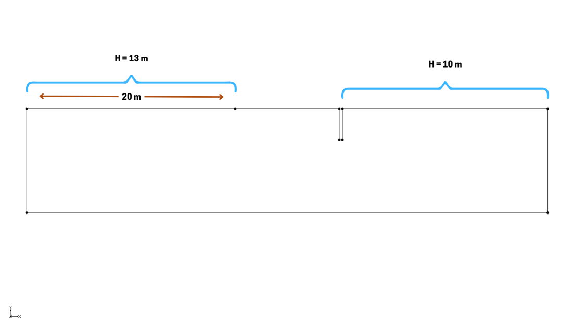

Figure 7 Constant-head boundary conditions

The region on the left in Figure 7 represents the top of the mesh on the upstream side not covered by the clay blanket, while the region on the right represents the downstream side of the mesh. Using a datum of zero, the total head at these locations corresponds to the elevation of the water. As noted previously, all other boundaries retain the default no-flow boundary condition.

To enter the constant-head boundary conditions for the arc on the top of the model:

1. Select the “File:Coverage Active Icon.svg Profile lines” coverage in the Project Explorer to make it active.
2. Using the **Select Arcs** File:GMS Select Arc Tool.svg tool, double-click on the top-left arc of the model to open the *Attribute Table* dialog.
3. From the drop-down in the *Type* column, select “head”.
4. In the *Head (m)* column, enter “13.0”.
5. Click **OK** to exit the *Attribute Table* dialog.

The arc will now appear blue, indicating that a constant-head boundary condition has been successfully assigned (Figure 8).

1. Repeat steps 2–5 for the top right arc, entering “10.0” in the *Head (m)* field.
2. Click anywhere in the Graphics Windows to deselect the arc.

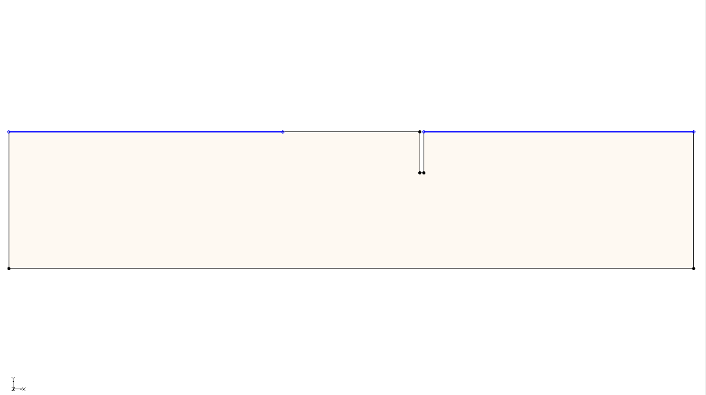

Figure 8 Constant-head boundaries marked in blue

## Building the Finite-Element Mesh

The finite-element mesh for SEEP2D can now be generated. This mesh is automatically constructed from the conceptual model features. Element size is controlled by the spacing of vertices along the arcs that define the model boundary.

Each arc consists of two nodes and may include intermediate vertices. The segments between vertices are called edges. Currently, all arcs contain a single edge with no vertices.

To subdivide the arcs to create appropriately sized edges, follow these steps:

1. After selecting the **Select Arcs** File:GMS Select Arc Tool.svg tool, select *Edit* | **Select All** to select all the arcs.
2. Select *Feature Objects* | **Redistribute Vertices…** to bring up the *Redistribute Vertices* dialog.
3. From the *Specify* drop-down, select “Specified spacing”.
4. For the *Average* *spacing*, enter “1.2”.
5. Click **OK** to close the *Redistribute Vertices* dialog.
6. To see the vertices, switch to the **Select Vertices** File:GMS Select Vertex Tool.svg tool.

To make the vertices always visible, do the following:

1. Click the **Display Options** File:Display Options Macro.svg macro to bring up the *Display Options* dialog.

Select “Map Data” from the list on the left.

Under the *Map* tab, turn on *Vertices*.

Click **OK** to close the *Display Options* dialog.

At this point, it is necessary to construct the mesh.

1. Click the **Map → 2D Mesh** File:Map to 2D Mesh Macro.svg macro to generate the mesh.

A 2D mesh should now be visible (Figure 9).

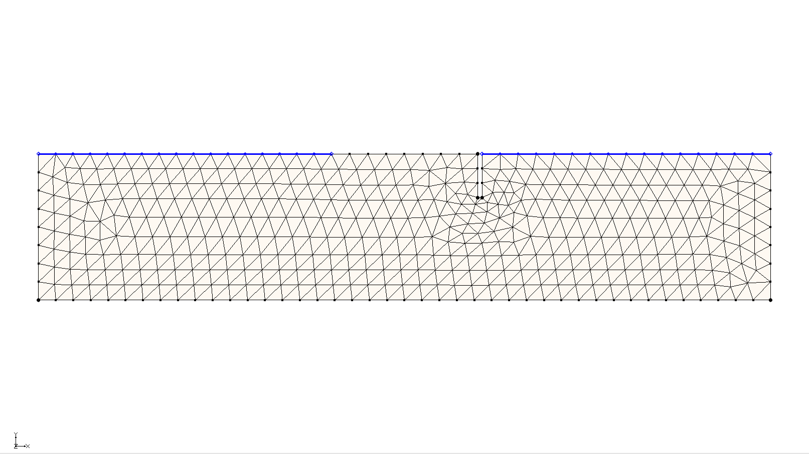

Figure 9 The 2D mesh created from the vertices

Finally, convert the conceptual model to the SEEP2D numerical model. This process transfers the boundary conditions defined on the feature objects to the corresponding node-based boundary conditions required by SEEP2D.

1. Click the **Map → SEEP2D** File:Map to SEEP2D Macro.svg macro.

A series of blue symbols should now appear along the constant-head boundaries, indicating that the boundary conditions have been successfully assigned.

# Running SEEP2D

Now to save the changes and run SEEP2D:

1. Click **Save** File:Save Macro.svg.
2. Click the **Run SEEP2D** File:Run SEEP2D Macro.svg macro to open the *Seep2d* model wrapper dialog.
3. When the solution is finished, turn on *Read solution on exit* and click **Close** to close the *Seep2d* model wrapper dialog.

GMS automatically imports the SEEP2D solution, which is displayed as a flow net. The flow net includes equipotential lines (total head contours) and flow lines, as shown in Figure 10).

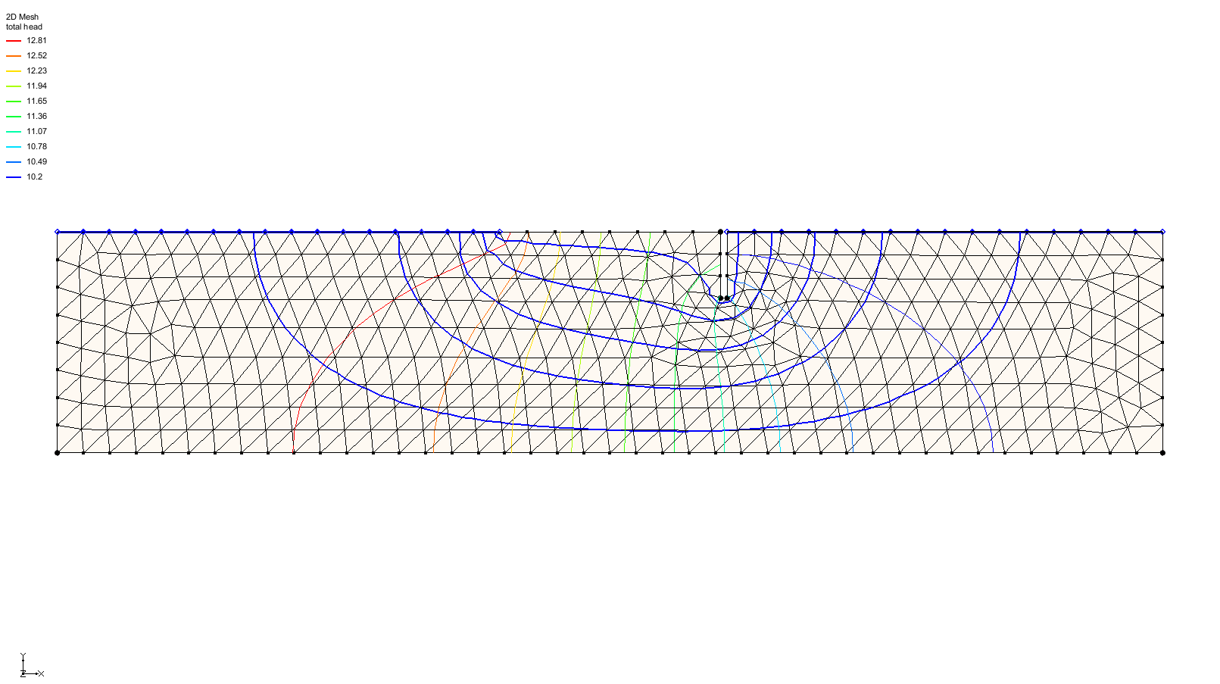

Figure 10 Total head contours are visible

To turn on the display of the total flow through the cross section, do the following:

1. Click the **Display Options** File:Display Options Macro.svg macro to bring up the *Display Options* dialog.
2. Select “2D Mesh Data” from the list on the left.
3. Under the *2D Mesh* tab, turn off *Nodes* and *Element edges* and turn on *Mesh boundary*.
4. Under the *SEEP2D* tab, turn on *Title* and *Total flow rate*.
5. Click **OK** to close the *Display Options* dialog.

The display should appear similar to Figure 11.

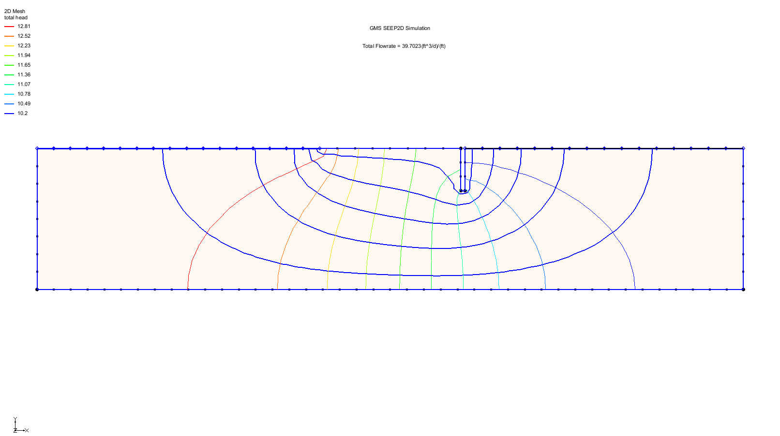

Figure 11 The final view

# Conclusion

This concludes the “SEEP2D – Sheet Pile” tutorial. The following topics were discussed and demonstrated:

* SEEP2D is a 2D, finite-element seepage model.
* A conceptual model was used to define geometry, materials, and boundary conditions.
* Boundary conditions were assigned using arcs in the conceptual model.
* The conceptual model was converted to a numerical model and meshed.
* The SEEP2D solution was visualized as a flow net with head contours and flow lines.