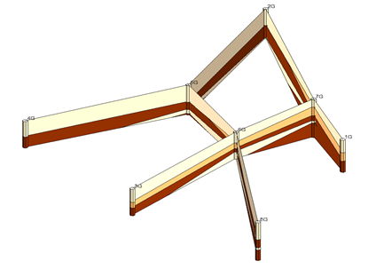

GMS 10.9

GMS 10.9 Tutorial

***Stratigraphy Modeling – Boreholes and Cross Sections***

Become familiar with boreholes and borehole cross sections in GMS

Objectives

Learn how to import borehole data, construct a set of cross sections between the holes to achieve site characterization, and edit the cross sections in the *Cross Section Editor*.

Time

* 15–25 minutes

Required Components

* GMS Core
* Subsurface Characterization

Prerequisite Tutorials

* Getting Started

|  |
| --- |
| 1 Introduction 2  1.1 Getting Started 2  2 Importing Borehole Data 2  3 Displaying the Hole Names 3  4 Editing the Materials 4  5 Creating Blank Cross Sections 5  5.1 Auto-Create Blank Cross Sections 5  5.2 Snapping the Cross Section Tops to a Surface 5  5.3 Manually Create Blank Cross Sections 7  6 Auto-Fill Blank Cross Sections 7  7 Manually Fill Cross Sections 7G–2G 8  7.1 Building Cross Section 7G–2G 8  8 Manually Editing Multiple Cross Sections 9  9 Conclusion 11 |

# Introduction

The Borehole module of GMS visualizes boreholes created from drilling logs and to construct three-dimensional cross sections between boreholes. These cross sections show the soil stratigraphy between two boreholes. Once a set of cross sections is built, the cross sections can be displayed in 3D space to help characterize and visualize the soil stratigraphy at a site.

This tutorial illustrates how to construct a set of cross sections for site characterization using borehole data by doing the following:

* Importing boreholes
* Displaying the borehole names and editing the materials
* Creating and filling cross sections automatically and manually

## Getting Started

To get started, do the following:

1. If necessary, launch GMS.
2. If GMS is already running, select *File |* **New** to ensure that the program settings are restored to their default state.

# Importing Borehole Data

The first step in the construction of borehole cross sections is to create some boreholes. The second step is to import a set of previously defined borehole logs.

1. Click **Open** File:Open Macro.svg to bring up the *Open* dialog.
2. Browse to the *Boreholes_and_Cross_Sections* directory for this tutorial.
3. Select “Text Files (*.txt;*.csv)” from the *Files of type* drop-down.
4. Select “holes.txt” and click **Open** to close the *Open* dialog and bring up the *Step 1 of 2* page of the *Text Import Wizard* dialog.
5. Below the *File import options* section, check the *Heading row* box and click **Next** to go to page *2 of 2* of the *Text Import Wizard* dialog.
6. From the *GMS data type* drop-down, select “Borehole data” (not “Borehole sample data”).

Notice all the column types are automatically assigned based on the header row because GMS recognized the headings. Examine the format of the borehole file being imported using a text editor, if desired.

1. Click **Finish** to close the *Text Import Wizard* dialog and import the borehole data.
2. Click **Oblique View** File:Oblique View Macro.svg so the boreholes are more visible (Figure 1).

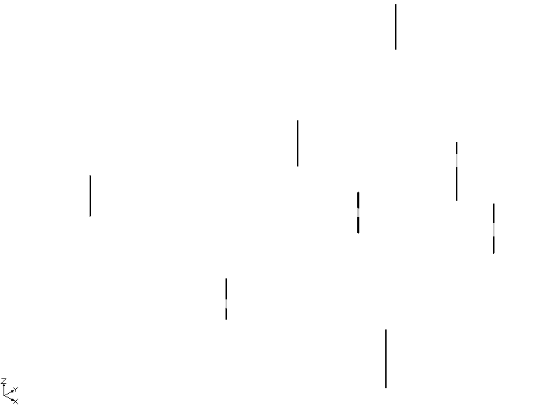

Figure Oblique view showing the imported boreholes

# Displaying the Hole Names

The boreholes currently appear very long and thin, making it difficult to distinguish the different materials. The next step is to adjust the borehole display options to improve the view.

1. Click the **Display Options** File:Display Options Macro.svg macro to bring up the *Display Options* dialog.
2. Select “File:Borehole Module Icon.svgBorehole Data” from the list on the left.
3. In the *Stratigraphy* section, enter “7.0” in the *Diameter* field.
4. Turn on the Hole names option.
5. Click **OK** to close the *Display Options* dialog.

The boreholes should be more visible now, and the names of the holes should appear at the tops of the holes (Figure 2).

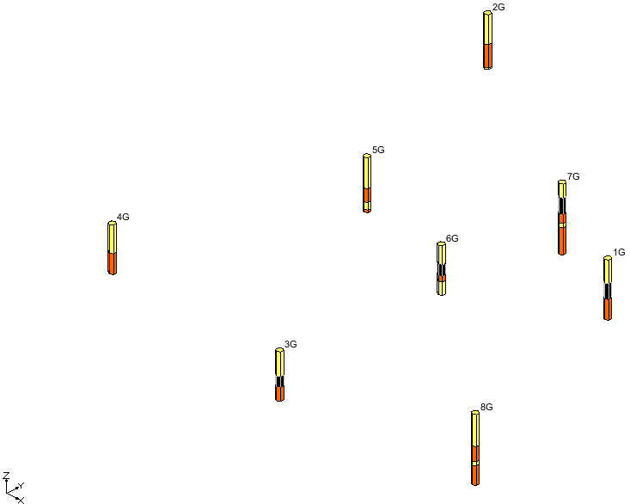

Figure The boreholes are now more visible

# Editing the Materials

Each of the colors represents a different type of soil. The file that was just imported specified a material ID number for each section of each borehole. GMS also created materials with those IDs and gave them default names and colors. The next steps show how to change the material names and colors.

1. Click **Materials** File:GMS Materials Macro.svg to bring up the *Materials* dialog.
2. Click on “material_1”, enter “Clean Sand”, and press the *Enter* key to set the new name.
3. For this same material, click the down arrow in the *Color/Pattern* column and select “Green” from the palette.
4. Follow steps 2–3 for “material_2”, renaming it “Silty or Clayey Fine Sand” and changing its color to blue.
5. Follow steps 2–3 for “material_4”, renaming it “Silty Clay**”** and changing its color to red.
6. Click **OK** to close the *Materials* dialog.

To turn on the material legend, do the following:

1. Click **Display Options** File:Display Options Macro.svg to bring up the *Display Options* dialog.
2. Select “File:Materials Display Options.svg Materials”from the list on the left.
3. On the *Materials* tab, turn on *Display material legend*.
4. Click **OK** to close the *Display Options* dialog.

The legend will appear in the bottom right corner of the Main Graphics Window.

# Creating Blank Cross Sections

The next step is to create a set of blank cross sections. The set of cross sections will be “blank” because, at this point, this step indicates where the cross sections should be, not what they should look like. The blank cross sections will appear as two lines connecting the tops and bottoms of the two boreholes. Cross sections created between two boreholes are named using a combination of the two holes’ names. For example, a cross section created between holes 1G and 7G will be named 1G–7G.

## Auto-Create Blank Cross Sections

The easiest way to create blank cross sections is to do it automatically.

1. Select *Boreholes |* **Auto-Create Blank Cross Sections**.

Notice that GMS connects the holes with blank cross sections (Figure 3). GMS simply triangulates the boreholes to determine how to connect them.

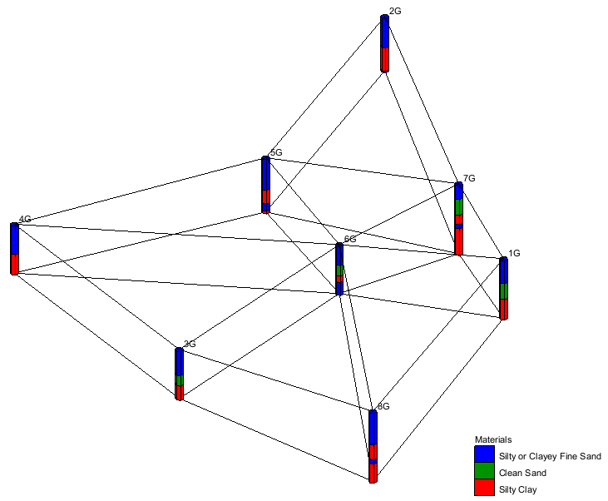

Figure Blank cross sections created automatically

## Snapping the Cross Section Tops to a Surface

The top and bottom lines that define each cross section can be adjusted to match a TIN that defines each surface. The next step is to import a TIN and snap the cross section tops to the TIN elevations.

1. Click **Open** File:Open Macro.svg to bring up the *Open* dialog.
2. Select “All Files (*.*)” from the *Files of type* drop-down and select “top_elev.tin”.
3. Click **Open** to import the TIN and close the *Open* dialog.

A TIN should appear in the graphics window (Figure 4).

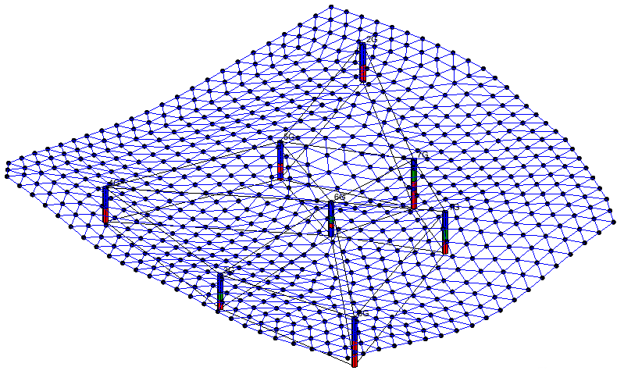

Figure Imported TIN file

1. Select *Boreholes | Advanced |* **Snap Cross Sections to TIN…** to bring up the *Snap Cross Sections to TIN* dialog.
2. In the *Top TIN Selection* section, turn on *Snap Top to TIN* and click **OK** to close the *Snap Cross Sections to TIN* dialog.
3. To hide the TIN, uncheck the “File:TIN Module Icon.svg top elevation” TIN in the “File:TIN Folder.svg TIN Data” folder in the Project Explorer.

The cross section tops should now be adjusted to match the TIN elevations (Figure 5).

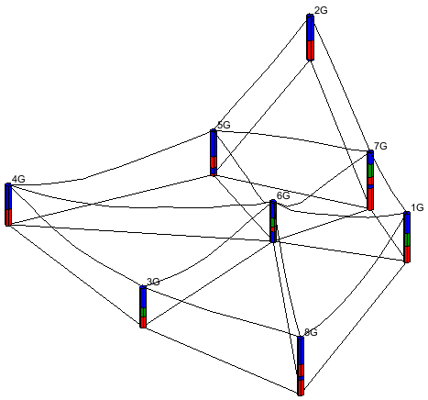

Figure Cross section tops adjusted to match TIN elevation

## Manually Create Blank Cross Sections

This section demonstrates creating cross sections manually. Before doing this, it is necessary to delete all the cross sections that were created automatically.

1. Click the **Select Borehole Cross Sections** File:Select Cross Section Tool.svg tool.
2. Select *Edit |* **Select All** to highlight all of the cross sections.
3. Press the *Delete* key.

All of the cross sections in the Project Explorer will disappear.

The set of blank cross sections to be created are as follows: 1G–7G, 7G–2G, 2G–5G, 4G–5G, 5G–6G, 6G–7G, 3G–6G, and 6G–8G.

1. Select the **Create Borehole Cross Sections** File:Create Cross Section Tool.svg tool.
2. Click on hole 1G to begin, then single-click on holes 7G, 2G, 5G, and 6G in sequence, double-clicking on hole 8G to end.
3. Create cross sections 3G–6G and 6G–7G by clicking on hole 3G to begin, clicking on hole 6G, and double-clicking on hole 7G to end.
4. Create cross section 4G–5G by clicking on hole 4G to begin and double-clicking on hole 5G to end.

The “blank” cross sections should look like those in Figure 6.

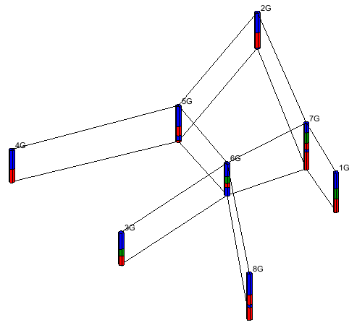

Figure Blank cross sections created manually

# Auto-Fill Blank Cross Sections

The next step is to delineate soil layers for the blank cross sections. This is done using arcs and polygons, just like the arcs and polygons created in the Map module of GMS. Familiarity with the Map module is not necessary for this tutorial, however. The easiest way to fill the blank cross sections is to let GMS do it automatically.

1. Select *Boreholes |* **Auto-Fill Blank Cross Sections…** to bring up the *Auto-Fill Cross Sections* dialog.

This dialog has two options: *Match using horizon IDs* and *Match using materials*. It is generally preferable to assign horizon IDs before using the auto-fill command, and to then use the horizon IDs to fill the cross sections. This makes the cross sections consistent with the horizon IDs. Horizons are discussed in detail in another tutorial.

1. Select the *Match using materials* option, and click **OK** to close the *Auto-Fill Cross Sections* dialog.

After a moment, GMS fills the blank cross sections.

# Manually Fill Cross Sections 7G–2G

GMS cannot automatically fill in the details of the cross section between the two boreholes if they are too dissimilar, or if the results of the automatic fill may not be desirable. Because of this, it is often necessary to manually fill and edit cross sections.

With this relatively simple set of boreholes, GMS had no problem automatically filling all the cross sections. The next section illustrates how to do it manually.

## Building Cross Section 7G–2G

1. Expand the “File:Cross Section Folder.svg Cross Sections” folder in the Project Explorer and double-click on cross section “7G–2G” to bring up the *Cross Section Editor* dialog.
2. Click the **Delete All** File:Borehole Delete All Cross Sections Tool.svg button to delete the existing interior polygons and arcs.
3. Using the **Create Arc** File:GMS Create Arc Tool.svg tool, create all the interior arcs shown in Figure 7.

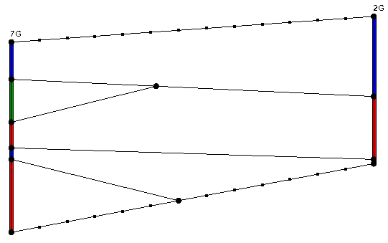

Figure Interior arcs created

1. Click the **Build Cross Section Polygons** File:Borehole Build Cross Section Polygons Tool.svg button. The cross section should appear similar to before the previous interior arcs and polygons were deleted.
2. Click **OK** to close the *Cross Section Editor* dialog.

# Manually Editing Multiple Cross Sections

GMS also allows editing multiple cross sections simultaneously in the *Cross Section Editor*. This is useful when considering geologic trends from adjacent cross sections.

1. Using the **Select Borehole Cross Sections** File:Select Cross Section Tool.svg tool, hold down the *Shift* key and select 6G–8G, 5G–6G, and 2G–5G in the Graphics Window.
2. Select *Boreholes* | **Cross Section Editor…** to bring up the *Cross Section Editor* dialog (Figure 8).

The first panel from the left is brighter than the other panels in the dialog. This is the active panel that can be edited. Change the active panel by using the arrow buttons.

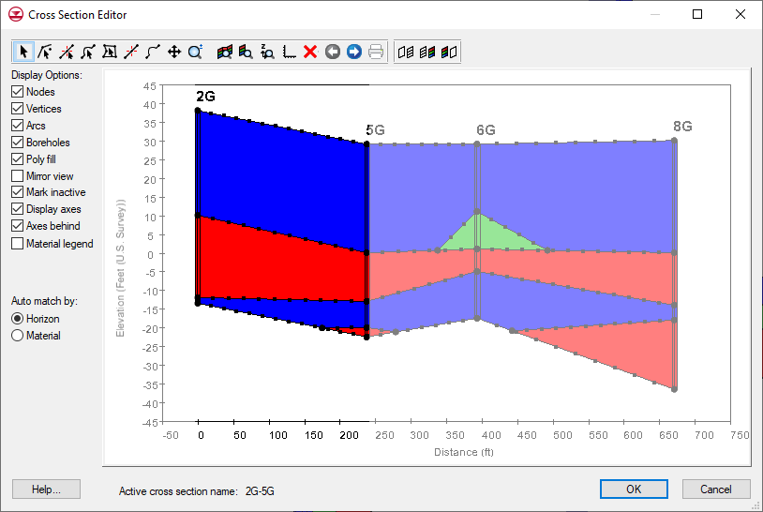

Figure Cross Section Editor dialog

The next step is to edit the middle panel.

1. Click the **Right Arrow** File:Borehole Right Tool.svg button to make the middle panel active.
2. Click **Frame Current Cross Section** File:Borehole Frame Current Cross Section Tool.svg to see this panel more closely.
3. Click **Delete All** File:Borehole Delete All Cross Sections Tool.svg to delete the existing interior polygons and arcs.
4. Using the **Create Arc**File:GMS Create Arc Tool.svg tool, create the cross sections shown in Figure 9.
5. Click **Build Cross Section Polygons** File:Borehole Build Cross Section Polygons Tool.svg so the materials fill the cross section.
6. Click **Frame All Cross Sections**File:Borehole Frame All Cross Sections Tool.svg to see all of the cross sections.

The *Cross Section Editor* dialog allows adjusting the plot that is displayed around the cross sections for high quality print outs, including adding titles and grid lines.

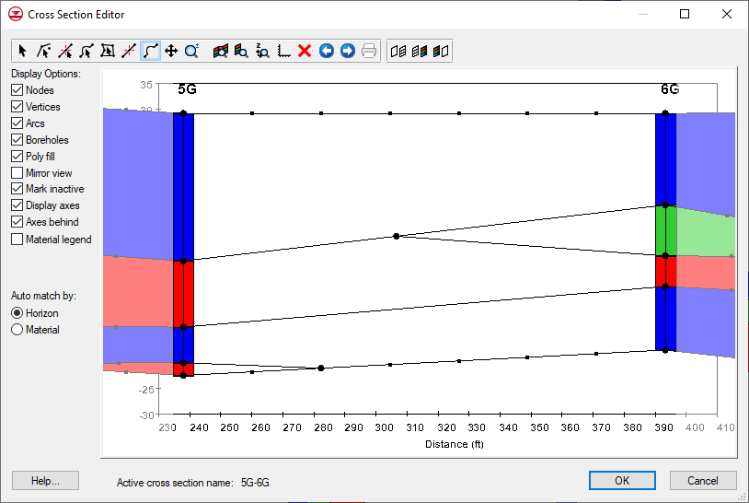

Figure Cross section 5G–6G being edited

1. Click **Plot Options** File:Borehole Plot Options Tool.svg to bring up the *Plot Options* dialog.
2. On the *Options* tab in the *Titles* section, enter “Section A-A” in the *Title 1* field.
3. On the *Y-Axis* tab below the *Left* section, turn on *Display grid*.
4. Click **OK** to exit the *Plot Options* dialog.
5. In the *Display Options* section on the left, turn off *Nodes*, *Vertices*, and *Mark inactive*. The plot should now look something like Figure 10.
6. Click **OK** to exit the *Cross Section Editor* dialog.

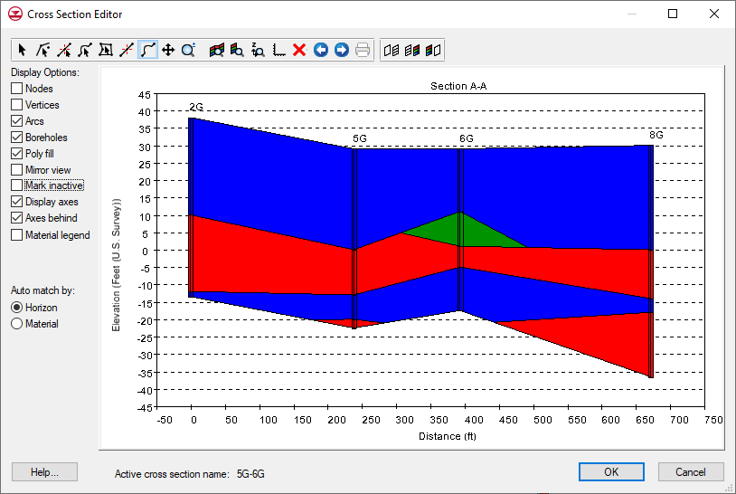

Figure Multi-panel cross section ready for printing

Building the cross sections is now complete, and they should appear as in Figure 11.

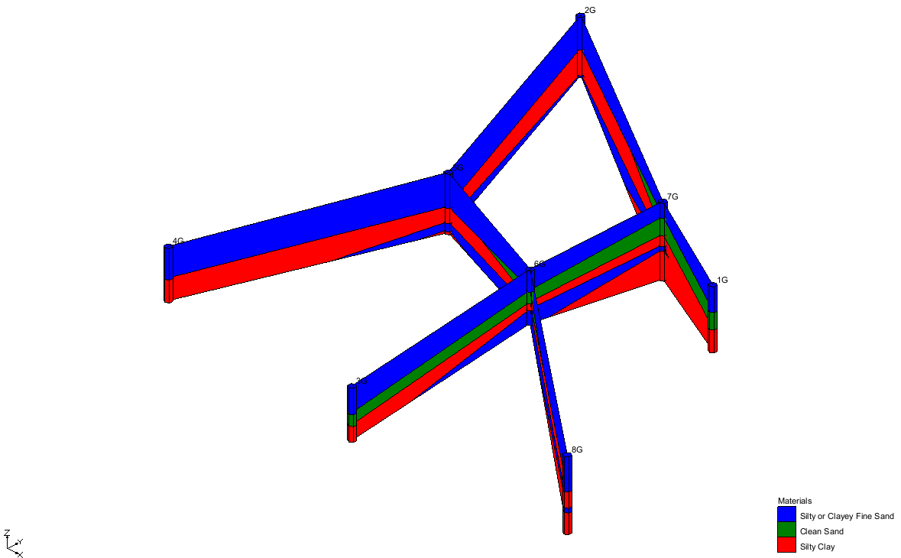

Figure Final appearance of cross sections and boreholes

# Conclusion

This concludes the “Stratigraphy Modeling – Boreholes and Cross Sections” tutorial. The following topics were demonstrated and discussed:

* Boreholes can be imported via the *Text Import Wizard*.
* The display options for boreholes can be changed to aid in visualization.
* Borehole names and materials can be edited.
* When borehole cross sections are first created, they are blank.
* The boreholes can be manually connected to create cross sections.
* Cross sections can also be created automatically using the **Auto-Create Blank Cross Sections** command.
* Cross sections can be automatically filled using the **Auto-Fill Blank Cross Sections** command.
* Cross sections can be manually filled by creating the desired arcs between the two boreholes and then selecting the **Build Cross Section Polygons** File:Borehole Build Cross Section Polygons Tool.svg button in the *Cross Section Editor*.
* The *Cross Section Editor* can be used to define how the soil layers are connected.
* Cross section arcs can be matched to a TIN.