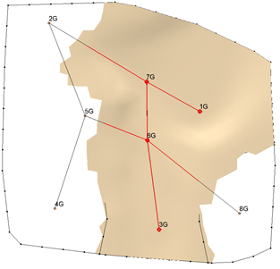

GMS 10.9

GMS 10.9 Tutorial

***Stratigraphy Modeling – Horizon Coverages***

Use horizon coverages to help control the **Horizon → Solids** operation

Objectives

Learn how to constrain the areal extent of the solids created using the **Horizons → Solids** command.

Time

* 20–30 minutes

Required Components

* GMS Core
* Subsurface
* Geostatistics

Prerequisite Tutorials

* Stratigraphy Modeling – Horizons and Solids

|  |
| --- |
| 1 Introduction 2  1.1 Getting Started 2  2 Creating Solids using Horizons → Solids 3  2.1 Viewing the Clean Sand Solid 4  3 Creating the Horizon Conceptual Model 5  3.1 Horizon Coverage 4 5  3.2 Defining the Polygon 6  3.3 Marking the Outside-Boundary Arcs 6  3.4 Building and Deleting Polygons 7  4 Horizons → Solids Command 8  4.1 Comparing the results 8  5 Automatically Build the Horizon Coverages 9  6 Building Solids 10  6.1 Creating Solids from the Horizon Coverage 10  6.2 Comparing the results 10  7 Conclusion 12 |

# Introduction

This tutorial builds on the concepts taught in the “Stratigraphy Modeling—Horizons and Solids” tutorial. In that tutorial, solids were created using horizons and cross sections. GMS uses 2D interpolation in an algorithm to define the solids. Sometimes, the 2D interpolation continues trends in the data that cause the areal extent of the solids to extend beyond what is desired.

This tutorial illustrates a way to constrain the areal extent of the created solids through the following.

1. Creating horizon coverages manually.
2. Creating horizon coverages automatically.
3. Creating solids from the horizon conceptual model.
4. Comparing the solids made from a horizons conceptual model to the solids created without a horizons conceptual model.

## Getting Started

Do the following to get started:

1. If necessary, launch GMS.
2. If GMS is already running, select the *File |* **New** command to ensure that the program settings are restored to their default state.

Next, import the same set of boreholes that were used in the “Stratigraphy Modeling—Horizons and Solids” tutorial:

1. Click **Open** File:Open Macro.svg to bring up the *Open* dialog.
2. Select “All Files (*.*)” from the *Files of type* drop-down.
3. Browse to the *Horizon_Coverages\Horizon_Coverages* directory and select “xsects.gpr”.
4. Select **Open** to import the project (Figure 1) and close the *Open* dialog.

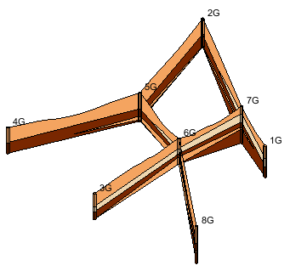

Figure Imported project

# Creating Solids using Horizons → Solids

Next, create solids as outlined in the “Horizons and Solids” tutorial. The horizon IDs have already been assigned and the cross sections have already been created, so all that is necessary is to run the **Horizons → Solids** command.

1. In the Project Explorer, select the“File:Borehole Folder.svgBorehole Data” folderto switch to the Borehole module.
2. Select *Boreholes |* **Horizons → Solids…** to bring up the *Horizons to Solids – Horizon Elevations* dialog.
3. Accept the default settings by clicking **Next** to bring up the *Top and Bottom Elevations* page of the *Horizons to Solids* dialog.
4. In the *Top elevation* section, select *Top of boreholes*.
5. In the *Bottom elevation* section, select *Constant elevation* and enter “-37.0” in the field below that.
6. Click **Finish** to close the *Horizons to Solids* dialog. GMS will now create the solids and the Main Graphics Window should appear similar to Figure 2.

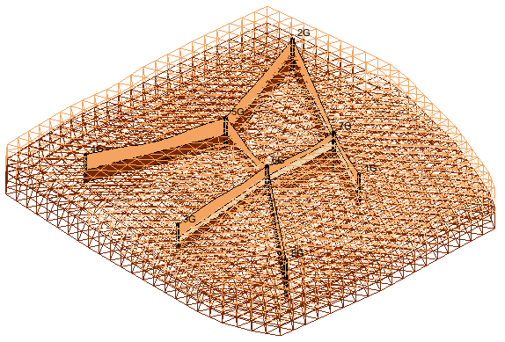

Figure After solids have been created

## Viewing the Clean Sand Solid

Do the following to look at the clean sand layer.

1. In the Project Explorer under the “File:Solids Folder.svg Solid Data” folder, expand the “File:Generic Folder.svg solids” folder to see the solids that were just created.
2. Turn off all the solids except for “File:Solid Module Icon.svg Clean_Sand 4”.
3. Click **Display Options** File:Display Options Macro.svg to bring up the *Display Options* dialog.
4. From the list on the left select “Borehole Data*”*.
5. On the *Borehole* tab in the *Stratigraphy* section, turn on *Hole names*.
6. From the list on the left select “Solid Data”.
7. On the *Solid* tab, turn on *Solid faces.*
8. Click **OK** to close the *Display Options* dialog.

Notice how the “File:Solid Module Icon.svg Clean_Sand 4” layer intersects with cross section 5G–2G even though there is no clean sand material in that cross section (Figure 3).

1. Using the **Rotate** File:Rotate Tool.svg tool, rotate the view to get a feel for the extent of this solid. For example, notice how it passes through cross section 6G–8G outside of the clean sand area in the cross section.

This is the result of the interpolation that the **Horizons → Solids** command used. The interpolation identifies the trends in the data and continues the trends—sometimes further than is desirable. Using horizon coverages allows the interpolation to be constrained.

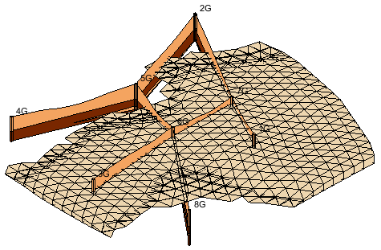

Figure Clean sand material passing through cross section

# Creating the Horizon Conceptual Model

Now to create a horizon conceptual model:

1. Right-click on the “MapFolder Map Data” folder and select **New Conceptual Model…** to bring up the *Conceptual Model Properties* dialog.
2. For the *Name, e*nter “Horizons”.
3. From the *Type* drop-down, select “Horizons”.
4. Click **OK** to exit the *Conceptual Model Properties* dialog.

## Horizon Coverage 4

Create a new coverage and set up the attributes by doing the following:

1. In the Project Explorer, right-click on “File:Coverage Active Icon.svg default coverage” and select **Duplicate** to create a new coverage called “Copy of default coverage”.
2. Drag the new coverage on top of the “File:Conceptual Model Icon.svg Horizons” conceptual model. Click **Yes** to dismiss the warning regarding moving the coverage. The new coverage will now be under the “File:Conceptual Model Icon.svg Horizons” conceptual model (Figure 4).

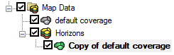

Figure New coverage after moving it

1. Right-click on “File:Coverage Active Icon.svg Copy of default coverage” and select **Coverage Setup…** to bring up the *Coverage Setup* dialog.
2. In the *Coverage name* field enter “4”. This is the horizon ID corresponding to the clean sand material.
3. Enter “4” for the *Horizon ID*.
4. Click **OK** to exit the *Coverage Setup* dialog.

## Defining the Polygon

Now it is necessary to create the polygon which will constrain the clean sand material.

1. In the Project Explorer, turn off the “File:Solid Module Icon.svg Clean_Sand 4” solid.
2. Turn on the “File:Coverage Active Icon.svg 4” coverage, then select it to make it active.
3. Click **Plan View** File:Plan View Macro.svg.

Notice how part of the cross section lines are highlighted in red. The red portion represents the part of the cross sections where the clean sand material exists. This red highlighting only appears when in plan view and the active coverage is a horizon coverage.

1. Using the **Create Arc** File:GMS Create Arc Tool.svg tool, create two arcs similar to those identified by the arrows shown in Figure 5. Notice that the arcs surround the red highlighting on the cross sections.

Each of the vertices on the arcs will be used when interpolating the horizon, so create arcs with more vertices to more strongly control the interpolation.

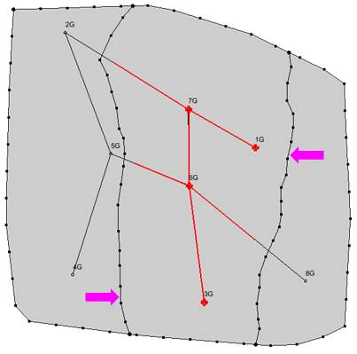

Figure Arcs created in the Horizon 4 coverage

## Marking the Outside-Boundary Arcs

It is necessary to tell GMS which arcs are outside boundary arcs. GMS uses this information to decide where the solid should end and where it should be allowed to continue. The vertices on the outside boundary arcs are not used when interpolating the horizon.

1. Using the **Select Arcs** https://www.xmswiki.com/images/thumb/8/80/GMS_Select_Arc_Tool.svg/60px-GMS_Select_Arc_Tool.svg.png tool, hold down the *Shift* key and select the two arcs identified by the arrows shown in Figure 6.
2. Right-click on one of the selected arcs and select **Attribute Table…** to bring up the *Attribute Table* dialog.
3. In the *Outside Boundary* column in the table, check the box in the *All* row to mark the two selected arcs as outside boundaries.
4. Click **OK** to exit the *Attribute Table* dialog.
5. Click anywhere in the background to deselect the arcs.

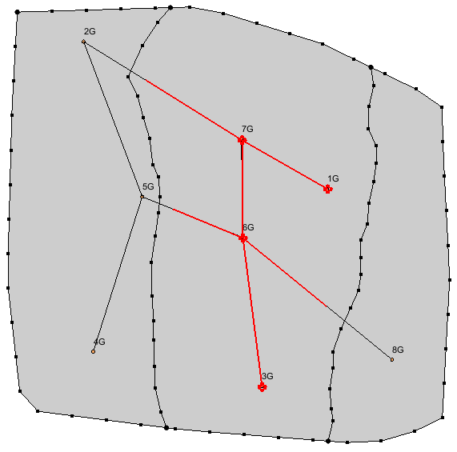

Figure Outside-boundary arcs

## Building and Deleting Polygons

The next step is to build the polygons.

1. Select *Feature Objects |* **Build Polygons** to build the new polygons.
2. Using the **Select Polygons** File:GMS Select Polygon Tool.svg tool, hold down the *Shift* key and select the two highlighted polygons (to the left and right of the center polygon, Figure 7).
3. Press the *Delete* key to delete the select polygons. Solids will only be created where a polygon exists.

Creating the horizon coverage for the clean sand material is now done. At this point, the horizon coverages for the other horizons could be defined. For the purposes of this tutorial, it is only necessary to define this one.

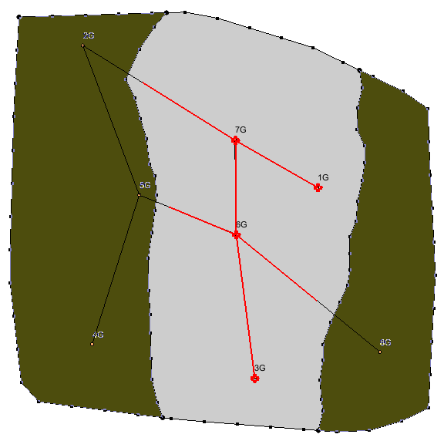

Figure Polygons to delete (highlighted in green)

# Horizons → Solids Command

The horizons conceptual model is all set up now and ready to use in creating solids.

1. In the Project Explorer, click on the “File:Borehole Folder.svg Borehole Data” folder to switch to the borehole module.
2. Select *Boreholes |* **Horizons → Solids…** to bring up the *Horizon Elevations* page of the *Horizons to Solids* dialog.
3. In the *Conceptual model* section, turn on *Use horizons conceptual model*.
4. Click **Finish**. GMS will now create the new solids.

## Comparing the results

The newly created solids were added to the Project Explorer in a new folder that should be called “solids (2)”.

1. Expand the “File:Generic Folder.svg solids (2)” folder and turn off all the new solids except the “File:Solid Module Icon.svg Clean_Sand 4” solid.

Notice that the boundary of the new solid is almost entirely inside the polygon that was defined in the horizons coverage, with only a few parts of the solid overlapping beyond the edge of the new polygon (Figure 8). Also notice that only one horizon coverage exists per horizon ID.

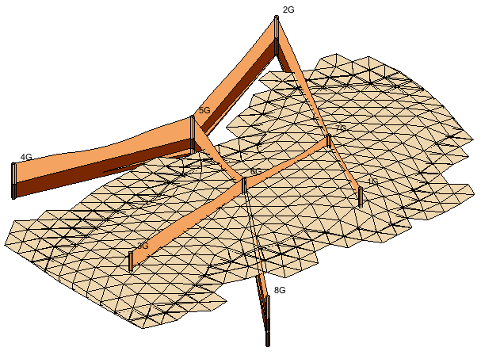

Figure Clean sand material with correct boundary

1. Turn off and on the original “File:Solid Module Icon.svg Clean_Sand 4”solid in the original “File:Generic Folder.svg solids” folder to see how the area of the new solid differs from the original.

The boundaries of the other new solids are identical to the other old solids because this tutorial only defined the horizon 4 coverage. If desired, verify that the boundaries for the other solids are indeed the same as before.

# Automatically Build the Horizon Coverages

Another way to create horizon coverages is to build them automatically using the **Build Horizon Coverages** option. When automatically building the coverages, it is possible to choose whether or not to include cross sections. Typically, if the model has cross sections, it is natural to want to use them.

1. In the Project Explorer, right-click on the “File:Conceptual Model Icon.svg Horizons” conceptual model and select **Duplicate** to create a conceptual model named “File:Conceptual Model Icon.svg Horizons (2)”.
2. Right-click on “File:Conceptual Model Icon.svg Horizons (2)” and select **Properties…** to bring up the *Conceptual Model Properties* dialog.
3. Enter “Horizons Auto” in the *Name* field and click **OK** to close the *Conceptual Model Properties* dialog.
4. Right-click on coverage “File:Coverage Active Icon.svg 4” under the “File:Conceptual Model Icon.svg Horizons Auto” conceptual model and select **Delete**.
5. Turn off both the “File:Conceptual Model Icon.svg Horizons” conceptual model and coverage “File:Coverage Active Icon.svg 4”.
6. Right-click on the “File:Conceptual Model Icon.svg Horizons Auto” conceptual model and select **Build Horizon Coverages…** to bring up the *Boreholes* page of the *Build Horizon Coverages* dialog.
7. Select *Use all boreholes* and click **Next** to close the*Boreholes* page and go to the *Boundary* page.
8. Select “default coverage” and click **Next** to close the*Boundary* page and go to the *Horizons* page.
9. Turn on *Use cross sections* and select *Generate for each horizon*.
10. Click **Finish** to close the *Build Horizon Coverages* dialog and create five new coverages under the “File:Conceptual Model Icon.svg Horizons Auto” conceptual model.
11. Turn on “File:Conceptual Model Icon.svg Horizons Auto” in the Project Explorer.
12. Examine the new coverages by selecting each of them in turn in the Project Explorer.

# Building Solids

The next process is to build solids with the conceptual model and compare the results with the previously constructed solids.

## Creating Solids from the Horizon Coverage

1. Click on the “File:Borehole Folder.svg Borehole Data” folder in the Project Explorer to switch to the Borehole module.
2. Select *Boreholes |* **Horizons → Solids…** to bring up the *Horizon Elevations* page of the *Horizons to Solids* dialog.
3. In the *Boreholes* section, turn on *Use boreholes* and *Use borehole cross sections*, and select the *Use all boreholes* radio button.
4. In the *TINs* section, turn off *Use horizon TINS*.
5. In the *Raster Catalog* section, select “NONE” from the drop-down.
6. In the *Conceptual model* section, turn on *Use horizons conceptual model* and select “Horizons Auto” from the list under the “Map Data” folder.
7. Click **Finish** to close the *Horizons to Solids* dialog**.**

A new set of solids will be created by GMS and placed in a folder called “File:Generic Folder.svg solids (3)” in the Project Explorer.

## Comparing the results

To compare the results, do the following:

1. Turn off all the solids in all three solids folders.
2. In the “File:Generic Folder.svg solids (3)” folder, turn on the “File:Solid Module Icon.svg Silty_Clay 1” solid. Notice the area that it covers (Figure 9).
3. Turn on the corresponding solid (“File:Solid Module Icon.svg Silty_Clay 1”) in the “File:Generic Folder.svg solids (2)” folder. Notice the area that the solid covers (Figure 10).
4. Turn on and off (“File:Solid Module Icon.svg Silty_Clay 1”) in the “File:Generic Folder.svgsolids (2)” folder until comfortable with the difference between the one from “File:Generic Folder.svg solids (2)” and the one from “File:Generic Folder.svg solids (3)”.

Notice that the solids created using the horizon conceptual model are clearly constrained by the polygons in the horizon coverages.

1. Repeat steps 1–4 for the remaining solids.

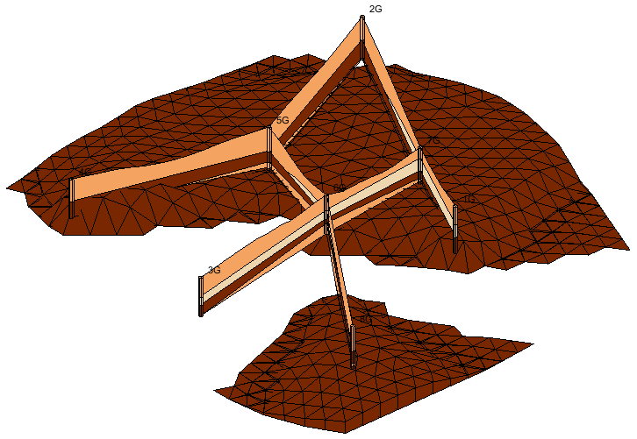

Figure Silty_Clay 1 solid created with the conceptual model

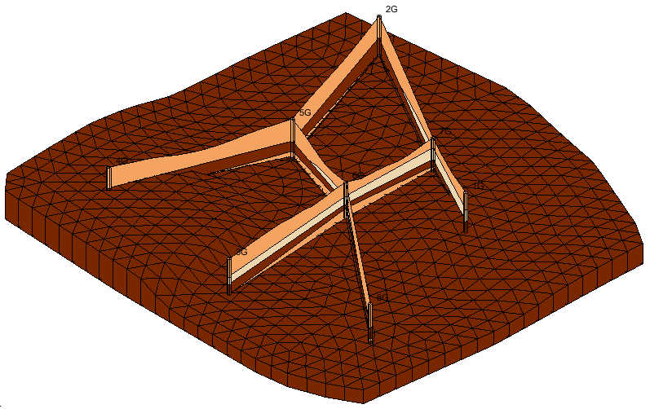

Figure Previous Silty_Clay 1 solid

# Conclusion

This concludes the “Stratigraphy Modeling – Horizon Coverages” tutorial. Here are some of the key concepts in this tutorial:

* Horizon coverages can be created manually and automatically.
* Choose whether or not to use the borehole cross sections when automatically creating horizon coverages.
* Solids can be created from the horizon conceptual model.
* It is possible to create a horizon conceptual model containing horizon coverages that constrain the areal extent of the solids.
* One horizon coverage exists per horizon ID.
* In a horizon coverage, the outside boundary arcs must be explicitly identified.
* In a horizon coverage, polygons are only defined for the areas where the solids should appear.
* When selecting a horizon coverage in plan view, GMS highlights in red parts of the cross sections to show where the soil layer with the same horizon ID as the coverage exists on the cross sections.