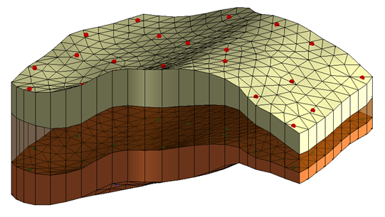

GMS 10.9

GMS 10.9 Tutorial

***Stratigraphy Modeling – Horizons, TINs, and Meshes***

Use TINs with horizons to create 3D, finite element meshes

Objectives

Learn how to use TINs to assign horizon surfaces and how to create three-dimensional, finite-element meshes from the horizon data.

Time

* 15–30 minutes

Required Components

* GMS Core
* Subsurface
* Geostatistics

Prerequisite Tutorials

* Stratigraphy Modeling – Horizons and Solids

|  |
| --- |
| 1 Introduction 2  1.1 Getting Started 2  2 Reading Scatter Data 2  3 Constructing the Meshing Conceptual Model 3  3.1 Setting up the Conceptual Model 3  3.2 Creating the Meshing Polygon 3  4 Creating Horizon Surfaces 5  4.1 Create the Tins 5  4.2 Interpolate 5  4.3 View the Surfaces 6  4.4 Organize TINs into a Folder 6  5 Creating the Mesh 7  5.1 Viewing the 3D Mesh 7  6 Conclusion 8 |

# Introduction

This tutorial builds on the concepts taught in the tutorial entitled “Stratigraphy Modeling —Horizons and Solids”. In that tutorial, solids were created using horizons defined on boreholes and cross sections. This tutorial demonstrates how to use TINs to assign horizon surfaces and how to create three-dimensional, finite element meshes from the horizon data.

Creating a three-dimensional mesh of soil stratigraphy using the horizons approach in GMS is accomplished in just a few steps. First, import a set of scatter data. The second step creates a meshing conceptual model. Third, use the conceptual model and scatter data to create the TIN horizon surfaces. Finally, execute the **Horizons → 3D Mesh** command to create a three-dimensional mesh.

## Getting Started

Do the following to get started:

1. If necessary, launch GMS.
2. If GMS is already running, select *File |* **New** to ensure that the program settings are restored to their default state.

# Reading Scatter Data

The first step in the construction of the 3D mesh is to import the scatter data. Scatter data can be entered into GMS manually, or the data can be import from a file. In the interest of time, import a previously prepared file by doing the following:

1. Click **Open** File:Open Macro.svg to bring up the *Open* dialog.
2. Select “Project Files (*.gpr)” from the *Files of type* drop-down.
3. Browse to the *Horizons_TINs_and_Meshes\Horizons_TINs_and_Meshes* directory and select “scatter.gpr”.
4. Click **Open** to import the project and close the *Open* dialog.

The Graphics Window should appear similar to Figure 1.

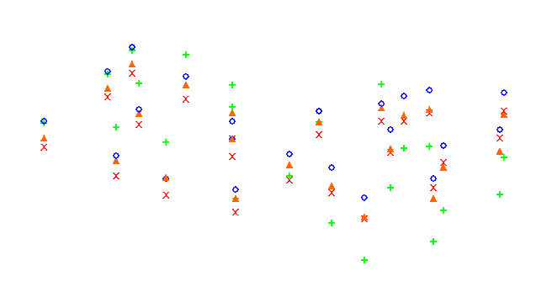

Figure Scatter set data after importing the project file

# Constructing the Meshing Conceptual Model

A conceptual model needs to be constructed here by using the map module. The conceptual model will contain a coverage that is used to define the TIN layers and a 2D mesh. The 2D mesh will then be used to define the topology and boundary of the 3D mesh.

## Setting up the Conceptual Model

1. Right-click on an empty space in the Project Explorer and select *New |* **Conceptual Model…**to bring up the *Conceptual Model Properties* dialog.
2. As the *Name,* enter “Case1”.
3. From the *Type* drop-down, select “FEMWATER”.
4. Click **OK** to close the *Conceptual Model Properties* dialog.

A FEMWATER model is not going to be created here. However, it is necessary to have a coverage that can be used to create a 2D mesh, something possible with a FEMWATER conceptual model.

1. Right-click on the “File:Conceptual Model Icon.svg Case1” conceptual model and select **New Coverage…** to bring up the *Coverage Setup* dialog.
2. As the *Coverage name,* enter “mesh1”.
3. In the *Areal Properties* section, turn on *Meshing options*.
4. Click **OK**to create the new coverage and exit the *Coverage Setup* dialog.

## Creating the Meshing Polygon

Do the following to create a polygonal boundary:

1. Select “File:Coverage Active Icon.svg mesh1” in the Project Explorer to make it active.
2. Switch to **Plan View** File:Plan View Macro.svg.
3. Using the **Create Arc** File:GMS Create Arc Tool.svg tool, click out a closed arc as shown in Figure 2. Click on the starting point to finish creating the closed arc.

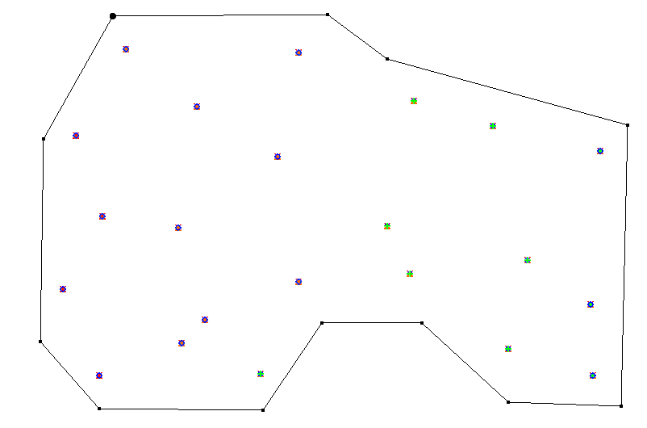

Figure Closed arc enclosing the scatter points

1. Select *Feature Objects |* **Build Polygons** to convert the closed arc into a polygon.
2. Using the **Select Arcs** https://www.xmswiki.com/images/thumb/8/80/GMS_Select_Arc_Tool.svg/60px-GMS_Select_Arc_Tool.svg.png tool, select the arc, right-click on it, and select **Redistribute Vertices…** to bring up the *Redistribute Vertices* dialog.
3. From the *Specify* drop-down, select “Specified Spacing”.
4. For *Average spacing* enter “150” and click **OK** to close the *Redistribute Vertices* dialog.

The Graphics Window should appear similar to Figure 3.

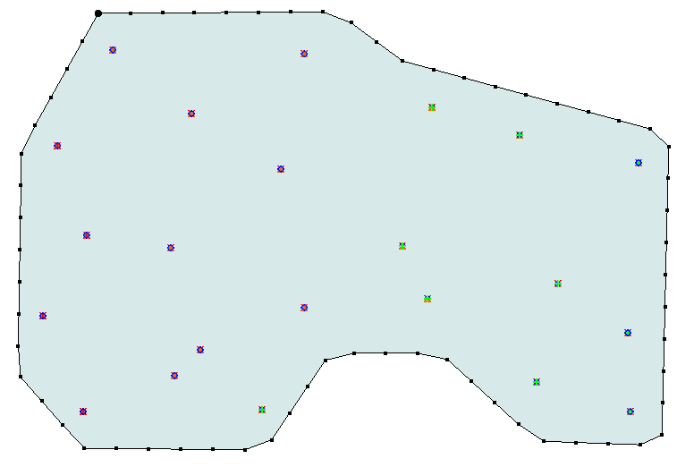

Figure The polygon with redistributed vertices

# Creating Horizon Surfaces

The newly defined polygon can now be used to create the TIN horizons.

## Create the Tins

1. Right-click on the “File:Coverage Active Icon.svg mesh1” coverage and select *Map To |* **TIN** to bring up the *Properties* dialog.
2. For the *TIN name,* enter “Case1_Hor4”.
3. From the *TIN material* drop-down, select “Fine Sand”.
4. As the *Horizon ID,* enter “4”.
5. Click **OK** to close the *Properties* dialog.
6. Repeat steps 1–5 to create 3 more TINs from the coverage with the following properties:

|  |  |  |  |
| --- | --- | --- | --- |
|  | **1** | **2** | **3** |
| **TIN Name:** | Case1_Hor3 | Case1_Hor2 | Case1_Bot |
| **TIN Material:** | Silty Clay | Silty Sand | Bedrock |
| **Horizon ID:** | 3 | 2 | 0 |

## Interpolate

The next step is to interpolate the layer elevations from the scatter sets to the TINs.

1. In the Project Explorer, select “File:TIN Module Icon.svg Case1_Hor4” to make it active.
2. If necessary, expand the “File:2D Scatter Folder.svg 2D Scatter Data” folder and the “File:2D Scatter Icon.svg Case 1” sub-folder in the Project Explorer.
3. Select “File:Dataset Points Active.svg top1” under the “File:2D Scatter Icon.svg Case 1” scatter set to make it active.
4. Right-click on “File:2D Scatter Icon.svg Case 1” and select *Interpolate To |* **Active TIN** to bring up the *Interpolate → Object* dialog.
5. Click **OK** to interpolate the values and close the *Interpolate → Object* dialog.
6. In the Project Explorer, expand the “File:TIN Module Icon.svg Case1_Hor4” TIN, right-click on the “File:Dataset Points Active.svg default” dataset,and select **Delete**.
7. Repeat steps 1–6 to interpolate all of the remaining layer elevations to the corresponding TIN horizons as seen in the following table:

|  |  |
| --- | --- |
| **Case 1 Scatter Set Dataset** | **TIN** |
| bot1 | Case1_Hor3 |
| bot2 | Case1_Hor2 |
| bot3 | Case1_Bot |

## View the Surfaces

To view the horizon surfaces:

1. Switch to **Oblique View** File:Oblique View Macro.svg. The Graphics Window should appear similar to Figure 4.
2. Select the **Rotate** File:Rotate Tool.svg tool and drag the mouse in the graphics window to rotate the view.

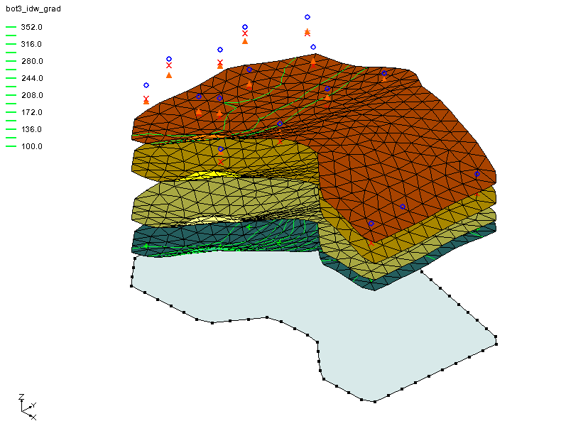

Figure After interpolating the layer elevations

## Organize TINs into a Folder

Now it is possible to organize the TINs into a folder to be used in the horizons process.

1. In the Project Explorer, right-click on “File:TIN Folder.svg Tin Data” and select **New Folder**.
2. Enter “Case1” and press the *Enter* key to set the new name.
3. In the Project Explorer, drag and drop each of the four TINs into the “File:Generic Folder.svg Case1” folder (see Figure 5).

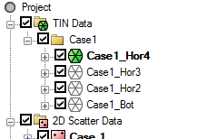

Figure TINs organized into a folder

# Creating the Mesh

Do the following to create the mesh from the TIN horizons:

1. Right-click on the “File:Coverage Active Icon.svg mesh1” coverage and select *Map To |* **2D Mesh**. This 2D mesh is needed in order to generate the 3D mesh.
2. Select the“File:TIN Folder.svgTIN Data” folder, then select *TINs* | **Horizons → 3D Mesh…** to bring up the *Horizon Elevations* page of the *Horizons to Mesh* dialog.

This allows selection of the interpolation scheme to be used in creating the mesh. The next steps specify how the top and bottom elevations of the stratigraphy model will be determined.

1. In the *TINs* section, select the *Select TIN folder* option.
2. Select the “Case1” folder in the tree window, and click the **Next** button to close the *Horizon Elevations* page and open the *Top and Bottom Elevations* page of the *Horizons to Mesh* dialog.
3. In the *Top elevation* section, select the *TIN elevations* option. This means that the specified TIN surface will be used in interpolating to the top of the 3D Mesh.
4. Select the “Case1_Hor4” TIN to be used as the top elevation in the tree window.
5. In the *Bottom elevation* section, select the *TIN elevations* option and select the “Case1_Bot” TIN.
6. Click the **Next**button to close the *Top and Bottom Elevations* page and open the *Build Mesh* page of the *Horizons to Mesh* dialog.
7. In the *Interpolation method* section, select the *Inverse distance weighted* option.
8. Select the **Finish** button to close the *Horizons to Mesh* dialog.

A simple 3D Mesh has been created consisting of three different layers of materials.

## Viewing the 3D Mesh

To view the mesh:

1. Select the “File:2D Mesh Folder.svg 3D Mesh Data” folder and click **Display Options** File:Display Options Macro.svg to bring up the *Display Options* dialog.
2. Select “3D Mesh Data” from the list on the left.
3. On the *3D Mesh* tab in the first section, turn on *Element faces*.
4. Click **OK** to close the *Display Options* dialog. The Graphics Window should appear similar to Figure 6.
5. Using the **Rotate** File:Rotate Tool.svg tool, drag the mouse to rotate the view.

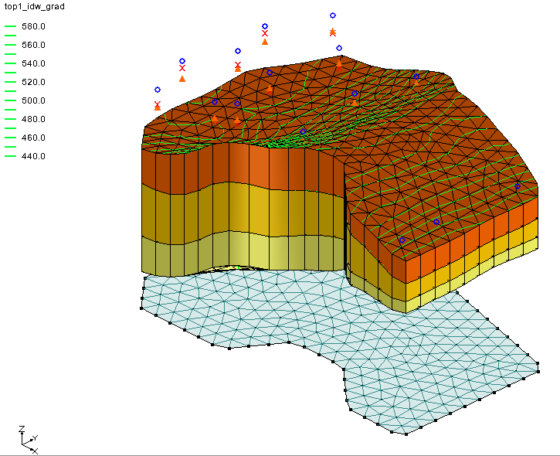

Figure The final view after the 3D mesh is created

# Conclusion

This concludes the “Stratigraphy Modeling – Horizons, TINs, and Meshes” tutorial. Included in the project file are four other scatter sets that can be used to create different layer elevations. A project could interpolate these values to the TIN horizons and create different meshes. Feel free to experiment with those scatter sets.

The key concepts demonstrated in this tutorial include:

* TINs can be used to create horizon surfaces.
* A 3D mesh can be created directly from horizon data.
* The **Horizons** command can operate on just a subset of the TINs or boreholes in the project.