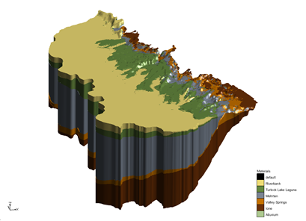

GMS 10.9

GMS 10.9 Tutorial

***Stratigraphy Modeling – Horizons with Rasters***

Create UGrids from rasters using the **3D UGrid from Rasters** tool

Objectives

Learn how to create subsurface models using the *3D UGrid from Rasters* tool.

Time

* 20–30 minutes

Required Components

* GMS Core
* Subsurface
* Geostatistics

Prerequisite Tutorials

* Stratigraphy Modeling – Horizons and Solids

|  |
| --- |
| 1 Introduction 2  1.1 Getting Started 2  2 Importing the Project 2  3 Viewing Raster Elevations 3  4 Using the 3D UGrid from Rasters Tool 4  4.1 Viewing the UGrid 5  5 Changing the Fill and Clip Fields 6  5.1 Viewing the UGrid 6  5.2 Changing the Clip Field 7  5.3 Viewing the UGrid 8  6 Sacramento Data 8  6.1 Creating the UGrid 9  6.2 Viewing the UGrid 10  7 Conclusion 11 |

# Introduction

This tutorial builds on the concepts taught in the “Stratigraphy Modeling—Horizons and Solids” tutorial. In that tutorial, solids were created using horizons defined on boreholes and cross sections. In this tutorial, horizons will be assigned to rasters and then used to create 3D unstructured grids (UGrids). This tutorial will begin with a simple problem to illustrate the concepts involved in using rasters to create UGrids. Then this tutorial will apply the method to data from Sacramento, California, USA.

This tutorial will demonstrate the following:

* Importing a project with rasters.
* Creating a raster catalog and assign horizon IDs.
* Creating UGrids from the horizons.
* Applying these steps to data from the Sacramento, California region.

## Getting Started

Do the following to get started:

1. If necessary, launch GMS.
2. If GMS is already running, select the *File |* **New** command to ensure that the program settings are restored to their default state.

# Importing the Project

The first step in the construction of the UGrid is to import a set of borehole logs. Borehole data can be entered into GMS manually, or the data can be read from a file. In the interest of time, import a previously prepared file by doing the following:

1. Click **Open** File:Open Macro.svg to bring up the *Open* dialog.
2. Select “Project Files (*.gpr)” from the *Files of type* drop-down.
3. Browse to the *Horizons_with_Rasters\Horizons_with_Rasters* directory and select “rasters.gpr”.
4. Click **Open** to import the project and close the *Open* dialog.

A 2D UGrid and multiple rasters have been loaded into this GMS project (Figure 1).

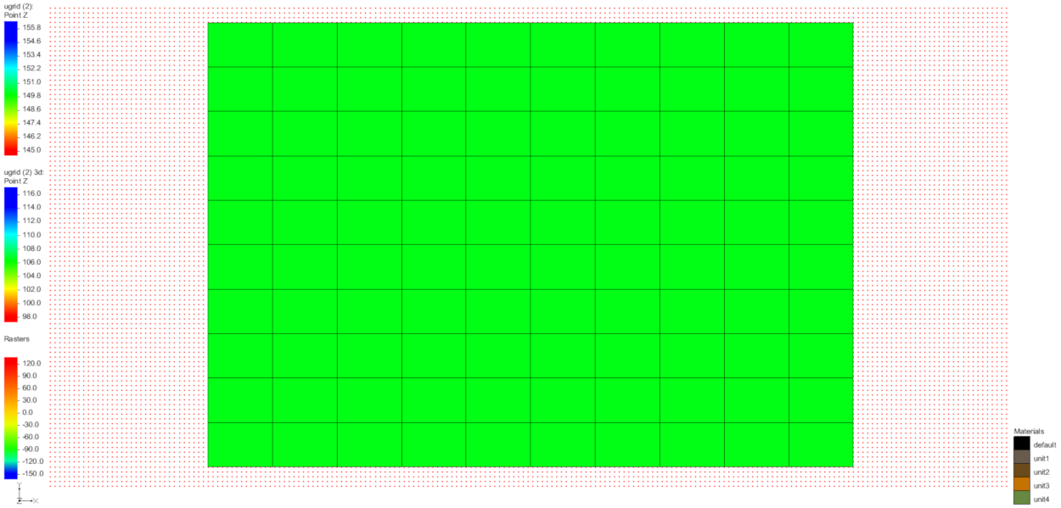

Figure 1 Tin and rasters displayed in the Graphics Window

# Viewing Raster Elevations

The display options are currently set to view the rasters as points.

1. Switch to **Oblique View** File:Oblique View Macro.svg.
2. **Frame** File:Frame Macro.svg the project.

The two lower rasters slope upward toward the right of the image. The upper two rasters are at constant elevations (Figure 2).

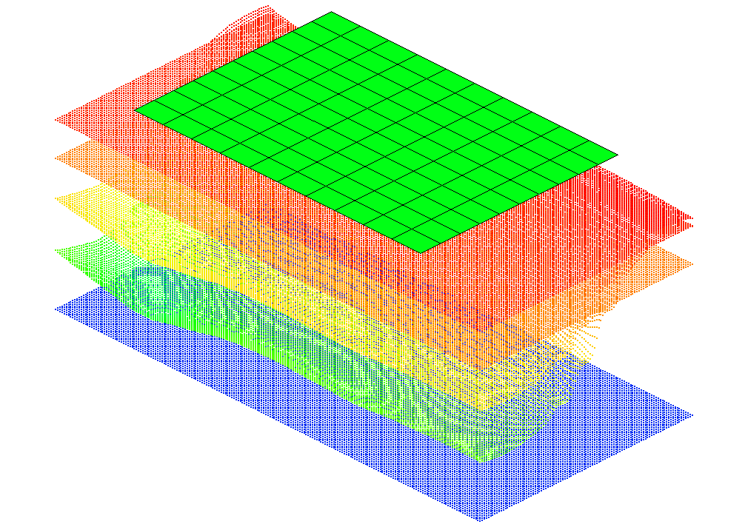

Figure 2 Raster surfaces

The next step is to change the display of the raster to background imagery.

1. Change to **Plan View** File:Plan View Macro.svg.
2. In the Project Explorer, select the first listed unit File:GIS Raster Icon.svg then hold the *Shift* key and select the last listed unit File:GIS Raster Icon.svg, to select all of the rasters.
3. Right-click on any of the rasters in the Project Explorer and select **Display Options…** to bring up the *Raster Display Options* dialog.
4. In the *All Rasters* section, select *Display as 2D image* and click **OK** to exit the *Raster Display Options* dialog.
5. In the Project Explorer, hide all of the rasters except “File:GIS Raster Icon.svg unit1”.

The Graphics Window should now appear similar to Figure 3.

1. When done, turn on the other rasters in the Project Explorer.

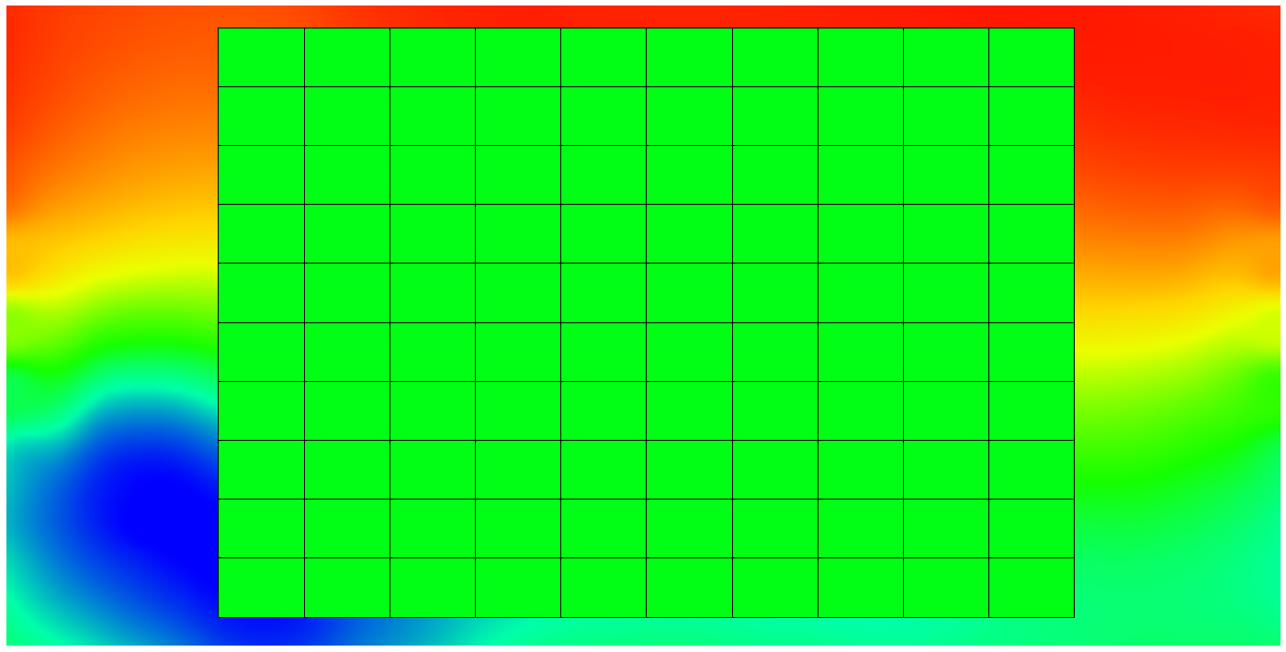

Figure 3 Rasters displayed as background imagery

# Using the 3D UGrid from Rasters Tool

The 3D UGrid from Rasters tool creates a 3D UGrid using one or more rasters contained in the project. With the rasters imported in the project, they can now be used to generate 3D UGrid.

1. Click the **Toolbox** File:Toolbox macro.png macro to open the *Toolbox* dialog.
2. In the *Tools* tab, expand the “File:Generic Folder.svg Unstructured Grids” folder.
3. Double-click on the **3D UGrid from Rasters** tool to open the *3D UGrid from Rasters* dialog.
4. For the *2D UGrid* drop-down, make certain “UGrid Data/ugrid (2)” is selected.
5. In the *Rasters* section, click the **Add Row** File:Row-add.svg button five times so there are five rows.
6. Using the following table, select the correct raster that matches the *Horizon* ID:

|  |  |  |  |
| --- | --- | --- | --- |
| **Horizon ID** | **Raster** | **Fill** | **Clip** |
| 5 | unit4 | √ |  |
| 4 | unit3 | √ |  |
| 3 | unit2 | √ |  |
| 2 | unit1 | √ |  |
| 1 | bottom | √ |  |

1. For the *3D UGrid* name, enter “3d ugrid”.
2. Select **OK** to run the *3D UGrid from Raster* dialog.
3. When the tool finishes, click **OK** to close the *3D UGrid from Raster* dialog.

## Viewing the UGrid

The *3D UGrid from Rasters* process should complete quickly, and a new UGrid will appear in the Project Explorer.

1. Switch to **Oblique View** File:Oblique View Macro.svg.
2. In the Project Explorer, under the “ 3d ugrid”, select “File:Elevation Data Active.svg Cell Bottom Z”.
3. Turn off “ ugrid (2)”.

The 3D Ugrid should look similar to Figure 4. Notice how the lower two layers extend upward on the left side of the UGrid and cut off the upper two layers.

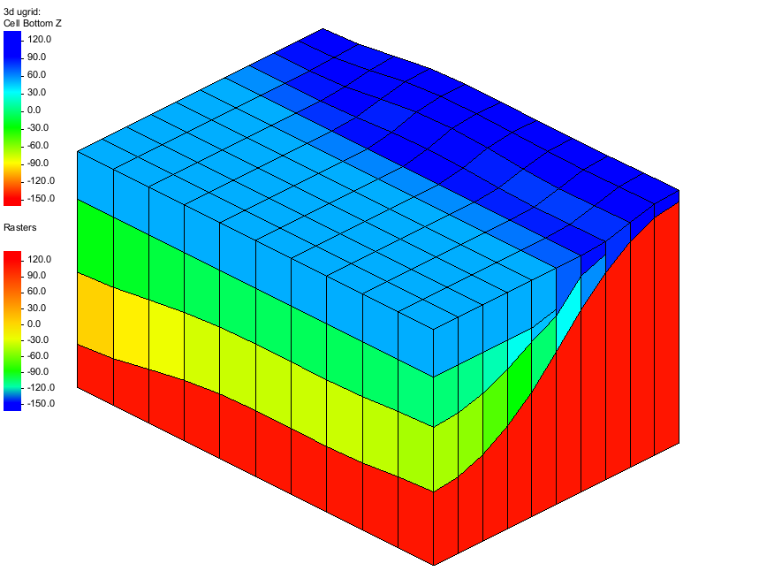

Figure 4 UGrid created from raster catalog

# Changing the Fill and Clip Fields

Now see the effect of changing the *Fill* and *Clip* fields in the raster catalog. When the raster catalog was first created and the dialog appeared, the check boxes for the *Fill* field were on by default. The *Fill* field indicates to use the raster to create a UGrid layer. It means the *3D UGrid from Rasters* operation will *Fill* between this raster and the lower surfaces. If the *Fill* field is turned off, then it will not create a layer that is associated with the particular raster. The *Clip* field is used to indicate a surface that “Clips” or truncates any lower surfaces. This process is best illustrated by the following steps:

1. Click the **Toolbox** File:Toolbox macro.png macro to open the *Toolbox* dialog.
2. In the *Tools* tab, expand the “File:Generic Folder.svg Unstructured Grids” folder.
3. Double-click on the **3D UGrid from Rasters** tool to open the *3D UGrid from Rasters* dialog.
4. For the *2D UGrid* drop-down, make certain “UGrid Data/ugrid (2)” is selected.
5. In the *Rasters* section, click the **Add Row** File:Row-add.svg button five times so there are five rows.
6. Using the table below, select the correct raster that matches the *Horizon* ID and turn off the *Fill* for the “File:GIS Raster Icon.svg unit3” raster:

|  |  |  |  |
| --- | --- | --- | --- |
| **Horizon ID** | **Raster** | **Fill** | **Clip** |
| 5 | unit4 | √ |  |
| 4 | unit3 |  |  |
| 3 | unit2 | √ |  |
| 2 | unit1 | √ |  |
| 1 | bottom | √ |  |

1. For the *3D UGrid* name, enter “3d ugrid fill”.
2. Select **OK** to run the *3D UGrid from Raster* dialog.
3. When the tool finishes, click **OK** to close the *3D UGrid from Raster* dialog.

## Viewing the UGrid

When the *3D UGrid from Rasters* process is finished, another UGrid will have been created. To view the new UGrid, do the following:

1. In the Project Explorer, hide “ 3d ugrid”.
2. Under the “ 3d ugrid fill”, select “File:Elevation Data Active.svg Cell Bottom Z”.

The UGrid should look like Figure 5 below. Notice that no layer was created for “unit3”.

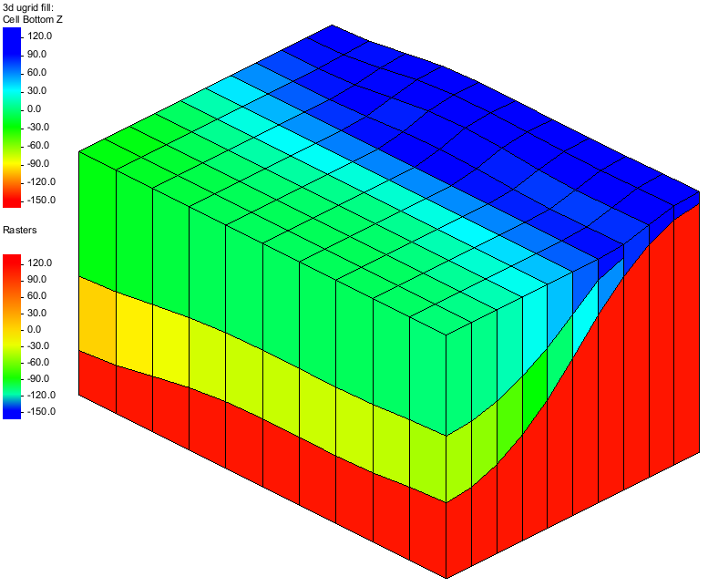

Figure 5 UGrid created with the “Fill” field off for the unit3 raster

## Changing the Clip Field

Now it is possible to change the *Clip* field for the “File:GIS Raster Icon.svg unit3” raster and view the effect.

1. Click the **Toolbox** File:Toolbox macro.png macro to open the *Toolbox* dialog.
2. In the *Tools* tab, expand the “File:Generic Folder.svg Unstructured Grids” folder.
3. Double-click on the **3D UGrid from Rasters** tool to open the *3D UGrid from Rasters* dialog.
4. For the *2D UGrid* drop-down, make certain “UGrid Data/ugrid (2)” is selected.
5. In the *Rasters* section, click the **Add Row** File:Row-add.svg button five times so there are five rows.
6. Using the table below, select the correct raster that matches the *Horizon* ID and change the *Fill* and *Clip* for the “File:GIS Raster Icon.svg unit3” raster:

|  |  |  |  |
| --- | --- | --- | --- |
| **Horizon ID** | **Raster** | **Fill** | **Clip** |
| 5 | unit4 | √ |  |
| 4 | unit3 |  | √ |
| 3 | unit2 | √ |  |
| 2 | unit1 | √ |  |
| 1 | bottom | √ |  |

1. For the *3D UGrid* name, enter “3d ugrid clip”.
2. Select **OK** to run the *3D UGrid from Raster* dialog.
3. When the tool finishes, click **OK** to close the *3D UGrid from Raster* dialog.

## Viewing the UGrid

1. In the Project Explorer, hide “ 3d ugrid fill”.

Under the “ 3d ugrid clip”, select “File:Elevation Data Active.svg Cell Bottom Z”.

The UGrid should look like Figure 6 below. Notice that while no layer was created for unit3, the raster was used to "clip" or truncate the units as seen in Figure 6.

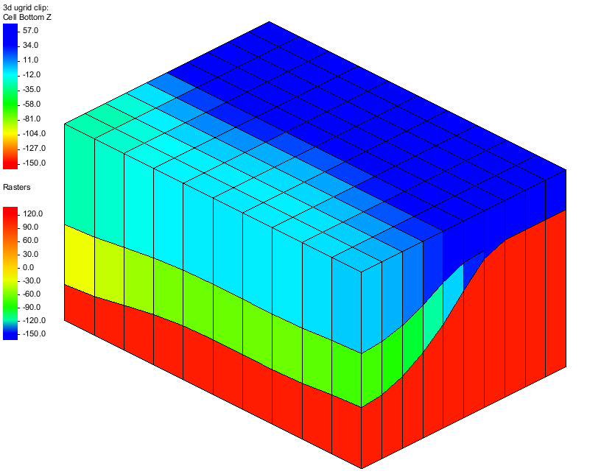

Figure 6 UGrid created with the “Clip” field on for the unit3 raster

# Sacramento Data

It is now possible to use what has been learned to create a UGrid using data from the Sacramento Valley.

1. Select the *File |* **New** command.
2. Select **Don’t Save** when asked to save the project.
3. Select the **Open** File:Open Macro.svg button to bring up the *Open* dialog.
4. Select “Project Files (*.gpr)” from the *Files of type* drop-down.
5. Browse to the directory entitled *Horizons_with_Rasters\Horizons_with_Rasters* and select the file named “sacramento.gpr”.
6. Click **Open** to import the project and close the *Open* dialog.

The Figure 7 image should be visible in the GMS graphics window. This project contains two TINs to define the top and bottom of the UGrid, a map coverage with the surface geology, multiple rasters to define top elevations for stratigraphic units, and an aerial photo of the Sacramento region.

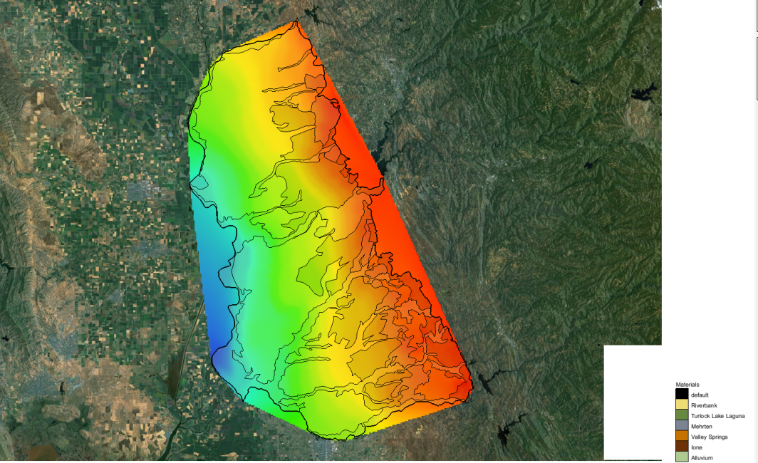

Figure 7 Map view of Sacramento Region Data

## Creating the UGrid

It is now possible to convert the rasters to a UGrid by doing the following:

1. Click the **Toolbox** File:Toolbox macro.png macro to open the *Toolbox* dialog.
2. In the *Tools* tab, expand the “File:Generic Folder.svg Unstructured Grids” folder.
3. Double-click on the **3D UGrid from Rasters** tool to open the *3D UGrid from Rasters* dialog.
4. For the *2D UGrid* drop-down, make certain “UGrid Data/ugrid” is selected.
5. In the *Rasters* section, click the **Add Row** File:Row-add.svg button seven times so there are seven rows.
6. Using the following table, select the correct raster that matches the *Horizon* ID.

|  |  |  |  |
| --- | --- | --- | --- |
| **Horizon ID** | **Raster** | **Fill** | **Clip** |
| 7 | sacramentotop | √ |  |
| 6 | TOP7.bil | √ |  |
| 5 | TOP6.bil | √ |  |
| 4 | TOP4.bil | √ |  |
| 3 | TOP2.bil | √ |  |
| 2 | TOP1.bil | √ |  |
| 1 | sacramentobottom | √ |  |

1. For the *Minimum layer thickness* option, enter a value of “1.0”.
2. For the *3D UGrid* name, enter “3d ugrid”.
3. Select **OK** to run the *3D UGrid from Raster* dialog.
4. When the tool finishes, click **OK** to close the *3D UGrid from Raster* dialog.

## Viewing the UGrid

When the *3D UGrid from Rasters* process finishes, a new UGrid will appear in the Project Explorer.

1. Switch to **Oblique View** File:Oblique View Macro.svg.
2. In the Project Explorer, under the “File:Ugrid-icon.png 3d ugrid”, select “File:Elevation Data Active.svg Cell Bottom Z”.
3. Click the **Display Options** File:Display Options Macro.svg macro to open the *Display Options* dialog.
4. From the list on the left, select “UGrid: 3d ugrid – [Active]”.
5. Check on *Define UGrid specific options.*
6. Turn off the *Cell edge* option and turn on the *Face contours* option.
7. Click the **Options** button to open the *Dataset Contour Options* *– UGrid – Cell Bottom Z* dialog.
8. Change the *Contour method* to “Color Fill”
9. Click **OK** to close the *Dataset Contour Options* dialog.
10. Click **OK** to close the *Display Options* dialog.

The UGrid should appear like Figure 8 below.

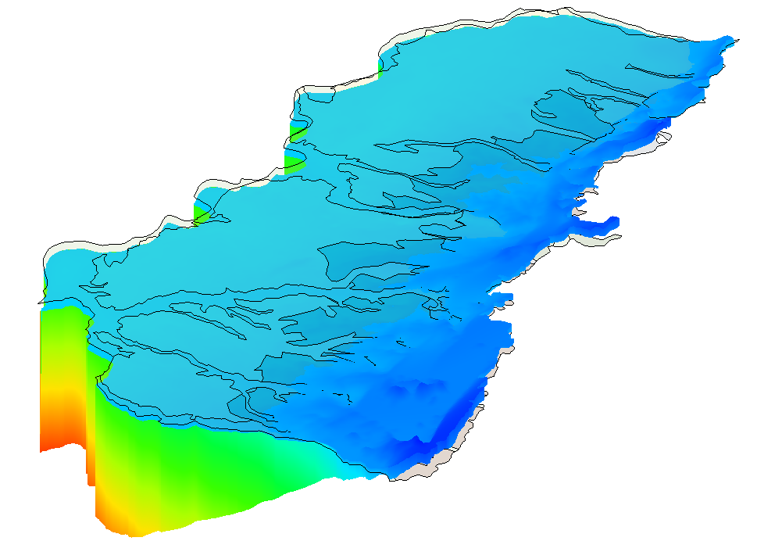

Figure 8 UGrid of the Sacramento Valley

If desired, rotate the view, apply lighting, adjust the display options, or cut cross sections through the UGrid.

# Conclusion

This concludes the “Stratigraphy Modeling – Horizons with Rasters” tutorial. Here are some of the key concepts in this tutorial:

* Rasters can be used to create UGrids.
* To use rasters with the horizons method, it is necessary to use the *3D UGrid from Rasters* tool.