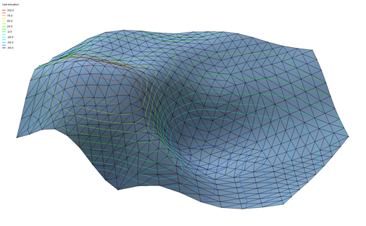

GMS 10.9

GMS 10.9 Tutorial

***Stratigraphy Modeling – TIN Surface***

Introduction to the TIN (Triangulated Irregular Network) surface object

Objectives

Learn to create, read, alter, and manage TIN data from within GMS.

Time

* 20–35 minutes

Required Components

* GMS Core
* Subsurface
* Geostatistics

Prerequisite Tutorials

* None

|  |
| --- |
| 1 Introduction 2  1.1 Getting Started 2  2 Importing Vertices 2  3 Triangulating 3  4 Contouring 4  5 Lighting 5  6 Editing TINs 6  6.1 Locking/Unlocking Vertices 6  6.2 Dragging Vertices 7  6.3 Dragging in Oblique View 7  6.4 Using the Edit Window 7  6.5 Adding Vertices 7  6.6 Deleting Vertices 8  7 Smoothing a TIN 8  7.1 Deleting the TIN 8  7.2 Copying the Vertices 9  7.3 Subdividing the TIN 9  7.4 Interpolating the Elevations 10  7.5 Deleting the Scatter Point Set 11  8 Importing TIN 11  9 Changing the Active TIN 11  10 Hiding and Showing TINs 12  11 Conclusion 12 |

# Introduction

The TIN module in GMS is used for general-purpose surface modeling. TIN is an acronym for “Triangulated Irregular Network”. TINs are formed by connecting a set of *xyz* points with edges to form a network of triangles. The surface varies linearly across each triangle. TINs can be used to represent the surface of a geologic unit or the surface defined by a mathematical function. Elevations or other values associated with TINs can be displayed with contours. TINs are used in the construction of solid models and 3D finite-element meshes.

The tutorial will demonstrate and discuss creating a TIN by importing vertices and triangulating, changing the contour and lighting options, editing the TIN vertices, smoothing the TIN, importing another TIN, and managing multiple TINs.

## Getting Started

To get started, do the following:

1. If necessary, launch GMS.
2. If GMS is already running, select *File |* **New** to ensure that the program settings are restored to their default state.

# Importing Vertices

It is first necessary to import a set of vertices from a file into the TIN module to begin reviewing the tools available for TIN modeling. To import the vertices, do the following:

1. Click **Open** File:Open Macro.svg to bring up the *Open* dialog.
2. Select “Project Files (*.gpr)” from the *Files of type* drop-down.
3. Browse to the *TINs\TINs* directory and select “verts.gpr”.
4. Click **Open** to import the project and close the *Open* dialog.

A set of vertices should appear on the screen (Figure 1). The vertices are not yet connected by triangles.

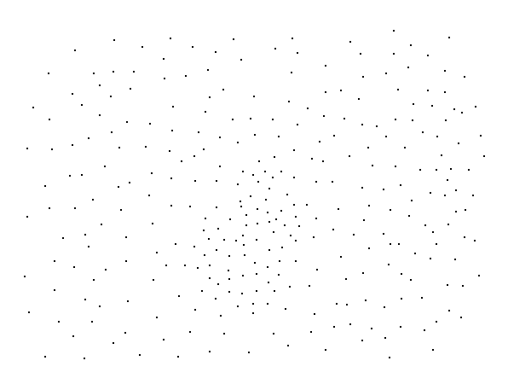

Figure The imported vertices

# Triangulating

To construct a TIN, it is necessary to triangulate the set of imported vertices by doing the following:

1. In theProject Explorer, expand the “File:TIN Folder.svg TIN Data” item so that the “File:TIN Module Icon.svg verts” TIN can be seen.
2. Right-click on “File:TIN Module Icon.svg verts” and select **Triangulate**.

The vertices should now be connected with edges forming a network of triangles. The triangulation is performed automatically using the Delaunay criterion. The Delaunay criterion ensures that the triangles are as equiangular as possible. In other words, wherever possible, long, thin triangles are avoided. A more complete description of the triangulation algorithm can be found in the GMS User’s Manual.

Some long, skinny triangles on the border need to be deleted. GMS can find them automatically.

1. Select *TINs | Advanced |* **Select Boundary Triangles** to select the long, skinny triangles.
2. Press the *Delete* key to remove them.

The long, skinny triangles are now gone. The Main Graphics Window should appear similar to Figure 2.

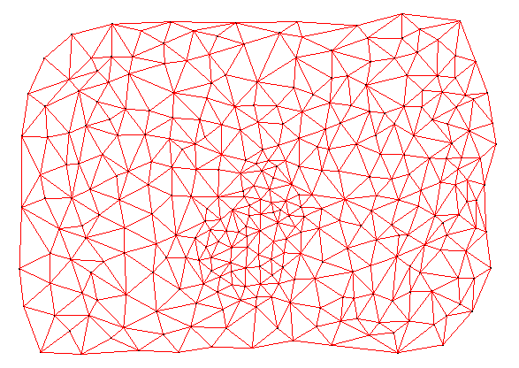

Figure The vertices triangulated with the long, skinny triangles deleted

# Contouring

Now that the TIN is constructed, it can be used to generate a contour plot of the TIN elevations.

1. Click **Display Options** File:Display Options Macro.svg to bring up the *Display Options* dialog.
2. From the list on the left, select “TIN Data”.
3. In the top section, turn off Vertices and Triangle edges and turn on TIN boundary.
4. In the lower section, turn on Contours.
5. Click **OK** to close the *Display Options* dialog.

The contours are generated by assuming that the TIN defines a surface that varies linearly across the face of each triangle ( Figure 3).

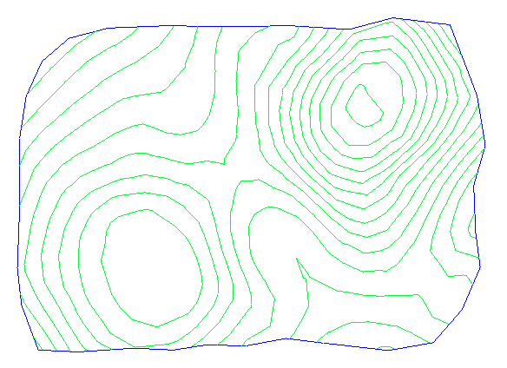

Figure TIN showing the boundary and contours

# Lighting

Another way to visualize a TIN is to use a light source.

1. Click **Display Options** File:Display Options Macro.svg to bring up the *Display Options* dialog.
2. From the list on the left, select “TIN Data”.

In the top section, turn off TIN boundary and turn on Triangle faces.

In the bottom section, turn off *Contours*.

From the list on the left, select “Lighting Options”.

Turn on *Enable lights*.

Drag the selected light sphere so it appears as in Figure 4.

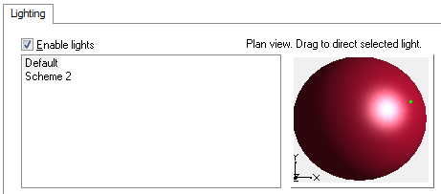

Figure Lighting Options settings

Click **OK** to exit the *Display Options* dialog*.*

Select the **Oblique View** File:Oblique View Macro.svg button.

The TIN should now be shaded with a patterned red material as seen in Figure 5. The material color and pattern can be adjusted be clicking on the **Material** File:GMS Materials Macro.svg macro, though that is not covered in this tutorial.

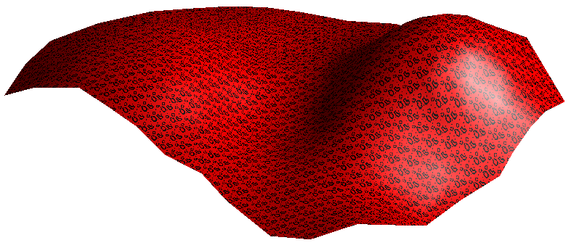

Figure TIN with triangle faces, patterned material, and a light source

Use the **Rotate** File:Rotate Tool.svg tool to drag the mouse in the graphics window and rotate the view.

Feel free to experiment with the lighting options to see the different display effects for the TIN.

# Editing TINs

A variety of tools are provided in GMS for editing TINs. Before reviewing these tools, it is important to reset some of the display options.

1. Click **Display Options** File:Display Options Macro.svg to bring up the *Display Options* dialog.
2. From the list on the left, select “TIN Data”.
3. In the top section, turn on Vertices and Triangle edges, and turn off *Triangle faces.*
4. In the bottom section, turn on *Contours*.
5. Click the **Options…** button to the right of Contours to bring up the *Dataset Contour Options – TIN – default* dialog.
6. In Contour interval section, select “Specified Interval” from the drop-down and enter “20.0” in the field to the right.
7. Click **OK** to exit the *Dataset Contour Options – TIN – default* dialog.
8. Click **OK** to exit the Display Options dialog. The Graphics Window should appear as in Figure 6.

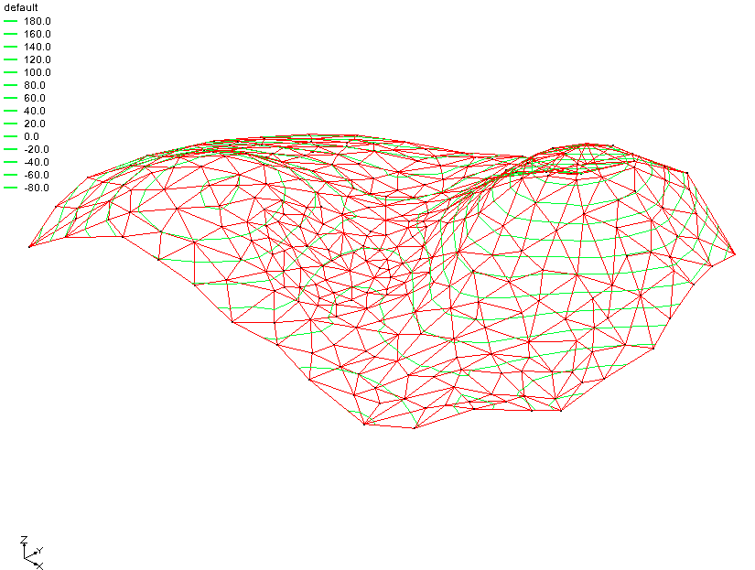

Figure The Graphics Window after the Display Options have been reset

## Locking/Unlocking Vertices

In many cases, some of the vertices defining a TIN come from actual measured data—such as a borehole log—and can be considered “hard” data. In other cases, vertices are added manually and represent “soft” data simply used to fill in gaps. By default, TIN vertices are locked and not editable so that a vertex corresponding to an actual measurement is not accidentally edited. Editing TIN vertices can be accomplished by unlocking the vertices.

1. Select TINs | **Lock All Vertices** to unlock the vertices.
2. Notice that this removed the check mark next to this menu option by selecting the *TINs* menu again.

The TIN vertices are now unlocked and can be edited. Unlocked vertices can be locked by again selecting the TINs | **Lock All Vertices** menu command.

## Dragging Vertices

One of the simplest ways to edit a TIN is to drag the vertices with the mouse. This can be accomplished with the **Select Vertices** File:Select Point Tool.svg tool.

1. Select the **Plan View** File:Plan View Macro.svg button.
2. Using the **Select Vertices**  File:Select Point Tool.svg tool, choose one of the vertices in the interior of the TIN and drag it to a new location.

Notice that it is not possible to drag an interior vertex beyond the boundaries of the adjacent triangles. This prevents the triangles from becoming inverted.

## Dragging in Oblique View

When dragging in plan view, the vertex is constrained to move in the *xy* plane. To change the *z* coordinate, it is necessary to drag the vertices in oblique view (or front or side view).

1. Switch to **Oblique View** File:Oblique View Macro.svg.

Using the **Select Vertices** File:Select Point Tool.svg tool, select one of the vertices and drag the vertex up and down.

Notice that as dragging the vertex in oblique view, the vertex can only be moved along the *z* axis.

## Using the Edit Window

In many cases, dragging vertices with the mouse is not adequately precise. It is often necessary to change the vertex coordinates to a specific value. This type of editing can be accomplished with the input fields at the top of the GMS window.

1. With the **Select Vertices** File:Select Point Tool.svg tool, click on any one of the vertices to select it.

Notice that as the vertex is selected, the coordinates of the vertex are displayed in the edit fields at the top of the window (see Figure 7). The edit fields can be used to change the *x, y, z,* or *s* coordinates of the selected vertex.



Figure 7 XYZS edit fields

1. Move the cursor to the *z* coordinate field and enter a value that is 10 more than whatever the current *z* value is.

Hit the Return or Tab key.

The vertex will now move accordingly.

## Adding Vertices

When working with TINs, it is often necessary to edit a TIN by adding supplemental vertices to provide more resolution or detail in an area of interest. Vertices can be added to a TIN in GMS simply by pointing and clicking.

1. Switch to **Plan View** File:Plan View Macro.svg.

Using the **Create Vertices** File:Create Points Tool.svg tool, place the cursor inside one of the triangles in the TIN.

Create a vertex by clicking the mouse button.

The new *z* value for the vertex is computed using a linear interpolation of the surrounding vertices. The vertex is selected and can be edited—if unlocked—using the *XYZS* edit fields in the Edit bar.

## Deleting Vertices

It is also frequently necessary to delete vertices. To delete the newly created vertex, do as follows:

1. Using the **Select Vertices** File:Select Point Tool.svg tool, select the newly-created vertex.

Select Edit | **Delete** to delete it.

Notice that all of the triangles connected to the vertex were deleted. By default, this is what happens when a vertex is deleted. The resulting void can be filled with triangles by using the **Create Triangles** File:GMS Create Triangle Tool.svg tool to manually create triangles. Another option is available for deletion that automatically retriangulates the region surrounding a deleted vertex.

1. Select TINs | **TIN Settings…** to bring up the *Preferences* dialog. Notice that “TINs” is already selected from the list on the left.
2. In the *Vertex Options* section, turn on Retriangulate after deleting.
3. Click **OK** to close the *Preferences* dialog.
4. Using the **Select Vertices** File:Select Point Tool.svg tool, select a vertex in the interior of the TIN.
5. Select Edit | **Delete** to delete it.

Notice that the triangles next to the deleted vertex are deleted, but the resulting void is retriangulated.

# Smoothing a TIN

As mentioned above, a TIN represents a piecewise linear surface. If the vertices defining the TIN are sparse, the linear surface defined by the triangles may appear excessively irregular. A TIN can be smoothed in GMS by copying the TIN vertices to a scatter point set, subdividing the TIN into a denser set of triangles, and interpolating the elevations to the new vertices in the TIN. The resulting TIN is still a piecewise linear surface, but it appears much smoother because the triangles are smaller.

## Deleting the TIN

This tutorial will now provide an example of TIN smoothing. First, it is necessary to import a different TIN since several changes were made to this one.

1. Click **New** File:New Macro.svg and select **Don’t Save** to avoid saving the changes.
2. Click **Open** File:Open Macro.svg to bring up the *Open* dialog.
3. Select “Project Files (*.gpr)” from the *Files of type* drop-down.
4. Select “sparse.gpr” and click **Open** to import the file and close the *Open* dialog.

## Copying the Vertices

The first step in smoothing the TIN is to copy the vertices of the TIN to a scatter point set. This will allow later using the scatter point set to interpolate the *z* values of the original vertices to the new vertices created while subdividing the TIN.

1. Expand the “TIN Data” File:TIN Folder.svg folder in theProject Explorer.
2. Right-click on “File:TIN Module Icon.svg sparse” TIN, and select *Convert To* | **2D Scatter Points**. A set of scatter points should appear (Figure 8).

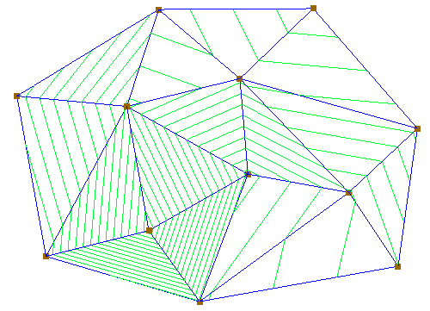

Figure Scatter points appearing at the vertices

## Subdividing the TIN

The next step is to increase the resolution of the TIN by uniformly subdividing the TIN.

1. Right-click on the “File:TIN Module Icon.svg sparse” TIN in theProject Explorer and select **Subdivide…** to bring up the *Subdivision Factor* dialog.

In the *Factor* field, enter “8”. This can also be done by moving the slider to the right until “8” appears in the field.

Click **OK** to close the *Subdivision Factor* dialog. The Graphics Window should now appear similar to Figure 9.

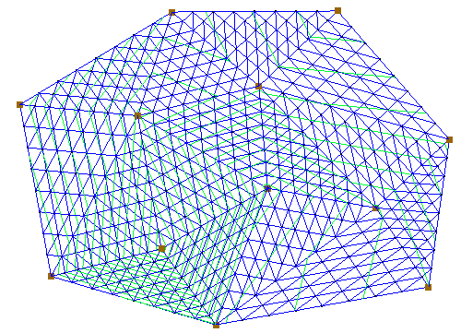

Figure After subdividing

## Interpolating the Elevations

Notice that the contours of the TIN have not changed. There are more triangles in the TIN, but they still define essentially the same surface. To smooth the TIN, use one of the interpolation schemes and interpolate from the original vertices of the TIN to the new vertices created during the subdivision process.

1. Switch to **Oblique View** File:Oblique View Macro.svg.

In the Project Explorer, right-click on the “File:2D Scatter Icon.svg sparse” scatter point set and select Interpolate To | **Active TIN** to bring up the *Interpolate → Object* dialog.

At this point, the interpolation options could be chosen manually (through the **Interpolation Options…** button). In this example, the default options will be used.

As the *Interpolated dataset name,* enter “new elevations”.

Click **OK** to finish the interpolation and close the *Interpolate → Object* dialog.

The TIN now appears smoother (Figure 10). Switch between the “default” and “new elevations” datasets in the Project Explorer to see the difference on the TIN. It may be necessary to expand the “File:TIN Module Icon.svg sparse” TIN in the Project Explorer to see the datasets.

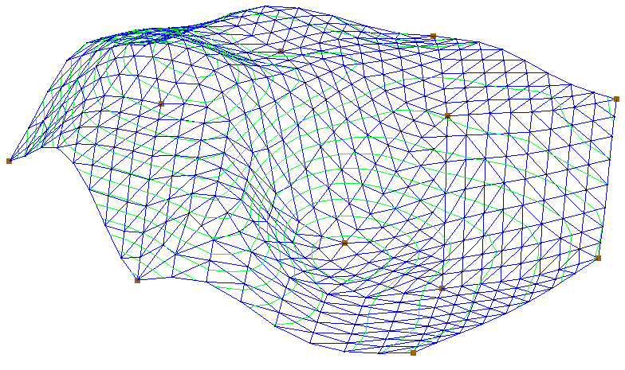

Figure The smoother TIN

## Deleting the Scatter Point Set

The TIN smoothing process is now completed. Since the scatter point set is no longer needed, it may be deleted.

1. Collapse the “File:TIN Folder.svg TIN Data” folder in the Project Explorer.
2. Right-click on the “File:2D Scatter Icon.svg sparse” scatter point set and select **Delete**.

The only folder in the Project Explorer now should be the “File:TIN Folder.svg TIN Data” folder.

# Importing TIN

In GMS, several TINs can be modeled at once without having to delete existing TINs. To import a second TIN without first deleting the existing TIN, do the following:

1. Click **Open** File:Open Macro.svg to bring up the *Open* dialog.

Select “All Files [*.*]” from the *Files of type* drop-down.

Select “surface.tin” and click **Open** to import the TIN and close the *Open* dialog.

Two TINs should now be displayed at the same time (Figure 11).

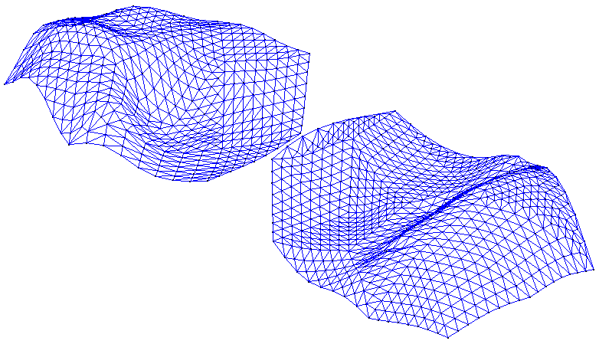

Figure Both TINS are visible

# Changing the Active TIN

Whenever multiple TINs are being modeled, one of the TINs is designated as the active TIN. A TIN can be designated as the active TIN by selecting it in theProject Explorer or by using the **Select TINs** File:Select TIN Tool.svg tool. Regardless of the method used to select a TIN (in the Project Explorer or using the tool), the Project Explorer updates to show which TIN is active. Only the active TIN can be edited.

1. Expand the “File:TIN Folder.svg TIN Data” folder in the Project Explorer if necessary.
2. Click on the **Select TINs** tool File:Select TIN Tool.svg.

Notice the triangular shaped icons at the center of each TIN (Figure 12). The name of each TIN is displayed beneath the icon. Click on the triangular icon using the **Select TINs** File:Select TIN Tool.svg tool to select the desired TIN. The active TIN has a letter “A” displayed in the center of the icon.

1. Click on the TIN icon named “sparse”. The letter “A” is now displayed in the icon for the “sparse” TIN.

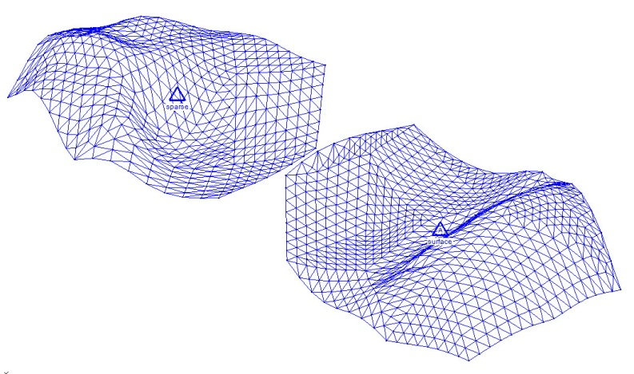

Figure The sparse TIN and surface TIN

In the Project Explorer, select the “File:TIN Module Icon.svg surface” TIN.

Notice that the “A” has switched back to the “surface” TIN.

# Hiding and Showing TINs

When multiple TINs are taking up memory, it is sometimes useful to hide some of the TINs temporarily. This makes the display less cluttered and makes it easier to edit or visualize an individual TIN. For example:

1. In the Project Explorer, uncheck the TIN named “File:TIN Module Icon.svg sparse”.

That TIN will now be hidden, though the icon will remain in the Graphics Window to show where the TIN is located. Another way to hide a TIN is to do the following:

In the Project Explorer, turn on the “File:TIN Module Icon.svg sparse” TIN so that it becomes visible.

Using the **Select TINs** File:Select TIN Tool.svg tool, select the “sparse” TIN, then click **Hide**File:GMS Hide Macro.svg..

# Conclusion

This concludes the “Stratigraphy Modeling – TIN Surfaces” tutorial. The following topics were demonstrated and discussed:

* How to triangulate a set of points.
* How to visualize a TIN in different ways, including using contours, turning on the triangle faces, and adjusting the lighting.
* How to edit the TIN by dragging, adding, and deleting vertices.
* How to smooth a TIN via interpolation.
* How to read in multiple TINs.
* How to specify the active TIN among multiple TINs.
* How to hide and show TINs among multiple TINs.