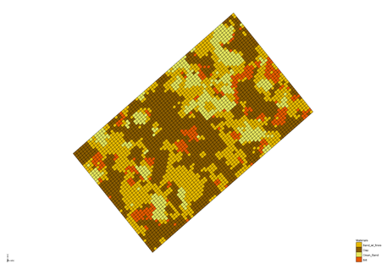

GMS 10.9

GMS 10.9 Tutorial

***T-PROGS***

Use T-PROGS to generate multiple material sets on a 3D grid from borehole data

Objectives

This tutorial shows how to use the T-PROGS interface in GMS to create multiple material sets on a 3D grid with equal probability, based on borehole data. Additionally, T-PROGS creating data for the MODFLOW HUF package is demonstrated in this tutorial.

Time

* 50–70 minutes

Required Components

* GMS Core
* Geostatistics
* MODFLOW Interface
* Subsurface
* Stochastic & T-PROGS

Prerequisite Tutorials

* MODFLOW – Grid Approach
* Stratigraphy Modeling – Boreholes and Cross Sections

|  |
| --- |
| 1 Introduction 2  1.1 Problem Description 3  1.2 Getting Started 4  2 Phase I – Multi-Layer Orthogonal Grid 4  2.1 Loading the Borehole Data 5  2.2 Saving the Project 6  2.3 Viewing the Borehole Data 6  2.4 Building the 3D Grid 6  2.5 Initializing the T-PROGS Simulation 8  2.6 Developing the Vertical Markov Chains 8  2.7 Defining the Strike/Dip Transition Trends 11  2.8 Running TSIM 12  2.9 Viewing the Results 13  3 Phase II – Single Layer Grid 14  3.1 Saving the Project 15  3.2 Building the Single Layer Grid 15  3.3 MODFLOW Layer Elevations 15  3.4 Running TSIM 15  4 Phase III – Generating Multiple HUF Datasets 16  4.1 Saving the Project 16  4.2 Turning Off Cell Faces 16  4.3 Building the Grid 16  4.4 Initializing MODFLOW 17  4.5 Interpolating the Layer Elevations 17  4.6 Running TSIM 19  4.7 Viewing the Results 20  5 Conclusion 21 |

# Introduction

T-PROGS is a software package that performs Transition PRObability GeoStatistics to generate multiple, equally probable models of aquifer heterogeneity, that can be conditioned to borehole data. It is generally used in a stochastic modeling approach with MODFLOW. T-PROGS can be used to generate multiple material sets which, in GMS, can be used to create input data for the Layer Property Flow (LPF) package in MODFLOW and multiple instances of Hydrogeologic Unit Flow (HUF) data used in the HUF package in MODFLOW 2000.

T-PROGS was originally developed by Graham Fogg and Steven Carle at the University of California, Davis. For more information, consult the T-PROGS User Manual.[1]

This tutorial describes how to use the T-PROGS interface in GMS. It demonstrates the application of T-PROGS in generating material sets for both single- and multi-layer grids. This tutorial also demonstrates how to generate multiple sets of HUF data.

This tutorial starts by importing borehole data and creating a bounding grid. Vertical Markov chains are then developed before defining additional parameters. TSIM will be run for both 3D and 2D cases. A scatter point set is then imported, interpolated, and used to compare data.

## Problem Description

The tutorial problem is illustrated in Figure 1. The objective is to set up a stochastic simulation for a local scale model of a site in Texas. The grid for the local scale model will be oriented in the general direction of the ground water flow at the site and the two ends of the model will be marked as constant head boundaries.



Figure 1 Conceptual representation of site to be modelled

Seventy-four borehole logs are available in the vicinity of the site. A 3D oblique view of the borehole data is shown in Figure 2. The borehole logs indicate that the geology corresponds to an alluvial system with considerable heterogeneity. One approach for dealing with such a site in GMS would be to create a solid model of the site stratigraphy, including a detailed 3D representation of each of the lenses.

However, the solid modeling approach will not work at this site since the heterogeneity is too complex and there is not sufficient correlation between the boreholes to develop meaningful cross sections. In contrast, the transition probability geostatistics approach is ideally suited for this type of situation. With this approach, first analyze the borehole data to determine transitional tendencies, proportions, and mean lens lengths. These data will then be used to generate multiple realizations of the site heterogeneity as input for a stochastic simulation. Each of the realizations will preserve the geologic tendencies inherent in the borehole data and will be conditioned to the borehole data (i.e. the cells coinciding with borehole locations will match the stratigraphy in the borehole log).

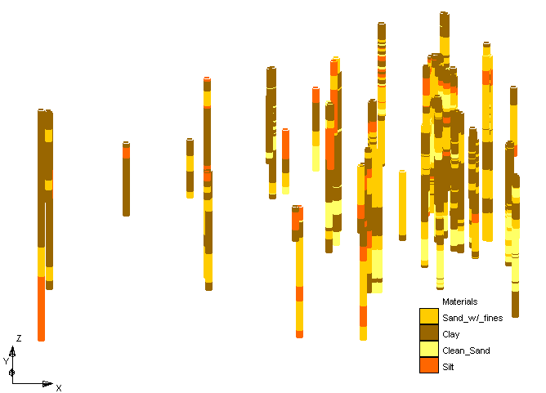

Figure 2 3D oblique view of borehole data

This tutorial will be completed in three phases. The first phase develops the input for a stochastic MODFLOW model using the LPF package and a 3D (multi-layer), orthogonal grid. The second phase will again use the LPF package but use a 2D (single-layer) grid. The third phase will use the HUF package with a 3D grid with non-uniform layer elevations. The second and third phases of the tutorial can be completed relatively quickly since it is possible to re-use the transition probability data developed during the first phase.

While this tutorial illustrates how to use the T-PROGS interface to develop the input data for a stochastic MODFLOW simulation, the MODFLOW simulation will not actually be run. The steps involved in running a stochastic MODFLOW simulation using either the T-PROGS approach or a “Monte Carlo” style approach are described in the “MODFLOW – Stochastic Modeling, Indicator Simulations” tutorial.

## Getting Started

Do the following to get started:

1. If necessary, launch GMS.
2. If GMS is already running, select the *File |* **New** command to ensure that the program settings are restored to their default state.

# Phase I – Multi-Layer Orthogonal Grid

The underlying equations solved by the T-PROGS software require an orthogonal grid with constant cell dimensions (X, Y, and Z). The X values can be different from the Y and Z values, and the Y values can be different from the Z values, but all cells must have the same X, Y, and Z dimensions. However, GMS can be used with T-PROGS with both uniform grids and non-uniform grids. If a uniform grid is used, the T-PROGS calculations are carried out directly on the grid cells. If a non-uniform grid is used, the T-PROGS calculations are carried out on a uniform background grid which bounds the user-defined grid.

After the calculations are complete, the material IDs are transferred from the background grid to the user-defined grid by comparing the coordinates of the cell center for each cell in the user-defined grid to determine which cell in the background grid contains the cell center. The material ID for this cell is then inherited by the cell in the foreground grid. Best results are obtained when the user-defined grid is uniform. When the HUF package is used, a more sophisticated approach is used to handle the stratigraphic layering in the vertical direction. The heterogeneity from the background grid is preserved in a set of HUF input arrays.

The first phase of this tutorial will run T-PROGS on a multi-layer orthogonal MODFLOW grid. The MODFLOW model will use the LPF Package with the *Material ID* option for assigning aquifer properties. With this option, each cell in the grid is assigned a material ID and the aquifer properties (Kh, Kv, etc.) associated with each material are automatically assigned to the layer data arrays for the LPF package when the MODFLOW files are saved. The T-PROGS software generates multiple material sets (arrays of material IDs), each of which represents a different realization of the aquifer heterogeneity.

When running a MODFLOW simulation in stochastic mode, GMS automatically loads each of the *n* material sets generated by the T-PROGS software and saves *n* different sets of MODFLOW input files. The *n* solutions resulting from these simulations can be read into GMS and used to perform risk analyses such as probabilistic capture zone delineation.

## Loading the Borehole Data

The first step in setting up the T-PROGS simulation is to import the borehole data.

1. Click **Open** File:Open Macro.svg to bring up the *Open* dialog.
2. Browse to the *t-progs* folder for this tutorial and select “LH 3D.gpr”.
3. Click **Open** to import the file and exit the *Open* dialog.

The project should appear similar to Figure 3, showing a set of boreholes displayed in plan view.

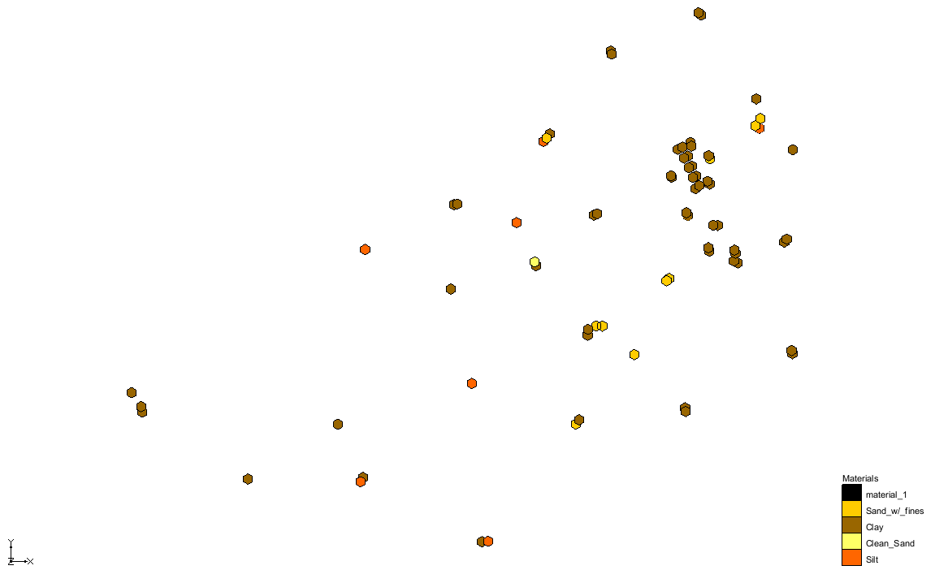

Figure 3 The imported boreholes

## Saving the Project

Before proceeding, save the project under a new name by doing the following:

1. Select *File* | **Save As…** to bring up the *Save As* dialog.
2. Enter “tprob3d.gpr” as the *File name* and click **Save** to exit the Save As dialog.

It is recommended to periodically **Save**File:Save Macro.svg changes while going through this tutorial.

## Viewing the Borehole Data

To view the heterogeneity in the borehole logs, view the boreholes in oblique view.

1. Switch to **Oblique View** File:Oblique View Macro.svg.

Notice that the most common material at the site is clay and the least common material is clean sand. It can also be seen that the site has considerable heterogeneity. It should be noted that the current display has a z magnification factor of 5.0. This factor can be adjusted in the *Display Options* dialog.

1. Switch to **Plan View** File:Plan View Macro.svg.

## Building the 3D Grid

Before editing the T-PROGS data, first create the 3D grid. For sites, such as this one, where the grid must be rotated to align it with the regional ground water flow direction, the best approach is to use the grid frame to define the grid location. The grid frame is located in the Map module of GMS, and is used to define the location, size, and orientation of the grid. Do the following to create the grid frame:

1. Right-click on an empty space in the Project Explorer and select *New |* **Grid Frame**.

A grid frame should appear. For more information on creating and modifying grid frames, please see the “Feature Objects” tutorial.

1. Switch to the https://www.xmswiki.com/images/thumb/3/3e/Map_Module_Icon.svg/52px-Map_Module_Icon.svg.png **Map** module by selecting “File:Map Folder.svg Map Data”*.*
2. Using the **Select Grid Frame** File:Select Grid Frame Tool.svg tool, double-click on the grid frame to bring up the *Grid Frame Properties* dialog.
3. Enter the following values for the grid frame:

|  |  |
| --- | --- |
| Origin x: | 3313550.0 |
| Origin y: | 6952450.0 |
| Origin z: | 130.0 |
| Dimension x: | 1710.0 |
| Dimension y: | 1010.0 |
| Dimension z: | 80.0 |
| Rotation Angle: | 40.0 |

1. Click **OK** to exit the *Grid Frame Properties* dialog.
2. **Frame** File:Frame Macro.svg the project.

The project should appear similar to Figure 4.

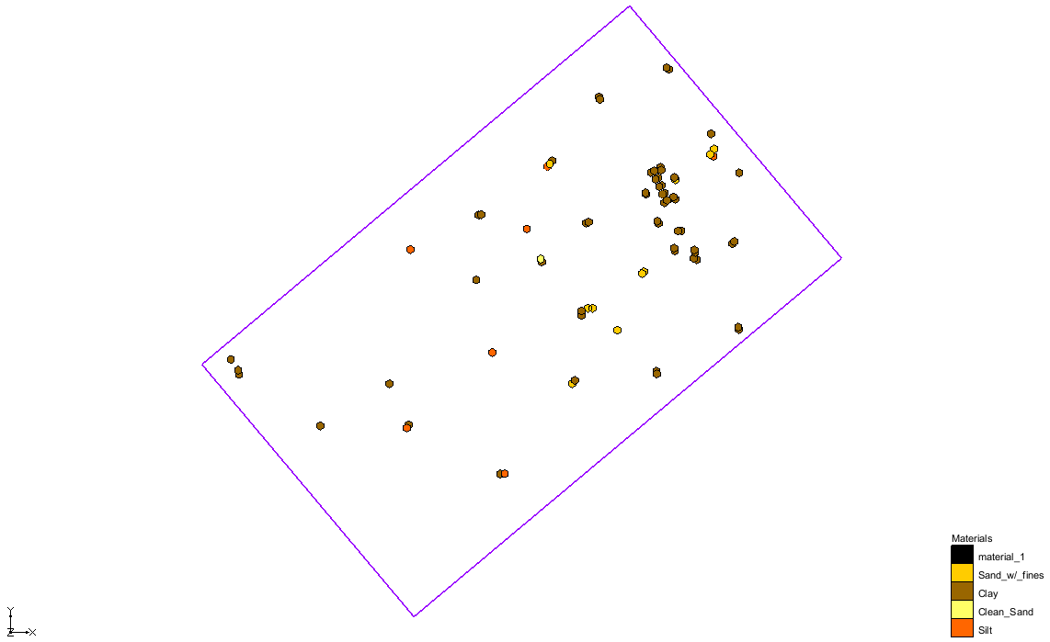

Figure 4 Grid frame surrounding the boreholes

Now it is possible to create the grid:

1. Select Feature Objects | **Map → 3D Grid** to open the *Create Finite Difference Grid* dialog.
2. In the *X-Dimension* section for *Number cells*, enter “70”.
3. In the *Y-Dimension* section for *Number cells*, enter “50”.
4. In the *Z-Dimension* section for *Number cells*, enter “20”.
5. Click **OK** to close the *Create Finite Difference Grid* dialog.

After a few moments, the grid should appear (Figure 5).

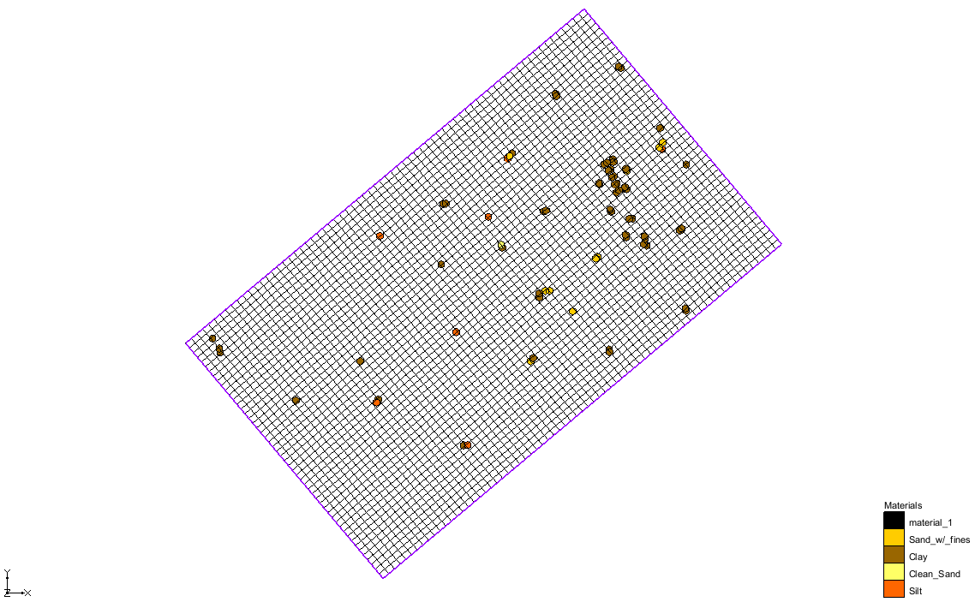

Figure 5 Grid frame with new 3D grid

## Initializing the T-PROGS Simulation

The next step is to initialize the T-PROGS simulation and define some general options including the azimuth angle, background material, and materials included in the simulation.

1. Select “https://www.xmswiki.com/images/thumb/f/fa/Borehole_Folder.svg/60px-Borehole_Folder.svg.png Borehole Data” to switch to the **Boreholes** https://www.xmswiki.com/images/thumb/7/7d/Borehole_Module_Icon.svg/58px-Borehole_Module_Icon.svg.png module.
2. Right-click on a empty space in the Project Explorer and select *New* | **T-PROGS** to open the *T-PROGS Boreholes* dialog.
3. Since all of the boreholes will be used, click **Next** to close the *T-PROGS Boreholes* dialog and open the *T-PROGS Materials* dialog.

The *T-PROGS Materials* dialog lists the materials in use on the boreholes and an *Azimuth* angle. The azimuth angle represents the angle corresponding to the *Strike (X)* direction. If there is anisotropy in the *xy* plane, this angle should be set to the principle direction of the anisotropy. If anisotropy is not present, this angle should be coincident with the *x*-axis (the rows or *j*-direction) of the grid. By default, the azimuth angle is defaulted to a value that aligns it with the *x*-axis of the grid. This value corresponds to the negative grid rotation angle that was entered in the grid frame. This is because the grid rotation angle is counterclockwise from the *x*-axis, but the azimuth angle is clockwise from the *y*-axis.

The upper part of the dialog lists the materials in the boreholes. The first column of options indicates which materials are to be used in the analysis. By default, all materials associated with the boreholes are selected. These options are necessary since it is possible that there may be materials defined in the materials list that are not associated with boreholes. Furthermore, a T-PROGS simulation can be performed without borehole data. In such a case, define the mean proportions and lens lengths for each material.

The third column in the top section of the dialog lists the background material. By default, the material type that had the predominant occurrence (greatest proportion) in the boreholes is marked as the background material. When defining the transition probability data in the next section, the input parameters do not need to be edited for the background material. The parameters for this material are automatically adjusted to balance the equations.

1. Click **Next** to close the *T-PROGS Materials* dialog and bring up the *Vertical (Z) Markov Chains* dialog.

## Developing the Vertical Markov Chains

The most important step in setting up the T-PROGS data is to define the transition probability data for each material located in the boreholes in the three primary directions: vertical, strike, and dip. The vertical transition trends are developed first, based on the borehole data. The data in the strike and dip directions can then be derived from the vertical data.

The first step in setting up the transition data is to run a utility within T-PROGS called GAMEAS that computes a set of transition probability curves as a function of lag distance for each material for a given sampling interval. GAMEAS is launched by doing the following:

1. In the *Measured data* section, click **Compute…** to bring up the *TPROGS* model wrapper dialog.

The *TPROGS* model wrapper dialog lists the output from the GAMEAS utility. Depending on the speed of the computer being used, this can take a few minutes. When it finishes, “Successful Completion” should appear at the bottom of the window and the **Abort** button should change to **Close**.

1. When GAMEAS finishes, click **Close** to exit the *TPROGS* model wrapper dialog.
2. Click **Yes** to the prompt requesting permission to strike and dip data with borehole data.

At this point, the plots in the upper right corner of the dialog should be updated. These plots display the transition probabilities for each material with respect to each of the other materials. The rows (top to bottom) correspond to “Clean_Sand,” “Sand_w/_fines,” “Silt,” and “Clay”. Likewise, the columns (left to right) correspond to “Clean_Sand,” “Sand_w/_fines,” “Silt,” and “Clay”. Thus, the plot in the top row and leftmost column represents the probability of transitioning from clean sand to clean sand. The plot in the top row and second leftmost column represents the probability of transitioning from clean sand to sand with fines, etc.

The plots can be better viewed by maximizing them:

1. Right-click on any of the plots and select **Maximize Plot**.
2. Press *Esc* to minimize the plot.

If desired, use this feature to view other plots.

Each of the plots contains two curves depicting the transition probability. The dashed line represents the transition probability measured from the borehole data by the GAMEAS utility. In general, this curve represents the transition probability from material *j* to material *k*. The transition probability *tjk*(h)is defined by:

*tjk*(h)= Pr{*k* occurs at **x + h** | *j* occurs at **x}** .1

Where *x* is a spatial location, *h* is the lag (separation vector), and *j,k* denote materials. The lag is defined by the *Lag spacing* item in the upper left corner of the *Vertical (Z) Markov Chains* dialog. The curve shown with the solid line is called a Markov chain.

The Markov chains are used to formulate the equations used by T-PROGS to generate the multiple material sets during the simulation stage. The objective of this stage of the analysis is to fit the Markov chain curves as accurately as possible to the measured transition probability curves. This process is similar to fitting a model variogram to an experimental variogram in a kriging exercise.

Mathematically, a Markov chain model applied to one-dimensional categorical data in a direction  assumes a matrix exponential form:

**T**(*h*) = exp(**R***h*) .2

Where  denotes a lag in the direction h, and **R** denotes a transition rate matrix.

 .3

With entries *rjk,* representing the rate of change from category *j* to category *k* (conditional to the presence of *j*) per unit length in the direction . The transition rates are adjusted to ensure a good fit between the Markov chain model and the observed transition probability data.

It should be noted that the self-transitional curves on the diagonal start at a probability of 1.0 and decrease with distance, and the off-diagonal curves start at zero probability and increase with distance. In both cases, the curves eventually flatten out at some distance. The probability corresponding to the flat part of the curve represents the mean proportion of the material. All curves on a particular column should flatten out to the same proportion. The proportions are displayed in the lower left corner of the dialog. As expected, clay has the highest proportion of the four materials.

The point where a tangent line from the early part of the curves on the diagonal intersects the horizontal (lag distance) axis on each curve, represents the mean lens length for the material. The mean lens lengths are shown just to the right of the mean proportions in the lower left part of the dialog. The slope at the beginning of each of the Markov chains represents the transition rate. Together, the proportions, lens lengths, and transition rates define the Markov chains.

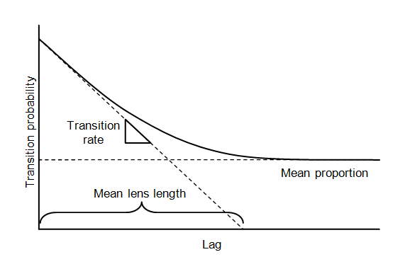

Figure 6 Markov chain curve diagram

Several methods are provided for fitting the Markov chains to the measured transition probability curves. These methods are listed in the *Markov chains* section of the dialog. By default, GMS automatically makes an attempt to fit the curves using the *Edit maximum entropy factors* option. In many cases, this fit is sufficiently accurate. However, it is often useful to explore the other options for fitting the curves.

1. In the *Markov chains* section, select *Edit the transition rates*.

With this option, directly edit the transition rates and the mean proportions using the two spreadsheets at the bottom of the dialog. The proportion and rates for the background material need not be defined. The proportion for the background material is adjusted so that the proportions sum to “1.0”. The transition rates involving the background material are adjusted so that the row sums obey:

 .4

and the column sums obey

 .5

Where *j* is the row index, *k* is the column index, *p* is the proportion, and *r* is the transition rate.

1. Select the *Edit embedded transition probabilities* option in the *Markov chains* section.

With both this option and the next option (*Edit embedded transition frequencies*), GMS parses the borehole data and computed embedded transition probabilities (i.e. transition frequencies) and displays the results in the matrix in the *Transition Rates* section. The transition rates can be computed from the transition probabilities (or frequencies). This option is described in more detail in the *T-PROGS Users Guide*.

1. In the *Markov chains* section, select *Edit maximum entropy factors*.

With this option, the diagonal terms of the rate matrix are computed from the mean lens lengths using the relationship:

 .6

Where *L* is the mean lens length. The off-diagonal terms represent the ratio of the current transition rate to the transition rate corresponding to maximum entropy.

When this factor is equal to “1.0”, the probability that a given material is adjacent to another material is consistent with a random distribution of the materials. In other words, the probability will be dependent only on the proportions of the two materials. Viewing these factors illustrates the juxtapositioning tendencies in the borehole data.

For example, the *Silt → Clean_Sand* factor (in the *Silt* row and the *Clean_Sand* column) should be equal to “0.39”. This factor represents the transition from silt to clean sand moving in the +Z (upwards) direction. The *Clean_Sand → Silt* factor is “1.01”. With factors less than “1.0”, it could be concluded that the type of transition occurs less frequently than possibly expected, given the proportions of the materials.

Since the *Clean_Sand → Silt* factor is greater than the *Silt → Clean_Sand* factor, conclude that it is less likely to transition from “Silt” to “Clean_Sand” than from “Clean_Sand” to “Silt” when moving in the +Z direction. In other words, these two materials exhibit a fining-upwards tendency. The maximum entropy factors provide a simple and intuitive way to view and edit the transition rates.

1. In the *Markov chains* section, select *Fit curves to a discrete lag*.

This option is the simplest to use. With this option, a curve fitting process is used to adjust the transition rates and proportions so that the curve coincides exactly with the measured transition probability at the selected lag interval. By adjusting the lag interval, an excellent fit can often be obtained. This option will be used to fit the curves and proceed to the next step.

1. Enter “17” as the *Lag #* and press *Tab*.

This number produces a good fit between the measured transition data and the Markov chains.

1. Click **Next** to close the *Vertical (Z) Markov Chains* dialog and open the *Strike (X) Markov Chains* dialog.

## Defining the Strike/Dip Transition Trends

The next step is to define the Markov chains in the strike and dip directions. In theory, the GAMEAS utility could be run in the strike and dip directions to develop measured transition probability data which could then be modeled with Markov chains. However, borehole data are not sufficiently dense in these directions to develop meaningful data. Therefore, it is necessary to apply Walther’s Law to develop the strike and dip Markov chains. Walther’s Law states that vertical successions of deposited facies represent the lateral succession of environments of deposition. In other words, the transition rates in the horizontal directions can be derived from the transition rates in the vertical direction.

To begin with, assume that the proportions are the same in all three directions. The lens length ratios method is then used to define the transition rate matrix. With this method, the diagonal transition rates are defined from the lens lengths using equation 6. The lens lengths in the horizontal directions are derived from the lens length ratios entered for each material using the spreadsheet on the bottom left of the dialog. These ratios represent the lens length in the horizontal direction versus the lens length in the vertical direction. GMS sets up the matrix using a default ratio of approximately “10.0”. The off-diagonal terms in the rate matrix are then inherited from the vertical transition rates and then scaled by dividing by the lens length ratio.

Once the Markov chains have been defined by the lens length ratios method, the other four methods listed in the *Markov Chains* section of the dialog can be used to view or edit the Markov chain data. In this case, accept the default data for both the strike and dip directions.

1. Click **Next** to exit the *Strike (X) Markov Chains* dialog and open the *Dip (Y) Markov Chains* dialog.
2. Click **Finish** to close the *Dip (Y) Markov Chains* dialog.
3. **Save** File:Save Macro.svg the project.

## Running TSIM

With the Markov chains defined in all three primary directions, run TSIM to generate the material sets. The **Run TSIM** command launches up to three different utilities: GAMEAS, MCMOD, and TSIM. If the *Fit curve to a discrete lag* option is used, GAMEAS is launched first to develop the transition trends from the borehole data (as is the case with this simulation). GAMEAS only runs if this option is used for the vertical Markov chains. MCMOD then takes the one-dimensional Markov chains defined in the three primary directions and formulates a three-dimensional Markov chain. This Markov chain is then read into TSIM and TSIM generates the material sets.

Running TSIM can take anywhere from several minutes to several hours depending on the number of materials, the resolution of the grid, and the number of material sets desired. To ensure that this tutorial can be completed in a reasonable amount of time, only create five material sets.

1. Select T-PROGS | **Run TSIM…** to bring up the *TSIM* dialog.
2. Select *Launch TSIM internal in GMS* and click **Next** to close the TSIM dialog and open the *TSIM Options* dialog.
3. For the *Simulation name,* enter “sim3d”.
4. For the *Number of realizations,* enter “5”.
5. Click **Finish** to accept the other default settings, close the *TSIM Options* dialog and open the *TPROGS* model wrapper dialog.
6. When the GAMEAS utility finishes, click **Close** to exit the *TPROGS* model wrapper dialog and open a new *TPROGS* model wrapper dialog that will run MCMOD and TSIM.

The output from MCMOD and TSIM will display until they both successfully complete.

1. When TSIM finishes, click **Close** to exit the *TPROGS* model wrapper dialog.

The project should appear similar to Figure 7.

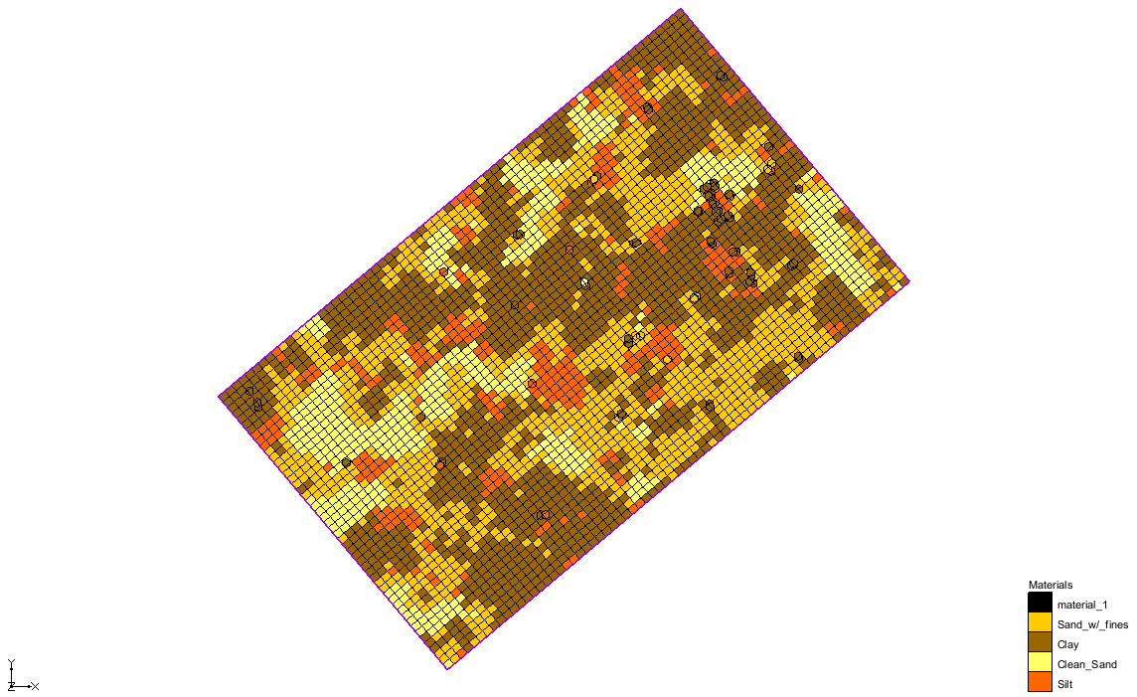

Figure 7 After the TSIM run

## Viewing the Results

The output from T-PROGS is a series of material sets. The material sets are organized in theProject Explorerassociated with the 3D GridModule. The first material set is automatically loaded and the *Cell faces* display option is turned on. The material set simulations are organized into a “Material Sets” folder in the Project Explorer.

1. Right-click on “File:Material Set Folder.svg Material Sets” and select **Expand All**.

All five material sets are listed under the “File:Generic Folder Locked.svg sim3d” folder. The active material set, “File:Materials Display Options.svg sim3d 1,” is bold.

1. Change material sets by selecting “File:Materials Display Options.svg sim3d 2” and notice that the grid display updates.
2. In the Mini-Grid toolbar , change to the second layer.
3. Switch to the **Front View**File:Front View Macro.svgto view the grid from the front side.
4. Use the arrow buttons in the Mini-Grid toolbar  to view different cross-sections.
5. Return to plan view by clicking **Plan View**File:Plan View Macro.svg.
6. View the material set properties by right-clicking on any of the material sets and selecting **Properties…** to open the *Material Set Info* dialog. If desired, repeat this with other material sets to confirm that all material sets have the same proportions.
7. Click **OK** to exit the *Material Set Info* dialog.

A probability dataset for each material can also be created and displayed. First, save the current display settings and then change the setting to view the probability datasets.

1. Right-click in an empty space in the Project Explorer and select *New |* **Display Theme…**to open the *Display Theme Properties* dialog.

A display theme is used to save the current display settings.

1. Click **OK** to accept the defaults of the display template and close the *Display Theme Properties* dialog.

A new “Display%20Theme Display (1)” display theme should appear in the Project Explorer.

1. Right-click on “File:Generic Folder Locked.svg sim3d” and select **Create Probability Datasets**.

A series of new datasets under a “https://www.xmswiki.com/images/thumb/9/90/Generic_Folder.svg/52px-Generic_Folder.svg.png sim3d Prob” folder should appear in the Project Explorer.

1. Select “File:Dataset Cells Active.svg Clean_Sand” in theProject Explorer and click **Display Options** File:Display Options Macro.svg to open the *Display Options* dialog.
2. Select *3D Grid Data* from the list on the left.
3. On the *3D Grid* tab, in the *Active dataset* section, turn on *Contours* and click **Options…** to open the *Dataset Contour Options – 3D Grid – Clean Sand* dialog.
4. In the *Contour method* section, select “Color Fill” from the first drop-down.
5. Near the bottom of the dialog, turn on *Legend*.
6. Click **OK**to exit the *Dataset Contour Options – 3D Grid – Clean Sand* dialog.
7. Click **OK** to exit the *Display Options* dialog.

The probability of the “Clean_Sand” material existing in each grid cell is now contoured. Now select the other datasets to view the different material probabilities.

1. Select “Display%20Theme Display (1)” in the Project Explorer to reset the display settings.
2. **Save** https://www.xmswiki.com/images/thumb/0/00/Save_Macro.svg/53px-Save_Macro.svg.png the project.

This completes the 3D grid portion of this tutorial.

# Phase II – Single Layer Grid

This portion of the tutorial demonstrates the generation of multiple material sets for a single-layer model. When developing a single layer model, the modeler must determine how to distribute the hydraulic conductivity values within the layer. A common approach is to delineate zones of hydraulic conductivity by examining the subsurface stratigraphic data. The modeler often faces a difficult task of trying to determine a reasonable strategy for delineating two-dimensional zones of hydraulic conductivity based on complex 3D borehole data.

The 2D T-PROGS approach provides a simple, rational approach to representing borehole data in a single layer MODFLOW model. This is similar to the 3D approach. The first step is to generate the Markov chains in the three principal directions. Since these data have already been generated in the first phase of the tutorial, the Markov chain information will be reused for this phase. The main difference between the two approaches is what happens when TSIM is executed.

For the 2D case, GMS determines the predominant material at each borehole and creates a single sample at the *xy* location of the borehole corresponding to the predominant material type. These samples are input to TSIM in the place of the entire borehole log that is input to TSIM in the 3D case. TSIM then performs a 2D indicator simulation in the xy plane and each of the resulting material sets is conditioned to the simplified borehole data.

## Saving the Project

Before continuing, save the project under a new name:

1. Select *File* | **Save As…** to open the *Save As* dialog.
2. Enter “tprob2d.gpr” as the *File name* and click **Save** to close the *Save As* dialog.

## Building the Single Layer Grid

First, use the same grid frame created in the first phase of the tutorial to create a single layer grid.

1. Right-click on “https://www.xmswiki.com/images/thumb/e/e3/Grid_Frame_Icon.svg/53px-Grid_Frame_Icon.svg.png Grid Frame” and select *Map to |* **3D Grid** to bring up the *Create Finite Difference Grid* dialog.
2. Click **OK** at the prompt to confirm the replacing the existing grid with a new grid.
3. In the *X-Dimension* section for *Number cells*, enter “70”.
4. In the *Y-Dimension* section for *Number cells*, enter “50”.
5. In the *Z-Dimension* section for *Number cells*, enter “1”.
6. Click **OK** to close the *Create Finite Difference Grid* dialog.

## MODFLOW Layer Elevations

Grid layer elevations could be interpolated from scatter point data using the **To MODFLOW Layers** command in the 2D Scatter Point module. However, for the sake of simplicity, use constant top and bottom elevations with the model.

## Running TSIM

The transition probability data developed in the first phase of this tutorial will be used for the 2D case. Therefore, proceed directly to running TSIM.

1. Select T-PROGS | **Run TSIM…** to open the *TSIM* dialog.
2. Select *Launch TSIM internal in GMS* and select **Next** to close the *TSIM* dialog and open the *TSIM Options* dialog.
3. Enter “sim2d” as the *Simulation name*.
4. Enter “5” as the *Number of realizations*.
5. Accept the other defaults and click **Finish** to close the *TSIM Options* dialog.
6. When asked to confirm that each borehole will be simplified to a single point in the calculations, click **OK** to bring up the *TPROGS* model wrapper dialog.
7. When the GAMEAS utility finishes, click **Close** to exit the *TPROGS* model wrapper dialog and bring up another *TPROGS* model wrapper dialog.

The MCMOD and TSIM utility will then execute. Helpful information is displayed at the top of the dialog including *Elapsed Time* and *Time Remaining*. This simulation runs much faster than the 3D case.

1. Click **Close** when TSIM finishes to exit the *TPROGS* model wrapper dialog.
2. Repeat steps 1–20 from section 2.9 to view the results.

# Phase III – Generating Multiple HUF Datasets

In the final phase of this tutorial, generate HUF data using T-PROGS. Using HUF arrays overcomes the main limitation of T-PROGS: grid cell dimensions must be kept small to capture the heterogeneity. This results in thin cells at the top of the grid that are prone to wetting and drying problems. With the HUF approach, larger cell thicknesses can be used.

When using the HUF approach, first create a grid with constant row and column widths. The layer elevations are then interpolated as desired to match aquifer boundaries. When TSIM is executed in HUF mode, GMS creates a background grid that has the same dimensions as the primary grid in terms of rows and columns, but has a greater number of layers than the primary grid, resulting in greater detail or resolution in the vertical direction. The background grid is an orthogonal grid compatible with the T-PROGS interpolation algorithm. The T-PROGS simulation is then performed on the background grid. The heterogeneity resulting from the dense background grid is then translated by GMS into a set of grid-independent HUF units.

Once again, reuse the transition probability data created in the first phase of the tutorial.

## Saving the Project

Before continuing, save the project under a new name.

1. Select *File* | **Save As…** to open the *Save As* dialog.
2. Enter “tprobhuf.gpr” as the *File name* and click **Save** to exit the *Save As* dialog.

## Turning Off Cell Faces

Before continuing, turn off the display of the grid cell materials.

1. Click **Display Options** File:Display Options Macro.svg to open the *Display Options* dialog.
2. Select *3D Grid Data* from the list on the left.
3. On the *3D Grid* tab, turn off *Cell faces*.
4. Click **OK** to close the *Display Options* dialog.

## Building the Grid

First, create a four-layer grid using the grid frame.

1. Right-click on “File:Grid Frame Icon.svg Grid Frame” and select *Map to |* **3D Grid** to open the *Create Finite Difference Grid* dialog.
2. Click **OK** when advised the existing grid will be deleted.
3. In the *X-Dimension* section for *Number cells*, enter “70”.
4. In the *Y-Dimension* section for *Number cells*, enter “50”.
5. In the *Z-Dimension* section for *Number cells*, enter “4”.
6. Click **OK** to close the *Create Finite Difference Grid* dialog.

## Initializing MODFLOW

Before interpolating the top and bottom elevations for the grid, initialize the MODFLOW data.

1. Select *MODFLOW* | **New Simulation…** to initialize MODFLOW and open the *MODFLOW Global/Basic Package* dialog*.*
2. Click **Packages…** to open the MODFLOW Packages/Processes dialog.
3. In the Flow package section, select HUF – Hydrogeologic Unit Flow.
4. Click **OK** to close the MODFLOW Packages/Processes dialog.
5. Click **OK** to exit the MODFLOW Global/Basic Package dialog.

## Interpolating the Layer Elevations

Next, import a set of scatter point data and interpolate the top and bottom elevations for the four layers of the MODFLOW grid. To do this, interpolate the elevations for the top of the grid. For the elevations at the bottom of the grid, leave these values at a constant value for simplicity. Next, use the **Redistribute Layers** command to evenly distribute the elevations for the interior layer boundaries.

### Importing the Scatter Point Data

Import the scatter data from a tabular text file:

1. Click **Open** File:Open Macro.svg to bring up the *Open* dialog.
2. Select “Text Files (*.txt;*.csv)” from the *Files of type* drop-down.
3. Select “topo.txt” and click **Open** to exit the *Open* dialog and open the *Step 1 of 2* page of the *Text Import Wizard* dialog.
4. Below the top section, turn on *Heading row* and click **Next** to go to the *Step 2 of 2* page of the *Text Import Wizard* dialog.
5. From the *GMS data type* drop-down, select “2D scatter points”.

The spreadsheet at the bottom of the dialog enables specifying what types of data are in each column.

1. In the first column, on the *Type* row, select “Label” from the drop-down.
2. In the fourth column, on the *Type* row, select “Dataset” from the drop-down.

This indicates that the fourth column represents an elevation dataset.

1. Click **Finish** to close *Text Import Wizard* dialog.

A set of scatter points should appear in the vicinity of the grid (Figure 8).

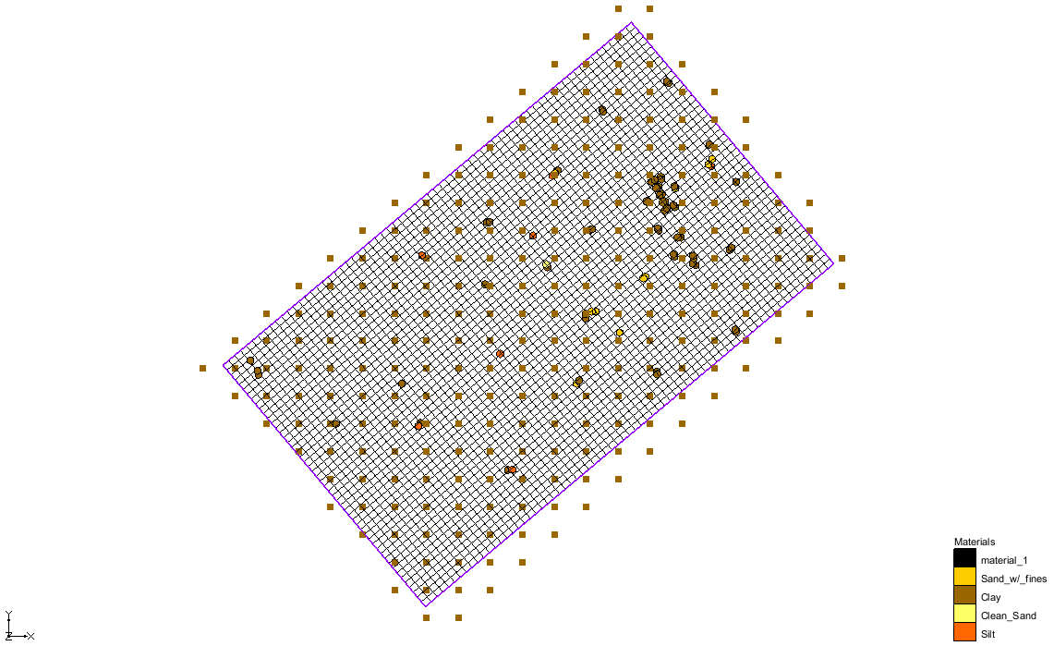

Figure 8 Scatter set with the grid and boreholes

### Interpolating the Layer Elevations

Next, interpolate the elevations associated with the scatter point set to the top of the MODFLOW grid using the default interpolation options.

1. Right-click on “File:2D Scatter Icon.svg topo” in the Project Explorer and select *Interpolate To* **| MODFLOW Layers…** to open the *Interpolate to MODFLOW Layers* dialog.
2. In the *Scatter point datasets* section, select “elevation”.
3. In the *MODFLOW data* section, select “Top Elevations Layer 1”.
4. Click **Map**.
5. Click **OK** to close the *Interpolate to MODFLOW Layers* dialog.

To view the results:

1. Turn off “File:2D Scatter Icon.svg topo” and“File:Borehole Folder.svg Borehole Data” in the Project Explorer.
2. Select “File:3D Grid Folder.svg 3D Grid Data” to switch to the **3D Grid** https://www.xmswiki.com/images/thumb/9/92/3D_Grid_Icon.svg/60px-3D_Grid_Icon.svg.png module.
3. Using the **Select Cells** File:Select 3D Cell Tool.svg tool, select a cell near the center of the grid.
4. Switch to **Front View** images/FrontView.bmp.

The project should appear similar to Figure 9.

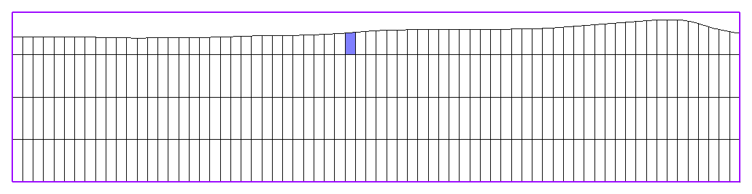

Figure 9 Front view showing the elevations mapped to the top layer

1. Switch to **Side View** images/SideView.bmp.

The project should appear similar to Figure 10.

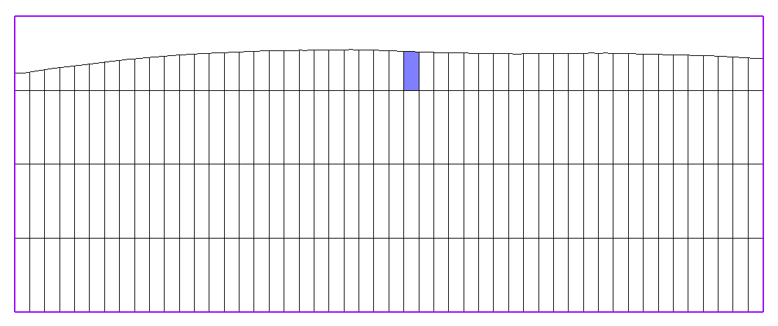

Figure 10 Side view showing the elevations mapped to the top layer

### Redistributing the Interior Layer Elevations

Now use the **Redistribute Layers** command to distribute the elevations of the interior layer boundaries between the current elevations at the top and bottom of the grid. Make the top layer a little larger than the other three layers. The other three layers will be evenly distributed.

1. Select *Grid* | **Redistribute Layers…** to bring up the *Redistribute Layers* dialog.
2. In the spreadsheet on the right, enter “0.35” on *Layer* *1* in the *Fraction* column.

Note how the fractions for the other layers are automatically updated.

1. Click **OK** to close the *Redistribute Layers* dialog.
2. Click **Yes**when asked to confirm overwriting the MODFLOW elevations.

Note the change in the layer elevations (Figure 11). Having a thicker layer at the top reduces difficulties caused by cell wetting and drying.

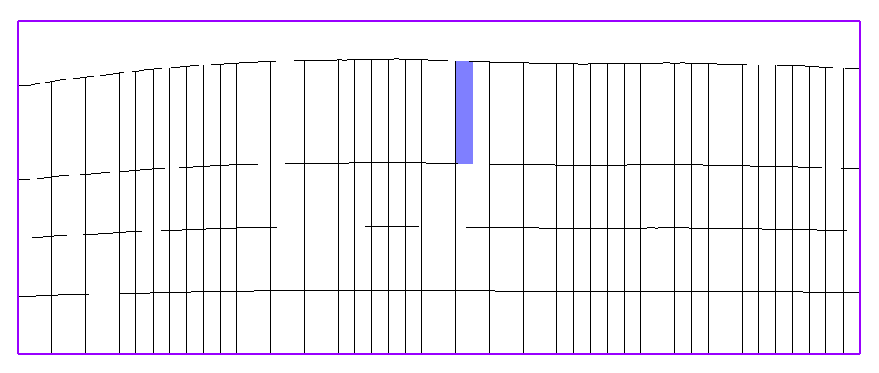

Figure 11 The top layer is now thicker

## Running TSIM

It is now possible to run TSIM.

1. Select T-PROGS | **Run TSIM…** to open the *TSIM* dialog.
2. Click **Next** to close the *TSIM* dialog and open the*TSIM Options* dialog.
3. Enter “simhuf” as the *Simulation name*.
4. Enter “5” as the *Number of realizations*.
5. In the *TSIM output* section, select *Generate HUF arrays*.
6. In the *Background grid* section, for *Num Z,* enter “20”.

This defines the number of layers in the background grid and controls the level of detail in the resulting HUF units.

1. Click **Finish** to close the *TSIM Options* dialog and open the *TPROGS* model wrapper dialog.
2. When the GAMEAS utility finishes, click **Close** to exit the *TPROGS* model wrapper dialog and open another *TPROGS* model wrapper dialog.
3. When MCMOD and TSIM finish, click **Close** to exit the *TPROGS* model wrapper dialog.

The project should appear similar to Figure 12.

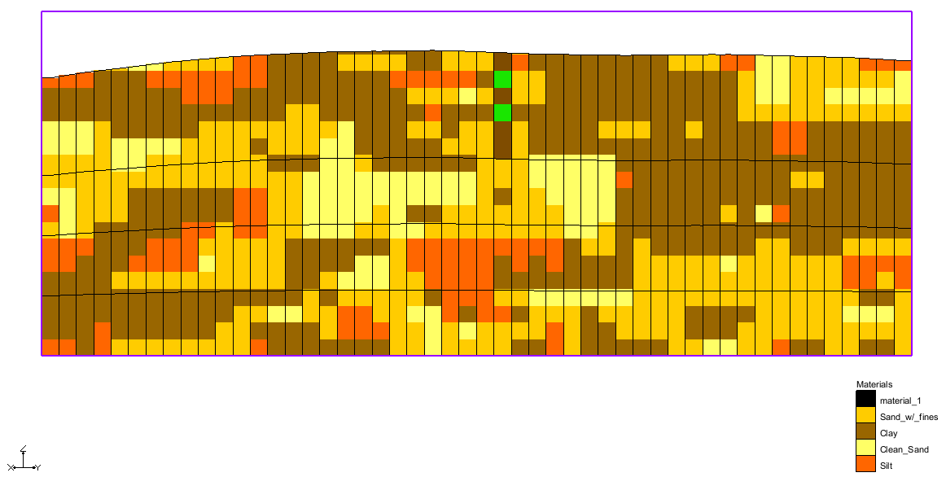

Figure 12 Side view after TSIM run

## Viewing the Results

The output from T-PROGS is automatically converted to a series of HUF datasets. The HUF datasets are organized in the “File:3D Grid Folder.svg 3D Grid Data” folder in the Project Explorer. The first HUF dataset is automatically loaded and the *Display hydrogeologic units* option is turned on. Note that the stratigraphic definition is independent of the MODFLOW grid boundaries.

1. Expand the “File:HUF folder.svg simhuf” folder”. It is found under the “File:HUF folder.svg HUF Data” folder under the “File:3D Grid Folder.svg 3D Grid Data” folder.
2. Notice that the “File:HUF icon.svg simhuf 1” dataset is selected.

All five realizations are listed under the “simhuf” folder. The active HUF dataset, “File:HUF icon.svg simhuf 1”, is identified by a bolded name and selected icon. If desired, view other HUF datasets by them from the list, and view different columns and rows of the MODFLOW grid. White viewing the results, the solid lines represent the boundaries of the MODFLOW grid cells. The filled colors in the background represent the HUF units.

While viewing the cross sections, keep in mind that the vertical scale is currently magnified by a factor of 5.0. If desired, change back to the true scale in the *Display Options* dialog.

# Conclusion

This concludes the “T-PROGS” tutorial. The following key concepts were discussed and demonstrated in this tutorial:

* T-PROGS can be used to help create a single or multi-layer MODFLOW model that uses the Material IDs approach with the LPF package.
* T-PROGS can also be used with the MODFLOW HUF package.

1. Carle, Steven F. (1999). *T-PROGS: Transition Probability Geostatistical Software Version 2.1*, Hydrologic Sciences Graduate Group, University of California, Davis. <http://gmsdocs.aquaveo.com/t-progs.pdf>