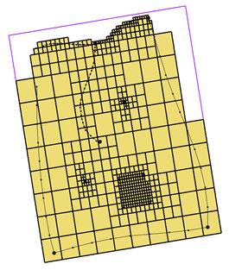

GMS 10.9

GMS 10.9 Tutorial

***UGrid Creation***

Creating unstructured grids (UGrids) in GMS

Objectives

This tutorial gives an overview about unstructured grids, or UGrids, and several methods for creating them in GMS.

Time

* 15–30 minutes

Required Components

* GMS Core

Prerequisite Tutorials

* Getting Started

|  |
| --- |
| [1 Introduction 2](#_Toc199233131)  [2 Getting Started 2](#_Toc199233132)  [3 Importing a UGrid 2](#_Toc199233133)  [3.1 Importing a 3D UGrid 2](#_Toc199233134)  [3.2 Cell Faces 3](#_Toc199233135)  [3.3 Importing a 2D UGrid 4](#_Toc199233136)  [4 Creating a New UGrid 5](#_Toc199233137)  [4.1 3D UGrid 5](#_Toc199233138)  [4.2 2D UGrid 6](#_Toc199233139)  [4.3 Using a Grid Frame 7](#_Toc199233140)  [4.4 Moving and Resizing the Grid Frame 7](#_Toc199233141)  [5 Converting from Other Object Types 9](#_Toc199233142)  [5.1 Converting from a 3D Grid 9](#_Toc199233143)  [5.2 Converting from a Shapefile 9](#_Toc199233144)  [5.3 Extruding a 2D UGrid to a 3D UGrid 10](#_Toc199233145)  [6 Using the Map to UGrid Dialog 11](#_Toc199233146)  [6.1 Regular (Not Refined) 13](#_Toc199233147)  [6.2 Quadtree / Octree 14](#_Toc199233148)  [7 Horizons to UGrid 18](#_Toc199233149)  [7.1 Viewing the 3D Quadtree UGrid 20](#_Toc199233150)  [8 Conclusion 21](#_Toc199233151) |

# Introduction

The UGrid module in GMS makes use of “unstructured grid” geometric objects, referred to as “UGrids”. Similar to the 3D grids and meshes in GMS, UGrids offer greater flexibility by supporting cells with any number of faces and nodes. This allows for more realistic modeling of complex geologic features such as pinchouts. UGrids were introduced to GMS to support MODFLOW*–*USG, which uses the finite volume method.

There are several ways to create UGrids in GMS. This tutorial will discuss and demonstrate importing UGrids and using the **New UGrid** commands to create UGrids. UGrids will be created using multiple methods, including by converting other data types to UGrids, using the **Map → UGrid** command, and using the **Horizons → UGrid** command.

# Getting Started

Do the following to get started:

1. If necessary, launch GMS.
2. If GMS is already running, select *File |* **New** to ensure that the program settings are restored to their default state.

# Importing a UGrid

## Importing a 3D UGrid

The simplest way to load a UGrid into GMS is by importing an existing one. GMS supports the VTK unstructured grid file format.

To import a 3D UGrid from a file, do the following:

1. Click **Open** File:Open Macro.svg to bring up the *Open* dialog.
2. Select “All Files (\*.\*)” from the *Files of type* drop-down.
3. Browse to the \*UGridCreation\UGridCreation* directory and select “ugrid.vtu”.
4. Click **Open** to import the file and exit the *Open* dialog.
5. Switch to **Oblique View** File:Oblique View Macro.svg.

A wireframe depiction of the UGrid should appear (Figure 1).

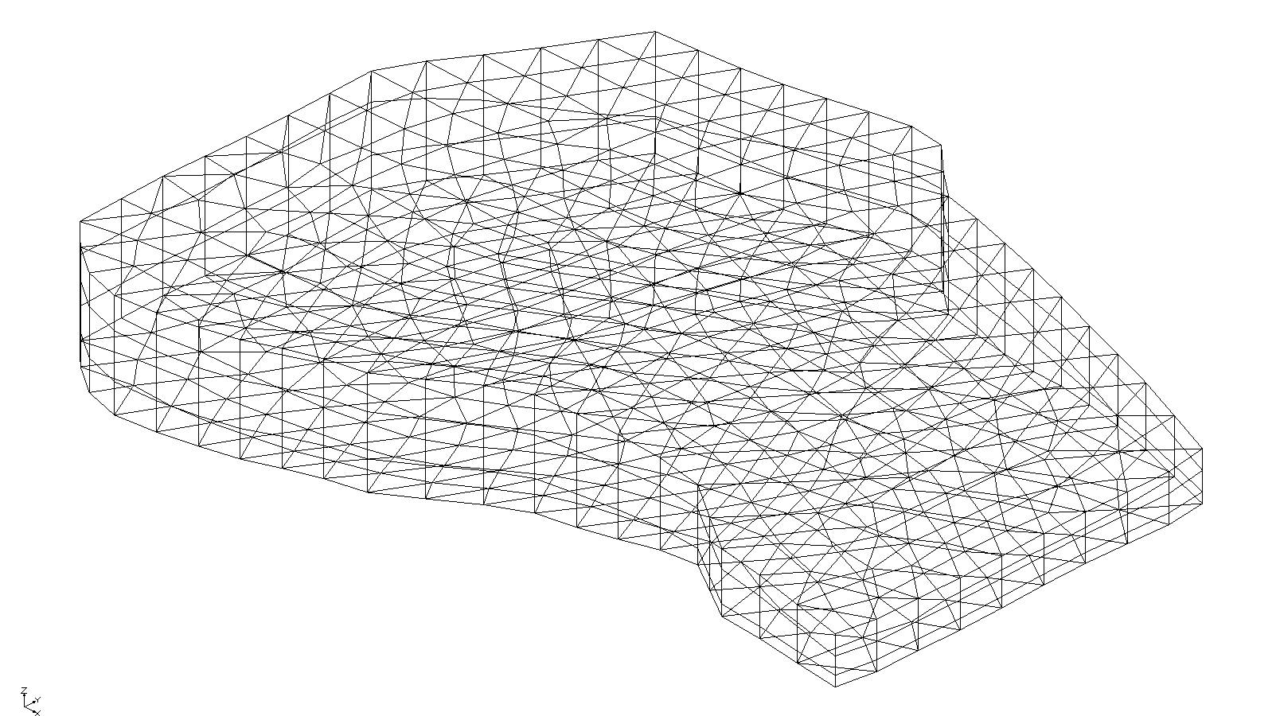

Figure 1 Imported UGrid

## Cell Faces

To review some of the UGrid display options:

1. Click the **Display Options** File:Display Options Macro.svg macro to bring up the *Display Options* dialog.
2. Select *Ugrid:ugrid – [Active]* from the list on the left.
3. Turn on *Define UGrid specific options.*
4. Turn on *Cell faces*.
5. Click **OK** to exit the *Display Options* dialog.

The cell faces should be visible with different colors for different layers (Figure 2). The colors come from the materials assigned to the cells.

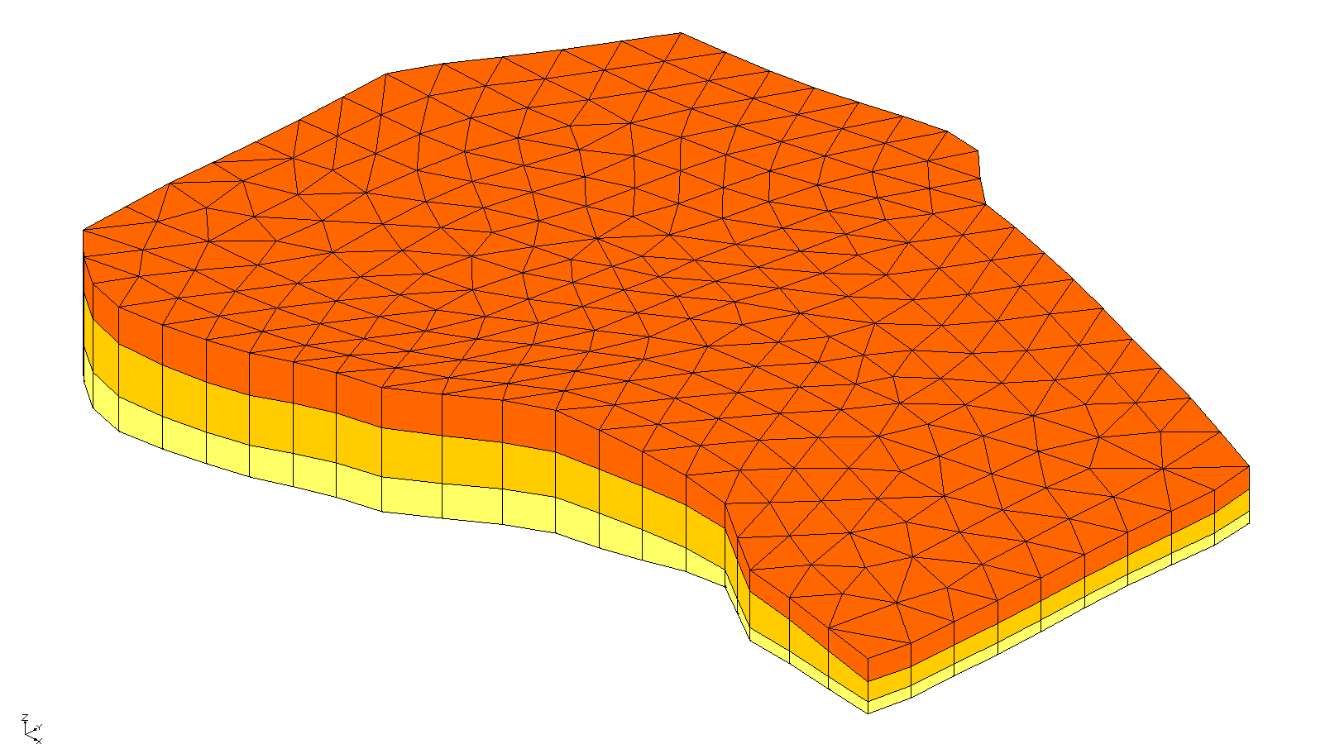

Figure 2 UGrid with cell faces turned on

1. Use the **Rotate** File:Rotate Tool.svg tool to view the UGrid from different angles.

This UGrid consists of prismatic wedge elements with an irregular boundary and appears to have three layers. However, as an unstructured grid, a UGrid does not require continuous layers—or any layers at all. All cells in this grid are 3D.

To review the *UGrid Properties* dialog, do the following:

1. In the Project Explorer, right-click on “Ugrid_lock_3D ugrid” and select **Properties…** to open the *UGrid Properties* dialog.

Notice the number of 2D and 3D cells; this UGrid is composed of only 3D cells.

1. Click **OK** to close the *UGrid Properties* dialog.

## Importing a 2D UGrid

To review another example of an imported UGrid:

1. Click the **New** File:New Macro.svg macro to start a new project.
2. If asked to save, click **Don’t Save**.
3. Click **Open** File:Open Macro.svg to bring up the *Open* dialog.
4. Select “All Files (\*.\*)” from the *Files of type* drop-down.
5. Select “cow.vtu” and click **Open** to import the project and exit the *Open* dialog.

A UGrid should appear showing a wireframe cow (Figure 3). This type of unstructured grid is not very useful for groundwater modeling, but it illustrates the flexibility of the UGrid module in GMS.

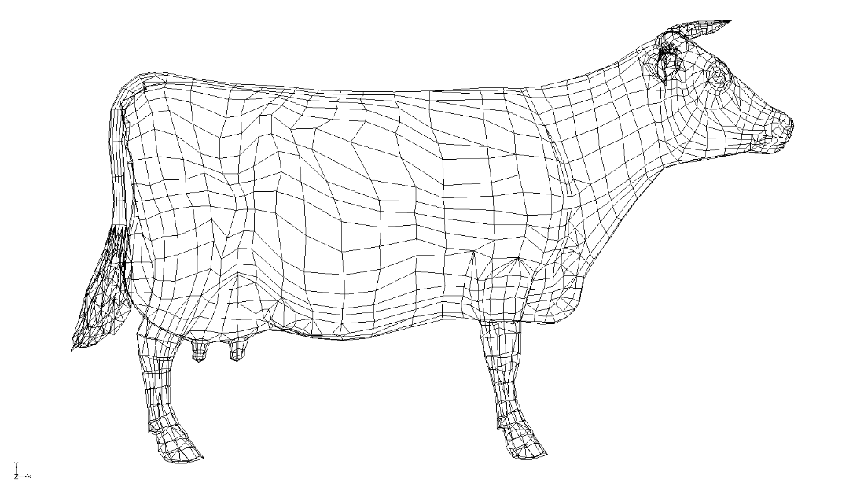

Figure 3 Imported cow unstructured grid

1. Use the **Rotate** File:Rotate Tool.svg tool to view the UGrid from different angles.
2. In the Project Explorer, right-click on the “Ugrid_lock_3D cow” UGrid and select **Properties…** to open the *UGrid Properties* dialog.

Note the number of 2D and 3D cells: this UGrid is a hollow shell made up of 2D cells. While not particularly useful for groundwater modeling, 2D UGrids in GMS serve as projection grids for generating 3D UGrids, as discussed later.

1. Click **OK** to exit the *UGrid Properties* dialog.

# Creating a New UGrid

Another simple way to create a UGrid in GMS is by using the UGrid options in the *New* menu, accessible by right-clicking in the Project Explorer. These commands and their dialogs function much like those used to create new 2D and 3D structured grids.

## 3D UGrid

1. Click the **New** File:New Macro.svg macro to start a new project.
2. If asked to save, click **Don’t Save**.
3. Right-click in either the Project Explorer or the Graphics Window and select *New* | **UGrid 3D…** to bring up the *New UGrid* dialog (Figure 4).

This dialog closely resembles the one used to create structured 3D grids. It allows for specifying the grid’s origin, dimensions, and the number of cells in the *X*, *Y,* and *Z* directions. Alternatively, cell sizes can be defined, with the option to apply bias, causing cell sizes to gradually increase or decrease across the grid. A more effective method for cell biasing will be discussed later in this tutorial.

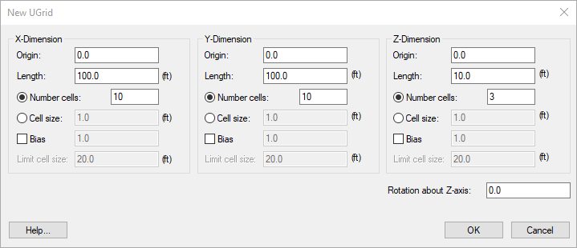

Figure 4 New UGrid dialog

1. Below the *Z-Dimension* section, enter “10.0” as the *Rotation about Z-axis*.
2. Click **OK** to close the *New UGrid* dialog.
3. Switch to **Oblique View** File:Oblique View Macro.svg.

A 3D UGrid should be visible (Figure 5). Notice that the cells are all 6-sided 3D objects, or hexahedrons. This method always creates UGrids with hexahedron cells in 3D and quadrilateral cells in 2D. The creation of more complex cell types will be covered later in the tutorial.

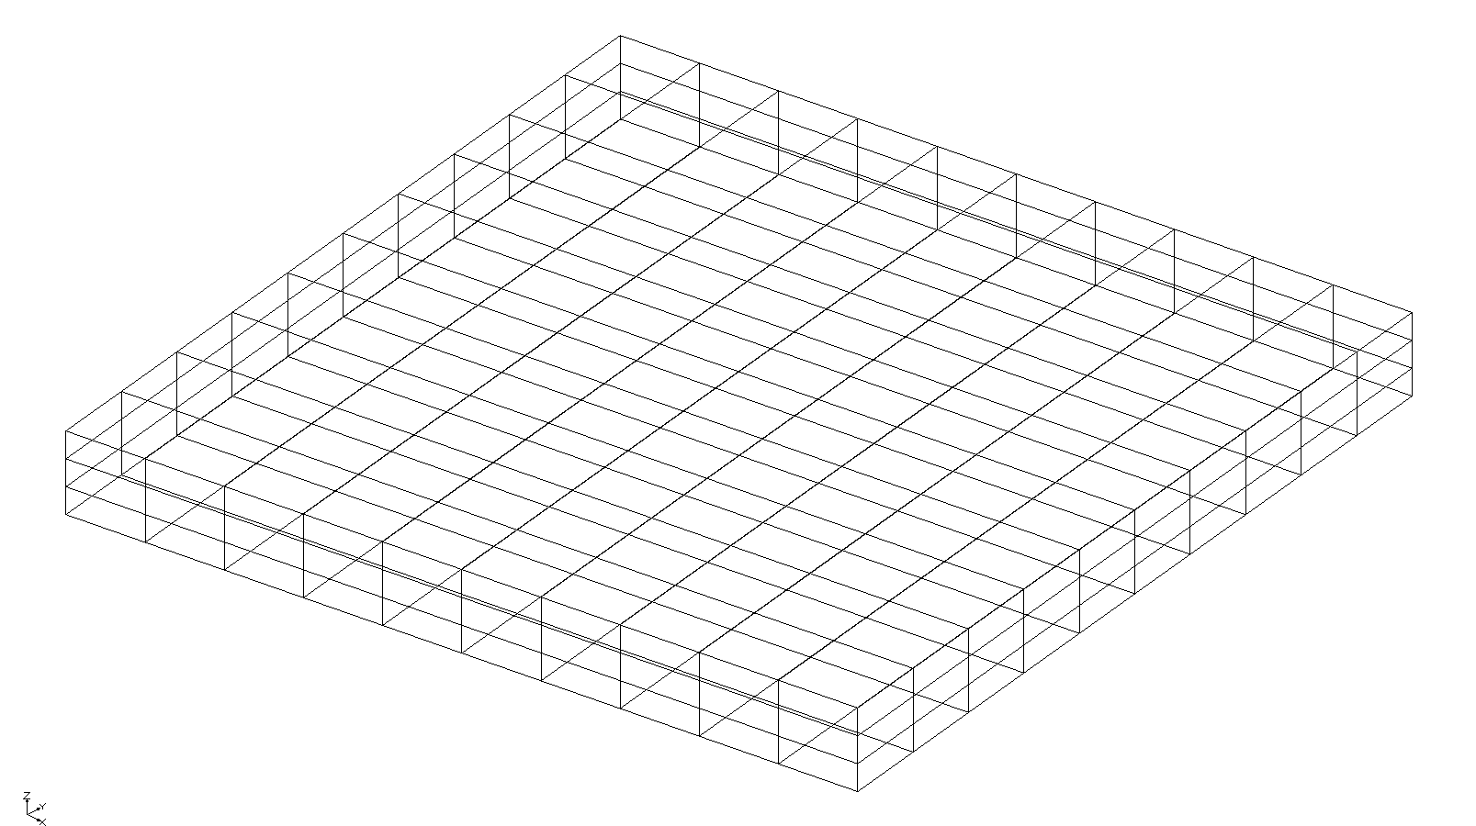

Figure 5 New 3D UGrid

## 2D UGrid

The *New* **| UGrid 2D…** command functions similarly but creates a UGrid comprised of only 2D cells. The dialog is the same except that only the option to specify cells in the *Z* dimension is available. Feel free to experiment with this command.

## Using a Grid Frame

While the *New UGrid* dialog provides a quick and easy way to create a UGrid, it requires predefined values for the origin and lengths of the grid in each dimension. A more intuitive approach is to create a grid frame that surrounds the existing data, allowing the grid to be oriented graphically before using the *New UGrid* dialog.

1. Click the **New** File:New Macro.svg macro to start a new project.
2. If asked to save, click **Don’t Save**.
3. Click **Open** File:Open Macro.svg to bring up the *Open* dialog.
4. Select “Project Files (\*.gpr)” from the *Files of type* drop-down.
5. Select “biscayne.gpr” and click **Open** to import the project and exit the *Open* dialog.

A conceptual model should be visible including well points and arcs representing rivers and canals.

1. Right-click in either the Project Explorer or the Graphics Window and select *New*| **Grid Frame** to create a new grid frame.

Now it is necessary to fit it around the data.

1. In the Project Explorer, right-click on “File:Grid Frame Icon.svg Grid Frame” in the Project Explorer and select **Fit to Active Coverage**.

## Moving and Resizing the Grid Frame

While the **Fit to Active Coverage** command is convenient, it is possible to rotate the grid frame or resize it to better fit the data.

1. Using the **Select Grid Frame** File:Select Grid Frame Tool.svg tool, select the frame and rotate, resize, and reposition the grid frame to more or less match the image shown in Figure 6.

* Drag the corner or side anchor points of the grid frame to resize it
* Click anywhere inside the grid frame, or on an edge—but not on an anchor point—to drag and move the entire grid frame
* Click and drag on the circle in the lower right corner to rotate the grid frame

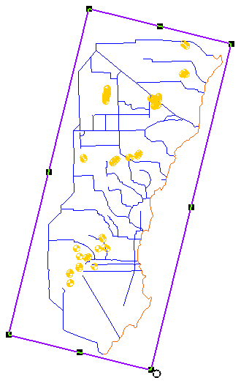

Figure 6 Grid frame surrounding a conceptual model

1. When finished positioning the grid frame, right-click in the Project Explorer and select *New* **| UGrid 3D…** to bring up the *New UGrid* dialog.

Notice that the origins, lengths, and rotation are defaulted to values that come from the grid frame.

1. Click **OK** to accept the defaults and close the *New UGrid* dialog.

GMS creates the UGrid inside the boundary of the grid frame (Figure 7). If this were a real model, more cells might need to be created.

1. Turn off the “Ugridlocksingle ugrid”in the Project Explorer.

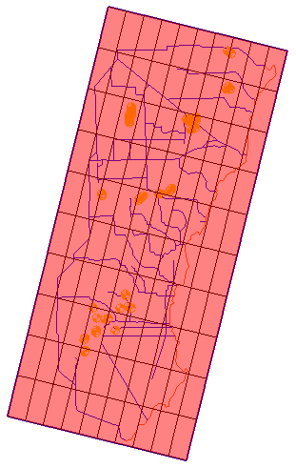

Figure 7 The UGrid created inside the grid frame

# Converting from Other Object Types

UGrids can be created from several other types of objects in GMS, including TINs; 2D grids, 3D grids, and meshes; polygons in a coverage; and polygon shapefiles in the GIS module. Two example conversions are demonstrated here.

## Converting from a 3D Grid

The current project includes a 3D Grid that is turned off. It is possible to convert it to a UGrid.

1. Fully expand the “File:3D Grid Folder.svg 3D Grid Data” folder in the Project Explorer.
2. Turn on “File:3D Grid Icon.svg grid” then right-click and select *Convert To* **| UGrid**.
3. Select **Yes** to the prompt to only convert active cells used by MODFLOW.

There are inactive cells in the 3D grid that can’t be seen because they are set to zero in the MODFLOW IBOUND array. By selecting yes, GMS will not include those cells in the UGrid.

1. Turn off “File:3D Grid Icon.svg grid” so the UGrid is visible.
2. Click the **Display Options** File:Display Options Macro.svg macro to bring up the *Display Options* dialog.
3. Select *Ugrid: ugrid (2) – [Active]* from the list on the left.
4. Turn on *Define UGrid specific options*.
5. Turn on *Cell faces*.
6. Click **OK** to close the *Display Options* dialog.

The UGrid should now look like the 3D grid it came from (Figure 8).

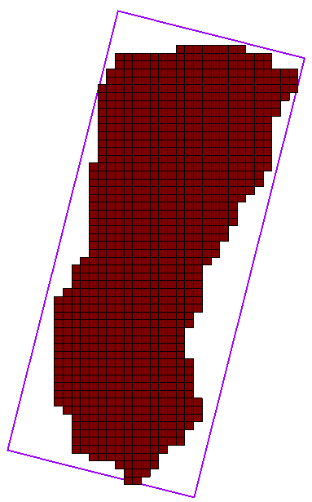

Figure 8 UGrid created from the 3D grid

## Converting from a Shapefile

A UGrid can be created by conversion from a shapefile.

1. Turn off “File:Map Folder.svg Map Data” and “Folder UGrid Data” in the Project Explorer.
2. Turn on “File:GIS Folder.svg GIS Layers”.

A shapefile should appear in the form of a quadtree grid (Figure 9). Quadtree UGrids can be created in GMS or imported and then converted to UGrids as shown here.

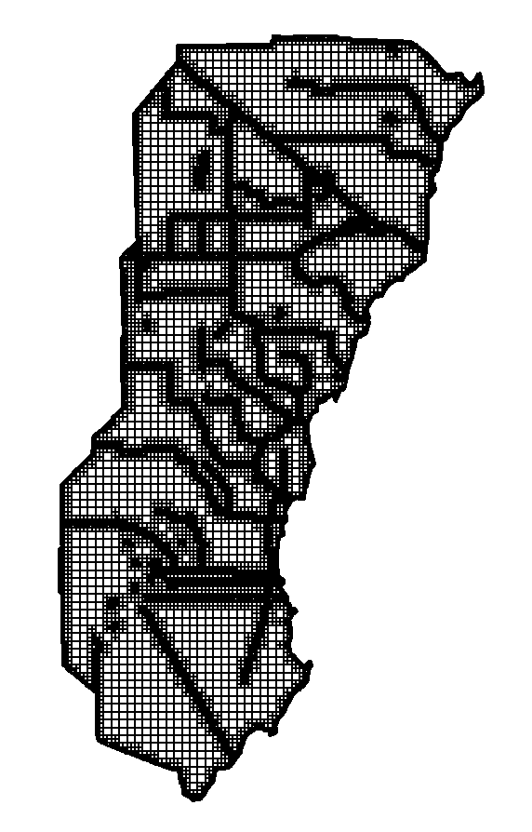

Figure 9 Shapefile showing a quadtree grid

1. **Zoom** File:Zoom Tool Icon.svg in on the shapefile to better see the quadtree refinement.
2. When done examining the grid refinement, **Frame** File:Frame Macro.svg the project.
3. In the Project Explorer, right-click on “File:Map Folder.svg Map Data” and select **New Coverage…**.
4. Expand “File:GIS Folder.svg GIS Layers” then right-click on “File:GIS Polygon Data Shapefile.svg biscayne.shp” and select *Convert To |* **Feature Objects** to open the first page of the *GIS to Feature Objects Wizard* dialog.
5. From the *Select a coverage for mapping* drop-down, select “new coverage”.
6. Select **Next >** to go to the next step of the *GIS to Feature Objects Wizard* dialog.
7. Accept the default settings and click **Next >**.
8. Accept the default settings and click **Finish** to close the *GIS to Feature Objects Wizard* dialog.
9. Under the “File:Map Folder.svg Map Data” folder, right-click on “File:Coverage Active Icon.svg new coverage” and select *Map To* | **Polygons →** **UGrid**.
10. Turn off “File:GIS Polygon Data Shapefile.svg biscayne.shp”.
11. **Zoom** File:Zoom Tool Icon.svg in to see that the quadtree refinement matches the shapefile.

## Extruding a 2D UGrid to a 3D UGrid

Now the UGrid consists of 2D cells. To create a MODFLOW model with the grid, a 3D UGrid is needed. To extrude the 2D UGrid into a 3D UGrid, do the following:

1. Switch to **Oblique View** File:Oblique View Macro.svg.
2. **Zoom** File:Zoom Tool Icon.svg on one of the edges of the grid to see that the cells have no depth.
3. Click the **Toolbox** File:Toolbox macro.png macro to open the *Toolbox (beta)* dialog.
4. Under the *Tools* tab, expand the “File:Generic Folder.svg Unstructured Grids” folder.
5. Double-click on the “ Extrude UGrid” tool to open the *Extrude UGrid* dialog.
6. For the *Input grid*, select “UGrid Data/ugrid (3)”.

Note that the *Extrude UGrid* tool allows defining multiple layers for the new 3D UGrid. For this example, only one layer will be generated.

1. For the *Layer 1 thickness*, enter “100.0”.
2. For the *Output grid*, enter “biscayne 3d”.
3. Click **OK** to close the *Extrude UGrid* tool dialog and to start the progress window for the tool
4. Click **OK** to close the *Extrude UGrid* progress window.

The new UGrid is now 3D and therefore has depth (Figure 10).

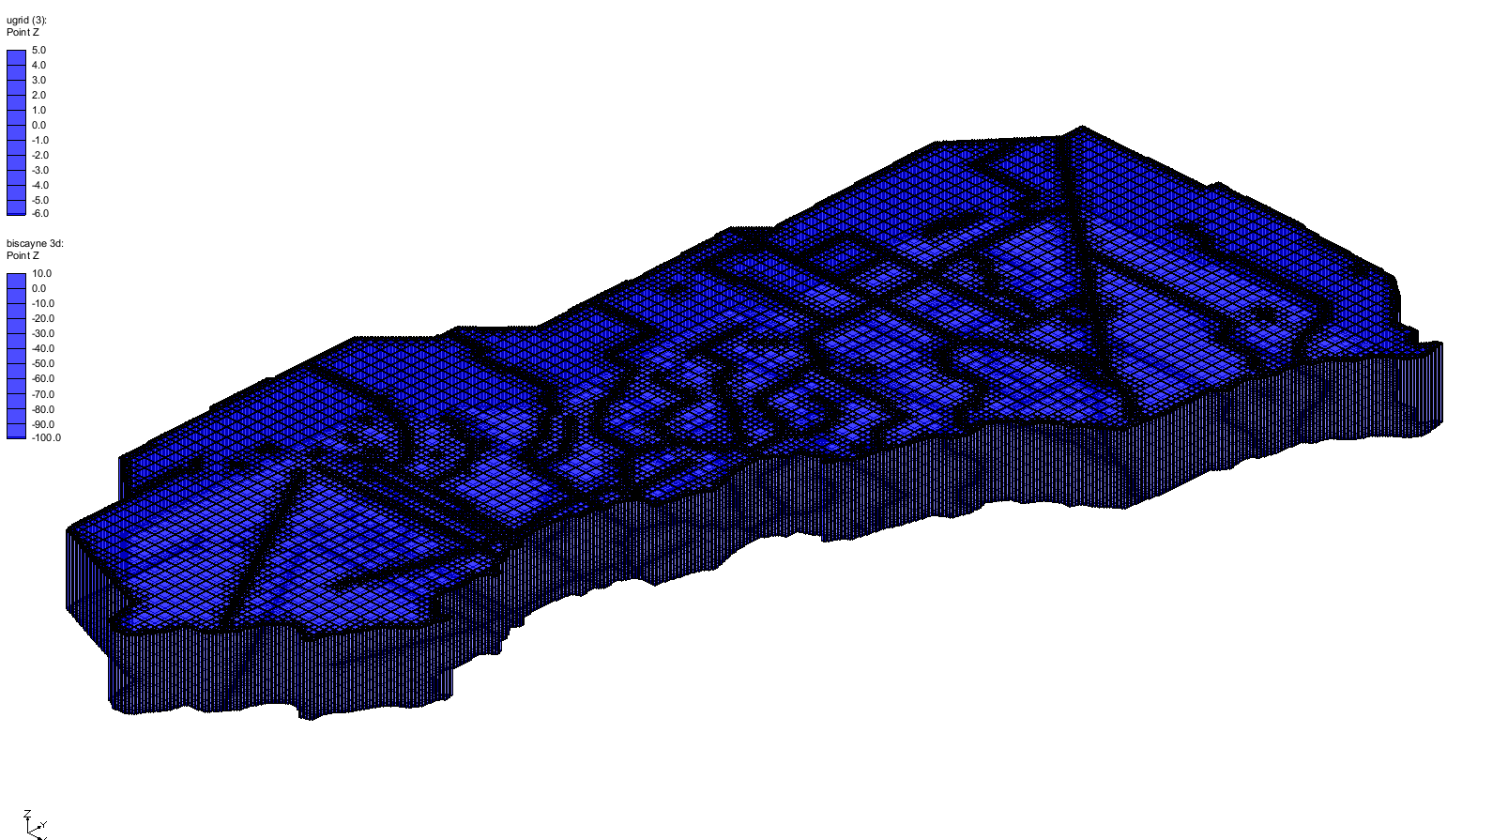

Figure 10 2D UGrid extruded to a 3D UGrid

# Using the Map to UGrid Dialog

Another method for creating UGrids is through the *Map → UGrid* dialog. This approach offers more advanced tools compared to previous methods seen previously, allowing the creation of quadtree, octree, and Voronoi UGrids based on a conceptual model. Additionally, the UGrid boundaries can be aligned to match those of the conceptual model.

1. Click the **New** File:New Macro.svg macro to start a new project.
2. If asked to save, click **Don’t Save**.
3. Click **Open** File:Open Macro.svg to bring up the *Open* dialog.
4. Select “Project Files (\*.gpr)” from the *Files of type* drop-down.
5. Select “mapToUGrid.gpr” and click **Open** to import the project and exit the *Open* dialog.
6. Fully expand “File:Map Folder.svg Map Data” and turn on “Grid Frame item Grid Frame” in the Project Explorer.

This opens a grid frame and conceptual model with two coverages (Figure 11).

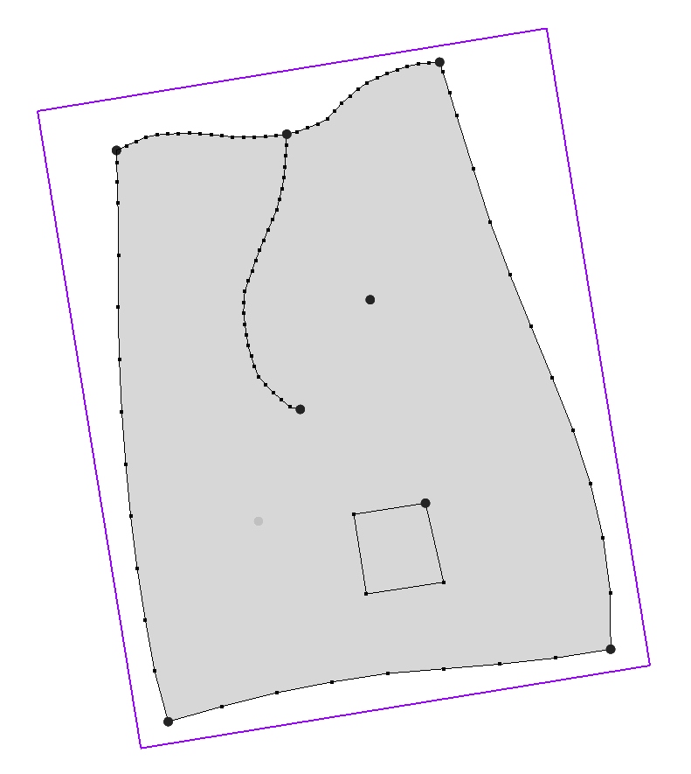

Figure 11 Conceptual model and grid frame

The conceptual model defines an area of interest for building a groundwater model. In this setup, the top arc is designated as a constant head boundary, while the remaining boundary arcs are defined as no-flow boundaries. A central arc represents a stream, and two well points are included—one of which is located in a separate coverage. Additionally, a rectangular region in the lower right part of the model has been identified for increased grid refinement.

To map the feature objects to create a new UGrid and look at the options:

1. Select the “Grid Frame item Grid Frame” so it’s active.
2. Click the **Map → UGrid** Map to Ugrid macro to bring up the *Map → UGrid* dialog (Figure 12).

The first drop-down is *Dimension,* which allows you to choose between either “2D” or “3D”. The next option is *UGrid type,* which has four choices: “Regular (not refined),” “Quadtree / Octree,” “Nested Grid,” and “Voronoi”. While the nested grid option is not covered in this tutorial[[1]](#footnote-1), the other three types are best explained through demonstration.

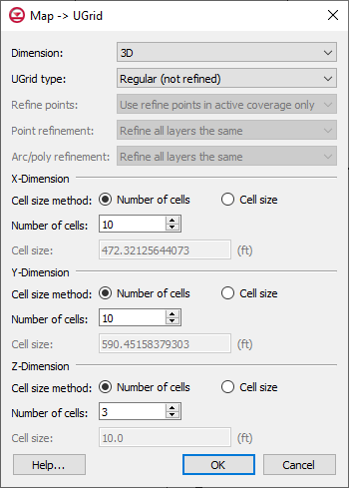

Figure 12 Map → UGrid dialog

## Regular (Not Refined)

For this example, the grid has 10 cells in the *X* and *Y* dimensions and three cells in the *Z* dimension. GMS uses the grid frame to determine the size of the grid, while the number of cells determines the size of each individual cell. Either specify the number of cells directly, as shown here, or define the target cell size and let GMS determine how many cells will fit within each dimension. When using a target cell size, keep in mind that GMS may slightly adjust the size to prevent partial cells from appearing along the grid lines.

1. Click **OK** to accept the defaults and close the *Map → UGrid* dialog.

Notice the rectangular cells. This is what is meant by the “Regular (not refined)” option. Also notice that the cells outside the outer polygon boundary (the grid frame) are not included in the UGrid. They are not inactive—they simply don’t exist.

1. Switch to **Oblique View** File:Oblique View Macro.svg.

The UGrid is 3D with three layers and fits the dimensions of the grid frame. It consists of 10 cells in both the *X* and *Y* dimensions (Figure 13).

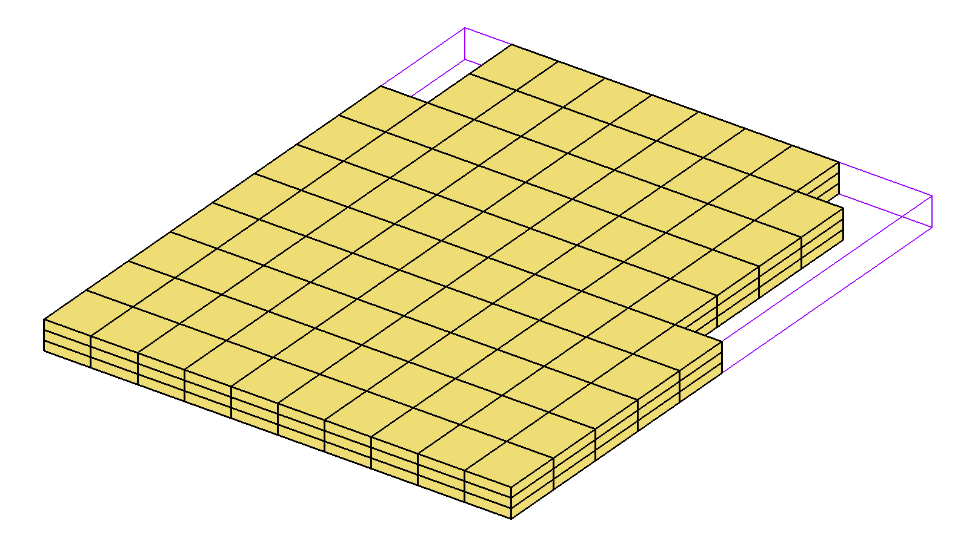

Figure 13 Regular (not refined) appearance

## Quadtree / Octree

### Quadtree: All Layers the Same

To see what the quadtree option produces:

1. Switch to **Plan View** File:Plan View Macro.svg and turn off the new “Ugrid_lock ugrid”.
2. Click the **Map → UGrid** Map to Ugrid macro to open the *Map* **→** *UGrid* dialog.
3. From the *UGrid type* drop-down, select “Quadtree / Octree”.
4. From the *Refine points* drop-down, select “Use refine points in active coverage only”.
5. From both the *Point refinement* and *Arc/poly refinement* drop-downs, select “Refine all layers the same”.
6. Click **OK** to close the *Map → UGrid* dialog.

Notice that the grid has been refined in a quadtree pattern around the arcs, points, and polygons (Figure 14). In a quadtree grid, each cell has, at most, two neighboring cells along each side. The largest cells match the size of those in the regular grid. This means the cell count specified in the *Map → UGrid* dialog for the *X*, *Y,* and *Z* dimensions refers to the unrefined grid—what the grid would look like without any refinement.

1. Turn on the *Single layer* option in the UGrid Viewing Mode http://www.xmswiki.com/w/images/3/30/SingleLayerToolbar.png toolbar and change the layer to “2” then “3”.

The *Single layer* option allows viewing one layer of the UGrid at a time. Notice that all layers are refined the same. This tutorial will now cover how to define the refinement in the conceptual model.

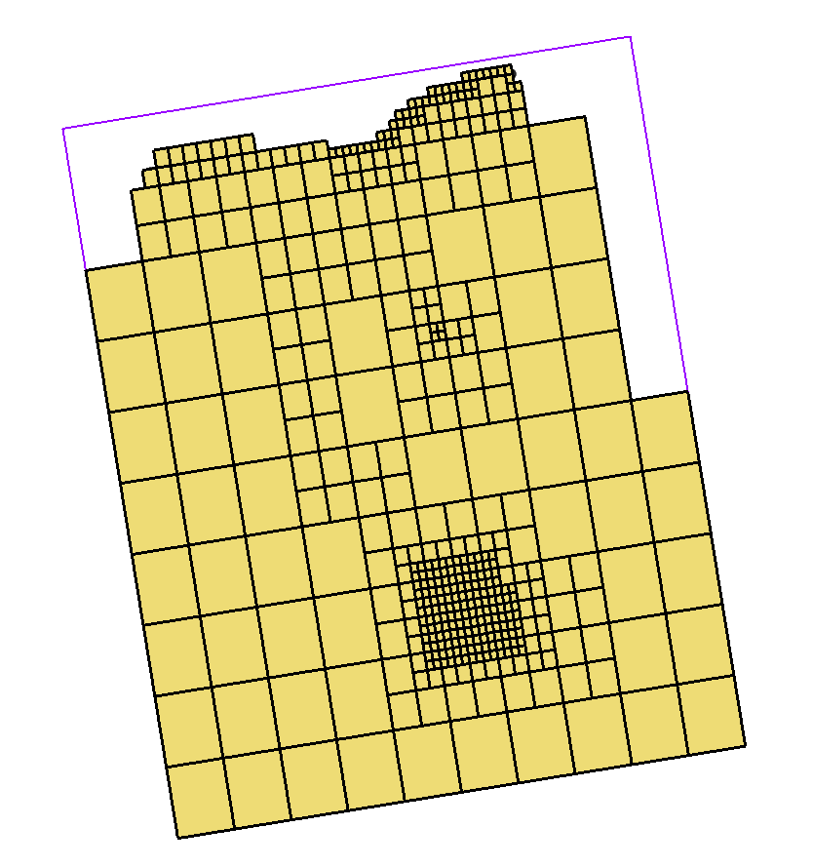

Figure 14 Quadtree UGrid

### Refinement Attributes

Refinement is specified as attributes on feature objects in the conceptual model.

1. Turn off the new “Ugrid_lock ugrid (2)” in the Project Explorer.
2. Select “File:Map Folder.svg Map Data”.
3. Using the **Select Arc** File:GMS Select Arc Tool.svg tool, double-click one of the arcs along the top of the coverage to bring up the *Attribute Table* dialog.

Notice that the *Refine* attribute is on and that the *Base size (ft)* is set to either “100.0” or “200.0”, depending on the selected arc. UGrid cells along this arc will be about 100 (or 200) feet in size.

1. Click **Cancel** to close the *Attribute Table* dialog.
2. Using the **Select** File:Select Object Tool.svg tool, double-click the well point in the upper right area to bring up the *Attribute Table* dialog.

Notice that the *Refine* attribute is on and the *Base size (ft)* is set to “75.0”. This means the UGrid cell at this location will be 75 feet in size. The *Bias* and *Max size* options are ignored when creating quadtree UGrids. These options are only used when creating structured 3D grids.

1. Click **Cancel** to close the *Attribute Table* dialog.
2. Using the **Select** File:Select Object Tool.svg tool, double-click the rectangular polygon in the lower area to bring up the *Attribute Table* dialog.

*Refine* is on and *Base size (ft)* is set at “100.0”, so all cells in this area of the UGrid will be about 100 feet in size.

1. Click **Cancel** to close the *Attribute Table* dialog.
2. Double-click somewhere in the main polygonal area to bring up the *Attribute Table* dialog.

Notice that *Refine* is off. Cells in this area will be allowed to grow to the maximum allowed size.

1. Click **Cancel** to close the *Attribute Table* dialog.
2. Double-click on the “File:Coverage Active Icon.svg M1” coverage in the Project Explorer to bring up the *Coverage Setup* dialog.

Notice the *Refinement* attribute is on in the list of *Sources/Sinks/BCs*. This must be on to have the *Refine* attribute available for points, arcs, and polygons.

1. Click **Cancel** to close the *Coverage Setup* dialog.

### Quadtree/Octree

To review the *Octree* option for points:

1. Using the **Select** File:Select Object Tool.svg tool, double-click the well point in the upper right area to bring up the *Attribute Table* dialog.
2. Select “Points” from the *Feature type* drop-down.
3. Enter “3” in both the *From layer* and *To layer* columns.
4. Click **OK** to close the *Attribute Table* dialog.
5. Click the **Map → UGrid** Map to Ugrid macro to bring up the *Map → UGrid* dialog.
6. From the *Point refinement* drop-down, select “Octree”.
7. Click **OK** to accept the defaults and close the *Map → UGrid* dialog.
8. Use the UGrid Viewing Mode http://www.xmswiki.com/w/images/3/30/SingleLayerToolbar.png toolbar to view layers 2 and 3.

Note that each layer has a different level of refinement. Layer 3—where the point is located—is the most highly refined. The “Octree” option supports both vertical and horizontal refinement. As a result, every cell can have up to two neighboring cells on either side, and up to four neighboring cells above or below. However, this option does not subdivide layers into additional sublayers. The grid still consists of just three distinct layers across the entire UGrid.

The octree option is also available for arcs and polygons and works similarly.

### Quadtree on Assigned Layers

To look at the quadtree on assigned layers option:

1. Turn off the new “Ugrid_lock ugrid (3)”.
2. Click the **Map → UGrid** Map to Ugrid macro to bring up the *Map → UGrid* dialog.
3. From the *Arc/poly refinement* drop-down, select “Quadtree on assigned layers”.
4. Click **OK** to close the *Map → UGrid* dialog.
5. Use the UGrid Viewing Mode http://www.xmswiki.com/w/images/3/30/SingleLayerToolbar.png toolbar to view layers 2 and 3.

Note that quadtree refinement around arcs and polygons occurs only in layer 1. This is because the *Quadtree on assigned layers* option refines cells only in the layer(s) to which arcs or polygons are assigned. In this case, all arcs and polygons are assigned to layer 1 by setting the *Layer range* attribute in the *Coverage Setup* dialog, and specifying 1 for both the *From layer* and *To layer* values for each arc or polygon. As a result, the transition from layer 2 to layer 3 is more abrupt, lacking the smoothing effect seen with the *Octree* option.

While this approach results in fewer cells—which can significantly reduce computation time—it comes at the cost of reduced accuracy. However, if groundwater flow is primarily horizontal, this might be an acceptable tradeoff.

For more practice creating quadtree UGrids, the “MODFLOW-USG *–* Quadtree” tutorial also discusses and demonstrates quadtree creation.

### Voronoi

The last option to look at in the *Map → UGrid* dialog is the Voronoi option.

1. Turn off “Ugrid_lock ugrid (4)” in the Project Explorer.
2. Click the **Map → UGrid** Map to Ugrid macro to bring up the *Map → UGrid* dialog.
3. Select “Voronoi” from the *UGrid type* drop-down.

Note that most other options become unavailable when using Voronoi grids. This is because Voronoi UGrids are fundamentally different from the other types; the number of cells in the *X* and *Y* dimension cannot be specified. Instead, cells are generated using a meshing and triangulation algorithm based solely on the geometry of the points, arcs, and polygons in the active coverage.

1. Click **OK** to accept the defaults and close the *Map → UGrid* dialog.
2. Click anywhere in the Graphics Window.
3. Switch to **Plan View** File:Plan View Macro.svg.

A Voronoi UGrid features a distinct type of cell. Cells are constructed so that boundary conditions are applied at the cell center, and the faces between adjacent cells are perpendicular to the line connecting those centers (Figure 15). This configuration improves computational accuracy when applying the finite volume method.

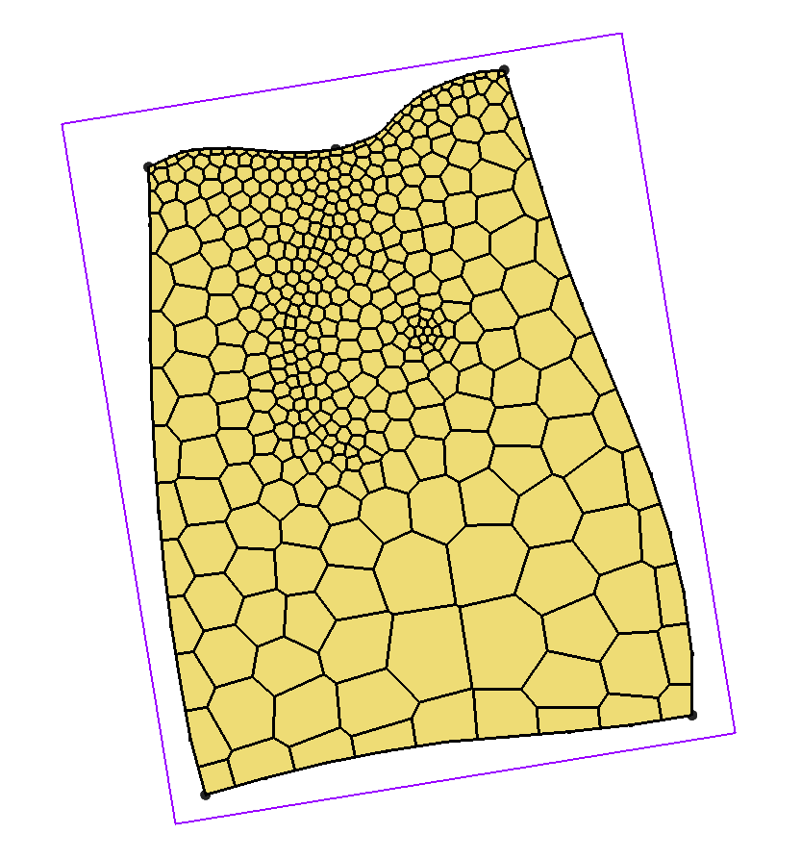

Figure 15 Voronoi UGrid on layer 1

For Voronoi grids, refinement attributes on feature objects are ignored; only the geometry of the feature objects influences the grid. To achieve finer resolution, vertices must be redistributed along arcs. In this case, increasing vertex density along the arc defining the rectangular polygon in the lower right results in smaller cells sizes in that area.

### Refining the Polygon Arc

1. Turn off “Ugrid_lock_3D ugrid (5)” in the Project Explorer.
2. Select “File:Coverage Active Icon.svg M1” to make it active.
3. Using the **Select Arcs** File:GMS Select Arc Tool.svg tool, select the arc that forms the rectangular polygon in the lower-right area of the larger polygon.
4. Right-click on the arc and select **Redistribute Vertices…** to open the *Redistribute Vertices* dialog.
5. Enter “100.00” for the *Average spacing*.
6. Click **OK** to close the *Redistribute Vertices* dialog.
7. Click **Map → UGrid** Map to Ugrid to bring up the *Map → UGrid* dialog.
8. Click **OK** to accept the defaults and close the *Map → UGrid* dialog.

Now the cells in the area of the polygon are much smaller (Figure 16).

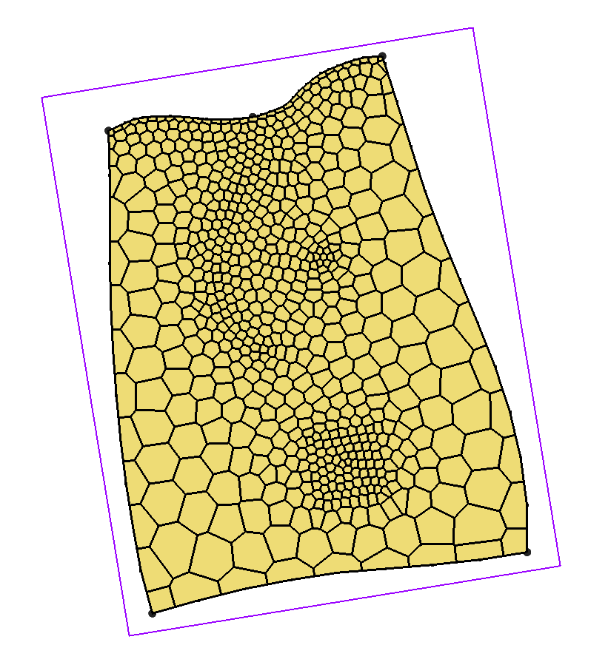

Figure 16 The area of the rectangular polygon is more refined

# Horizons to UGrid

So far, the methods used to generate UGrids have produced either 2D UGrids or 3D UGrids with continuous, flat layers in the *Z* dimension. Elevation data for layer boundaries can be used to interpolate to MODFLOW layer arrays, allowing the UGrid to be warped after creation. This process is the same as that used for structured 3D grids and is described in the “MODFLOW – Interpolating Layer Data” tutorial.

Another way for generating UGrids allows for the creation of layers that are not flat and may even pinch out. This method uses the **Horizons → UGrid** command and is covered in detail in the “MODFLOW-USG –Complex Stratigraphy” tutorial.

To briefly look at this method, do the following:

1. Click **New** File:New Macro.svg to start a new project.
2. If asked to save, click **Don’t Save**.
3. Click **Open** File:Open Macro.svg to bring up the *Open* dialog.
4. Select “Project Files (\*.gpr)” from the *Files of type* drop-down.
5. Select “horizons.gpr” and click **Open** to import the project and exit the *Open* dialog.

A project containing a lot of data—including boreholes, cross sections, and TINs—will appear (Figure 17). All of this data is used in the converting from a horizons conceptual model to UGrid.

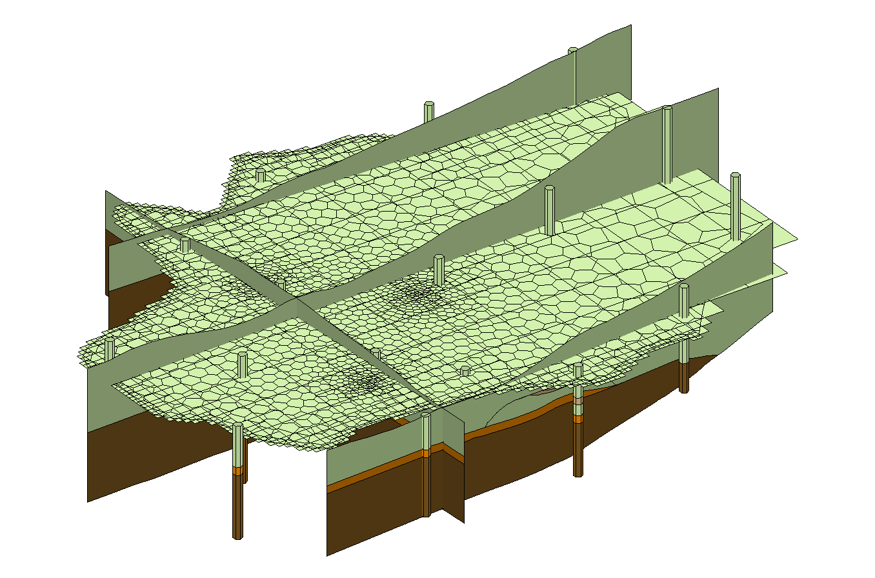

Figure 17 The horizons conceptual model

1. Select “File:TIN Folder.svg TIN Data” in the Project Explorer to make it active.
2. Select *TINs |* **Horizons → UGrid…** to bring up the *Horizon Elevations* page of the *Horizons to UGrid* dialog.
3. In the *Conceptual model* section, turn on *Use horizons conceptual model*.
4. Click **Next >** to go to the *Top and Bottom Elevations* page of the *Horizons to UGrid* dialog.
5. In the *Primary UGrid* section, select “2D UGrid item – locked voronoi”.
6. In the *Top elevation* section, select *TIN elevations*.
7. Click **Next >** to go to the *Build UGrid* page of the *Horizons to UGrid* dialog.
8. In the *Meshing options* section, turn on *Minimum element thickness* and enter “2.0” in the field below that.
9. Click **Finish** to create the 3D UGrid and close the *Horizons to UGrid* dialog.

## Viewing the 3D Quadtree UGrid

The 3D UGrid should be generated within a few moments, depending on the speed of the computer used. It is considered best practice to assign a more descriptive name to the new UGrid; however, for the purposes of this tutorial, it will not be renamed.

1. Turn off “File:Borehole Folder.svg Borehole Data” and “File:Solids Folder.svg Solid Data” in the Project Explorer.

The 3D UGrid should appear similar to Figure 18.

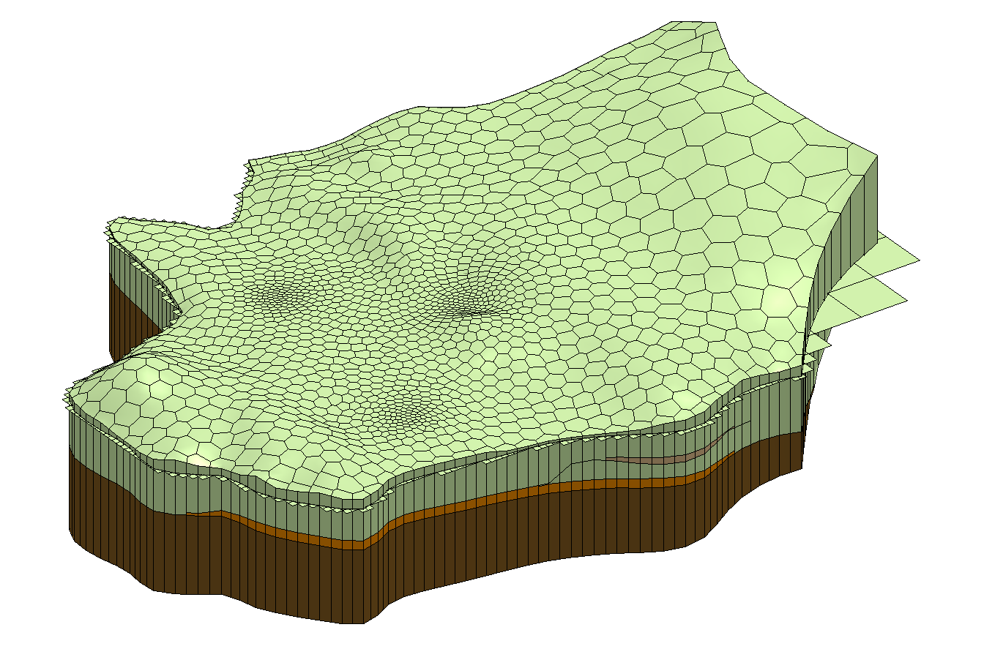

Figure 18 3D Voronoi UGrid made using the Horizons → UGrid command

1. On the UGrid Viewing Mode http://www.xmswiki.com/w/images/3/30/SingleLayerToolbar.png toolbar, turn on *Single layer*.
2. Review layers 1–5 using the toolbar.

Note that this UGrid includes some layers that are discontinuous, or “pinched out”. The top and bottom elevations of each layer are irregular, conforming to the solid, borehole, and cross-section data.

Feel free to experiment with the **Horizons → UGrid** command. For further practice, refer to the “MODFLOW*–*USG – Complex Stratigraphy” tutorial.

# Conclusion

This concludes the “UGrid Creation” tutorial. The following key concepts were discussed and demonstrated in this tutorial:

* UGrids can be created in GMS in the following ways:
* Importing
* New UGrid commands
* Conversion from other objects
* **Map → UGrid** command
* **Horizons → UGrid** command
* The **Map → UGrid** command can create the following types of UGrids:
* Regular (not refined)
* Quadtree/Octree
* Voronoi
* The **Horizons → UGrid** command can create complex UGrids with layers that pinch out

1. The nested grid option creates a grid with rectangular cells that are refined like the quadtree option, but the surrounding cells are not smoothed. [↑](#footnote-ref-1)